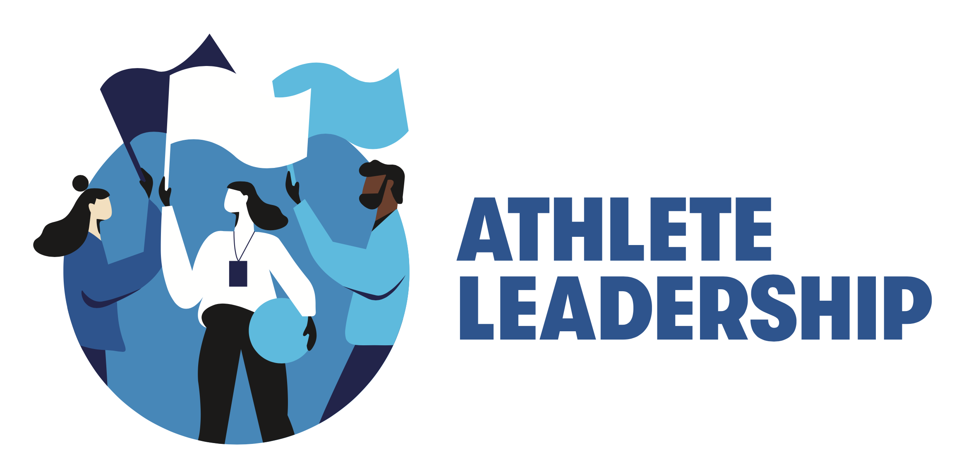

Athlete Leadership: A Program Considerations Guide

Why Athlete Leadership?

If we want a more inclusive organization and accepting world, Special Olympics athletes must be allowed to contribute in ways beyond the sports field. One of the most powerful ways we do this is through Athlete Leadership, which creates opportunities for people with intellectual disabilities to learn new skills, develop an individualized leadership style, and ultimately demonstrate their abilities in meaningful leadership roles.

Special Olympics is for athletes, so it should be led by athletes as well. They should be involved in every decision we make as an organization. In order to truly become a movement led by athletes, they must be given the opportunity to share their abilities, experiences, and knowledge. Not only are we fulfilling our mission by providing opportunities for people with intellectual disabilities but having athletes in leadership roles improves their lives as a whole, helps us as an organization by having more athlete leaders in place to help carry out the day-to-day work of Special Olympics, and demonstrates to the world that people with intellectual disabilities can and should hold meaningful leadership positions. It's not just the right thing to do, it’s good business!

But this doesn’t happen by accident. It takes strategic vision by a Program. It requires dedicated resources, and it flourishes when there’s an authentic organizational and cultural commitment to embrace the philosophy of Unified Leadership - from the highest levels of leadership down (from the Board of Directors, CEO, and staff to coaches, volunteers, and families) - to prioritize the training and empowerment of athletes as leaders. Sustainable Athlete Leadership also includes a commitment to creating an environment where these meaningful roles are accessible to every athlete and they have a reasonable opportunity to be successful.

Athlete Leadership and Unified Leadership are not the same thing, nor are they mutually exclusive. They are approaches to understanding and achieving true inclusive leadership (Unified Leadership) and it starts with empowering and equipping people with intellectual disabilities to lead the way (Athlete Leadership).

There are many ways Programs can engage athletes in leadership roles. Programs can offer training sessions from the SOI leadership and skills curriculum, and create opportunities for athletes to lead in health, sport, events, communication, youth/schools, and athlete representative roles. Ideas for meaningful athlete leadership roles include, but are not limited to, public speaking, leading Input Councils, serving on boards and event and competition planning committees, taking photos and videos at events, serving as health messengers, becoming coaches, and much more! Any role that exists within Special Olympics that is available to a person without an intellectual disability should also be an option for qualified and interested athlete leaders.

Things for Programs to Consider
This is not a complete list of considerations, nor is it a “checklist.” Rather, these are thought-starters to help your Program as you think about starting or expanding Athlete Leadership programming.

Commitment / Culture:
- Does the Board of Directors/President/CEO/staff understand and support the concept Unified Leadership?
- Does the Board of Directors/President/CEO/staff support Athlete Leadership?
- Does the staff see the benefits of/opportunities for, Athlete Leadership, with respect to their duties?
- Does key field leadership understand and support Athlete Leadership?

- Do we have commitment from key decision-makers to make Athlete Leadership development and expansion an organizational priority and goal?
- Have we discussed how Athlete Leadership fits our strategic plan and vision?
- Do we “walk the talk” already? Are we consistently modeling Unified Leadership and inclusion in this space for others? Do we have tokenistic or patronizing practices and behaviors we need to acknowledge and constructively work to address?

Resources:
- Do we currently have capacity to have a person (paid staff or volunteer) dedicating a sufficient percentage of their time (full or part) to Athlete Leadership?
- Have we assessed what other labor / staff support introducing or expanding Athlete Leadership may entail or impact?
- Do we have athlete(s) on staff currently (paid or unpaid)? If not, do we have a plan to in the near future?
- If “no,” do we have commitment from leadership to add at least one athlete staff position (paid or unpaid)?
- Do we have staff, volunteers, and athletes interested in helping get Athlete Leadership off the ground?
- Do we currently have any financial capacity to invest in Athlete Leadership?
- Have we projected what our financial investment in Athlete Leadership might look like for the first 3 years?
- Do we have current or potential partners or sponsors who may wish to support Athlete Leadership?
- Have we talked to SONA (bschatsiek@specialolympics.org) to learn about potential funding / grant opportunities?
- Are we familiar with the SOI Athlete Leadership resources and curriculum, SONA resources, and /or SOI Unified Leadership resources?

Opportunities & Inventory:
- Do we have a list of possible roles / jobs, at all levels of the Program, for athlete leaders currently?
- If “no” to above…have we brainstormed / audited current and potential future roles / opportunities? Have we identified which athletes and leaders without ID could be a part of this exercise?
- Do we have job descriptions for any / all of our various roles that we would modify for athlete leaders?
- Do we have capacity to create job descriptions for roles if they don’t currently exist? Do we know who could best help create them?’
- Do we know of athletes who are diverse in gender, ethnicity, and disability who already display leadership qualities that that could be the foundation for our Athlete Leadership development / expansion?
Education / Training:
- Do we have a preliminary plan for how we could / will offer education / training to Board, CEO, staff, field leadership to ensure accurate understanding of Unified Leadership and how Athlete Leadership plays into that, as well as the annual commitments required for it to succeed?
- Is the Board familiar with or willing to adopt the “suggested criteria for selecting athlete leaders to serve on Boards of Directors” (as created by the U.S. Athlete Input Council)?
- Have we assessed what capacity / expertise / funds will we need to train athletes and volunteers?
- Have we determined approximately how many trainings we wish to conduct annually in years 1, 2 and 3, and in what format (one training at a time vs. multi or “bundled” class session)
- Have we determined which trainings / curriculum for athletes we want to prioritize and offer? And to how many participants, ideally?

Marketing:
- Are we marketing Athlete Leadership currently?
- If “no,” have we discussed how we could / will market Athlete Leadership to potential athlete leaders, mentors, partners, etc.?
- Do we have the ability to promote on social media and in digital communications (website, e-newsletters, emails)?
- Do we have the ability to create basic promotional collateral materials?

Tips:
- Start small and build from there; it can start with minimal cost in terms of staff time and resources
- Start with a focus on training / supporting the current athlete leader on the Board and future ones
- Scale at a responsible pace so quality, purpose, and impact are maintained
- Don’t sacrifice quality for quantity
- Have athlete leaders as part of the team building your Athlete Leadership and Unified Leadership development or expansion plan!
- Use the SOI curriculum and resources – no need to reinvent the wheel
- Talk to other Programs with Athlete Leadership Programs for ideas and learnings!
- Talk to Brandon Schatsiek, Manager, Athlete Leadership Development, SOI/SONA (bschatsiek@specialolympics.org) about resources, trainings, and opportunities. Make sure he knows your staff member in charge of Athlete Leadership

