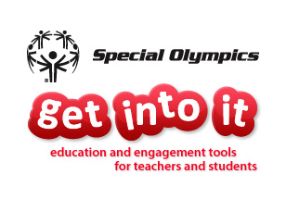
Elements of Program-Educator Relationship

- Contact educators who have downloaded GII to see if they have any questions and if/how/when they will be implementing the curriculum. You can also provide them with background information on Special Olympics, Project UNIFY, or your state/local Program details.

- Inform educators of additional materials that you have to supplement the curriculum. This may include leftover materials from previous SOGII, state-specific PSAs, videos, or youth leadership materials.

- Provide educators with a calendar of Program events and, if possible, opportunities for their students to contribute. This can include: fundraising, volunteering, advertising and publicity, or adding in youth leadership components.

- Provide educators with details on how to set up an athlete visit for their classroom. This is an activity described in GII, so teachers may mention this opportunity.

- Offer to brainstorm service-learning project ideas with the educator. The service-learning component of GII is the most enticing, but also the most daunting activity. The project serves as a culmination of GII, and teachers will be looking for ideas that have a meaningful impact on both the school and community. This is a perfect place and a new opportunity for educators, Programs – and youth! - to work together.

- Provide opportunities for educators to connect with each other. This may be through conference calls with GII educators from the same area/region or may involve a summit or professional development opportunity.

- Ask teachers to provide feedback on their experience with GII. In addition to the basic feedback link on the GII website (which just sends an email to me), we are putting together a questionnaire for teachers to complete after using GII to help us gather insight on effectiveness, relevance, and feasibility, and to guide us in changes and updates made to GII. (More information on this will be distributed once the materials are ready.)

