Travel & Accommodation Management Plan – Guidance & Template
This document is part of the Special Olympics Europe Eurasia Sport Environmental Sustainability Framework guidance to support event organizers to:
- Demonstrate commitments to selecting and promoting of low carbon travel options, utilizing the travel hierarchy. Create a plan by working through the sustainable travel hierarchy:
  - Minimization of carbon impact of event staff travel
  - promotion of active travel and public transport links to stakeholders (including athletes, sponsors, suppliers and partners)
  - collaboration with local authorities and operators to ensure sufficient public transport provision
- Demonstrate commitments to selecting and promoting accommodation which have sustainability commitments and/or meet recognized sustainability standards/recognition.

Key Guidance
This travel and accommodation management plan should relate to all your stakeholders/client groups related to the event.
As travel and accommodation is very often one of the largest greenhouse gas emissions sources of an event, this plan also compliments your carbon management and reduction plan.
If working with an existing venue, ensure that questions around travel provision are asked from the outset, for example:
- Is the venue in close proximity to public and active transport links? Ideally less than 1km
- Is the travel provider and supplier able to support more sustainable forms of travel/transport?
- Has sustainable and active travel been communicated to all stakeholders prior to and during the event?
- Have you selected accommodation providers who are also prioritizing sustainability and low carbon initiatives?
Further information can be found by contacting Colin Kenny, Senior Manager of Projects and Grants at SOEE, ckenny@specialolympics.org.
Travel and Accommodation Management Plan – Template
Contents
Introduction 3
Event Transport Provision 4
Engaging and communicating with stakeholders 6
Data Collection and Post-event Reporting 6
Accommodation: Sustainability Evaluation 7

Key Contacts

Name | Role | E-mail Address

Introduction
[Provide overview of the event – including the location, title of the event and the reporting period].
Delivering an effective network of transport will be key to the success of the event. This includes transport relating to client groups of:
- [Event staff and contractors
- Suppliers
- Commercial partners / sponsors
- VIPs, guests and members
- Athletes and teams
- Spectators]

This event travel plan, will set out how the event plans to adhere to the travel hierarchy, and includes:

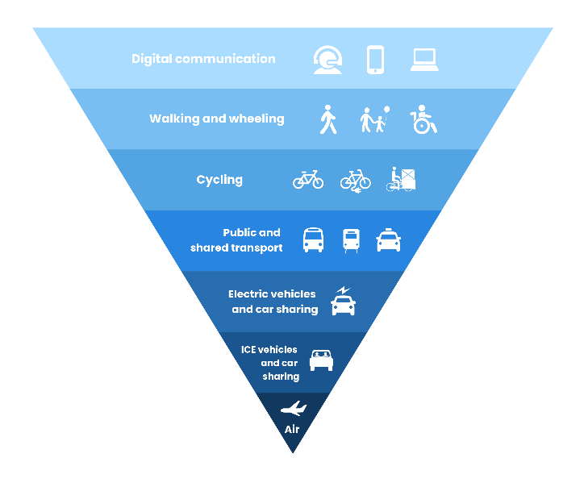
- [Insert details of key initiatives – for example
- Minimization of carbon impact of event staff travel

- Promotion of active and sustainable travel and public transport links to client groups

- Collaboration with local authorities and operators to ensure sufficient public transport provision

- Communications in alignment with the travel hierarchy, to all event stakeholders and provide travel options through event communication streams.]
Figure 1 Sustainable Travel Hierarchy (Source: Energy Saving Trust)

The transport provision will be primarily made up of:
- [Insert details of transport provision – for example
- Shuttle Bus service from city center locations to the venue
- Public transport
- Only very limited parking on site (disabled and priority access only – no public parking)]

Event Transport Provision
The below table outlines the different transport options available for the event, in order of the travel hierarchy. [Please update and modify the table as relevant to your event]
Travel Hierarchy | Event Transport Provision | Description
Active Travel | Walking, cycling | Cycling:  - Is the venue/event cycle accessible  - Is their bike storage on-site?  Walking: Walking routes…(?)
Public & Shared Transport | T1 Fleet | Client Group: The primary fleet is for [insert client group].  Vehicle numbers and types: It will be made up of [XX number of vehicles] of which [XX number are low emissions (EV/Hybrid)]  Estimated fleet mileage for the event: [based on number of cars, expected demand, where based, is it possible to give an estimate mileage?]  Actions to reduce impact:  - [Actions to reduce the number of miles travelled? – efficient schedule etc.]  - [Actions to promote car-sharing?]  - [communications with client group/s to promote the above?]  - Other actions?
 | Shuttle Bus Service | Client Group: The shuttle bus service is for [insert client groups].  Vehicle numbers and types: There will be [XX number of XX seater] of shuttle buses…, provided by [insert supplier].  Estimated fleet mileage for the event: [based on number of cars, expected demand, where based, is it possible to give an estimate mileage?]  Actions to reduce impact:  - We are considering [XX to ensure we runs services as efficiently as possible to avoid unnecessary trips]…  - Other actions?
 | Public Transport | Client group: Public transport will be encouraged across all client groups.  Public Transport Links: [description of public transport links relating to the event]  Actions to reduce impact - client groups (excl. spectators):  Actions to reduce impact - spectators:  Spectators will also be actively encouraged to use public transport and a number of efforts have been made to make this easier for people:  - [Any collaboration with local transport providers]  - [wayfinding and signage provided to make travelling by public transport clear and easy]  - [Signposts and detail of public transport encouraged within external communications]
Private vehicles | Private cars | Client group: [insert relevant client groups]  Car Parking:  [insert details of car parking provision, or lack of]
Air | Flights | Client group: [insert relevant client group]  A lot of athletes and teams travelling to events, as well as SOEE staff, who are likely travelling from overseas, there is little alternative to flying.  Actions to reduce impact:  - [Travel policy – does this state preference for public transport over flying?] – limited flights taken due to this, examples of using trains as an alternative  - [Use  - of local suppliers to reduce the need for people to fly in?]  - [use of local volunteers meaning limited flights expected from volunteer group]  - [XX% of ticket holders are local and/or within reasonable driving distance meaning flights not expected to be a common form of travel for spectators?]

Engaging and communicating with stakeholders
[Insert details on comms plan, including -
- How is the event going to be communicating the provision of primary fleet, shuttle services and public / active transport to attendees?
- Is the promotion of public transport planned to be included within spectator communications (pre-event email, social media)?
- Is the promotion of public transport planned for website comms?
- How is the event communicating sustainable and low carbon accommodation to event stakeholders in advance of the event?]

Data Collection and Post-event Reporting
Data relating to transport services provided by the event will be reported to [XXX] by the [XXX}, as soon as possible after the event.

The below types of data will be collected to evaluate success of plan:
- Number of people using public transport, sustainable transport and active transport
- Number of cars on-site
- Total visitors to event

The aim is to collect this data from a mix of sources including:
- Mileage logs/reporting from fleet and shuttle bus providers
- Parking pass allocation
- Volunteer data
- Spectator and athlete surveys

[Remove if not calculating your even’s carbon footprint - This data will also allow the carbon emissions associated with transport around the event to be calculated and included in the event carbon footprint. A data collection spreadsheet will also be provided to support this process.]

Accommodation: Sustainability Evaluation
Sustainability Evaluation
[The below evaluation has been done by looking at the following sources:
- Hotel website (sustainability policies, commitments and pledges)
- Booking.com’s travel sustainable programme rating
- Green Tourism – Criteria Definitions
- Google – ‘eco-certified’ hotels
- Green Key Accreditation
- Hotel specific sustainability policy and objectives
- Any sustainability certifications listed on the Travalyst website]

Total Primary Hotels: [Insert number here]
% accommodation suppliers demonstrating internationally recognized sustainability certification or documented sustainability commitments: [Insert here]
Hotel Name | Green Tourism | Booking.com |  | Google – ‘eco-certified’ | Other notes or recognized certifications
 |  | Sustainable Rating | Sustainability steps  (out of 29)
Hilton | - | 3+ | 22 | Yes | Travel with Purpose Summary 2022  - Certified by: ISO 14001:2015 Environmental management system  - ISO 50001:2018 Energy management systems  - ISO 9001:2015 Quality management systems  - Part of the Hilton Worldwide sustainability programme: LightStay  - Travel with Purpose
Hilton Suite | - | 3+ | 16 | Yes
[insert hotel name]
[insert hotel name]

[Elements of the sustainable accommodation plan may include:
- Development and implementation of an accommodation contract including a sustainability clause used for negotiations with hotel partner;
- Guidance for guests when using accommodation e.g. reusing bedding and towels (to conserve water and energy);
- Select hotels near to the event to minimize travel emissions;
- Selecting hotels with electric vehicle charging and cycling facilities in place, or where these can be found within a 5 minute walk.]

Funded by the European Union. Views and opinions expressed are however those of the author(s) only and do not necessarily reflect those of the European Union or the European Education and Culture Executive Agency (EACEA). Neither the European Union nor EACEA can be held responsible for them

