[Program Name] 2021 Plan

SWOT Analysis of Program internal and external factors:
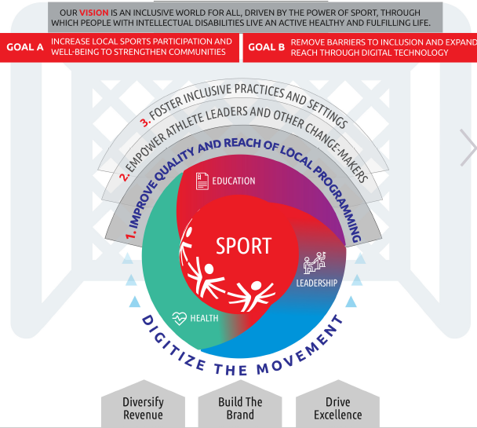
Strengths:

Weaknesses:

Opportunities (political, economic, social, technological, organizational):

Threats (political, economic, social, technological, organizational):

S1. Improve quality and reach of local programming

Strategic Initiative | Measure of success | 2021 Target | 2021 Actions | Owner
Choose an item. | Choose an item.
Choose an item. | Choose an item.
Choose an item. | Choose an item.
Choose an item. | Choose an item.
Choose an item. | Choose an item.
Choose an item. | Choose an item.

S2. Empower athlete leaders and other change-makers

Strategic Initiative | Measure of success | 2021 Target | 2021 Actions | Owner
Choose an item. | Choose an item.
Choose an item. | Choose an item.
Choose an item. | Choose an item.
Choose an item. | Choose an item.
Choose an item. | Choose an item.

S3. Foster inclusive practices and settings

Strategic Initiative | Measure of success | 2021 Target | 2021 Actions | Owner
Choose an item. | Choose an item.
Choose an item. | Choose an item.
Choose an item. | Choose an item.

E1. Digitize the Movement

Strategic Initiative | Measure of success | 2021 Target | 2021 Actions | Owner
Choose an item.
Choose an item.
Choose an item.

E2. Diversify revenue

Strategic Initiative | Measure of success | 2021 Target | 2021 Actions | Owner
Choose an item. | - Choose an item.
Choose an item. | - Choose an item.
Choose an item. | - Choose an item.

E3. Build the brand

Strategic Initiative | Measure of success | 2021 Target | 2021 Actions | Owner
Choose an item.
Choose an item.
Choose an item.

E4. Drive excellence

Strategic Initiative | Measure of success | 2021 Target | 2021 Actions | Owner
Choose an item.
Choose an item.
Choose an item.
Choose an item.
Choose an item.

