Special Olympics Learning Portal
U.S. Unified Champion Schools Learning Area Registration Guide
For Educators

Welcome to the Special Olympics Unified Champion Schools® (UCS) online professional development portal. This information sheet provides step by step instructions for:
- Registering on the Special Olympics Learning Portal as an individual learner within the U.S. UCS learning area, and
- Accessing the UCS Implementation courses through the portal catalogue.

If any questions or issues arise during the registration process please contact, learn@specialolympics.org, and someone will follow up to assist you as soon as possible.

Instructions for Completing the Registration Form

Step 1
Go to learn.specialolympics.org and click "Register"
  - Google Chrome is preferred
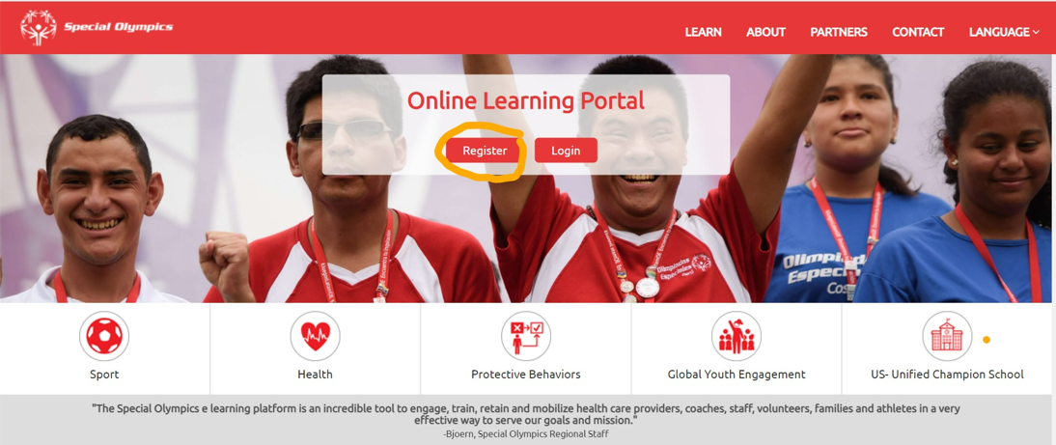

Step 2
Select the following options:
  - Learning Area: "US – Unified Champion School"
  - Registration status: “Individual”
  - Type: “School/School District/College based individual “

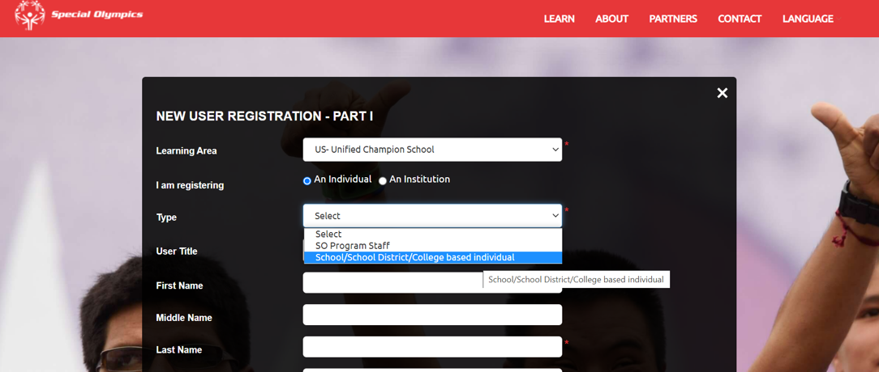

Step 3
Next, fill in all fields marked by the red asterisks *
- Name, Email, Date of Birth, Address
- Region: Select “SO – North America”
- Program: This is your Special Olympics Program, select your State
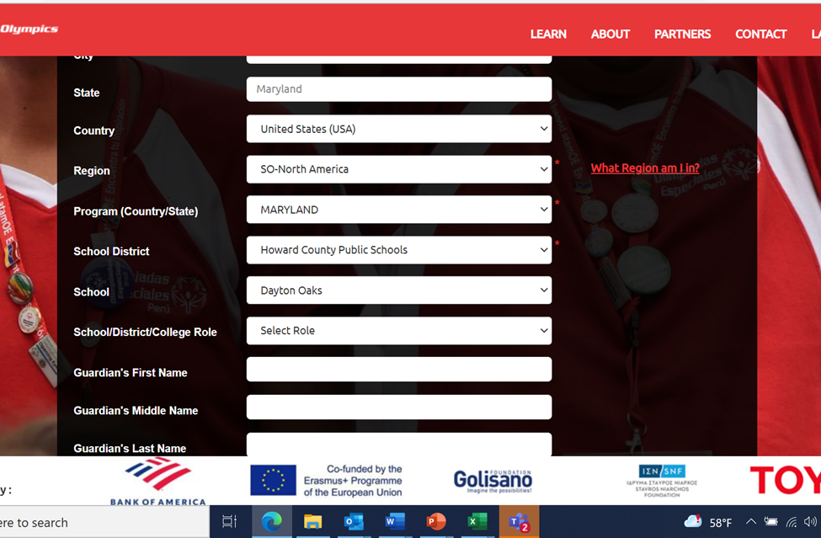

- School District - click the arrow on the upper right corner and a drop down list of school districts in your state will appear. Select your school district. If you do not find your school district listed, select “N/A”. (You must fill in your State for the system to generate the dropdown list of Districts, once you select your district a dropdown list of schools will be generated.
- School - click the arrow in the upper right corner and a drop down list of the schools in your school district will appear. Select your school. (You must fill in your School District for the system to generate the dropdown list of Schools). Again, if you do not see your school listed, select “N/A”.
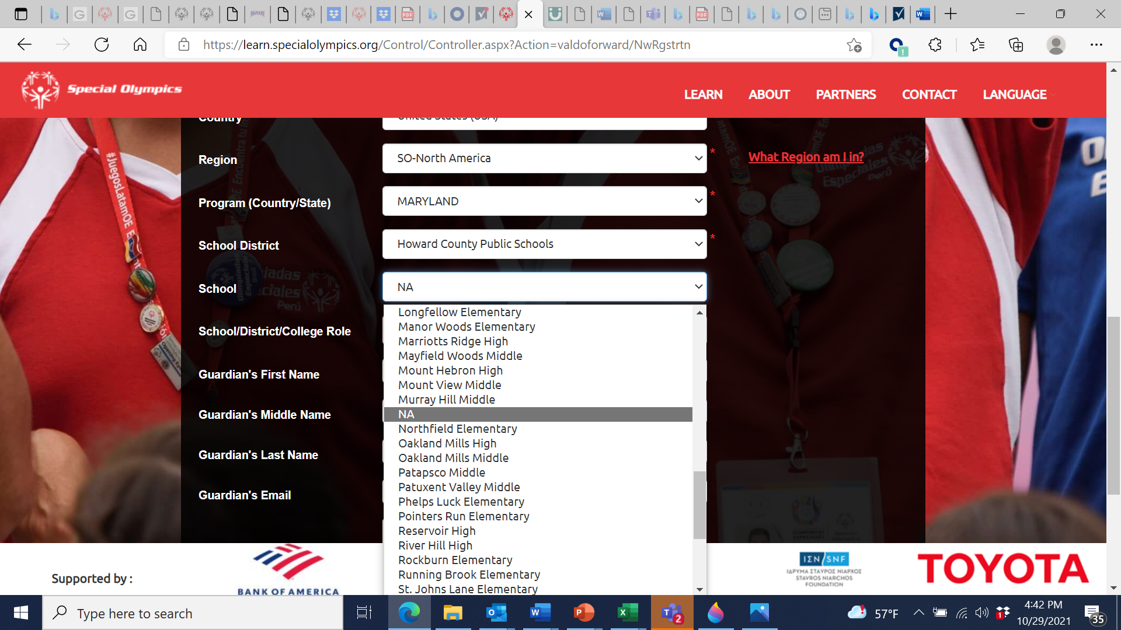

Step 4
- Check "I’m not a robot” and agree to the Privacy Policy, Terms, and Conditions
- Click “Register”

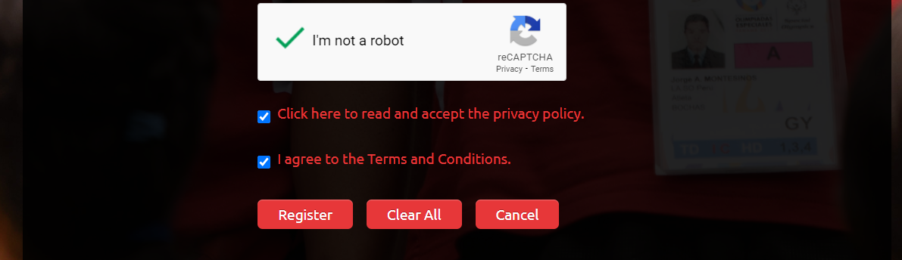

Step 5

Once you click “Register,” you will see the following notification:
  - Select “Done”
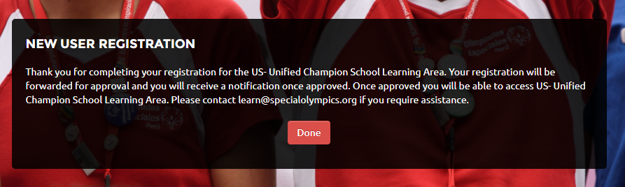

After the account has been approved by the Special Olympics Online Learning Portal Team, the Learner will receive an email from noreply@okta.com with the subject “Welcome to Special Olympics!”
- Follow the prompt and select “Single Use Special Olympics Account Activation Button”
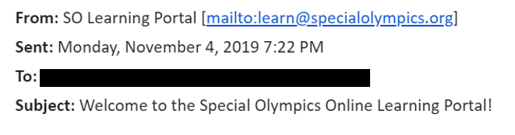
- Once the Learner’s account has successfully activated, they will receive an email from learn@specialolympics.org with the subject of “Welcome to the Special Olympics Online Learning Portal!”

Step 7

Instructions for Accessing the UCS Online Courses Through the Learning Portal Catalogue

- Go to learn.specialolympics.org
- The Learner can log in on using the email and the password they created and clicking “Login”

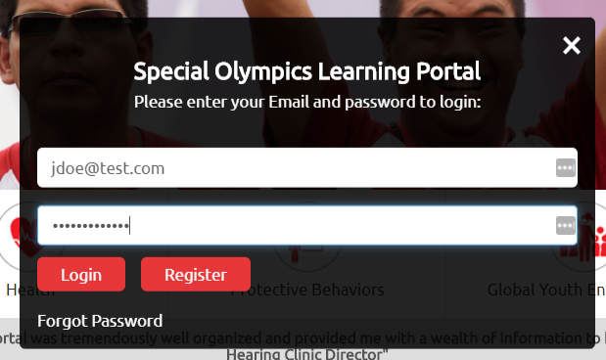

- Once registered, the Learner can access the Unified Champion Schools Implementation for Educators courses by clicking on “Catalogue” in the navigation bar.
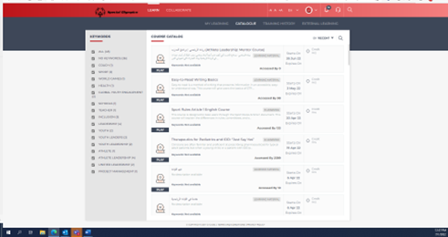
- Next, go to the RED BAR at the top of the page anc click the SEARCH ICON. Next, type “UCS” into the search box.

- The four UCS Implmentation for Educators courses will appear, the Learner then selects the course they would like to take. A Learner can take one or more courses by returning to the catalogue.
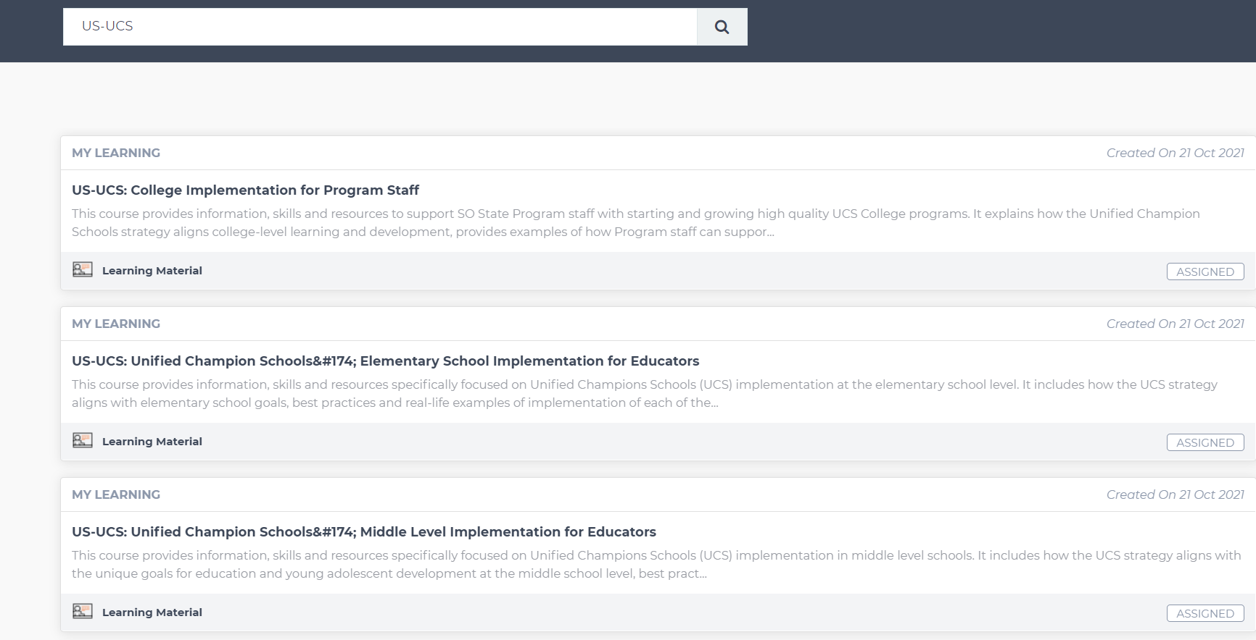
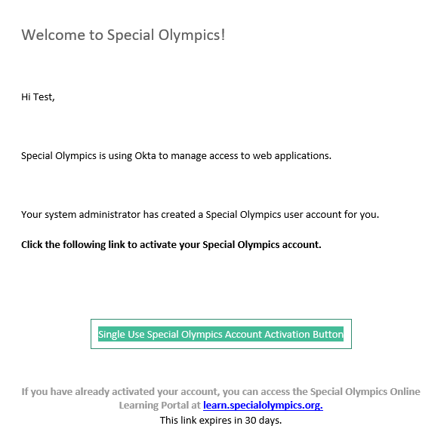

Thank you for taking the time to improve your Unified Champion Schools understanding, knowledge and skills.
Enjoy your learning!

Please email learn@specialolympics.org with any additional questions

