Special Olympics Learning Portal
U.S. Unified Champion Schools Learning Area Registration Guide
For Special Olympics Program Staff

Welcome to the Special Olympics Unified Champion Schools® (UCS) online professional development portal. This information sheet provides step by step instructions for:
- Registering on the Special Olympics Learning Portal as an individual learner within the U.S. UCS learning area, and
- Accessing the UCS Implementation courses through the portal catalogue.

If any questions or issues arise during the registration process please contact, learn@specialolympics.org, and someone will follow up to assist you as soon as possible.

Instructions for Completing the Registration Form

Step 1
Go to learn.specialolympics.org and click "Register"
  - Google Chrome is preferred
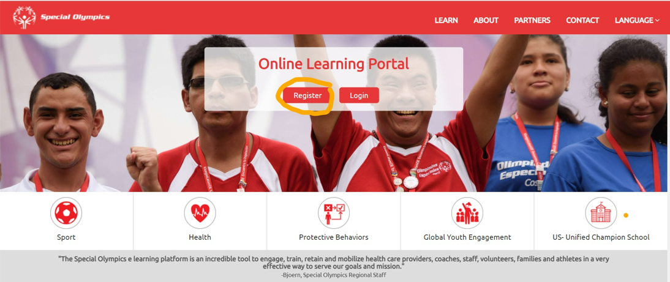

Step 2
Select the following options:
  - Learning Area: "US – Unified Champion School"
  - Registration status: “Individual”
  - Type: “SO Program Staff “

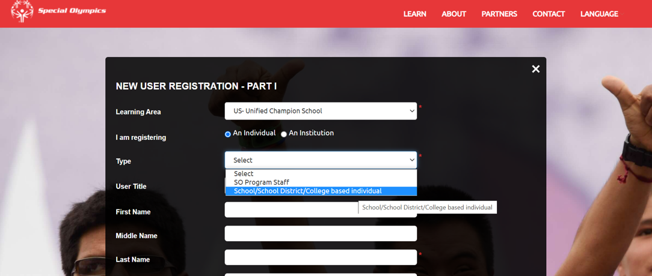

Step 3
Next, fill in all fields marked by the red asterisks *
- Complete all required fields including State
- For School District, select N/A from the dropdown
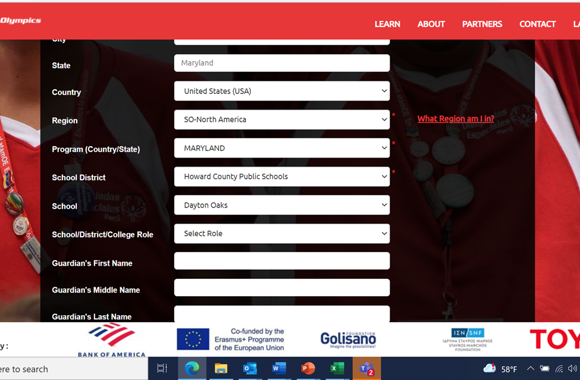

Step 4
- Check "I’m not a robot” and agree to the Privacy Policy, Terms, and Conditions
- Click “Register”

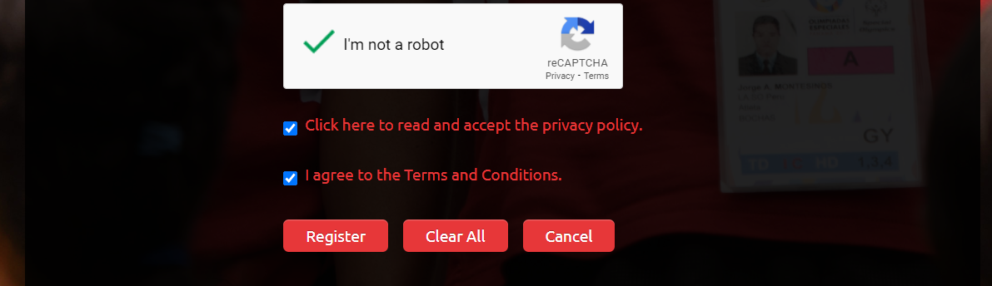

Step 5

Once you click “Register,” you will see the following notification:
  - Select “Done”
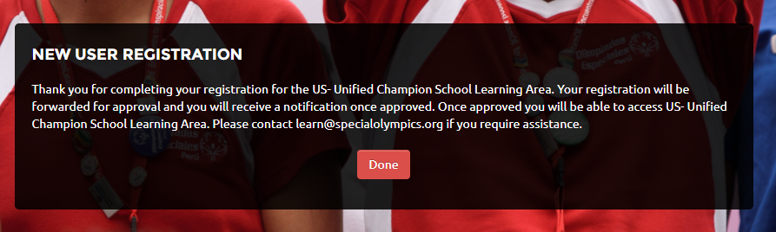

After the account has been approved by the Special Olympics Online Learning Portal Team, the Learner will receive an email from noreply@okta.com with the subject “Welcome to Special Olympics!”
- Follow the prompt and select “Single Use Special Olympics Account Activation Button”
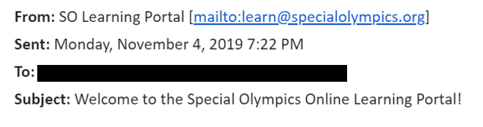
- Once the Learner’s account has successfully activated, they will receive an email from learn@specialolympics.org with the subject of “Welcome to the Special Olympics Online Learning Portal!”

Step 7

