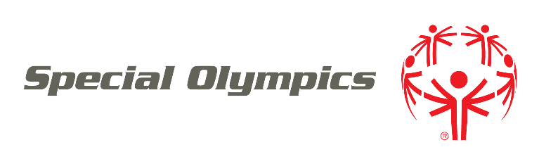

ATHLETE REGISTRATION

**Dear Special Olympics Athletes, Parents, and Guardians:**

Through the power of sports, our athletes find joy, confidence and fulfillment — on the playing field and in life. Whether you are new to Special Olympics or have been involved for years, we are excited you are part of the movement!

To register or re-register as a Special Olympics athlete, please complete the enclosed forms:

* **REGISTRATION FORM.** This form is required for all athletes and asks for contact information and health history.
* **WAIVERS, RELEASES AND POLICIES FORM.** This form is the second part of the registration form and goes over risks, use of likenesses, emergency medical care, consent for health program participation, personal information, and other important details about Special Olympics participation. Waivers, releases, and policies help create a safe and supportive environment, ensuring everyone’s health, safety, and dignity are respected.
* **ATHLETE REGISTRATION RENEWAL FORM.** This form is required annually for all athletes participating in Special Olympics. The purpose of a yearly Athlete Registration Renewal Form is to update and capture any changes in an athlete’s health or medication. This ensures that the most current information is on file, helping coaches and medical personnel provide appropriate care and support, and ensuring the safety and well-being of the athlete during participation.
* **MEDICAL FORM.** This form must be completed and signed by a Licensed Medical Practitioner (for example, Physician, Registered Nurse Practitioner, or Physician Assistant) who is qualified to conduct physical examinations and prescribe medications. It is minimally required for all Regional and World Games events and is designed to identify health concerns and clear an athlete to participate.

If you have any other questions, please contact Special Olympics PROGRAM NAME at PHONE or EMAIL.

Please submit registration forms to:

INSERT SUBMISSION INSTRUCTIONS