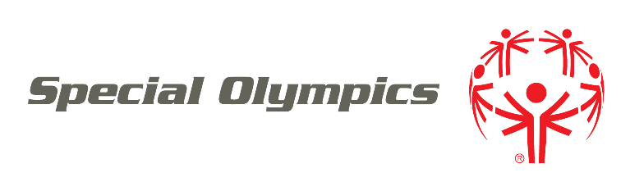
ATHLETE REGISTRATION

Dear Special Olympics Athletes, Parents, and Guardians:
Through the power of sports, our athletes find joy, confidence and fulfillment — on the playing field and in life. Whether you are new to Special Olympics or have been involved for years, we are excited you are part of the movement!
To register or re-register as a Special Olympics athlete, please complete the enclosed forms:
- REGISTRATION FORM. This form asks for contact and other information.
- RELEASE FORM. This form goes over some important details about Special Olympics participation.
- OPTIONAL LIKENESS RELEASE FOR SPONSORS. If you would like to allow Special Olympics sponsors to use your photos, videos and stories, you may sign this form. This form is optional.
- MEDICAL FORM. This form is designed to identify health concerns that are more common among people with intellectual disabilities and clear an athlete to participate. Please fill out the Health History section on pages 1 and 2. If you do not understand any parts of the form, you may leave those parts blank to be discussed during the exam. The Physical Exam section on page 3 should be filled out and signed by a licensed medical professional (for example, Physician, Registered Nurse Practitioner, or Physician Assistant).
The Release Form and the Medical Form instruct you to complete other forms in certain uncommon situations. If this applies to you or if you have any other questions, please contact Special Olympics PROGRAM NAME at PHONE or EMAIL.
Please submit registration forms to:
INSERT SUBMISSION INSTRUCTIONS

