Project Management Training
for Athlete Leaders
Training Facilitator Guide
Project Management Training for Athlete Leaders
Training Facilitator Guide
Note: Please make sure you have downloaded and installed the Ubuntu Family font and the GT Walsheim Pro font to ensure correct formatting and visualization of the Project Management course resources.
This facilitator guide provides an outline on how to host and lead the Project Management training using the PowerPoint presentation and other resources. These resources are for the facilitator to use in the way that works best for the audience and the Program (virtually, in-person, individually, etc.). Feel free to adapt them, but please do not change them so much that the goals or outlined learning objectives are compromised. If you are looking for resources to help you prepare for and lead a training virtually through Zoom, WhatsApp, Facebook, etc., you can find them here.
Intended Learner Audience | The content and objectives of this training are for advanced athlete leaders who have gone through other trainings in the Leadership & Skills Curriculum. We recommend participants are experienced athlete leaders that have held multiple roles within our movement or held the same role for several years. It is important to be upfront with your co-facilitators and athlete leaders: this course will likely be the toughest one they’ve taken so far—but it also has the potential to be the most meaningful and rewarding.  For this reason, we recommend that Programs hold a pre-training virtual meeting to give athletes an idea of what to expect, explain the objectives, give them pre-homework, and go over logistics. During this meeting, if it applies, you can start exploring individual project ideas from athlete leaders.  We’ve provided a Pre-Training Meeting Guide, (linked here) with ideas from other Programs about what they’ve covered to properly set expectations for everyone.
Ideal Number of Participants | To ensure each participant receives personalized support and guidance, we recommend keeping the group size small—ideally no more than 10 athlete participants per training.
Mentors | For athlete leaders going through the Leadership & Skills Curriculum, the mentor role is always recommended but not required. As mentioned above, this course is advanced when compared to other courses in the curriculum, so mentors are HIGHLY recommended due to the difficulty of the course and the project piece.
Training Structure & Time Commitment | This training is divided into two parts, designed to be completed in approximately four hours total. We recommend that Part 1 be delivered in one day, while Part 2 comes a few weeks after; our explanation for this recommendation is below.  We highly recommend leaving 2-3 weeks between Part 1: “Welcome and Project Idea Building” and Part 2: “Planning and Managing Your Project.” This break gives participants time to do research, talk to others about their project idea, reflect and refine their idea, and complete their homework from Part 1: Step 2 and Step 3 “Building Your Project Idea Assessment” in the Participant Workbook. They can also adjust their project idea if needed.  Facilitators must emphasize that participants should not begin any project work before attending Part 2: “Planning and Managing Your Project”. Part 2 provides the key tools and guidance they’ll need to set themselves up for success. If they start work that is not the required homework mentioned above before going into Part 2, they may end up retracing their steps or starting over.  We understand that adding a 2 - 3 week break between trainings can be challenging, especially when factoring in time and travel costs, but this pause is important. It allows participants to gather feedback from their Program or community, helping them build a stronger, more relevant, and likely more successful, project.  If holding two in-person training sessions with a break in between is not realistic, it is possible to deliver Part 2 virtually. While Part 1 is more discussion-heavy and benefits from in-person 1:1 support during brainstorming, Part 2 focuses more on content and structured planning, making it easier to deliver virtually. We believe the break between these parts is more important than any slight decrease in quality of training that might occur by doing Part 2 virtually.
  PART 1 | Welcome and Project Idea Building
    2 hours | This first part starts with introductions and a simple overview of the 5 steps in project management. Then, participants begin working on their big ideas for change. They’ll think about problems they see in their community or Program and come up with possible solutions. The goal is to help each person shape a clear project idea.  We recommend doing this part in person if you can—it makes it easier for facilitators to walk around, check in, and support each participant. If you need to do it virtually, just plan to use breakout rooms and allow for extra time and support.
  PART 2 | Planning and Managing your Project
  2 hours | Now that participants have a clear project idea, this part helps them build a plan to bring it to life. They’ll learn key project management skills—like setting goals, creating a timeline, and tracking progress—to make sure their project stays on track. They’ll also practice how to share the story of their project with others.
Using the Notes Effectively | You’ll notice that many slides in this training include detailed facilitator notes—but that doesn’t mean you need to say everything word-for-word. These notes are meant to guide your delivery, not script it. Feel free to put things in your own words and focus on striking a balance between presenting information, asking participants questions, and encouraging discussion. For most slides, aim to speak for 30 to 60 seconds, depending on the content. Use the notes as a resource but keep your delivery conversational to maintain engagement.

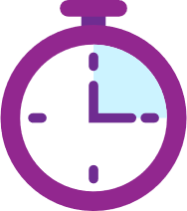
Icons used throughout the Training
 | Timed activity  (In slides) |  | Workbook Activity  (In slides) |  | Facilitation Recommendations  (In this Guide) |  | Facilitator notes  (In this Guide)

Be sure to complete the following actions to prepare for the training (all parts):
- When possible, identify at least one athlete leader to co-facilitate with you. It’s important the athlete leader has received Project Management training before and can speak to their own project they came up with and then completed.
- Review this facilitator guide, the accompanying PowerPoint presentation, and all other resources.
- Review the slide deck and facilitator guide and complete each activity yourself to be familiar with the activity. Think about what information you can add from your Program’s perspective. Ask the athlete leader co-facilitator what they can add from their perspective.
- Host a practice training with all facilitators and cover every slide.
- Give feedback to each other.

Prep | Description | Slide
PART 1
Topic  Welcome and introductions  Time:  3 min  Lead:  xxx | - Welcome to the Project Management Training.  - Introduce the facilitators.  - If necessary, create and share a slide that takes them through Zoom and the features we will use (interpretation, chat, breakout rooms, reactions, annotation). | 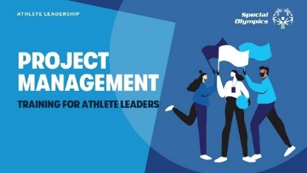
Topic  Welcome and introductions  Time:  3 min  Lead:  xxx | Welcome! We’re so excited to have you here. This training will challenge you, stretch your thinking, and ask you to put in the work—but every bit of effort will be worth it when you see the impact you can make. Remember, you’re not in this alone! You have support from your mentor, Program staff, and those around you who want to see you succeed. If things ever feel tough or frustrating, that’s okay—growth comes with challenges. Don’t hesitate to ask for help, lean on your support system, and trust the process. You’ve got this!  First, we want to get to know all of you.  Please tell us your name and which city you are from and something you learned from being part of Special Olympics.
Topic  Welcome and introductions  Time:  3 min  Lead:  xxx | Explain there are two parts to this training: | 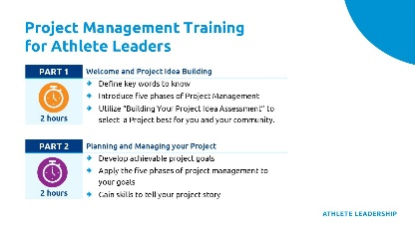
Topic  Welcome and introductions  Time:  3 min  Lead:  xxx | - Part 1 : Welcome and Project Idea Building (This is the block we are in right now.)  Part 1 prepares you for the training. We will explain why we're here, what you'll learn and do, and introduce the key words you'll hear throughout the training. Next, we’ll list the 5 phases of project management for the very first time. These phases will guide us throughout our entire training. Then, you will utilize the “Building Your Project Idea Assessment” to begin to think about and then select a project that is best for you and your community.  Before we move on, let’s define what we mean by community.  Community is anything around you. Let’s give a few examples: your team, school, community center, neighborhood, Special Olympics Program. Who can think of others?  - Part 2 Planning and Managing Your Project  After we finish Part 1 today, we will break for a few weeks and come back together for Part 2, where you will finalize and decide on your project, develop specific and achievable goals for the project, identify people who can help you, and apply the phases of project management to reach your goals and put you on the path to fulfill your project. You will also gain skills to tell your project story.  In summary, in this training, there are activities and information that will help you understand the five phases of project management, show you how to design an athlete-led project, create a team, identify risks that may come up during your projects, and talk confidently about your project to others.
 | Distribute the workbooks to learners if you have not already. Explain the purpose and function of the learner workbooks. | 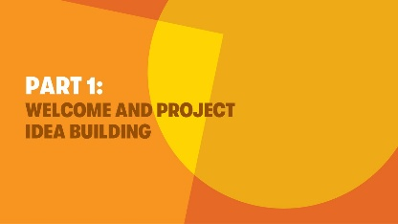
Topic  Overview of Goals and Objectives  Time:  2 min | This training was developed for athletes like you who are committed to serving as leaders. In a lot of ways, this course can be seen as the culmination of all your hard work. That means that this course will ask you to use all your skills and knowledge from other courses you have taken and experiences you have had and apply them here.  The Objectives of this training are:  1. Learn how to identify a problem or gap in your Program or community and design a project to address it.  2. Review key words of project management.  3. Learn and understand the five phases of project management.  4. Explore tools to use during each phase of project management.  5. Develop a project plan that outlines clear steps, resources, and timelines to bring your idea to life.  Next, we’ll go over a few key words you’ll need for this training. These definitions will help you understand important concepts as we move forward. You can also find them in your workbooks. | 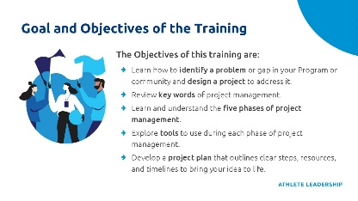
 | Facilitation Option: Please feel free to add other key words and definitions that you feel will set the learner up for success in the training
 | Why are we here? What is Project Management?  Pause for a moment to ask if any athletes can define what project management means. When ready, click to reveal the answer.  Project management empowers you to turn big ideas into action and make a lasting impact in your SO Program or your community. By learning to plan, organize, and execute effectively, you’ll gain the skills to lead with confidence, inspire people around you, and create meaningful change.  Have you ever had an idea to improve your community or your Special Olympics Program but didn’t know how to take that idea and make it a reality? As athlete leaders you have amazing and creative ideas to impact and improve your community. This training will help turn your big ideas into a product, service, or result. | 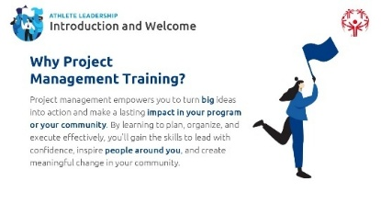
Topic  Key words and Definitions  Time:  10 min | What is a project?  Pause for a moment to ask if any athletes can define what a project is. When ready, click to reveal the answer.  A project is a temporary activity that has a set beginning and end that creates a product, service, or result.  A project is not a task that you do regularly, such as attend practice or fill out a timesheet at work because those are things that happen all the time and do not have a clear end date. | 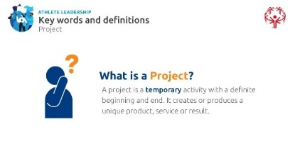
Topic  Key words and Definitions  Time:  10 min | Ask learners to think of any projects they’ve been involved in, or seen others lead—at school, work, or in their personal lives—and invite a few to share. Encourage mentors to do the same to set an example. Then, ask learners to think about projects related to Special Olympics, like events or initiatives, and discuss how planning and teamwork played a role. Invite participants to share a few examples and then share the examples on the next slide:
 | You gave excellent examples, now, let’s take a look at a few more examples. | 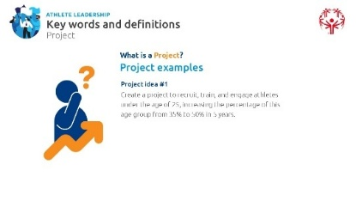
 | Facilitation Option: Here you can present two examples from your Program or use the examples on the slide.
 | We’ve talked a little about what project management is, but does anyone want to guess what the official definition is?  Pause for a moment to ask if any athletes can define what project management is. When ready, click to reveal the answer.  Project management is the application of knowledge, skills, and other tools to meet project requirements.  Or more simply…  Using what you know, the right tools, and helpful skills to get things done and reach what you want to achieve in the project.  Project Management is a Team Sport  When working on a project, you typically are not alone. Within the Special Olympics Leadership & Skills Curriculum, you are taught how to think and act like a leader, but most of the time those courses focus on you leading by yourself.  Leaders can be successful working alone, but we know that the best leaders make the biggest impact when they work with other people. Eunice Kennedy Shriver, who started Special Olympics, was a great leader, and she knew that she had to work with other people to make her dream of a more inclusive world become a reality. She used Project Management to create Special Olympics! | 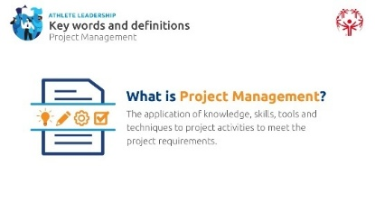
 | When you have a big idea to change or fix a problem like Eunice did, it is important to have a good team of people around you, if possible. Some potential team roles and responsibilities include:  - Project manager: (When ready, click for definition)  An individual who is responsible for ensuring the project is completed on time within budget and on schedule.  And guess what? This person is you! You are the project manager for your project. | 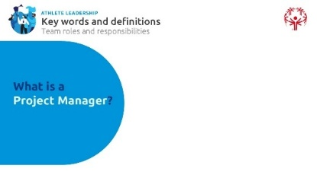
 | - Team member: (When ready, click for definition)  People who help support in the completion of the project (show diversity within the project members by considering people with and without I/DD, and a difference in gender, skillset, experience, etc.)  A lot of times, it takes a team of people working together to complete projects and accomplish great things. The project manager is technically a member of the project team, but a lot of times the project manager oversees the project and empowers their “team members” to do the work.  Emphasize:  A strong project manager doesn’t do all the work—they share it. It's important to assign tasks and trust your team to carry them out.  Team members play a key role. Projects succeed when team members are committed and ready to take action, especially when unexpected challenges come up. | 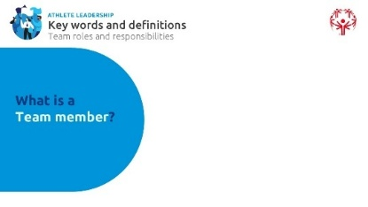
 | Two other roles in project management are a Sponsor and a Stakeholder. Who knows what a Sponsor is? (When ready, click for definition.)  An individual or organization that provides support and funding for a project | 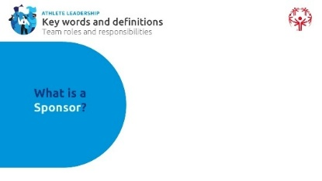
 | Examples of sponsors include:  - Board of Directors  - Local businesses  - School administrators  - Stakeholders | 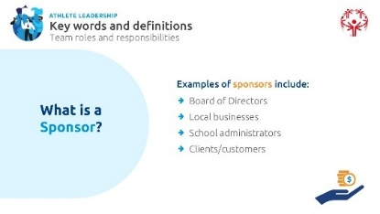
 | Does anyone know what a stakeholder is?  (When ready, click for definition.)  People or organizations that have an interest in the project. They are typically people who will be impacted by your project and want to see it succeed (students, families, community members, etc.). | 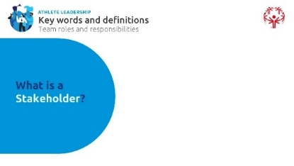
 | Examples of stakeholders include:  - Customers – people who buy or use your product  - Suppliers – people who have resources or parts that help you build your product  - Vendors – people who sell or share your product  - Team members  - Project sponsors  Let’s provide an example of a stakeholder using the project idea we shared earlier – our project is to increase the number of volleyball teams by 50% to a total of 40 teams over the next 3 years.  Who do you think would want to see that project succeed, which would make them stakeholders in this instance?  - Athletes who enjoy playing volleyball  - Parents with children who play volleyball  - The Special Olympics Program  - Your state or country’s volleyball federation/organization  Anyone else you can think of?  All four of those groups of people are stakeholders because they have an interest in your project succeeding because they want more Special Olympics athletes playing volleyball. | 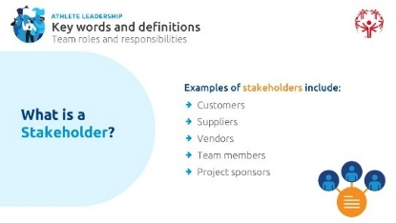
Topic  Project Management Phases  Time:  10 min | In this training, we'll cover the five key phases of project management. These phases help guide a project from start to finish:  Developing a project takes time. From the very beginning when you identify an issue or a problem, then how you think of ideas to solve it, then put them into practice and finally evaluate the progress.  That is why the best way to learn about Project Management is to think about it in multiple phases.  There are 5 phases of Project Management: (When ready, click to reveal the first one)  - Initiating, (When ready, click to reveal the next one)  - Planning, (When ready, click to reveal the next one)  - Executing, (When ready, click to reveal the next one)  - Monitoring, Controlling, and Evaluation (When ready, click to reveal the next one)  - Closing | 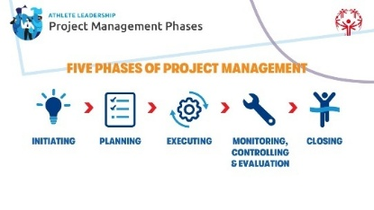
 | Before we define each of the 5 phases of project management, let’s briefly discuss that these phases are in a certain order, but that doesn’t mean you will always tackle them in the same order every time, one after another. You might need to jump back to a previous phase as your project moves along/progresses  There is a saying, “Progress is not linear.” Does anyone know what this means? | 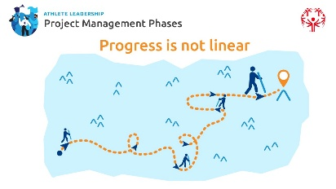
 | Give them a chance to answer
 | "Progress is not linear" means that sometimes you'll move forward, then face setbacks, and need to take a step or two back before moving forward again. Just like in sports training, you might make progress toward a goal, then encounter challenges that require you to reassess and adjust or get better before you can move ahead. You’ll likely experience this in your projects too, but knowing it’s normal will help you push through when things get tough!
 | Facilitation Option: Create and offer a sports analogy of “progress is not linear” if you choose to incorporate. Here is an example: Think of it in terms of sports. When training to improve, progress isn’t always steady, right? Let’s say your goal as a swimmer is to shave 10 seconds off your 100m backstroke by improving your flip turns. At first, you struggle with the basics, but after some practice, you perfect them and hit your goal of being 10 seconds faster in training. But when you compete, you only shave off 5 seconds—that’s a setback. So, you go back to practicing flip turns, work through the setback, and eventually hit your goal again in practice and in competition. This shows how progress isn’t always smooth, and setbacks are part of the process. You’ll likely experience this in your projects too, but knowing it’s normal will help you push through!
 | Facilitation Option: Either introduce the phases by name only for now, letting athletes know you'll define each phase throughout the training or provide a brief description of each phase now:
Let’s now define each of the five phases of project management:
- Initiating: This is where we define the project, its goals, and get approval to move forward.
- Planning: Here, we create a detailed plan, outlining how the project will be carried out, including tasks, deadlines, and resources.
- Executing: This is where the project gets done! Tasks are carried out, and team members work together to achieve goals.
- Monitoring & Controlling: Throughout the project, we keep an eye on progress, checking for any issues or changes needed to stay on track.
- Closing: Once everything is complete, we review the project to make sure all goals were met and officially close it.
We will cover each of these phases one-by-one, starting with initiating…next…after the break.
Break:  15 minutes |  | 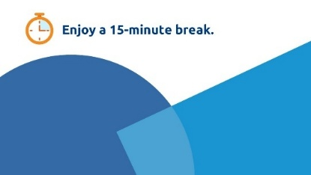
Topic  Project Management Phases - Initiating  Time:  30-45+ min | Initiating Phase  Before the break we learned the five phases of program management, the first is the initiating phase and that is where we will begin. | 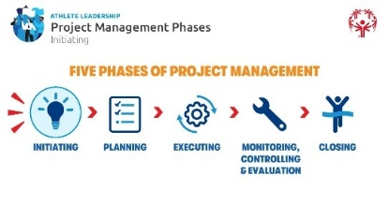
 | The Initiating Phase is where we define the project, its goals, and get approval to move forward. | 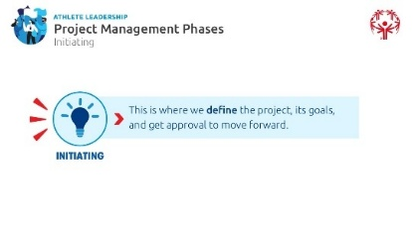
 | During the Initiating Phase of project management, you will:  - Determine the need your project will address or try to fix  - Decide what product or service you want to create  Many of you have already identified things that you would like to change within your Special Olympics Program or within your community. We will work together to help determine a project that works for you and your Program/community. Let’s go… | 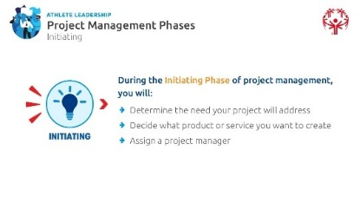
Facilitation Option:
Option 1: If athletes completed Step 0 (Know Your Strengths and Interests) and Step 1 (Look at Your Community) of the “Building Your Project Idea” assessment ahead of time, use these slides to review and refine their responses.
Option 2: If athletes did NOT complete Step 0 and Step 1 of the “Building Your Project Idea” assessment in advance, use these slides to introduce the content and guide them through the questions during the session.
 | Step 0  Explain that the group will begin by discussing Step 0 of the “Building Your Project Idea” assessment. Invite participants to share their responses to Step 0—focusing on their own skills, strengths, passions, and interests.  Facilitate this as a brainstorming activity, recording responses on extra large paper notepads or a whiteboard.  After the brainstorm, to highlight the importance of choosing a project aligned with interests and skills, ask questions like:  - Why is it okay for everyone to have different strengths, interests, or passions?  - Why is it important to start thinking about a project by first reflecting on our own interests and strengths? | 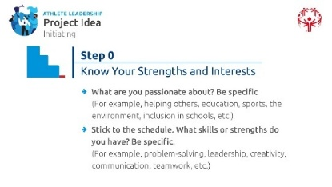
 | Facilitator Note: If athletes are having trouble thinking of something they are passionate about, instruct them to go back and read their mission statement from when they took “Introduction to Athlete Leadership” and “Understanding Leadership” —those might help point them in the right direction.
 | Step 1  Next, invite participants to share their responses to Step 1, where they thought about their Special Olympics Program or local community through their own experiences and perspectives.  Guide the discussion with questions to help them think about community needs, such as:  - What area did you choose to study and think about improving (Special Olympics Program or community)?  - What positive things did you notice in your Program/community? Be specific.  - What problems or needs did you notice? Be specific.  - How do these observations connect with your interests, skills, and strengths?  - What is one thing you saw or experienced that made you think this is a need or issue in your Program/community? | 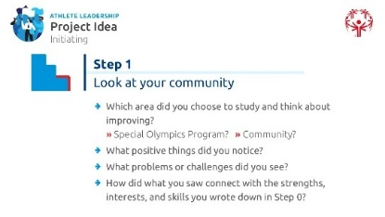
 | Facilitation Option: This can be done individually or in small-group or large-group discussions.
 | Record a few of the athlete leaders’ observations on the large paper notepads or white board used in Step 0.
 | For this section we will use a tool called the Problem Tree, also found in your Participant Workbook. We will skip Steps 2 and 3 of the “Building Your Project Idea Assessment” in your workbook for right now.  Every issue or problem in a community is kind of like a tree—it has deep roots (causes), a strong trunk (the way the problem exists today), and many branches (the effects it has on people). The best projects don’t just trim the branches; they tackle the roots to create lasting change.  What is a Problem Tree?  A Problem Tree is a tool that helps us understand a problem by breaking it down into its causes, the way it shows up today, and its effects. It helps us see the bigger picture before deciding on a possible solution and creating a project to fix it.  The Parts of a Problem Tree  - The Trunk: This is the main problem you’re focusing on.  - The Roots: These are the causes of the problem—why it’s happening.  - The Branches/Leaves: These are the effects or consequences—how the problem affects people.  Why Use a Problem Tree?  - Think about when a tree is sick or dying. How do we see that a tree is sick? A lot of times, the only way we can see it is in the leaves or the branches, right? But that does not mean the sickness starts there – the sickness or problem could be coming from something we don’t see – the roots! Just like with any problem, we may see the effects of that problem (the leaves), but we don’t see the cause of the problem (the roots). The Problem Tree helps us think about things that we cannot see to help identify the cause of the problem.  - It helps us find the root causes of a problem so we can create better solutions.  - It helps everyone understand the problem in the same way.  - It leads to creating a Problem Tree, where we can turn the problem into clear goals and solutions.  How to Use It:  Let’s look at an example of how you can use the Problem Tree to begin to think about where to focus your project. Will you work on fixing the roots (the causes), the trunk (how the problem exists now), or the branches (the effects)? The answer will guide you in creating lasting change. | 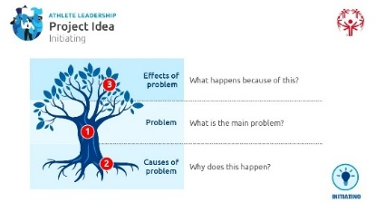
Facilitator Note:
Remember to keep it conversational—put ideas in your own words, balance presenting with discussion, and use the "Problem Tree" notes as a guide, not a script.
 | An example:  What is the problem? In this example, the problem is:  (When ready, click for next layer.)  There are no Special Olympics activities in schools near me/my area.  Next, we will think about the root causes of the problem or in other words, what caused the problem?  Keep in mind that you are guessing or making assumptions about what you think caused the problem. You don’t actually know what caused the problem yet, right? Maybe you have an educated guess, but you don’t know for sure until you do Parts 2 and 3 of the assessment, where you do research and talk to other people. You don’t need to know the exact cause of the problem in order to try and fix it but it does help to have information and educated guesses to try and address those issues.  (When ready, click for next layer.) | 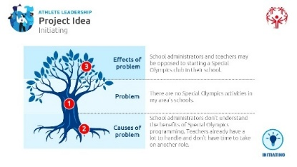
In this example, the thing that we think caused this problem (also called “root cause”) is:
School administrators don’t understand the benefits of Special Olympics programming. Another potential cause is that teachers already have a lot to handle, which means they don’t have time to take on another activity.
The reason these are the roots of the tree is because we don’t see these causes of the problem right away, right? They’re hidden underground just like tree roots. How do we uncover these causes of the problem?
What are some other potential causes of this specific problem?
 | Give time for people to guess.
We find these potential causes of the problem by talking to people affected by the problem. We talk to the teachers and students and parents in this area and ask them their opinions. We talk to school administrators who help us dig up the causes that we never would have seen. That’s why the “Building Your Project Idea” assessment is so important! We don’t expect you to have all the answers right away. You need to go out there and talk to people to uncover the roots/answers!
And finally, knowing the problem and what could have caused that problem, what are the negative effects of that problem?
(When ready, click for next layer.)
(When ready, click for next layer.)
Understanding the negative effects of the problem will help us better understand our project and how we can come up with a solution to the problem. In other words, what happened because of this problem? What effect does it have on the project/Program/community?
In this case, the effect this problem has on the community is that their school is not inclusive toward all people, and especially not inclusive toward people with I/DD. Students with I/DD at this school have a negative school experience where teachers and students without I/DD have low expectations of them and never see people with I/DD as people first.
What are some other effects of this problem for the school and for the community?
 | Give time for people to guess.
This helps us think about how our project will have a positive effect and move toward fixing this problem. It also helps us better understand how we can pitch or market this idea to the people who might be against it. We need to show them the positive effect our project is going to have so they can support it.
Now, it’s your turn! In your handbook, there is a section for you to use the Problem Tree template to analyze what you have in mind right now for your project idea. What is the problem? What are the possible causes of that problem? And, lastly, what are the effects of that problem on your Program or your community? Take a few minutes to work on that and then we’ll ask a few of you to share.
 | Let’s go back to Step 0 and Step 1 of the “Building Your Project Idea” assessment to help you explore your project idea a bit more. The Problem Tree activity likely sparked some new thoughts or helped you start shaping a possible direction for your project. To build a strong project, we need to define three things: what we want to do, why it matters, and how we’ll make it happen. | 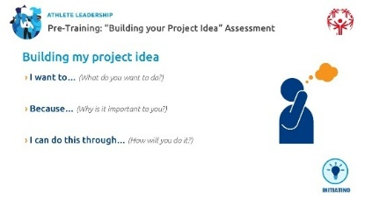
 | Let’s walk through these questions using a real example. You can follow along with this section in your workbook before we ask you to do the activity on your own. | 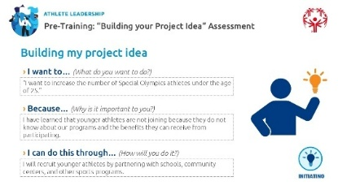
 | Facilitation Option: You may use the example provided here, revisit the one from the Problem Tree, or use a local example. Whichever you choose, be sure to update the slide and workbook accordingly.
Imagine our Special Olympics Program wants to recruit more athletes under the age of 25. We’ll break it down step by step to see how a project idea comes together.
- I want to… (What do you want to do?)
This is where we define the project’s main goal. (When ready, click to reveal the answer)
Example: We want to increase the number of Special Olympics athletes under the age of 25.
- Because… (Why is it important to you?)
This helps connect the project to a real need or motivation that you have as the project manager. (When ready, click to reveal the answer)
Example: Right now, only 35% of our athletes are under 25. More of our athletes are “retiring” from Special Olympics so we need to find new, younger athletes to compete against. This is important to me because I want the younger generation of kids with I/DD to find Special Olympics and feel included in sports at a younger age than I did.
Ask: Why does this project matter? Who will benefit from it?
- I can do this through… (How will you do it?)
This is the action plan—how the project will come to life. (When ready, click to reveal the answer)
Example: We will recruit younger athletes by partnering with schools, community centers, and other sports programs. We’ll also train coaches to work with them and create fun, engaging events to keep them involved.
 | Activity: 15 minutes.  Now it’s your turn…complete this project idea form in your workbooks… | 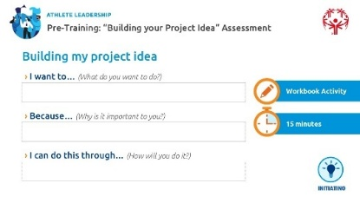
Be clear with learners that:
- Selecting a single project to address a community need does not diminish the importance of other gaps but allows for focused and impactful action. In other words, they may find a very large problem within their community that they want to help solve (e.g., homelessness), but it is your job as a facilitator and the job of their mentor to help them narrow their focus to something that is addressing just one small part of a larger problem and it needs to be something that they can actually control or have influence over. They may be disappointed by you reigning them in but tell them you aren’t saying they can’t eventually accomplish their very big goal, it just helps if you take one step at a time, succeed at that one aspect, get some momentum, and then keep chipping away at the problem.
- This step is about aligning their project with realistic goals, their unique strengths, and the community's priorities. It must check all three of those boxes to give it the highest chance of succeeding.
Facilitator Note:
Be prepared as it might take longer than 15 minutes. It’s important for everyone to finalize this before moving on.
 | Now that you’ve shaped your project idea, let’s make sure it’s the right fit. A great project is one you have the ability, confidence, and passion to take on. In a few minutes you are going to ask yourself these questions and write your answers in the workbook:  - Do you have the resources, skills, and knowledge to handle this project?  Think about what you already have and what you might need. Do you have access to the right people, tools, or training? Who and what do you need to be successful?  - Do you feel this project would be easy to track and measure success?  How will you know if you’re making progress? What does success look like?  - Are you confident you can tackle this project and help solve a Special Olympics Program/community need?  Does this project excite you? Are you ready to put in the effort to make a difference?  - Can you easily explain this need and project to others?  If you had 30 seconds to convince someone to support your project, could you do it?  - Does this need truly matter to your community?  Think about the impact. Will this project make a real difference for the people you want to help?  - Is completing this project realistic for you?  Don’t set a goal so high that you will not be able to complete it. We will talk more about goal-setting in Part 2 of the session, but make sure that your project is something that you can actually accomplish instead of a wish that you hope will come true. | 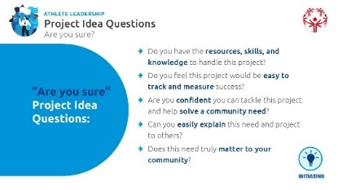
 | Activity: 15 minutes  Explain that it is now their turn to answer these “Are you Sure” Project Idea questions in their workbook. | 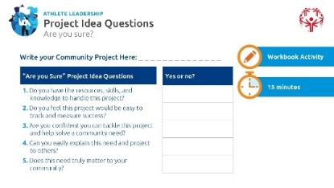
Before we have you fill out the “Are You Sure” section in your workbook, please read through the Project Examples in the workbook to get even more ideas from your fellow athlete leaders around the world.
Once you have read through those examples, take some time to answer the “Are You Sure” questions in your workbook. If you can answer ‘yes’ to most of these, you’re on the right track! If not, think about ways to adjust your idea or get the support you need to make it work.
 | Facilitator Note:  Presentation: Be sure to leave time at the end of Part 1 for participants to share their project ideas in a “Gallery Walk” (defined below) or class presentation. This gives you a chance to take notes, ask questions, and let others engage; and maybe even be inspired by each other’s ideas. | 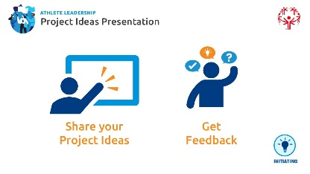
Facilitation Option: Some Programs use poster presentations for this activity. Depending on how much time you have at the end, feel free to get creative! Presentation ideas include:
- Gallery Walk*: Learners display their project ideas, and peers walk around to review and provide feedback. (described below)
- Small Group Shares: Learners present their ideas in small groups for discussion and feedback.
- Lightning Talks: Each learner stands in front of the room and gives a brief, timed presentation (e.g., 1-2 minutes) on their project. Others have the chance to ask questions and provide feedback.
- Digital Showcase: Learners create and share a short slide deck or video presentation
*Gallery Walk: A Gallery Walk is an interactive activity where participants display their work—like posters or project ideas—around the room. The group then walks around to view each display, often leaving comments or asking questions. It encourages peer learning, sparks discussion, and allows everyone to showcase their thinking. You can guide the group in small clusters or let them move freely. Wrap up with a group reflection or a few volunteer highlights.
Whether you're using a gallery walk or simple verbal presentations/discussions, use these simple questions to help guide and inspire participants as they create their posters or presentations:
- I want to (What do you want to do?)
- Because (Why is it important to you?)
- I can do this through (How will you do it?)

Prep | Description | Slide
PART 1 TO PART 2 TRANSITION
Topic  Transition from Part 1 to Part 2 | The learners should leave Part 1 with an understanding of how to choose a project idea and a clear starting point for their own project. This is the most important part of Part 1, so if this goes long and you have to leave the rest of the training for another session another time (even if it is virtual), that’s okay. Because if they leave this session without you having the chance to poke holes in their idea by asking questions and giving suggestions, it will be much more difficult to do so after they have already started making progress on their project.

Facilitation Option/Recommendation:
As mentioned on page 1 of this Facilitator Guide, this is a good time to take a break for a few weeks before starting Part 2.
This allows learners time to reflect on their project ideas, gather feedback, and complete Step 2 and Step 3 of the ”Building Your Project Idea” Assessment.
Before continuing to Part 2, participants should have clear, well-defined answers to the following questions
  - WHAT is the need; WHAT will you do; WHAT skills will you use
  - WHY is it important to you and others
  - HOW will you do it; HOW will it benefit others
  - WHEN will you complete it
  - WHO will help you complete it? How will they help you?
  - WHO will it help? WHO will benefit
Without thoughtful answers to these, Part 2 will be challenging.
If you do take a break between Part 1 and Part 2, make sure participants know NOT to begin their actual project work during that time. If they begin work on their projects too soon, it may lead them to miss key steps covered in Part 2 of the training, forcing them to start over or revisit certain steps they missed. Instead, they should use this time to look through their workbook, complete Step 2 and Step 3 of the “Building Your Project Idea Assessment,” talk to people in their community to get feedback on their project, and complete the “Finalizing Your Project Idea” section found in the Participant Workbook.
Least Recommended: If you go straight into Part 2, without a multi-week break, let participants know it may be harder and they likely will not have all the answers to the questions yet or have received important feedback from others on their project idea. That means their project idea may shift as they work through Part 2
If you go straight into Part 2, take a 15-minute break
 | If you do take a recommended multiweek break between Part 1 & 2, here is some language to help you close and bridge to Part 2: | 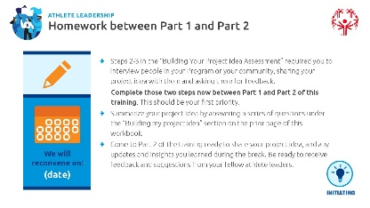
- We will reconvene on (date, time, location)
- Part 1 Summary
In Part 1, we reviewed the five phases of project management. We focused on building your project idea—identifying a need, exploring potential solutions, and starting to shape a plan based on your interests and strengths. You’ve each started thinking about what you want to change, why it matters, and how you might approach it.
- Over the next two weeks, take time to reflect and gather more input but this time from other people – people in your community, your Special Olympics Program, or by people who will be impacted by your project. The goal is to come back with a clearer, more informed project idea after talking to people in your community so we’re ready to build a solid plan in Part 2.
- Homework for Learners before the next training
- Review your workbook. Revisit any sections you didn’t complete or want to revise.
- Talk to others in your community or your Program. Get feedback on your idea from people who know the topic or may be impacted by your project.
- Part A. of the homework: Complete or revisit your “Building Your Project Idea Assessment” – it is the first part of your workbook. Use what you learned to refine your project idea. In Part 1 of this training, we went through and discussed what you put for Step 0 and Step 1 in the “Building Your Project Idea Assessment.” During this multi-week break you will go back and reconsider and refine those first steps. Then, as homework before Part 2 of the training, you’ll move forward by completing Step 2 and Step 3 of that same assessment. Use what you learned in Part 1 of this training to revisit and possibly reconsider some of the key questions we covered in Part 1 (it’s okay if your answers change between Part 1 and Part 2 of the training).
- Part B. of the homework: After talking to other people about your project and rethinking some of your answers, fill out the “Finalizing my project idea” section of your handbook. This is a great resource to help you write down the main details of your project. You will share these with the class in Part 2.
- What is the need?
- What will you do?
- Why does it matter—to you and your community?
- How will you do it?
- When will you complete it?
- Who will help you complete it? How will they help you?
- Whom will this project help? How will it help them?
- “What did you learn from talking to other people about your Project (Steps 2 and 3 of “Building Your Project Idea Assessment)?”
- Part C. of the homework: Come to Part 2 of the training ready to share your project idea and any updates and insights you learned during the break. Be ready to receive feedback and suggestions from your fellow athlete leaders.
- Come ready to share any updates and insights when we are all back together as a group.

Prep | Description | Slide
PART 2
Topic  Project Management Phases - Initiating  Time:  20+ min | Welcome to Part 2 Planning and Managing Your Project  Welcome back! Now that you've had time to reflect on your project idea, gather feedback, and complete the “Finalizing Your Project Idea” section, you're ready to take the next step.  In this section, you’ll develop specific and achievable goals, identify people who can help you, apply the phases of project management to reach your goals and put you on the path to fulfill your project, and gain skills to tell your project story. | 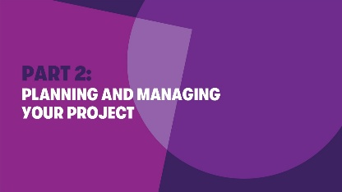
 | But first, let’s explore your findings from Steps 2 & 3 of the “Building Your Project Idea Assessment.” | 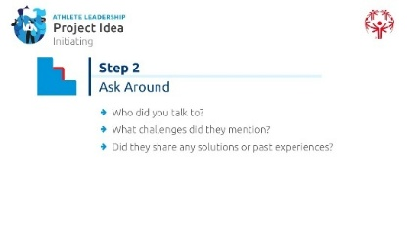
 | Discuss Step 2—what did participants discover when they talked to others about what they think the Program’s/community's needs or issues are? Ask them to share any interesting or surprising insights they gathered from these conversations.
Facilitator Note:
A note about community feedback: Explain that even though this exercise encouraged them to ask for feedback from a peer, mentor, or family member, community members, etc., they still need to keep in mind that the project idea should be their idea, not someone else’s idea. Their project needs to be something they care about. If they work on a project that isn’t their idea or that they are not passionate about, they are more likely to fail. They should choose something that they care about deeply so you will try their hardest to succeed, so the feedback they received from others should be based on facts, not other peoples’ opinions about if they like their project idea or not.
 | Discuss Step 3 - Ask them to share the top needs they identified and any ideas they have for how they might help. Encourage them to talk about one action they’re excited to take—something that connects to their strengths and could make a real difference in their Program or community. | 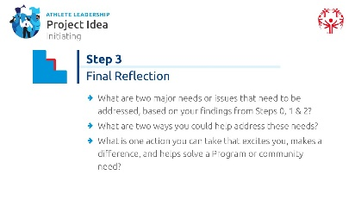  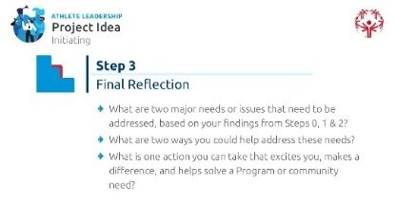
 | Now before we move on and discuss the other 4 steps of project management, we need to make sure your project ideas are good to go.  Remember these questions from Part 1, based on your findings from Steps 2 & 3:  - What is the Program or Community need?  - What will you do?  - Why does it matter—to you and your community?  - How will you do it?  - When will you complete it?  - Who will help? How will they help you?  - Who will this project help? How will it help them?  Let’s spend some time going around the room and having everyone share some of their answers to these questions. | 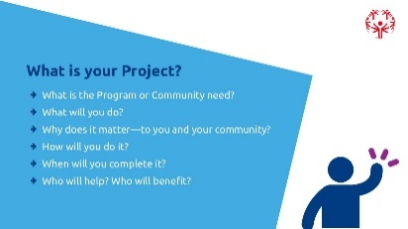  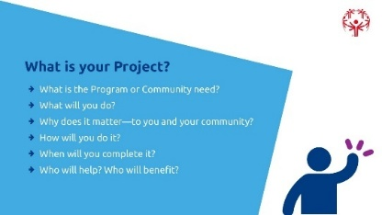
Facilitation Option/Recommendation:
Many Programs use the multi-week break to connect with Athlete Leaders and their mentors to help them refine their project ideas.
- If that’s already been done, the homework and “Finalizing Your Project Idea” check-in here will be quick and will not focus on adjusting project ideas, instead it will be a chance for the other participants to hear about the other project ideas and how they have changed since Part 1. If this was not done, use this time to listen to their project outlines, provide feedback, and fine tune Athlete Leaders’ project ideas.
- If some projects are way off base, use this time to give helpful but constructive feedback to get them back on track. Remember, your job as a facilitator is also to ensure that the projects are realistic and achievable given the deadline you give them.
- If you are unsure whether a project can be successful for any reason, now is the best time to speak up and tell them. You may feel like you are being “mean” by giving overly-constructive feedback, but in reality, you are being nice and helping them avoid issues down the road by helping them define what success looks like – do not hold back! Make sure when you share this feedback that you tell them you don’t mean for it to come across as if you are attacking them, you are just trying to help them refine their idea so it’s the best project it can be.
- If you have time, letting other athletes and mentors give feedback on project ideas is a great way for everyone to practice their communication skills and allow other people the opportunity to give advice so you are not the only one.

Topic  Project Management Phases - Planning  Time:  45 min | Let’s return to the five phases of Project Management  Congratulations.  Now that you have your project idea, we have completed initiating and will now move onto planning…. | 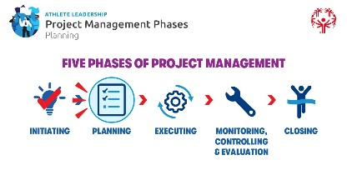
 | Planning: Here, we create a detailed plan of how the project will be completed, including tasks, deadlines, and resources | 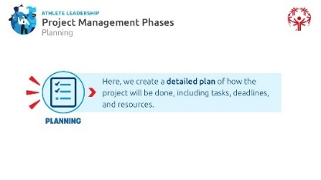
 | During this phase, you take your basic ideas of your project and turn them into a more complete and organized project.  During the Planning Phase of project management, you will:  - Organize your goals  - List things you’ll need to complete your project (for example: money, people, etc.)  - Create a Project Summary  - Create a project plan  - Set deadlines to complete your goals | 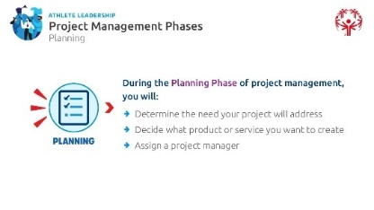
Facilitator Note: Prioritizing the Planning Phase
The Planning phase is essential in this training. Even if learners do not reach the latter phases in full during the session or have to revisit them later in post-training follow-ups, they must complete the Planning phase with a clear, actionable plan. Encourage discussions, provide support, and ensure they walk away with a well-thought-out action plan that will guide them toward completing their project. This foundation will set them up for success in execution, even if they have to further refine details later.
Your role in guiding them through this phase is critical to their overall project success.
 | The first step in the Planning Phase is organizing your goals, and we do that by setting SMART goals.  Setting a goal helps you stay focused on achieving something in the future. Today, we’ll learn how to set a specific type of goal and create steps to reach it.  We’ll use the SMART goal format, where each letter in SMART stands for a key part of a strong goal. SMART goals help you create a clear plan to succeed!  Look at the graphic on the slide—it uses icons or pictures to help you remember what each letter stands for. Follow along in your workbook and complete the question under each letter in SMART, when I say it’s time.  Has anyone completed the goal-setting personal development lesson before? For those of you who have, who remembers what the letter “S” stands for? If you haven’t completed the goal-setting lesson yet, feel free to guess based on the graphic that you see.  (Give them time to answer. When ready, click for next slide) | 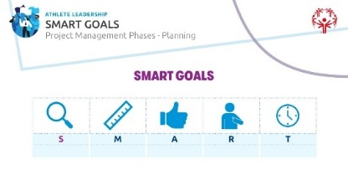
 | Yes, Let’s start with "S" for Specific.  Specific: Your goal should be clear and detailed so you know exactly what you're working toward. If a goal is too vague, it’s harder to focus and stay motivated. | 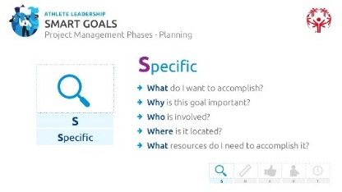
Facilitator Note:
If there is time, ask the participants what they think having a “vague” goal means. Give them a chance to answer.
An example for sports is “I want to be a stronger basketball player.”
An example in terms of project management could be, “I want to start a new sport in my Program.”
These are not specific enough. They need to be able to answer the five W questions when explaining their goal.
To make your goal specific, answer these five W questions:
- What do I want to accomplish?
- Why is this goal important?
- Who is involved?
- Where is it located?
- What resources do I need to accomplish it?
With your project, how is it specific? In your workbook, answer this question: With your project, how is it specific? Let’s take a moment to share and discuss!
 | Who knows what the letter “M” stands for?  (Give them time to answer. When ready, click for next slide)  Let’s explore "M" for Measurable.  A goal should be measurable so you can track your progress and stay motivated. When you can see how far you've come, it's easier to stay focused, meet deadlines, and feel excited as you get closer to achieving your goal.  To make a goal measurable, ask yourself:  - How much?  - How many?  - How will I know when I’ve completed it?  By setting clear measurements, you’ll know exactly when you’ve reached your goal!  In your workbook: With your project, how is it measurable? | 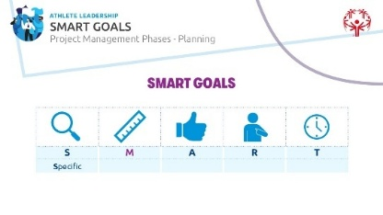  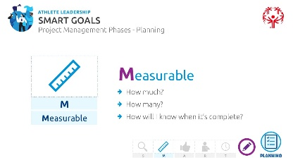
 | “A” stands for Achievable? But what does it mean?  Wait for responses.  “Achievable” means that your goal should challenge you but still be realistic and possible to accomplish. A good goal pushes you to grow while staying within reach.  When ready, click for next slide.  When setting an achievable goal, think about:  - How can I accomplish this goal?  - What resources or opportunities could help me?  - Are there any obstacles, like time or money, that I need to consider?  By making sure your goal is achievable, you set yourself up for success while still aiming high!  In your workbook: With your project, how is it achievable? | 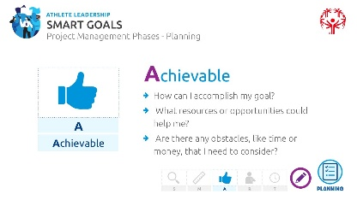  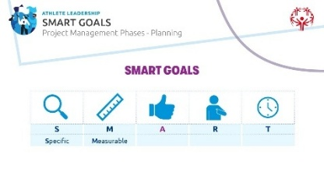
 | Now, let’s explore "R" for Relevant. What does it mean when something is relevant?  Wait for responses.  A relevant goal is one that matters—to you, your program, or your community. We discussed something similar earlier in the training when you created your project idea.  This step helps ensure that your goal is truly yours and not just something others want you to complete because it helps them. While support from others is great, your goal should be something you care about deeply because you want to complete it not because someone else wants you to.  Click for next slide.  To check if a goal is relevant, ask yourself:  - Does this goal matter to me?  - Is this the right time for me to do this?  - Am I the right person to take this on?  - For group projects: Does this match what our team or community needs?  In your workbook: With your project, how is it relevant to you?  By setting a relevant goal, you’re making sure your effort leads to something meaningful! | 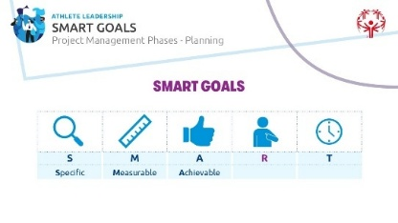  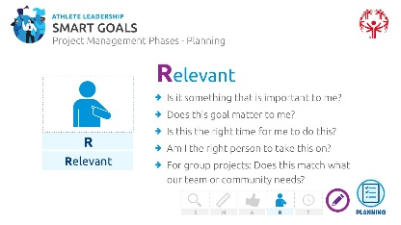
 | Finally, let’s talk about "T" for Time-Bound—one of the most important parts of setting a SMART goal!  When we say a sporting event is time-bound, what do we mean?  Wait for thoughts.  A sporting event is time-bound because it has a clear start and end time—you know exactly when the race begins and when it will be over. That’s what makes it time-bound: there's a deadline. The same goes for the "T" in SMART goals—it means your goal should have a set timeline so you know when you're aiming to finish.  Every goal needs a deadline so you have something to work toward. Without a timeline, everyday tasks can take over, and your goal may get pushed aside. Setting a timeframe helps you stay on track and motivated.  Click for next slide.  To make sure your goal is time-bound, ask yourself:  - When do I want to achieve this?  - What can I do today to move toward my goal?  - What can I accomplish in six weeks?  - Where do I want to be in four months?  In your workbook: With your project, how is it time-bound?  By setting a clear timeline, you create focus—helping you take real steps toward success! | 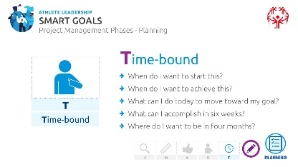  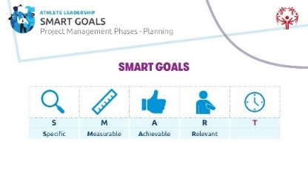
 | Organizing your goals will help you with the next step…The Project Summary and Project Plan  There are two key documents you need for your project as part of the Planning Phase: a Project Summary and a Project Plan.  - A project summary is a high-level overview that briefly describes the project's purpose, key goals, major milestones, and expected outcomes, often used when you want to tell others what your project is about. This is usually a one-page document that you can show people to give them a picture of what you want to accomplish. It only includes key details, not every step of your plan.  - A project plan is a very detailed document outlining the objectives, scope, timeline, tasks, resources, and risks of a project, serving as a roadmap for execution. The project plan is usually organized in a checklist that has start dates, end dates, color-coded trackers, comments, etc. It is very similar to a spreadsheet. It is not shared with the public, but only for you and your team members to use to stay on track. | 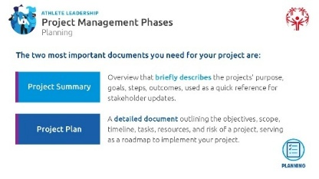
 | Facilitation Option:  Option 1: Skip to the next slide and review the project summary steps, definitions, and examples together.  Option 2: First, take your time to explain the steps and definitions on this slide, then review the steps with examples on the next slide. | 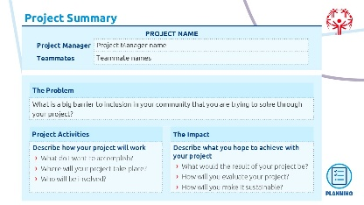
 | Remember to think about your own project as we go over all the steps of this project summary example. Let’s do this one line/section at a time using the example we used before – your Program has very few athletes under the age of 25.  - Complete the Project Title and Project Manager (should be YOUR name). Provide your teammates’ names, role and contact information.  Recruiting and Empowering Athletes  - The Problem: What is the big barrier for inclusion you want to solve in your community or Program?  Not enough athletes (under 25) are participating in our Programs.  What’s the challenge here?  There is a lack of awareness in the community of what Special Olympics is. We don’t know how to recruit younger athletes.  What is a potential solution?  We could launch an initiative that includes reaching out to different community events, asking our current Special Olympics athletes if they would like to be mentors to younger athletes, etc.  - Project Activities: Describe how your project will work.  What will you do?  We will recruit, train, and engage athletes under 25 through outreach events, mentorship, and leadership opportunities.  Where will your project take place?  We will also “showcase” our athletes at public events to raise awareness and excitement.  Who will be involved?  Mentors, teachers, students, athletes, myself  - The Impact: Describe what you hope to achieve with your project.  What would the result of your project be?  Increase the percentage of athletes under 25 from 35% to 50% in 5 years.  How will you evaluate your project so you know it’s successful?  Based on the growth of the number of athletes under 25 over 5 years.  How will you make it sustainable? In other words, how will you make sure that the project’s impact lives on and continues to impact others for years to come?  Create a peer mentorship program where current athletes help recruit and train 5 athletes under the age of 25 each year.  (Go through each box with the examples in underlined purple above.)  Now that you have seen an example, it’s your turn. Please use your workbook to complete your own project summary. | 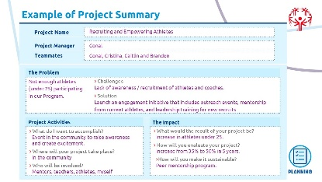
 | Facilitation Option: You can use the example provided or create one that aligns with your Program and resonates with your athlete leaders.
 | A project summary template is provided to help learners organize the full scope of a project by outlining the problem, title, goals, planned activities, and intended impact.  Give participants at least 20 minutes to develop their project summary and take a break | 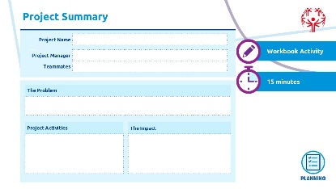
Break:  15 minutes |  | 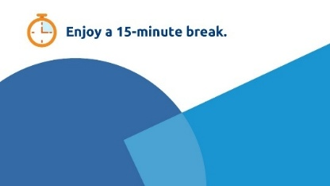
Topic  Project Management Phases - Planning  Time:  45 min | We are still in the Planning Phase of Project Management. We finished with the project summary before break. Next, let’s move on to developing a project plan  Remind learners of the difference between these two tools. Ask if anyone remembers the difference and can share with the class.  - A project summary is a high-level overview that briefly describes the project's purpose, key goals, major milestones, and expected outcomes, often used when you want to tell others what your project is about. This is usually a one-page document that you can show people to give them a picture of what you want to accomplish. It only includes key details, not every step of your plan.  - A project plan is a very detailed document outlining the objectives, scope, timeline, tasks, resources, and risks of a project, serving as a roadmap for execution. The project plan is usually organized in a checklist that has start dates, end dates, color-coded trackers, comments, etc. It is very similar to a spreadsheet. It is not shared with the public, but only for you and your team members to use to stay on track.  The project plan is usually created by the project manager (that’s you!) and is used to plan and manage activities and your team members over the entire project lifecycle. | 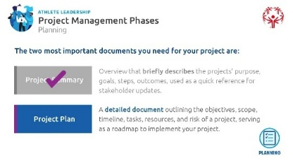
 | The project plan shows planned start and finish dates for project activities; this sets expectations for the project team members and stakeholders for what is happening when and who is in charge of that task.  Describe each of these columns:  - Complete – Indicates whether the task is finished, typically marked as a percentage or a simple "Yes/No."  - Status – Provides the current state of the task, such as "In Progress," "On Hold," or "Completed." More on this on the next slide.  - Activity/Task – Describes the specific work or action that needs to be completed.  - End Date – The deadline or expected completion date for the task.  - Owner – The person responsible for overseeing and ensuring task completion.  - Helpers – Additional team members who assist the owner in completing the task.  - Notes – Any relevant details, updates, or comments about the task.  A project plan also helps people visualize all the tasks at the same time and see how the pieces of the puzzle fit together to help everyone complete the project on schedule. | 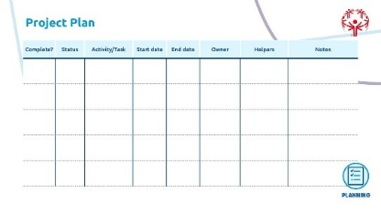
 | A way to keep track of the tasks and what is done or not done is by using the traffic light system. Who can guess how the traffic light color coding might work?  What might green show for a task? (Wait for answers. When ready click to reveal)  Use green when the task is in progress. | 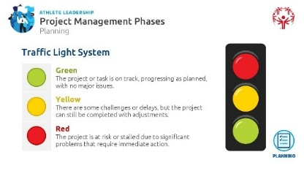
 | Facilitator note: They may say that green means the task is complete, which is fine, but it mainly means that something is on target to be completed by the due date. The completed section is a simple checkmark to show that a task is actually complete.
What about yellow? (Wait for answers. When ready click to reveal)
Use yellow when a task is at risk or delayed.
What about red? (Wait for answers. When ready click to reveal)
Use red when a task is in danger of not being completed.
Summary:
The Traffic Light System in project planning is a simple way to track progress using three colors:
🟢 Green – The project or task is on track, progressing as planned, with no major issues or the task is finished.
🟡 Yellow – There are some challenges or delays, but the project can still be completed with adjustments.
🔴 Red – The project is at risk or stalled due to significant problems that require immediate action.

This system helps teams quickly assess status and decide where to focus their attention.
 | Group Activity: Walking Through a Project Plan  To reinforce the Project Plan, walk through the provided project plan example as a group. Explain each section, highlight key considerations, and use the example to highlight how planning sets the foundation for project success. Encourage questions and reflections. Make sure they understand that yellow or red is not necessarily a “bad” thing. Red or yellow just means it is an item that needs to be addressed and might need more attention than the others. | 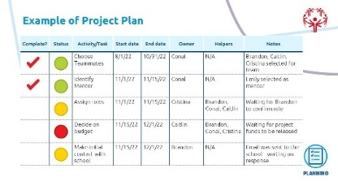
 | Facilitation Option: You can use the example provided on this slide (“Example of Project Plan”) or create one that aligns with your Program and resonates with your athlete leaders.
 | - Give athlete leaders 30 minutes to work through the project planning template themselves, using their project idea. They won’t come out of this training with a full project plan but encourage them to identify at least 3-5 tasks that they can add to their project plan so they at least have something to go home with and start working on their project.  - Make sure they understand that a project plan is always evolving. It is impossible to think of everything that they will need to complete with their project before they even start working on their project, so they will be adding things to the project plan all the way up until they complete their project (and maybe even after it’s “done!”)  Reconvene as a full group to discuss insights, challenges, and takeaways. Ask if anyone wants to share a task that they put on their project plan. | 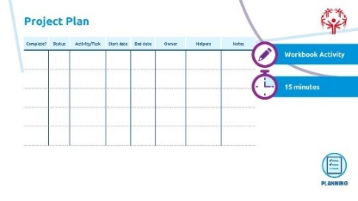
 | We have covered the two most crucial phases of Project Management: Initiating and Planning. These two phases lay the foundation for a successful project.  In the remaining time, we will briefly discuss the final three phases—Executing, Monitoring & Controlling, and Closing—to give you a general understanding. These phases will become more relevant once you begin working on your project. | 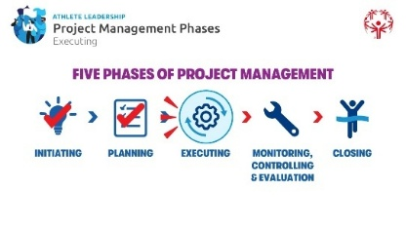
Topic  Project Management Phases - Executing  Time:  5 min | Executing Phase  ‘Executing’ means that we are now doing the work of our project. | 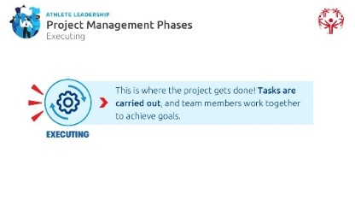
 | During this phase, you will:  - Begin working on assigned tasks  - Share regular updates with the team, stakeholders, sponsors  - Adjust your project plan as needed  Starting the execution of your project sometimes can make you feel like you are moving at 100 mph, which means it is easy to become distracted, or overwhelmed. That’s normal. | 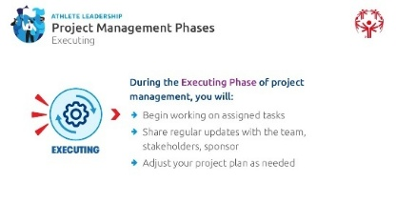
 | There are three key practices that will help you execute your project better:  - Setting and sticking to a consistent routine  - Good communication between you and others  - Documenting everything that happens  Let’s talk about each of these in the next few slides… | 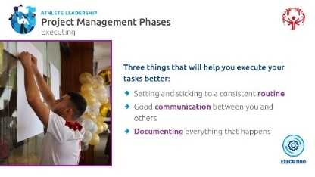
 | Setting and sticking to a consistent routine.  A good idea is to set a routine or schedule so you can check your own work and the work of others on your team.  - A clear schedule helps you stay on track and ensures steady progress.  - Break tasks into smaller steps and set deadlines to keep momentum.  - Identify your most productive times of the day and plan key tasks during those most productive times.  - A good routine can assist with reminding you and your team of tasks.  - Everyone is held accountable, but as project manager, you are held MOST responsible. Setting a routine helps ensure that you don’t forget something. | 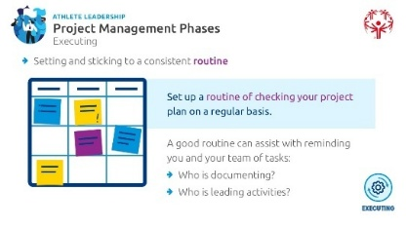
 | Good Communication Between you and Others.  Communication is the number one factor in leading your project and team. By having good communication and regular project meetings, you can capture things that you need to do to keep your project moving forward!  - Keep everyone informed about progress, changes, and challenges.  - Use regular check-ins, emails, or meetings to ensure alignment.  - Be clear, concise, and proactive in asking for help or offering updates.  To enhance communication skills, check out The Special Olympics Leadership & Skills Curriculum and Personal Development lessons. | 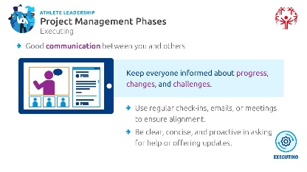
 | Documenting Everything That Happens.  Documentation is when you write down notes of the results and progress, when you take pictures and videos of the activities, when you interview people and write down their answers.  Ask learners why they think documentation is important.  First, documenting things as you move along is easier than trying to remember every step, event, goal, contact, etc., days or weeks after you have completed them. And, it shows you and others the progress you are making with your project. Without this documentation, you may be completing tasks but feel like you aren’t actually getting anywhere because you and your team don’t see the progress.  - Keep records of decisions, changes, and completed tasks to track progress.  - Documentation helps solve problems, maintain accountability, and improve future projects.  - Use tools like notebooks, digital trackers, or project management software—such as Smartsheet or Excel—to stay organized.  - If your Special Olympics program already uses tools like Google Sheets, Trello, or Microsoft Teams to track progress and manage tasks successfully, consider sharing those examples with others. | 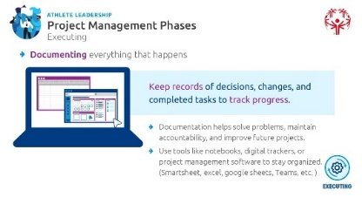
 | Reflection Question:  As a Project Manager, what are 3 ways you will document your project work so that you are not relying on memory? Will you use monthly check-in meetings, Google Sheets, notebook, voice notes, etc.? Write your answers in your workbook. | 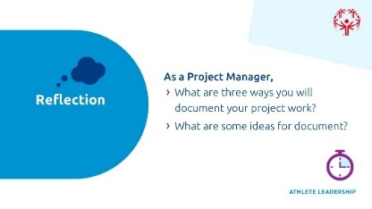
Topic  Project Management Phases – Monitoring, Controlling and Evaluation  Time:  20 min | Monitoring, Controlling and Evaluating Phase  Next, let’s discuss the next phase of PM: Monitoring, Controlling, and Evaluation.  Throughout the project, we keep an eye on progress, checking for any issues or changes needed to stay on track.  (Click for next slide) | 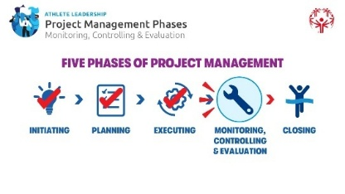
 | Monitoring and Evaluation may be the fourth phase but it is more like an umbrella that happens early on when you are working on your project summary and carries on throughout the rest of the project. Going through this phase helps protect you from any problems that may come up. It doesn’t prevent problems from happening, just like an umbrella doesn’t completely prevent you from getting rained on, but when done right, this phase can help make some of the problems you encounter seem less bad. | 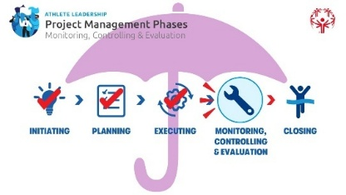
 | In this phase, you ensure your project stays on track, problems are managed effectively, and you measure success. This involves three key actions: | 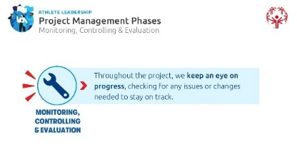
 | - Review and Track Progress  - Regularly check if the project is moving according to plan.  - Compare actual progress with goals and deadlines.  - Adjust timelines or resources if needed to stay on schedule.  - Manage Project Issues  - Identify problems early and find solutions before they grow into bigger problems.  - Communicate with team members to resolve challenges quickly.  - Keep track of any changes and how they impact the project.  - Assess Risks  - Watch for potential obstacles that could slow down or stop progress.  - Develop backup plans in case things don’t go as expected.  - Learn from mistakes and successes to improve future projects.  Think of it like checking your GPS while walking or biking somewhere new. You make sure you’re on track and on time and adjust if needed.  In the next few slides, we will talk a bit more about this third action: Assessing Risks | 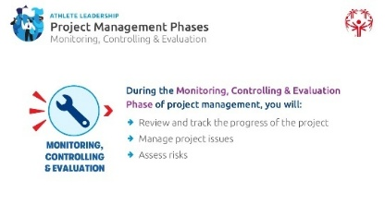
 | Define Risks & Issues  "Every project has challenges, but good project managers try to spot them early. We call these risks and issues." (Click to reveal)  Risks are problems that could happen in the future.  (Example: A key team member might leave before the project is done or the funding we have for the project may not come through.) (Wait for answers. When ready click to reveal)  Issues are problems that are already happening.  (Example: The venue you booked for an event just canceled on you.)  "We can’t prevent every problem, but we can plan for them. That’s what makes a great project manager!" | 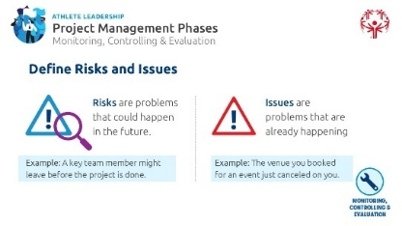
 | Step 1: Anticipate Risks & Issues  Think About Your Project:  - What could go wrong? What challenges might come up?  Example: If you’re recruiting young athletes, what if no one signs up? Or, what if you have a lot of young athletes, but don’t have enough coaches?  - Sort the Problems:  Which ones are risks (might happen)?  Which ones are issues (already happening)?  - Plan for Solutions:  For each risk, how can you prevent or prepare for it?  For each issue, how can you fix it?  By thinking ahead, you’ll be ready to handle challenges and keep your project on track!  By going through this exercise of identifying potential risks, that does not mean that risks will be eliminated, but many of them can be anticipated and the impact lessened because we took the time to think of them ahead of time. | 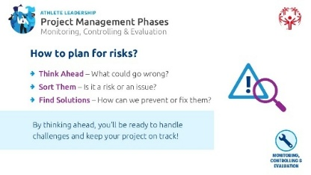
 | Step 2: Assess the Risk  Not all risks are the same. Some are small and easy to handle, while others could stop your project completely. The reason why we think about risks before they happen is to answer the question “how big is the risk?” and assess the how likely it is to happen, the impact it could have on the project, and how to keep it from happening in the first place.  Risk Rating System: Spot the Risk, Trust Your Instincts  💤 Low – Snooze. Not a big deal, continue as planned BUT keep an eye on it because it could grow into a big problem in the future.  🤔Medium – Thinking? Take some action to reduce risk.  😬 High – Yikes. Get help and adjust your plan.  😱 Extreme – Full uh-oh. May need to pause or rethink the project.  By planning ahead, we can keep risks from turning into disasters!  And remember, you are not alone in this process. Get your whole team involved in the risk assessment and planning phase; everyone sees different risks! Let’s give you some time to think about potential risks that could impact your project.  Let’s take some time to answer some reflection questions in your workbook:  - What is a potential risk in your project? And how would you rate it on the coloring scale we just discussed?  - What steps can you take to avoid that risk or lessen its impact? | 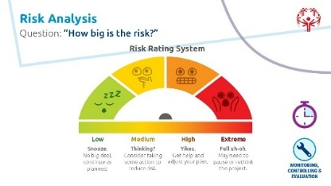
Topic  Project Management Phases – Closing  Time:  20 min | Closing Phase  Now we are going to transition into the fifth and final phase of project management, Closing. | 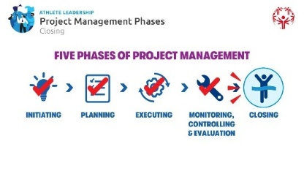
 | Once everything is complete, we review the project to make sure all goals were met and officially close it. | 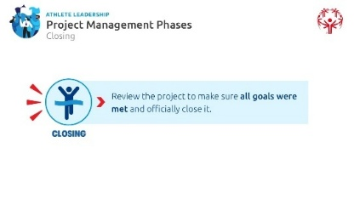
 | During the Closing Phase of project management, you will:  - Document what you learned  - Complete any remaining requirements  - Create a report to share what you accomplished and show others how to follow your lead if they want to build off your project  - Celebrate with your team | 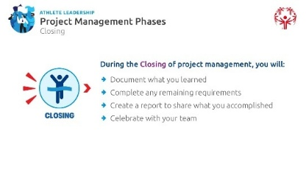
 | Look at your project plan.  - Have you checked off all your tasks?  - Review to see what is still missing.  - What needs to be completed? | 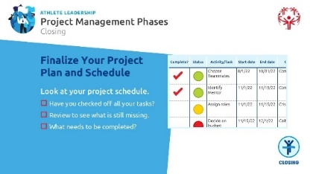
 | You did it! The project is complete, and now it’s time to celebrate! How will you recognize the hard work of your team and supporters?  For example, host a team wrap-up meeting to share wins, give shout-outs to key contributors, or send a fun appreciation message to everyone involved! | 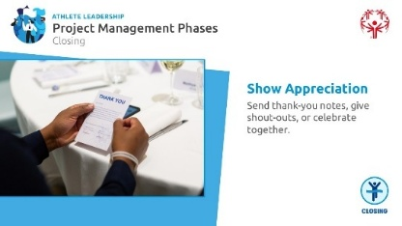
 | Remember, telling the story of your project is important. Just like in sports, the highlight reel helps others see the big plays, the strategy, and the teamwork behind the win. Sharing your project story makes it easier to gain support for future efforts or inspire others to take what you started and add to it or start their own project.  Let’s talk about how to tell your project story in a way that connects with others, invites support, and keeps the momentum going. | 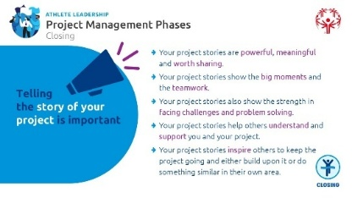
 | First, Why Share Your Project?  - Sharing your project isn’t just about giving information—it’s about connecting with people.  - When you tell your story, others start to understand what matters to you and why your project matters to the community. The impact.  - Stories build empathy—they help people feel what you feel and see what you see and care about what you care about.  - Sharing helps clarify big ideas and make complicated issues easier to understand.  - There’s power in being genuine and honest—when you speak from the heart, people are more likely to listen and support you.  - Your story is one of your greatest tools for creating change. Use it to inspire, teach, and motivate others to join your effort or to create their own projects that they are passionate about.  Ask participants: “Has someone else’s story ever changed the way you think or feel? What made it powerful?” | 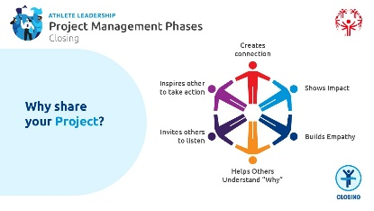
 | What makes a story about your project powerful?  - It explains how a problem was faced, what someone did, and how things changed.  - A strong story shows impact—that means it clearly tells what action was taken and what happened because of it.  - When you tell your story, try to include:  - What the challenge or need was  - What you (or someone else) did to help  - What changed because of that action  - Good stories help people understand hard or confusing topics because they include real people (but you don’t have to share names or private details!) and real experiences. Instead of just giving facts, stories show what someone felt or went through. That makes it easier for others to care and understand.  - These parts work together to help others connect to your project and understand how it can make a difference. | 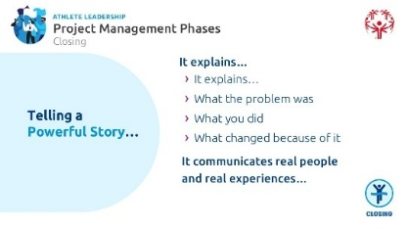
 | Workbook Activity: Build Your Story  Obviously, your project is not finished – you just started it! But think about what you hope your project will achieve when it is done.  This exercise will help you see why telling your project’s story is important. It will also help you imagine what your project could look like when it’s done. | 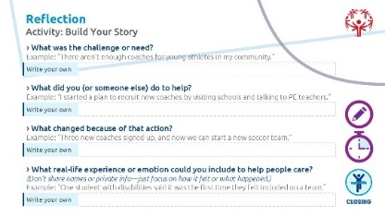
 | Provide 15 minutes for learners to complete the activity and then another 10 minutes for sharing with a partner.
1. What was the challenge or need?
Example: “There aren’t enough coaches for young athletes in my community.”
2. What did you (or someone else) do to help?
Example: “I started a plan to recruit new coaches by visiting schools and talking to teachers.”
3. What changed because of that action?
Example: “Three new coaches signed up, and now we can start a new soccer team for younger athletes.”
4. What real-life experience or emotion could you include to help people care?
(Don’t share names or private info—just focus on how it felt or what happened.)
Example: “One student with disabilities said it was the first time they felt included on a team.”
Activity:
Read your story to a partner. Ask: “Did my story help you understand the project and why it matters?” If not, that’s okay, ask what was missing and re-write it.
 | Now we will discuss 4 things you need to remember when sharing your project story.  - Be Confident  You know your project and your story better than anyone else. Trust what you’ve created, and believe in yourself.  Stand tall, speak clearly, and make eye contact with your audience.  - Emphasize Key Words  How you say something can be just as important as what you say.  Try saying the same sentence, but change which word you emphasize. This helps people understand your main point.  - Use Body Language  Your body can help tell the story—use hand movements, facial expressions, and posture.  Avoid crossing your arms or looking down; show that you’re open and ready to connect.  - Stay Calm  If something goes wrong, don’t panic.  Take a deep breath, smile if you can, and keep going.  Remember: the audience is cheering you on, not judging you. | 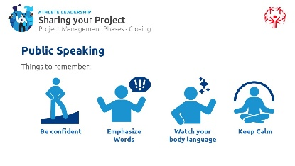
 | Group Activity:  Ask 2-3 volunteers to share their project story with the group from the previous activity:  - What the challenge or need was  - What they (or someone else) did to help  - What changed because of that action  - A real-life feeling or experience they can share (without using private info)  Instructions for the Group:  As you listen, use the 4 Public Speaking Tips to give helpful, kind feedback:  - Be Confident: Did the speaker believe in their message? Did they speak clearly and look comfortable?  - Emphasize Key Words: Did they use their voice to highlight the most important parts of their story?  - Use Body Language: Did they make eye contact, use hand gestures, or look relaxed while speaking?  - Stay Calm: Did they keep going even if they forgot something or made a mistake? | 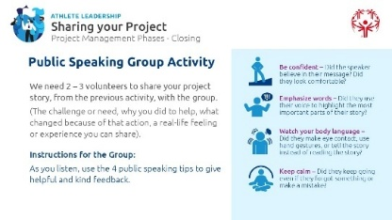
Feedback Prompt:
After each speaker, ask the group to offer one positive comment and one helpful suggestion using this sentence:
“I liked how you…” and “Next time, you could try…”
Remind the group that the goal is to build each other up and grow as speakers, not to be perfect.
 | After You Present – Learn and Improve  Let’s give a round of applause to the volunteers who presented their project story—and thanks everyone who gave thoughtful feedback. Sharing your project takes courage, and each time you practice, you get stronger and clearer in your message.  Eventually all of you will need to share your project with others. After sharing your project, take time to reflect. Listen to feedback from the audience and other speakers.  Ask yourself:  - What went well?  - What could I do better next time?  - Make notes to help you grow as a presenter and improve your project.  - Practice sharing your project again—each time builds your confidence and helps your message land more clearly.  Encourage learners to think of feedback as a gift or a tool, not a judgment. | 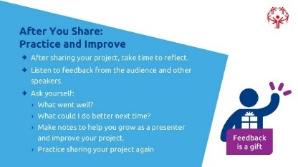
 | Where to Share Your Project  - Sharing your idea helps your project grow and get support.  - Think about who needs to hear your idea and who can help—especially people who can provide funding, resources, or connections. | 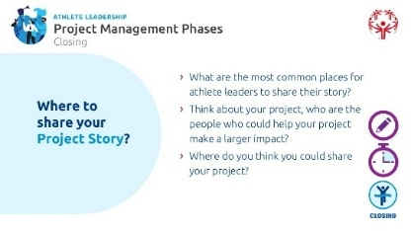
 | This is a brainstorm so pause and ask participants to list 2–3 places they could share their project to gain support or make a bigger impact.
- Here are some good places to start:
- Local schools or school boards
- Civic groups (like Rotary Clubs or youth organizations)
- City councils or local government
- Social media or community newsletters
- Events where your audience or supporters will be
 | Facilitation Option: If you think it would help participants, you can create a slide that lists good places to share their project to gain support or make a bigger impact. Be as specific as possible with local people, leadership stakeholders, and locations.
Reflection in the Workbook: Where will you share your project story?
When you share your project story, you’re not just talking about what happened—you’re helping others see what’s possible. Your voice can inspire future projects, attract support, and strengthen the impact of Special Olympics around the world.
Topic  Wrap up | Congratulations! You have successfully completed the Project Management Training for Athlete Leaders. You now know the five phases of project management and we hope you are better prepared to continue leading projects in your community!  As we wrap up this training, remember that you’re not just a project manager—you’re a leader, a storyteller, and a change-maker in your community.  Thanks to amazing athlete leaders like you, Special Olympics is a project-driven and athlete-led organization. We can all contribute to the Special Olympics mission by executing high quality projects across the world.  We would appreciate it if athlete leaders and mentors could take a quick survey to let us know how we did sharing this content with you. Please follow the QR code on the screen to take the survey.  We look forward to seeing all your finished projects! Remember that we are here to support you in this journey so please reach out with questions or concerns as you work on them. | 
Inform learners of next steps, follow-up meetings, and project idea implementation support that you and your Program staff can give them, especially if their projects are related to your Program (e.g., if their project is about recruiting athletes under the age of 25, put them in touch with someone in your Program who works with schools).
Be sure to communicate any regular check-ins you’d like to have with them and how they should turn in their final projects when they are done.
You will want to be sure to work with your marketing team to highlight the completed projects and show off the amazing work of your athlete leaders so make sure the project managers or their mentors are documenting their project work with photos, videos, and recording notes throughout the process.

