CERTIFICATE OF COMPLETION

In recognition of

COACH NAME
for successfully completing the Special Olympics Fitness Captain Training, and committing to support their athletes to fulfill their duties as a Fitness Captain.
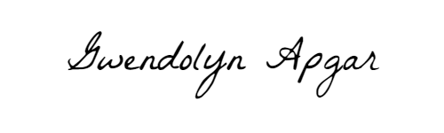

GWENDOLYN APGAR
Manager, Fitness for Sports Performance
Special Olympics International

YOUR NAME HERE
Your Title Here
Your Program Name Here

