CERTIFICATE OF COMPLETION

In recognition of

ATHETE NAME
for successfully completing the Special Olympics Fitness Captain Training, and committing to encourage and empower their teammates to be healthy and fit.
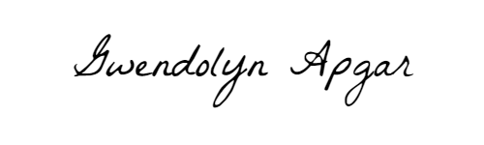

GWENDOLYN APGAR
Manager, Fitness for Sports Performance
Special Olympics International
YOUR NAME HERE
Your Title Here
Your Program Name Here

The mark “CDC” is owned by the US Dept. of Health and Human Services and is used with permission. Use of this logo is not an endorsement by HHS or CDC of any particular product, service, or enterprise.

