Instructions
Fitness Captain
Participant Workbook
- When you participate in a Fitness Captain training you will use this workbook. For the activities do one of the following:
  - Print out and complete it by hand.
  - Complete on your computer and save.
- It can also be helpful if you go through it before the training session so you can get familiar with the information beforehand.

Lesson 1:
Overview of Fitness

Lesson 1:
Overview of Fitness
Fitness is Your best health and performance through proper physical activity, nutrition, and hydration.
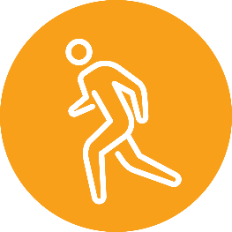

QUESTION: Think of a person you consider fit. What kind of things do they do, or you think they do to stay fit?

Being fit has many benefits to your health and performance:
PHYSICAL ACTIVITY
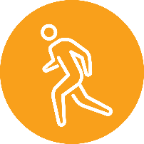
Physical Activity is any movement that our body makes. It is produced by our muscles and that uses energy.
Physical Activity could include the ways you move your body throughout the day such as grocery shopping, walking at work, or gardening.
Exercise is planned, structured, repetitive, and focuses on maintaining or improving one or more components of physical fitness.
Exercise has four different components that work your body in different ways. Certain exercises can help you improve the skills needed for your sport.
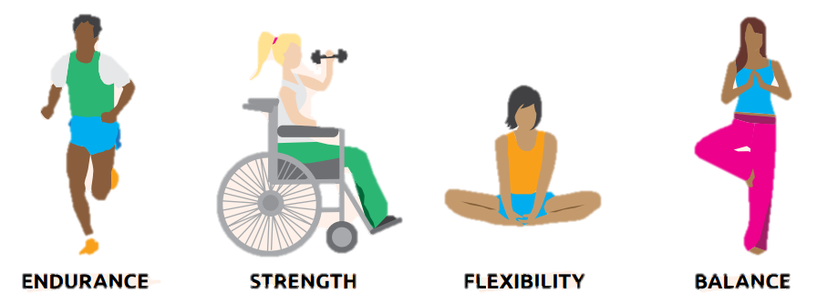
Endurance
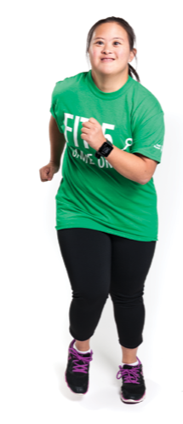
Endurance is the ability of your body to keep moving for long periods of time. This might also be called aerobic fitness, cardiovascular fitness, or cardio.
QUESTION: What are some examples of endurance exercises?
Strength
Strength is the ability of your body to do work. You can use body weight, or weights (example: dumbbells) and resistance bands when you do these exercises.
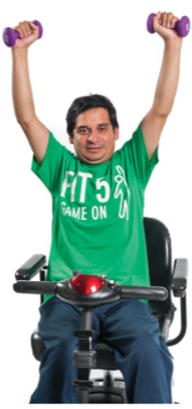
QUESTION: What are some examples of strength exercises?

Flexibility
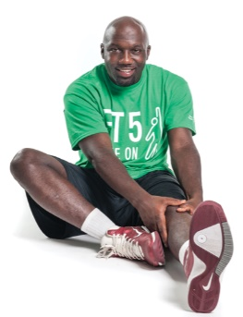
Flexibility is the ability of your body to move easily in all directions. The best way to get flexible is to stretch! Being flexible makes it easier to do sports skills and helps prevent injuries to your muscles and joints.
QUESTION: What are some examples of flexibility exercises?

TAKE NOTES: What is the difference between static and dynamic exercises?

Static | Dynamic

Balance
Balance is the ability of your body to stay upright or stay in control of your movements. Balance helps you to stay in control when you are playing sports and helps you to avoid falls
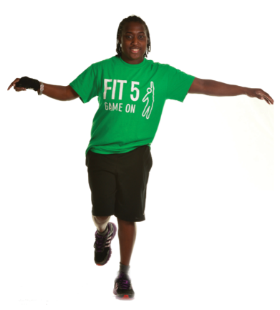
QUESTION: What are some examples of balance exercises?

NUTRITION
Eating a variety of foods can give you the nutrients you need to properly fuel your body.
Eating right can be easy because there are many delicious healthy choices!
Eating well helps you both on and off the field. It keeps your body and mind healthy, and increases your sport performance and recovery.
Healthy eating keeps the body and mind healthy by:
- Giving your body the energy to be active and function well
- Helping your body to grow and repair itself
- Helping the body to fight infections and illness

Healthy eating can increase your sports performance and recovery by:
- Giving you more energy
- Strengthening your muscles and bones
- Improving your focus

QUESTION: What kind of healthy foods do you eat?
Fruits & Vegetables
Fruits and vegetables give your body important vitamins, minerals and energy needed for good health and sports performance. During meals, try to make half of your plate fruits or vegetables.
QUESTION: What are some of your favorite fruits and vegetables? Write down at least 3 fruits and 3 vegetables.
Fruits | Vegetables

Dairy
Dairy foods contain Vitamin D and calcium which help keep your bones strong. This can prevent fractures, and prevent muscle pain and weakness.
QUESTION: What are some of your favorite dairy foods? Write down at least 3 examples.
Grains
Grains are naturally high in fiber, helping you feel full and satisfied — which makes it easier to maintain a healthy body weight!
QUESTION: What are some of your favorite grain foods? Write down at least 3 examples.

Protein
Protein helps with recovery and repair of tissues in the muscles, skin, organs, blood, hair and nails. Protein gives you energy.
QUESTION: What are some of your favorite sources of proteins? Write down at least 3 examples.
Portion Control
Portion control means choosing a healthy amount of a certain food. Portion control helps you get the benefits of the nutrients in the food without overeating.
Eat what your body needs. Here are some tips to help you with portion control:
- Use smaller plates and bowls
- Limit distractions during meals
- Keep food off the table
- Eat slowly and chew your food

QUESTION: Are there other things you try to do to control how much you eat?
HYDRATION
Hydration is keeping the amount of fluid you need in your body.
Drinking the right amount of water helps to keep your body working properly, especially when you exercise!
Did you know that your body is made up of 60% water? It’s not surprising that water is the most important drink for your body. It’s needed for every function in our body!
Healthy Beverage Choices
There are many beverage options available, but some of them are healthier choices than others:

Sodas, energy drinks, and sports drinks are not good beverage choices.
- These drinks have extra sugar and can make you gain weight.
- Energy drinks and many sodas also have caffeine. Caffeine does not help you stay hydrated.
Moderate amounts of low-fat milk and 100% juice are also good choices in small amounts.
- No more than 3 cups of milk and 1 cup of juice per day.
Water is the best choice for a beverage! Drink water every day! Water doesn’t have to be boring either. If you like flavored drinks, try sparkling water or try infusing your water.
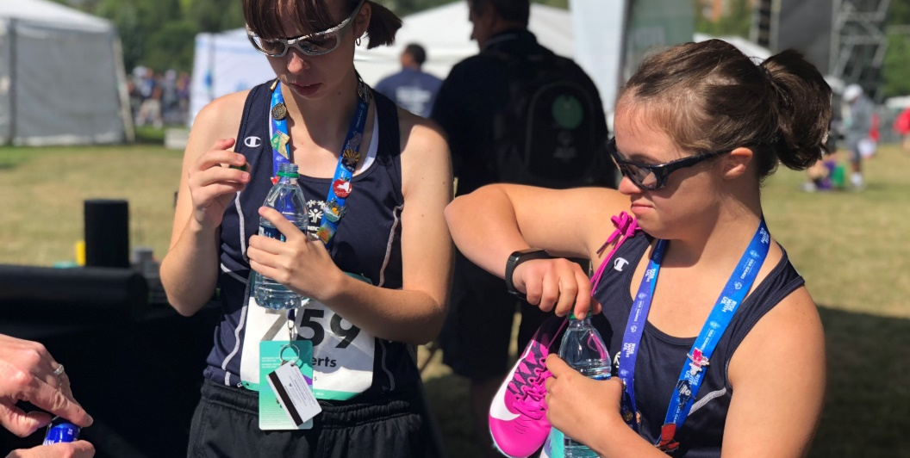
ACTIVITY: Pick your 5 favorite flavors for a personalized water recipe recommendation:
SWEET | HERBAL | CITRUS | TROPICAL
- Strawberry  - Watermelon  - Grape  - Blueberry | - Mint  - Rosemary  - Basil  - Cucumber | - Orange  - Lemon  - Lime  - Grapefruit | - Mango  - Pineapple  - Kiwi  - Passion Fruit

Dehydration
Drink enough water throughout the day to stay healthy, hydrated and perform at your best. You lose water when you go to the bathroom, sweat, exercise, and breathe. If you lose too much water without drinking more, your body won’t work as well.
Your goal with Fit 5 is to drink 5 bottles of water every day! If you lose too much water without drinking more, your body won’t work as well. This is called dehydration.
Signs of dehydration:
- You feel thirsty
- You are tired or sluggish
- You have a headache
- Your mouth is dry
- Your urine is dark yellow brown

QUESTION: What are some tips to stay hydrated?
LESSON 1: HOMEWORK
Create a Health Tip and Practice Presenting

Fitness Captains will use their leadership skills to share Health Tips to their teammates. Health Tips are small but useful pieces of advice that can help you and your teammates make healthy choices.

You can give a health tip about any of the parts of fitness:
Physical Activity
Hydration
Nutrition
Consider the following information as your start writing your tip:
What do you want your teammates to DO?
WHEN will you share your tip?
What do you want your teammates
to KNOW?

Knowing the answers to those questions is important. Let’s practice!
See the example below and use the outline to write your own health tip.
Topic: Hydration
When will you share your tip? | I will share my tip during cool-down stretches.
What do you want your teammates to know? | Staying hydrated keeps your body working properly.
What do you want them to do? | Drink at least 5 bottles of water per day.
Health Tip (3-4 Sentences) | Staying hydrated is important for your health, especially when you exercise! If you lose too much water without drinking more, your body won’t work as well. Your goal with Fit 5 is to drink 5 bottles of water every day! Try to have a glass of water with every meal and bring a reusable water bottle with you wherever you go.
Your turn! Here’s a blank table for you to use when preparing your Health Tips. You can reuse this outline every time you make a new tip.
Topic: _________________________________________________________________
When will you share your tip?
What do you want your teammates to know?
What do you want them to do?
Health Tip (3-4 Sentences)
Practice makes perfect! Now that you have written your health tip, it’s time to practice. Ask a mentor, friend, family member to listen and give you feedback before you share the tip with your teammates.

Things to Remember
Be Confident: Practice reading your tip many times. Do not feel like you must memorize your tip. It is okay to read it from a piece of paper or a device.

!!!
Emphasize Words: Your voice is a powerful tool. You can use pauses between sentences, don’t speak to slow or too fast and use your voice to emphasize words.

Watch your Body Language: Using your body movements can be an effective tool for adding emphasis and clarity to your words. Consider your facial expressions, eye contact, and body movements when speaking.

Keep Calm: You can always pause and re-start the word or phrase if you are feeling nervous or made a mistake. Take a deep breath – you can do this!

Visual Aids: You can bring visual aids, like your Fit 5 Guide or photos, to help you when you present your Health Tip. This may help your teammates remember what you said.

Lesson 2:
Leading Warm-Ups and Cool-Downs

Lesson 2:
Leading Warm-Ups and Cool-Downs
Fitness Captains can take on the responsibility of leading their team to complete safe and effective warm-up and cool-down routines at all practices and competitions.

WARM-UPS
A warm-up should be the first physical activity in every training session or competition. It helps athletes prepare their body and mind for their sport.
When athletes prepare both the body and the mind, they are less likely to suffer an injury and will perform better at each practice, training, and competition.

WARM-UP: PHYSICAL AND MENTAL BENEFITS
- Increase heart rate
- Increase breathing rate
- Increase body and muscle temperature
- Greater blood flow to the active muscles
- Shift focus from life to sport
- Connects the mind and the body

Every sport is different, and each sport has specific skills and movements. The warm-up should be specific to the sport you’re playing and the ability levels of your teammates.
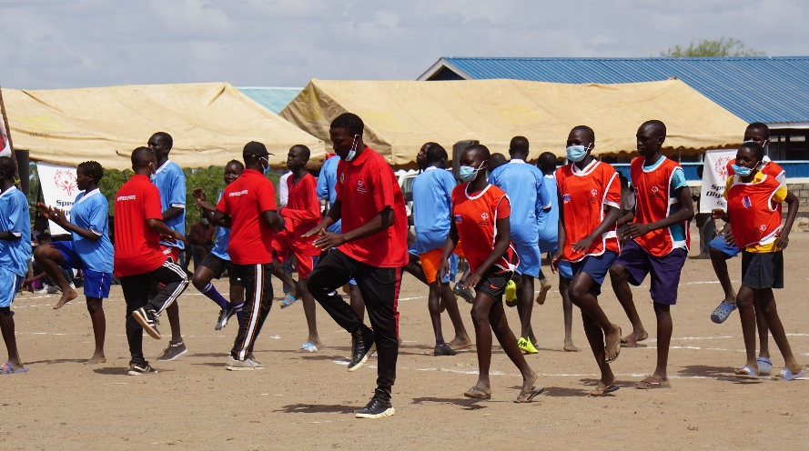
These two elements should be included in all warm-ups:
- Aerobic Activity
- Dynamic Stretches

Aerobic Activity
Aerobic activities are whole body movements that will increase the heart rate.
Think back to Lesson One… Aerobic = Endurance
- Start at a slow pace and gradually increase in intensity/difficulty
- Last at least 5 minutes
Athletes should feel warm, a little out of breath and energized by the end. This can be a fun part of your training session.

Tips for aerobic activities:
- You can introduce games or dances
- Involve your teammates in choosing the activity
- Routine can be helpful for some athletes, but variety is also important.

QUESTION: What are some aerobic activities that you can lead?
Dynamic Stretches
Once your body is warm, it’s time to focus on stretching the muscles you will use during your sport!
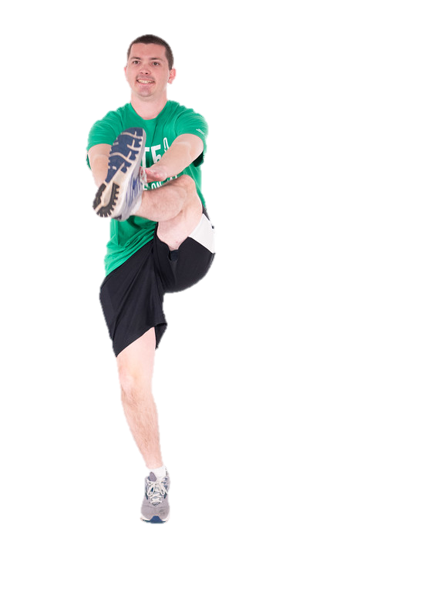
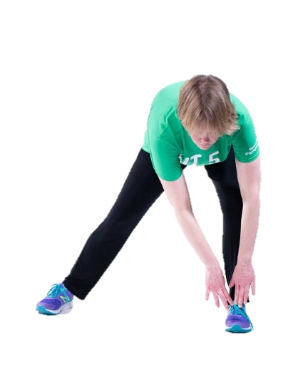
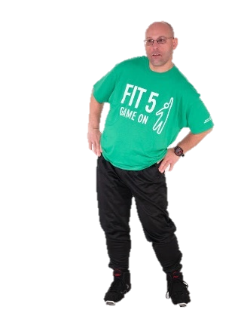
Dynamic stretches consist of active, controlled movements that take body parts through a full range of motion.

Dynamic stretches help keep the body temperature and heart rate elevated. Do you remember the difference between dynamic and static stretches?
QUESTION: What are the main body parts you use in your sport? What is 1-2 dynamic stretches you can do for that body part?

Body Part | Dynamic Stretch

HOW-TO LEAD A WARM-UP
- Warm-ups can be done in place or across the playing area
- Start off slow, and gradually increase speed/pace
- When possible, provide modifications for your teammates if exercises are too easy or too difficult
ACTIVITY: What are some ways to make these dynamic stretches easier or more challenging?
Exercise | Easier Modification | More Difficult Modification
Example:  High Knees | - Go slower  - March in place  - Fast Feet | - Increase your speed
Butt Kicks
Hip Hinges
Arm Circles

COOL-DOWNS
When your training, practice or sport session is complete, you should always cool-down. It is just as important to have a good cool-down as it is to have a good warm-up.
A good cool-down allows the body to gradually return to a state of rest.
COOL-DOWN: PHYSICAL AND MENTAL BENEFITS
- Decrease heart rate
- Decrease breathing rate
- Decrease body and muscle temperature
- Returns rate of blood flow from the active muscles to resting level
- Decrease muscle soreness
- Improve flexibility
- Increases the rate of recovery from exercise
- Promote relaxation

What do you notice about this list? How does it differ from warm-ups?
Like warm-ups, your cool-up should be specific to the sport you’re playing and the ability levels of your teammates.
These two elements should be included in all cool-downs:
- Light Aerobic Activity
- Static Stretches
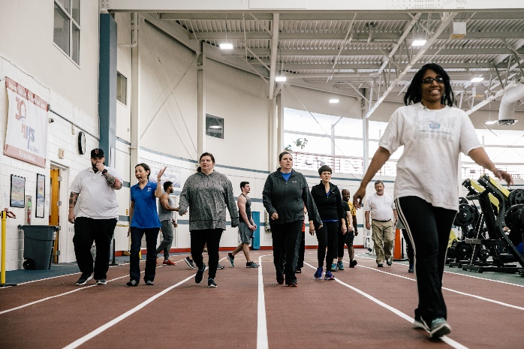
Light Aerobic Activity
The aerobic activity should gradually decrease in intensity or difficulty. You should be putting in half your effort or less. This means that you aren’t trying to go as fast as you can, but you aren’t going as slow as you can either. You should be able to move and hold a conversation without being out of breath. Your heart rate should be slowing down.
Examples:
- Light jog into a walk
- Slow skate around the rink
Static Stretches
Stretching is a great way to help your muscles recover and prevent injuries! Static stretches should be held for 30 seconds or more and can help to improve flexibility.
Each sport places stress on different muscles and joints, so it is important to make your stretches sport specific.
QUESTION: What are some static stretches that are important for your sport? Think about the different body parts you use.
Tips for static stretching:
- Hold each stretch for at least 30 seconds
- Stretches should be performed to mild discomfort, but should not be painful
- Stretch both sides
  - Example: if you stretch the muscles your right leg, you should also stretch the muscles your left leg

HOW-TO LEAD A COOL-DOWN
- Follow a standard routine for your cool-downs
- Have your team stand in a circle. You can stand in the middle so that everyone can see you and follow your stretches
- Encourage your teammates to hold onto a steady surface or each other’s shoulders for balance
- You can also use the time at the end of practice to encourage healthy habits at home. Your teammates can listen to your tips while they stretch!
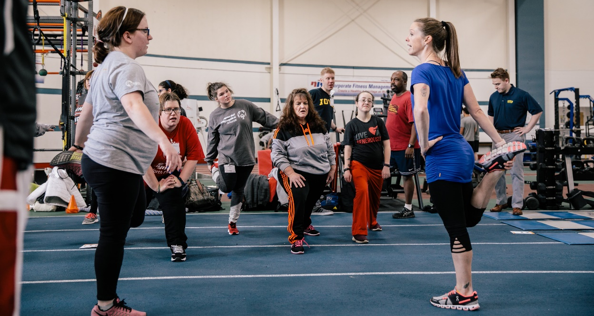

LESSON 2: HOMEWORK
Complete a Practice Plan for your Team
By having a practice plan, Fitness Captains can stay organized and be prepared to lead warm-ups, cool-downs, and Health Tips.
Using the Fitness Captain Practice Planner, fill in the information for your first practice of the season.
Remember, you can use these helpful resources when planning:
- Special Olympics Warm-Up Guides
- Special Olympics Cool-Down Guides
- Health Tip Outline
- Fit 5 Guide and Fitness Cards
- Special Olympics Health Education toolkit
- High 5 for Fitness
- Health Promotion – Educational Materials
- Fitness Captain workbook
- Your Program’s fitness resources and guides

Your turn! Complete the Fitness Practice Planner for your first practice of the season. You can reuse this practice planner before every practice session.

Practice # 1 Date: _________________________
Introduce yourself and let your team know you are a Fitness Captain, and you will be leading everyone in warm-ups and cool-downs all season.
Health Tip of the Day:

Warm-Up 5 -7 minutes
Aerobic Activity | Modification(s)
1.
2.

Dynamic Stretch | Modification(s)
1.
2.

3.
4.

Practice # 1 Date: _________________________

Cool-Down 5 -7 minutes
Light Aerobic Activity | Modification(s)
1.

Static Stretch | Modification(s)
1.
2.

3.
4.

What went well today? What didn’t? Complete this section after practice.
Congratulations! Thanks for participating, you have now concluded the Fitness Captain training course.
Remember, to be a great athlete, you must be a healthy athlete. Your role as a Fitness Captain is important! You will encourage and empower your teammates to be healthy and fit.
When writing Health Tips, you can look at these resources for information about physical activity, nutrition, and hydration:
- Fit 5 Guide and Fitness Cards
- Special Olympics Health Education toolkit
- High 5 for Fitness
- Health Promotion – Educational Materials
- Fitness Captain workbook
- Your Program’s fitness resources and guides
When learning and practicing warm-up and cool-down routines specific to your sport, make sure you reference the helpful guides and videos that Special Olympics made:
- Dynamic Warm-Up Guides and Videos

Your coach, Program staff and fellow Fitness Captains are here to help you!

