Independent Activities
Unified Leadership
Note: If you see a word you do not know and it has a ^ next to it, you can look at the glossary on the final page of this document. You can also use a dictionary (www.m-w.com).
Athletes: You can use this training on your own or with personal support. Print out and fill in answers to the questions or type your answers into the Word document. Go through these trainings at your own speed.
In this course, you will:
- Learn the definition of “Unified^ Leadership”
- Understand how Unified Leadership is different than Athlete Leadership
- Understand how Unified Leadership is used in all Special Olympics activities
- Learn how to explain Unified Leadership to others
- Identify ways you want to lead within Special Olympics

Topic | Description
Lesson 1: What is Unified Leadership?  - Definition of Unified Leadership  - Barriers^ to inclusion  - Recognizing your own bias^ | Learn the definition of Unified Leadership and identify barriers^ as well as your own biases^. Discuss ways to overcome those barriers^ and biases^.
Lesson 2: Unified Leadership in Special Olympics programming  - Learn how Unified Leadership is used throughout the Special Olympics movement | Unified Leadership is not a standalone program. It is a way to develop leaders who create opportunities for people with intellectual disabilities to lead. Explore what this means for each programming area.

Updated: June 2021
Unified Leadership: Lesson 1
What is Unified Leadership?
Instructions
- Follow this link to watch the Unified Leadership: Let them Lead video. Feel free to look at the other resources on this webpage as well.
- Read what Unified Leadership means below. Circle the words that stand out and mean the most to you.
- Answer the reflection questions on page 4 either by printing this out and writing answers or by typing your answers in the space provided.
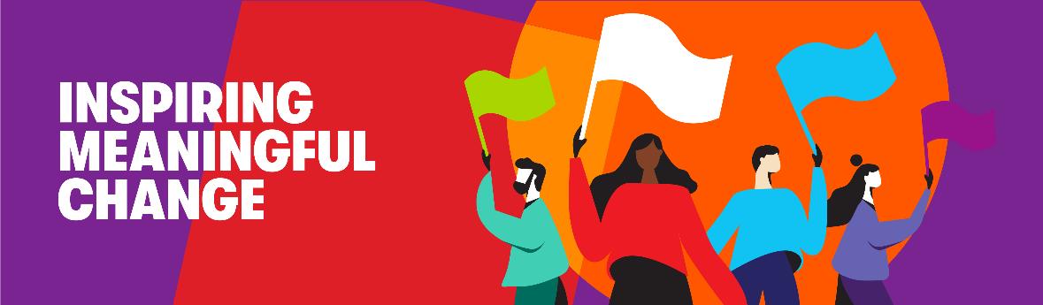

Unified Leadership is…
In Special Olympics we believe
that people with and without intellectual disabilities
should have an equal opportunity^ to succeed in sports and in life.
They should be able to play together
according^ to their ability and interest.
Everyone should have a meaningful^ role^
on the sport field
and an opportunity^ to make a difference off the field as well.

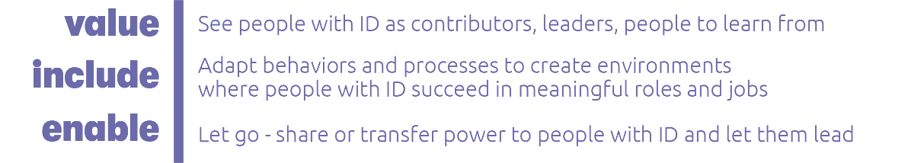
Building from sport,
Unified Leadership teaches leaders without disabilities
to value and learn from people with intellectual disabilities,
to make changes and create environments^,
where people with intellectual disabilities get opportunities
to have meaningful^ jobs and roles^ within the organization
and in their communities.

In Athlete Leadership, training focuses on leaders with intellectual disabilities
by teaching them the basics of leadership
and preparing them for roles^ through skills training and hands-on experience.

Unified Leadership teaches leaders of ALL abilities:
to learn from and value each other
and to lead in the best possible way.
It focuses on leaders without intellectual disabilities,
because, they may not realize it, but
often they are the ones who play a major role^
in creating or maintaining^ barriers^ to full inclusion.

In Unified Leadership,
leaders without intellectual disabilities learn how to:
- see the value of all people
especially those with intellectual disabilities
- recognize behavior that excludes^ others
and work to change it,
- have a better understanding of what it is like to work
with people with intellectual disabilities, and
- create environments^ where people with intellectual
disabilities can be successful.

Unified Leadership is a process.
It is a way to develop inclusive leaders.
This helps everyone and makes our communities more inclusive.

Reflection Questions
- What is the definition of Unified Leadership?

- How is Unified Leadership different than Athlete Leadership?

- What do people without intellectual disabilities learn from Unified Leadership?

- Why is Unified Leadership important to you as an athlete leader?

<< END OF LESSON 1 >>

Unified Leadership: Lesson 2
How Unified Leadership leads to full inclusion

Special Olympics Leadership visual
Athletes (in the blue circle below) are at the center of everything we do as an organization. The reason the circles below all overlap is to show you that athletes have a role to play a role in all areas of the organization. Think about how athletes can play a role in the various parts of Special Olympics activities listed below. The examples in each box below are not a complete list of roles in each area; they are just a few ideas to get you thinking.
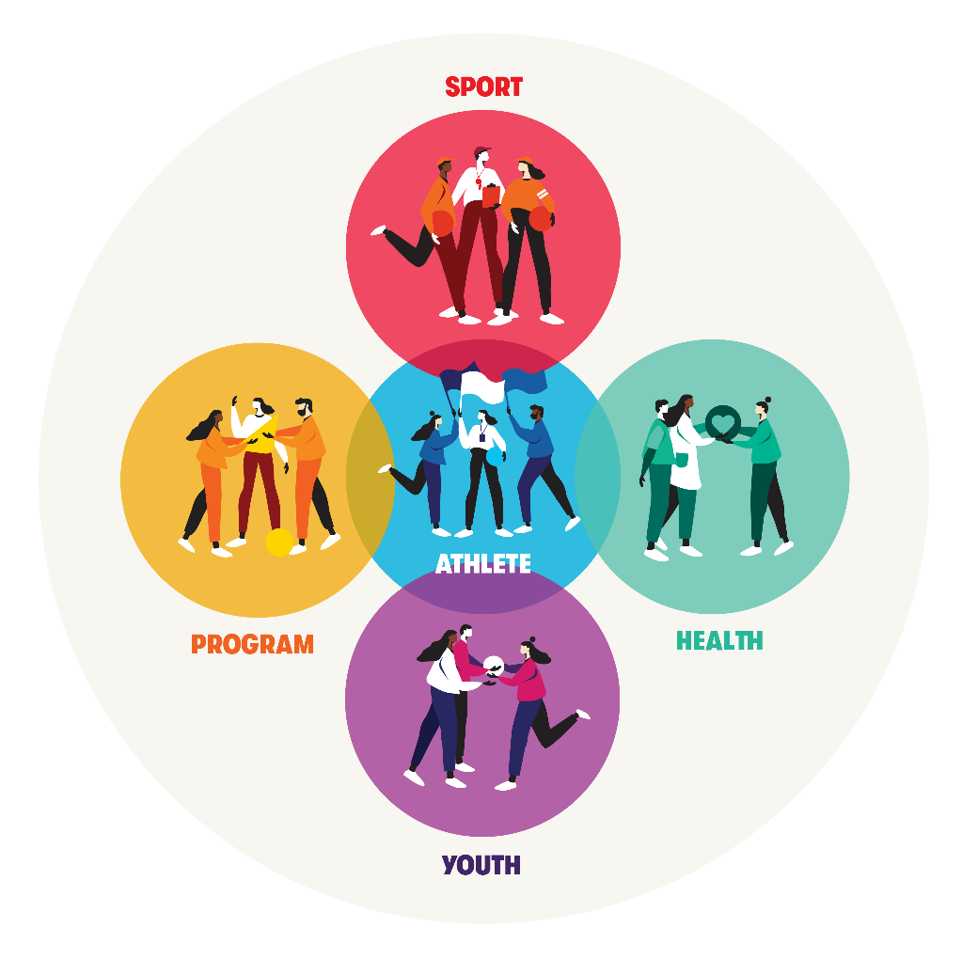
SPORT: Athletes can be team captains, coaches, officials, and more. How else can athlete leaders play a role in sports programming and activities within Special Olympics?
YOUTH: Athletes can be Young Athletes volunteers, coaches, mentors, and more. How else can athlete leaders play a role in youth programming and activities within Special Olympics?
HEALTH: Athletes can be Healthy Athletes volunteers, Health Messengers, fitness captains, and more. How else can athlete leaders play a role in health programming and activities within Special Olympics?
PROGRAM: “Program” here means that there are roles within your local Program that athletes can fill, including as staff members, volunteers, event coordinators, and much more. How else can athlete leaders play a role in your Program?

Reflection Questions
- Why should athletes be leading in these areas (Program, Sports, Youth, and Health)?

- What meaningful leadership roles are there in each of these areas? List one from an example listed in the boxes above. List one example that is not listed that you thought of.

- Working with leaders without intellectual disabilities, what can you do to help get more athlete leaders in meaningful roles within your local Program?

- What areas (Program, Sport, Youth, and Health) are you most interested in participating in and why?

- What are some other areas within Special Olympics not listed above that could use athlete leaders to help lead?

Glossary/Dictionary
It is okay if you do not know what a word means. This glossary (also known as a short dictionary) is supposed to help you learn new words and how to use them. Some of these words have more than one meaning. The definitions below relate to how the words are used in this document only. If there are other words in this lesson that you do not understand, try looking them up online at www.m-w.com.
Lesson 1:
- According: to be consistent with or in agreement with
- Barriers: a wall; something that could keep someone from doing something; an obstacle; something that gets in the way
- Bias: a thought or feeling that you prefer something over another without giving equal chance to the other thing; often are opinions that can be unfair to a person, place, thing, or group of people based on race, gender, disability, etc.
- Environments: a place or safe space where people live and work and play
- Excludes: opposite of include; actively keeps certain people away or outside
- Maintaining: to uphold; to keep in a current state or situation; to keep something from changing
- Meaningful: important; to have a purpose or meaning to someone
- Opportunity: a chance
- Role: a part to play; a job
- Unified: something brought together as one; includes everyone

Please complete the Training Evaluation Form:
You can also access the evaluation form by typing this link into your browser (it is case-sensitive!): https://bit.ly/2SrjVNG or by taking a picture of the QR code with your phone.

