Independent Activities
Understanding Leadership
Note: If you see a word you do not know and it has a ^ next to it, you can look at the glossary on the final page of this document. You can also use a dictionary (www.m-w.com).
Athletes: You can use this training on your own or with personal support. Print out and fill in answers to the questions or type your answers into the Word document. Go through these trainings at your own speed.
In this course, you will:
- Learn what leadership means
- Come up with a list of attributes^ and skills^ good leaders have
- Think of what you are good at and identify^ leadership skills^ you already possess^
- Look at the list of good leadership skills^ and think about which of those you do NOT have; ask yourself how you can get better at them
- Learn what “leadership” means to YOU
- Describe great leaders you know
- Explore skills and behaviors^ of great leaders
- Think about your value and impact as a leader
- Using the mission statement you wrote in Introduction to Athlete Leadership, plan your next steps as a leader

Topic | Description
Lesson 1: Leadership basics  - Definition of leadership  - Everyday leaders activity  - Finding out what you are good at and what you can improve | Learn the definition of leadership used in the Special Olympics Leadership Academy and think about great leaders you know personally and discuss their behaviors.
Lesson 2: Behaviors of great leaders  - Learn how great leaders behave  - Putting behaviors^ into practice | Learn the five behaviors^ of great leaders and how to make them a part of your daily life
Lesson 3: Leadership skills  - 6 basic leadership skills  - Improving communication skills | Leadership development includes six important skills: communication, adaptability, decision making, goal orientation, relationship building and continuous improvement.
Lesson 4: Leadership journey  - What is your leadership journey?  - Put together an action plan | Think about your journey as a leader. What have you already done and where do you want to go? Develop an action plan to help you get there.

Updated: June 2021
Understanding Leadership: Lesson 1
What is leadership?

Definition of Leadership
The Special Olympics Leadership Academy definition of leadership:
- Leadership is a relationship where one person influences^ the behavior or actions of other people to help them to achieve goals.
- Leadership is the ability to guide, direct, or influence^ people.

Reflection Worksheet
Note: Do not feel like you need to complete all these questions at the same time. Take your time! If you need more space to answer your questions, use a separate sheet of paper or another Word document.

We all know leaders, whether they are in our family or our community. Think about somebody in your life who you would consider a leader. This could be a coach, teacher, community member, volunteer, or Special Olympics staff. Think about the things they do and how they act that inspires people to follow them.

Write down the name of that leader here: ________________________________________

- Why do you think they are a good leader? List out their traits^/skills^ that make them a good leader. In other words, what are they good at?

- Looking at the things you just listed above as traits^/skills^/characteristics^ of a good leader, which of these do you also have? What are you good at? Why do you think you either currently are – or could become – a good leader?

- What are some things you are NOT good at? What might hold you back from being a good leader? What are some things you should work on or improve to become a good leader?

- How can you get better at those things? What plan do you have to turn those weaknesses^ into strengths⁷?

- In your own words, how would you define^ leadership? Write down one example of seeing “good leadership” in action in your community?

- Share your definition of leadership with someone you know. Ask them how they would define^ leadership. What is the same and what is different about your definitions?

<< END OF LESSON 1 >>
Understanding Leadership: Lesson 2
What is Athlete Leadership? Source: https://www.leadershipchallenge.com/
Behaviors of Great Leaders
Model the Way | - Leaders set good examples of excellence^ and show how people should treat each other. They also set an example for others to follow.  - They help people take small steps toward their goals (this is called goal setting). They support people by helping them find direction when they are unsure about next steps and by creating opportunities^ for success.
Inspire the  Shared Vision | - Leaders believe they can make a difference. They share enthusiasm^ for the future and “what could be.” Good leaders also find ways to get others to be a part of their team.  - They see new possibilities^ and share those big ideas with others.
Challenge the Process^ | - Leaders search for opportunities to change and improve the way things currently are.  - They are not afraid to ask questions.  - They look for new ways to improve the way things are done.  - They use disappointments^, mistakes, and failures, as moments to learn and get better. Good leaders pick themselves up and get back to work; they learn from those mistakes and move on.  - They try new things and do not let people use the excuse, “That is the way it has always been done.”
Enable^ Others  to Act | Leaders encourage^ and empower^ their teammates and promote collaboration^.  They get others involved because it makes the whole team better.  They create an atmosphere^ of trust and respect.
Encourage the Heart | - Leaders recognize^ and give credit to others when they do good work.  - They encourage^ people when things are difficult.  - They create an atmosphere^ of teamwork and hope.  - They celebrate the accomplishments^ of everyone on the team.
Reflection Worksheet
Note: Do not feel like you need to complete all these questions at the same time. Take your time! If you need more space to answer your questions, use a separate sheet of paper or another Word document.

- Pick a 1-2 of these behaviors^ listed above. How will you use them to become a leader?

- Do you think you need to be good at these behaviors^ before you can be a good leader or can you learn these things and get better at them as you go along? Why do you think that?

- To you, which behaviors^ will be easy to practice? Why?

- To you, which behaviors^ will be difficult to practice? Why? How can you get better at them?

- How does the leader you identified in Lesson 1 (someone in your community that you think is a good leader) demonstrate these behaviors^ we talked about above?

- Share these five behaviors^ with someone you consider to be a leader. Ask them how they think these behaviors^ show up in their own leadership; write down their answer. Share with them how you think they show these behaviors^ on a regular basis.

- Ask them what behaviors^ they think you show on a regular basis; write them down here. Then ask them what behaviors^ they think you need to improve to become an even better leader; write these down as well.

- Ask them to help you create a plan for how you can turn those things you are not good at into behaviors^ that you are good at.

<< END OF LESSON 2 >>

Understanding Leadership: Lesson 3
Basic leadership skills
Six skills that successful leaders have
There are many leadership skills that good leaders have. When looking at what a lot of great leaders have in common, we can see there are six basic leadership skills that make successful leaders.

- Decision making
  - Leaders listen to ideas from other people, get input, and make decisions.
  - A good leader is someone who makes the decision that makes the most sense at the time, not the decision that is easiest.
- Adaptability^
  - When working on a plan, you need to know what is going well and what is not going well. Then you can change the plan if needed.
  - Sometimes you need to be flexible and let people do their tasks in a way that works for them even if the way they do it is confusing to you.
- Relationship Building
  - Good relationships help you work better together and respect each other.
  - Build healthy relationships to have a strong team that works together and trusts one another.
- Goal-oriented
  - Stay focused on the goal to help guide your team.
  - Distractions^ can be one of the biggest obstacles to meeting a goal.
- Continuous^ improvement
  - Strong and confident leaders realize that change can be a good thing and make things better.
  - A leader takes note of things and asks for input and feedback to improve the project or event for the next time.
- Communication
  - Good communications is not just about you sharing your message; it is also about listening to and understanding other people’s messages as well.
  - As a leader, make sure your message is easy to understand.

Deep dive into “Communication”
Communication is an essential skill for both leaders and team members.
- Having great ideas is important, but ideas do not mean anything without a team that understands how to follow through and implement^ them. Problems in a group usually come up when there is a problem with communication.
- It is a leader’s responsibility to make sure their team understands the tasks and is motivated to participate.
- It is important to remember that good leaders do not just communicate information to their team, they also let the team know the goals and vision.
- Effective^ communication is a two-way street. It is NOT one person talking AT someone or a group of people. It is everyone invited to share in the conversation together. It also involves listening or paying attention when someone else is communicating. A good communicator asks thoughtful questions of others; this shows that you are interested in what they can add to the conversation.

Communication Tips for Leaders
- Summarize: People who are good at communicating listen to what someone else said. They can take what the other person said and explain it in a way that is short and to the point. It is a way to highlight^ someone’s best ideas so everyone can understand. It is not always necessary to do this, but when participating on a committee and facilitating^ a conversation, you may need to summarize information to make sure everyone understood them.
- Ask follow-up questions: If you are not sure what someone else is saying or what they mean, do not be afraid to ask them to explain. When asking questions of others, don’t just ask “yes” or “no” questions – ask things such as “Why do you think that?” or “Why do you feel that way?” The goal is to get them to give you an answer that is more than just “Yes” or “No.”
- Show passion^: Having passion^ or excitement for what you are talking about makes people MUCH more likely to listen to you. You have passion^ for Special Olympics, right? Make sure in every conversation you have that your passion^ for the topic is obvious to the people you are talking with.
- Honesty: The people you are talking with need to be able to trust what you are saying is true. If you share wrong information, people might think you do not know very much about the topic. If someone asks a question and you do not have the answer, do not make something up. Tell them you do not know, but you will try to find out for them.
- Invite everyone to the table: This may be the most important skill a good leader has – it is your job to make sure everyone feels comfortable sharing their opinion. It is okay if you have some people who are quiet and do not like sharing their opinion in big groups. Pull them aside one-on-one^ and ask their opinion or have them send you an email with their thoughts (some are better at writing their thoughts instead of speaking them).
- It is okay to not have an opinion: There will sometimes be things certain people do not have an opinion about, and that is okay. If you make sure you have created a safe space for everyone to feel comfortable sharing their opinion, you have done your job.
Communication Activity
- Find at least two people (mentors, coaches, friends, or family members) and have them complete the following activity. You can do this activity via Zoom, Facebook Live, or Facetime if you live by yourself. You will be the leader and they will follow your instructions. To complete this activity, the participants will need one regular size sheet of paper per person. You will be giving them instructions on how to make a paper airplane. But do NOT tell them that is what they are making. It is VERY important they do not know what it is. Just tell them to follow your instructions and that they cannot ask questions. Before you do this activity with someone else, you will want to make your own paper airplane first (watch this video to help).
- Please tell them that the instructions you give them are supposed to be missing details and confusing.

- They should not get help from others around them or even look at the other person’s paper. If anyone asks a question, tell them to follow your instructions the best that they can.

- Read these instructions in order. Make sure to give them time to complete each action before moving to the next action. Remember, do not let them ask questions!

- Fold the paper in half
- Open it up and fold the top down leaving a little bit at the bottom
- Open it back up and fold down to the crease you just made
- Fold that same section down again
- Fold the top two corners into the center
- Open those up and fold the corners again, but this time to the creases you just made
- Tuck those newly folded pieces into the center pocket
- Lay the paper down and flatten it out
- Fold it in half on the center crease
- Fold the top half down to meet the bottom edge
- Flip it over and do the same thing on the other side
- Open it up and show everyone what you have made!

After the activity, have everyone show off what they have created. Then show them YOUR version and tell them what it is supposed to be!

At the end of the activity, you will see how different everyone’s finished products look. You can have a good laugh at how different they are. It is not your fault; you did not do anything wrong. It is just how you communicated the instructions to them. The lesson here is that sometimes breakdowns in communication are not anyone’s fault – they just happen.

This is to show when you communicate with others, they may hear things differently than you explain them. Something may make sense to you because you know what you are supposed to be making, but to them, the instructions do not make sense.
This exercise shows how important it is for people to ask follow-up questions if they do not understand something. Finally, this exercise shows how important it is for everyone to be on the same page and to understand one another.

Ask them the following questions and write down some of their answers:
- While you were folding the paper, what did you think you were making?
- Did you understand the instructions? Why or why not?
- What could I have done a better job of? What communication skills did I not do that would have helped you?
- It is easier to understand when someone else shows you how to do it by modelling the way, right? How?
Reflection Worksheet
Note: Do not feel like you need to complete all these questions at the same time. Take your time! If you need more space to answer your questions, use a separate sheet of paper or another Word document.

- Think about the activity you led, what did you learn about communicating as a leader?

- Why do you think effective^ communication is sometimes difficult?

- Which two communication tips do you think you are good at? Explain why.

- What are two things you can improve about your communication skills? What steps can you take to improve them?

- Find a peer, mentor, or family member and share what you learned about communication. Ask them what tips they have about communicating with team members?

<< END OF LESSON 3 >>
Understanding Leadership: Lesson 4
Your leadership journey
Where are you on your leadership journey?
Every leader has their own journey. Along the way, leaders take additional^ training, reflect on their experiences, ask others for help, try new things, and take steps to find new ways to be a leader.
In this next activity, describe the journey you have been on so far. Think about what you have already done and what you want to do next.
The goal is to get you thinking about the next steps in your leadership journey and how you can set and accomplish goals in the future.
- Fill in important moments in your journey, also called milestones^.

- Included is a second journey path where you can make notes of the things you want to do next.
When you are finished with the activity below, fill out the evaluation form on the last page.

Was there a specific moment where you realized^ you wanted to be an athlete leader? Did someone inspire^ you to take on a leadership role? Describe that moment.
Have you served as a leader yet – it could be in Special Olympics or in your community? If so, what was that experience like? What did you learn? If you have not served as a leader yet, what are some roles that you would like to take on? Why do those interest you?
3
2
1
What modules/classes/exercises have you completed so far in your journey? Which one has been your favorite and why? What did you learn? If you have NOT taken any classes yet, what are you most looking forward to learning about leadership?
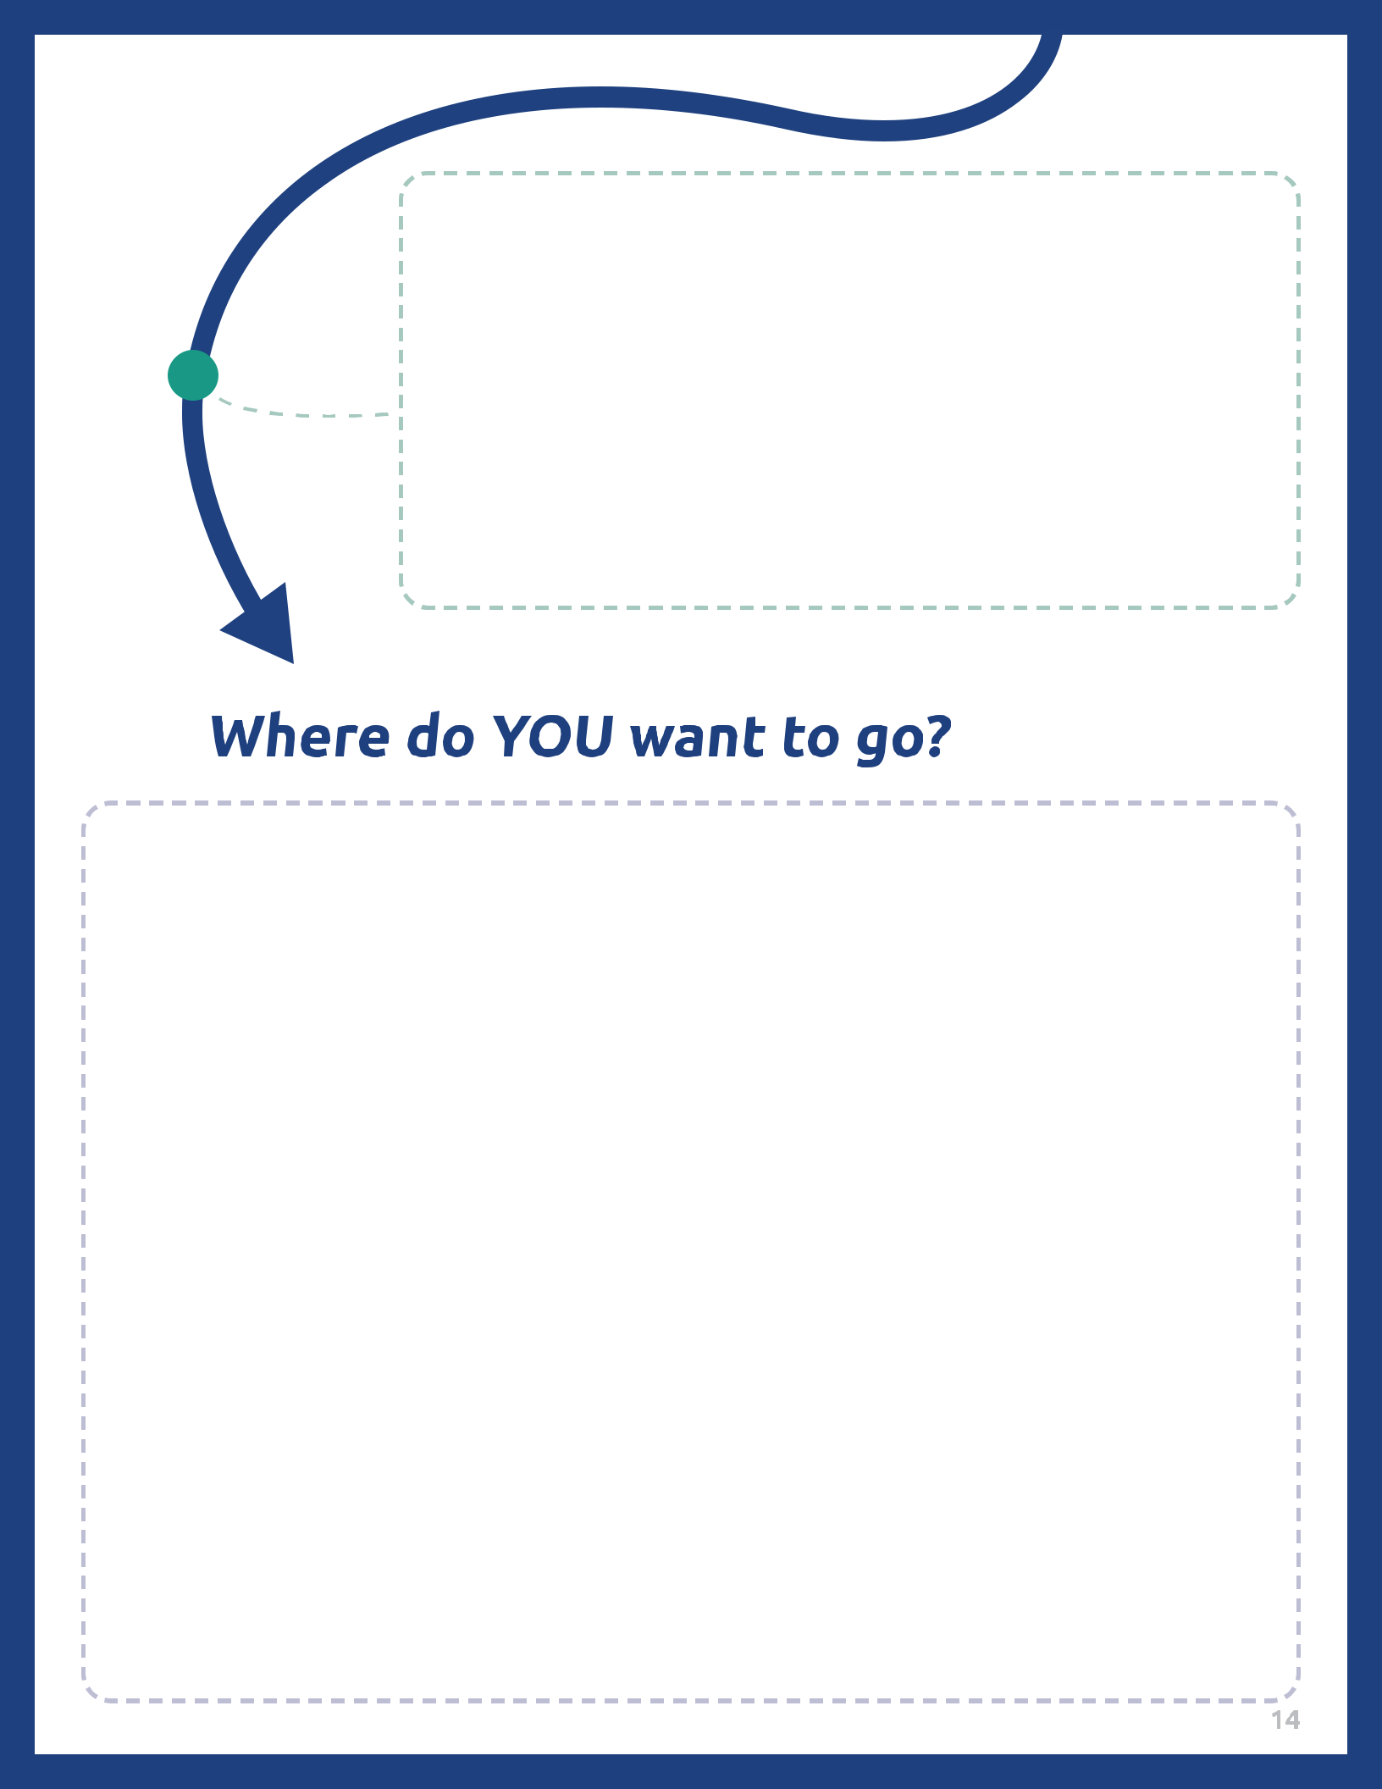
4
So what is your plan now? Use your Mission Statement that you put together from the Introduction to Athlete Leadership course and come up with a plan of how you are going to become a better athlete leader and fulfill your mission statement. What do you need to do next? Who will help you reach your goals? Why are those goals important to you? Who will your goals help?
Have you served as a leader yet? It could be in Special Olympics or in your community If so, what was that experience like? What did you learn? If you have not served as a leader yet, what are some roles that you would like to take on? Why do those interest you? How will you be successful in those roles?

Glossary/Dictionary
It is okay if you do not know what a word means. This glossary (also known as a short dictionary) is supposed to help you learn new words and how to use them. Some of these words have more than one meaning. The definitions below relate to how the words are used in this document only. If there are other words in this lesson that you do not understand, try looking them up online at www.m-w.com.
Lesson 1:
- Attributes: like Characteristic and Trait; a quality that describes someone or their actions
- Characteristics: like Attribute and Trait; a quality that describes someone or their actions
- Define/Definition: to explain a meaning of a word, phrase, or idea
- Identify: create; work on; to make clear
- Influence: to change or cause a change in someone’s actions; influences can be bad and good
- Possess: have; hold
- Skills: things that you are good at
- Strengths: things that you are good at
- Traits: like Characteristic and Attribute; a quality that describes someone or their actions
- Weaknesses: things that you are not good at
----------------------------
Lesson 2:
- Accomplishments: something that is finished/completed, usually after hard work; completing a goal
- Atmosphere: a safe space that is created by someone
- Behavior: ways that people act; things that people do
- Collaboration: people working together
- Disappointment: a feeling when someone fails or doesn’t meet their goal
- Empower: to give power to someone/something; to lift up and give a platform to someone; to cheer on/give confidence to
- Enable: to help; convince; motivate
- Encourage: when someone helps someone else feel better
- Enthusiasm: excitement; happiness
- Excellence: being really good at something
- Opportunities: chances
- Possibilities: options; outcomes; different way of looking at things
- Process: the way things are done
- Recognize: notice; see
-----------------------
Lesson 3:
- Adaptability: ability to change
- Continuous: uninterrupted; not distracted
- Distractions: something that directs someone attention away from something
- Effective: good; competent
- Facilitating: to help carry on a conversation especially in a large group
- Highlight: to point out; to bring attention to
- Implement: to put into action; to take an idea and make a plan for it
- One-on-One: one person to another person; away from others
- Passion: excitement; happiness; love for a topic/idea
- Strategies: ways to help reach goals; plans
- Vision: a way to see/visualize goals and a plan
- Vision: way of looking at something; clear understanding
-----------------------
Lesson 4:
- Additional: extra; more
- Inspire: to motivate others
- Milestones: important point/moment in your life
- Realized: to notice; to understand
Please complete the Training Evaluation Form:
You can also access the evaluation form by typing this link into your browser (it is case-sensitive!): https://bit.ly/2SrjVNG or by taking a picture of the QR code with your phone.

