Understanding Leadership
Facilitator Guide

This facilitator guide provides an outline on how to host and lead the Understanding Leadership training course using the PowerPoint presentation and the participant workbook.

These resources are for you to use in the way that works best for you and your Program (virtually, in-person, individually, etc.). Feel free to adapt them. If you are looking for resources to help prepare for and lead a training virtually through Zoom, WhatsApp, Facebook, etc., you can find them here. Alternatively, the workbook, PowerPoint, and this resource can be used for in-person delivery as well.

Be sure to complete the following actions to prepare for each session:
- Identify at least one athlete leader to co-facilitate.
- Review this facilitator guide and accompanying PowerPoint presentation.
- Review the workbook and complete each activity yourself to be familiar with the activity and have examples to share. Additionally, think about what information you can add from your Program’s perspective. Ask the athlete leader what they can add from their perspective.
- Host a practice session with all facilitators and cover every slide.
- Give feedback to each other.
- Host a second practice of the entire presentation.
- Send out the workbook and session instructions to the participant one or two weeks before the training. Invite athlete leaders to look through all the resources before the training so they are familiar with the content.

Training Overview

Topic | Description | Estimated Time
Lesson 1: Leadership basics  - Review the definition of leadership  - Talk about leaders we know | To understand how you can become a better leader, it helps if you think about people you know who are leaders and ask yourself, “What do they do well?” and “Why are they good leaders?” | 15 mins
Lesson 2: Behaviors of great leaders  - Discuss behaviors or actions of great leaders we know  - Learn 5 basic behaviors of good leaders | Not every leader acts the same exact way, but most good leaders do have similar behaviors that set them apart from others. Learn and understand the 5 basic behaviors of good leaders so you can practice them yourself. | 25 mins
Lesson 3: Basic leadership skills  - Learn 6 basic leadership skills | Learn and understand the 6 basic leadership skills so you can practice them yourself. | 25 mins
Lesson 4: Your leadership journey  - Think about your leadership journey to this point  - Determine your next steps | Ask yourself, “How did I get here in my leadership journey?,” “Why do I want to be a leader?,” and “Where do I want to go as a leader?” This exercise will help you determine your next steps as a leader. | 30 mins

We encourage you to add Program-specific content to make it more relatable to your group of athlete leaders. It is recommended that lessons are facilitated in order and each session be no longer than 2 hours in length. The course can be divided into multiple sessions. In the end, these are just resources at your disposal. You will need to adapt them to fit your constraints as a Program (time, space, technology, etc.).

Special Olympics International
Facilitator’s Guide

Understanding Leadership

Time | Lead | Topic | Description | Slide(s)
20 min | Facilitator 1 | Welcome  Review of first session  Overview of session | Hello, everyone. Welcome to the second training in SOI’s Athlete Leadership and Skills Curriculum called “Understanding Leadership.”  Before we begin today’s session, we wanted to review the information from last week and see how much you remember!  Do a review of Zoom features/etiquette if you feel it is necessary.  Let’s take a quiz!  If doing this training virtually, you can set up an actual poll through Zoom or have them type their answers in the chat. If in-person, just have them shout out the answers.  This group of athlete leaders should be the same group who already took “Introduction to Athlete Leadership,” but if you think they need to re-introduce themselves to everyone again, let them do that before they answer the question and ensure every person answers a question so they can tell everyone who they are.  What is the process called where athletes are grouped by ability for competitions?  - Divisioning – Correct answer  - Sorting  - Assigning  Around the world, how many Special Olympics athlete leaders are in meaningful roles?  - 30,000  - 40,000  - 50,000 – Correct answer  Thinking about Guiding Principle 1: Education and Awareness, what is the name of the new Special Olympics leadership approach?  - Developing Leaders  - Unified Leadership – Correct answer  - Promoting opportunities  True (Correct answer) or False. The organization is shifting from being for athletes to being led by athletes.  We just told you the first Guiding Principle to Athlete Leadership is “Education & Awareness,” can anyone name the other two? The answer is “Training” and “Leadership Positions.”  Thinking back to what we learned in the first course “Introduction to Athlete Leadership,” does anyone have any reflection or something they would like to share with the group? Maybe you have a question or comment about what you learned?  Give plenty of time to share what they learned or ask questions.  At the first training we asked you to write your personal mission statement. Now, we would like to ask each of you to share it with us!  Encourage everyone to share their personal mission statement. If it does not have all three components (what they want to be or do; how they will do it; and why it is important to them) then tell them their mission statement still needs some work and ask them to finish that up now while the others share theirs. It is incredibly important that they have a complete mission statement before moving onto the rest of this course.  Wow! You all have great ideas. We cannot wait to follow your lead and support you in this journey.  We also had you come up with an action plan, but we will hold that until the end of this session.  Let us go over the expectations for everyone during this training. | 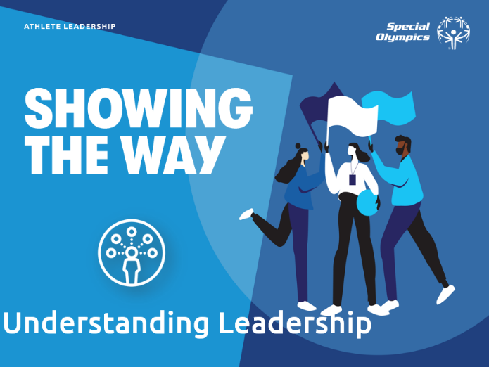
5 min | Facilitator 1 | Expectations | Go over how each group – athlete leaders, mentors, facilitators – all have different expectations during this training | 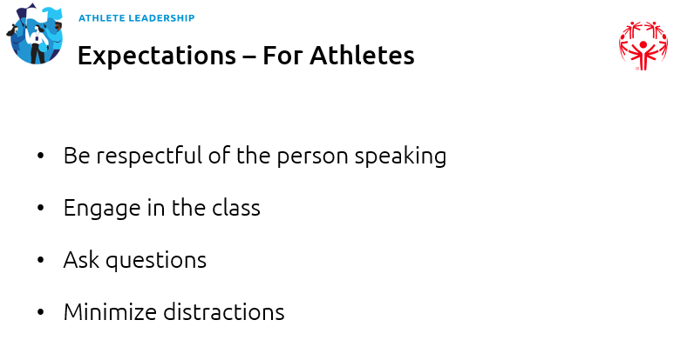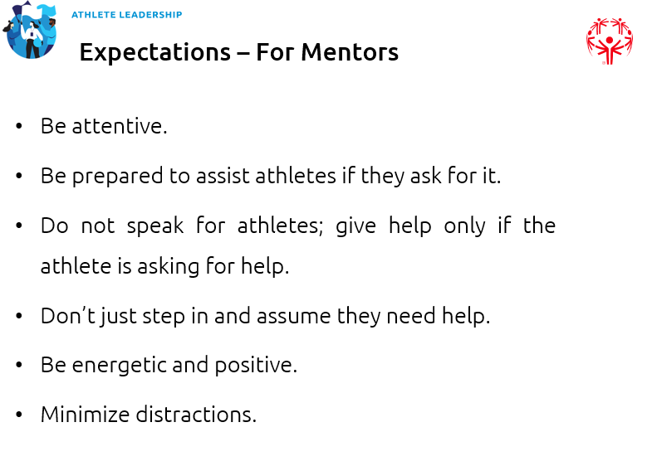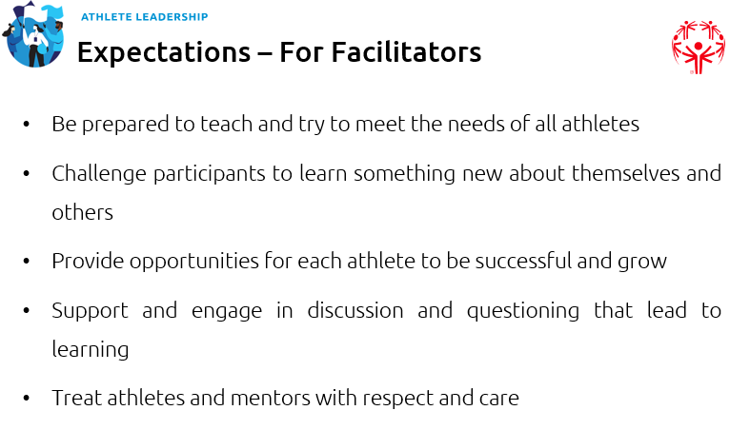
1 min | Facilitator 1 | Module overview | In today’s course we will focus on understanding leadership – what leadership means, traits that good leaders have, and how you can become a leader.  There are four lessons:  - Definition of leadership  - Behaviors of great leaders  - Leadership skills  - Your leadership journey  Now I would like to turn it over to Facilitator 2.  Introduce Facilitator 2 | 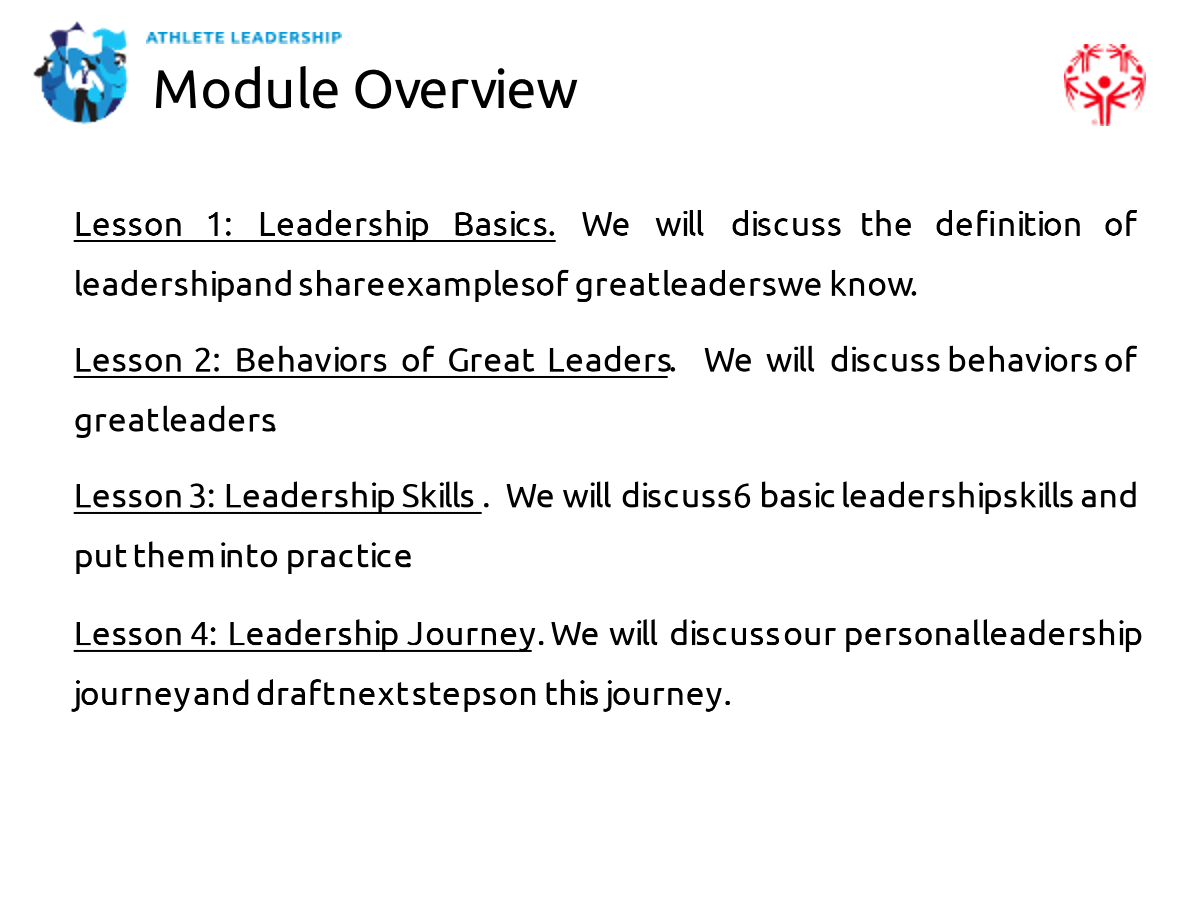
9 min | Facilitator 2 | Lesson 1: Leadership Basics | Thanks, Facilitator 1 for the welcome and introduction.  Before we start, I would like to share with you a little bit more about my leadership journey. As Facilitator 1 said, I have been involved for many, many years!  If Facilitator 2 is an athlete leader, have them share their personal leadership journey.  That is a little bit more about my own experience. In today’s session we will learn more about leadership and then ask you to think about your own leadership journey.  To begin this lesson, I’d like to ask for a volunteer to answer this question:  How do you define leadership?  Give them time to answer the question.  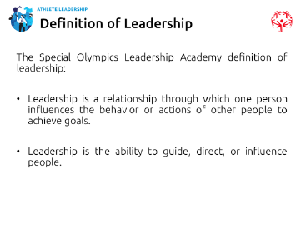  Thank you for sharing. Would anyone else like to tell us how they explain leadership?  Give them time to answer the question. If you have time, have them discuss the similarities and differences between all of their definitions.  Great, thank you for sharing.  Let us look at the definition of leadership that we use.  - Leadership is a relationship where one person influences the behaviors or actions of other people to achieve goals.  - Leadership is the ability to guide, direct, or influence people. | 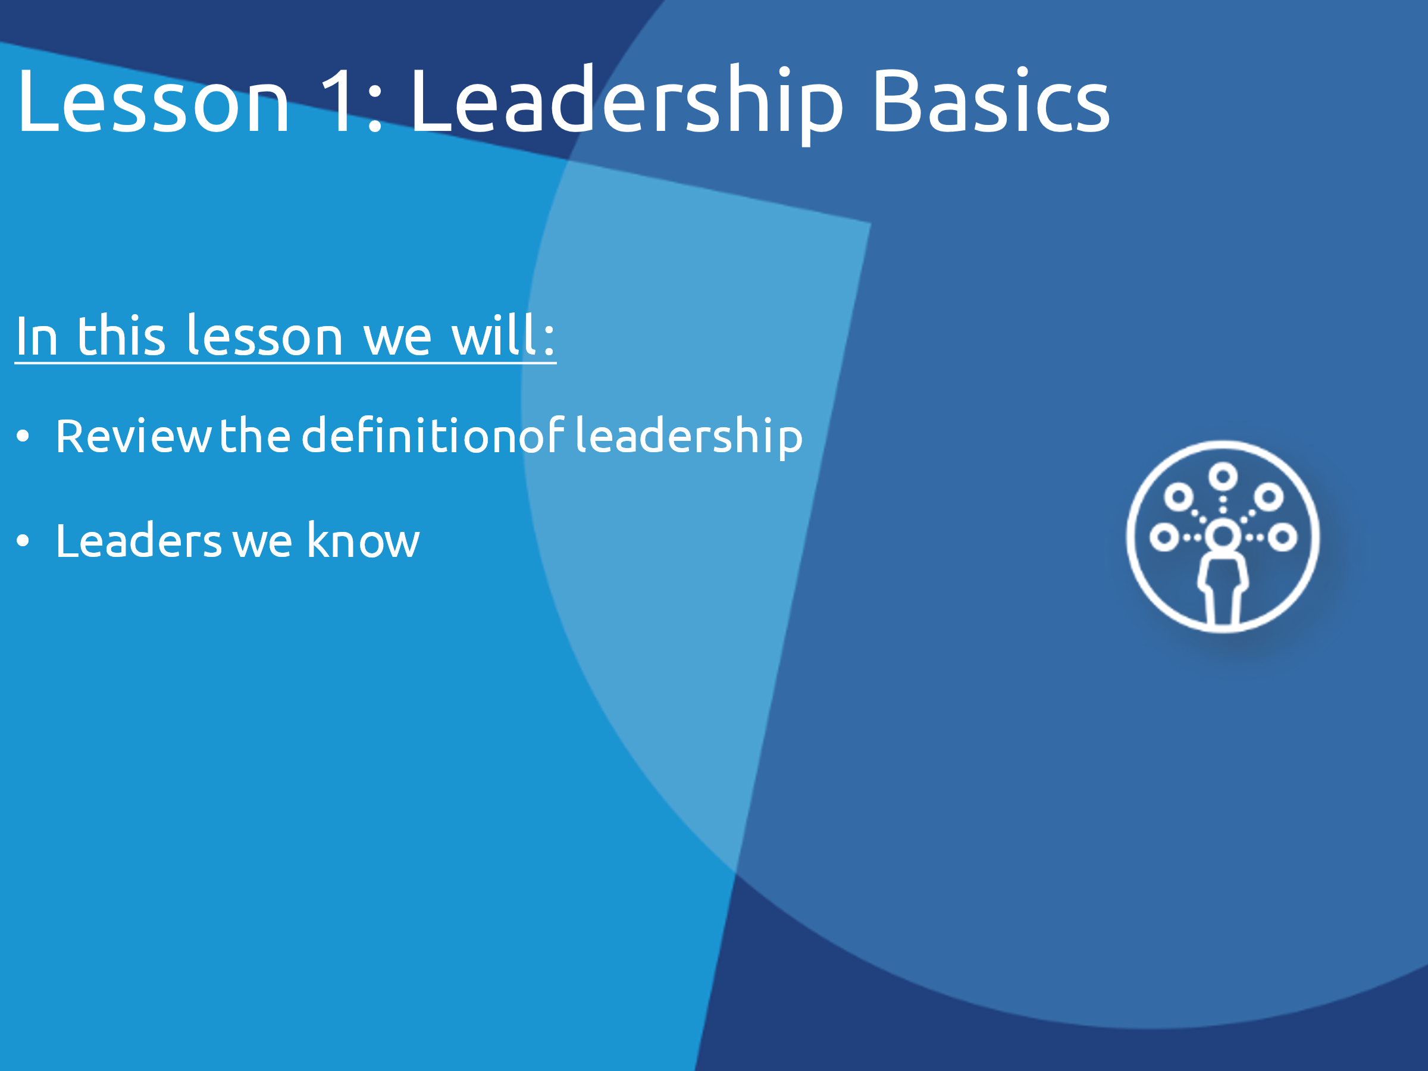
5 min | Facilitator 2 | Everyday Leaders | Okay, now that we have thought about what leadership means, let us think about leaders we know in our lives.  Please think about a leader in your life. It can be someone you know either in Special Olympics or in your community.  Let us take a poll.  If offering this class virtually, set up in Zoom polls or have them type in the chat. If the training is in-person have them tell you the category they are in and write down the answers on a sheet or paper or whiteboard.  Please pick the category that best represents the leader you picked.  - Coach  - Teacher  - Teammate  - Special Olympics Volunteer  - Community group leader  - Co-Worker  - Athlete Leader  Point out any trends that you see in the kind of person they picked. What traits do they share? Ask the group to point out any similarities among the groups.  Keep this leader in mind as we go through these next few slides. We will use them for an activity coming up. | 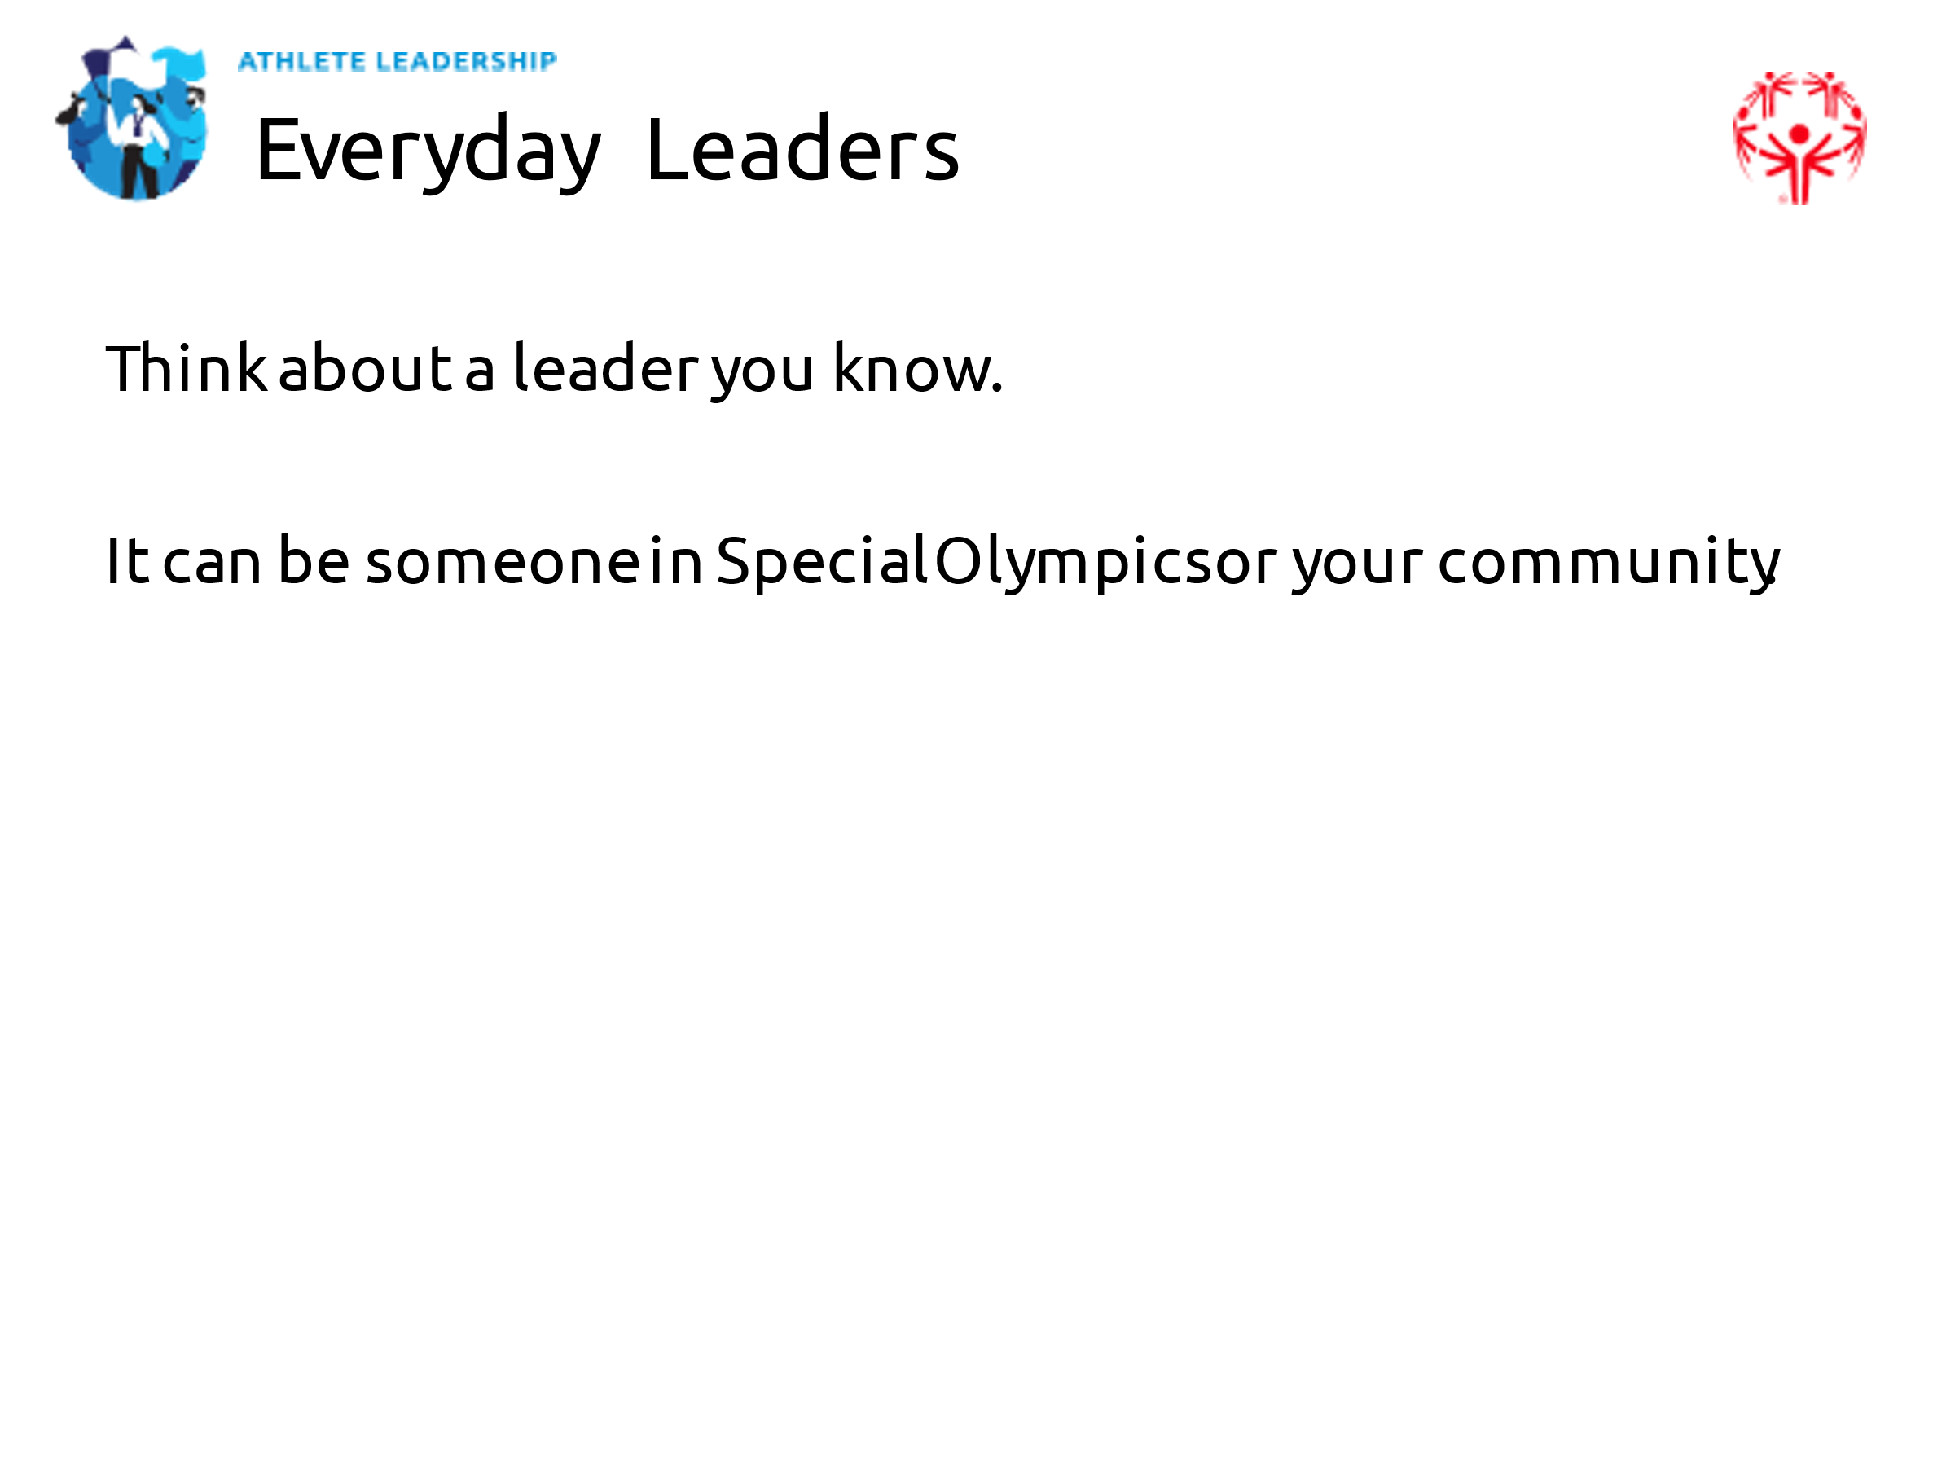
1 min | Facilitator 2 | Lesson 2: Behaviors of Great Leaders | We are going to move on to behaviors of great leaders.  Do you know what the word “behavior” means?  Explain what it means if they do not know. | 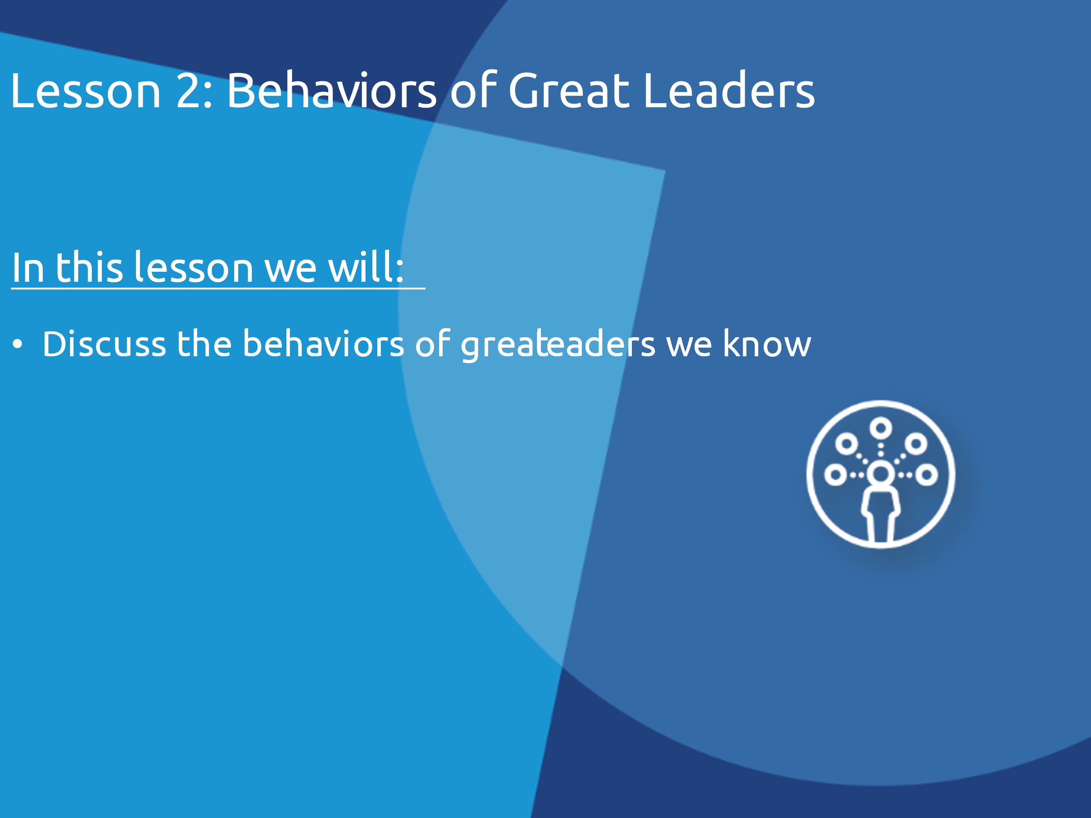
8 min | Facilitator 2 | Behaviors of Great Leaders | Now, think about the leader you selected.  If you have time, the questions below can be posed one at a time for some to answer. If running behind, just ask them rhetorically until you get to the last piece asking them to share a behavior.  What are their actions? What are the behaviors they have?  How do they show good leadership?  What inspires people to follow that person?  I would like to ask each of you to share a behavior of the leader you came up with. We are going to make a list.  Make sure each person shares at least one example of a good leadership behavior. Have someone write the answers down where everyone can see them (whiteboard function on Zoom or on a whiteboard if you are doing this training in-person). | 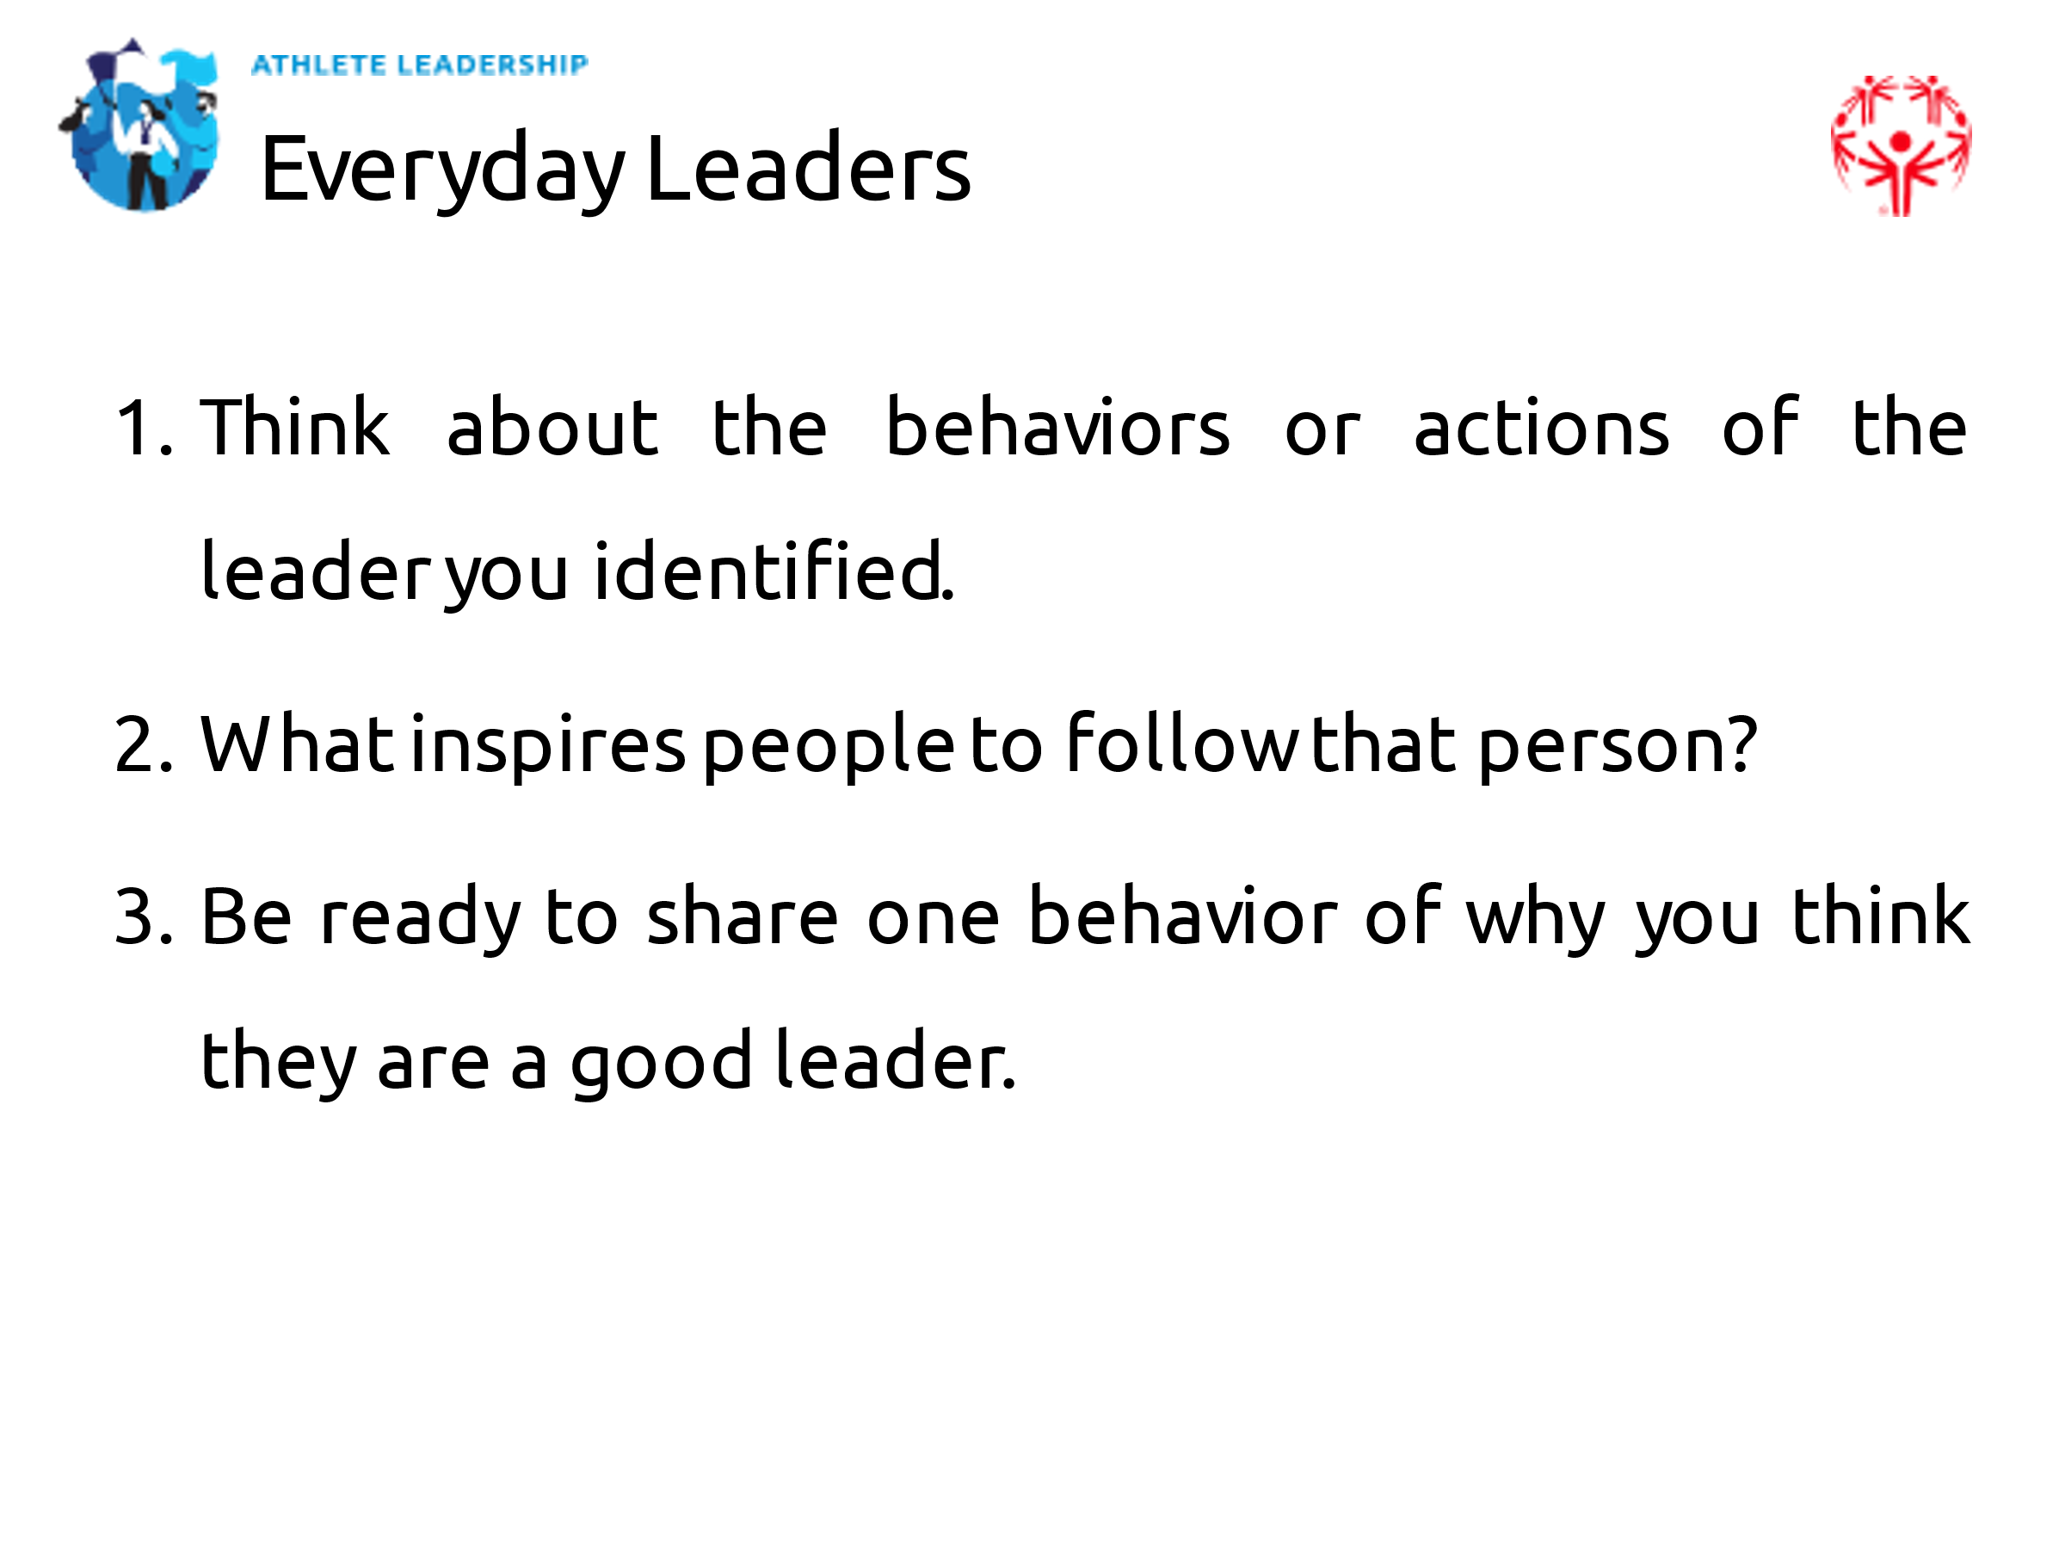
5 min | Facilitator 2 | Behaviors of great leaders | There are many behaviors that leaders have and things they do that make them good leaders. Here are few examples of behaviors that the best leaders have.  Good leaders…  - Model the way: They set good examples for other people to look up to. They show people how they should treat others and how to work hard.  - Inspire the shared vision: Leaders believe they can make a difference. They share enthusiasm for the future. Great leaders find a way to inspire others to act.  - Challenge the process: Great leaders are always learning new things and improve the way things are done. They are not afraid to ask questions and do not let people use the excuse, “Well that’s the way it has always been done!”  - Encourage the heart: Great leaders see when others are doing good things and give them credit for their work. They cheer people on, especially when things are difficult.  - Enable others to act: Great leaders encourage and empower others. They want everyone on the team to contribute. They create an atmosphere of trust and respect for everyone involved. | 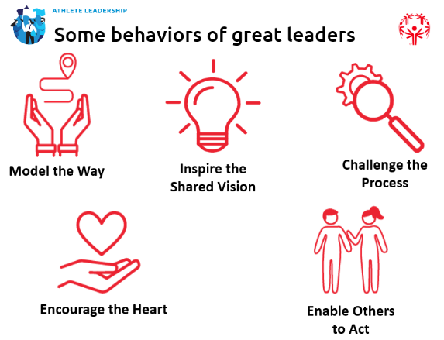
10 min | Facilitator 2 | Behaviors of Great Leaders Breakout | Now we are going to move into 3-5 small breakout groups.  Assign each group 1-2 of the five behaviors to talk about. It is okay if there are multiple groups talking about the same behaviors.  Each person in the group should answer these questions about that behavior:  - How have YOU shown this behavior as a leader?  - How have you seen OTHER leaders show this behavior?  - Is this behavior hard to do consistently sometimes? If so, how is it hard to show this behavior?  If you have time left in your groups, you can go around the group again with a different behavior and answer the questions but pick a different behavior this time.  You will have 10 minutes in your group. | 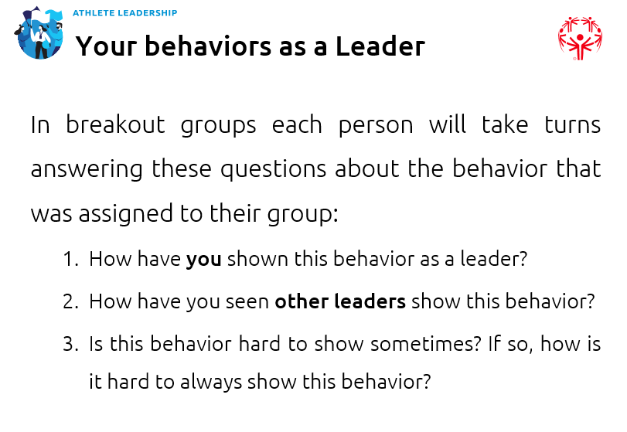
1 min | Facilitator 1 | Lesson 3: Basic Leadership Skills | Thank you Facilitator 2 for leading us in the definition of leadership and leadership behaviors.  Now we are going to discuss 6 basic leadership skills. These are skills that all leaders need to be successful. | 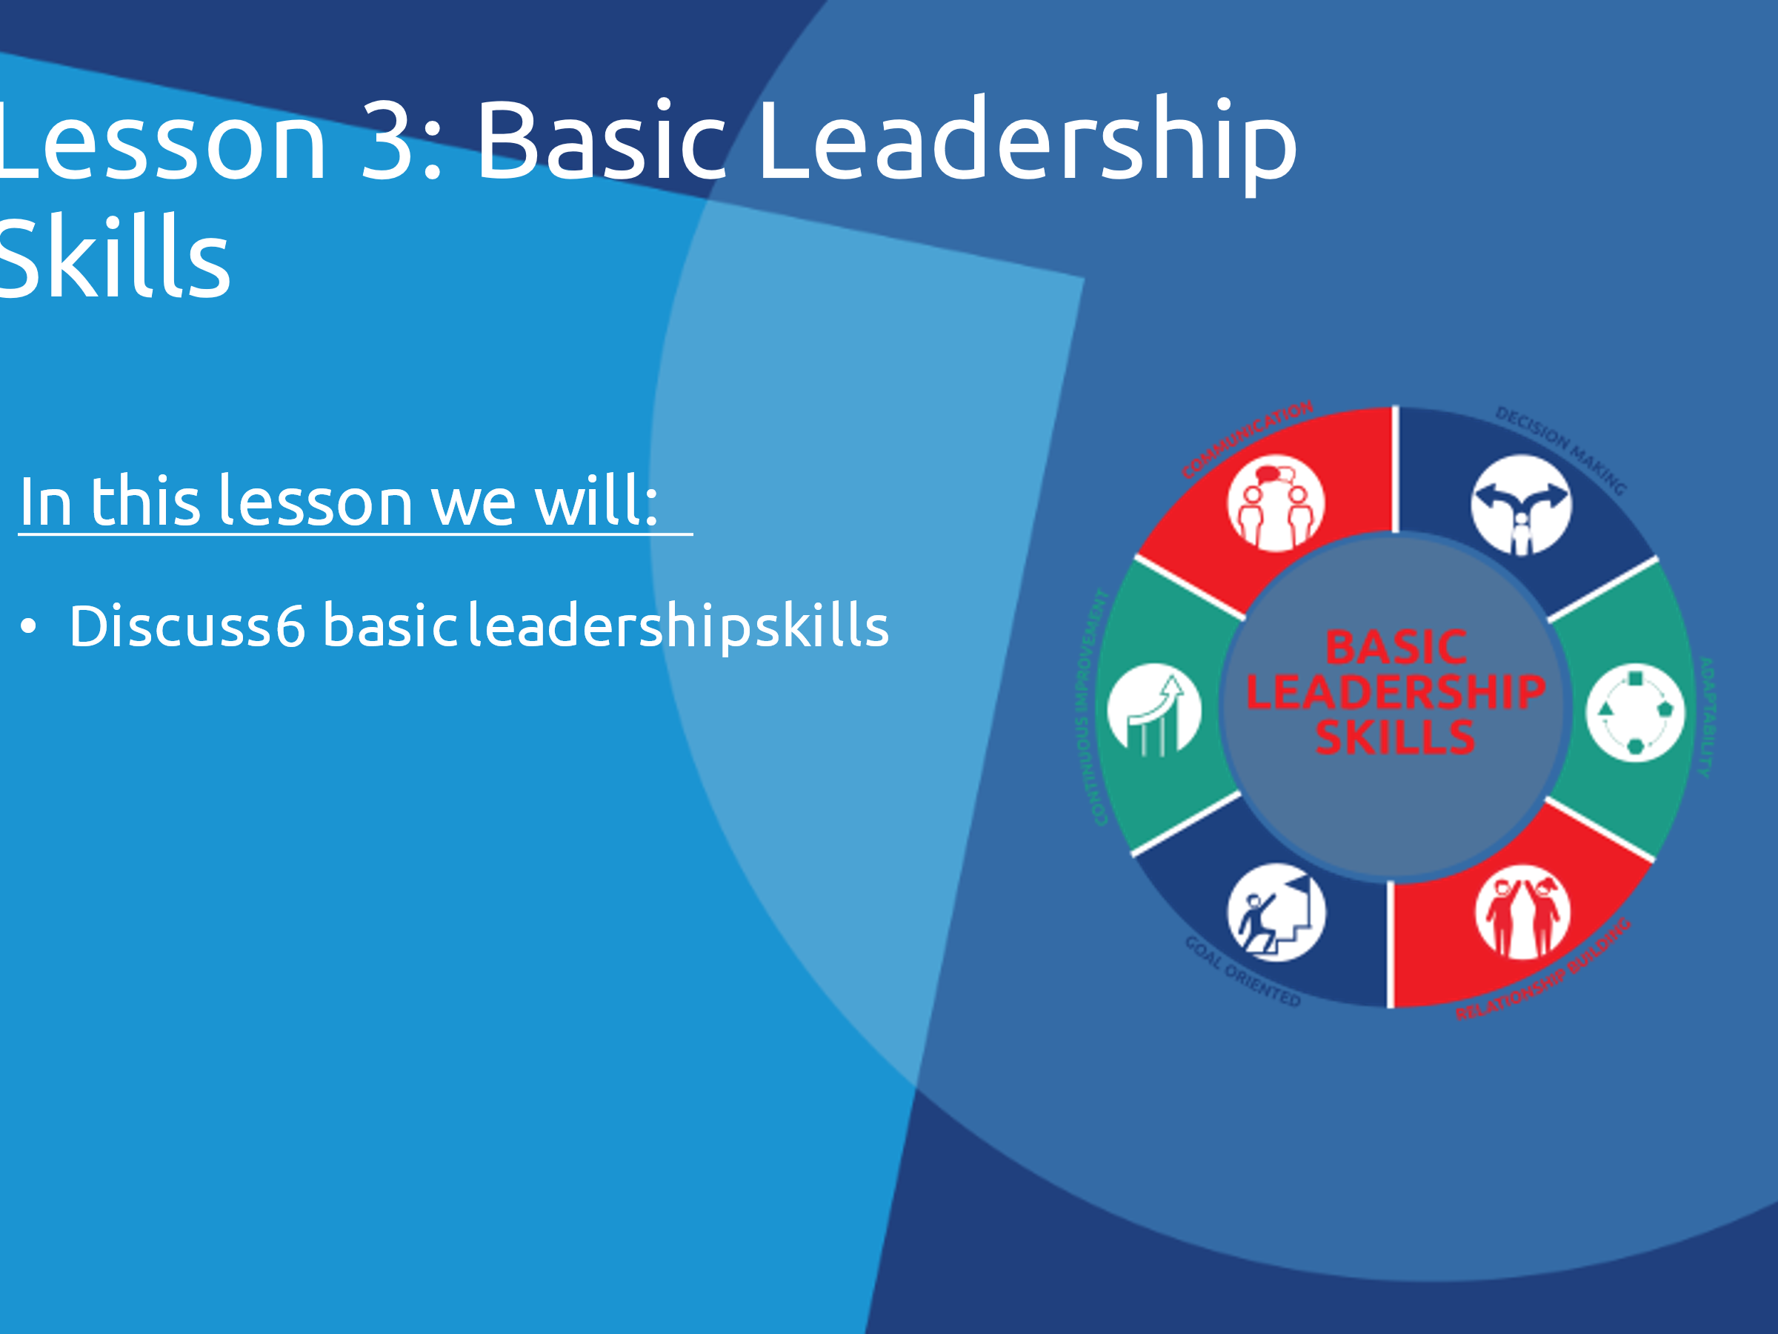
14 min | Facilitator 1 | 6 basic leadership skills | It is important for us to think about which skills we are good at and which ones we want to improve.  We all have things we are good at (strengths) and things we can improve (weaknesses). Everyone has strengths and everyone has weaknesses.  Knowing your strengths and weaknesses is very important to becoming a great leader. It helps you know what to improve or how to build a successful team. Good leaders surround themselves with people whose strengths work well with their own and cover their weaknesses or gaps in knowledge.  Communication  - It is a leader’s responsibility to inspire and motivate the team.  - Good communication is not just about YOU sharing your message; it is about listening to and understanding other people’s messages as well.  - As a leader, make sure your message is easy to understand.  Adaptability  - As a leader you need to know what is going well and what is not going well. Then you can change the plan if needed.  - An important skill for a leader is to adapt and help people use their skills and talents to help the team.  - Sometimes you need to be flexible and let people do their tasks in a way that works for them.  Decision Making  - Leaders listen to ideas from other people, get input, and make decisions.  - A good leader is one who makes the decision that makes the most sense at the time, not the decision that is the easiest.  - Remember to communicate the decision and your reasoning. Not everyone will agree with the decision, but by explaining your thinking they may come to respect it.  Goal Oriented  - Stay focused on the goal to help guide your team.  - Distractions can be one of the biggest obstacles to meeting a goal.  - Create an environment that helps you and your team focus.  Relationship Building  - Good relationships help you work better together and respect each other.  - Build healthy relationships to have a strong team that works together and trusts one another.  Always Improving  - Strong and confident leaders realize that change can be a good thing and make things better.  - A leader takes note of things, and asks for input and feedback to improve the project or event for the next time.  - A good leader wants to grow and improve as a leader.  Okay, now we are going to take a poll.  Can be set up virtually via Zoom polls or in-person just by having athlete leaders tell you their answers. Have them write down their answers.  Which skill do you think you are best at?  - Communication  - Decision Making  - Adaptability  - Relationship Building  - Goal Oriented  - Continuous Improvement  Which skill do you want to get better at?  - Communication  - Decision Making  - Adaptability  - Relationship Building  - Goal Oriented  - Continuous Improvement  How do you think you can get better at your skill? Write down your answer and work on that over the next few weeks and months. Remember, good leaders are always getting better at things. | 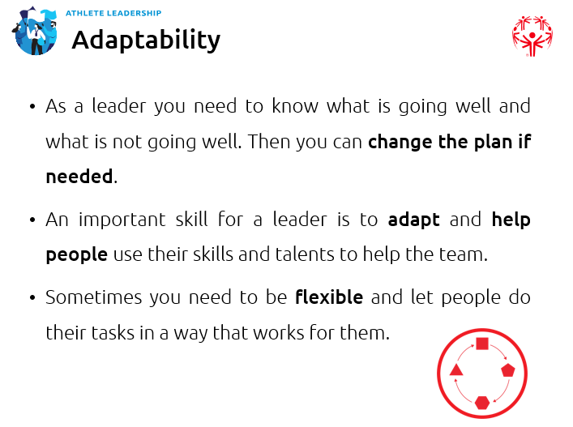  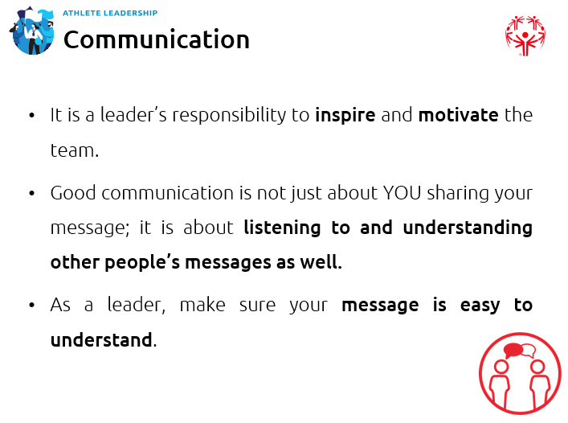  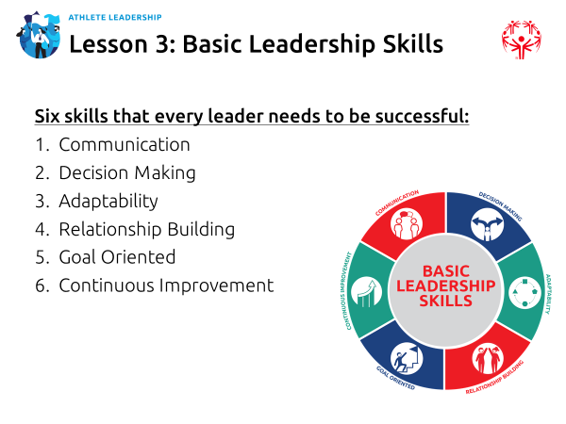

10 min | Facilitator 1 | Activity | Below are two activities that you can do with your athlete leaders. Both can be done virtually or in-person. Depending on time, you can do one or both activities. They both work on to improve their communication skills.  Activity #1 – 10 minutes  If possible before the training, have one facilitator watch this video and make a paper airplane by following the instructions.  Give the group the following instructions, but do not tell them what you are making and do not let them ask any questions. You can repeat an instruction if they need you to, but this exercise is purposefully about modeling a breakdown in communication.  - Find any piece of regular printer-sized or notebook-sized piece of paper  - I am going to give you instructions, but you are NOT allowed to ask questions. Just follow my instructions as best as you can. You may get frustrated, but that is okay. I can repeat steps if you need me to, but that is it.  - Ready? Okay, let’s go! Take your piece of paper and fold it in half.  - Open it up and fold the top down leaving a little left bit at the bottom  - Open it back up and fold down to the crease you just made  - Fold that same section down again  - Fold the top two corners into the center  - Open those up and fold the corners again, but this time to the creases you just made  - Tuck those newly-folded pieces into the center pocket  - Lay the paper down and flatten it out  - Fold it in half on the center crease  - Fold the top half down to meet the bottom edge  - Flip it over and do the same thing on the other side  - Open it up and show everyone what you have made!  Give them time to finish up and then ask them to hold up their finished product.  We have a lot of variety here, don’t we? What do you all think it is supposed to be?  Try to throw it and see if it will fly. That is right, I just gave you instructions for a paper airplane!  We can have a good laugh at how different they are. It is not your fault; you did not do anything wrong. It is just how I communicated the instructions to you. The lesson here is that sometimes breakdowns in communication are not anyone’s fault – they just happen.  This is to show when you communicate with others, they may hear things differently than you explain them. This exercise shows how important it is for people to ask follow-up questions if they do not understand something. Finally, this exercise shows how important it is for everyone to be on the same page and to understand one another before and during a project.  Ask them some of the following questions:  • While you were folding the paper, what did you think you were making?  • Why do you think all our “airplanes” look so different?  • Did you understand the instructions? Why or why not?  • What could I have done a better job of? What communication skills did I not do that would have helped you?  • It is easier to understand when someone else shows you how to do it by modelling the way, right?  Activity #2 – 10 minutes  Divide your group into pairs (will need to use breakout rooms in Zoom if doing virtually) – one partner will be the “talker” and the other will be the “listener.” Give them the following instructions:  - The talker will describe what they look for when thinking about where to go on vacation - for example: price, location, activities.  - The listener is to listen closely to what the talker is saying - and what is not being said.  - After about 30-60 seconds of listening, the listener should summarize (make sure they understand what this word means) the three main ideas the talker considers when it comes to choosing a vacation spot.  - The talker can then tell the listener if they summarized well or if they missed anything.  - Switch roles and do it over again.  What did we practice here?  Give them a chance to answer.  The answer is “active listening.” As listeners, you paid close attention to what they were saying because you knew you would have to summarize their thoughts. To facilitate or organize a discussion, sometimes you will need to summarize what people say. This is great practice, especially if there are any language barriers, to make sure you and the other person understand one another.  What other lessons could we take from this?  What else did you learn?  Why is active listening important?
5 min | Facilitator 1 | Lesson 4: Leadership Journey | Every leader has their own journey. Along the way leaders:  - take additional training  - reflect on their experiences  - try new things  - take initiative to find new ways to be a leader  We hope you think about this training as another milestone in your journey. Today, we learned more about leadership and you had a chance to think about your journey as a leader – where you have come and where you want to go.  The goal in this final lesson is to help you start to think about specific actions you can take to achieve your goal -- the goal that you defined in your personal mission statement from our last class.  If you have time, there is a more detailed Athlete Leadership journey worksheet in the independent activities and the athlete leader handbook that you can have the athlete leaders fill out during class. If you are running out of time, have them fill it out on their own. | 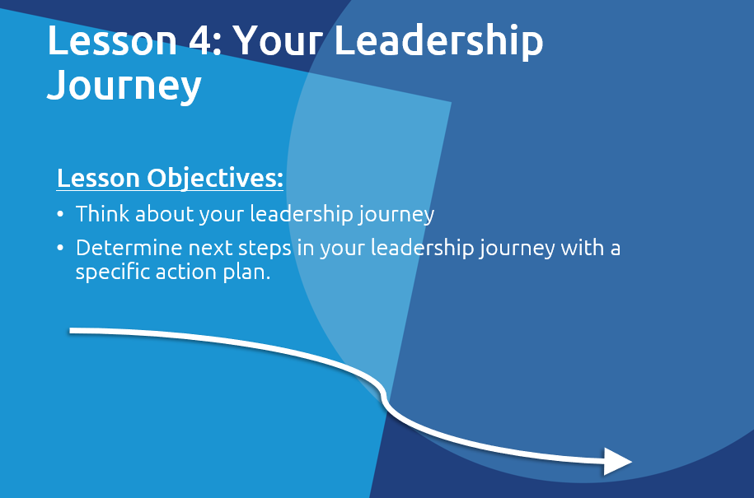  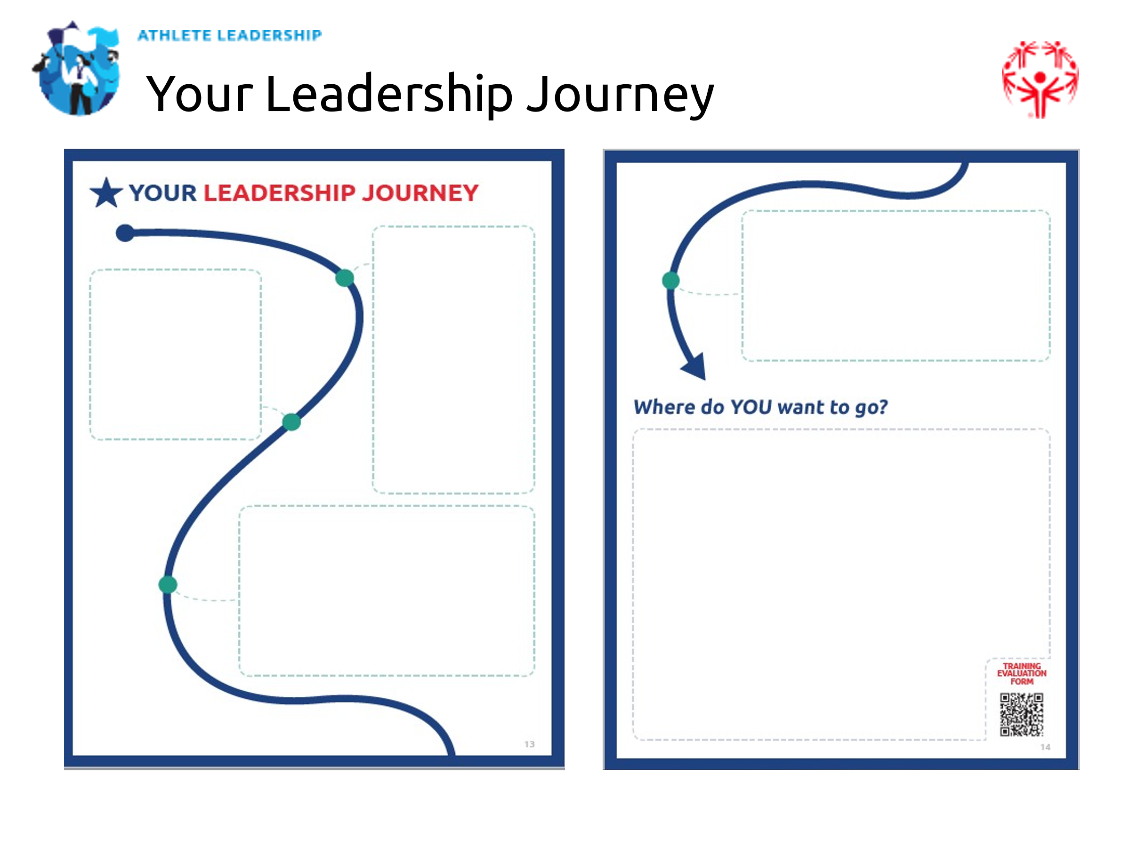
20 min | Facilitator 1 | Action Plan | Now we are going to send you back to your breakout groups that you were in before.  We are going to go over the action plans you completed from “Introduction to Athlete Leadership.” You should have filled these out when you completed your mission statements. Did everyone finish their action plans from the last class?  If some have not finished their action plans, send them off to the side and give them time to wrap those up. They can join their groups later.  You probably want to first remind the group of your mission statement.  Then you will answer each of the questions listed on the action plan:  - Who are the people that I need to talk to?  - What training do I need?  - What challenges might I face?  - What are solutions to those challenges?  This is an opportunity to share any concerns or challenges you think you might face. You can support each other and think about solutions.  If after talking with your group, you want to change your action plan, that is okay. You may find out that a fellow athlete leader gave you a great suggestion for training or solutions to potential challenges.  Give them about 15 minutes to share and discuss in their groups.  Great job, everyone. I hope you found that useful and now have an action plan to help you achieve your leadership goal. | 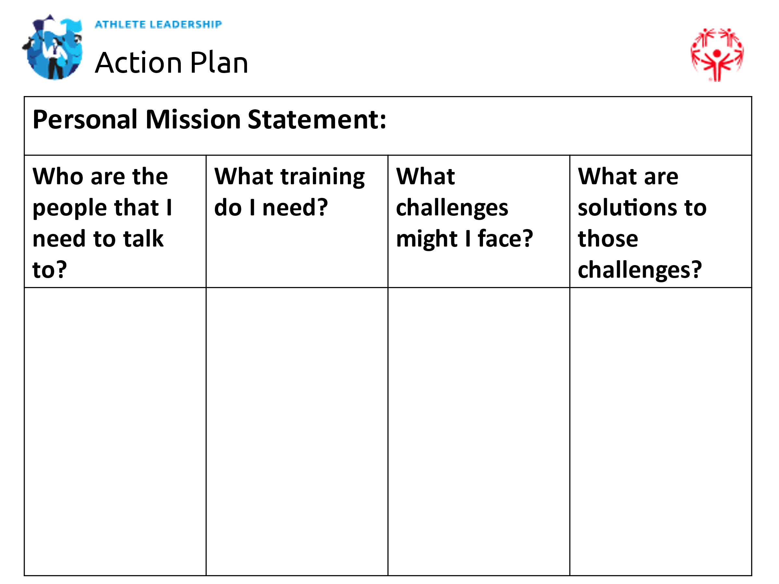
5 min | Facilitator 1 | Wrap up and questions | Wonderful job, everyone!  Thank you for your commitment to growing as a leader and continuing in your personal development.  Remember, your leadership journey, mission statement, and action plan are unique to you.  Do not compare yourself to other leaders, just be the best leader you can be.  It is okay to look up to other leaders and learn from them but learn to be your own leader.  You may go through several different styles of leadership before you settle on one. Your style of leadership could change over time and that is okay.  If you are always true to yourself, you will be fine!  If you also offer trainings in the Advanced Leadership Modules, tell the athlete leaders when those trainings will be offered. Give them a series of next steps so they do not think this is the end of the road. What other classes can they take? How will you as their Program staff engage them in leadership opportunities? Make sure they know there are other trainings available and opportunities for them to put their new skills to good use.  Thank you!

