Understanding Emotions
Facilitator Guide

This facilitator guide provides an outline on how to host and lead the Understanding Emotions training course using the PowerPoint presentation and the participant workbook.

These resources are for you to use in the way that works best for you and your Program (virtually, in-person, individually, etc.). Feel free to adapt them. If you are looking for resources to help prepare for and lead a training virtually through Zoom, WhatsApp, Facebook, etc., you can find them here. Alternatively, the workbook, PowerPoint, and this resource can be used for in-person delivery as well.

Be sure to complete the following actions to prepare for each session:
- Identify at least one athlete leader to co-facilitate.
- Review this facilitator guide and accompanying PowerPoint presentation.
- Review the workbook and complete each activity yourself to be familiar with the activity and have examples to share. Additionally, think about what information you can add from your Program’s perspective. Ask the athlete leader what they can add from their perspective.
- Host a practice session with all facilitators and cover every slide.
- Give feedback to each other.
- Host a second practice of the entire presentation.
- Send out the workbook and session instructions to the participant one or two weeks before the training. Invite athlete leaders to look through all the resources before the training so they are familiar with the content.

Training Overview

Topic | Description | Estimated Time
Lesson 1: Self-awareness  - Identify and understand emotions  - Are emotions good or bad?  - Emotion diary | We all have emotions. There is nothing wrong with the emotions you have, but it is important to understand what they are and how they show themselves in yourself and in others. | 40 mins
Lesson 2: Self-management  - Define self-management  - Review self-management techniques | Keeping your emotions under control will help you become a better leader. | 30 mins
Lesson 3: Empathizing with others  - Define pity, sympathy, empathy, and compassion  - Discuss how empathy and compassion can make you a better leader | Understanding these feelings and how to use them will not only help you become a better leader, but they will help you become a better person as well. | 40 mins

We encourage you to add Program-specific content to make it more relatable to your group of athlete leaders. It is recommended that lessons are facilitated in order and each session be no longer than 2 hours in length. The course can be divided into multiple sessions. In the end, these are just resources at your disposal. You will need to adapt them to fit your constraints as a Program (time, space, technology, etc.).

Special Olympics International
Facilitator’s Guide

Understanding Emotions

Time | Lead | Topic | Description | Slide(s)
1 min | Facilitator 1 | Welcome  Overview of session | Hello, everyone. Welcome to another course in SOI’s Athlete Leadership and Skills Curriculum called “Understanding Emotions.”  This course was designed to help you better identify your own emotions, understand why you have them, and ultimately help you better control them.  Let everyone introduce themselves and ask them to share the emotion they are feeling right now as we get ready to begin the training!  Do a review of Zoom features/etiquette if you feel it is necessary.  Let us go over the expectations for everyone during this training. | 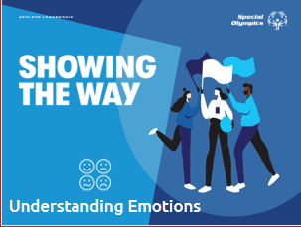
2 min | Facilitator 1 | Expectations | Go over how each group – athlete leaders, mentors, facilitators – all have different expectations during this training | 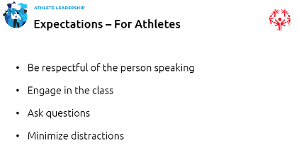  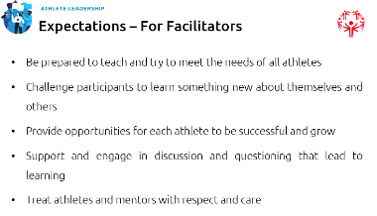  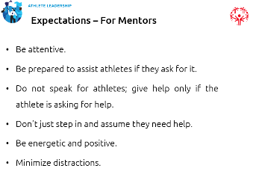
1 min | Facilitator 1 | Module overview | In today’s course we will focus on better understanding our emotions.  There are four lessons:  - Self-awareness  - Self-management  - Empathizing with others  There are a lot of big words here.  We’ll get into their definitions a little later, but I’m curious if you have a basic idea of what they mean now before we begin.  Can someone explain what self-awareness is? What about self-management? Lastly, does anyone want to explain what empathy is?  Now I would like to turn it over to Facilitator 2.  Introduce Facilitator 2 | 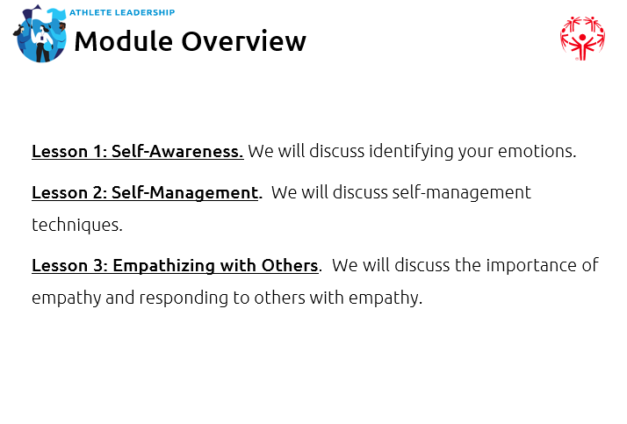
5 min | Facilitator 2 | Lesson 1: Self-awareness | Thanks, Facilitator 1 for the welcome and introduction.  If Facilitator 2 is an athlete leader, have them share their personal leadership journey.  Before we start, I would like to share with you a little bit more about my leadership journey. As Facilitator 1 said, I have been involved for many, many years!  Facilitator 2 shares their journey and background  Now let’s talk about what self-awareness means and how it can help you become a better leader. | 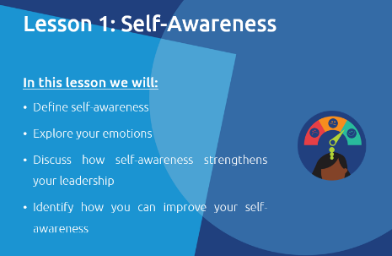
7 min | Facilitator 2 | Identifying your emotions | Self-awareness is the ability to identify and understand your own emotions.  Thinking about your emotions will help you manage them, which will help you become a stronger leader.  As a leader, you need to keep your emotions from getting in the way of reaching your goals and leading others.  There is nothing wrong with having emotions; in fact, they are our body and our mind’s way of helping us understand what we are experiencing in that moment. They help us figure out how to react. This process of understanding our emotions is called “emotional awareness” or “self-awareness.”  This awareness of our emotions helps us understand and communicate to others the things that we like and don’t like. It helps us avoid conflict and process difficult feelings.  Why is it important to be self-aware as a leader?  Responses could be:  i. You do not want your emotions to get in the way of guiding others.  ii. You do not want your emotions to get in the way of reaching your goals.  iii. Being in control of your emotions helps you respond in a calm and productive way, which sets an example for the whole team.  What are some typical emotions that you feel during any given day?  Let them name off as many emotions that they can think of either verbally or in the chat. Make sure to create a list of all the emotions athletes shared so you can use them in Lesson 3. If someone lists an emotion that is more complex, have them explain what the emotion is, how it feels, and what can cause it.  Great job naming off so many different emotions! | 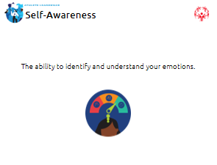
5 min | Facilitator 1 | Emotion wheel | Before you can truly understand your own emotions, you first need to know what emotions are. There are a lot of different emotions people can have, but most are related to the seven main emotions, which are: love, fear, anger, happiness, disgust, sadness, and surprise.  Does anyone need help understanding what the seven main emotions are and their definitions? There are other emotions that are a part of those seven categories, but before we go deeper, it is important that everyone understand these seven first. It is okay if you need us to help define any of these, just say so!  They likely won’t end up understanding every emotion on the wheel, but it is important they at least understand the seven basic emotions (colored sections), so take time now to define them if you need to. Give examples when possible.  Within the seven main emotions (colored sections) on the wheel above, there are even more emotions that fall within that main emotion. This means that each emotion shows itself in different ways. Emotions are confusing sometimes. Let’s talk about that.  Do not go into every emotion within the colored categories, but going over one or two colors and all the emotions within that category could be helpful in setting up the next slide. | 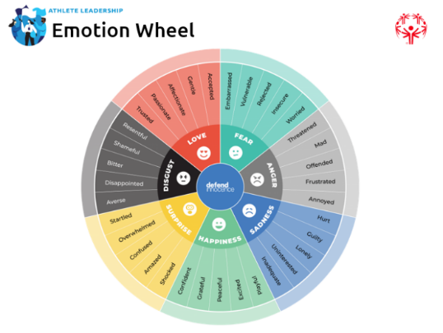
5 min | Facilitator 1 | Emotions can be confusing | Depending on the situation or scenario you are in, the emotions you feel can mean different things. Emotions can be really confusing to understand sometimes.  Let’s try an activity to put this to practice. Close your eyes and imagine how you feel when these things happen to you:  - You win a gold medal (give them 5-10 seconds to visualize this). What emotion is this for you? What does it feel like?  - Now think about what emotions you feel when you get a hug from a family member or friend (give them 5-10 seconds to visualize this). What emotion is this for you? What does it feel like?  - Both of these feelings are of happiness, right? The second one could also be love, but just looking at the green-colored section for happiness on the wheel, how are these feelings different or are they different for you at all? For some, the happiness from winning a gold medal could be EXCITED, while the emotion from being hugged by a family member or friend could be PEACEFUL.  - Both of these are emotions of happiness, but sometimes depending on the situation they can feel completely different.  There are examples of different emotions within the different feelings below that you are welcome to use if you’d like.  • The fear you feel while skydiving is probably different than the fear you feel before giving a speech to hundreds of people.  • The anger you feel when your sibling steals your toy is different than the anger you feel when you lose a competition.  • The disgust you feel after disappointing or letting down a friend or family member is different than the disgust you feel when you watch a bad movie.  • The love you feel when you make a new friend at work or school is different than the love you feel when your partner hugs you.  • The surprise you feel when someone throws you a surprise party is different than the surprise you feel when you are told you have a quiz in school.  • The sadness you feel when someone hurts your feelings is not the same as the sadness you feel when you are alone. | 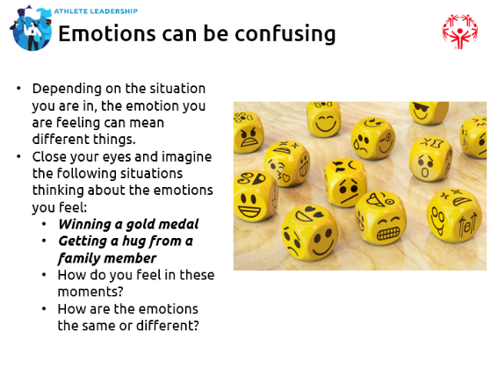
2 min | Facilitator 2 | Good/bad emotions? | There are no such things as good emotions and bad emotions – however, there is a healthy way to express your emotions. That is what this course is trying to teach you; we don’t want you to hide your feelings because that is not healthy. We just want you to understand HOW you feel, WHY you feel that way, and know how that emotion could affect you or those around you.  Everyone’s emotions are different – It is so important to understand that people react differently when they are experiencing a certain emotion. Some people when they are mad like to scream and yell, while others may not say anything and go off to be by themselves. Some people when they are sad will cry, while other people who are sad may not cry at all and look like they are not experiencing emotion at all.  Think back to the example earlier of winning a medal. That happiness from one person may mean they cry on the award stand, while in others it results in them screaming for joy!  So don’t judge other people based on the emotions they are showing because you never truly know how they are feeling. Ask them! Let’s normalize talking about our feelings with other people.  Emotions can have a wide range of intensity – They can be mild, extreme, or anything in between. When you feel sad or angry, there are times when you have been just a little angry and other times where you are really angry, right? The intensity can depend on the situation and on the person.  Also, our emotions change a lot. Most of us feel a wide range of emotions in a typical day. You may start out excited about the day and then something happens to you where you become sad or angry, right? Also think about how after participating in a Special Olympics event and you are upset that you didn’t win a gold medal. You may start out really angry, but over time, that emotion goes away, right? Emotions change over time. | 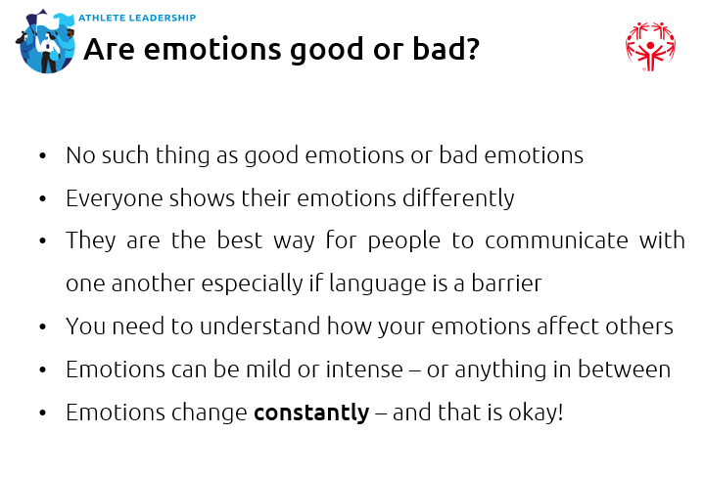
5 min | Facilitator 2 | Emotional awareness | Noticing your emotions and understanding why you feel that way is the first step to making sure emotions cannot control you – instead YOU control THEM. This is also called “emotional awareness.”  How do you control your emotions?  Why is it important to control your emotions?  Give them time to answer these questions and talk about their emotions. If you have a large group, break up into smaller groups.  There are a variety of ways to help you better identify your emotions and better control them.  Make a habit of tuning in to how you feel throughout the day – Depending on the situations you are in during the day, you may notice that you feel excited when you make plans to be with friends, or that you feel satisfied after exercising. Noticing your emotions throughout the day is great practice; then pay attention to when that emotion goes away or changes AND if anything triggered that emotion in you to change. The exercise you do below is a great start for this.  Rate how strong the feeling is – Noticing when your emotion changes is key, but after you are aware, rate how strongly you feel that emotion on a scale of 1 to 10 (1 being very little and 10 being very intense) or use a range of emojis/faces.  Share your feelings with people you trust – Talking to people about your emotions (partners, family, coaches, etc.) helps you feel closer to other people and shows them that you aren’t afraid to talk about things that are bothering you.  Just remember to NOT judge your feelings. When you feel an emotion, it’s because you really feel that way. Learning to control your emotions does NOT mean that you should push them down or fight that emotion and hide it away.  Don’t ever feel bad for feeling a certain emotion. Notice them, identify them, talk about them, and do so on a regular basis. This will help you control them. Practice makes perfect! | 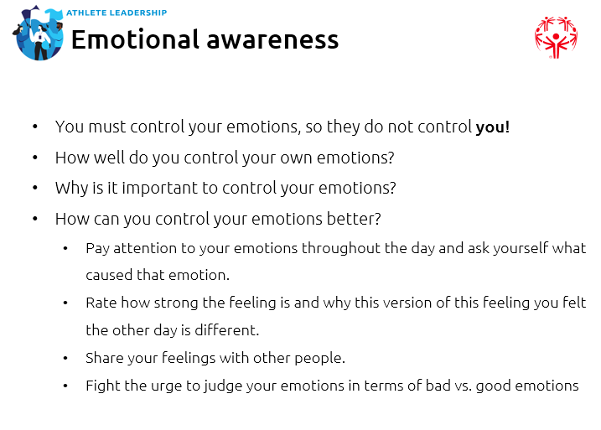
5 min | Facilitator 1 | Emotion Diary | To practice identifying your emotions and tracking them better, use the emotion diary in your handbook or on this slide. Work on this over the next week. Pick a day that you are likely to be busy with school or work or other activities. It’s important to pick a day where your emotions will change a lot over the course of the day.  Complete an entry in the diary every 2-3 hours. For each entry, ask yourself the following questions:  - What am I doing right now?  - What am I thinking about?  - What emotions am I feeling?  - Why do I think I’m feeling that way?  - How would you describe the emotions you are feeling. Do your best to put into words how the emotion FEELS to you.  Take the time to do this activity over the next couple of weeks. Do it a couple of times and eventually you will get better at understanding your emotions and knowing how you can better control them.  Potential discussion questions you can use throughout this lesson:  - What are the signs that tell you when you are happy? What are the signs that tell you when you are sad?  - Why is it important to have self-awareness as a leader?  - How can your emotions keep you from becoming a good leader?  - How do you get better at recognizing your emotions? How do you keep them from taking over and affecting the rest of your day? Possible answers: Some examples include using the Emotion Diary template to continue tracking emotions, keeping a journal, getting exercise, meditation, and yoga, therapy, just talking to family/friends. Emphasize that just learning about emotions and understanding how to recognize emotions is half the battle in getting control over them. The next activity they will learn some tools that will help them keep their emotions in check.  Any questions before we move onto the next lesson? | 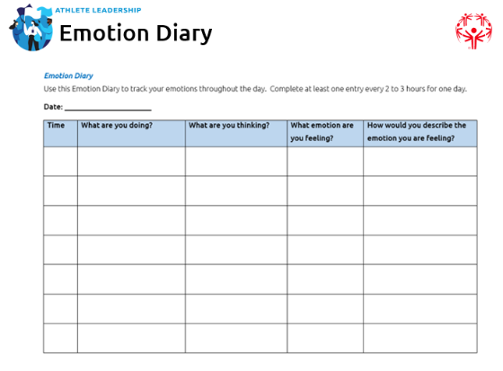
1 min | Facilitator 2 | Lesson 2: Self-Management | Now that we understand emotions better, let’s talk about how we might be able to control them.  Go over the lesson outline.  Before going to the next slide, ask if anyone thinks they know what self-management means in relation to understanding their emotions.  Once they have had the chance to answer, go to the next slide and share the definition with them. | 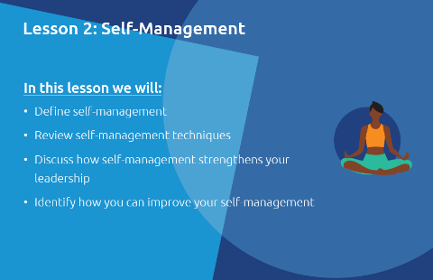
10 min | Facilitator 2 | Self-Management definition | Self-management is the ability to control your emotions, thoughts, and behaviors. You are managing yourself – that’s the goal!  Why is it important to be good at self-management as a leader?  Possible answers:  - Being able to control your emotions, thoughts and behaviors will help you reach to situations calmly instead of emotionally. As a leader, it is important you stay calm in all situations.  - It will prevent your emotions from getting in the way of your goals.  - Controlling your emotions helps create a positive work environment for everyone.  As a leader, you need to be able to keep calm and stay focused so you can accomplish your goals. However, it is not good to not show any emotion at all like a robot. Showing emotion (with control) is healthy. It is impossible to always hold your emotions down. It is okay to sometimes have an emotional reaction to something, but it is important to not let it get out of hand.  Has anyone ever had a time where they had a very emotional reaction to something and regretted/felt bad about it later? Give them a chance to answer. Give your answer to jumpstart the conversation.  Dealing with emotion is not easy. Some people are good at it while others really struggle. But by taking this course and practicing, you will get better at understanding your emotions and keeping them in check.  Let’s practice!  Close your eyes and picture this.  You are traveling to a venue where you will give a speech to a large audience about Special Olympics. You have practiced for weeks, and the big day is finally here. You feel confident and prepared. You know you will succeed.  You arrive on time for the speech and find out that somehow you are actually 30 minutes late! You don’t know how it happened, but they have skipped you in their show’s agenda/run of show.  How do you honestly react? What emotions are you feeling? Share them with the group! No answer is a wrong answer right now.  After they give their answers, ask them:  Lucky for you, you have taken this course and know what you should and should not do with your emotions, so what should your emotions be and what do you do next?  There are a lot of potential answers here, but the idea is that we want them to understand while it is important to keep their emotions in check, it is okay to be upset for a short period of time. However, after that short period of time, they need to move on. In the end, it does not matter whose fault it was so don’t try to blame someone else. Be upset for a few seconds, take a deep breath, apologize for the miscommunication, and ask if there is anything else you can do to make up for it. Can they fit you in somewhere else in their agenda? Can you shorten your speech a bit to make up for lost time? Can you agree to stick around after the agenda is over and meet with small groups of people individually and turn it into a meet-and-greet? Can you record your speech for them to send out to everyone later that week? Basically, we don’t want them to think showing any emotion is bad, but it should be under control and not last very long.  Now that we’ve talked through that scenario, let’s learn about some techniques or ways that could help you better control your emotions. | 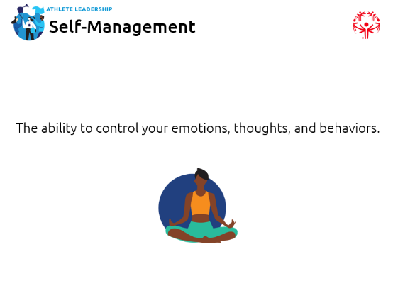
15 min | Facilitator 1 | Self-management techniques | There are MANY ways to try and control your emotions or reactions to things. Before we go through some of our recommended techniques, what works for you? Give them a couple of minutes to think about and then share their answers.  Go through each of the techniques on the slide and spend as much or as little time on each one.  Give them 5-10 minutes to go through each one and mark on each one if they have tried it and how it worked out or if they want to try it.  Your homework for this course is to take one technique you just marked from the “want to try” column and one technique from the “do not think it will work” column and try both the next time you find yourself getting emotional to see if they work.  Keep in mind that just because a technique does not work right away, that does not mean it will never work – just like in sports, it takes practice!  Does anyone want to share a technique from their “tried it and it works” column? How about sharing a technique from the “do not think it will work” column with an explanation why you think that? | 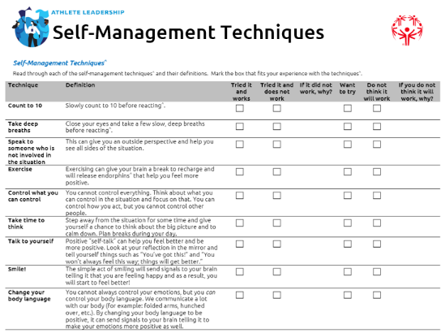
1 min | Facilitator 1 | Strong Minds | You know that Special Olympics has resources to keep you physically strong through exercises, eating healthy, and competition. But did you know that Special Olympics also has resources to keep your mind and emotional state strong? This program is called Strong Minds. For more information and to see the resources available to you, visit https://resources.specialolympics.org/health/strong-minds. | 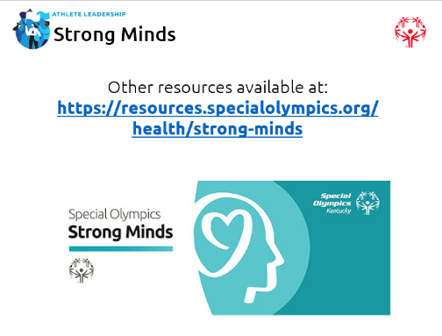
10 min | Facilitator 2 | Discussion questions | Potential discussion questions that we haven’t asked yet that you can use now or throughout this lesson:  - How do you know if a self-management technique has worked to calm you or not? The answers will be different for everyone.  - Are there any techniques that are not on this list that you would recommend to others?  - How can you get better at managing your emotions?  - Is showing emotions good or bad? Answer: GOOD! Emotions are our body’s and mind’s way of communicating with us and with others. The emotions themselves are not bad. It is how you react to them that is often bad. Remember back to the example of the speech going wrong earlier. That’s a stressful situation where it’s okay to be upset or angry or disappointed, but you probably should not scream or yell about that while in public, right? Being okay with showing your emotions and talking about your emotions is healthy and shows maturity.  - Mentors: How do you deal with your emotions? Any advice for the athlete leaders?  Any questions before we move onto the next lesson? | 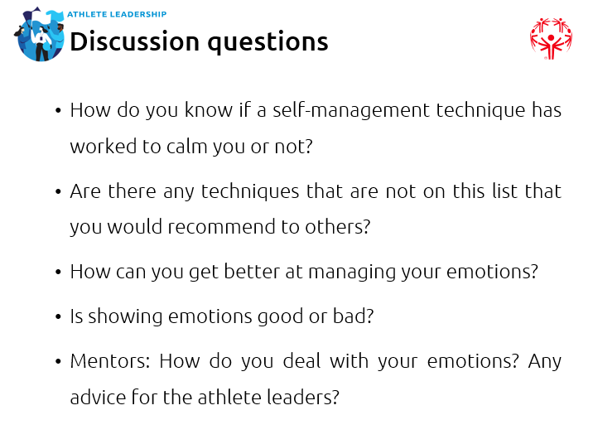
5 min | Facilitator 2 | Lesson 3: Empathizing with Others | Go over the lesson outline.  Empathy is the main word we want to focus on for this lesson, but is important to know these three other words and how you will experience them in your lives and how you will use (or avoid) them as you lead others. Think of these words as the steps toward the end goal of compassion. You start with pity, then move to sympathy, then empathy, and finally compassion.  Before going to the next slide, ask if anyone thinks they know what any of these words (pity, sympathy, empathy, compassion) mean.  Once they have had the chance to answer, go to the next slide. | 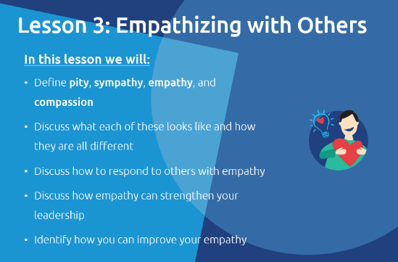
7 min | Facilitator 1 | Pity definition | We’re going to go in order of progression here and start with the definition of pity.  Pity is the feeling of sadness you have that is caused by the suffering of other people. The person feeling pity toward someone else does feel something, but it is a reaction to something or someone in a situation, not an emotional understanding of that person’s feelings or situation.  When Lucy pities Brad, it is often done in a way that means Lucy is above or better than Brad. It is often done in a condescending or judgmental way. There is often a lack of wanting to help that person or thing that is being pitied.  That may sound confusing, so let’s think through a potential example. As someone with a disability, you have probably been pitied by others before in your life – just because you have a disability.  Others feel bad for you just because you have a disability/are disabled. They assume you cannot do certain things anymore because you are disabled and they feel bad about that.  An example of pity is when a disabled person gets a wheelchair and a non-disabled person pities them or feels bad for them because they see the wheelchair as something that limits their ability in the world, while the wheelchair actually gives a disabled person freedom and opens up more opportunities for them.  People who pity others usually mean well and do not think they are doing any wrong, but people who receive pity usually do not like it.  Do any of you have an example of being pitied before?  Take a few minutes for people to share their examples if they have any. | 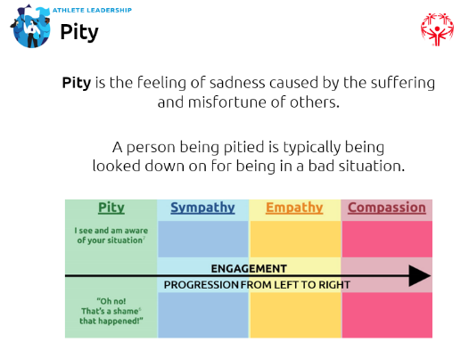
1 min | Facilitator 2 | Sympathy definition | Next up is sympathy.  Sympathy often involves an unconscious or automatic feeling (the person feeling it does not think about it – it just happens).  Sympathy is the relationship between people so when something affects Lucy, the Brad feels it as well.  For example: You might automatically sympathize with the feelings of someone who grew up in the same hometown you did or who has a life that sounds like yours.  A person can sympathize with someone else’s situation, but their feelings are not yet strong enough to act on them and help find a solution. | 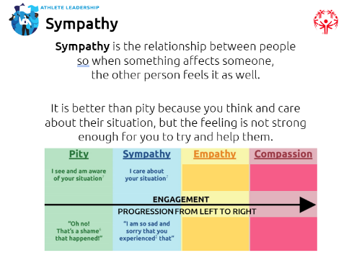
2 min | Facilitator 1 | Empathy definition | Next is empathy.  Empathy is the ability to understand and share the feelings of someone else.  The difference between empathy and the other two we have covered so far is empathy requires the person feeling it to act. It is like the phrase “to put yourself in someone else’s shoes.” When Lucy is empathizing with Brad, she takes a moment to think about what Brad is going through and feeling.  Think back to the example we gave for “sympathy” and being able to sympathize with someone from the same hometown as you. Now think about someone from a different country with a different culture than you – it would be impossible to sympathize with them because you cannot relate to them. You can, however, empathize with them by thinking what it would be like to live in their country and experience their lives. Empathy takes action.  Sometimes empathy is also achieved because the person actually has gone through the same situation before and can remember what it was like (for example: being bullied in school, growing up in a divorced family, being lonely as an only child, etc.) | 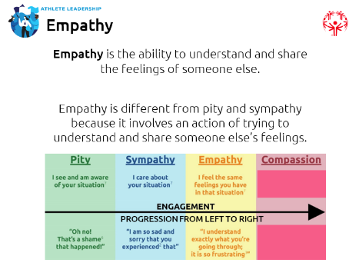
2 min | Facilitator 2 | Compassion definition | Compassion is the goal. It will help you become a better person and a better leader because people will trust you and want to work with you.  Compassion is the feeling when your sense of empathy is so incredibly strong that it forces you to act on it. Lucy understands Brad’s feelings, and maybe even shares Brad’s feelings herself, but instead of stopping there like in pity and sympathy, Lucy wants to do anything she can to make Brad feel better.  For example: Your teammate breaks their leg at practice and must sit out the rest of the season. You are empathetic to your teammate’s experience because this happened to you a few years ago. So you visit your teammate a couple of times per week to watch their favorite movie and cheer them up. You took the extra action to make them feel better. That is compassion. That is the goal. | 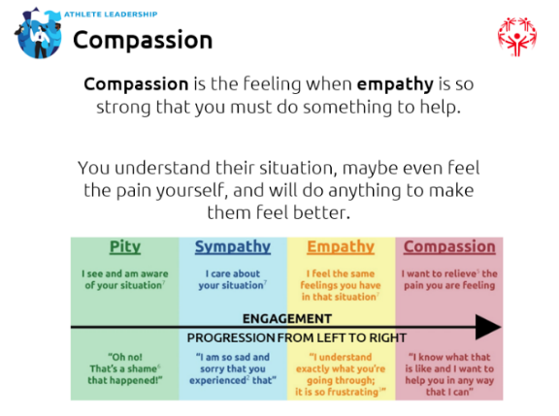
3 min | Facilitator 2 | Review | To recap, compassion and empathy are incredibly important feelings to understand and have toward other people and things. They help you connect with others and build trust with them – both are important to becoming good leaders.  Think about when people say “I know how you feel.” Often people mean well when they say it, but it is very difficult to truly know exactly how someone else feels.  Pity is not helpful in most situations and sympathy is not likely if the person does not have a similar experience.  So you are left with empathy which requires actual effort on their behalf, right? Combining empathy with compassion (acting to make their situation better) shows people that you care enough about them to not just say “I know how you feel” but to show them you are willing to do whatever you can to take away their pain.  Compassion is the ultimate action and result of showing empathy for someone or something. Knowing what empathy is and learning how to have it will make you a better leader.  This will help you respond appropriately to the situation. It will also allow you to build relationships with your team members, which in turn will strengthen your leadership and your team. | 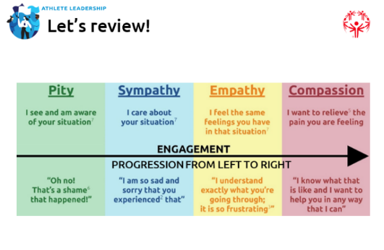
5 min | Facilitator 2 | Empathy quiz | The next three slides are questions to see if they understood all four definitions and how they are slightly different from one another. Feel free to change these examples if you think they are too easy or too hard to find the right answers.  Make sure you take the time to explain WHY the correct answer is the correct one and point out the subtle differences between each definition.  Answers:  - B  - C  - A (also a good example of compassion) | 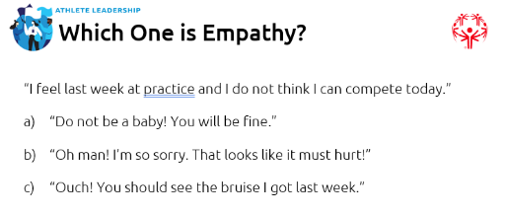  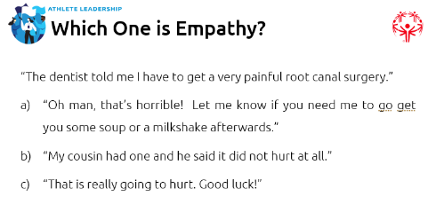  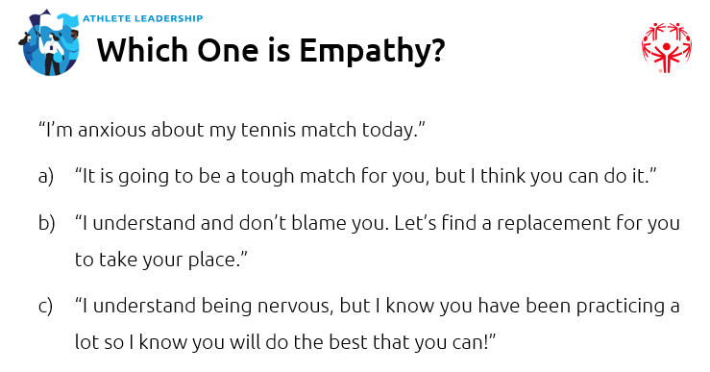
10 min | Facilitator 1 | Reflection questions | Potential discussion questions that we haven’t asked yet that you can use now or throughout this lesson:  - Tell us a time when someone showed you compassion. How did it make you feel (use the emotion wheel).  - Tell us about a time when you showed someone else compassion.  - How can having empathy help you as a leader?  - How can you get better at showing empathy? | 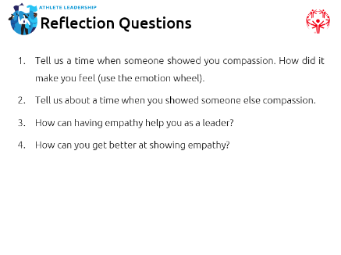
10 min | Facilitator 2 | Emotion game | The next few slides are an Emotion Game that you can play if you have time. You can have them do it in small groups or as two teams where you keep track of points and announce an actual winner. Feel free to also include any activities of your own if you prefer those.  The goal here is to obviously get them to correctly guess the different emotions, but it’s also to show them that everyone has their own way of showing that emotion. Sadness is not always exhibited through crying and anger is not always exhibited through screaming and yelling. Take time to point that out.  There are also discussion questions to go over with the group after the activity is completed.  Discussion questions:  - What was difficult about guessing the emotions?  - Were there certain emotions that were easier to guess?  - What did you pay attention to in order to correctly guess the emotion?  - How can identifying emotions in other people (and yourself) help you with others and become a better leader? | 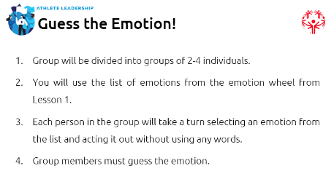  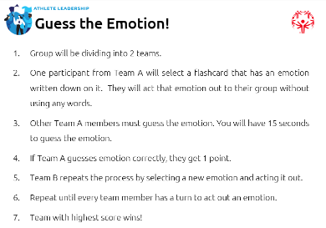  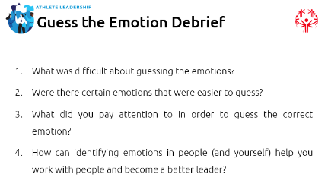
5 min | Facilitator 1 | Wrap up and questions | Wonderful job, everyone!  Thank you for your commitment to growing as a leader and continuing in your personal development.  Thank you!

