Independent Activities
Understanding Emotions
Note: If you see a word you do not know and it has a ^ next to it, you can look at the glossary on the final page of this document. You can also use a dictionary (www.m-w.com).
Athletes: You can use this training on your own or with personal support. Print out and fill in answers to the questions or type your answers into the Word document. Go through these trainings at your own speed.
In this course, you will:
- Learn about self-awareness
- Practice identifying^ your emotions
- Learn how to manage your emotions
- Practice responding to emotions of others
- Learn what “pity,” “sympathy,” “empathy,” and “compassion” mean and how they all relate to one another.
- Understand why having “empathy” is important to being a good leader

Topic | Description
Lesson 1: Self-awareness  - Defining self-awareness  - Identifying^ emotions  - Reflection activity | Understanding your emotions takes time and intentional reflection. Explore the first steps to becoming self-aware and practice naming the emotions you have experienced.
Lesson 2: Self-management  - Defining self-management  - Self-management techniques | Explore what you can do during times of intense emotions. Find a technique^ that works for you and create a plan to remind you of your self-management techniques^.
Lesson 3: Empathizing with others  - Defining empathy  - The importance of empathy  - Responding to others with empathy | We do not experience emotions alone, that is where empathy comes in. Explore the meaning of empathy, how to work with it, and understand the emotions of others.

Updated: June 2021
Understanding Emotions: Lesson 1
Learn about your emotions
Identifying emotions and self-awareness (Source: Defend Innocence)
Self-awareness is the ability to identify^ and understand your own emotions. Thinking about your emotions will help you manage them, which will help you become a stronger leader. As a leader, you need to keep your emotions from getting in the way of reaching your goals and leading others.

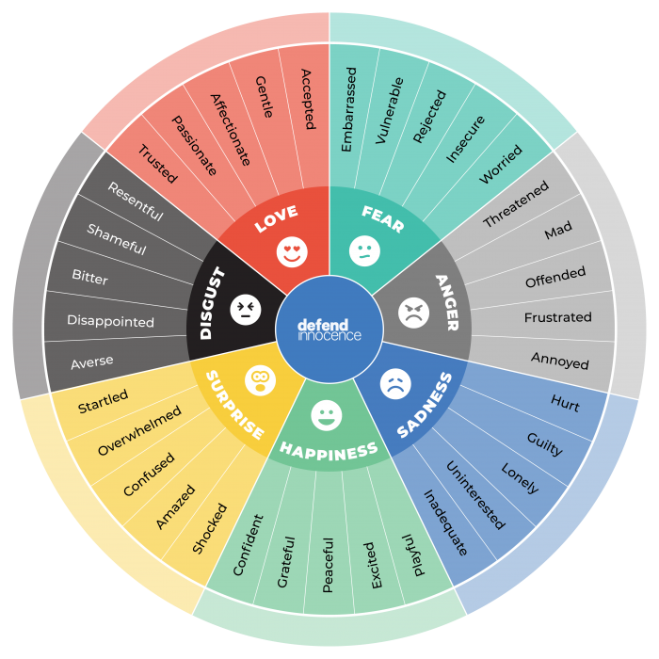
Before you can truly understand your own emotions, you first need to know what emotions are. There are a lot of different emotions people can have, but most are related to the seven main emotions of love, fear, anger, happiness, disgust, sadness, and surprise.

The graphic on the right shows you how, within those seven emotions, there are ways that those emotions can show themselves. For people who do not verbally share their emotions, they can use the emojis to communicate their emotions.
Emotions are a part of who we are as humans. There is nothing wrong with having emotions; in fact, they are our body and our mind’s way of helping us understand what we are experiencing. They help us figure out how to react. This process^ of understanding^ our emotions is called “emotional awareness.”

This awareness^ of our emotions helps us understand and communicate with others the things that we like and do not like. It helps us avoid conflicts^ and process^ difficult feelings.

We will cover more on emotional awareness later. For now, let us learn about the different kind of emotions. When looking at the graphic at the right, do not think you have to memorize all these words and emotions.

This graphic is included to show you how many emotions there are and how emotions can mean different things depending on the situation.

Examples:
- The fear you feel while skydiving is probably different than the fear you feel before giving a speech to hundreds of people.
- The anger you feel when your sibling steals your toy is different than the anger you feel when you lose a competition.
- The disgust you feel after disappointing a friend or family member is different than the disgust you feel when you watch a bad movie.
- The happiness you feel when you reach your goal is different than the happiness you feel when you are with friends and family who love you.
- The love you feel when you make a new friend at work or school is different than the love you feel when your partner hugs you.
- The surprise you feel when someone throws you a surprise party is different than the surprise you feel when you are told you have a quiz in school.
- The sadness you feel when someone hurts your feelings is not the same as the sadness you feel when you are alone.

There are no such things as “good emotions” and “bad emotions” – however, there is a healthy way to express your emotions. That is what this course is trying to teach you; do not hide your feelings, but understand how you feel, why you feel that way, and know how that emotion could affect you or those around you.
Emotions can have a wide range of intensity^ – They can be mild, strong, or anything in between. There are times when you have been just a little angry and other times where you are really angry, right? The intensity^ can depend on the situation and on the person.
Emotions change all the time -- Most of us feel a wide range of emotions in a typical day. You may start out excited about the day and then something happens to you where you become sad or angry, right? Also think about how after participating in a Special Olympics event and you are upset that you did not win a gold medal. You may start out angry, but over time, that emotion goes away, right? Emotions change over time.
Emotional Awareness Source: TeensHealth from Nemours
Noticing your emotions and understanding^ why you feel that way is the first step to making sure emotions cannot control you – instead, you control them. This is also called “emotional awareness.”

There are different ways to do this:
- Make a habit of thinking about your feelings throughout the day – Depending on what you are doing during the day, you may notice^ that you feel excited when you make plans to be with friends, or that you feel satisfied^ after exercising. It is a good practice to notice your different emotions throughout the day and think about what made you feel that way.
- Rate how strong the emotion is – Noticing when your emotion changes is key. But after you are aware, rate how strongly you feel that emotion on a scale of 1 to 10 (1 being very little and 10 being very intense) or use a range of emojis/faces.
- Share your feelings with people you trust – Talking to people about your emotions (partners, family, coaches, etc.) helps you feel closer to other people. It is healthy to talk about your feelings, especially is something made you angry or sad.
Example of having “emotional awareness:” Amani is participating in a group discussion. Paul says something upsetting to the group. Amani notices her heart starts to beat faster. She frowns and becomes restless. Amani realizes that she is angry and understands it is because what Paul said. Now that she knows how she feels and why she started to feel that way, she can deal with her emotions.
Activity
- Choose a day where you are likely busy with school, work, and a variety of other activities. It is important to choose a day where your emotions could change a lot. Every 2 to 3 hours during the day, complete an entry in the Emotion Diary provided on page 5.
- Carry the Emotion Diary with you throughout the day so it is always with you when it is time to complete an entry or have your phone or a tablet with you to take notes in case you do not have your printed paper. If you need help remembering to make entries during the day, you can set an alarm at different points during the day to help remind you to make an entry. For each entry, you will answer the following questions:
  - What am I doing right now?
  - What am I thinking about?
  - What emotions am I feeling?
  - Why might I be feeling that way?
  - How would you describe the emotions you are feeling? Do the best to put into words how the emotion feels to you.

Emotion Diary
Use this Emotion Diary to track your emotions throughout the day. Complete at least one entry every 2 to 3 hours for one day.
Date: _______________________
Why did you choose this day/what do you have going on today? ________________________________________________
Time | What are  you doing? | What are you  thinking about? | What emotions  are you feeling? | Why do you think you feel that way? Did something trigger it? | How would you describe the emotions you are feeling?

Reflection Questions
- Look over your Emotion Diary. What do you notice^? Did your emotions change? Did you feel one emotion more often than others throughout the day? Did ever you feel more than one emotion at a time? If so, what were they and what caused that?

- Why do you think you felt the emotions you were feeling? Did something trigger those emotions?

- Before you wrote in the diary, were you immediately aware of how you were feeling? Or did you not notice^ you were feeling until you went to fill out your diary?

- What are the signs that tell you when you are happy? What are the signs that tell you when you are sad?

- How can your emotions keep you from becoming a good leader?

- Without looking at the graphic on page 5, what are all the emotions you can list right now?

- How do you get better at recognizing your emotions? How do you keep them from taking over and affecting the rest of your day?

<< END OF LESSON 1 >>

Understanding Emotions: Lesson 2
Self-management
In the first lesson, you learned to identify and understand your emotions. You also learned that while there are no bad or good emotions, you still need to remember to keep those emotions in check to keep you calm and balanced.

Self-Management is the ability to control your emotions, thoughts, and behaviors^. Being able to do this will help you react^ to situations^ calmly instead of emotionally, which will strengthen your leadership ability. As a leader, you need to be able to keep calm and not let your emotions get in the way so that you can stay focused^ and accomplish^ your goals or lead a team.

Review the self-management techniques^ on page 9 and do one of the following:
  - Print out and fill in the table
  - Fill in the worksheet on your computer and save.
  - If you do not have access to a printer and want to handwrite your answers, draw the template on a blank piece of paper and then fill it in (see No. 2 for directions).
Mark on the sheet one of the following for each technique^:
  - You have tried it and it works
  - You have tried it, but it does not work for you
  - You have not tried it but want to in the future
  - You have not tried it, but you do not think it will work for you

After filling it out, take one technique^ from the “want to try” column and one technique^ from the “do not think it will work” column and try both the next time you find yourself getting emotional about something. Focus on using those two techniques^ in emotional situations^ over the next few days to see if they work. Remember, just because a technique^ does not work right away does not mean it will never work – just like your sports, it takes practice.
Complete the reflection questions at the end.

More resources
You know that Special Olympics has resources to keep you physically strong through exercises, eating healthy, and competition. But did you know that Special Olympics also has resource to keep your mind and emotional state strong? This program is called Strong Minds. For more information and to see the resources available to you, visit https://resources.specialolympics.org/health/strong-minds.

Self-Management Techniques^
Read through each of the self-management techniques^ and their definitions. Mark the box that fits your experience with the techniques^.
Technique | Definition |  | Tried it and works | Tried it and does not work | If it did not work, why? | Want to try | Do not think it will work | If you do not think it will work, why?
Count to 10 | Slowly count to 10 before reacting^. | ☐ |  | ☐ |  | ☐ | ☐
Take deep breaths | Close your eyes and take a few slow, deep breaths before reacting^. | ☐ |  | ☐ |  | ☐ | ☐
Speak to someone who is not involved in the situation | This can give you an outside perspective and help you see all sides of the situation. | ☐ |  | ☐ |  | ☐ | ☐
Exercise | Exercising can give your brain a break to recharge and will release endorphins^ that help you feel more positive. | ☐ |  | ☐ |  | ☐ | ☐
Control what you can control | You cannot control everything. Think about what you can control in the situation and focus on that. You can control how you act, but you cannot control other people. | ☐ |  | ☐ |  | ☐ | ☐
Take time to think | Step away from the situation for some time and give yourself a chance to think about the big picture and to calm down. Plan breaks during your day. | ☐ |  | ☐ |  | ☐ | ☐
Talk to yourself | Positive “self-talk” can help you feel better and be more positive. Look at your reflection in the mirror and tell yourself things such as “You’ve got this!” and “You won’t always feel this way; things will get better.” | ☐ |  | ☐ |  | ☐ | ☐
Smile! | The simple act of smiling will send signals to your brain telling it that you are feeling happy and as a result, you will start to feel better! | ☐ |  | ☐ |  | ☐ | ☐
Change your  body language | You cannot always control your emotions, but you can control your body language. We communicate a lot with our body (for example: folded arms, hunched over, etc.). By changing your body language to be positive, it can send signals to your brain telling it to make your emotions more positive as well. | ☐ |  | ☐ |  | ☐ | ☐

Reflection Worksheet
Note: Do not feel like you need to complete all these questions at the same time. Take your time! If you need more space to answer your questions, use a separate sheet of paper or another Word document.

- Before this lesson, what techniques^ did you use to help you stay calm when you were upset? Did they work?

- How do you know if a technique^ to calm you worked or not?

- After filling out the worksheet, were there any techniques^ that you thought would not work, but after practicing them you found that they did work? If so, what ones?

- Are there any techniques^ that are not on this list that you would recommend^?

- How could you get better at managing your emotions?

- Talk to a family member, friend, or coach and ask them how they deal with their emotions. What is their advice?

- Ask a family member, friend, or coach if they noticed certain times when you usually get emotional. Write down their answer. Did you know that you react^ a certain way in those kinds of situations^? Work with them to find a way to get better at controlling your emotion in those situations^.

<< END OF LESSON 2 >>

Understanding Emotions: Lesson 3
Pity vs. sympathy vs. empathy vs. compassion
Understanding the difference between pity, sympathy, empathy, and compassion is incredibly important to being, not just a good leader, but a good person.
Pity: It shows that someone feels bad about something. It is nice that they feel bad, but it is often done in a way that means the person feeling pity is above/better than the person being pitied. An example that you probably know very well is people pity you because you have an intellectual disability, especially if it is a disability that is visible. Many Special Olympics athletes have felt pitied by someone before. The other person feels bad just because you have a disability, not because they understand your situation^. People who give pity to others usually mean well and think they are not doing anything wrong. People who receive pity usually do not like it.

Sympathy: This is the act of feeling sorry for someone who is in a bad situation^. It could be a conscious^ feeling (they thought about the situation^ enough to feel this way) or it could be an unconscious^ feeling (they did not even think about it – they just felt that way automatically). For example, you may be sympathetic to someone’s situation^ because they have a similar story to yours. Sympathy is better than pity, and a step closer to the goal of Compassion.

Empathy: This is the ability to understand and share the feelings of someone else. To use a phrase that is frequently used, you are “putting yourself in someone else’s shoes.” You are trying to understand and share their feelings. Sometimes this could take a lot of effort for you to feel empathy toward someone, especially if you do not have the same experience as them. For example, you may be empathetic to someone who has a family member with cancer because you experienced^ the same thing with one of your family members. Empathy is better than pity and sympathy, and a step closer to the goal of Compassion.

Compassion: This is what happens when the feeling of empathy is so strong that it forces you to act and involve^ yourself in a situation^. You understand, and maybe even feel their pain yourself, but instead of stopping there, you want to do anything you can to make them feel better. For example, your teammate twists their ankle in practice and must sit out of the next competition. You are empathetic to this athlete’s experience because something similar happened to you last year AND you visit them at their home with their favorite movie and candy to make them feel better; you took an extra action to make them feel better. Compassion is the goal.
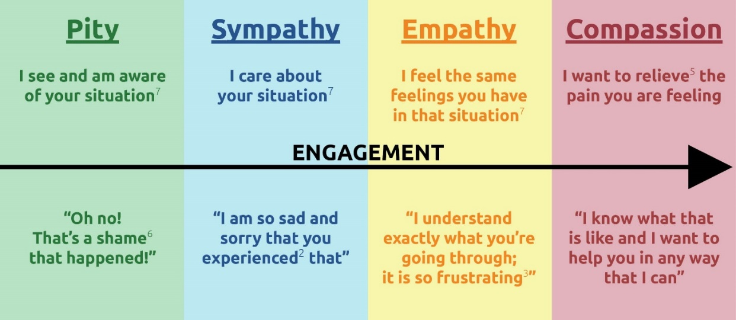
PROGRESSION FROM LEFT TO RIGHT

For this lesson and how it relates to leadership, we want to focus on empathy.
Compassion is the ultimate action and result of showing empathy for someone or something. Knowing what empathy is and learning how to have it will make you a better leader.

This will help you respond appropriately to the situation^. It will also allow you to build relationships with your team members, which in turn will strengthen your leadership and your team.
Reflection Questions
Note: Do not feel like you need to complete all these questions at the same time. Take your time! If you need more space to answer your questions, use a separate sheet of paper or another Word document.
- How would you define empathy?

- Do you remember a time when someone showed you pity? How did this make you feel? If it is easier, you can draw what happened.

- How have you demonstrated compassion in the past? If it is easier, you can draw what happened.

- Has someone else ever shown YOU compassion in the past? If so, what did they do? If it is easier, you can draw what happened.

- How are empathy and compassion different?

- How can having empathy help you as a leader?

- How have you shown empathy in the past?

8. How could you improve your empathy?

<< END OF LESSON 3 >>

Glossary/Dictionary
It is okay if you do not know what a word means. This glossary (also known as a short dictionary) is supposed to help you learn new words and how to use them. Some of these words have more than one meaning. The definitions below relate to how the words are used in this document only. If there are other words in this lesson that you do not understand, try looking them up online at www.m-w.com.
Lesson 1:
- Anticipate: prepare for; be ready for ahead of time
- Awareness: similar to Understanding; knowledge that something is happening
- Conflicts: fights or disagreements with other people
- Identify: to see something and know what it is; similar to Notice
- Intensity: a lot of energy and strength in feelings
- Notice: to see something and know what it is; similar to Identify
- Process: a way to understand things; to move toward completion
- Satisfied: to feel good, like you completed something/reached a goal
- Tendencies: the way people do things the same way over and over again
- Triggers: to cause an emotion or reaction in people
- Understanding: similar to Awareness; knowledge of a thing or a topic
----------------------------
Lesson 2:
- Accomplish: reach a goal; complete something
- Behaviors: ways that people act; things that people do
- Endorphins: a chemical your body produces when it is happy or satisfied
- Focused: won’t let something get in the way of accomplishing a task; not distracted
- React: to respond to a situation or emotion
- Recommend: to suggest; to tell other people about because you support it
- Situations: a time, place, or position of people, places, or things where things could happen; instances where people or things could be emotional and get out of control
- Technique: a way to approach situations or accomplish certain things; a way of doing things
----------------------------
Lesson 3:
- Conscious: something you do and you are aware that you are doing it
- Experienced: to have felt something or gone through something; to endure
- Involve: to put yourself in; to engage as a participant
- Relieve: to take away in a good way; to make feel better
- Shame: disappointing; sad
- Situations: a time, place, or position of people, places, or things where things could happen; instances where people or things could be emotional and get out of control
- Unconscious: opposite of Conscious; something you do and you are NOT aware that you are doing it

Please complete the Training Evaluation Form:
You can also access the evaluation form by typing this link into your browser (it is case-sensitive!): https://bit.ly/2SrjVNG or by taking a picture of the QR code with your phone.

