Leadership Lessons
Personal and Professional Development

Topic 4 of 5:
Healthy Relationships

Level 1
Understanding Relationships
Level 2
Healthy Relationships and Boundaries
Level 3
Conflict Resolution

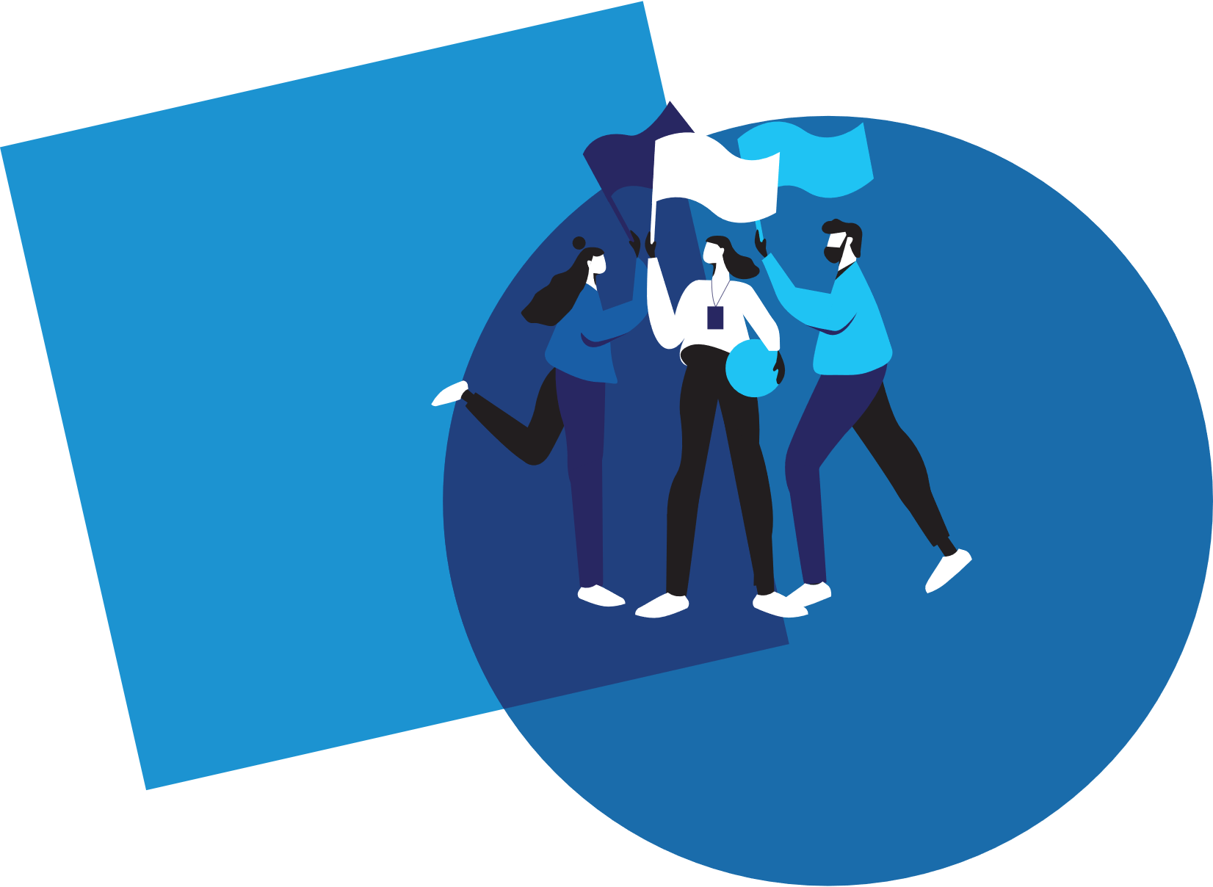

Welcome!
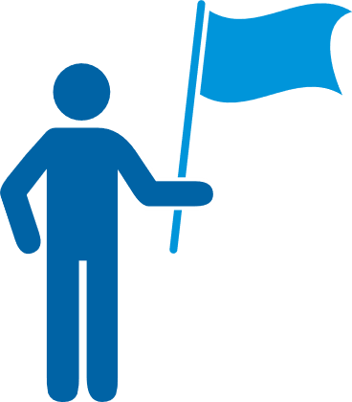 | Welcome to the 1st edition of Personal and Professional Development Lessons in the Special Olympics Leadership & Skills Curriculum. Before you begin, you deserve a high-five for taking the time to gain skills and knowledge so you can live your daily life as a friend, athlete, employee, and leader better than ever before.

There are a total of 15 different lessons within the Personal and Professional Development suite of resources.
The 15 lessons are split into 5 different topics (listed below) with 3 Levels in each topic. The Levels are designed to start out easier and get more difficult as you progress.
1.
Communication
2.
Handling Disappointment
3.
Setting Goals
4.
Healthy Relationships
5.
Advocacy

 |  | Here are a few tips to help you use this workbook and the other 4 workbooks in this suite of Personal and Professional Development resources:
 | 1 |  | We have included a complete list of topics with Topic Descriptions starting on page 4 to help you gain an understanding of all the topics and levels.
 | 2 | 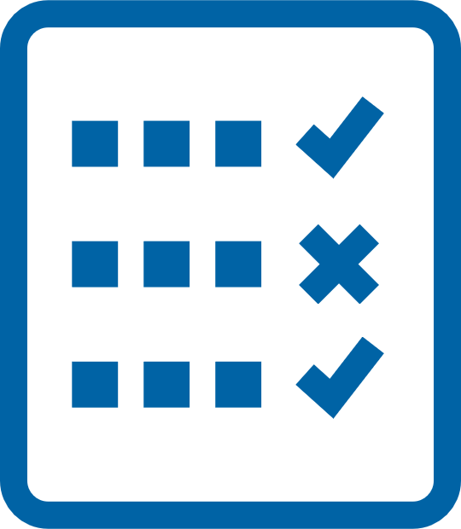 | We have also included a Pre-Skills Assessment on pages 9-15 to help you decide which topic to start with.  This optional resource will help you see your strengths and weaknesses, which will help you to identify which of the 5 Personal and Professional Development topics you should start with.  You even have the option to have someone else who knows you well (like a coach or a family member or a mentor) complete the pre-skills assessment about you, providing feedback to help you better determine the topic and level you should start with.
 | 3 |  | Within each lesson, you will see this graphic below, which encourages you to pause your learning and decide what to do next.
 |  |  | 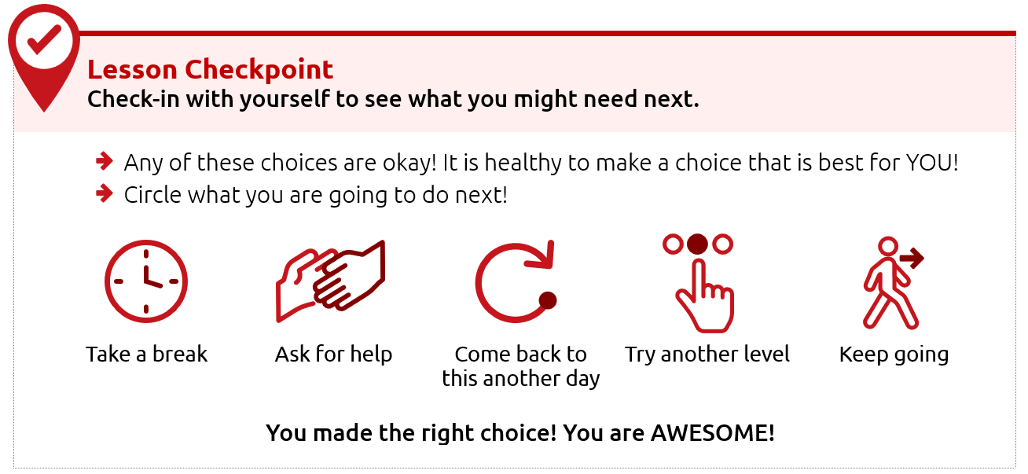
 | 4 |  | Each level takes approximately 30-45 minutes to complete, but it is okay if you take a longer or shorter time. Also, you do not have to complete a full level in one sitting. You can complete these levels at your own pace - even over the course of a few days, weeks, or months.
 | 5 |  | This resource is meant to be self-guided, which means you should be able to do them by yourself. But if you need help, do not be afraid to ask someone to assist you in completing them!
 | 6 |  | The content for each level is on the same topic (for example: Healthy Relationships or Communication) but the way the level asks you to participate is different. Some levels ask you to write your answers, while others ask you to draw your answers. Complete the levels however you prefer.

Alright, are you ready to begin?
We are very excited that you are starting this journey with us!
We believe in you - let’s go!
Topic descriptions and
what you should expect

In total, there are 5 different handbooks covering 5 different topics.
Each topic will have 3 different lessons in it.
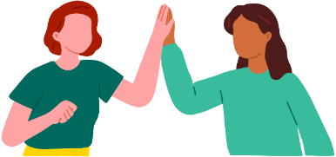
The 5 topics and the 3 lessons within those 5 topics are listed below.

Topic 4: Healthy Relationships (THIS HANDBOOK)
Level 1  Understanding Relationships  Page 15 |  | Learning about relationships is important.  Here is what you will learn in this lesson:  - What it means to have a relationship with someone  - The difference between a healthy relationship and an unhealthy relationship  - What to do if you have an unhealthy relationship
Level 2  Healthy Relationships and Boundaries  Page 29 |  | It is important to have healthy relationships in your life. One important part of a healthy relationship is having boundaries.  Here is what you will learn in this lesson:  - What are different types of relationships?  - What are different types of boundaries?  - How to set your own personal boundaries
Level 3  Conflict Resolution  Page 40 |  | It is important to know how to solve problems and disagreements in your relationships.  Here is what you will learn in this lesson:  - What conflict is and how to identify it in relationships  - Effective ways to prevent conflict  - Strategies to resolve conflict when it happens

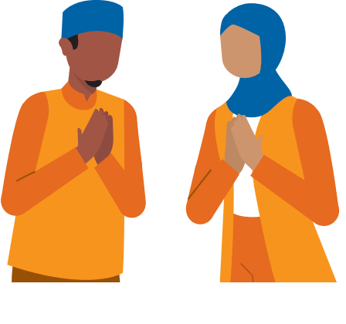

Topic 1: Communication (Different handbook)
Level 1  Starting a Conversation |  | It is important to know how to talk to other people.  Here is what you will learn in this lesson:  - Steps for how to start a conversation with someone  - Different topics that you could use when starting a conversation
Level 2  Appropriate and Inappropriate Conversations |  | It is important to know what is okay or “appropriate” and what is not okay or “inappropriate” when having conversations with others.  Here is what you will learn in this lesson:  - When to start a conversation and when to wait  - When to say something and when you should only think it  - What are appropriate topics for work or school?
Level 3  Active Listening Skills |  | Good communication involves both speaking and listening. If you do not practice “active listening” skills, it can lead to misunderstanding and miscommunication.  Here is what you will learn in this lesson:  - What “active listening” is  - Why listening is a very important part of communicating  - 3 ways to practice “active listening”

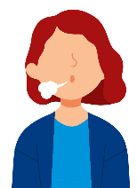
Topic 2: Handling Disappointment (Different handbook)
Level 1  Emotions and Safe Actions |  | Learning how to handle your emotions is important.  Here is what you will learn in this lesson:  - Safe and unsafe ways to handle difficult emotions  - Tips to help you when you have difficult emotions
Level 2  What to do when you feel disappointed |  | An emotion that can be challenging is disappointment. Disappointment can happen when you want something to happen and it does not happen. It can also happen when you expect someone to do something and they do not do it.  Here is what you will learn in this lesson:  - Examples of disappointment  - What are “expectations” and how do we handle them?  - What to do when you feel disappointed
Level 3  Accepting who  you are |  | It is important to practice self-acceptance, especially when facing disappointment. This lesson will help you handle and cope with disappointments in a positive way.  Here is what you will learn in this lesson:  - How to use self-acceptance to deal with disappointment  - The importance of positive self-talk  - Specific strategies for managing emotions / self-acceptance

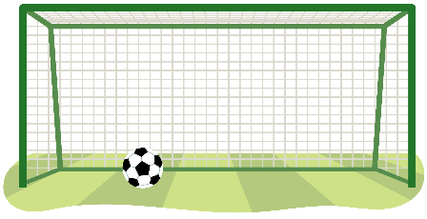
Topic 3: Setting Goals (Different handbook)
Level 1  The Basics of Setting Goals |  | Learning to set goals helps you get better.  Here is what you will learn in this lesson:  - What is a goal?  - How to set a goal for yourself
Level 2  Setting SMART goals |  | Setting a goal is a great way to stay focused on achieving something in the future. This lesson will help you set a goal and create steps to help you meet that goal.  Here is what you will learn in this lesson:  - What is a SMART goal?  - The difference between a goal and a SMART goal.  - How to set a SMART goal for yourself
Level 3  Overcoming Obstacles |  | This lesson will help you build on your understanding of SMART goals and how to overcome challenges.  Here is what you will learn in this lesson:  - How to learn and grow with your goals  - Why it is important to prepare for failure  - Why it is important to keep going and follow through on your goals

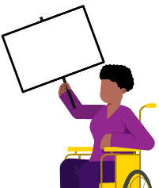
Topic 5: Advocacy (Different handbook)
Level 1  Discovering Yourself |  | It is important to know more about yourself because that helps you to better advocate for yourself and the things you care about.  Here is what you will learn in this lesson:  - What it means to “advocate”  - Ways to learn more about yourself  - Why knowing yourself helps you advocate better
Level 2  Strengths and Weaknesses |  | Being able to name your strengths and weaknesses can help you know how to advocate for yourself and for others.  Here is what you will learn in this lesson:  - How to identify your strengths and weaknesses  - Ways to use your strengths to help others  - Ways to ask others to help you improve your weaknesses
Level 3  Self-advocacy |  | It is important to know how to advocate for yourself. Through “self-advocacy” you can make choices that shape your life.  Here is what you will learn in this lesson:  - What “self-advocacy” is and why it is important  - Examples of self-advocacy in real-life situations  - Steps to practice self-advocacy

Personal and Professional Development Lessons
Pre-Skills Assessment
Skills-Assessment for athlete learner
Directions
This assessment is optional. We created it to help you if you do not know where to begin your learning journey with these topics and levels. If that is the case, please use this assessment to help guide you where to begin. If you would rather go through each topic and level in your own order, that is okay, too.
The statements below describe situations you might encounter in your daily life as a friend, athlete, employee, and leader. For each statement select a number between 1 and 3 to indicate your current confidence level, where:
1 = I am not at all confident | 2 = I am somewhat confident | 3 = I am completely confident

How confident are you that you can… |  |  |  | Not at all  Confident | Somewhat  Confident | Completely  Confident
 | Topic 1: Communication
 | I can start up a conversation with people I do not know. |  |  | 1 | 2 | 3
 | I can ask questions when I want to learn more about what someone is saying. |  |  | 1 | 2 | 3
 | I can listen well to what others are saying to me. |  |  | 1 | 2 | 3
 | Communication total score:
 | Topic 2: Handling Disappointment
 | I can express my emotions in a way that is safe for me and others. |  |  | 1 | 2 | 3
 | I can handle disappointment. |  |  | 1 | 2 | 3
 | I can accept myself for who I am. |  |  | 1 | 2 | 3
 | Handling Disappointment total score:
 | Topic 3: Setting Goals
 | I can set goals for myself and follow a plan. |  |  | 1 | 2 | 3
 | I can adjust my goals when I am faced with failure or obstacles. |  |  | 1 | 2 | 3
 | I can set goals to challenge and push myself outside of my comfort zone. |  |  | 1 | 2 | 3
 | Setting Goals total score:
 | Topic 4: Healthy Relationships
 | I can make and keep healthy relationships. |  |  | 1 | 2 | 3
 | I can work through conflict with other people without hurting their feelings. |  |  | 1 | 2 | 3
 | I can set boundaries with friends and respect when friends set boundaries with me. |  |  | 1 | 2 | 3
 | Healthy Relationships total score:
 | Topic 5: Advocacy
 | I can identify and explain who I am and what I believe in. |  |  | 1 | 2 | 3
 | I can easily accept that there are things that are out of my control. |  |  | 1 | 2 | 3
 | I can advocate for what I want clearly and calmly. |  |  | 1 | 2 | 3
 | Advocacy total score:

Skills-Assessment for Mentor
to complete about the Athlete
Directions
This assessment is optional and should be completed by a mentor or family member of the athlete leader. The person filling this out should be someone who knows the athlete very well and can provide constructive criticism and positive feedback. Your assessment of them is meant to help the athlete leader see their strengths and weaknesses according to someone else so they can identify where to begin their learning journey.
The statements below describe situations the athlete might encounter in their daily life as a friend, athlete, employee, and leader. For each statement, circle a number between 1 and 3 to indicate where you think the athlete’s confidence level is, where:
1 = not at all confident | 2 = somewhat confident | 3 = completely confident.

How confident are you that the athlete can… |  |  |  |  | Not at all  Confident | Somewhat  Confident | Completely  Confident
 | Topic 1: Communication
 | Start up a conversation with people they do not know. |  |  |  | 1 | 2 | 3
 | Ask questions when they want to learn more about what someone is saying. |  |  |  | 1 | 2 | 3
 | Listen well to what others are saying. |  |  |  | 1 | 2 | 3
 | Communication total score:
 | Topic 2: Handling Disappointment
 | Express their emotions in a way that is safe for them and others. |  |  |  | 1 | 2 | 3
 | Handle disappointment. |  |  |  | 1 | 2 | 3
 | Accept themselves for who they are. |  |  |  | 1 | 2 | 3
 | Handling Disappointment total score:
 | Topic 3: Setting Goals
 | Set goals and follow a plan. |  |  |  | 1 | 2 | 3
 | Adjust goals when faced with failure or obstacles. |  |  |  | 1 | 2 | 3
 | Set goals to challenge and push themselves outside of their comfort zone. |  |  |  | 1 | 2 | 3
 | Setting Goals total score:
 | Topic 4: Healthy Relationships
 | Make and keep healthy relationships. |  |  |  | 1 | 2 | 3
 | Work through conflict with other people without hurting their feelings. |  |  |  | 1 | 2 | 3
 | Set boundaries with friends and respect when friends set boundaries with them. |  |  |  | 1 | 2 | 3
 | Healthy Relationships total score:
 | Topic 5: Advocacy
 | Identify and explain who they are and what they believe in. |  |  |  | 1 | 2 | 3
 | Easily accept that there are things that are out of their control. |  |  |  | 1 | 2 | 3
 | Advocate for what they want clearly and calmly. |  |  |  | 1 | 2 | 3
 | Advocacy total score:

Scoring
Add the numbers for each of the five leadership topics. See the example below:
 | Topic 4: Healthy Relationships
 | Make and keep healthy relationships. |  |  |  | 1 |  | 2 |  | 3
 | Work through conflict with other people without hurting their feelings. |  |  |  | 1 |  | 2 |  | 3
 | Set boundaries with friends and respect when friends set boundaries with them. |  |  |  | 1 |  | 2 |  | 3
 | Healthy Relationships total score: |  |  |  |  |  |  |  | 5
What is next?
Congratulations! Like everyone, you have a lot of skills, but you also have new things to learn. These lessons can help you gain new skills and improve upon what you already know.
To help you figure out where to start your learning journey, you can follow these steps:
 | Step
 | 1 | 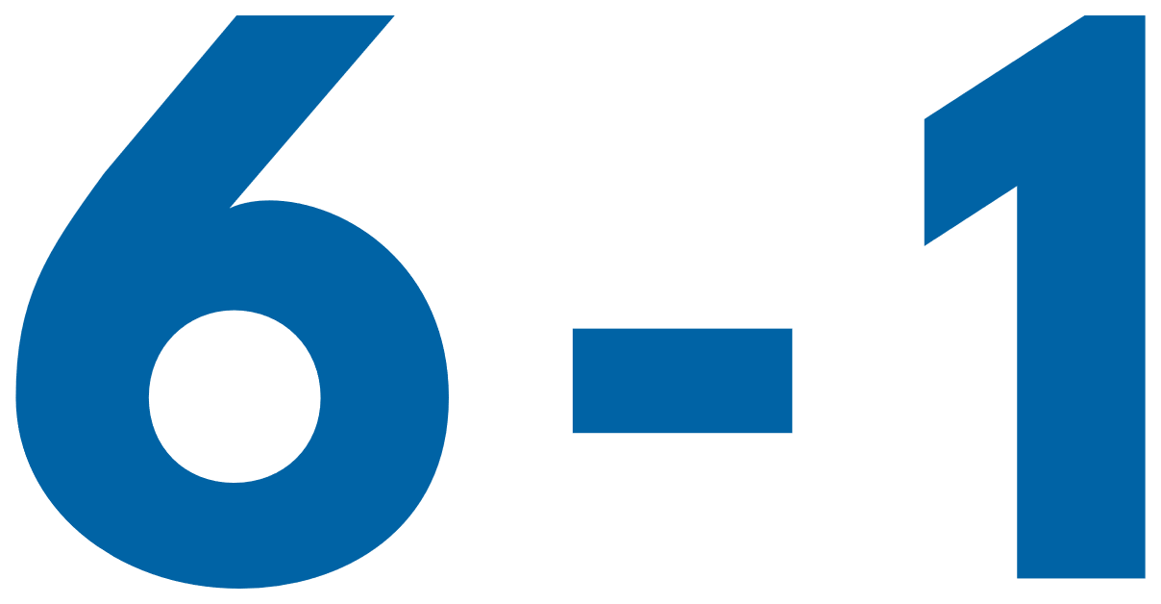 | If you or your mentor/helper gave a total score for any topic of 6 or below, that topic should be one of the first you consider starting at because that shows you have more to learn on that topic.  For example, the athlete listed above who scored five (5) on Healthy Relationships will go to the Healthy Relationships lessons first. If this lesson that you have is not what you are looking for, you can find all 5 topics at the Special Olympics resources website (https://bit.ly/41GT7rW) or you can ask your Program where to find it.
What happens if you and your mentor have scored a topic very differently?
If you and your mentor have different scores for a topic, discuss this with your mentor. Having different scores is an excellent opportunity to receive feedback from someone else and learn more about how others view your knowledge and skills in that category. It is okay if they think that you are lower in a category than you scored yourself. They have a different perspective of your strengths and weaknesses.
There are activities within Communication, Healthy Relationships, and Handling Disappointment that will help you get better with giving and receiving feedback.
 | 2 |  | Continue completing lessons until you have completed all the leadership lessons within the leadership topics that you or your mentor scored 6 or less. Stop after each lesson and give yourself a big round of applause!
 | 3 |  | Take your time and go through one leadership topic or lesson daily so you have time to practice and tell your coach, teammates, and friends what you are learning.
 | 4 |  | After you have completed all the leadership lessons where you scored a 6 or below, complete all the other leadership topics and lessons you are interested in. Even if you scored above a 6 in them, there is always more to learn, so go through all of them! Again, you can find all 5 topics and their 15 lessons by visiting the Special Olympics resources website (https://bit.ly/41GT7rW) or contacting your local Special Olympics staff member and ask for help.

Level 1:
Understanding Relationships
Leadership Lessons
Healthy Relationships
Level 1
Healthy Relationships
Understanding Relationships
 | Think about these questions:
 | 1. | What is a healthy relationship?
 | 2. | How do you know if your relationship with a friend or family member is a healthy relationship?
 | If you do not know yet, do not worry! This lesson will teach you all about relationships and what makes them healthy or unhealthy!
Think about someone who cares about you.
Possible answers: family members, teachers, coaches, mentors, community members, teammates, coworkers.
What do they do or say to show they care about you?
 | 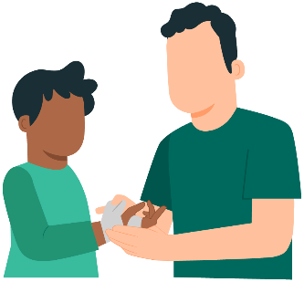 |  | 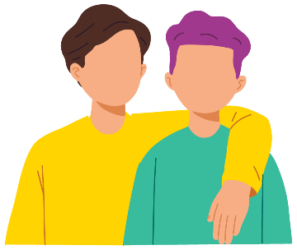 |  | 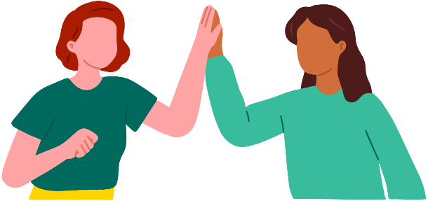
Possible answers: give hugs, encourage you, say kind words, spend time with you, help you.
We have relationships with different people in our lives.

LEARN
 | 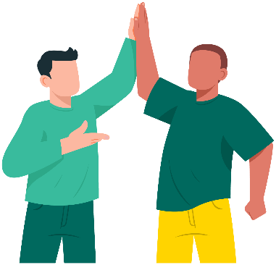 |  | A relationship is a connection between people.
 | There are different kinds of relationships too!
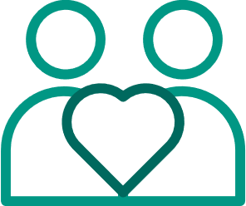
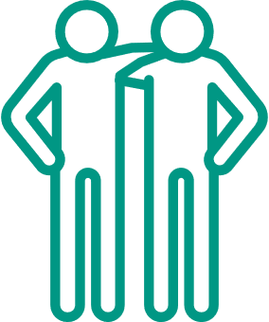
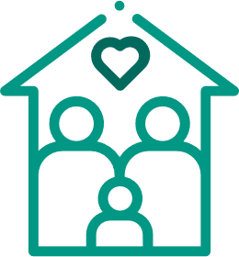
 | Family | Friend |  |  | Romantic
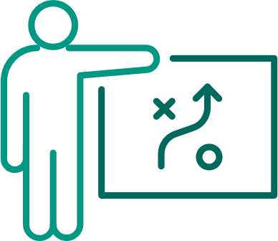
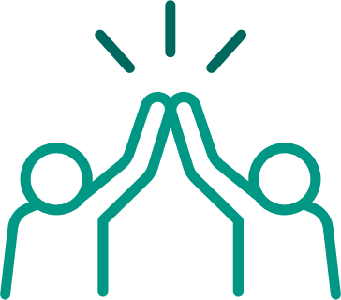
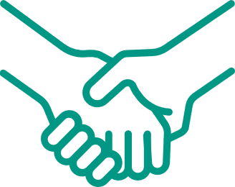
 | Coach | Teammate |  |  | Just met
 | Draw a picture of someone who makes you happy and the things they do to make you happy!
 | It is important to feel happy in your relationships. That means it is healthy!

 | Part 1: Healthy vs Unhealthy
 | A relationship can be healthy or unhealthy.
 | Healthy means good, strong, and happy. |  |  |  |  |  | Unhealthy means bad, harmful, or unhappy.
 | 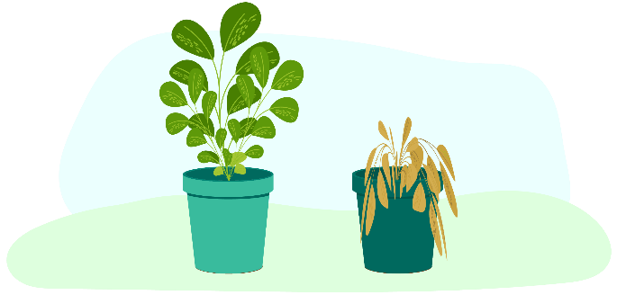
 | It is important to understand what makes a relationship healthy or unhealthy.
 | What makes a relationship healthy?
 |  |  | 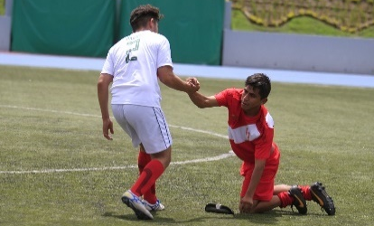
 | Healthy relationships  make us feel happy, safe,  and supported. |  | People in healthy relationships are kind  and helpful. |  |  | Healthy relationships have open communication and trust between people.
 | What makes a relationship unhealthy?
 | Unhealthy relationships can make us feel sad, scared, or not respected. |  | People in unhealthy relationships may act mean or exclude you. |  |  | Unhealthy relationships create problems between people.

Stories
Let us find out if the following stories show healthy or unhealthy relationships.
Story 1
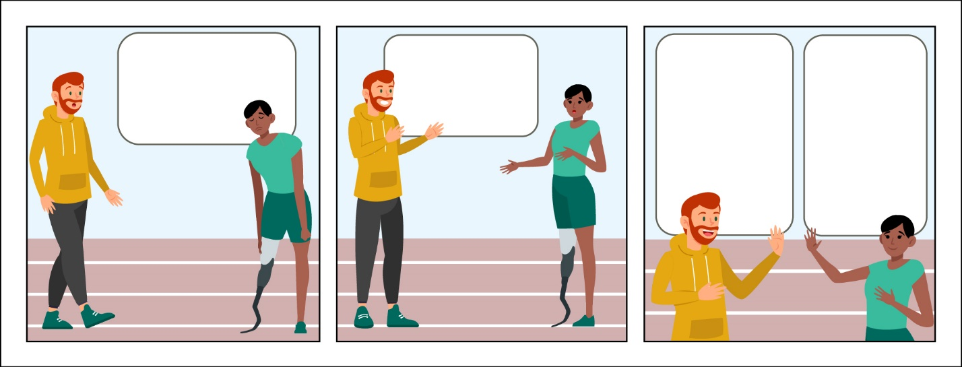
Coach Tom, I did not win.
Do you want to talk about it?
You did not win, Lucy, but I am still proud of you!
Thanks, Coach Tom. You made me feel better!
This relationship seems healthy!
Coach Tom listened to Lucy and they both treated each other kindly.
Story 2
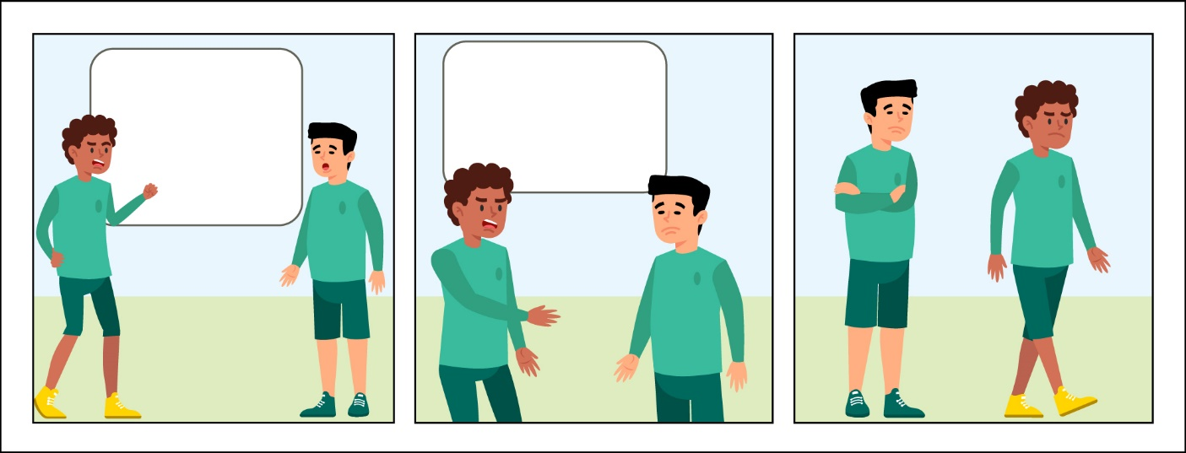
It is all your fault we lost the game!
You should have passed it to me!
Circle One
- This relationship seems healthy.
- This relationship seems unhealthy.
Great job! This relationship is unhealthy because Tim made Derek feel bad for making a mistake and blamed him for losing the game. That is not kind or supportive.

 | Part 2: Practice
 | Put a √ next to the pictures showing a healthy relationship, and a X next to the picture showing an unhealthy relationship.
 | 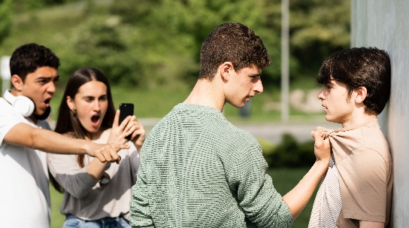 |  |  | 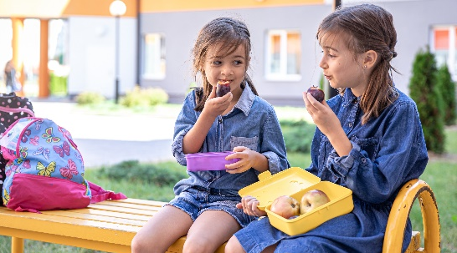
 | Pushing or hitting someone |  |  | Eating lunch together
 | 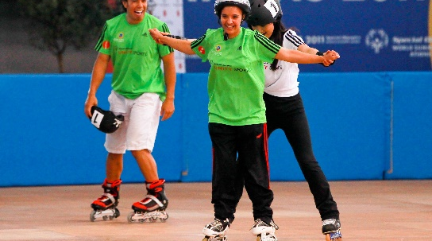
 | Helping someone learn to skate |  |  | Yelling at someone
 | Excluding someone else |  |  | Walking with someone
 | 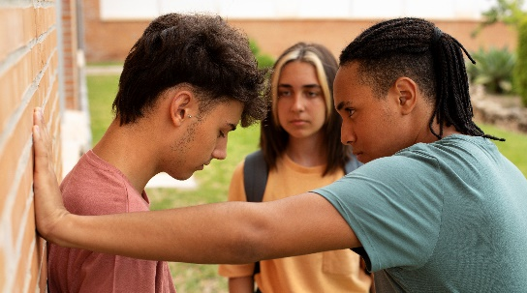 |  |  | 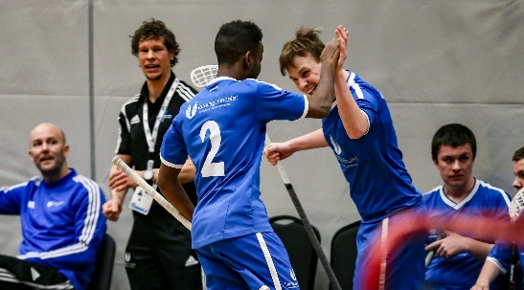
 | Saying mean things |  |  | Giving a high-five to a teammate

 | Answers
 | Pushing or hitting someone | X |  | Eating lunch together | √
 | Helping someone learn to skate | √ |  | Yelling at someone | X
 | Excluding someone else | X |  | Walking with someone | √
 | Saying mean things | X |  | Giving a high-five to a teammate | √

 | Lesson Checkpoint
 | Check-in with yourself to see what you might need next.
- Any of these choices are okay! It is healthy to make a choice that is best for YOU!
- Circle what you are going to do next!
 | 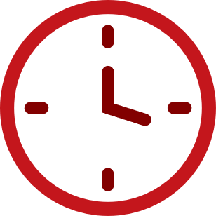 | 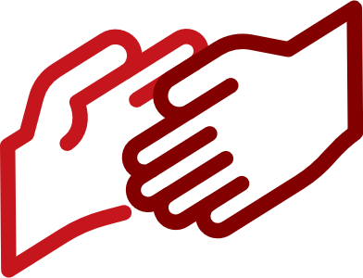 |  |  | 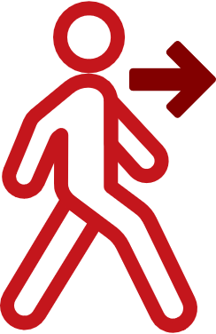
 | Take a break | Ask for help | Come back to this another day | Try another level | Keep going
 | You made the right choice! You are AWESOME!

Stories
Story 3
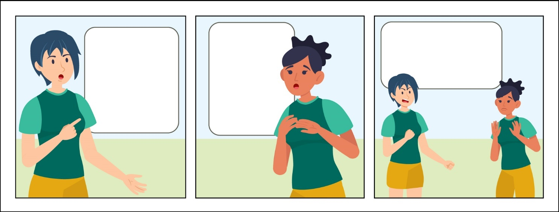
Jasmine, you have to be the goalie today!
Lee, I am always goalie. Can you take a turn?
No. If you want to be on this team you have to do it!
Circle One
- This relationship seems healthy.
- This relationship seems unhealthy.
Explain your answer by writing or drawing in the space below.
Answers
Circle One
a. This relationship seems healthy.
b. This relationship seems unhealthy.
Explain your answer by writing or drawing in the space below.
This relationship is unhealthy because Lee is telling Jasmine what to do. Lee is trying to control Jasmine. That is not kind.

 | Challenge
 | Use what you learned in Lesson 2 about handling emotions safely to circle the right response for Jasmine in the situations below!
 |  | Choice 1 |  |  |  |  | Choice 2
 |  | 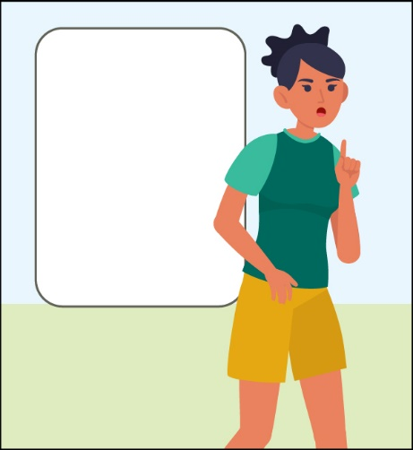  I need to walk away and take a break, I am upset. |  |  |  |  | 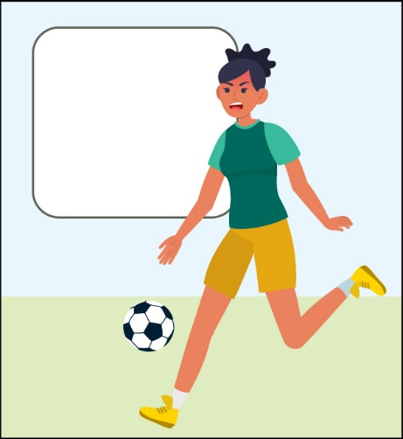  I HATE YOU!
 | Answer:
 |  |  | Choice 1 |  |  |  | Choice 2
 |  | I need to walk away and take a break, I am upset. |  |  |  |  | I HATE YOU!
 | Choice 1 is the best way for Jasmine to handle her emotions because she is using a strategy before she says unkind words and hurts a teammate’s feelings.

Story 4
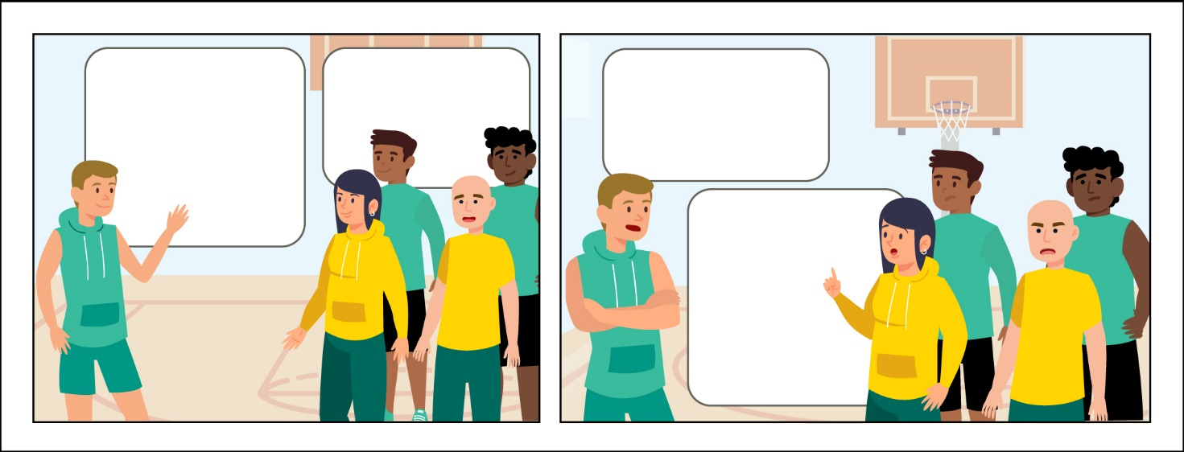
Do you want to play basketball?
Sure!
Chris, you cannot play with us.
Not letting Chris play is not inclusive or kind.
Chris is angry, what should he do?
Finish the story below by drawing a picture or writing it out, so that Chris chooses a safe way to handle his emotions!
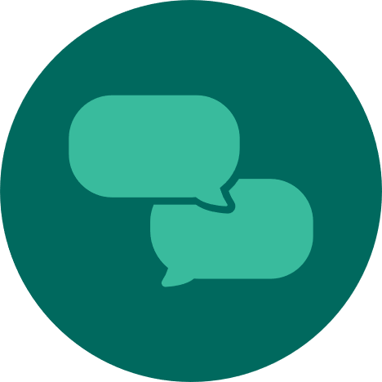
Talk to someone and tell them why you chose that ending! Ask them what they would do in that situation.

Part 3: Healthy Relationship Checklist
Write or draw 2-3 things that make a relationship healthy!
If you ever feel unsafe in a relationship,
it is good to find someone else to talk to. It is okay to ask for help!
In the space below, make a list of people who you will ask for help if you need to!
(Possible answers: Mom, dad, grandparents, sister, brother, aunt, uncle, friends, coaches, mentors, church members, doctors, boss at work, coworkers, police, teammates)

REFLECT
Write or draw what you have learned about in this lesson!
Talk to a mentor about what makes a healthy and unhealthy relationship!

When you are ready for Level 2, where you will learn about boundaries!

Lesson Summary
- A relationship is a connection between people.
- It is important to have healthy relationships.
- A healthy relationship means there is kindness, respect, and support.

Level 2:
What are boundaries?
Leadership Lessons
Healthy Relationships
Check-in
Welcome to Level 2! Before you begin this lesson, see if you can answer a few of the questions below. If these questions are challenging, go to Level 1 and complete that before starting this level. If you already completed Level 1 and still do not know the answers below, it may be a good idea to go back and review them before continuing with Level 2.
What are 2 types of relationships you might have in life?
1
2
What are 2 signs that a relationship is a healthy relationship?
1
2
What are 2 signs that a relationship is an unhealthy relationship?
1
2

Check in
Check your answers
What are 2 types of relationships you might have in life?
Answers could include:
Family, friend, coworker, dating, acquaintance…
What are 2 signs that a relationship is a healthy relationship?
Answers could include:
- They listen to you, they respect you, they are kind to you…
What are 2 signs that a relationship is an unhealthy relationship?
Answers could include:
- They do not respect your boundaries, they take more than they give, they are mean to you
If you could answer these 3 questions, continue with Level 2. If you did not know how to answer them, go to Level 1 to learn all about healthy and unhealthy relationships.

Level 2
Healthy Relationships
What are boundaries?
It is important to have healthy relationships in your life. One important part of a healthy relationship is having boundaries. During this level, you will learn about:
- What are different types of relationships?
- What are different types of boundaries?
- What are your personal boundaries?

Work through these lessons to learn about and then practice having healthy relationships.

Part 1: What are different types
of relationships?
 |  |  |  | Boundaries are the rules or limits that someone sets for themselves to keep them healthy, respected, and safe. Boundaries are important because they protect you.
Different relationships may have different boundaries. Let’s look at different relationships you might have throughout your life.
 |  |  | Write the name of people who fit in each category for you. If the category does not apply right now, leave it blank.
 |  |  | Type of relationship |  | Names of people who fit this category
 |  |  | Family |  | Example:  Chris (my dad)  Emily (my sister)
 |  |  | Friends
 |  |  | Teammates
 |  |  | Coworkers
 |  |  | Strangers |  | Example:  Store cashier  People at the park

Now let’s look at a few examples of different types of boundaries.
 | Scenario 1
 | 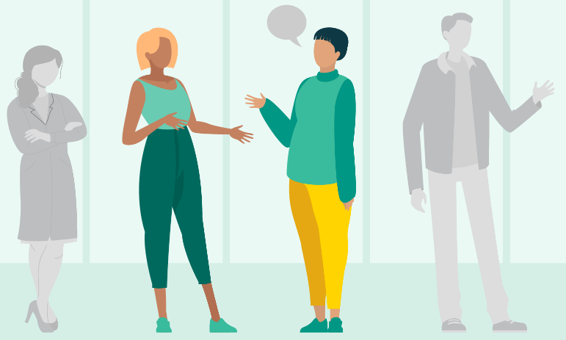 |  |  |  | Rachel was standing in line with her friend. Her friend was standing very close to Rachel – too close for Rachel. So Rachel asked her friend, “Can you please take a step back? I need space.”
 | This is an example of a physical boundary. Physical boundaries include privacy, personal space, and touching.
 | If you were Rachel, how would you handle this situation?
 | Scenario 2
 | 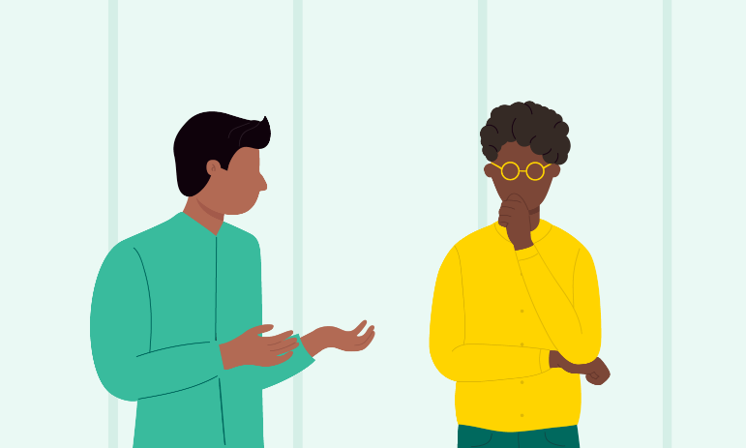 |  |  |  | Sam is always sharing too much about his problems or asking Josh for advice. Sam never asks Josh how he is feeling.  Josh tells Sam that he wants to help him, but sometimes he does not feel valued or respected by Sam because he never gets to share.
 | Josh is setting an example of an emotional or mental boundary. Being a good friend means listening to others, but a healthy relationship also makes space for both people to share and listen equally. Friends should both listen and be able to share with each other. By telling Sam that he needs to be able to share his problems with Josh, he is setting a boundary for their friendship to continue.
 | If you were Josh, how would you handle this situation?
 | Scenario 3
 | 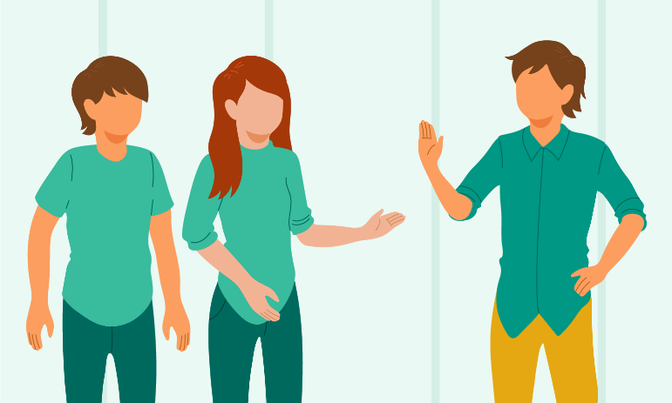 |  |  |  | Muhammed enjoys laughing with his friends. One day his friends started making jokes about someone’s skin color. Muhammed told them that he likes laughing but does not think it is funny to joke about how someone looks, especially their skin color.
 | Muhammed is setting an example of a verbal boundary with his friends. Verbal boundaries are lines that people set to protect themselves or others on topics that they feel uncomfortable discussing.
 | If you were Muhammed, how would you handle this situation?
 | These examples were between friends. You may have different personal boundaries with your friends than with a coworker, a family member, or stranger. For the next few sections, we will use boundaries with friends as our examples.

 | Part 2: What are different types of boundaries?
In order to figure out what your personal boundaries are, think about these two things: things that make you feel safe and things that make you feel uncomfortable.
 |  | Write your answers in the boxes below.
 |  | In these boxes, think about things that family and close friends do:
 |  | Things that make me feel safe, supported, and energized |  | Things that make me feel uncomfortable or exhausted
 |  | (Examples: hugs from my parents, friends, cheering me on, someone asking how I’m doing, spending time alone) |  | (Examples: eye contact, spending too much time with strangers, talking with strangers, shaking hands)
 |  | In these boxes, think about things that family and close friends do:
 |  | Things that make me feel safe, supported, and energized |  | Things that make me feel uncomfortable or exhausted
 |  | By thinking about what makes you feel comfortable and what makes you uncomfortable, you can start thinking about your personal boundaries. Use the next page to help you think about what is important to you.

Put the statements in order from most important to you to least important to you (Use numbers 1 through 8 with 1 meaning it is the most important thing to you, up until 8, which would be the least important thing to you).
There are many possible ways to order these and no wrong answers!
Ask before using my things.
Telling the truth.
Not sharing secrets.
Ask before hugging.
Making eye contact.
Saying please and thank you.
Not making fun of other people.
Being able to share your problems.

 | Lesson Checkpoint
 | Check-in with yourself to see what you might need next.
- Any of these choices are okay! It is healthy to make a choice that is best for YOU!
- Circle what you are going to do next!
 | Take a break | Ask for help | Come back to this another day | Try another level | Keep going
 | You made the right choice! You are AWESOME!

 | Part 3: What are your personal boundaries?
Now that you have been able to look over some different types of boundaries, you can start to think about what boundaries are important to you and how you should communicate them with others.
In this part, you will pick 3 different personal boundaries that are important to you.
- Physical boundaries include privacy, personal space, and touching.
- Emotional boundaries allow you to separate your feelings from someone else’s feelings.
- Verbal boundaries are topics that you feel comfortable talking about or what you feel comfortable joking about.
Here are some examples to look through before you write your own.
Boundary |  |  |  | My personal boundary
Physical boundary |  |  |  | - I want people to ask before they hug me.  - My room is my personal space, I want someone to ask or knock before they come into my room.
Emotional boundary |  |  |  | - If I am feeling sad, I do not want to hear about a friend’s problem at that moment.  - I would like a friend to listen to my whole problem before offering me advice.
Verbal boundary |  |  |  | - I like to be called Samuel, not Sam or Sammy (do not use nicknames).  - I like to joke with my friends, but not when the jokes involve being mean.
Now you try!
Look through examples of different boundaries used in this lesson or think about your own personal beliefs and preferences to come up with a boundary in each of the 3 areas.
Boundary |  |  |  | My personal boundary
Physical boundary
Emotional boundary
Verbal boundary

Lesson Summary
Boundaries are the rules or limits that someone sets for themselves to keep them healthy, respected, and safe. Boundaries are important because they protect you and others.
In this lesson we learned:
- What are different types of relationships?
- What are different types of boundaries?
- What are your personal boundaries?

Healthy Relationships
Leadership Lessons
Level 3:
Conflict Resolution
Check-in
Welcome to Level 3! Before you begin this lesson, see if you can answer a few of the questions below. If these questions are challenging, go to Level 1 or Level 2 and complete those lessons before starting this level. If you already completed Level 1 and Level 2 and still do not know the answers below, it may be a good idea to go back and review them before continuing with Level 3.
What are different types of relationships?
What are different types of personal boundaries in relationships?
What are examples of your personal boundaries?

Check in
Check your answers
What are different types of relationships?
Answers could include:
Family, friends, teammates, coworkers, strangers.
What are different types of personal boundaries in relationships?
Answers could include:
Physical, emotional, verbal, financial…
What are examples of your personal boundaries?
Answers will vary.
If unsure, check Level 2 for ideas.
Here are two examples:
I do not allow my friends to speak to me unkindly.
I do not loan my friends money.
If you could answer these three questions, continue with Level 3. If you did not know how to answer them, go to Level 2 to learn all about boundaries!

Level 3
Healthy Relationships
Conflict Resolution
 | 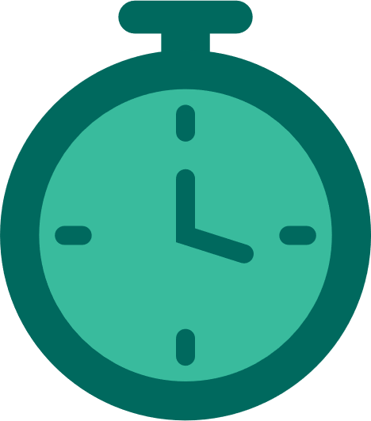 | Workbook Activity Time | 20 minutes
 |  | On Your Own Practice Time | 10 minutes

It is important to know how to solve problems and disagreements in your relationships. In this lesson you will learn more about how to solve and prevent conflicts when they happen to you.
Here is what you will learn in this lesson:
- What conflict is and how to identify it in relationships.
- Effective ways to prevent conflict.
- Strategies to resolve conflict when it happens.

In this lesson we will explore strategies to prevent and resolve conflict.
- Prevent means to keep something from happening. By preventing conflict, we will do things to try to keep conflict from happening.
- Resolve means to solve, handle, or deal with conflict. When we resolve conflict, we solve the problem.

 | Part 1: Defining conflict
Conflict is:
- A normal part of relationships with other people.
- A problem between two or more people who have, or think they have, goals or ideas that do not agree or match.
- Something that happens in every relationship (for example, with your family, classmates, teammates).
 | Conflict is different from violence
 | Conflict is a situation between two or more people who do not agree. |  |  |  |  |  | Violence consists of actions, words and attitudes, that cause physical, mental, or social damage and prevent people from reaching their full potential.
 | Conflict can be a healthy part of having good relationships. |  |  |  |  |  | Violence is hurtful and never okay in relationships.
We will look at a few everyday examples of where conflict may occur:
 | “At practice, my coach wanted to move to the next drill, but I was struggling so I asked my coach and the team to wait. They advanced to the next drill anyway. I need to talk to my coach about this after practice.”
 | “At work, I asked not to work on Fridays, because I have sports practice, but my supervisor keeps putting me on the schedule for Fridays. I need to talk to her about this.”
 |  | These may sound like examples you heard about in the Self-Advocacy Lesson. Do you remember what you learned in the Self-Advocacy Lesson? Those same skills can help you prevent or handle conflict. If you have not been through the Self-Advocacy Lesson, visit it next.
 |  |  | Think about a time you experienced conflict.
 | What happened?
 | How did you feel?
 | List two ways you handled the conflict well:
 | 1
 | 2
 | List two things you could have done better to handle the conflict:
 | 1
 | 2
 | What did you learn from the experience?

 | Part 2: Preventing conflict
 |  |  | You may want to view this optional video on conflict and relationships by Special Olympics Arizona "Understanding Me" program to see two athletes work through conflict.
 |  |  | Scan via  your phone | Or type in a browser
 |  |  |  | https://www.youtube.com/watch?v=sjvDdFjNqa
Conflict or disagreement is a normal thing that can happen. But did you know that conflict can also be prevented?
Think of it like this: While practicing or playing sports, you need to drink water before you feel thirsty, right? That keeps you from becoming dehydrated. Just like you can take steps to prevent dehydration, you can also take steps to prevent conflict.
Steps to prevent conflict:
- Know how you feel about conflict. Does it bother you a lot or do you feel comfortable in conflict situations?
- Use good communication skills.
- Build connections with others.
We will learn more about each of these below…
 | 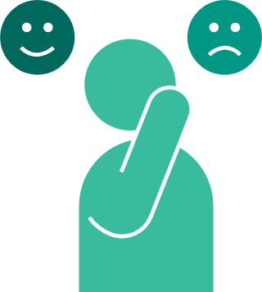 |  | Know how you feel about conflict
Knowing how you feel about conflict or disagreement will help you better approach a conflict situation.
Think about the last time you disagreed with someone. What thoughts or behaviors did you have? For example:
- Did you want conflict to happen because you like to be right?
- Did you agree to whatever the other person wanted because you wanted to avoid conflict?
- Did you avoid the situation, topic, and person completely to escape further disagreement?
None of these are good ways to approach conflict, but it is helpful to know how you feel about conflict. Why? So that you can develop healthy ways to work through conflict that are unique to you.
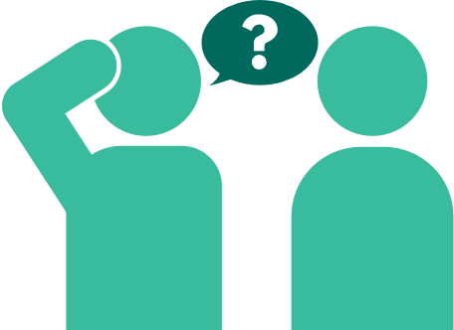 |  |  | Use good communication
When there is disagreement, even the best communicators can lose their ability to stay calm and speak in a nice tone. The next time you are trying to prevent conflict, try one of these things:
- Take a deep breath.
- Use a calm voice.
- Allow the other person to share their thoughts, without interruption.
- Listen; pay attention to what the person is actually saying.
- Ask the person questions to gain more information or explain what is being discussed.
- Share your thoughts calmly and without blaming the other person.
- Share your needs and wants.
Do you remember what you learned in the Active Listening lesson?
Those same communication skills will help you prevent or handle conflict.
Did you learn about getting calm and breathing in the Accepting Me lesson? If you have not been through the Active Listening or Accepting Me lessons, visit those next.
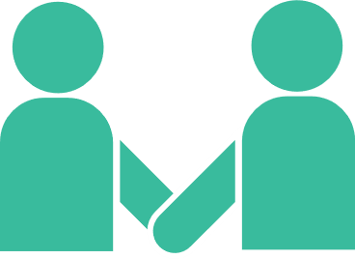
 |  |  | Build healthy relationships with others
Building relationships with others at work, school, on your team, or in your community can help prevent conflict.
How? Connecting with a person can make it easier to work through a disagreement because you have shared experiences and stories, and you see that person as a whole person. This can work even if the connection is virtual and not in-person.
To review, preventing conflict is not running away and hiding or agreeing to something you do not want.
Preventing conflict takes using healthy strategies, such as the ones we just listed above, to gain better communication and understanding, so we can work through problems before conflict occurs.
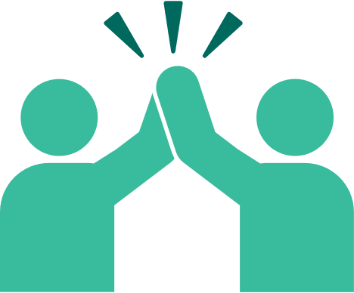
 | Lesson Checkpoint
 | Check-in with yourself to see what you might need next.
- Any of these choices are okay! It is healthy to make a choice that is best for YOU!
- Circle what you are going to do next!
 | Take a break | Ask for help | Come back to this another day | Try another level | Keep going
 | You made the right choice! You are AWESOME!

 | Part 3: Work through conflict
In Part 2 we talked about preventing conflict. But what if preventing conflict was not successful, how can you work through or resolve the conflict once it has started?
Julian and Mateo have a conflict.
To better understand, read this in-person conversation between Julian and Mateo at practice and then answer a few questions:
 | Mateo: | Can I have money to buy a sports drink? I forgot my water.
 | Julian: | No, I gave you money last month and you never gave it back.  (Julian is pointing his finger in Mateo’s face.)
 | Mateo: | I promise I’ll pay you back next week; I am thirsty. You are not my real friend if you say no.  (Mateo is using a loud voice.)
 | Julian: | You are not a friend if you keep pressuring me to give you money.
 | Mateo: | OK then you are not my friend.  (Mateo and Julian each walk away angry and do not talk the rest of practice.)
 | Question:
 | What actions or words between these teammates made the conflict worse?
Pick all that apply:
- Mateo asked for money to buy a drink.
- Julian said he did not want to give Mateo money.
- Julian pointed his finger in Mateo’s face.
- Mateo used a loud voice.
- Julian said Mateo is not a friend if he keeps pressuring him.
- Mateo tells Julian that he is not his friend.
 | These words or actions made the conflict worse, not better:
- Julian pointed his finger in Mateo’s face.
- Mateo used a loud voice.
- Julian said Mateo is not a friend if he keeps pressuring him.
- Mateo tells Julian that he is not his friend.
 | These words did not make the conflict worse. It is important to ask for what you want and tell people how you feel when you disagree with someone.
- Mateo asked for money to buy a drink.
- Julian said he did not want to give Mateo money.

 | So, how could this situation have been better between Julian and Mateo?
 | Statement/Action |  |  | Try this instead
 | Julian pointed his finger in Mateo’s face. |  |  | Julian keeps his hands calmly beside him and does not use threatening or rude actions such as pointing, getting too close to Mateo, etc.
 | Mateo used a loud voice. |  |  | Mateo takes a deep breath when he realizes he is getting upset and maintains a calm voice. He also uses a normal voice that is not angry, provoking, sarcastic, etc.
 | Julian said Mateo is not his friend if he keeps pressuring him. |  |  | Julian rephrases his sentence to speak more about how he feels: “I feel like you do not care about me when you keep asking me for money” or “I feel hurt when you keep asking me for money after I say no.”
 | Mateo tells Julian that he is not his friend. |  |  | Julian realizes he is upset so before he says something he will regret, he calmly tells Mateo he needs a break and walks away. Or Julian rephrases his statement to speak more about how he feels: “We are friends, I just get upset when someone tells me no, and that is something I am working on.”

Conflict resolution
Mateo and Julian are teammates and friends, and we want to get them back on the path of friendship. We also want to give them some strategies so they can deal with conflicts in the future.
Let’s face it, because it has happened several times before, Mateo is probably going to forget his water and ask Julian for money again in the future.
Here are some strategies for these two friends for the next time:
Mateo and Julian agree to talk about their conflict and disagreement, instead of acting like it did not happen.
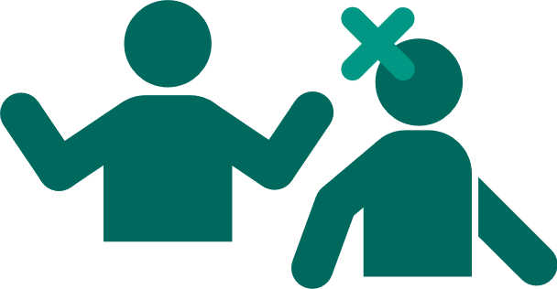
Do not ignore or avoid; be comfortable discussing about the conflict
When Mateo and Julian are talking again, they calmly, and without interrupting each other, talk about what happened from their own side.
Mateo tells Julian his perspective and Julian listens. Next, Julian tells Mateo his perspective and Mateo listens.
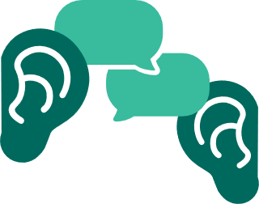
Understand both sides
Mateo and Julian talk about how they will handle this situation the next time Mateo forgets his water.
Instead of asking Julian for money, Mateo will ask Julian if he has an extra water bottle to share. If he does, Julian will share the extra water bottle, but if not, Mateo will accept Julian’s “no” and go ask the coach for help.
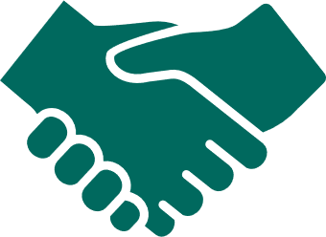
Reach a solution both are happy with
The following week Mateo forgets his water again. He also forgets his and Julian’s agreement and asks Julian for money. Julian reminds his friend of their agreement. Julian does not have an extra water bottle, so Mateo goes to the coach. Mateo is a little upset, but he comes back to Julian and says he is glad they are friends.
Practice and patience
Part 4: Conflict resolution – You try!
Activity: Help Maryam and Ali
Read this situation between athlete leader Maryam and her mentor, Ali and fill in the categories to guide them through their situation:
Maryam is an athlete leader trying to get her mentor, Ali, to help her prepare for two speeches she must deliver in the coming weeks. Ali has responded that he is busy with work, and feels Maryam is ready to give the speeches without his help. Maryam is feeling anxious and wants Ali to help her prepare. She is feeling angry and upset with Ali that he is not helping her.
Fill in the categories below, with successful examples of how Maryam and her mentor can work through this situation.
What are some reasons why Maryam should tell Ali how she is feeling?
Don’t ignore or avoid
What are both sides of the conflict…
What does Maryam want or think?
Understand both sides
What does Ali want or think?
What is a solution you think both Maryam and Ali might be happy with?
Reach a solution both are happy with
How will Maryam and Ali know if their solution will work?
Practice and patience
Keep practicing. Like anything else, preventing or working through conflict takes practice.

Lesson Summary
In this lesson we learned:
- How to understand and define conflicts in relationships.
- Effective ways to work through conflicts, including talking calmly, understanding both sides, and finding solutions that make everyone happy.
- Strategies to prevent conflicts by understanding your feelings, using good communication, and building connections.

Congratulations on completing a lesson on
Personal and Professional Development!
If you completed all 3 Levels on this topic, please take a 5-minute survey using this link or this QR code. Your feedback will help us improve lessons for the future and help us decide what topic or subject we should create next!
 | Click or scan |  | Or type in your browser
 | 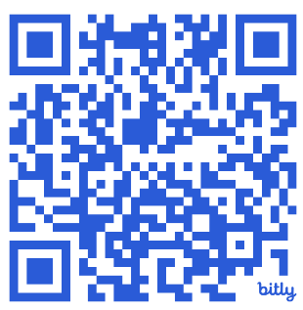 |  | https://bit.ly/3H5v1NU
Do not forget that we have 4 other subjects on Personal and Professional Development that you can complete. If you do not know where to find them, email your Special Olympics Program staff member and they can help you.
Again, congratulations for completing this lesson. We hope that you learned a lot and will use it to become a better leader within your community and within the Special Olympics movement.

