Leadership Lessons
Personal and Professional Development

Topic 2 of 5:
Handling Disappointment

Level 1
Emotions and safe actions
Level 2
What to do when you feel disappointed
Level 3
Accepting who you are

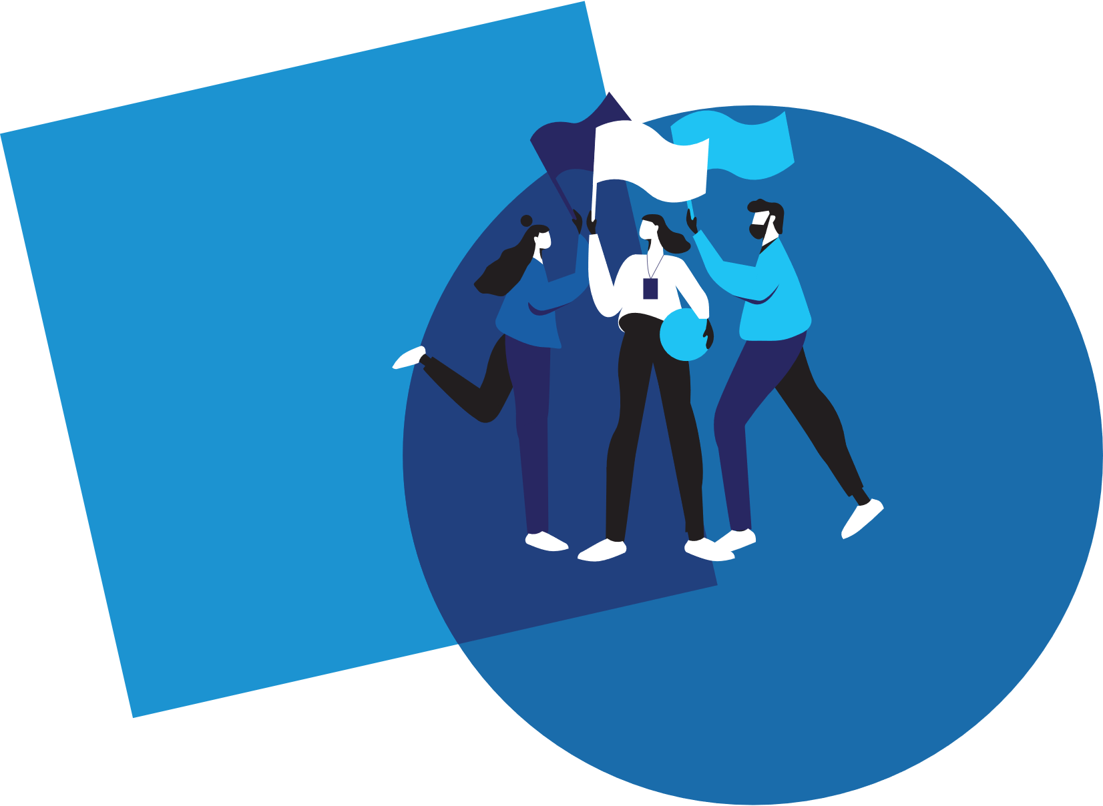

Welcome!
Welcome to the 1st edition of Personal and Professional Development Lessons in the Special Olympics Leadership & Skills Curriculum. Before you begin, you deserve a high-five for taking the time to gain skills and knowledge so you can live your daily life as a friend, athlete, employee, and leader better than ever before.

There are a total of 15 different lessons within the Personal and Professional Development suite of resources.
The 15 lessons are split into 5 different topics (listed below) with 3 Levels in each topic. The Levels are designed to start out easier and get more difficult as you progress.
1.
Communication
2.
Handling Disappointment
3.
Setting Goals
4.
Healthy Relationships
5.
Advocacy

 |  | Here are a few tips to help you use this workbook and the other 4 workbooks in this suite of Personal and Professional Development resources:
 | 1 |  | We have included a complete list of topics with Topic Descriptions starting on page 4 to help you gain an understanding of all the topics and levels.
 | 2 |  | We have also included a Pre-Skills Assessment on pages 9-15 to help you decide which topic to start with.  This optional resource will help you see your strengths and weaknesses, which will help you to identify which of the 5 Personal and Professional Development topics you should start with.  You even have the option to have someone else who knows you well (like a coach or a family member or a mentor) complete the pre-skills assessment about you, providing feedback to help you better determine the topic and level you should start with.
 | 3 |  | Within each lesson, you will see this graphic below, which encourages you to pause your learning and decide what to do next.
 |  |  | 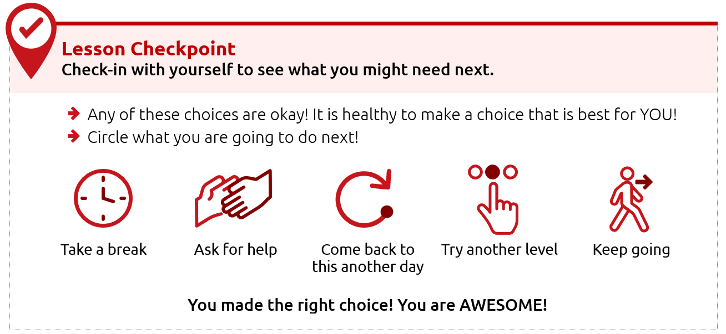
 | 4 |  | Each level takes approximately 30-45 minutes to complete, but it is okay if you take a longer or shorter time. Also, you do not have to complete a full level in one sitting. You can complete these levels at your own pace - even over the course of a few days, weeks, or months.
 | 5 |  | This resource is meant to be self-guided, which means you should be able to do them by yourself. But if you need help, do not be afraid to ask someone to assist you in completing them!
 | 6 |  | The content for each level is on the same topic (for example: Healthy Relationships or Communication) but the way the level asks you to participate is different. Some levels ask you to write your answers, while others ask you to draw your answers. Complete the levels however you prefer.

Alright, are you ready to begin?
We are very excited that you are starting this journey with us!
We believe in you - let’s go!
Topic descriptions and
what you should expect

In total, there are 5 different handbooks covering 5 different topics.
Each topic will have 3 different lessons in it.
The 5 topics and the 3 lessons within those 5 topics are listed below.

Topic 2: Handling Disappointment (THIS HANDBOOK)
Level 1  Emotions and Safe Actions  Page 15 |  | Learning how to handle your emotions is important.  Here is what you will learn in this lesson:  - Safe and unsafe ways to handle difficult emotions  - Tips to help you when you have difficult emotions
Level 2  What to do when you feel disappointed  Page 29 |  | An emotion that can be challenging is disappointment. Disappointment can happen when you want something to happen and it does not happen. It can also happen when you expect someone to do something and they do not do it.  Here is what you will learn in this lesson:  - Examples of disappointment  - What are “expectations” and how do we handle them?  - What to do when you feel disappointed
Level 3  Accepting who  you are  Page 42 |  | It is important to practice self-acceptance, especially when facing disappointment. This lesson will help you handle and cope with disappointments in a positive way.  Here is what you will learn in this lesson:  - How to use self-acceptance to deal with disappointment  - The importance of positive self-talk  - Specific strategies for managing emotions / self-acceptance

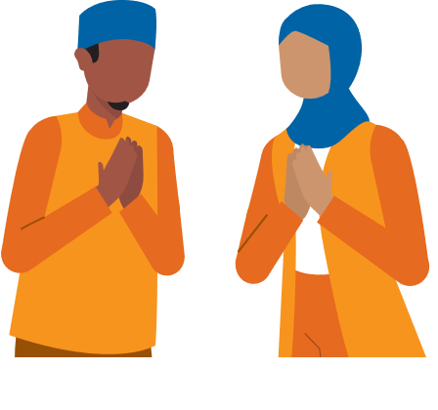

Topic 1: Communication (Different handbook)
Level 1  Starting a Conversation |  | It is important to know how to talk to other people.  Here is what you will learn in this lesson:  - Steps for how to start a conversation with someone  - Different topics that you could use when starting a conversation
Level 2  Appropriate and Inappropriate Conversations |  | It is important to know what is okay or “appropriate” and what is not okay or “inappropriate” when having conversations with others.  Here is what you will learn in this lesson:  - When to start a conversation and when to wait  - When to say something and when you should only think it  - What are appropriate topics for work or school?
Level 3  Active Listening Skills |  | Good communication involves both speaking and listening. If you do not practice “active listening” skills, it can lead to misunderstanding and miscommunication.  Here is what you will learn in this lesson:  - What “active listening” is  - Why listening is a very important part of communicating  - 3 ways to practice “active listening”

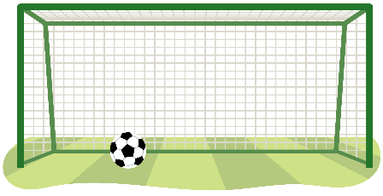
Topic 3: Setting Goals (Different handbook)
Level 1  The Basics of Setting Goals |  | Learning to set goals helps you get better.  Here is what you will learn in this lesson:  - What is a goal?  - How to set a goal for yourself
Level 2  Setting SMART goals |  | Setting a goal is a great way to stay focused on achieving something in the future. This lesson will help you set a goal and create steps to help you meet that goal.  Here is what you will learn in this lesson:  - What is a SMART goal?  - The difference between a goal and a SMART goal.  - How to set a SMART goal for yourself
Level 3  Overcoming Obstacles |  | This lesson will help you build on your understanding of SMART goals and how to overcome challenges.  Here is what you will learn in this lesson:  - How to learn and grow with your goals  - Why it is important to prepare for failure  - Why it is important to keep going and follow through on your goals

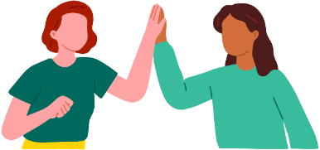
Topic 4: Healthy Relationships (Different handbook)
Level 1  Understanding Relationships |  | Learning about relationships is important.  Here is what you will learn in this lesson:  - What it means to have a relationship with someone  - The difference between a healthy relationship and an unhealthy relationship  - What to do if you have an unhealthy relationship
Level 2  Healthy Relationships and Boundaries |  | It is important to have healthy relationships in your life. One important part of a healthy relationship is having boundaries.  Here is what you will learn in this lesson:  - What are different types of relationships?  - What are different types of boundaries?  - How to set your own personal boundaries
Level 3  Conflict Resolution |  | It is important to know how to solve problems and disagreements in your relationships.  Here is what you will learn in this lesson:  - What conflict is and how to identify it in relationships  - Effective ways to prevent conflict  - Strategies to resolve conflict when it happens

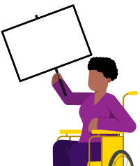
Topic 5: Advocacy (Different handbook)
Level 1  Discovering Yourself |  | It is important to know more about yourself because that helps you to better advocate for yourself and the things you care about.  Here is what you will learn in this lesson:  - What it means to “advocate”  - Ways to learn more about yourself  - Why knowing yourself helps you advocate better
Level 2  Strengths and Weaknesses |  | Being able to name your strengths and weaknesses can help you know how to advocate for yourself and for others.  Here is what you will learn in this lesson:  - How to identify your strengths and weaknesses  - Ways to use your strengths to help others  - Ways to ask others to help you improve your weaknesses
Level 3  Self-advocacy |  | It is important to know how to advocate for yourself. Through “self-advocacy” you can make choices that shape your life.  Here is what you will learn in this lesson:  - What “self-advocacy” is and why it is important  - Examples of self-advocacy in real-life situations  - Steps to practice self-advocacy

Personal and Professional Development Lessons
Pre-Skills Assessment
Skills-Assessment for athlete learner
Directions
This assessment is optional. We created it to help you if you do not know where to begin your learning journey with these topics and levels. If that is the case, please use this assessment to help guide you where to begin. If you would rather go through each topic and level in your own order, that is okay, too.
The statements below describe situations you might encounter in your daily life as a friend, athlete, employee, and leader. For each statement select a number between 1 and 3 to indicate your current confidence level, where:
1 = I am not at all confident | 2 = I am somewhat confident | 3 = I am completely confident

How confident are you that you can… |  |  |  | Not at all  Confident | Somewhat  Confident | Completely  Confident
 | Topic 1: Communication
 | I can start up a conversation with people I do not know. |  |  | 1 | 2 | 3
 | I can ask questions when I want to learn more about what someone is saying. |  |  | 1 | 2 | 3
 | I can listen well to what others are saying to me. |  |  | 1 | 2 | 3
 | Communication total score:
 | Topic 2: Handling Disappointment
 | I can express my emotions in a way that is safe for me and others. |  |  | 1 | 2 | 3
 | I can handle disappointment. |  |  | 1 | 2 | 3
 | I can accept myself for who I am. |  |  | 1 | 2 | 3
 | Handling Disappointment total score:
 | Topic 3: Setting Goals
 | I can set goals for myself and follow a plan. |  |  | 1 | 2 | 3
 | I can adjust my goals when I am faced with failure or obstacles. |  |  | 1 | 2 | 3
 | I can set goals to challenge and push myself outside of my comfort zone. |  |  | 1 | 2 | 3
 | Setting Goals total score:
 | Topic 4: Healthy Relationships
 | I can make and keep healthy relationships. |  |  | 1 | 2 | 3
 | I can work through conflict with other people without hurting their feelings. |  |  | 1 | 2 | 3
 | I can set boundaries with friends and respect when friends set boundaries with me. |  |  | 1 | 2 | 3
 | Healthy Relationships total score:
 | Topic 5: Advocacy
 | I can identify and explain who I am and what I believe in. |  |  | 1 | 2 | 3
 | I can easily accept that there are things that are out of my control. |  |  | 1 | 2 | 3
 | I can advocate for what I want clearly and calmly. |  |  | 1 | 2 | 3
 | Advocacy total score:

Skills-Assessment for Mentor
to complete about the Athlete
Directions
This assessment is optional and should be completed by a mentor or family member of the athlete leader. The person filling this out should be someone who knows the athlete very well and can provide constructive criticism and positive feedback. Your assessment of them is meant to help the athlete leader see their strengths and weaknesses according to someone else so they can identify where to begin their learning journey.
The statements below describe situations the athlete might encounter in their daily life as a friend, athlete, employee, and leader. For each statement, circle a number between 1 and 3 to indicate where you think the athlete’s confidence level is, where:
1 = not at all confident | 2 = somewhat confident | 3 = completely confident.

How confident are you that the athlete can… |  |  |  |  | Not at all  Confident | Somewhat  Confident | Completely  Confident
 | Topic 1: Communication
 | Start up a conversation with people they do not know. |  |  |  | 1 | 2 | 3
 | Ask questions when they want to learn more about what someone is saying. |  |  |  | 1 | 2 | 3
 | Listen well to what others are saying. |  |  |  | 1 | 2 | 3
 | Communication total score:
 | Topic 2: Handling Disappointment
 | Express their emotions in a way that is safe for them and others. |  |  |  | 1 | 2 | 3
 | Handle disappointment. |  |  |  | 1 | 2 | 3
 | Accept themselves for who they are. |  |  |  | 1 | 2 | 3
 | Handling Disappointment total score:
 | Topic 3: Setting Goals
 | Set goals and follow a plan. |  |  |  | 1 | 2 | 3
 | Adjust goals when faced with failure or obstacles. |  |  |  | 1 | 2 | 3
 | Set goals to challenge and push themselves outside of their comfort zone. |  |  |  | 1 | 2 | 3
 | Setting Goals total score:
 | Topic 4: Healthy Relationships
 | Make and keep healthy relationships. |  |  |  | 1 | 2 | 3
 | Work through conflict with other people without hurting their feelings. |  |  |  | 1 | 2 | 3
 | Set boundaries with friends and respect when friends set boundaries with them. |  |  |  | 1 | 2 | 3
 | Healthy Relationships total score:
 | Topic 5: Advocacy
 | Identify and explain who they are and what they believe in. |  |  |  | 1 | 2 | 3
 | Easily accept that there are things that are out of their control. |  |  |  | 1 | 2 | 3
 | Advocate for what they want clearly and calmly. |  |  |  | 1 | 2 | 3
 | Advocacy total score:

Scoring
Add the numbers for each of the five leadership topics. See the example below:
 | Topic 4: Healthy Relationships
 | Make and keep healthy relationships. |  |  |  | 1 |  | 2 |  | 3
 | Work through conflict with other people without hurting their feelings. |  |  |  | 1 |  | 2 |  | 3
 | Set boundaries with friends and respect when friends set boundaries with them. |  |  |  | 1 |  | 2 |  | 3
 | Healthy Relationships total score: |  |  |  |  |  |  |  | 5
What is next?
Congratulations! Like everyone, you have a lot of skills, but you also have new things to learn. These lessons can help you gain new skills and improve upon what you already know.
To help you figure out where to start your learning journey, you can follow these steps:
 | Step
 | 1 |  | If you or your mentor/helper gave a total score for any topic of 6 or below, that topic should be one of the first you consider starting at because that shows you have more to learn on that topic.  For example, the athlete listed above who scored five (5) on Healthy Relationships will go to the Healthy Relationships lessons first. If this lesson that you have is not what you are looking for, you can find all 5 topics at the Special Olympics resources website (https://bit.ly/41GT7rW) or you can ask your Program where to find it.
What happens if you and your mentor have scored a topic very differently?
If you and your mentor have different scores for a topic, discuss this with your mentor. Having different scores is an excellent opportunity to receive feedback from someone else and learn more about how others view your knowledge and skills in that category. It is okay if they think that you are lower in a category than you scored yourself. They have a different perspective of your strengths and weaknesses.
There are activities within Communication, Healthy Relationships, and Handling Disappointment that will help you get better with giving and receiving feedback.
 | 2 |  | Continue completing lessons until you have completed all the leadership lessons within the leadership topics that you or your mentor scored 6 or less. Stop after each lesson and give yourself a big round of applause!
 | 3 |  | Take your time and go through one leadership topic or lesson daily so you have time to practice and tell your coach, teammates, and friends what you are learning.
 | 4 |  | After you have completed all the leadership lessons where you scored a 6 or below, complete all the other leadership topics and lessons you are interested in. Even if you scored above a 6 in them, there is always more to learn, so go through all of them! Again, you can find all 5 topics and their 15 lessons by visiting the Special Olympics resources website (https://bit.ly/41GT7rW) or contacting your local Special Olympics staff member and ask for help.

Level 1:
Emotions and Safe Actions
Leadership Lessons
Handling Disappointment
Level 1
Handling disappointment
Emotions and Safe Actions
 | Think about these questions:
 | 1. | What are emotions that can be difficult to handle?
 | 2. | What are safe ways to express your emotions?
 | If you do not know yet, do not worry! This lesson will teach you all about emotions and how to handle them safely!
Emotions are the different ways we feel inside. They help us understand how we are feeling about things happening around us!
Draw yourself showing 3 different emotions!
Pick 3: Excited, frustrated, disappointed, worried, happy, sad, scared
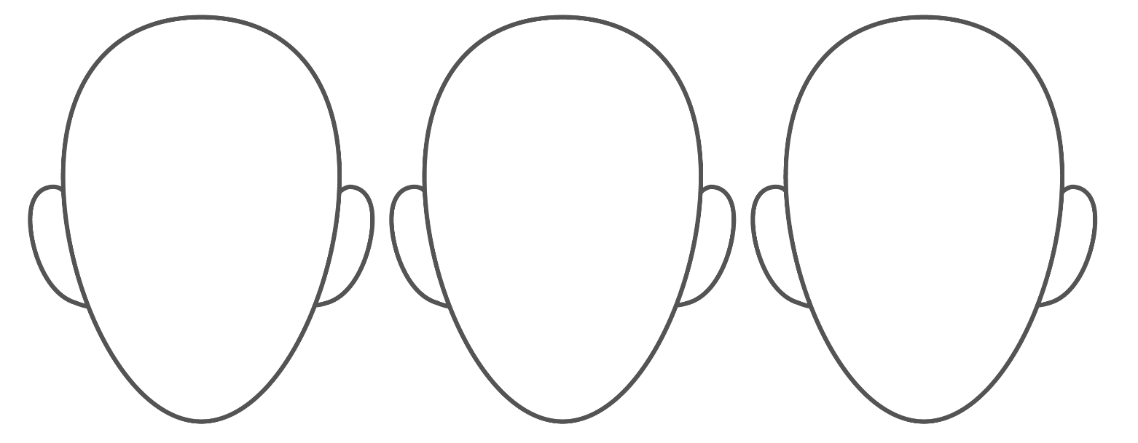

LEARN
Everybody has emotions!
It is important to learn how to handle and express our emotions because it helps us solve problems and make our relationships healthy!
Sometimes, certain emotions can feel too strong or overwhelming.
Strong feelings are okay, even if they are hard to talk about!
Think about a time when you were frustrated or disappointed.
Write or draw what happened.
Possible answers: lost a game, made a mistake, did not get what you wanted, got in a fight with someone…

How did you show your emotions? Write or draw your answer.
Possible answers: yelled, cried, threw something, hit myself or someone else, ran away, took deep breaths, said how you felt, went outside…
Discuss!
Ask a mentor about a time they were frustrated or disappointed and how they handled their emotions.
Write or draw about what happened below.
There are many ways to handle your emotions.
Let us learn some together!

 | Part 1: Express your emotions
It is good to express (let out) your emotions instead of holding them inside!
To express them safely you need a strategy. A strategy is another word for a “plan.”
 | Next time you feel a strong emotion inside, start by asking yourself these 3 questions:
 |  | What emotion do I feel?
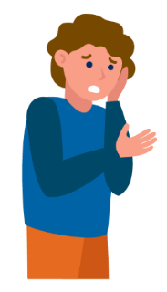
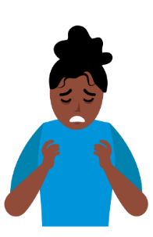
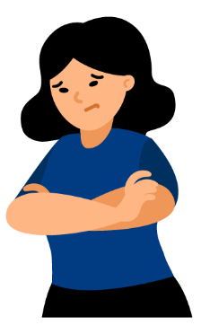
 | Angry |  | Sad |  | Nervous |  |  | Disappointed
 |  | What is the reason I feel this emotion?
 |  |  |  | 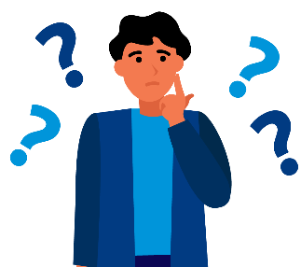
 |  | What strategy will work for me?
 | 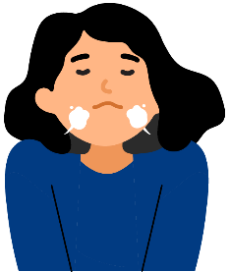 |  |  | 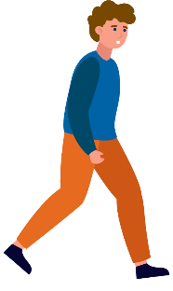
 | Deep breaths |  |  | Walk away |  |  | 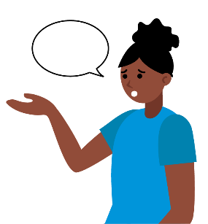  Say how you feel
 | Thinking about these questions can help you make a safe choice.

 |  |  | Strategies
 | Thinking about our breathing can help! Try the strategy using the graphic below.
 | - Put your finger on the star.
 | - Move your finger to trace the line while breathing in.
 | - When you get back to the star, breathe out and trace.
 | Left |  |  |  | Right
 | Left |  |  |  | Right
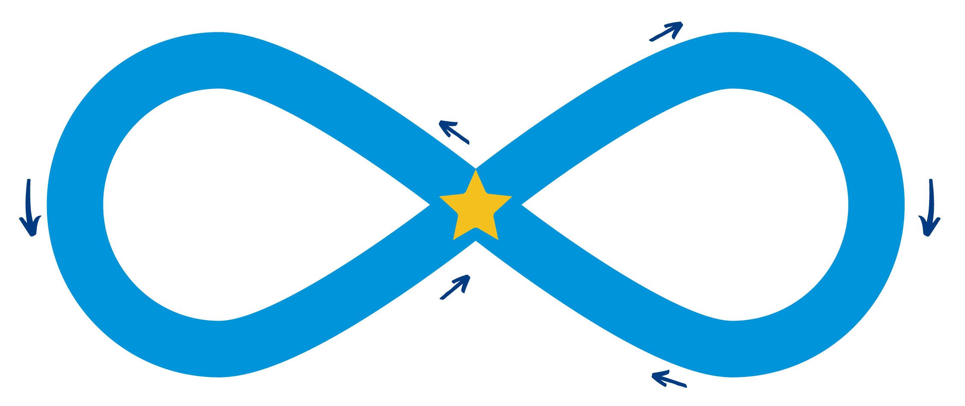
Breathe in
Breathe out
Breathe in
Breathe out
 | Choose one
 |  | Did you like this breathing strategy? |  |  |  | YES | NO
 |  | Did it help you feel calm? |  |  |  | YES | NO

 | Look at the pictures below. Circle any other strategies that help you handle your emotions! If you are not sure, that is ok. Circle things you would like to try.
 | Deep breathing | Write a letter | Imagine a quiet place | Child pose | Drink water | Noise- cancelling headphones
 | Play with pets | Squeeze something like a stress ball | Listen to music | Count backwards | Explore nature | Press and release palms together
 |  | 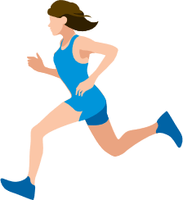 | 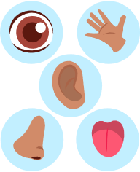 | 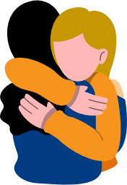
 | Warm bath | Run | 5-4-3-2-1 Grounding technique | Hug someone you care about | Paint
 | Draw or write your own ideas below!

 |  | Safe or unsafe
 | If we do not think about our emotions first, we do or say things that we do not mean to do. When we do that, sometimes our actions may be unsafe.
 | Next to each picture, write one of the symbols showing if the action is safe or unsafe.
 |  |  |  | Safe |  |  |  | Unsafe |  |  |  | Not sure
 | 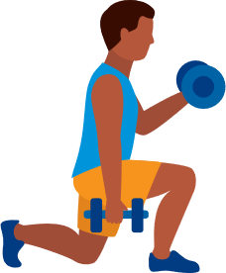 |  |  |  |  | 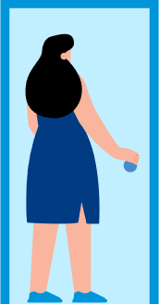
 | Exercise |  |  |  |  | Run away |  |  |  |  | Yell at someone |  |  |  | Cry
 |  |  |  |  |  |  |  |  |  |  | 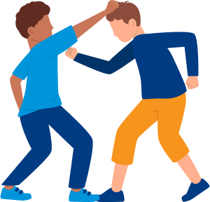
 |  |  |  |  |  |  |  |  |  |  |  |  |  |  | 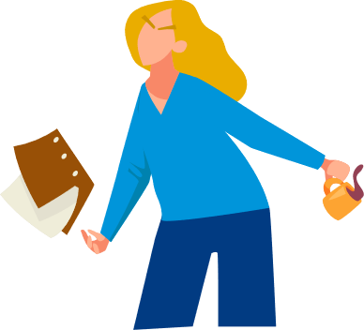
 | Read |  |  |  |  | Play with a pet |  |  |  |  | Fight |  |  |  | Throw things
 | Discuss!
 | Talk to 2 other people and ask them what they do to handle their emotions safely. In the space below, write down what they said that you would like to try.

 | Answers
 |  |  | Safe |  |  | Unsafe |  |  |  | Not sure
 | Exercise |  |  |  | Run away |  |  |  | Yell at someone |  |  |  | Cry
 | Read |  |  |  | Play with a pet |  |  |  | Fight |  |  |  | Throw things

 | Lesson Checkpoint
 | Check-in with yourself to see what you might need next.
- Any of these choices are okay! It is healthy to make a choice that is best for YOU!
- Circle what you are going to do next!
 | Take a break | Ask for help | Come back to this another day | Try another level | Keep going
 | You made the right choice! You are AWESOME!

 | Part 2: Practice with a story
 | Story
 |  | 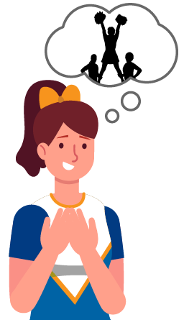 |  | Jill is on a cheerleading team and really wants to be the person on the top of the pyramid, but Jill's coach picked someone else to be at the top. |  |  |  |  |  | 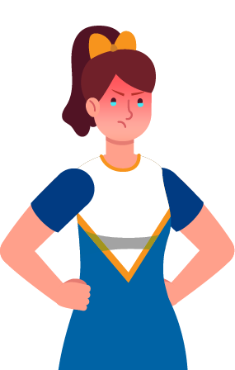 |  | Jill starts to feel a strong emotion inside. Her face feels hot and she has tears in her eyes.
Think about your emotions.
Jill asks herself the 3 questions:
 |  |  | What emotion do I feel?
 |  |  | I feel so disappointed.
 |  |  | What is the reason I feel this emotion?
 |  |  | I feel disappointed because I really want to be at the top.
 |  |  | What strategy will work for me?
 |  |  | I do not want to yell at my coach because that would not be kind. Before I yell, I am going to walk away and take a 5-minute break.
 |  | 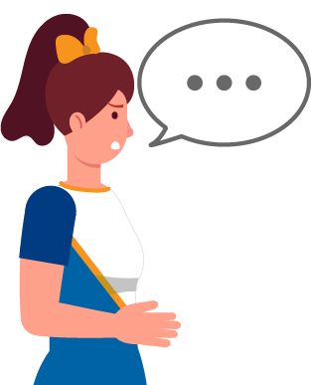 |  |  |  | Jill calmed down and went back up to her coach. She asked:  Coach, I am really disappointed. Is there a time when it will be my turn?
 | Jill did a great job choosing a strategy and expressing her emotions!

 |  | Let us see what would have happened if Jill did not practice a strategy.
 |  | 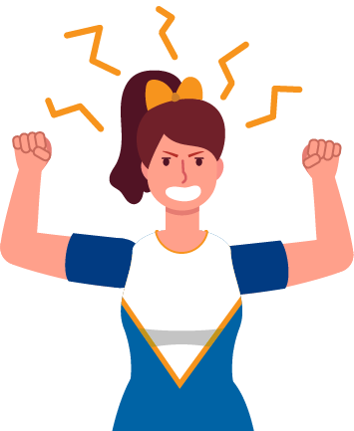 | Jill screams at her coach:  It is not fair! you are so mean! I quit!
Jill did not use a strategy, which means her emotions got stronger and took over.
She did not express her emotions the right way because yelling is not kind.
 | Write or draw another ending of the story where Jill chooses a different strategy!

Draw or Act!
Read each story and either draw or act out what you could do to handle or express your emotions!
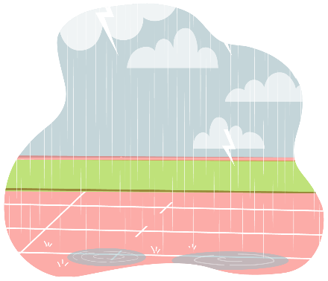
The track event was canceled because of the rain. You are disappointed.
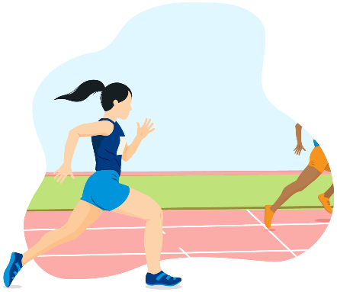
You tried so hard in the track event but you came in last place. You are mad.

REFLECT
Write or draw what you have learned about in this lesson!
Write or draw what a strategy you will do next time your emotions feel too strong.

Lesson Summary
- Emotions can be overwhelming and that is okay!
- It is important to express emotions in a safe way and not keep them inside.
- There are many strategies you can use to handle and express your emotions.

Leadership Lessons
Handling Disappointment
Level 2:
What to do when you feel disappointed
Check-in
Welcome to Level 2! Before you begin this lesson, see if you can answer a few of the questions below. If these questions are challenging, go to Level 1 and complete those lessons before starting this level. If you already completed Level 1 and still do not know the answers below, it may be a good idea to go back and review them before continuing with Level 2.
What emotions could you feel when you lose a game?
1
2
What are 3 strategies for managing your emotions?
1
2
3

Check your answers
What emotions could you feel when you lose a game?
Answers could include:
Frustrated
Sad
Upset
Disappointed
Mad
Furious
What are 3 strategies for managing your emotions?
Answers could include:
- Taking a deep breath
- Thinking of something happy
- Positive affirmation
- Taking a walk
- Listening to music
If you were able to answer these two questions, continue with Level 2. If you did not know how to answer them, go to Level 1 to learn all about how to control your emotions!

Level 2
Handling disappointment
What to do when you feel disappointed
An emotion that can be challenging is disappointment. Disappointment can happen when you want something to happen and it does not happen. It can also happen when you expect someone to do something and they do not do what you thought they would.
In this lesson we are going to talk about:
- Examples of disappointment
- Expectations: What they are and how we handle them
- What to do when you feel disappointed

Disappointment is when you feel sad or angry because something didn’t happen how you wanted it to.

It’s okay to feel disappointed sometimes. We are going to learn how to respond in a good way when you feel disappointed.

Part 1: Understanding Disappointment
Let’s look at some pictures and think about what could be disappointing.
Think about what is happening in this picture. Write why you think this child might be disappointed.
In this picture, the child looks disappointed that they lost the soccer game. Maybe they are disappointed because their coach did not put them in the game. Or they could be disappointed because they did not score a goal.
Let’s try another one!
Think about what is happening in this picture. Write why you think this child might be disappointed.
This child looks disappointed because it is raining. Maybe they had fun plans to do something outside and they cannot do those plans anymore because of the rain.

Let’s try another one!
Think about what is happening in this picture. Write why you think this person might be disappointed.
There are a variety of reasons that this person could be disappointed. They maybe didn’t get invited to a party or they found out that he didn’t make the team. Maybe they were bullied by the group of people behind him.

 | When you are disappointed, you might feel:
 |  |  | Sad |  | Upset |  |  |  | Mad
 |  |  | Angry |  | Frustrated
 | It is okay to feel these emotions! It is disappointing when expectations are not met. Knowing expectations for yourself and others can help you not be disappointed.

Part 2: What are expectations?
An expectation is a belief that something will happen in the future.
There are many places that have expectations of the people who are there. Think about your time in school. There were expectations of you in school, right?
Match the school expectation with the picture by drawing a line to connect the phrase with the picture.
 | Walk in the hallway, do not run
 | Raise your hand if you want to speak
 | Keep your hands to yourself |  | 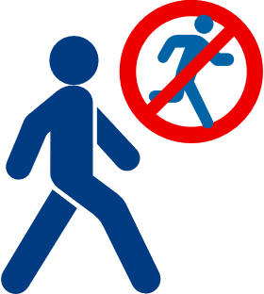  f
 | Listen to the teacher
 | Be kind |  | 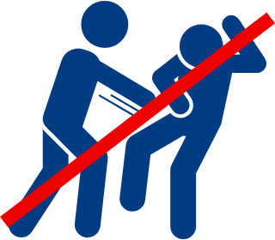

Check your answers
Walk in the hallway, do not run
Raise your hand if you want to speak
Keep your hands to yourself
Listen to the teacher
Be kind

These expectations at school are to help keep you and others safe and ready to learn. If you do not follow these expectations, there may be consequences, something that happens because of an action or choice, which could be disappointing.

We will now talk about other areas where you may have expectations.
When you are part of a sports team, such as a basketball team, there are expectations on how to be a good teammate.
Here are some expectations that your coach and other teammates might have of you:
- Play by the rules
- Do your best
- Help others
- Listen to the coaches
- Have fun

Can you think of other expectations your teammates might have of you?

A big expectation for sports is that you will win. Sometimes you will not win, and that can be disappointing!
We will now talk about what you can do when you lose a game.
Here are a few phrases that can help you if you lose. You can think or say these words to yourself, your teammates, or to the other team:
- That is okay, I might win next time!
- It is just a game.
- Congratulations, you did a good job!
- I enjoyed playing the game.
- I can keep practicing to get better.
- I still like to play games, even when I lose.

When you lose, it is important to still be thoughtful and kind. Here are some things you can do when you lose. You can:
- Tell the winner, ”Congratulations”
- Give the winner a high-five or shake their hand
- Take a break if you are angry or upset and come back when you are ready to talk about your emotions with others
 | Lesson Checkpoint
 | Check-in with yourself to see what you might need next.
- Any of these choices are okay! It is healthy to make a choice that is best for YOU!
- Circle what you are going to do next!
 | Take a break | Ask for help | Come back to this another day | Try another level | Keep going
 | You made the right choice! You are AWESOME!

 | Part 3: Practice responses
Use the next activity to help you practice responding when you lose.
Use the boxes below to help you brainstorm responses to write in each blank box.
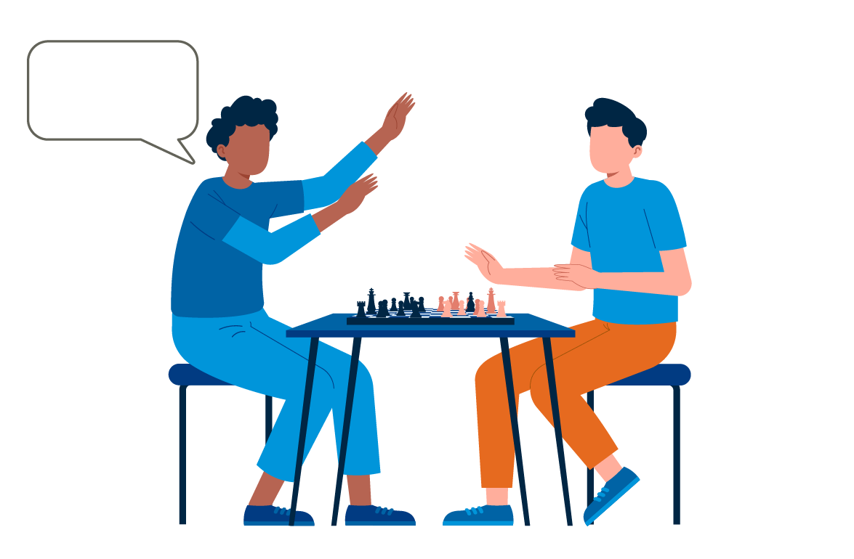
YAY!
I won!
Thanks for playing with me |  |  | We should play another game |  |  | Great job! You are good at this game!
Maybe next game I will win |  |  | I am frustrated that I lost, so I am going to take a break. |  |  | Congratulations (give a high-five)

Now your turn!
Use the ideas above or come up with your own to write the words in the empty box to practice what you could say to yourself or your teammates if you lost.
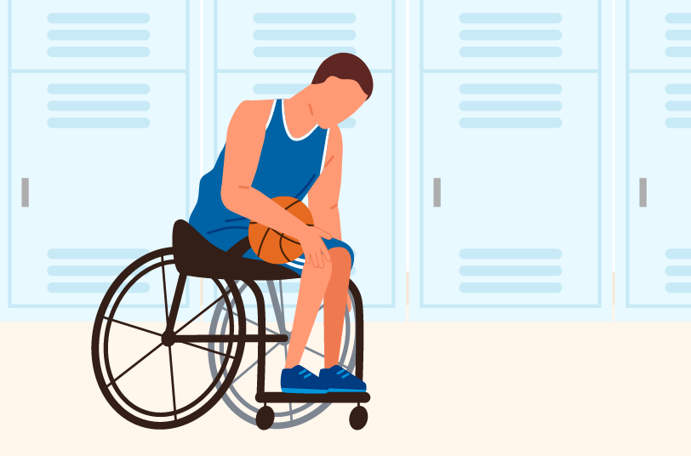

Now we will try another one!
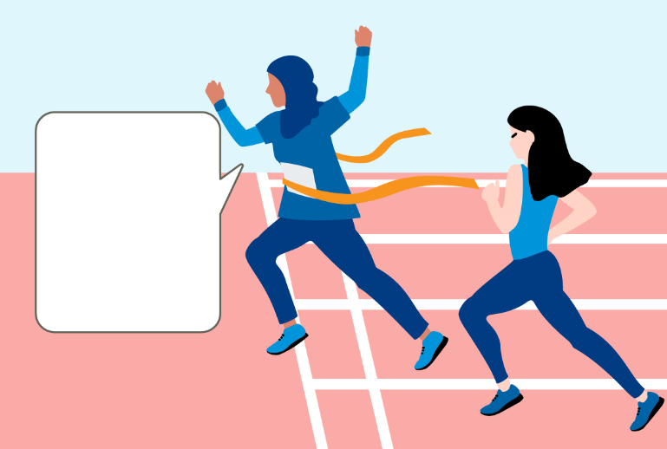
I got 1st place!

Think about how you could respond to these disappointments.
v
You did not get the job that you interviewed for.

Try one more!
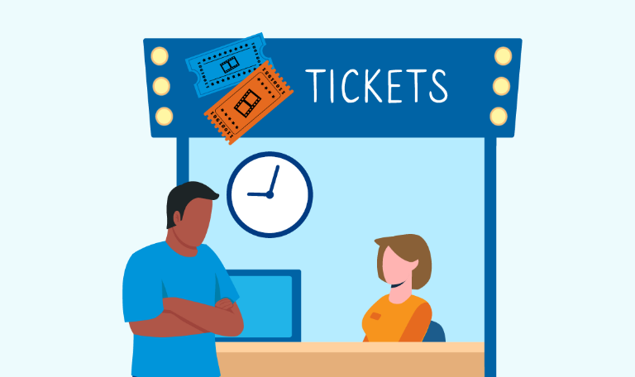
You go to the movie theater, but you missed the start time for the movie you wanted to see.

Think of a time that you lost a game. If you can’t think of a time, draw a picture of what it would look like if you lost playing your favorite game.
Write some words that you could say if you lost.
Connection time
Find a friend or family member and ask them these questions below. Write their answers in the spaces below.
- When was a time you were disappointed?

- What did you say or do at that moment?

- Share a time where you were disappointed in something I said or did?
How did you handle it?

Lesson Summary
Disappointment is when you feel sad or angry because something didn’t happen how you wanted it to. It’s okay to feel disappointed sometimes.
In this lesson we learned:
- Examples of disappointment
- How to know and handle expectations
- What to do when you feel disappointed

Level 3:
Accepting Me
Leadership Lessons
Handling Disappointment
Check-in
Welcome to Level 3! Before you begin this lesson, see if you can answer a few of the questions below. If these questions are challenging, go to Level 1 or Level 2 and complete those lessons before starting this level. If you already completed Level 1 and Level 2 and still do not know the answers below, it may be a good idea to go back and review them before continuing with Level 3.
What is an example of a time you were disappointed?
What are expectations and how do we handle them?
What do you do when you feel disappointed?

Check in
Check your answers
What is an example of a time you were disappointed?
Answers could include:
Losing a game, missing a goal, plans changing, weather not being good to do what you wanted to do, friends canceling on you.
What are expectations and how do we handle them?
Answers could include:
An expectation is a belief that something will happen in the future. Knowing expectations for a situation before going into the situation will help you prepare to not be disappointed. There are different expectations for different events. Asking what the expectations are or thinking about them ahead of time can be a great way to avoid disappointment.
What do you do when you feel disappointed?
Answers could include:
Appropriate responses to feeling disappointment are telling someone else that you are disappointed and need some time by yourself, being able to congratulate someone else if they won and you lost, taking a deep breath and being thankful for the opportunity.
If you could answer these three questions, continue with Level 3. If you did not know how to answer them, go to Level 2 to learn all about handling disappointment!

Level 3
Handling disappointment
Accepting me
 |  | Workbook Activity Time | 15 minutes
 |  | On Your Own Practice Time | 10 minutes

It is important to practice self-acceptance, especially when facing disappointment. This lesson will help you handle and cope with disappointments in a positive way.
Here’s what you will learn in this lesson:
- How to use self-acceptance to deal with disappointment
- The importance of positive self-talk
- Specific strategies for managing emotions / self- acceptance

Part 1: How have you dealt with disappointment?
This lesson is about using “self-acceptance” as a way to deal with disappointment. We will explain what we mean by self-acceptance later, but first we want to know about your experience with disappointment.
Examples of disappointment may include: not getting a job you wanted, your friend having other plans, not getting to play in the final 2 minutes of a game, someone else being chosen over you to serve on a committee.
Think about a time you were disappointed.
What happened?
How did you feel?
What did you do to feel better about the disappointment?
There are many effective strategies to deal with disappointment, such as: talking about it with someone, writing about it in a journal or blog, listening to music, going for a walk, and many others.

In this lesson, we will explore self-acceptance as a way to deal with disappointment. What do we mean by “self-acceptance”?

Self-Acceptance is:
- Accepting all your physical and mental habits, traits, personality, and abilities.
- Accepting the parts of you that you think are negative or not likeable.
- Celebrating yourself, no matter how small the accomplishment.

Part 2: Accepting me with positive self-talk
Positive Self-Talk
Positive self-talk will help with self-acceptance. Positive self-talk is when we say positive things to ourselves!
Using positive self-talk can:
- Improve how we feel about ourselves
- Help us face a difficult challenge
- Help us deal with disappointment
- Help us stay calm when faced with problems or obstacles
Question
Which of the below examples of positive self-talk would you like to try saying to yourself?
Put a checkmark beside each positive self-talk statement listed below that you would like to try.
Then in the final two spots, write down two positive self-talk statements you have tried and had success with or would like to try.
- I can do it.
- I am strong.
- I am good enough.
- It is okay if I make a mistake.
- I deserve this and I deserve to be happy.

Speak, Post, Listen, Read
Everyone learns differently. So, it makes sense that people also like to use positive self-talk differently.
Below are some ways that you can communicate positive messages to yourself
 |  | Speak it…
Pick your favorite positive self-talk statements and say them to yourself whenever you feel it is needed. Saying them in a mirror or on your phone in selfie mode could help!
For example:
- I can do this.
- I am strong.
- I am good enough.
You may pick different statements depending on the situation. You might rotate your statements depending on how useful they are to you!
 |  | Post it… | p
Create and write your favorite positive self-talk statements on a poster, sticky note, or paper, and post or place them in places where you will see them. You could do it on a door you pass as you are leaving for work, in a bag you carry with you, or on your mirror where you get dressed each day.
You don’t need to be a great writer to practice this skill. You are the only one who needs to see these, so write out whatever will motivate you!
Positive self-talk is saying positive things to ourselves, especially when things are not going well, and others are telling us that we cannot do it or that they do not believe in us.
Examples of Positive Self Talk:
- I can do it.
- I am good enough.
- It’s ok if I make a mistake. I will learn from it and do better next time!
- I deserve this and I deserve to be happy.
 |  | Listen to it… | p
 | Create recordings or a voice note on your mobile phone, tablet, or other device of positive self-talk statements that you personally like, so you can listen back to them whenever you feel they are needed.
 |  | Read it! | p
 | Create a journal of positive self-talk statements so that you have multiple options for whatever challenge or disappointment comes your way. When you find a statement, quote, or positive saying that you like, write it in your journal.

 | Lesson Checkpoint
 | Check-in with yourself to see what you might need next.
- Any of these choices are okay! It is healthy to make a choice that is best for YOU!
- Circle what you are going to do next!
 | Take a break | Ask for help | Come back to this another day | Try another level | Keep going
 | You made the right choice! You are AWESOME!

 |  | Part 3: Accepting me with relaxation & meditation
Why Relaxation?
In order to accept ourselves, we need to begin by slowing down, calming down, and taking a deep breath when faced with disappointment. Why?
Well, often when we are disappointed we are so angry or sad or frustrated that we practice unhealthy habits that are not good for us. Like saying bad things to ourselves (“I cannot do anything right”, “I fail at everything”), shouting at others, eating unhealthily, missing practice, hurting ourselves or others, or not seeking out supportive and trusted friends and adults.
These are not what we need after disappointment and these unhealthy behaviors are not helpful to us and will not fix the situation.
So, after a disappointment, we need to learn to STOP, slow down, and calm ourselves.
Stop |  |  |  |  |  |  |  |  |  |  |  | Slow down |  |  |  | Calm ourselves
Questions
- In the past, have you tried to calm yourself after experiencing anger, sadness, or frustration from being disappointed? Circle one:
 |  |  | Yes |  |  | No
- If yes, how did you try to calm yourself or feel better? Write two ways:
- Did these ways work? Were you able to slow down and calm yourself? Circle one:
 |  |  | Yes |  |  | No
- Were these healthy ways to calm yourself? Circle one:
 |  |  | Yes |  |  | No
- What made this approach feel healthy?
- What else could you have done to deal with the feelings of disappointment in a positive and healthy way? Write down two ideas:
 |  |  | Here are some ideas from other athlete leaders
 |  |  | - Take a walk  - Talk to a friend  - Draw or make art  - Work in the garden  - Meditation |  |  |  |  |  |  |  |  |  |  | - Practice deep breathing  - Listen to music  - Dance  - Listen to free podcasts or meditation playlists on Spotify
Meditation: What is it?
Meditation has been practiced for thousands of years. It is an activity that involves focusing on clearing and calming your mind. There are many physical and mental techniques to practice meditation to calm the mind and relax.
Here are some examples:
 |  |  |  | Walking meditation |  |  |  | o | Play quiet music and with your eyes open walk around a safe space without touching anything or making any noise. The goal of the walking meditation is to walk slowly and focus on the movement of your body, breath, and nothing else.
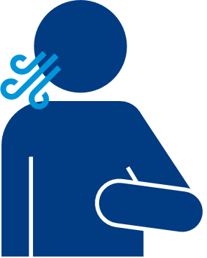 |  |  |  | Breathing meditation |  |  |  |  | - Sit or lie comfortably with your eyes closed or just look down. Take a few deep breaths and let your body and muscles relax. Feel yourself letting go of any tension you are holding in your body. Let your muscles relax and your breathing slow.  - Focus on your breath for several minutes. Slowly Inhale and then exhale. Inhale and then exhale.  - After a few minutes, begin to take deeper breaths. Slowly bring movement to your body, by wiggling your toes, fingers, gently turn your head side to side. If you are lying down, slowly roll onto one side and slowly make your way up to seated.  - Slowly open your eyes. Take a deep breath in and sigh it out. One more breath in and sigh it out.  From: https://media.specialolympics.org/resources/sports-essentials/fitness-model-resources/SOfit_Manual_UPDATED2017.pdf
 |  |  |  | Guided meditation |  |  |  |  | In guided meditation, you listen to and follow another person’s voice, typically through a recording. Listening to someone else’s voice guide you through meditation might keep you more focused on relaxation and keep your mind from wandering.  Here are some guided imagery resources to try:
 |  |  |  |  |  |  |  |  | Click or scan |  |  |  | Or type in a browser:
 |  |  |  |  |  |  |  |  | Belonging |  |  |  | https://media.specialolympics.org/resources/health/disciplines/strongminds/mindfulness-recordings/Strong-Minds-Belonging.mp3
 |  |  |  |  |  |  |  |  | Leadership |  |  |  | https://media.specialolympics.org/resources/health/disciplines/strongminds/mindfulness-recordings/Strong-Minds-Leadership.mp3
 |  |  |  |  |  |  |  |  | Wellness |  |  |  | https://media.specialolympics.org/resources/health/disciplines/strongminds/mindfulness-recordings/Strong-Minds-Wellness.mp3

 | Part 4: Self-acceptance – You try!
Activity – Positive Self-Talk
Pick one way that you would like to try to increase self-acceptance.
Because people like to receive positive self-talk differently, in Step 2, we offered different ways you can communicate positive messages to yourself. Pick one and try it for one week. Then when you are done using that one for a week, come back to this page and the next one to take notes on what worked with that strategy and what did not work with that strategy.
Then be sure to try one of the others. Do that until you have tried all four!
 |  | Speak it…
 | Pick your favorite positive self-talk statements and say them to yourself whenever you feel it is needed.
 |  |  | I tried this strategy, and it was helpful because: |  |  |  | This strategy did not really work for me, because:

 |  | Post it… |  | p
 | Create and write your favorite positive self-talk statements on a poster, sticky notes, or paper, and post or place them in places where you will see them.
 |  |  | I tried this strategy, and it was helpful because: |  |  |  | This strategy did not really work for me, because:
 |  | Listen to it… |  | p
 | Create recordings or a voice note on your mobile phone, tablet, or other device of positive self-talk statements that you personally like, so you can listen back to them whenever you feel they are needed.
 |  |  | I tried this strategy, and it was helpful because: |  |  |  | This strategy did not really work for me, because:
 |  | Read it! |  | p
 | Create a journal of positive self-talk statements. When you find a statement, quote, or positive saying that you like, write it in your journal.
 |  |  | I tried this strategy, and it was helpful because: |  |  |  | This strategy did not really work for me, because:
 | Keep practicing. Like anything else, self-acceptance takes practice.

Lesson Summary
In this lesson we learned:
- How to deal with disappointment using the concept of self-acceptance.
- The importance of positive self-talk and how it can improve your self-esteem and ability to deal with things that do not go your way.
- Techniques for practicing meditation and relaxation to manage your emotions and foster self-acceptance.

Congratulations on completing a lesson on
Personal and Professional Development!
If you completed all 3 Levels on this topic, please take a 5-minute survey using this link or this QR code. Your feedback will help us improve lessons for the future and help us decide what topic or subject we should create next!
 | Click or scan |  | Or type in your browser
 |  |  | https://bit.ly/3H5v1NU
Do not forget that we have 4 other subjects on Personal and Professional Development that you can complete. If you do not know where to find them, email your Special Olympics Program staff member and they can help you.
Again, congratulations for completing this lesson. We hope that you learned a lot and will use it to become a better leader within your community and within the Special Olympics movement.

