Leadership Lessons
Personal and Professional Development

Topic 1 of 5:
Communication

Level 1
Starting a Conversation
Level 2
Appropriate and Not Appropriate Conversation
Level 3
Active Listening

Welcome!
Welcome to the 1st edition of Personal and Professional Development Lessons in the Special Olympics Leadership & Skills Curriculum. Before you begin, you deserve a high-five for taking the time to gain skills and knowledge so you can live your daily life as a friend, athlete, employee, and leader better than ever before.

There are a total of 15 different lessons within the Personal and Professional Development suite of resources.
The 15 lessons are split into 5 different topics (listed below) with 3 Levels in each topic. The Levels are designed to start out easier and get more difficult as you progress.
1.
Communication
2.
Handling Disappointment
3.
Setting Goals
4.
Healthy Relationships
5.
Advocacy

 |  | Here are a few tips to help you use this workbook and the other 4 workbooks in this suite of Personal and Professional Development resources:
 | 1 |  | We have included a complete list of topics with Topic Descriptions starting on page 4 to help you gain an understanding of all the topics and levels.
 | 2 | 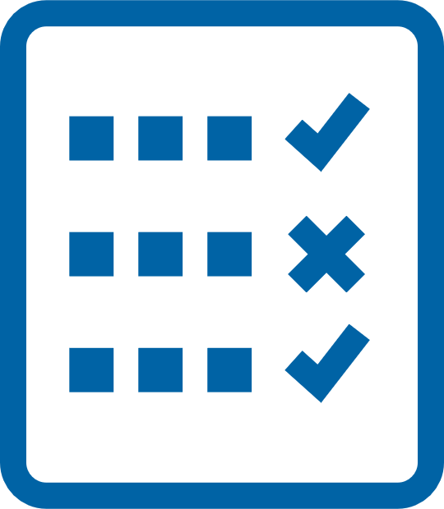 | We have also included a Pre-Skills Assessment on pages 9-15 to help you decide which topic to start with.  This optional resource will help you see your strengths and weaknesses, which will help you to identify which of the 5 Personal and Professional Development topics you should start with.  You even have the option to have someone else who knows you well (like a coach or a family member or a mentor) complete the pre-skills assessment about you, providing feedback to help you better determine the topic and level you should start with.
 | 3 |  | Within each lesson, you will see this graphic below, which encourages you to pause your learning and decide what to do next.
 |  |  | 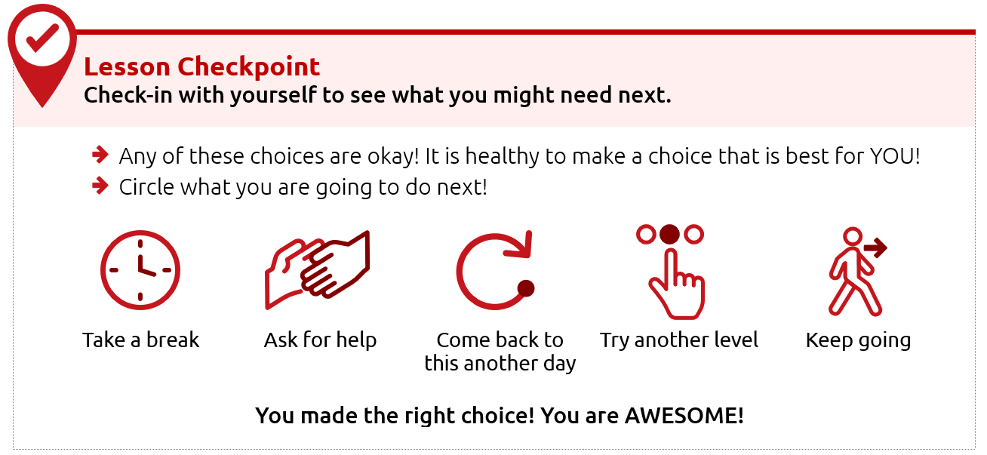
 | 4 |  | Each level takes approximately 30-45 minutes to complete, but it is okay if you take a longer or shorter time. Also, you do not have to complete a full level in one sitting. You can complete these levels at your own pace - even over the course of a few days, weeks, or months.
 | 5 |  | This resource is meant to be self-guided, which means you should be able to do them by yourself. But if you need help, do not be afraid to ask someone to assist you in completing them!
 | 6 |  | The content for each level is on the same topic (for example: Healthy Relationships or Communication) but the way the level asks you to participate is different. Some levels ask you to write your answers, while others ask you to draw your answers. Complete the levels however you prefer.

Alright, are you ready to begin?
We are very excited that you are starting this journey with us!
We believe in you - let’s go!
Topic descriptions and
what you should expect

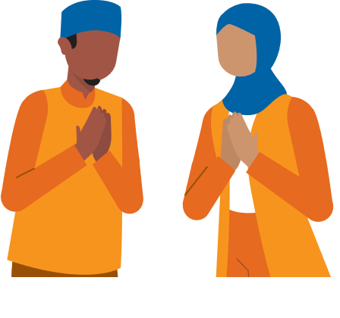
In total, there are 5 different handbooks covering 5 different topics.
Each topic will have 3 different lessons in it.
The 5 topics and the 3 lessons within those 5 topics are listed below.

Topic 1: Communication (THIS HANDBOOK)
Level 1  Starting a Conversation  Page 15 |  | It is important to know how to talk to other people.  Here is what you will learn in this lesson:  - Steps for how to start a conversation with someone  - Different topics that you could use when starting a conversation
Level 2  Appropriate and Inappropriate Conversations  Page 35 |  | It is important to know what is okay or “appropriate” and what is not okay or “inappropriate” when having conversations with others.  Here is what you will learn in this lesson:  - When to start a conversation and when to wait  - When to say something and when you should only think it  - What are appropriate topics for work or school?
Level 3  Active Listening Skills  Page 54 |  | Good communication involves both speaking and listening. If you do not practice “active listening” skills, it can lead to misunderstanding and miscommunication.  Here is what you will learn in this lesson:  - What “active listening” is  - Why listening is a very important part of communicating  - 3 ways to practice “active listening”

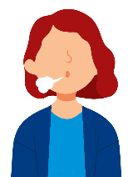
Topic 2: Handling Disappointment (Different handbook)
Level 1  Emotions and Safe Actions |  | Learning how to handle your emotions is important.  Here is what you will learn in this lesson:  - Safe and unsafe ways to handle difficult emotions  - Tips to help you when you have difficult emotions
Level 2  What to do when you feel disappointed |  | An emotion that can be challenging is disappointment. Disappointment can happen when you want something to happen and it does not happen. It can also happen when you expect someone to do something and they do not do it.  Here is what you will learn in this lesson:  - Examples of disappointment  - What are “expectations” and how do we handle them?  - What to do when you feel disappointed
Level 3  Accepting who  you are |  | It is important to practice self-acceptance, especially when facing disappointment. This lesson will help you handle and cope with disappointments in a positive way.  Here is what you will learn in this lesson:  - How to use self-acceptance to deal with disappointment  - The importance of positive self-talk  - Specific strategies for managing emotions / self-acceptance

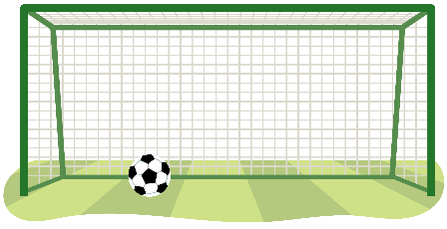
Topic 3: Setting Goals (Different Handbook)
Level 1  The Basics of Setting Goals |  | Learning to set goals helps you get better.  Here is what you will learn in this lesson:  - What is a goal?  - How to set a goal for yourself
Level 2  Setting SMART goals |  | Setting a goal is a great way to stay focused on achieving something in the future. This lesson will help you set a goal and create steps to help you meet that goal.  Here is what you will learn in this lesson:  - What is a SMART goal?  - The difference between a goal and a SMART goal.  - How to set a SMART goal for yourself
Level 3  Overcoming Obstacles |  | This lesson will help you build on your understanding of SMART goals and how to overcome challenges.  Here is what you will learn in this lesson:  - How to learn and grow with your goals  - Why it is important to prepare for failure  - Why it is important to keep going and follow through on your goals

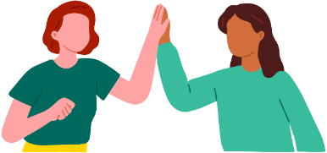
Topic 4: Healthy Relationships (Different handbook)
Level 1  Understanding Relationships |  | Learning about relationships is important.  Here is what you will learn in this lesson:  - What it means to have a relationship with someone  - The difference between a healthy relationship and an unhealthy relationship  - What to do if you have an unhealthy relationship
Level 2  Healthy Relationships and Boundaries |  | It is important to have healthy relationships in your life. One important part of a healthy relationship is having boundaries.  Here is what you will learn in this lesson:  - What are different types of relationships?  - What are different types of boundaries?  - How to set your own personal boundaries
Level 3  Conflict Resolution |  | It is important to know how to solve problems and disagreements in your relationships.  Here is what you will learn in this lesson:  - What conflict is and how to identify it in relationships  - Effective ways to prevent conflict  - Strategies to resolve conflict when it happens

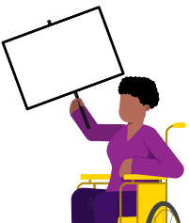
Topic 5: Advocacy (Different Handbook)
Level 1  Discovering Yourself |  | It is important to know more about yourself because that helps you to better advocate for yourself and the things you care about.  Here is what you will learn in this lesson:  - What it means to “advocate”  - Ways to learn more about yourself  - Why knowing yourself helps you advocate better
Level 2  Strengths and Weaknesses |  | Being able to name your strengths and weaknesses can help you know how to advocate for yourself and for others.  Here is what you will learn in this lesson:  - How to identify your strengths and weaknesses  - Ways to use your strengths to help others  - Ways to ask others to help you improve your weaknesses
Level 3  Self-advocacy |  | It is important to know how to advocate for yourself. Through “self-advocacy” you can make choices that shape your life.  Here is what you will learn in this lesson:  - What “self-advocacy” is and why it is important  - Examples of self-advocacy in real-life situations  - Steps to practice self-advocacy

Personal and Professional Development Lessons
Pre-Skills Assessment
Skills-Assessment for athlete learner
Directions
This assessment is optional. We created it to help you if you do not know where to begin your learning journey with these topics and levels. If that is the case, please use this assessment to help guide you where to begin. If you would rather go through each topic and level in your own order, that is okay, too.
The statements below describe situations you might encounter in your daily life as a friend, athlete, employee, and leader. For each statement select a number between 1 and 3 to indicate your current confidence level, where:
1 = I am not at all confident | 2 = I am somewhat confident | 3 = I am completely confident

How confident are you that you can… |  |  |  | Not at all  Confident | Somewhat  Confident | Completely  Confident
 | Topic 1: Communication
 | I can start up a conversation with people I do not know. |  |  | 1 | 2 | 3
 | I can ask questions when I want to learn more about what someone is saying. |  |  | 1 | 2 | 3
 | I can listen well to what others are saying to me. |  |  | 1 | 2 | 3
 | Communication total score:
 | Topic 2: Handling Disappointment
 | I can express my emotions in a way that is safe for me and others. |  |  | 1 | 2 | 3
 | I can handle disappointment. |  |  | 1 | 2 | 3
 | I can accept myself for who I am. |  |  | 1 | 2 | 3
 | Handling Disappointment total score:
 | Topic 3: Setting Goals
 | I can set goals for myself and follow a plan. |  |  | 1 | 2 | 3
 | I can adjust my goals when I am faced with failure or obstacles. |  |  | 1 | 2 | 3
 | I can set goals to challenge and push myself outside of my comfort zone. |  |  | 1 | 2 | 3
 | Setting Goals total score:
 | Topic 4: Healthy Relationships
 | I can make and keep healthy relationships. |  |  | 1 | 2 | 3
 | I can work through conflict with other people without hurting their feelings. |  |  | 1 | 2 | 3
 | I can set boundaries with friends and respect when friends set boundaries with me. |  |  | 1 | 2 | 3
 | Healthy Relationships total score:
 | Topic 5: Advocacy
 | I can identify and explain who I am and what I believe in. |  |  | 1 | 2 | 3
 | I can easily accept that there are things that are out of my control. |  |  | 1 | 2 | 3
 | I can advocate for what I want clearly and calmly. |  |  | 1 | 2 | 3
 | Advocacy total score:

Skills-Assessment for Mentor
to complete about the Athlete
Directions
This assessment is optional and should be completed by a mentor or family member of the athlete leader. The person filling this out should be someone who knows the athlete very well and can provide constructive criticism and positive feedback. Your assessment of them is meant to help the athlete leader see their strengths and weaknesses according to someone else so they can identify where to begin their learning journey.
The statements below describe situations the athlete might encounter in their daily life as a friend, athlete, employee, and leader. For each statement, circle a number between 1 and 3 to indicate where you think the athlete’s confidence level is, where:
1 = not at all confident | 2 = somewhat confident | 3 = completely confident.

How confident are you that the athlete can… |  |  |  |  | Not at all  Confident | Somewhat  Confident | Completely  Confident
 | Topic 1: Communication
 | Start up a conversation with people they do not know. |  |  |  | 1 | 2 | 3
 | Ask questions when they want to learn more about what someone is saying. |  |  |  | 1 | 2 | 3
 | Listen well to what others are saying. |  |  |  | 1 | 2 | 3
 | Communication total score:
 | Topic 2: Handling Disappointment
 | Express their emotions in a way that is safe for them and others. |  |  |  | 1 | 2 | 3
 | Handle disappointment. |  |  |  | 1 | 2 | 3
 | Accept themselves for who they are. |  |  |  | 1 | 2 | 3
 | Handling Disappointment total score:
 | Topic 3: Setting Goals
 | Set goals and follow a plan. |  |  |  | 1 | 2 | 3
 | Adjust goals when faced with failure or obstacles. |  |  |  | 1 | 2 | 3
 | Set goals to challenge and push themselves outside of their comfort zone. |  |  |  | 1 | 2 | 3
 | Setting Goals total score:
 | Topic 4: Healthy Relationships
 | Make and keep healthy relationships. |  |  |  | 1 | 2 | 3
 | Work through conflict with other people without hurting their feelings. |  |  |  | 1 | 2 | 3
 | Set boundaries with friends and respect when friends set boundaries with them. |  |  |  | 1 | 2 | 3
 | Healthy Relationships total score:
 | Topic 5: Advocacy
 | Identify and explain who they are and what they believe in. |  |  |  | 1 | 2 | 3
 | Easily accept that there are things that are out of their control. |  |  |  | 1 | 2 | 3
 | Advocate for what they want clearly and calmly. |  |  |  | 1 | 2 | 3
 | Advocacy total score:

Scoring
Add the numbers for each of the five leadership topics. See the example below:
 | Topic 4: Healthy Relationships
 | Make and keep healthy relationships. |  |  |  | 1 |  | 2 |  | 3
 | Work through conflict with other people without hurting their feelings. |  |  |  | 1 |  | 2 |  | 3
 | Set boundaries with friends and respect when friends set boundaries with them. |  |  |  | 1 |  | 2 |  | 3
 | Healthy Relationships total score: |  |  |  |  |  |  |  | 5
What is next?
Congratulations! Like everyone, you have a lot of skills, but you also have new things to learn. These lessons can help you gain new skills and improve upon what you already know.
To help you figure out where to start your learning journey, you can follow these steps:
 | Step
 | 1 |  | If you or your mentor/helper gave a total score for any topic of 6 or below, that topic should be one of the first you consider starting at because that shows you have more to learn on that topic.  For example, the athlete listed above who scored five (5) on Healthy Relationships will go to the Healthy Relationships lessons first. If this lesson that you have is not what you are looking for, you can find all 5 topics at the Special Olympics resources website (https://bit.ly/41GT7rW) or you can ask your Program where to find it.
What happens if you and your mentor have scored a topic very differently?
If you and your mentor have different scores for a topic, discuss this with your mentor. Having different scores is an excellent opportunity to receive feedback from someone else and learn more about how others view your knowledge and skills in that category. It is okay if they think that you are lower in a category than you scored yourself. They have a different perspective of your strengths and weaknesses.
There are activities within Communication, Healthy Relationships, and Handling Disappointment that will help you get better with giving and receiving feedback.
 | 2 |  | Continue completing lessons until you have completed all the leadership lessons within the leadership topics that you or your mentor scored 6 or less. Stop after each lesson and give yourself a big round of applause!
 | 3 |  | Take your time and go through one leadership topic or lesson daily so you have time to practice and tell your coach, teammates, and friends what you are learning.
 | 4 |  | After you have completed all the leadership lessons where you scored a 6 or below, complete all the other leadership topics and lessons you are interested in. Even if you scored above a 6 in them, there is always more to learn, so go through all of them! Again, you can find all 5 topics and their 15 lessons by visiting the Special Olympics resources website (https://bit.ly/41GT7rW) or contacting your local Special Olympics staff member and ask for help.

Communication
Leadership Lessons
Level 1:
Starting a Conversation
Level 1
Communication
Starting a conversation
 | Think about these questions:
 | 1. | How do you start a conversation with someone?
 | 2. | What are topics you could talk about with them?
 | If you do not know yet, do not worry! This lesson will teach you all about how to start a conversation with someone.
Think about a time you felt unsure of what to say or do when talking to someone else. Tell your mentor or a family member what happened or draw/write what happened below.
It is ok if communicating with others is difficult. You will get better with practice!

LEARN

 | Communication is how you give and get information.
 | 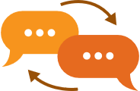 |  | - One way to communicate is by having a conversation.  - A conversation is when 2 or more people take turns talking about a topic.  - Conversations are a way to connect with others.
 | Starting a conversation, especially with strangers, can be hard. It can make us feel uncomfortable, and that is okay! It can also be fun.
 | How do YOU feel about starting a conversation with someone?
 | Circle one!
Remember, everyone is different, and it is okay if conversations
do not always go exactly as planned. Keep practicing!

 | Topics
 | Sometimes it can be helpful to think about what you know a lot about!
 | Look at the pictures and circle things that you like.
 |  | 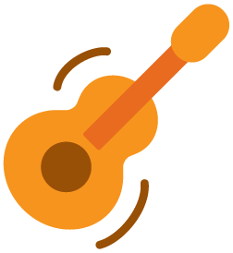 |  |  |  | 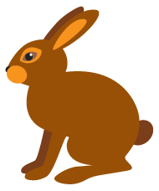
 | SPORTS | MUSIC |  | GAMES |  | FOOD
 | BOOKS | ART |  | MOVIES |  | PETS / ANIMALS
 | Think about other things you like or know a lot about and write or draw them.

 |  | Part 1: How to start a conversation
 | Follow these steps when you want to start a conversation
 |  |  |  |  |  | 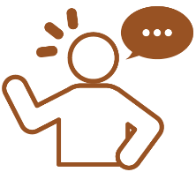
 | Step 1:  Greet |  |  |  |  | Step 2:  Start a topic |  |  | Step 3:  Listen and respond |  |  | Step 4:  End
 | Let us take a closer look at each step!
 |  |  |  | Step 1: Greet
 | It is polite to greet (say hi) someone before you start talking to them.
 |  |  | Ways to greet someone
- Say "Hello! My name is_______"
- Say "Hi! How are you today?"
- Do a sign or gesture like:
 |  |  | 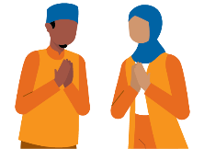 |  | 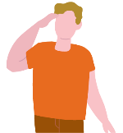 |  |  | 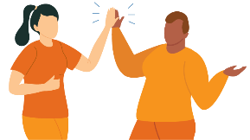 |  |  |  |  | 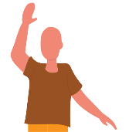
 | People and places have different ways to say hi!
 | 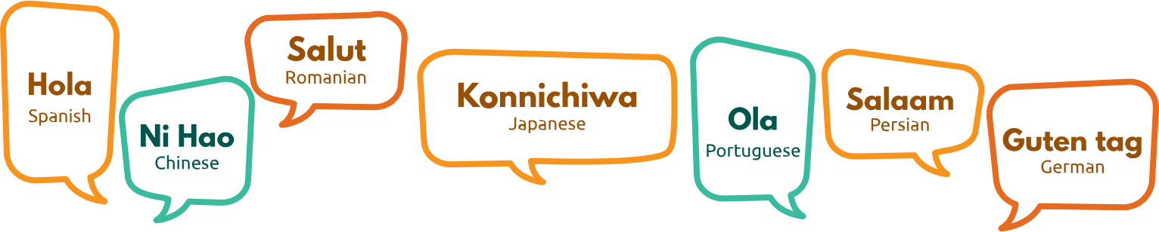

Step 2: Start with a topic
When starting a topic, it helps to think about thinks you like or know a lot about!
Ways to start a topic
Ask a question
- “What is your favorite sport to play?"
- "How long have you been playing football?"
Say a compliment
- "You are a fantastic goalie!"
- "You are a great team player!"
Share a fact
- "Real Madrid is Europe’s most successful football club winning 14 European Cup/UEFA Champions League titles!"
- "Did you know more than 250 million people around the world play soccer/football!"
Can you think of any other things you could say? Add your ideas by writing or drawing them below!

 |  |  | Step 3: Listen and respond
 | It is important to listen to what the other person is saying.
 |  | When you respond you can ask a question about what they said or respond by saying:
 |  | 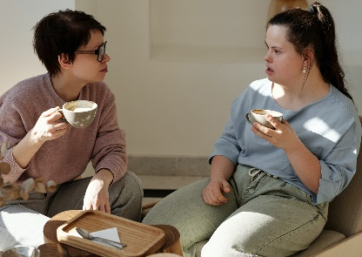 |  |  |  | - That is cool!  - I like your idea!  - Tell me more.
 |  |  | Step 4: End conversation
 | It is important to be kind when ending a conversation.
 |  | Ways to end a conversation
- Say “it is nice talking to you!”
- Say “have a great day.”
- Say “talk to you later!”

Part 2: Practice
Look at each picture and think about what might be happening. Write or tell someone you know what the people are saying.
Ask a Question
Possible answers: "What do you like to do for fun?” - "Where is your favorite place to go?" - "Do you like books or movies?"
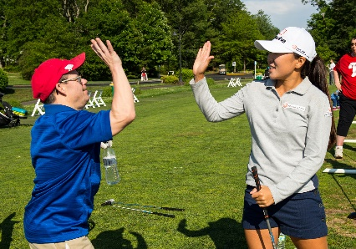
Say a compliment
Possible answers: "You are amazing!" - "Thank you for being so helpful!" - "You are a good friend."
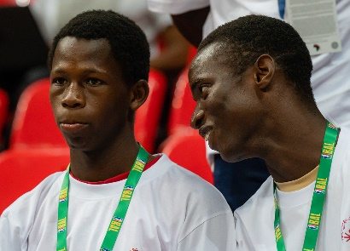
Share a fact
Possible answers: "This is my favorite game." - "This team won the championship last year!" - "I just got a job!"

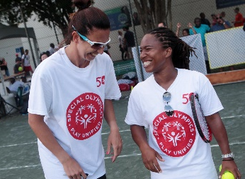 | Look at the pictures. Circle which way they started the conversation:
 |  |  | You are so funny!
 |  |  | Ask a question |  | Say a compliment |  | Share a fact
 | 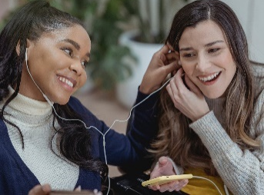 |  | What music are you listening to?
 |  |  | Ask a question |  | Say a compliment |  | Share a fact
 | 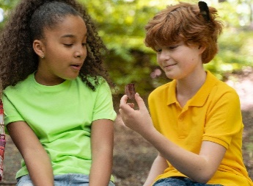 |  | I like collecting rocks!
 |  |  | Ask a question |  | Say a compliment |  | Share a fact
 |  |  | Your jump was so high!
 |  |  | Ask a question |  | Say a compliment |  | Share a fact
 |  |  | What is your favorite book?
 |  |  | Ask a question |  | Say a compliment |  | Share a fact

 | Answers
 | 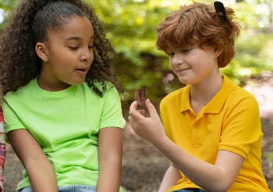 |  | You are so funny!
 |  |  | Ask a question |  | Say a compliment |  | Share a fact
 |  |  | What music are you listening to?
 |  |  | Ask a question |  | Say a compliment |  | Share a fact
 |  |  | I like collecting rocks!
 |  |  | Ask a question |  | Say a compliment |  | Share a fact
 |  |  | Your jump was so high!
 |  |  | Ask a question |  | Say a compliment |  | Share a fact
 |  |  | What is your favorite book?
 |  |  | Ask a question |  | Say a compliment |  | Share a fact

 | Lesson Checkpoint
 | Check-in with yourself to see what you might need next.
- Any of these choices are okay! It is healthy to make a choice that is best for YOU!
- Circle what you are going to do next!
 |  |  |  |  | 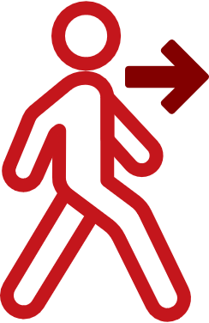
 | Take a break | Ask for help | Come back to this another day | Try another level | Keep going
 | You made the right choice! You are AWESOME!

 | Stories
 | Story 1
 | Let us check to see if Ben can remember the steps for having a conversation!
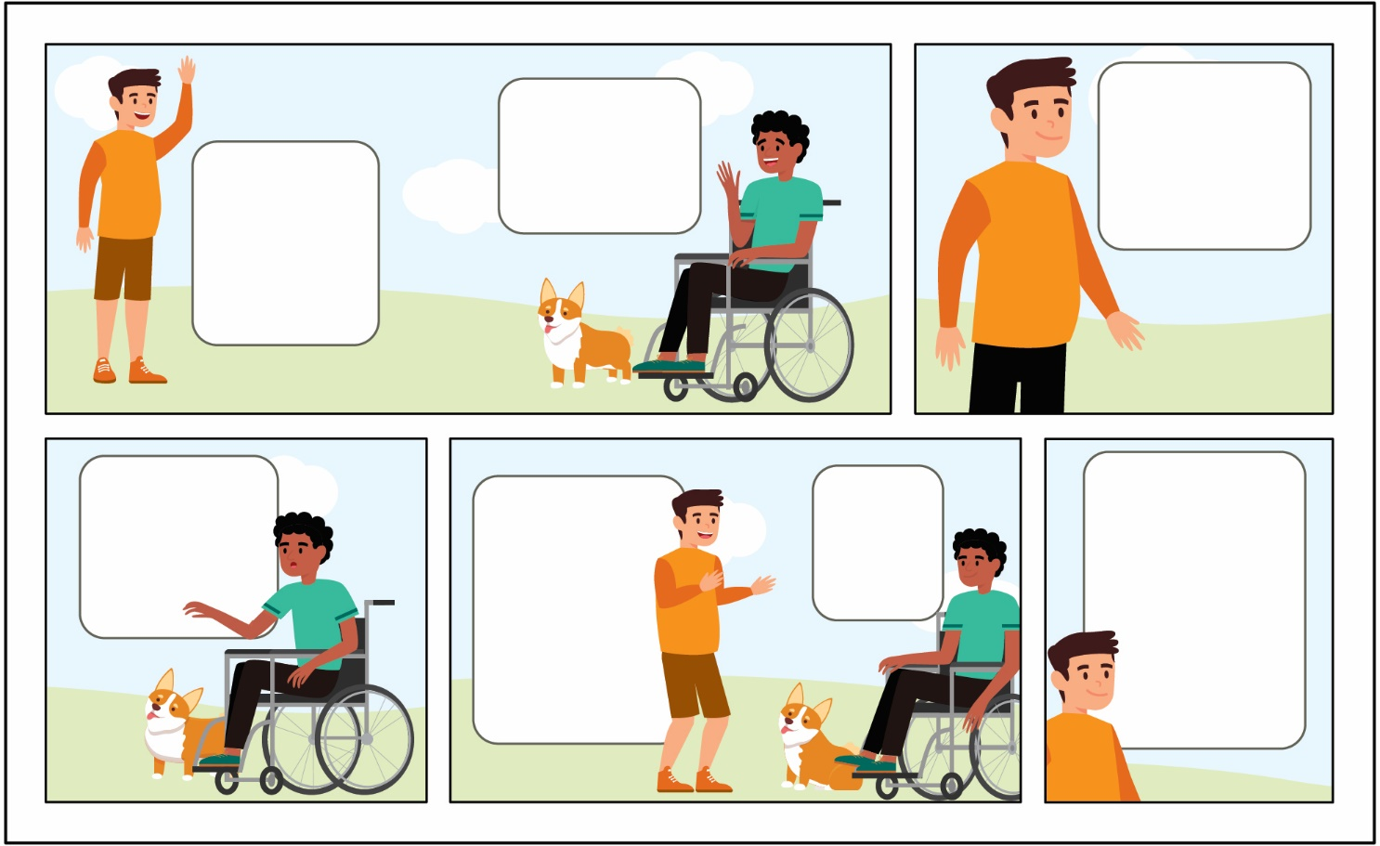
Hi! My name is Ben!
Hello Ben! I am Jake.
What is your dog’s name?
This is Pip!
That is a cool name! Can I pet her?
Sure!
Thank you for letting me pet Pip! Have a nice day.
 |  |  |  | Circle YES or NO.
 |  |  | Did Ben GREET Jake? |  |  |  | YES |  | NO
 |  |  | Did Ben START A TOPIC? |  |  |  | YES |  | NO
 |  |  | Did Ben LISTEN and RESPOND? |  |  |  | YES |  | NO
 |  |  | Did Ben END the conversation? |  |  |  | YES |  | NO
 |  | Answers
 |  | Did Ben GREET Jake? |  |  |  | YES |  | NO
 |  | Did Ben START A TOPIC? |  |  |  | YES |  | NO
 |  | Did Ben LISTEN and RESPOND? |  |  |  | YES |  | NO
 |  | Did Ben END the conversation? |  |  |  | YES |  | NO

Let us see Story 2 on the next page!

 | Story 2
 | Sara sees her friend Marco after the track meet and wants to talk to him!
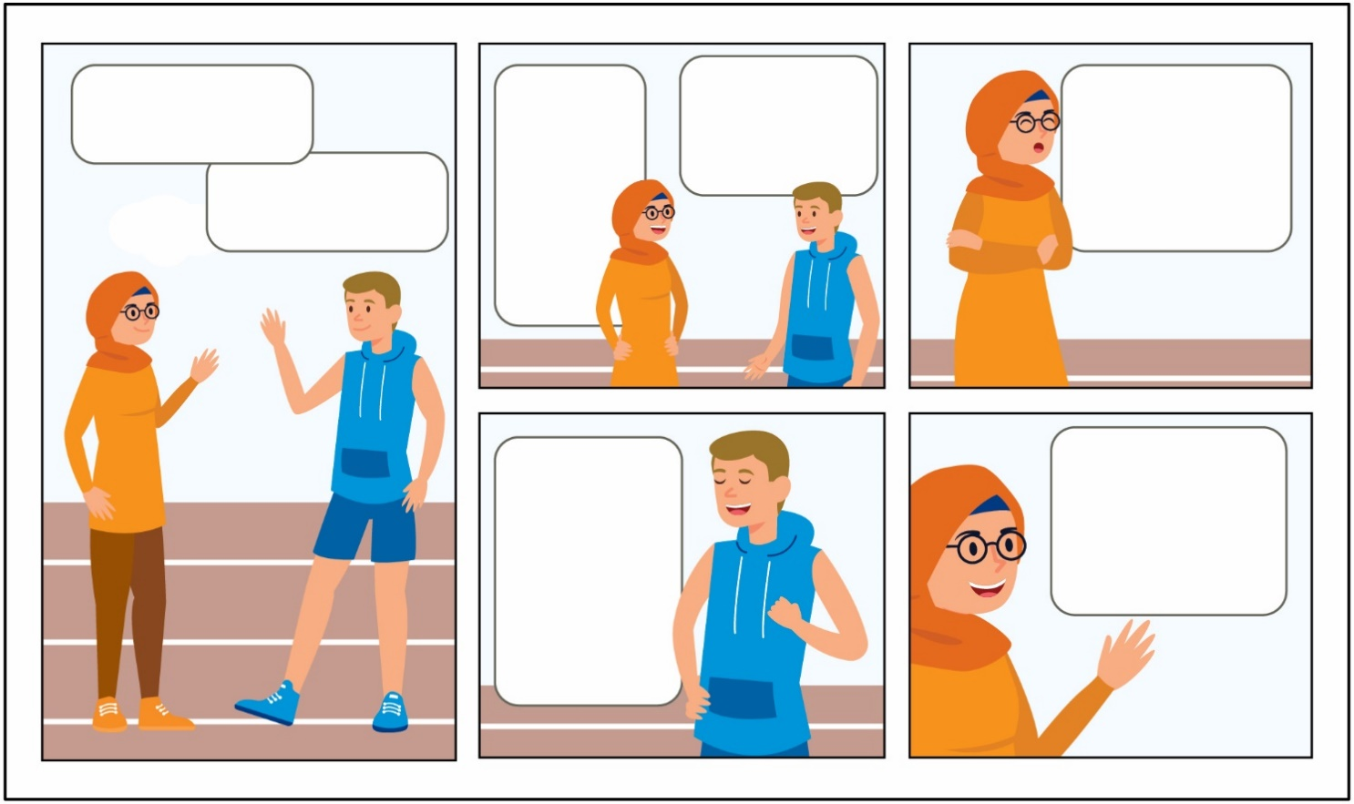
Hi Marco!
Hi Sara!
You did a great job in the race!
Thank you! You did great too!
Next time we should race each other!
I would enjoy that! I think it would be a really close race!
I agree!
See you tomorrow, Marco!
 |  |  |  | Circle YES or NO.
 |  | Did Sara GREET Marco? |  |  |  |  |  |  | YES |  | NO
 |  | Did Sara START A TOPIC? |  |  |  |  |  |  | YES |  | NO
 |  | Did Sara LISTEN and RESPOND? |  |  |  |  |  |  | YES |  | NO
 |  | Did Sara END the conversation? |  |  |  |  |  |  | YES |  | NO
 |  | Answers
 |  | Did Sara GREET Marco? |  |  |  |  |  |  | YES |  | NO
 |  | Did Sara START A TOPIC? |  |  |  |  |  |  | YES |  | NO
 |  | Did Sara LISTEN and RESPOND? |  |  |  |  |  |  | YES |  | NO
 |  | Did Sara END the conversation? |  |  |  |  |  |  | YES |  | NO
Now, to Story 3!
 | See next page for more stories!
 | Story 3
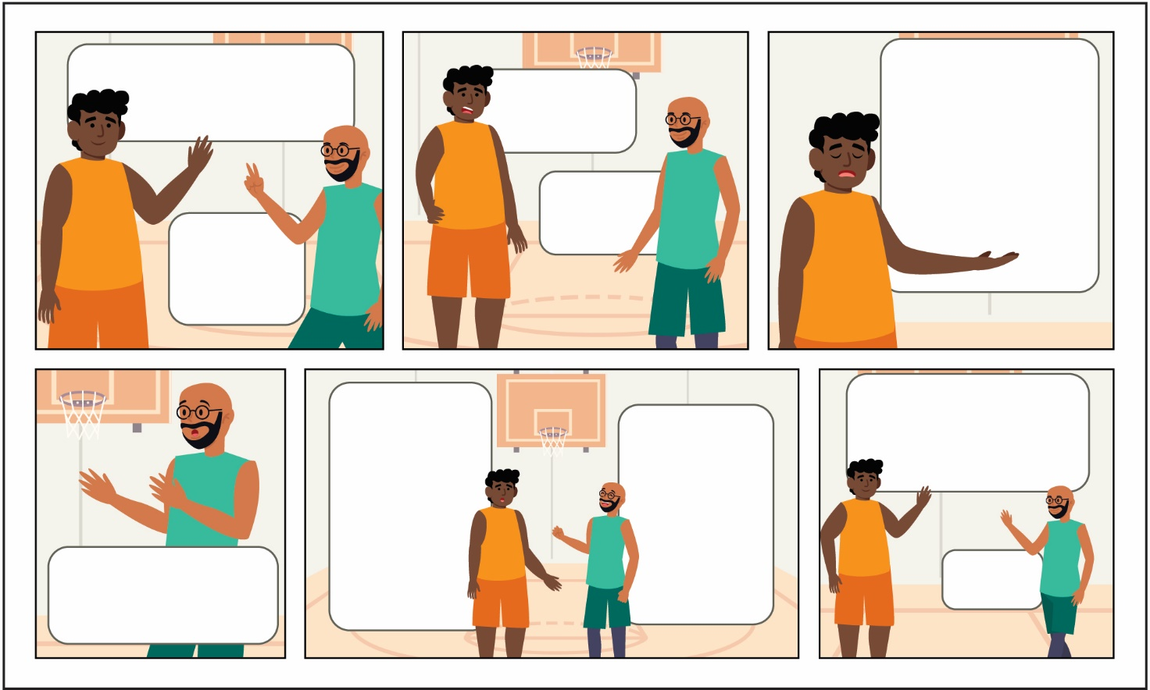
Tyson is upset with his teammate and decides to talk with him after the game.
Hey Diego, good game today!
Thanks Tyson!
Can we talk?
Sure!
I am a little disappointed you never passed the ball to me.
I am sorry, I did not see you.
Can you pass to me next game?
Yes! I will pass next game.
Thank you, Diego. I will see you tomorrow, bye!
Bye!
 |  |  |  | Circle YES or NO.
 |  | Did Tyson GREET Diego? |  |  |  |  |  |  | YES |  | NO
 |  | Did Tyson START A TOPIC? |  |  |  |  |  |  | YES |  | NO
 |  | Did Tyson LISTEN and RESPOND? |  |  |  |  |  |  | YES |  | NO
 |  | Did Tyson END the conversation? |  |  |  |  |  |  | YES |  | NO
 |  | Answers
 |  | Did Tyson GREET Diego? |  |  |  |  |  |  | YES |  | NO
 |  | Did Tyson START A TOPIC? |  |  |  |  |  |  | YES |  | NO
 |  | Did Tyson LISTEN and RESPOND? |  |  |  |  |  |  | YES |  | NO
 |  | Did Tyson END the conversation? |  |  |  |  |  |  | YES |  | NO
Try the last story next page!

 | Story 4
 | Ethan is mad at his coach because he did not get much playing time in the game.
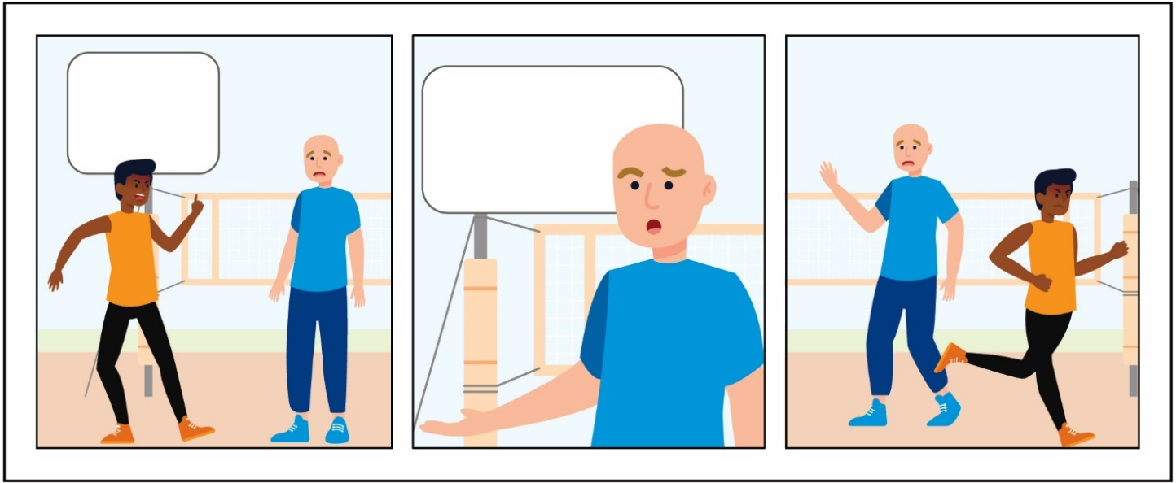
I AM SO MAD!
Ethan, why are you mad?
 |  |  | Circle YES or NO.
 |  | Did Ethan GREET his coach? |  |  | YES | NO
 |  | Did Ethan START A TOPIC? |  |  | YES | NO
 |  | Did Ethan LISTEN and RESPOND? |  |  | YES | NO
 |  | Did Ethan END the conversation? |  |  | YES | NO
 |  | Answers
 |  | Did Ethan GREET his coach? |  |  | YES | NO
 |  | Did Ethan START A TOPIC? |  |  | YES | NO
 |  | Did Ethan LISTEN and RESPOND? |  |  | YES | NO
 |  | Did Ethan END the conversation? |  |  | YES | NO
 | Ethan did not have a good conversation with his coach because he did not follow the steps. Ethan's coach might not understand what happened or he could be confused.

Your turn!
Write or draw a new story and help fix the conversation Ethan had with his coach so that it is a good and productive conversation!
Be sure to include all of the steps!

 | Activity
 | Find someone (a family member, coach, or teammate) who matches the description in each box! Then write their name inside the box. Try to fill as many boxes you can!
 | Someone who…
 | …loves traveling | …loves cake | …loves reading | …is good at telling jokes | …is an only child
 | …loves playing the guitar | …has a cat as a pet | …plays video games at night | …hates spiders | …who loves music
 | …likes sports | …speaks two languages | …can skateboard | …whose favorite color is pink | …loves summer
 |  |  |  | 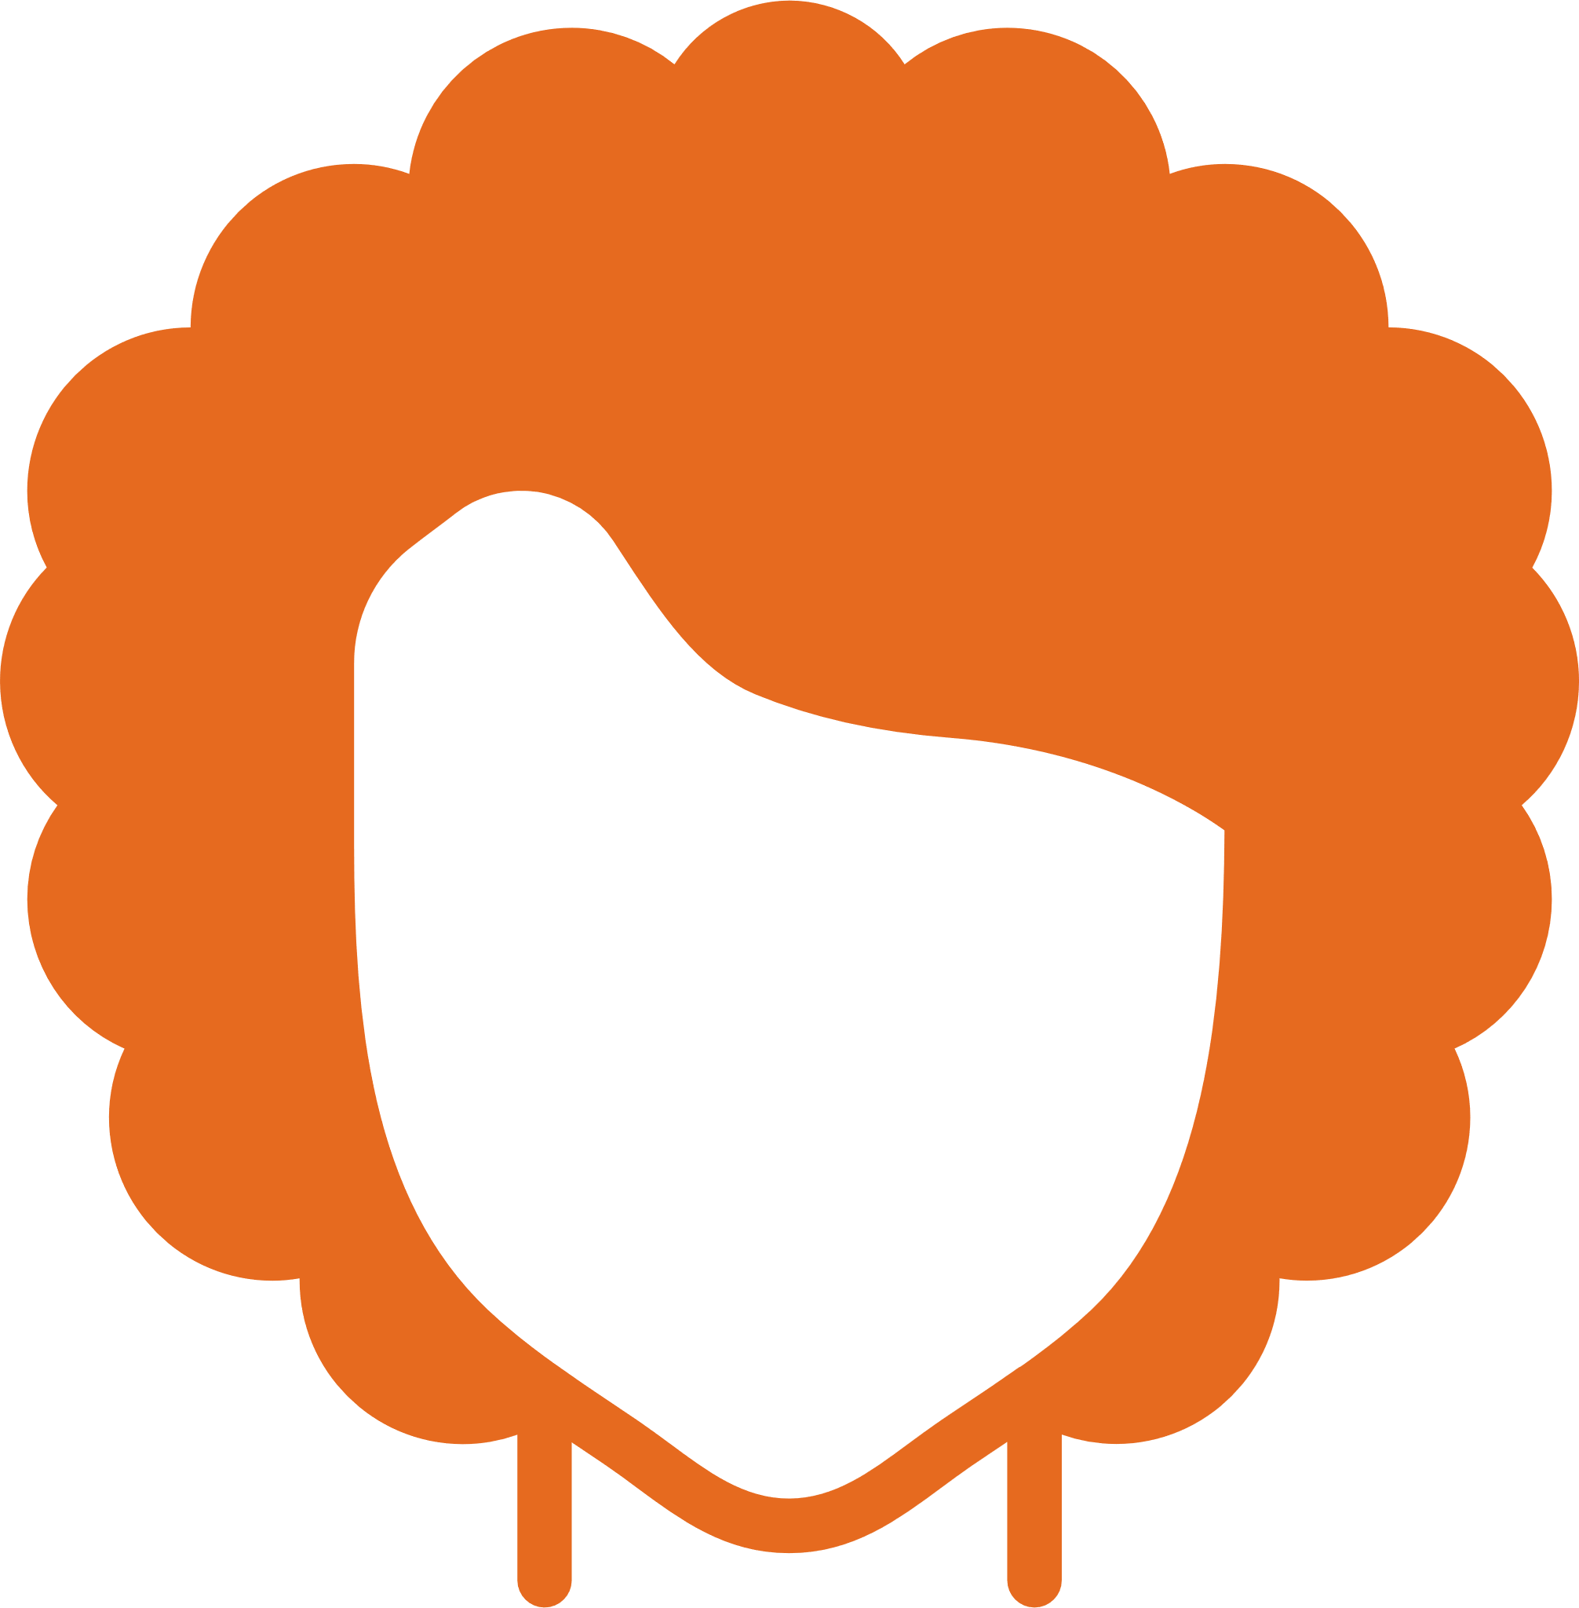
 | …is left-handed | …who has one brother | …who knows how to whistle | …has curly hair | …likes cooking

 | Having conversations with people is a great way to get to know them! Practicing will help you get better. Here are a few more ways to practice.
 | Role Play
 | 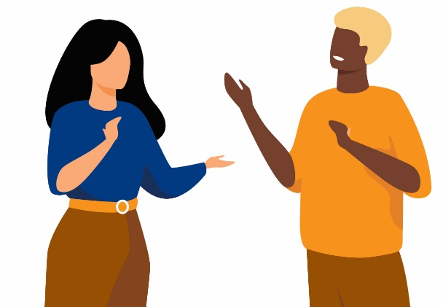 |  | Practice using the steps with a mentor or friend by acting out different situations!
 | Interview
 | 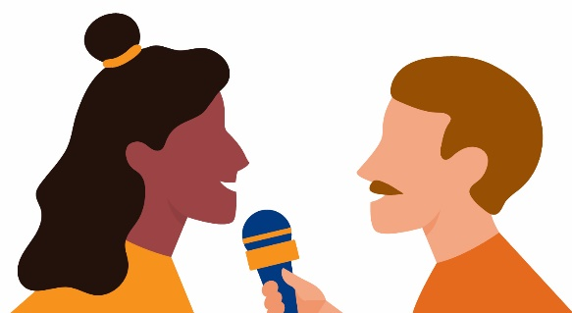 |  | Find someone new that you do not know very well yet. Ask them if you can interview them (ask questions) to find out more about them!
Possible questions to ask:
- What is your favorite sport?
- What is your favorite animal?
- What do you like to do for fun?
- What kind of movies do you like?

REFLECT
Write or draw what you have learned about in this lesson!

Lesson Summary
- There are steps to remember when you want to start a conversation! Greeting, start a topic, listen and respond, and end the conversation.
- You can start a conversation by asking a question, saying a compliment, or sharing a fact.

Communication
Leadership Lessons
Level 2:
Appropriate and Not Appropriate Conversation

Check-in or review
Welcome to Level 2! Before you begin this lesson, see if you can answer a few of the questions below. If these questions are challenging, go to Level 1 and complete that level before starting this level. If you already completed Level 1 and still do not know the answers below, it may be a good idea to go back and review them before continuing with Level 2.
What are 2 questions you could ask someone in a conversation?
1
2
What are 3 important parts to communicating?
1
2
3

Check in
Check your answers
What are 2 questions you could ask someone in conversation?
Answers could include:
- What is your favorite movie?
- What did you have for lunch?
- How do you like to spend your time?
- Do you play any sports?
What are 3 important parts to communicating?
Answers could include:
- Saying hi or waving and sharing your name.
- Asking the other person a question.
- Sharing something about yourself.
- Saying something nice.
- Listening and responding.
If you could answer these three questions, continue with Level 2. If you did not know how to answer them, go to Level 1 to learn all about how to start a conversation!

Level 2
Communication
Appropriate and not appropriate conversation
It is important to know what is okay or “appropriate” and what is not okay or “inappropriate” when having conversations with others. During these lessons, you will learn about:
- When to start a conversation and when to wait.
- When to say something and when you should only think it.
- What are appropriate topics for work or school.

Work through these lessons to learn and practice your conversation skills.

Part 1: Start or wait
When starting a conversation with someone, there are times that are appropriate to talk and there are times that are inappropriate to talk.
Learn how to decide when to start a conversation and when to wait to talk.
Look at the situations under “okay to start” and “wait to start”. Think about why it is important to know the difference.
 |  | OKAY to start conversation |  |  | 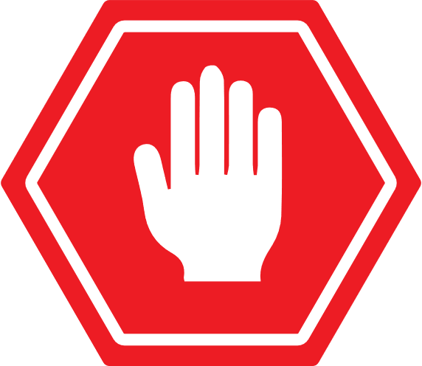 | WAIT to start conversation
 | - Eating dinner with your family.  - While waiting in line for a ride at an amusement park with friends.  - After your friend is done with their soccer game.  - Free time after school is done. |  |  |  | - During the singing of your national anthem.  - While a teacher or coach is talking to everyone.  - If someone is busy working on a project.  - Watching a movie at the theater.
Your turn!
Draw a line from the situation to the correct box. Look above to help you check your answers!
- Watching a movie at the theater.
- If someone is busy working on a project.
- Free time after school is done.
- After your friend is done with their soccer game.
- Eating dinner with your family.
- While a teacher or coach is talking to everyone.
OKAY to start conversation
WAIT to start conversation

Now read through some new situations and see if you can match them to “okay to start” or “wait to start”.
- Shopping with a friend.
- Two friends are talking about something important.
- Your parent is talking on the phone.
- Watching a football game.
OKAY to start conversation
WAIT to start conversation

Answers
Check and see if you matched them correctly!
- Shopping with a friend.
- Two friends are talking about something important.
- Your parent is talking on the phone.
- Watching a football game.
OKAY to start conversation
WAIT to start conversation

 | But why? See below for reasoning:
 |  | OKAY to start conversation |  |  |  |  | WAIT to start conversation
 | - Shopping with a friend  Casually hanging out with friends is a great time to start a conversation!  - Watching a football game  Making conversation during a sporting event can be a fun way to connect with a friend. |  |  |  |  | - Two friends are talking about something important.  It is better to wait while two people are talking so you do not interrupt them.  - Your parent is talking on the phone.  Only interrupt someone on the phone if it is an emergency.

Part 2: Think it or say it
When talking with friends, there are some things that are appropriate to talk about and some things that are inappropriate to talk about with friends.
Learn how to decide when to just think it and when it is okay say it in this lesson.
Example 1
Your friend gets a new haircut, and you think it looks kind of odd. You want to say, “Your haircut is kind of weird. I liked your hair before you cut it.”
STOP
and
THINK
Is it kind and helpful?
Yes
Say it
Think it
No
This is something that you should just think instead of sharing. By saying this, you could hurt your friend’s feelings because it isn’t a kind thing to say. The best way to help you think if you should say something or not is to stop and think about how it would make you feel if someone said that to you.

Example 2
Your friend helps you spell a few challenging words on a paper you are writing. You want to say, “Thank you for helping me. You are good at spelling!”
STOP
and
THINK
Is it kind and helpful?
Yes
Say it
Think it
No
Giving your friend a compliment or saying something nice to them is a great thing to say! It shows that you appreciate them and are thankful they took the time to help you. It feels good to receive a compliment, so it is okay for you to “say it” to them!

Read through each situation below.
Draw a check mark over the thought bubble if you should just “think it” or over the word bubble if you can “say it.”
 | Situation | Think it | Say it
- You receive a gift from a friend that is not what you wanted. You want to say:
“Why did you get me this? It’s not what I wanted!”
- You are shopping with a friend and they try on a pair of sunglasses that you think look great on them. You want to say:
“Those sunglasses look really good on you. You should buy them!”
- Your teammate won the award for best sportsmanship and you think you should have won it instead. You want to say:
“You are a good teammate, but I think I’m better!”
- Your friend does not swim very fast in her race and looks tired. You want to say:
“I’m sorry you didn’t do well. You look tired, are you okay?”
- Your friend has a lot of zits on his face. You want to say:
“Why does your face look like that? You have zits all over it.”

Answers
Check your answers!
 | Situation |  | Think it | Say it
- You receive a gift from a friend that is not what you wanted. You want to say:
“Why did you get me this? It’s not what I wanted!”
 |  | Reason: Saying this could make your friend feel sad and bad. You should say “Thank you for the gift, I appreciate your thoughtfulness.”
- You are shopping with a friend and they try on a pair of sunglasses that you think look great on them. You want to say:
“Those sunglasses look really good on you. You should buy them!”
 |  | Reason: If you think something nice about your friend, you should share it! It will make them feel good.
- Your teammate won the award for best sportsmanship and you think you should have won it instead. You want to say:
“You are a good teammate, but I think I’m better!”
 |  | Reason: Even if you think you should have won, it is important to still support your friend. Thinking this instead of saying it will be a kind way to support your friend. If you had won, you probably would have wanted your friend to be happy for you!
- Your friend does not swim very fast in her race and looks tired. You want to say:
“I’m sorry you didn’t do well. You look tired, are you okay?”
 |  | Reason: It’s okay to say that your friend looks tired and ask if they are okay. That shows that you notice them and care about how they are doing. This is appropriate to say out loud, especially to a friend!
- Your friend has a lot of zits on his face. You want to say:
“Why does your face look like that? You have zits all over it.”
 |  | Reason: Your friend probably already knows they have zits and calling attention to it can make them feel embarrassed or uncomfortable. This is something to keep to yourself.

As you think through these, think about how you would feel or how you would
want someone to talk to you. If you wouldn’t like to hear someone say it to you,
you should probably just think it!

 | Lesson Checkpoint
 | Check-in with yourself to see what you might need next.
- Any of these choices are okay! It is healthy to make a choice that is best for YOU!
- Circle what you are going to do next!
 | Take a break | Ask for help | Come back to this another day | Try another level | Keep going
 | You made the right choice! You are AWESOME!

Now that you’ve read through different examples, create your own scenario either from your life or make up an example to practice!
Write or draw your example here:
STOP
and
THINK
Is it kind and helpful?
Yes
Say it
Think it
No

Part 3: Appropriate conversations
When you are at work or school, it is important to have conversations that are appropriate. An inappropriate conversation might make someone feel uncomfortable. Topics that you talk about with close friends or family will be different from topics that you talk about with strangers or people you do not know that well.
Important
In the situations listed below, think about coworkers or people you know at school but are not really close friends with.
 | Topics OK for work or school |  |  | Topics that are not OK for work or school
 | - I want to run faster.  - Asking how their weekend was.  - Sharing what you had for dinner last night.  - Greeting your teacher or boss with “Hello, it is nice to see you today!”  - Sharing about your favorite movie.  - Asking about what kind of food they like. |  |  | - Telling your boss, coworker, or teacher that you think they are attractive.  - Sharing about a fight you got in with your parents.  - Using swear words.  - Asking who someone is voting for.  - Telling someone that it looks like they gained weight.
 |  | Write or draw an idea for a topic that would be appropriate to talk about at work or school.

 |  | Help the person complete an appropriate conversation for work or school.
Let’s try!
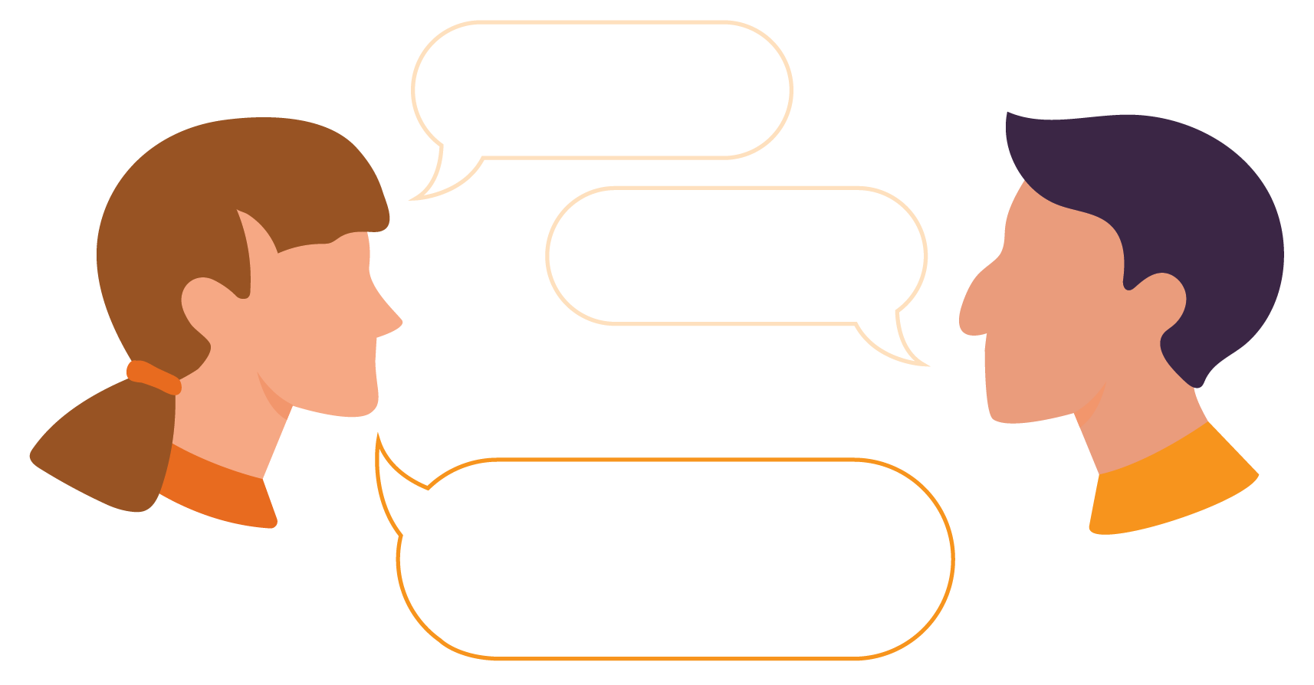
Hi Sam!
Hi Laura!
Pick one to continue the conversation:
 | How much do you weigh? |  |  |  |  |  | What did you do this weekend?
 | Correct answer
 | What did you do this weekend? |  |  |  | When you ask this question, it lets your coworker answer with what they are comfortable with and it helps you get to know them better!

Let’s try another one!
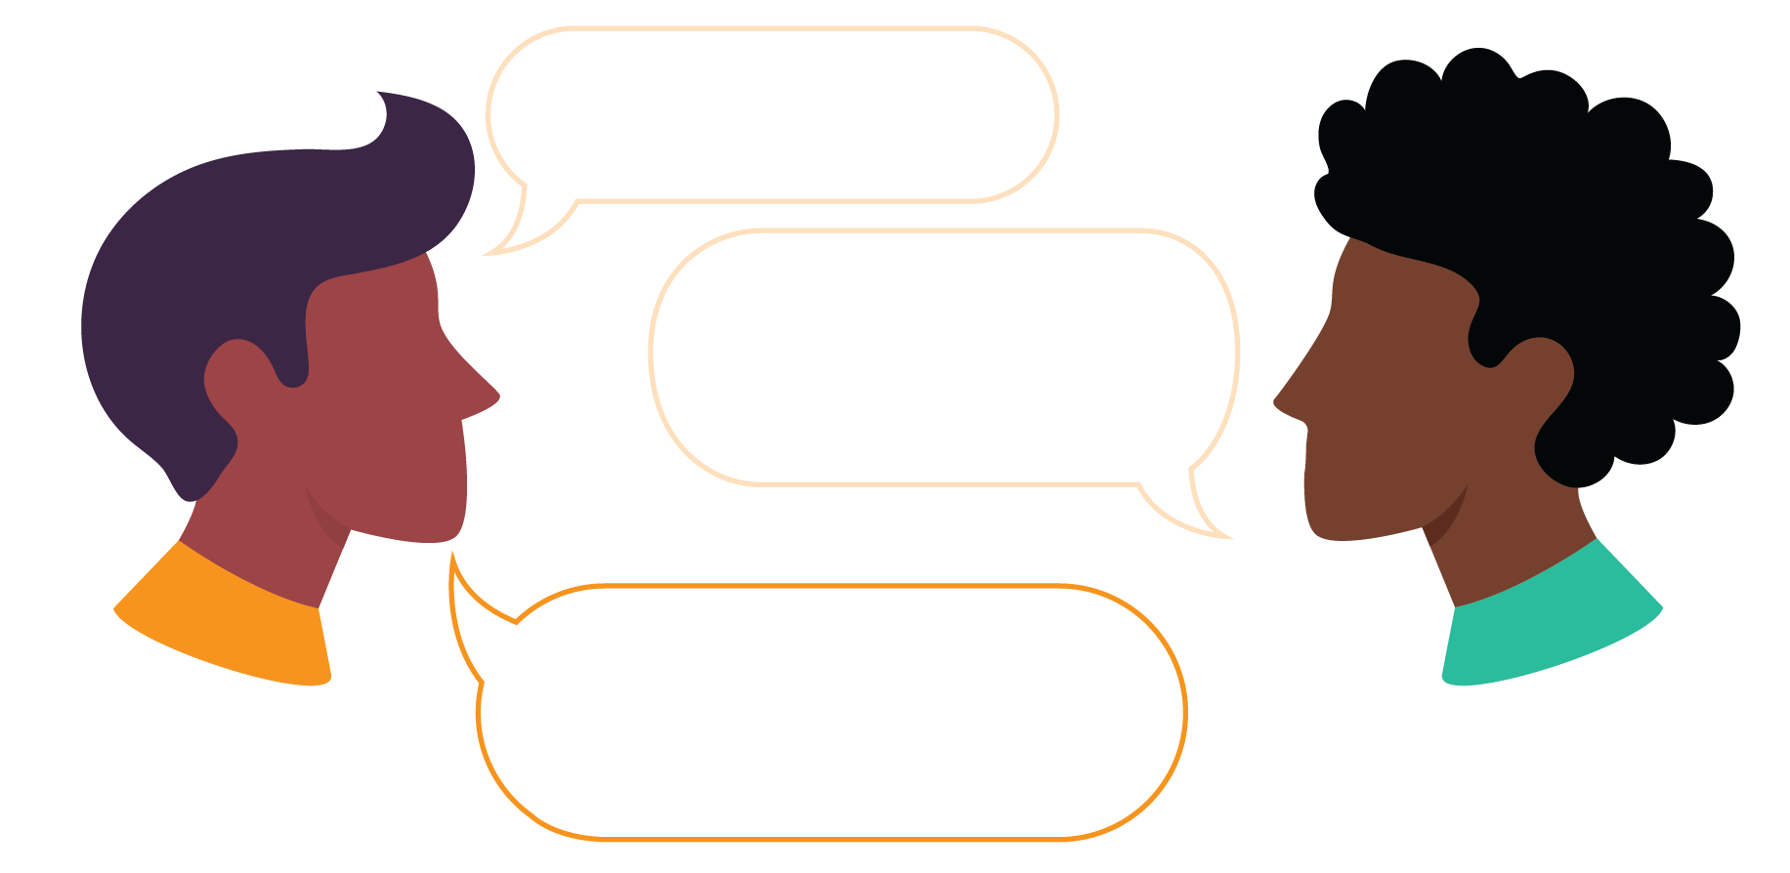
Good morning!
Hi! How was your weekend?
Pick one to continue the conversation:
 | Great! Have you seen the new Marvel movie? |  |  |  |  | Bad. My parents got in a really bad fight and were yelling at each other.
 | Correct answer
 | Great! Have you seen the new Marvel movie? |  |  | It is best not to share information from your personal life with coworkers or people you are not close with. That information can be shared with close friends or family, but asking about a more common topic like a movie is appropriate for the workplace or school.

Let’s try one more!
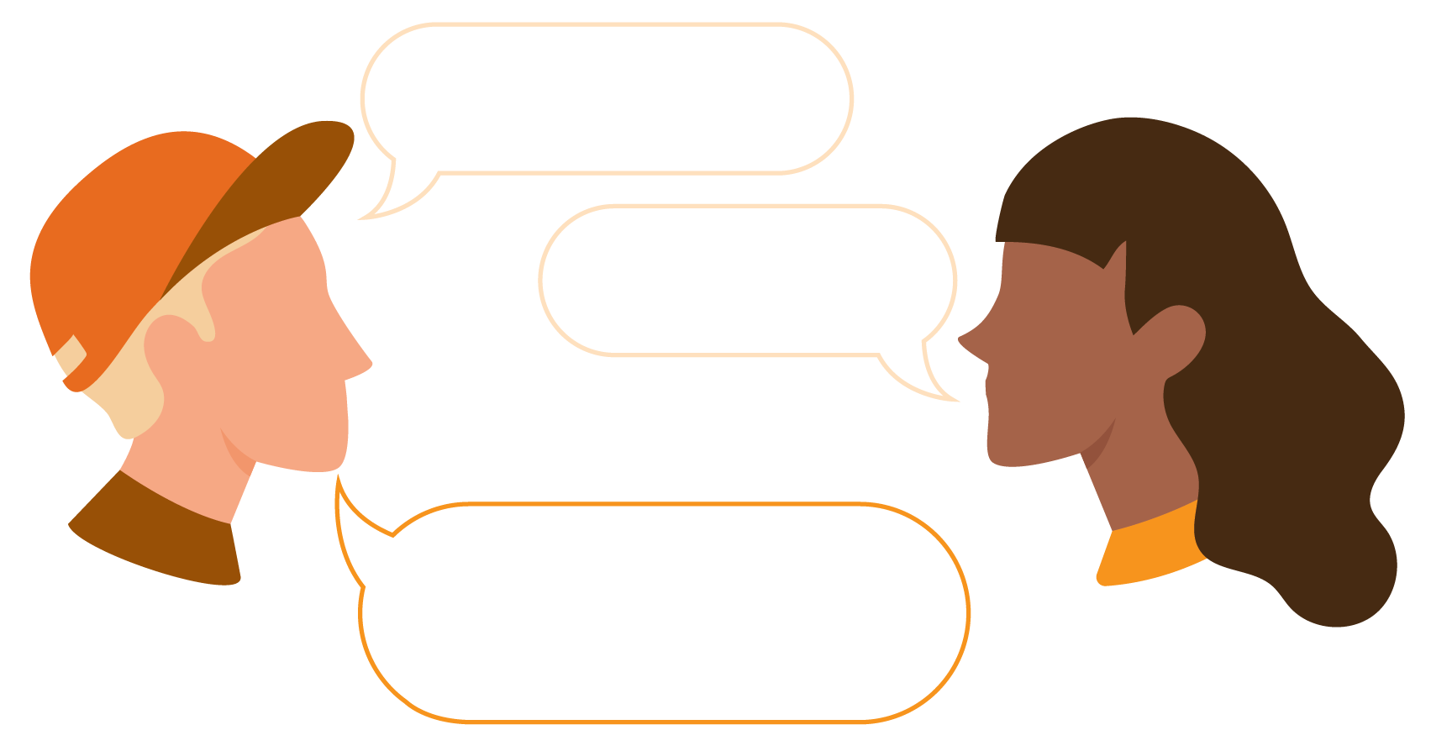
Hi, Mrs. Smith!
Hello!
Pick one to continue the conversation:
 | I think you’re really good looking! |  |  |  |  | I hope you have a great day!
 | Correct answer
 | I hope you have a great day! |  |  | It is never okay to tell a teacher, co-worker, or boss that you think they are attractive. You can tell them to have a great day to show that you respect them and to be kind to them.

Now pretend you are talking to your boss or teacher, fill in the speech bubbles to show an appropriate conversation.
THEM
YOU
YOU

REFLECT
During these lessons, you learned about 3 different topics. Look back at the lesson to help you reflect on what you have learned!
 |  | Fill in the box with an example of when to start a conversation and when to wait.
 |  |  | OKAY to start conversation |  |  |  |  | WAIT to start conversation

Write or draw your own example.
STOP
and
THINK
Is it kind and helpful?
Say it
Think it
Yes
No
What are 2 topics that are appropriate for the workplace or school?
1
2

Congratulations! You have completed level 2 of communication.
Here are a few challenges to help you practice what you have learned!
Pick 2 to try in the next couple of weeks.
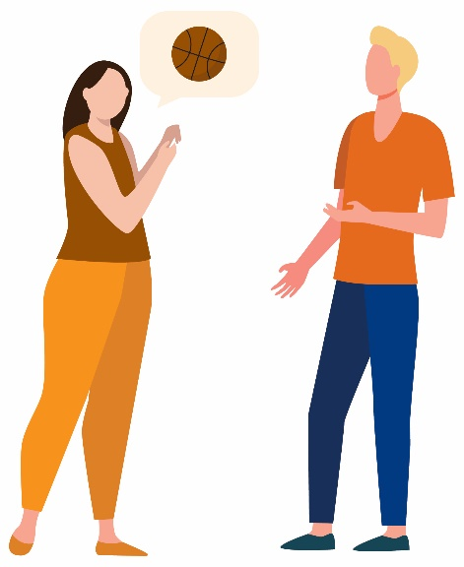 |  | - Introduce yourself to a new co-worker or classmate and start up a conversation with them.
 |  | - Talk with a friend about times that are appropriate and not appropriate to start a conversation
 |  | - Use “think it” or “say it” to help you decide what to do in a challenging situation with a friend.
 |  | - List out 3 appropriate topics that you can talk about with co-workers or friends.

Lesson Summary
It is important to know what is appropriate and what is inappropriate to have conversations with others.
In this lesson we learned:
- When to start a conversation and when to wait
- When to say something and when you should only think it
- What are appropriate topics for work or school

Level 3:
Active Listening Skills
Leadership Lessons
Communication
Check-in
Welcome to Level 3! Before you begin this lesson, see if you can answer a few of the questions below. If these questions are challenging, go to Level 1 or Level 2 and complete those lessons before starting this level. If you already completed Level 1 and Level 2 and still do not know the answers below, it may be a good idea to go back and review them before continuing with Level 3.

When would be a good time to start a conversation? When should you wait to have a conversation?
What is an example of a situation where it is ok to think something but not say it?
What is an example of an appropriate topic and an example of an inappropriate topic to talk about at work or school?

Check in
Check your answers
When would be a good time to start a conversation? When should you wait to have a conversation?
Answers could include:
You can start a conversation if the person is not busy and you both have free time. You should wait to have a conversation if someone is busy, speaking, performing or at the movies.
What is an example of a situation where it is ok to think something but not say it?
Answers could include:
It would be ok to think that your friend's new shirt is ugly, but not ok to say that to your friend.
What is an example of an appropriate topic and an example of an inappropriate topic to talk about at work or school?
Answers could include:
An appropriate topic could be about sports, books, or movies. An inappropriate topic would be talking about very personal things like body weight or appearances.
If you were able to answer these three questions, continue with Level 3. If you did not know how to answer them, go to Level 2 to learn all about appropriate and inappropriate things to say or do in a conversation!

Level 3
Communication
Active Listening Skills
 | 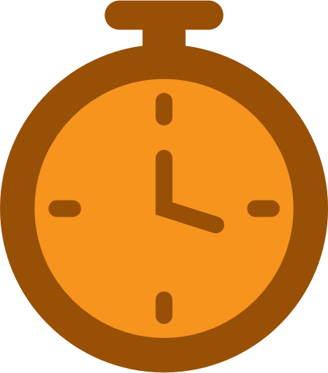 | Workbook Activity Time | 20 minutes
 |  | On Your Own Practice Time | 10 minutes

Effective communication involves both speaking and listening. If you do not practice good listening skills, it can lead to misunderstandings. This lesson will help you to learn and practice these communication skills.
Here’s what you will learn in this lesson:
Why listening is a very important part of communicating.
3 ways to practice active listening.

 | Part 1: Having a conversation
Maria and Leah have a conversation
Read this in-person conversation between friends Maria and Leah:
 | Leah: |  |  |  | Would you like to go see a movie tonight at 7:30?
 | Maria: |  |  |  | Yes, that would be fun.
 | Leah: |  |  |  | Want to get food, too?  (Leah looks down at her phone to read a text message from her mom, while Maria is talking.)
 | Maria: |  |  |  | Yes, I would like to get food together before the movie because I will be hungry. Let’s meet at my house at 6:30.
 | Leah: |  |  |  | Great. See you later.
 | This is what happened later:
- Leah meets Maria at her house at 7 PM to go to the movie.
- Leah tells Maria she just ate.
- Maria is confused and upset.
 | Question:
 | Why do you think Maria is confused and upset?
Pick one:
- Because Leah is late and she had already eaten, although they agreed to meet at 6:30 and have dinner together.
- Because Maria does not want to go to the movie.
- Because Leah ate something that Maria likes and did not buy her any.
- All of the above.
 | Correct answer
 | - Because Leah is late and she had already eaten, although they agreed to meet at 6:30 and have dinner together. |  |  |  |  |  |  |  |  |  |  |  | She feels Leah was not being a good friend by forgetting this.
What do you think happened?
Why was Leah late?
Why did Leah get food without Maria?
Why didn’t Leah follow the plan of meeting at Maria’s house at 6:30 so they had enough time to get food, together, before going to the movie?
 | Read the conversation between Maria and Leah again, below, and think about why Leah did not follow the plan of getting food, together, before the movie.
 |  | Leah: |  |  |  |  | Would you like to go see a movie tonight at 7:30?
 |  | Maria: |  |  |  |  | Yes, that would be fun.
 |  | Leah: |  |  |  |  | Want to get food, too?  (Leah looks down at her phone to read a text message from her mom, while Maria is talking.)
 |  | Maria: |  |  |  |  | Yes, I would like to get food together before the movie because I will be hungry. Let’s meet at my house at 6:30.
 |  | Leah: |  |  |  |  | Great. See you later.
 |  |  | Leah was not listening |  |  |  |  |  | She was looking at her phone and reading a message from her mom when Maria was talking, so she did not hear Maria when she asked that they meet at 6:30 and that she wanted them to eat together, before the movie.
 | How could this misunderstanding between two good friends, Maria and Leah, have been avoided?
 |  |  |  | Write your ideas here:

 | Part 2: Listening
Maria and Leah listen to each other
Read this in-person conversation between friends Maria and Leah:
 | Leah: | Would you like to go see a movie tonight at 7:30?
 | Maria: | Yes, that would be fun.
 | Leah: | Want to get food, too?  Maria, I need to read this text message from my Mom. Give me a few seconds.  (Leah gets a text message from her mom. She asks Maria to give her a few seconds to read the message and then respond to her mom. She quickly texts mom and then asks Maria to continue what he was saying.)  OK I texted Mom, continue what you were saying Maria.
 | Maria: | Yes, I would like to get food together before the movie because I will be hungry. Let’s meet at my house at 6:30.
 | Leah: | Great. See you at 6:30. We will get food and then go to the movie, right?
 | Maria | Yes, that’s right. See you then.

Part 3: Three active listening skills
- What was different?
Look again at both conversations between Leah and Maria in Part 1 and in Part 2.
How are they different?
Read or listen to both and circle what was new in Part 2, that you did not read or hear in Part 1.
- Do you know what was different?
In Step 2, Maria and Leah were both practicing good listing skills.

Understanding types of “good listening”
Tell the speaker what you think they said, but in your own words.
It is a way to make sure you understand what the person is saying and it shows them that you are listening. This is also called paraphrasing.
Example: If I heard you correctly, you want to eat before the movie, is that correct?
Reviewing
Show that you are listening and paying attention by making eye contact or nodding your head. Note that some people may not like making eye contact but may still be listening without it.
When you show you are listening, the speaker can talk more and trust that you understand what they are saying. This is also called being attentive.
Examples: Smiling, nodding your head, and making eye contact. Not looking at your phone or being distracted by other things around you shows them that you are paying attention.
Show you are listening
Ask the speaker questions so that you can learn more about the speaker or topic, clarify or better understand something they said, or finish a conversation.
Examples: Did I get that right? Is that correct? We will get food and then go to the movie, right?
Asking Questions

 | Lesson Checkpoint
 | Check-in with yourself to see what you might need next.
- Any of these choices are okay! It is healthy to make a choice that is best for YOU!
- Circle what you are going to do next!
 | Take a break | Ask for help | Come back to this another day | Try another level | Keep going
 | You made the right choice! You are AWESOME!

Part 4: You try!
Activity 1
Kris is your Special Olympics teammate.
Read Kris‘s statements, below, and then answer the questions.
- Kris: I love playing basketball, but when we travel for competitions, I miss my pets at home.
Question:
How could you respond to Kris to demonstrate the good listening skill of reviewing?
Pick one:
- I love playing basketball and traveling too!
- So, you love basketball, but not traveling because you miss your pets.
- Do you have pets?
- Kris: Have you heard from Coach Terri? I hope I am in the starting lineup today.
Question:
How could you respond to Kris to show you are listening?
Pick one:
- I have to go see my friend on a different team. Bye.
- It is exciting when you are in the starting line-up, isn’t it? I hope I get to start, too.
- (Looking at your phone and not saying anything.)
- Kris: I just saw on the schedule that our game is moved to another field. I am worried.
Question:
How could you respond to Kris to demonstrate the good listening skill of asking questions?
Pick one:
- I saw that too, but what has you worried about a field change?
- It’s nothing to worry about.
- If you are worried, you will play poorly.

Answers
- Kris: I love playing basketball, but when we travel for competitions I miss my pets at home.
Question:
How could you respond to Kris to demonstrate the good listening skill of reviewing?
Correct answer:
- So, you love basketball, but not traveling because you miss your pets.
You said to Kris what you thought Kris said, but in your own words. You wanted to make sure you understood what Kris was saying.
Why not the other answers? Here is why:
- I love playing basketball and travelling too!
This is not a bad thing to say, but it is not reviewing. It puts the focus back on you, instead of making sure you understood what Kris is explaining or describing.
- Do you have pets?
This shows that you are not listening. Kris already stated he has pets and missed them when at competitions.
- Kris: Have you heard from Coach Terri? I hope I am in the starting lineup today.
Question:
How could you respond to Kris to show you are listening?
Correct answer
- It is exciting when you are in the starting line-up, isn’t it? I hope I get to start, too.
You made a statement that was directly related to what Kris just said, to show you were listening. Good job!
Why not the other answers? Here is why:
- I have to go see my friend on a different team. Bye.
This is not good communication because you heard your teammate say something that bothered them, and then you walked away without responding.
- (Looking at your phone and not saying anything.)
This is not good communication because you were looking at your phone instead of looking at and listening to your teammate.
- Kris: I just saw on the schedule that our game is moved to another field. I am worried.
Question:
How could you respond to Kris to demonstrate the good listening skill of asking questions?
Correct answer:
- I saw that too, but what has you worried about a field change?
You asked Kris a question to gain more information about what Kris is saying. You want to know more about why Kris is worried.
Why not the other answers? Here is why:
- It’s nothing to worry about.
Just because you are not worried about it, does not mean that Kris is wrong for feeling worried. You saying this tells Kris his feelings do not matter.
- If you are worried, you will play poorly.
This will likely make Kris worry more, which is not something a good teammate does.

Activity 2
Below are examples of conversations between two teammates.
 | The first sentence is an example of what someone might say to you. The blank space below is for you to write or say out loud what you would say next. Be sure to use your good listening skills “reviewing,” “show you are listening,” and “ask question”
 | Reviewing
 | Joey | I like it when we have healthy snacks after practice because I get ideas of healthy snacks to eat at home.
 | You | (Use the Reviewing technique)
 | Show you are listening
 | Joey | I like my teammates because I feel we all care about each other on and off the field.
 | You | (Without speaking, how could you show Joey that you are listening by what you say or do?)
 | Ask a question
 | Joey | I wish I could play more soccer, but I don’t know if there are other teams in our area.
 | You | (Based on what Joey said, ask a question)

Part 5: Practice
It’s time for you to practice. Take the notes from this lesson with you.
- Find two people to have a 5-minute conversation with. Let each person know that you are having the conversation specifically to practice new communication skills.
- Pick a topic that you enjoy, food you like to eat, games you play, movies you have seen, or sports you enjoy.
- Have a conversation, while practicing your “reviewing,” “listening,” and “asking questions” skills.
- After each conversation, ask yourself:
What did I do well?
What could I have done even better?
You can also ask these same two questions of the people you had the conversation with.
- Keep practicing. Like anything else, using active listening skills takes practice.

Lesson Summary
In this lesson we learned:
- Why listening is just as important as speaking when communicating with others.
- To show active listening you can review what the person is saying, show you are listening, and ask questions.

Congratulations on completing a lesson on
Personal and Professional Development!
If you completed all 3 Levels on this topic, please take a 5-minute survey using this link or this QR code. Your feedback will help us improve lessons for the future and help us decide what topic or subject we should create next!
 | Click or scan |  | Or type in your browser
 |  |  | https://bit.ly/3H5v1NU
Do not forget that we have 4 other subjects on Personal and Professional Development that you can complete. If you do not know where to find them, email your Special Olympics Program staff member and they can help you.
Again, congratulations for completing this lesson. We hope that you learned a lot and will use it to become a better leader within your community and within the Special Olympics movement.

