Leadership Lessons
Personal and Professional Development

Topic 5 of 5:
Advocacy

Level 1
Discovering Yourself
Level 2
Strengths and Weaknesses
Level 3
Self-advocacy

Welcome!
Welcome to the 1st edition of Personal and Professional Development Lessons in the Special Olympics Leadership & Skills Curriculum. Before you begin, you deserve a high-five for taking the time to gain skills and knowledge so you can live your daily life as a friend, athlete, employee, and leader better than ever before.

There are a total of 15 different lessons within the Personal and Professional Development suite of resources.
The 15 lessons are split into 5 different topics (listed below) with 3 Levels in each topic. The Levels are designed to start out easier and get more difficult as you progress.
1.
Communication
2.
Handling Disappointment
3.
Setting Goals
4.
Healthy Relationships
5.
Advocacy

 |  | Here are a few tips to help you use this workbook and the other 4 workbooks in this suite of Personal and Professional Development resources:
 | 1 |  | We have included a complete list of topics with Topic Descriptions starting on page 4 to help you gain an understanding of all the topics and levels.
 | 2 |  | We have also included a Pre-Skills Assessment on pages 9-15 to help you decide which topic to start with.  This optional resource will help you see your strengths and weaknesses, which will help you to identify which of the 5 Personal and Professional Development topics you should start with.  You even have the option to have someone else who knows you well (like a coach or a family member or a mentor) complete the pre-skills assessment about you, providing feedback to help you better determine the topic and level you should start with.
 | 3 |  | Within each lesson, you will see this graphic below, which encourages you to pause your learning and decide what to do next.
 |  |  | 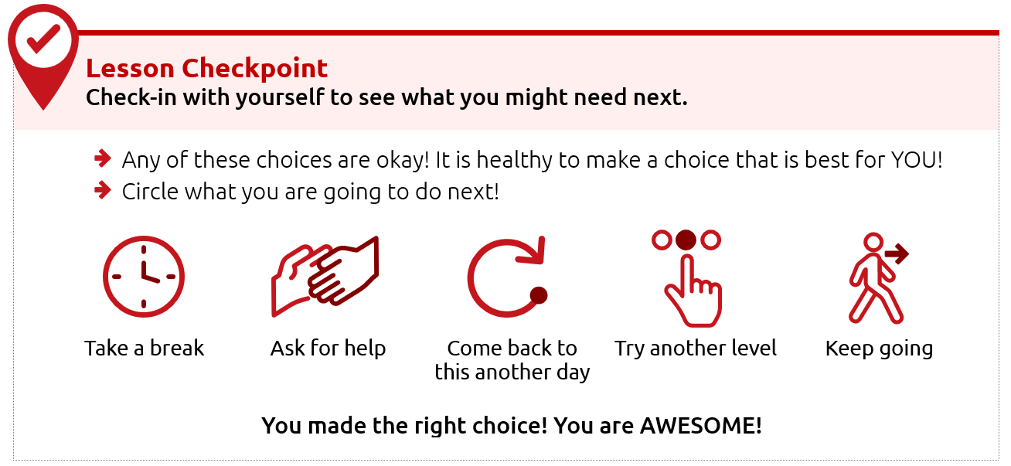
 | 4 |  | Each level takes approximately 30-45 minutes to complete, but it is okay if you take a longer or shorter time. Also, you do not have to complete a full level in one sitting. You can complete these levels at your own pace - even over the course of a few days, weeks, or months.
 | 5 |  | This resource is meant to be self-guided, which means you should be able to do them by yourself. But if you need help, do not be afraid to ask someone to assist you in completing them!
 | 6 |  | The content for each level is on the same topic (for example: Healthy Relationships or Communication) but the way the level asks you to participate is different. Some levels ask you to write your answers, while others ask you to draw your answers. Complete the levels however you prefer.

Alright, are you ready to begin?
We are very excited that you are starting this journey with us!
We believe in you - let’s go!
Topic descriptions and
what you should expect

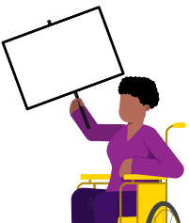
In total, there are 5 different handbooks covering 5 different topics.
Each topic will have 3 different lessons in it.
The 5 topics and the 3 lessons within those 5 topics are listed below.

Topic 5: Advocacy (THIS HANDBOOK)
Level 1  Discovering Yourself  Page 16 |  | It is important to know more about yourself because that helps you to better advocate for yourself and the things you care about.  Here is what you will learn in this lesson:  - What it means to “advocate”  - Ways to learn more about yourself  - Why knowing yourself helps you advocate better
Level 2  Strengths and Weaknesses  Page 31 |  | Being able to name your strengths and weaknesses can help you know how to advocate for yourself and for others.  Here is what you will learn in this lesson:  - How to identify your strengths and weaknesses  - Ways to use your strengths to help others  - Ways to ask others to help you improve your weaknesses
Level 3  Self-advocacy  Page 44 |  | It is important to know how to advocate for yourself. Through “self-advocacy” you can make choices that shape your life.  Here is what you will learn in this lesson:  - What “self-advocacy” is and why it is important  - Examples of self-advocacy in real-life situations  - Steps to practice self-advocacy

Topic 1: Communication (Different handbook)
Level 1  Starting a Conversation |  | It is important to know how to talk to other people.  Here is what you will learn in this lesson:  - Steps for how to start a conversation with someone  - Different topics that you could use when starting a conversation
Level 2  Appropriate and Inappropriate Conversations |  | It is important to know what is okay or “appropriate” and what is not okay or “inappropriate” when having conversations with others.  Here is what you will learn in this lesson:  - When to start a conversation and when to wait  - When to say something and when you should only think it  - What are appropriate topics for work or school?
Level 3  Active Listening Skills |  | Good communication involves both speaking and listening. If you do not practice “active listening” skills, it can lead to misunderstanding and miscommunication.  Here is what you will learn in this lesson:  - What “active listening” is  - Why listening is a very important part of communicating  - 3 ways to practice “active listening”
Topic 2: Handling Disappointment (Different handbook)
Level 1  Emotions and Safe Actions |  | Learning how to handle your emotions is important.  Here is what you will learn in this lesson:  - Safe and unsafe ways to handle difficult emotions  - Tips to help you when you have difficult emotions
Level 2  What to do when you feel disappointed |  | An emotion that can be challenging is disappointment. Disappointment can happen when you want something to happen and it does not happen. It can also happen when you expect someone to do something and they do not do it.  Here is what you will learn in this lesson:  - Examples of disappointment  - What are “expectations” and how do we handle them?  - What to do when you feel disappointed
Level 3  Accepting who  you are |  | It is important to practice self-acceptance, especially when facing disappointment. This lesson will help you handle and cope with disappointments in a positive way.  Here is what you will learn in this lesson:  - How to use self-acceptance to deal with disappointment  - The importance of positive self-talk  - Specific strategies for managing emotions / self-acceptance

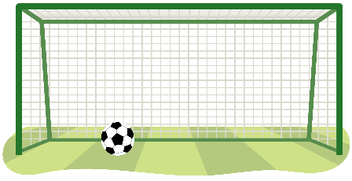
Topic 3: Setting Goals (Different handbook)
Level 1  The Basics of Setting Goals |  | Learning to set goals helps you get better.  Here is what you will learn in this lesson:  - What is a goal?  - How to set a goal for yourself
Level 2  Setting SMART goals |  | Setting a goal is a great way to stay focused on achieving something in the future. This lesson will help you set a goal and create steps to help you meet that goal.  Here is what you will learn in this lesson:  - What is a SMART goal?  - The difference between a goal and a SMART goal.  - How to set a SMART goal for yourself
Level 3  Overcoming Obstacles |  | This lesson will help you build on your understanding of SMART goals and how to overcome challenges.  Here is what you will learn in this lesson:  - How to learn and grow with your goals  - Why it is important to prepare for failure  - Why it is important to keep going and follow through on your goals

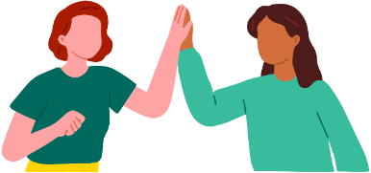
Topic 4: Healthy Relationships (Different handbook)
Level 1  Understanding Relationships |  | Learning about relationships is important.  Here is what you will learn in this lesson:  - What it means to have a relationship with someone  - The difference between a healthy relationship and an unhealthy relationship  - What to do if you have an unhealthy relationship
Level 2  Healthy Relationships and Boundaries |  | It is important to have healthy relationships in your life. One important part of a healthy relationship is having boundaries.  Here is what you will learn in this lesson:  - What are different types of relationships?  - What are different types of boundaries?  - How to set your own personal boundaries
Level 3  Conflict Resolution |  | It is important to know how to solve problems and disagreements in your relationships.  Here is what you will learn in this lesson:  - What conflict is and how to identify it in relationships  - Effective ways to prevent conflict  - Strategies to resolve conflict when it happens

Personal and Professional Development Lessons
Pre-Skills Assessment
Skills-Assessment for athlete learner
Directions
This assessment is optional. We created it to help you if you do not know where to begin your learning journey with these topics and levels. If that is the case, please use this assessment to help guide you where to begin. If you would rather go through each topic and level in your own order, that is okay, too.
The statements below describe situations you might encounter in your daily life as a friend, athlete, employee, and leader. For each statement select a number between 1 and 3 to indicate your current confidence level, where:
1 = I am not at all confident | 2 = I am somewhat confident | 3 = I am completely confident

How confident are you that you can… |  |  |  | Not at all  Confident |  | Somewhat  Confident | Completely  Confident
 | Topic 1: Communication
 | I can start up a conversation with people I do not know. |  |  | 1 |  | 2 | 3
 | I can ask questions when I want to learn more about what someone is saying. |  |  | 1 |  | 2 | 3
 | I can listen well to what others are saying to me. |  |  | 1 |  | 2 | 3
 | Communication total score:
 | Topic 2: Handling Disappointment
 | I can express my emotions in a way that is safe for me and others. |  |  | 1 |  | 2 | 3
 | I can handle disappointment. |  |  | 1 |  | 2 | 3
 | I can accept myself for who I am. |  |  | 1 |  | 2 | 3
 | Handling Disappointment total score:
 | Topic 3: Setting Goals
 | I can set goals for myself and follow a plan. |  |  | 1 |  | 2 | 3
 | I can adjust my goals when I am faced with failure or obstacles. |  |  | 1 |  | 2 | 3
 | I can set goals to challenge and push myself outside of my comfort zone. |  |  | 1 |  | 2 | 3
 | Setting Goals total score:
 | Topic 4: Healthy Relationships
 | I can make and keep healthy relationships. |  |  | 1 |  | 2 | 3
 | I can work through conflict with other people without hurting their feelings. |  |  | 1 |  | 2 | 3
 | I can set boundaries with friends and respect when friends set boundaries with me. |  |  | 1 |  | 2 | 3
 | Healthy Relationships total score:
 | Topic 5: Advocacy
 | I can identify and explain who I am and what I believe in. |  |  | 1 |  | 2 | 3
 | I can easily accept that there are things that are out of my control. |  |  | 1 |  | 2 | 3
 | I can advocate for what I want clearly and calmly. |  |  | 1 |  | 2 | 3
 | Advocacy total score:

Skills-Assessment for Mentor
to complete about the Athlete
Directions
This assessment is optional and should be completed by a mentor or family member of the athlete leader. The person filling this out should be someone who knows the athlete very well and can provide constructive criticism and positive feedback. Your assessment of them is meant to help the athlete leader see their strengths and weaknesses according to someone else so they can identify where to begin their learning journey.
The statements below describe situations the athlete might encounter in their daily life as a friend, athlete, employee, and leader. For each statement, circle a number between 1 and 3 to indicate where you think the athlete’s confidence level is, where:
1 = not at all confident | 2 = somewhat confident | 3 = completely confident.

How confident are you that the athlete can… |  |  |  |  | Not at all  Confident |  | Somewhat  Confident | Completely  Confident
 | Topic 1: Communication
 | Start up a conversation with people they do not know. |  |  |  | 1 |  | 2 | 3
 | Ask questions when they want to learn more about what someone is saying. |  |  |  | 1 |  | 2 | 3
 | Listen well to what others are saying. |  |  |  | 1 |  | 2 | 3
 | Communication total score:
 | Topic 2: Handling Disappointment
 | Express their emotions in a way that is safe for them and others. |  |  |  | 1 |  | 2 | 3
 | Handle disappointment. |  |  |  | 1 |  | 2 | 3
 | Accept themselves for who they are. |  |  |  | 1 |  | 2 | 3
 | Handling Disappointment total score:
 | Topic 3: Setting Goals
 | Set goals and follow a plan. |  |  |  | 1 |  | 2 | 3
 | Adjust goals when faced with failure or obstacles. |  |  |  | 1 |  | 2 | 3
 | Set goals to challenge and push themselves outside of their comfort zone. |  |  |  | 1 |  | 2 | 3
 | Setting Goals total score:
 | Topic 4: Healthy Relationships
 | Make and keep healthy relationships. |  |  |  | 1 |  | 2 | 3
 | Work through conflict with other people without hurting their feelings. |  |  |  | 1 |  | 2 | 3
 | Set boundaries with friends and respect when friends set boundaries with them. |  |  |  | 1 |  | 2 | 3
 | Healthy Relationships total score:
 | Topic 5: Advocacy
 | Identify and explain who they are and what they believe in. |  |  |  | 1 |  | 2 | 3
 | Easily accept that there are things that are out of their control. |  |  |  | 1 |  | 2 | 3
 | Advocate for what they want clearly and calmly. |  |  |  | 1 |  | 2 | 3
 | Advocacy total score:

Scoring
Add the numbers for each of the five leadership topics. See the example below:
 | Topic 4: Healthy Relationships
 | Make and keep healthy relationships. |  |  |  | 1 |  | 2 |  |  | 3
 | Work through conflict with other people without hurting their feelings. |  |  |  | 1 |  | 2 |  |  | 3
 | Set boundaries with friends and respect when friends set boundaries with them. |  |  |  | 1 |  | 2 |  |  | 3
 | Healthy Relationships total score: |  |  |  |  |  |  |  | 5
What is next?
Congratulations! Like everyone, you have a lot of skills, but you also have new things to learn. These lessons can help you gain new skills and improve upon what you already know.
To help you figure out where to start your learning journey, you can follow these steps:
 | Step
 | 1 |  | If you or your mentor/helper gave a total score for any topic of 6 or below, that topic should be one of the first you consider starting at because that shows you have more to learn on that topic.  For example, the athlete listed above who scored five (5) on Healthy Relationships will go to the Healthy Relationships lessons first. If this lesson that you have is not what you are looking for, you can find all 5 topics at the Special Olympics resources website (https://bit.ly/41GT7rW) or you can ask your Program where to find it.
What happens if you and your mentor have scored a topic very differently?
If you and your mentor have different scores for a topic, discuss this with your mentor. Having different scores is an excellent opportunity to receive feedback from someone else and learn more about how others view your knowledge and skills in that category. It is okay if they think that you are lower in a category than you scored yourself. They have a different perspective of your strengths and weaknesses.
There are activities within Communication, Healthy Relationships, and Handling Disappointment that will help you get better with giving and receiving feedback.
 | 2 |  | Continue completing lessons until you have completed all the leadership lessons within the leadership topics that you or your mentor scored 6 or less. Stop after each lesson and give yourself a big round of applause!
 | 3 |  | Take your time and go through one leadership topic or lesson daily so you have time to practice and tell your coach, teammates, and friends what you are learning.
 | 4 |  | After you have completed all the leadership lessons where you scored a 6 or below, complete all the other leadership topics and lessons you are interested in. Even if you scored above a 6 in them, there is always more to learn, so go through all of them! Again, you can find all 5 topics and their 15 lessons by visiting the Special Olympics resources website (https://bit.ly/41GT7rW) or contacting your local Special Olympics staff member and ask for help.

Level 1:
Discovering Yourself
Leadership Lessons
Advocacy
Level 1
Advocacy
Discovering Yourself
 | Think about these questions:
 | 1. | What does it mean to advocate?
 | 2. | How can I learn more about myself so I can advocate?
 | If you do not know yet, do not worry! This lesson will teach you all about what it means to advocate and why is it important!
Think about the questions below and write or draw your answers.
 |  |  | What do you like and dislike?
Possible answers:
(Likes) reading, music, ice cream...
(Dislikes) loud sounds, surprises, when people don’t listen…
 |  |  | What makes you happy?
 |  |  | Possible answers: my family, my pets, playing sports, my birthday…
 |  |  | What makes you upset?
 |  |  | Possible answers: mean people, losing games, unfairness…
 |  |  | What are you good at?
 |  |  | Possible answers: Riding my bike, putting together PowerPoint presentations…
 |  |  | What do you wish you were better at?
 |  |  | Possible answers: Talking about my feelings, gardening, taking notes during meetings…
 |  |  | What is something that you think is important?
 |  |  | Possible answers: Being kind, following the rules, being healthy, including others, helping people…
Now, ask a friend or mentor the same questions! Do any of their answers match
up with yours?
LEARN
 | To advocate means to stand up for what is right.  In order to advocate for ourselves, we have to learn about ourselves and know what is important to us! |  |  |  |  |  | 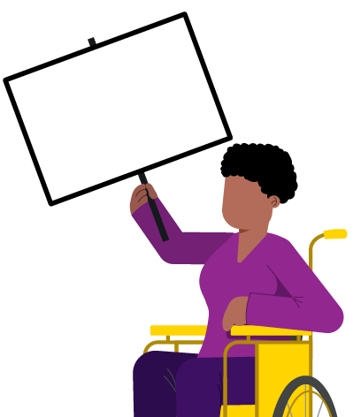
 | Here are some ways you can stand up for what is right or advocate for yourself!
 |  | Speaking up when something is unfair.
 |  | Asking others for help.
 |  | Saying "No" if you are uncomfortable.
 |  | Asking to have a turn or share with others.
Learning about what we like and dislike, what we are good at,
and what is important to us helps us to be able to advocate!

 | Part 1: Likes and Dislikes
 | Story 1
This is Li.
Li knows he likes to help kids.
 |  |  | 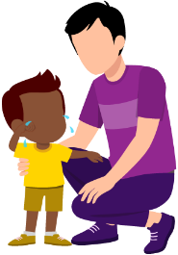 |  |  |  | 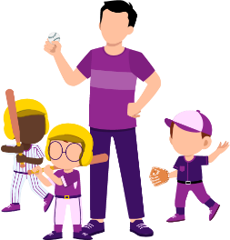
 |  |  | Li knows he is good at helping kids. |  |  |  | Li even helps coach a kid's community baseball team. |  |  |  |  | Li knows that helping kids is important to him.
 |  |  | Li wanted to get a job with kids but was told he could not. Li thought this was unfair.
 |  |  |  |  |  |  | 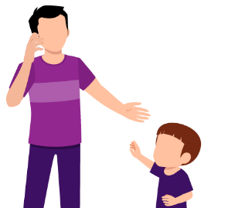  z |  |  |  |  | 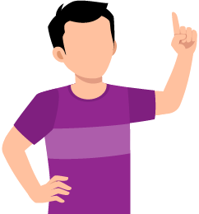
 |  |  | Li decided to advocate for himself! |  |  |  | Li said that he could do a great job and knew what to do because he has years of experience working with kids. |  |  |  |  | He said he should get a fair chance too.
 |  |  | Li was able to advocate for himself because he knew it was important to him and he could prove that he was a good fit for the role.

 | Story 2
 |  | 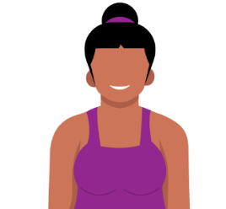 |  |  | This is Jordan  Jordan is not sure what activity to pick at school.
 |  | 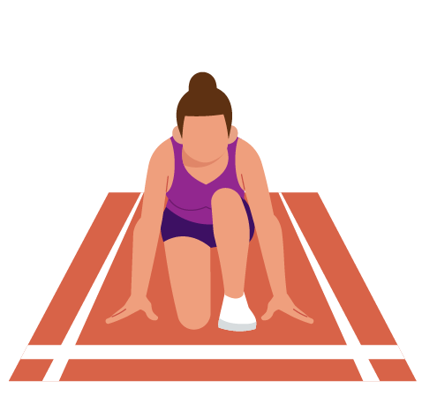 |  |  |  |  |  |  |  | 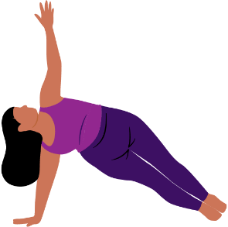
 |  | Track |  |  |  |  |  |  |  | Yoga
 |  | Jordan thinks about what she likes and dislikes.
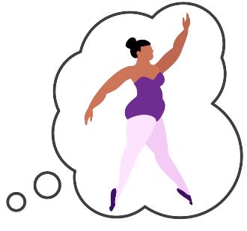
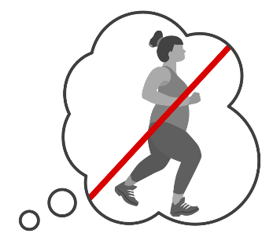
 |  | Jordan dislikes running and jumping. |  |  |  |  |  |  |  | Jordan likes dancing and stretching.
 |  | 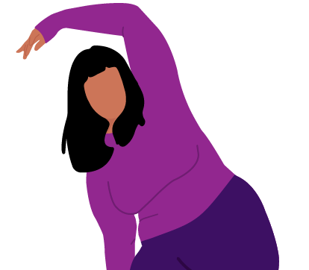 |  |  |  |  | Jordan knows she does not like to run or jump and track has both running and jumping.  Jordan knows she likes stretching, so Jordan picks yoga!
 |  | Learning what you like and do not like is important to become a self-advocate.

People have different likes and dislikes. It is okay if you do not like the same things as your family and friends.
 | Look at the icons and words below. Think about your personal feelings about each topic. Circle like or dislike. Then, have a friend do the same!
 |  |  |  | Me |  |  | My Friend
 |  | Books
 |  | Games
 |  | Soup
 |  | Cake
 |  | Sports
 |  | Writing
 |  | Dancing
 |  | Broccoli
 |  | Swimming
 |  | Public speaking
 |  | Hugging
 |  | Waking up early

 | Lesson Checkpoint
 | Check-in with yourself to see what you might need next.
- Any of these choices are okay! It is healthy to make a choice that is best for YOU!
- Circle what you are going to do next!
 | Take a break | Ask for help | Come back to this another day | Try another level | Keep going
 | You made the right choice! You are AWESOME!

 | Part 2: What is important?
Kate does not know what is important to her or what she cares about most.
We will help her figure out what she cares about the most.
This is what Kate did this week:
 | 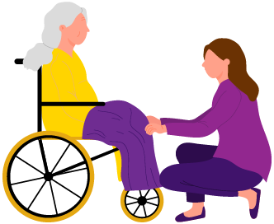 |  | 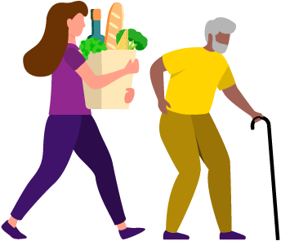
 | Helped her grandma |  | Carried groceries  for her neighbor |  | Gave old books  to a charity
Based on the graphics above, what do you think Kate cares about?
It seems like Kate cares about helping other people!
What are things you care about? Write or draw them below.
It is okay if you are not sure. The next activity will help you figure it out!
 | Learning what you care about is important!

 | Check the box under the one that fits you most. When you are finished, each row of boxes should only have one check mark.
 |  |  |  | NOT important to me | A LITTLE important to me | VERY important to me
 |  | Family
 |  | Fancy clothes
 |  | Friends
 |  | Music
 |  | Sports
 |  | Winning
 |  | Helping others
 |  | Being a leader
 |  | Making decisions
 |  | Doing things on my own
 |  | Following a plan
 | 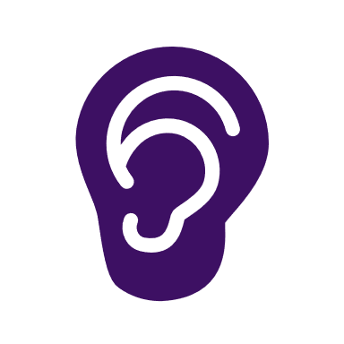 | Listening to other people
 |  | Following the rules
 |  | Doing chores
 |  | Cooking
If you do not know what is important to you,
you will not know when to advocate for yourself!

Talk to a mentor or friend about things they think are important.
Write or draw them below.
Can you think of any other things that are important to you that are not on the list above?
Write or draw them below.

 | Part 3: What are you good at?
Travis does not know what he is good at or not good at.
We can help him figure it out, right? This is what Travis did this week:
 |  |  |  | 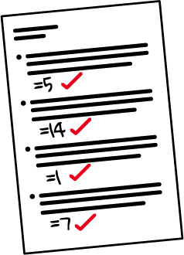 |  | 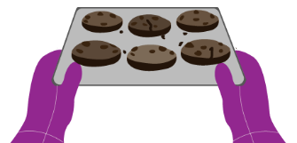 |  |  | 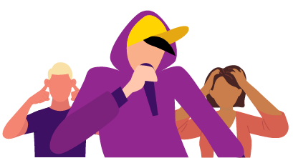
 | Told jokes |  |  | Took a test |  | Baked cookies |  |  | Sang songs
 | Based on the pictures above, what do you think Travis is good at? How can you tell he is good at it?
 | Write or draw your answer below.
 | Based on the pictures above, what do you think Travis is not good at yet? How can you tell he is not good at it?
 | Write or draw your answer below.
 | Answers:
 |  | He made others laugh. He is good at telling jokes!
 |  | He got all correct answers on his test. He is good at math!
 |  | His cookies were burnt so he is not good at baking yet
 |  | His singing hurt people's ears, so he is not good at singing yet

 | Your Turn!
 |  |  |  | Fill in 1 star if you are not good yet.
 |  |  |  | Fill in 2 stars if you are a little good.
 |  |  |  | Fill in 3 stars if you are good at it!
 |  |  | 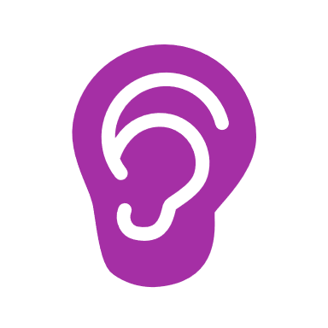 |  | Listening
 |  |  |  |  | Being a leader
 |  |  |  |  | Being kind
 |  |  |  |  | Being patient
 |  |  |  |  | Following the rules
 |  |  | 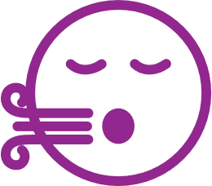 |  | Controlling my emotions
 |  |  |  |  | Being on time
 |  |  |  |  | Sharing with others

REFLECT
Write or draw what you have learned about in this lesson.

When you are ready for Level 2,
you will learn about your strengths and weaknesses!

Lesson Summary
In this lesson, we learned:
- More about yourself.
- How knowing more about yourself helps you advocate for yourself.

Level 2:
What are your strengths and weaknesses?
Advocacy
Leadership Lessons
Check-in
Welcome to Level 2! Before you begin this lesson, see if you can answer a few of the questions below. If these questions are challenging, go to Level 1 and complete that level before starting this level. If you already completed Level 1 and still do not know the answers below, it may be a good idea to go back and review it again before continuing with Level 2.
What are two things you like?
1
2
What are two things you dislike?
1
2
What is something that you care about? Why do you care about that thing?
If you could answer these three questions, continue with Level 2. If you did not know how to answer them, go to Level 1 to learn who you are and what is important to you!
Answers will change based on the person. If you are able to list things you like and dislike, you have a good understanding of who you are and can continue with this lesson. Talk with a family member or mentor or coach about things they care about if you need some ideas. They may even help you identify things that you care about!

Level 2
Advocacy
What are your strengths and weaknesses?
Being able to identify, or name, your strengths and weaknesses can help you know how to help yourself and others. During these lessons, you will learn about:
- How to identify your strengths and weaknesses
- Ways to use your strengths to help others
- Accepting and embracing your disability

Work through these lessons to learn more about who you are.

Knowing yourself
Knowing yourself is an important first step for being able to ask for what you need help with or to advocate for yourself.
Draw a picture or write some words in each box to share a little bit more about you.
My self portrait
I like to…
I am…
I am good at…

Part 1: Strengths
Things you are good at are called “strengths.”
Everyone has different things they are good at! Some strengths are things that you are good at without having to practice a lot or try hard and other strengths are things you have spent a lot of time practicing to be good at.
How is knowing your strengths helpful?
Answer: Knowing your strengths can help you know what kind of role or job you might like or let you help others in a very specific way. It also can give you a focus on what activities you might enjoy or hobbies you would like to participate in!
There are different things that you could be good at. Work through the next page and sort items into strengths, weaknesses, and things that are between the two.

Think about your strengths and weaknesses. Draw a line from each picture to sort each of these into a category. You can draw or write more things if you want to!
 | Reading |  | Running |  |  | Being a friend |  | Singing |  |  | Building or creating
 |  |  |  |  |  | 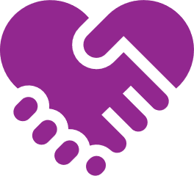 |  | 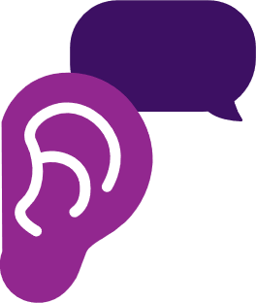
 | Swimming |  | Drawing |  |  | Helping others |  | Listening to others |  |  | Dancing
 | Strength |  |  | In the middle |  |  |  |  | Weakness

Now that you have sorted your strengths and weaknesses, we can look at the specific things you are good at and see what they say about you. Check out these examples:
- A strength you might have is being good at math. Another way to say that is that you like working with numbers or solving problems.
- Another strength you might have is being a fast runner. In other words, you can say that you are athletic!
- If you can tell awesome jokes, you are funny!
- The strength of listening can mean you are a good friend!
The next words are broad words or categories that can help you talk about your strengths to others.
 | Read through these words and put a check mark in the box next to the word if it is something that you think you are good at. If you do not know the word, ask a friend or look up the definition in a dictionary.
 | - Helpful  - Friendly  - Kind  - Humble  - Brave  - Honest  - Thoughtful  - Trustworthy  - Focused  - Patient |  | - Curious  - Problem solving  - Artistic  - Smart  - A leader  - Empathetic  - Cooperative  - Creative  - Loyal  - Funny
 | Out of the words that you put a checkmark next to, what are the 3 things that you think you are the best at? Why are you good at them?
 | 1
 | 2
 | 3
 | Then, you will ask someone else (a friend, a mentor, a family member) to share what they think your strengths are and you will write them below as well.
 | 1
 | 2
 | 3

Connection time
As mentioned above, now find a family member or trusted friend or mentor and ask them what strengths they see in you. See if they match up with what you said and ask them why they said the strengths that they did. Write what they said in the table on the previous page.
Think about what strengths you have. What are ways you can use your strengths to help others?
Example:
- I am artistic and like to paint pictures. I could paint pictures and send them to my grandma to cheer her up!
- My strength is that I am good at problem solving. I can listen to a friend with a problem and help them come up with a solution!

Now you try!

If your strength is being funny, what is one way that you could help others by being funny?
Answers:
- You could tell jokes if someone is having a bad day to make them feel better.
- You could send them a video that is funny to cheer them up.

If your strength is being thoughtful, how could you use that to help someone?
Answers:
- You could send a friend or family member a card that says you are thinking about them.
- If you have extra food, you could share it with a neighbor.
- Remembering people’s birthdays is a way to show that you are thoughtful.

What is one of your strengths?

How can you use this strength to help others?

 | Lesson Checkpoint
 | Check-in with yourself to see what you might need next.
- Any of these choices are okay! It is healthy to make a choice that is best for YOU!
- Circle what you are going to do next!
 | Take a break | Ask for help | Come back to this another day | Try another level | Keep going
 | You made the right choice! You are AWESOME!

 | Part 2: Weakness
Just like we all have unique strengths, we all have unique weaknesses or something we are not good at. “Weakness” is not a bad word. Everyone has weaknesses, so if you do not think you do, keep thinking to see what areas you could get better at. Or maybe ask a family member or coach if they can share some things they think you need to get better at.
 |  | Go through the list again and this time, circle the word if it is something you would like to get better at. You may not be terrible at it, you just may have a desire to get better!
 |  | - Helpful  - Friendly  - Kind  - Humble  - Brave  - Honest  - Thoughtful  - Trustworthy  - Focused  - Patient |  |  | - Curious  - Problem solving  - Artistic  - Smart  - A leader  - Empathetic  - Cooperative  - Creative  - Loyal  - Funny
 |  | Now that you have circled some words that you think are weaknesses, look over them again and decide on 2 that are most important to you to get better at and put a reason why as well.
 |  | 1
 |  | 2
 |  | 3
 |  | Then, you will ask someone else (a friend, a mentor, a family member) to share what they think your weaknesses are and you will write them below as well.
 |  | 1
 |  | 2
 |  | 3
 | Knowing your weaknesses can be very empowering because you will know how to advocate for yourself! Remember, advocating means knowing how to ask for help and what you need to be successful. Check out the next page for examples on how to work on your weaknesses.
 |  | Connection time
As mentioned above, now find a family member or trusted friend or mentor and ask them what weaknesses they see in you. See if they match up with what you said and ask them why they said the weaknesses that they did. Write what they said in the table on the previous page. Remember, it’s not always fun to hear someone share what you are not good at. We are using this as an opportunity to get better!
Thank the person for being honest with you!

 | Part 3: Identify your strengths and weaknesses
Great job identifying your strengths and weaknesses and learning how they can help you advocate for yourself better.
Remember that you can ask family and friends to help you get better at the things you said are your weaknesses. Maybe your strength is something that is a strength for your coach and you can ask them to help you get better at it! And maybe one of your strengths is something that your best friend has identified as their weakness, so you can help them get better at it!
 |  | Use this page to summarize what you have learned.
 |  | My strengths |  | My weaknesses
 |  | How I can use my strengths to help others |  | How I will work on my weaknesses
Share this page with a friend or family member
and see if they can help you add more to each box!

Lesson Summary
Being able to identify, or name, your strengths and weaknesses can help you know how to help yourself and others.
In this lesson, we learned:
- How to identify your strengths and weaknesses
- Ways to use your strengths to help others
- Ways to ask others to help you in your weaknesses

Advocacy
Leadership Lessons
Level 3:
Self-advocacy
Check-in
Welcome to Level 3! Before you begin this lesson, see if you can answer a few of the questions below. If these questions are challenging, go to Level 1 or Level 2 and complete those lessons before starting this level. If you already completed Level 1 and Level 2 and still do not know the answers below, it may be a good idea to go back and review them before continuing with Level 3.
What are your strengths and weaknesses?
Strengths:

Weaknesses:
How can you use your strengths to help others?
What is a weakness of yours and how can you ask for help?

Check in
Check your answers
What are your strengths and weaknesses?
Answers will vary, but here are some examples.
Strengths: good at dribbling the ball, always on time for practice, able to teach other people
Weakness: Remembering the practice schedule, not interrupting others when they are talking, asking questions
You should be able to identify at least one strength and one weakness or you should go back to Level 2 and review
How can you use your strengths to help others?
Answers will vary, but here is an example.
Because I am good at teaching other people, I am able to patiently explain practice drills to new athletes on our team.
You should be able to list a strength of yours and be able to share how it helps others.
What is a weakness of yours and how can you ask for help?
Answers will vary, but here is an example:
Because I have a difficult time remembering the practice schedule, I could ask my coach or teammates for tips and ideas they use to remember the schedule.
You should be able to list a weakness of yours and how you can ask for help in that area
If you were able to answer these 3 questions, continue with Level 3. If you did not know how to answer them, go to Level 2 to learn all about your strengths and weaknesses!

Level 3
Advocacy
Self-advocacy
 |  | Workbook Activity Time | 20 minutes
 |  | On Your Own Practice Time | 10 minutes

It is important to know how to advocate for yourself, which is also called self-advocacy. Through self-advocacy you can make choices that shape your life. This lesson will help you understand self-advocacy and how to effectively practice it.
Here is what you will learn in this lesson:
- The concept of self-advocacy and why it is important.
- Examples of self-advocacy in real-life situations.
- Steps to effectively practice self-advocacy.

Part 1: Self-advocacy explored
Self-advocacy is speaking up for yourself.
Self-advocacy gives you the ability to make choices and decisions that affect your life.
We will start by looking at a few everyday examples of self-advocacy:
“At practice, the coach wanted to go to the next drill, but I was struggling so I asked the coach and the team to please wait while I perfected the first drill.”
“My teacher was not going to pick me to give a speech to the class, but I told the teacher I could do it because I have the skills and have something worth sharing with the class.”
Question
Even though self-advocacy can be challenging, why do you think it is important for you to speak up for yourself?
Think of a time you advocated for yourself. What did you say or do that made you feel you were standing up for yourself?
Once you have thought of a time you advocated for yourself, answer these questions about that experience.
Where were you and who was there?
How did you know you needed to speak up for yourself?
What did you say or do that felt like advocating for yourself?
After you advocated for yourself, what happened next?
What did you learn from speaking up for yourself?
Self-advocacy might sound easy, but it can be hard.
Here are some reasons other athletes have shared how self-advocacy can be difficult for them.
- I do not think others will understand me or care about what I have to say.
- I get too emotional and cannot remember what to say.
- I do not want to hurt other people’s feelings, but my feelings matter too!
- It takes me a long time to express myself and others will just stop listening to me.

 | Part 2: Self-advocacy in real life
Read this situation and answer the question.
 | Situation 1
You arrive at a medical center for your doctor’s appointment, but it is your first time visiting this location and you are not sure where your doctor’s office is located. You look around and see an information desk.
What will you do next to find your doctor's office?
- Walk up to the first person you see and say, “Help, I can’t find my doctor.”
- Sit down and wait for someone to ask you if you need help.
- Continue to walk around the medical center until you find your doctor’s office.
- Walk up to the information desk and explain to the person there that you have an appointment, state your doctor’s name, and ask for directions to their office.
- Call a family member for help.
- Go home and reschedule your appointment.
 |  |  |  | Check:
- Walk up to the information desk and explain to the person there that you have an appointment, state your doctor’s name, and ask for directions to their office.
This option includes clear communication, independence, and self-advocacy.
 |  |  |  | Correct
- Walk up to the first person you see and say, “Help, I can’t find my doctor”.
- Call a family member for help.
Self-advocacy can be difficult, so sometimes you must take small steps before you can take a giant step. These answers are small steps. Great job, keep going.
 |  |  |  | Not quite, but close
- Sit down and wait for someone to ask you if you need help.
- Continue to walk around the medical center until you find your doctor’s office.
- Go home and reschedule your appointment.
While the following options might eventually get you help, it does not include clear communication, independence, or confident self-advocacy.
 |  |  |  | Incorrect
 |  |  |  | Remember, self-advocacy is speaking up for yourself. Self-advocacy gives you the ability to make choices and decisions that affect your life.
To self-advocate, you have to know what you want. In this situation, you knew what you wanted (directions to your doctor's office) and there was someone there to help (the person at the information desk). So in this example, you needed to take a deep breath, remember why you are there, what you want, and ask for help.
Remember, self-advocacy does not mean you have to do everything yourself. Asking for help does not mean you are not a self-advocate or independent. People will only know that you need help if you speak up and admit that you need assistance. Asking for help is not a weakness; it is a strength!
 |  | Lesson Checkpoint
 |  | Check-in with yourself to see what you might need next.
- Any of these choices are okay! It is healthy to make a choice that is best for YOU!
- Circle what you are going to do next!
 |  | Take a break |  |  |  | Ask for help | Come back to this another day | Try another level | Keep going
 |  | You made the right choice! You are AWESOME!

Situation 2
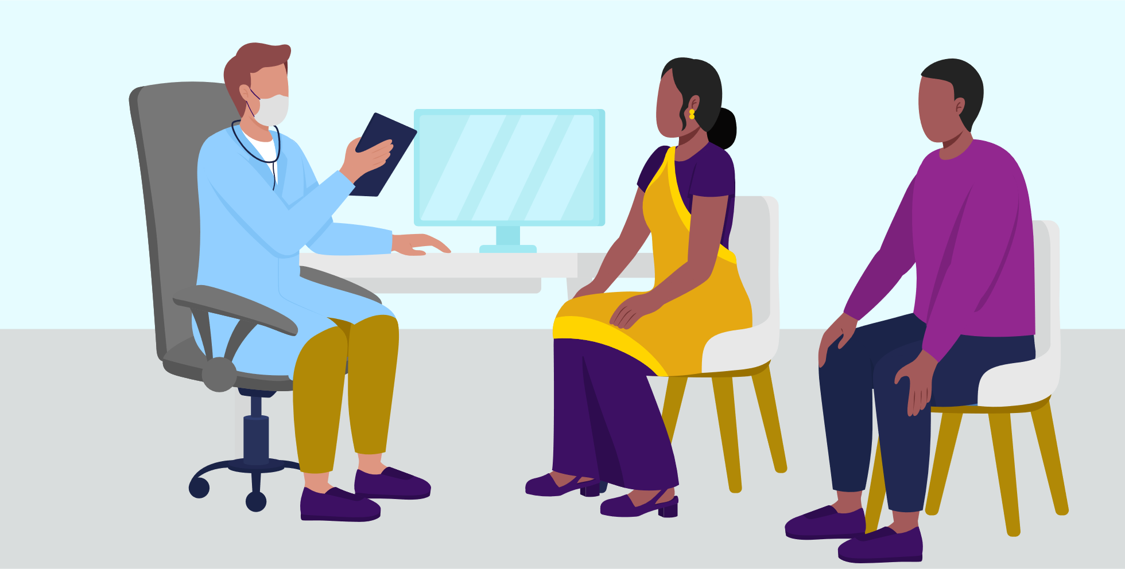
This time you are at the doctor with a family member. You are there for your yearly medical exam. Before beginning your exam, the doctor turns to your family member and asks them questions about how you are feeling, what you have been doing for exercise, what you are eating, etc. They do not talk to you at all. It is like you are invisible to them.
What should you do?
- Ask the doctor to speak to you and include you in the conversation.
- Explain that you can speak for yourself.
- Allow the doctor to continue talking to your family member.
- Focus on listening to what the doctor is saying.
- Ignore the conversation.
- Let your family member take care of everything.
- On the way home, tell your family member that next time you would like to speak for yourself.
Check:
- Ask the doctor to speak to you and include you in the conversation.
- Explain that you can speak for yourself.
These options include clear communication, independence, and self-advocacy.
Correct
- On the way home, tell your family member that next time you’d like to speak for yourself
Self-advocacy can be difficult, so sometimes you have to take small steps before you can take a giant step. This answer is a small step. Great job, keep going.
Not quite, but close
- Allow the doctor to continue talking to your family member.
- Focus on listening to what the doctor is saying.
- Ignore the conversation.
- Let your family member take care of everything.
These options do not show clear communication, independence, or confident self-advocacy.
Incorrect
Self-advocacy is speaking up for yourself and making your wants and needs known to other people.
It is easier to self-advocate if the other person you are asking for help is doing these things:
- Communicating so that you can understand what they are saying;
- Adjusting or modifying the environment or how they are communicating so that you can fully understand and communicate; or
- Giving you time to communicate and an opportunity for you to ask questions when you are ready.
So, be prepared to ask for time and accommodations, to express your wants, needs, and ideas fully. It is okay to ask for these things, they will help you advocate for yourself.
In this doctor example we just provided, you may need to self-advocate by:
- Asking the doctor to give you information in a way you understand, like giving examples or using photos or social stories.
- Asking the provider to slow down or repeat what they said .
- Asking the provider to explain or inform using different words.
- Inviting a person you trust to come with you.
- Asking for other accommodations to help you communicate your thoughts and ask questions.
These are example of self-advocacy because it helps you get what you need, which is information about your health.
When you tell your doctor, teacher, employer, or anyone how you like to be treated or what you need, that is self-advocacy!

 | Part 3: How to do self-advocacy
Self-advocacy can be easier if you follow a short checklist. We will take a look at the graphic below and follow it in clockwise form – from left to right, top to bottom:
 |  | 1 |  |  |  |  |  | 2 |  |  |  |  |  | 3
 |  |  | What is the current situation? |  |  |  |  |  | Is the situation okay or not okay with me? |  |  |  |  |  | If it is not okay with me, then what do I want?
 |  |  |  |  | 5 |  |  |  |  |  | 4
 |  |  |  |  |  | What happened after I advocated for myself? |  |  |  |  |  | Speak up and say something – self-advocate

 | Ask:  What is the current situation? |  |  |  | Identify the situation. Look at the situation and determine if you need to advocate for yourself.  - For example, you are competing in a football match, it is halftime, and your coach did not play you at all in the first half.
 | Ask:  Is this situation okay or not okay with me? |  |  |  | Once you identify the situation, ask yourself if you are okay with what is going on. Does something seem unfair?  - For example, not being called to play the first half is “not okay with you.” You attended all the practices and were on time for the game, so you do not think there is a good reason for you not to play.
 | Ask:  What do I want? |  |  |  | Know what you would like to happen that is different from the current situation. Tell someone, clearly and kindly, how you see the current situation and what changes you want to see. Speak about the facts, not rumors. Explain what is happening and then what you want to happen.  - For example, you can say: “Coach, I did not play the first half. I attended all the practices and was on time today. I want to play more in the second half. “
Say:
Speak up and say something – self-advocate
 | Ask:  What happened after I advocated for myself? |  |  |  | Think about the outcome of your self-advocacy. What happened after you advocated? Are you happy with what happened as a result? If not, go back to the beginning step, “What is the current situation?” and repeat the steps again.  - It is okay to continue to advocate for yourself until you get an outcome that is acceptable to you.  - Use good communication skills to ask your coach why they did not play you. Be willing to listen to what your coach as to say. Your coach may have a good reason that you did not play, such as, they may have wanted to give another group of less-experienced athletes a chance to play for a change. If that reason makes sense to you then great! You stood up for yourself and you also learned that your coach had a good reason for not playing you.
Do you remember what you learned in the Active Listening lesson?
Those same communication skills will help you self-advocate.
Did you learn about being calm and breathing in the Accepting Me lesson?
Those skills will help you stay focused and calm when advocating for yourself.
If you haven’t been through the Active Listening or Accepting Me Lessons, visit those next.

Part 4: You try
Activity 1
It is time for you to watch others in action.
Over the next week watch people advocating for themselves. These acts of self-advocacy likely happen every day, such as, people advocating for a specific restaurant choice, staying at practice longer, or having their opinion heard in a meeting.
If you do not see any examples happen in your life, ask a friend or a family member to give you some examples of times where they advocating for themselves then answer the questions below based on their examples.
In what you observed, answer the following questions:
Why do you think the person felt they needed to self-advocate?
What did they want? Did they know what they wanted?
What words did they use to self-advocate? Did they use words like “I want” or “I need” or “This is important to me”?
What happened after they advocated?
What did you learn from these examples that you can do when you self-advocate?
Activity 2
It’s time for you to practice.
We cannot always make an opportunity to self-advocate happen. But, over the next few weeks, you will likely have an opportunity to self-advocate.
Do it and write about it:
- What was the situation? What was happening?
- How did you know what you wanted?
- What did you want? How did you know this is what you wanted?
- What words did you use to self-advocate?
- What happened after you advocated?
- What did you learn that you can do in the future?
Keep practicing. Like anything else, self-advocacy takes practice.

Lesson Summary
In this lesson, we learned:
- The significance of self-advocacy and how it empowers us to make decisions.
- Strategies to recognize situations where self-advocacy is needed.
- Steps we can take to effectively self-advocate, including finding solutions.

Congratulations on completing a lesson on
Personal and Professional Development!
If you completed all 3 Levels on this topic, please take a 5-minute survey using this link or this QR code. Your feedback will help us improve lessons for the future and help us decide what topic or subject we should create next!
 | Click or scan |  | Or type in your browser
 |  |  | https://bit.ly/3H5v1NU
Do not forget that we have 4 other subjects on Personal and Professional Development that you can complete. If you do not know where to find them, email your Special Olympics Program staff member and they can help you.
Again, congratulations for completing this lesson. We hope that you learned a lot and will use it to become a better leader within your community and within the Special Olympics movement.

