Leadership Lessons
Personal and Professional Development

Topic 3 of 5:
Setting Goals

Level 1
The Basics of Setting Goals
Level 2
Setting SMART Goals
Level 3
Overcoming Obstacles

Welcome!
Welcome to the 1st edition of Personal and Professional Development Lessons in the Special Olympics Leadership & Skills Curriculum. Before you begin, you deserve a high-five for taking the time to gain skills and knowledge so you can live your daily life as a friend, athlete, employee, and leader better than ever before.

There are a total of 15 different lessons within the Personal and Professional Development suite of resources.
The 15 lessons are split into 5 different topics (listed below) with 3 Levels in each topic. The Levels are designed to start out easier and get more difficult as you progress.
1.
Communication
2.
Handling Disappointment
3.
Setting Goals
4.
Healthy Relationships
5.
Advocacy

 |  | Here are a few tips to help you use this workbook and the other 4 workbooks in this suite of Personal and Professional Development resources:
 | 1 |  | We have included a complete list of topics with Topic Descriptions starting on page 4 to help you gain an understanding of all the topics and levels.
 | 2 |  | We have also included a Pre-Skills Assessment on pages 9-15 to help you decide which topic to start with.  This optional resource will help you see your strengths and weaknesses, which will help you to identify which of the 5 Personal and Professional Development topics you should start with.  You even have the option to have someone else who knows you well (like a coach or a family member or a mentor) complete the pre-skills assessment about you, providing feedback to help you better determine the topic and level you should start with.
 | 3 |  | Within each lesson, you will see this graphic below, which encourages you to pause your learning and decide what to do next.
 |  |  | 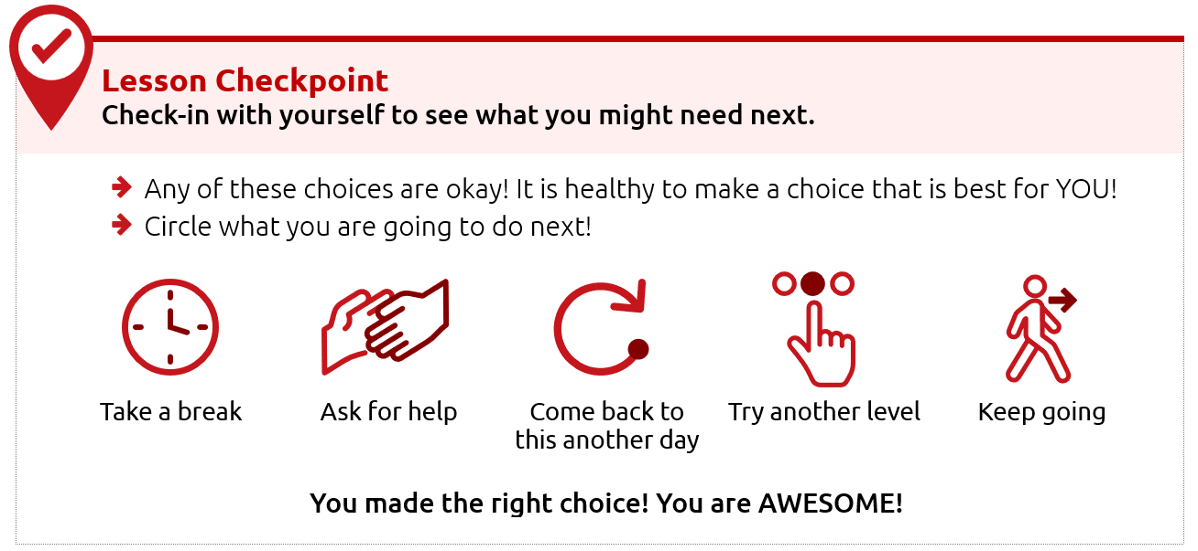
 | 4 |  | Each level takes approximately 30-45 minutes to complete, but it is okay if you take a longer or shorter time. Also, you do not have to complete a full level in one sitting. You can complete these levels at your own pace - even over the course of a few days, weeks, or months.
 | 5 |  | This resource is meant to be self-guided, which means you should be able to do them by yourself. But if you need help, do not be afraid to ask someone to assist you in completing them!
 | 6 |  | The content for each level is on the same topic (for example: Healthy Relationships or Communication) but the way the level asks you to participate is different. Some levels ask you to write your answers, while others ask you to draw your answers. Complete the levels however you prefer.

Alright, are you ready to begin?
We are very excited that you are starting this journey with us!
We believe in you - let’s go!
Topic descriptions and
what you should expect

In total, there are 5 different handbooks covering 5 different topics.
Each topic will have 3 different lessons in it.
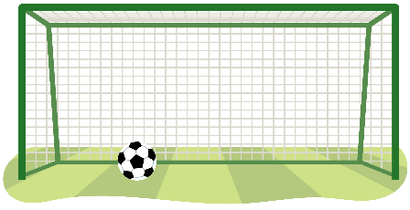
The 5 topics and the 3 lessons within those 5 topics are listed below.

Topic 3: Setting Goals (THIS HANDBOOK)
Level 1  The Basics of Setting Goals  Page 16 |  | Learning to set goals helps you get better.  Here is what you will learn in this lesson:  - What is a goal?  - How to set a goal for yourself
Level 2  Setting SMART goals  Page 31 |  | Setting a goal is a great way to stay focused on achieving something in the future. This lesson will help you set a goal and create steps to help you meet that goal.  Here is what you will learn in this lesson:  - What is a SMART goal?  - The difference between a goal and a SMART goal.  - How to set a SMART goal for yourself
Level 3  Overcoming Obstacles  Page 47 |  | This lesson will help you build on your understanding of SMART goals and how to overcome challenges.  Here is what you will learn in this lesson:  - How to learn and grow with your goals  - Why it is important to prepare for failure  - Why it is important to keep going and follow through on your goals

Topic 1: Communication (Different handbook)
Level 1  Starting a Conversation |  | It is important to know how to talk to other people.  Here is what you will learn in this lesson:  - Steps for how to start a conversation with someone  - Different topics that you could use when starting a conversation
Level 2  Appropriate and Inappropriate Conversations |  | It is important to know what is okay or “appropriate” and what is not okay or “inappropriate” when having conversations with others.  Here is what you will learn in this lesson:  - When to start a conversation and when to wait  - When to say something and when you should only think it  - What are appropriate topics for work or school?
Level 3  Active Listening Skills |  | Good communication involves both speaking and listening. If you do not practice “active listening” skills, it can lead to misunderstanding and miscommunication.  Here is what you will learn in this lesson:  - What “active listening” is  - Why listening is a very important part of communicating  - 3 ways to practice “active listening”

Topic 2: Handling Disappointment (Different handbook)
Level 1  Emotions and Safe Actions |  | Learning how to handle your emotions is important.  Here is what you will learn in this lesson:  - Safe and unsafe ways to handle difficult emotions  - Tips to help you when you have difficult emotions
Level 2  What to do when you feel disappointed |  | An emotion that can be challenging is disappointment. Disappointment can happen when you want something to happen and it does not happen. It can also happen when you expect someone to do something and they do not do it.  Here is what you will learn in this lesson:  - Examples of disappointment  - What are “expectations” and how do we handle them?  - What to do when you feel disappointed
Level 3  Accepting who  you are |  | It is important to practice self-acceptance, especially when facing disappointment. This lesson will help you handle and cope with disappointments in a positive way.  Here is what you will learn in this lesson:  - How to use self-acceptance to deal with disappointment  - The importance of positive self-talk  - Specific strategies for managing emotions / self-acceptance

Topic 4: Healthy Relationships (Different handbook)
Level 1  Understanding Relationships |  | Learning about relationships is important.  Here is what you will learn in this lesson:  - What it means to have a relationship with someone  - The difference between a healthy relationship and an unhealthy relationship  - What to do if you have an unhealthy relationship
Level 2  Healthy Relationships and Boundaries |  | It is important to have healthy relationships in your life. One important part of a healthy relationship is having boundaries.  Here is what you will learn in this lesson:  - What are different types of relationships?  - What are different types of boundaries?  - How to set your own personal boundaries
Level 3  Conflict Resolution |  | It is important to know how to solve problems and disagreements in your relationships.  Here is what you will learn in this lesson:  - What conflict is and how to identify it in relationships  - Effective ways to prevent conflict  - Strategies to resolve conflict when it happens

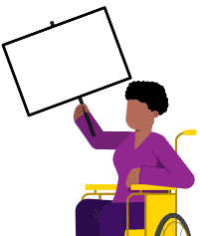
Topic 5: Advocacy (Different handbook)
Level 1  Discovering Yourself |  | It is important to know more about yourself because that helps you to better advocate for yourself and the things you care about.  Here is what you will learn in this lesson:  - What it means to “advocate”  - Ways to learn more about yourself  - Why knowing yourself helps you advocate better
Level 2  Strengths and Weaknesses |  | Being able to name your strengths and weaknesses can help you know how to advocate for yourself and for others.  Here is what you will learn in this lesson:  - How to identify your strengths and weaknesses  - Ways to use your strengths to help others  - Ways to ask others to help you improve your weaknesses
Level 3  Self-advocacy |  | It is important to know how to advocate for yourself. Through “self-advocacy” you can make choices that shape your life.  Here is what you will learn in this lesson:  - What “self-advocacy” is and why it is important  - Examples of self-advocacy in real-life situations  - Steps to practice self-advocacy

Personal and Professional Development Lessons
Pre-Skills Assessment
Skills-Assessment for athlete learner
Directions
This assessment is optional. We created it to help you if you do not know where to begin your learning journey with these topics and levels. If that is the case, please use this assessment to help guide you where to begin. If you would rather go through each topic and level in your own order, that is okay, too.
The statements below describe situations you might encounter in your daily life as a friend, athlete, employee, and leader. For each statement select a number between 1 and 3 to indicate your current confidence level, where:
1 = I am not at all confident | 2 = I am somewhat confident | 3 = I am completely confident

How confident are you that you can… |  |  |  | Not at all  Confident |  | Somewhat  Confident | Completely  Confident
 | Topic 1: Communication
 | I can start up a conversation with people I do not know. |  |  | 1 |  | 2 | 3
 | I can ask questions when I want to learn more about what someone is saying. |  |  | 1 |  | 2 | 3
 | I can listen well to what others are saying to me. |  |  | 1 |  | 2 | 3
 | Communication total score:
 | Topic 2: Handling Disappointment
 | I can express my emotions in a way that is safe for me and others. |  |  | 1 |  | 2 | 3
 | I can handle disappointment. |  |  | 1 |  | 2 | 3
 | I can accept myself for who I am. |  |  | 1 |  | 2 | 3
 | Handling Disappointment total score:
 | Topic 3: Setting Goals
 | I can set goals for myself and follow a plan. |  |  | 1 |  | 2 | 3
 | I can adjust my goals when I am faced with failure or obstacles. |  |  | 1 |  | 2 | 3
 | I can set goals to challenge and push myself outside of my comfort zone. |  |  | 1 |  | 2 | 3
 | Setting Goals total score:
 | Topic 4: Healthy Relationships
 | I can make and keep healthy relationships. |  |  | 1 |  | 2 | 3
 | I can work through conflict with other people without hurting their feelings. |  |  | 1 |  | 2 | 3
 | I can set boundaries with friends and respect when friends set boundaries with me. |  |  | 1 |  | 2 | 3
 | Healthy Relationships total score:
 | Topic 5: Advocacy
 | I can identify and explain who I am and what I believe in. |  |  | 1 |  | 2 | 3
 | I can easily accept that there are things that are out of my control. |  |  | 1 |  | 2 | 3
 | I can advocate for what I want clearly and calmly. |  |  | 1 |  | 2 | 3
 | Advocacy total score:

Skills-Assessment for Mentor
to complete about the Athlete
Directions
This assessment is optional and should be completed by a mentor or family member of the athlete leader. The person filling this out should be someone who knows the athlete very well and can provide constructive criticism and positive feedback. Your assessment of them is meant to help the athlete leader see their strengths and weaknesses according to someone else so they can identify where to begin their learning journey.
The statements below describe situations the athlete might encounter in their daily life as a friend, athlete, employee, and leader. For each statement, circle a number between 1 and 3 to indicate where you think the athlete’s confidence level is, where:
1 = not at all confident | 2 = somewhat confident | 3 = completely confident.

How confident are you that the athlete can… |  |  |  |  | Not at all  Confident |  | Somewhat  Confident | Completely  Confident
 | Topic 1: Communication
 | Start up a conversation with people they do not know. |  |  |  | 1 |  | 2 | 3
 | Ask questions when they want to learn more about what someone is saying. |  |  |  | 1 |  | 2 | 3
 | Listen well to what others are saying. |  |  |  | 1 |  | 2 | 3
 | Communication total score:
 | Topic 2: Handling Disappointment
 | Express their emotions in a way that is safe for them and others. |  |  |  | 1 |  | 2 | 3
 | Handle disappointment. |  |  |  | 1 |  | 2 | 3
 | Accept themselves for who they are. |  |  |  | 1 |  | 2 | 3
 | Handling Disappointment total score:
 | Topic 3: Setting Goals
 | Set goals and follow a plan. |  |  |  | 1 |  | 2 | 3
 | Adjust goals when faced with failure or obstacles. |  |  |  | 1 |  | 2 | 3
 | Set goals to challenge and push themselves outside of their comfort zone. |  |  |  | 1 |  | 2 | 3
 | Setting Goals total score:
 | Topic 4: Healthy Relationships
 | Make and keep healthy relationships. |  |  |  | 1 |  | 2 | 3
 | Work through conflict with other people without hurting their feelings. |  |  |  | 1 |  | 2 | 3
 | Set boundaries with friends and respect when friends set boundaries with them. |  |  |  | 1 |  | 2 | 3
 | Healthy Relationships total score:
 | Topic 5: Advocacy
 | Identify and explain who they are and what they believe in. |  |  |  | 1 |  | 2 | 3
 | Easily accept that there are things that are out of their control. |  |  |  | 1 |  | 2 | 3
 | Advocate for what they want clearly and calmly. |  |  |  | 1 |  | 2 | 3
 | Advocacy total score:

Scoring
Add the numbers for each of the five leadership topics. See the example below:
 | Topic 4: Healthy Relationships
 | Make and keep healthy relationships. |  |  |  | 1 |  | 2 |  |  | 3
 | Work through conflict with other people without hurting their feelings. |  |  |  | 1 |  | 2 |  |  | 3
 | Set boundaries with friends and respect when friends set boundaries with them. |  |  |  | 1 |  | 2 |  |  | 3
 | Healthy Relationships total score: |  |  |  |  |  |  |  | 5
What is next?
Congratulations! Like everyone, you have a lot of skills, but you also have new things to learn. These lessons can help you gain new skills and improve upon what you already know.
To help you figure out where to start your learning journey, you can follow these steps:
 | Step
 | 1 | 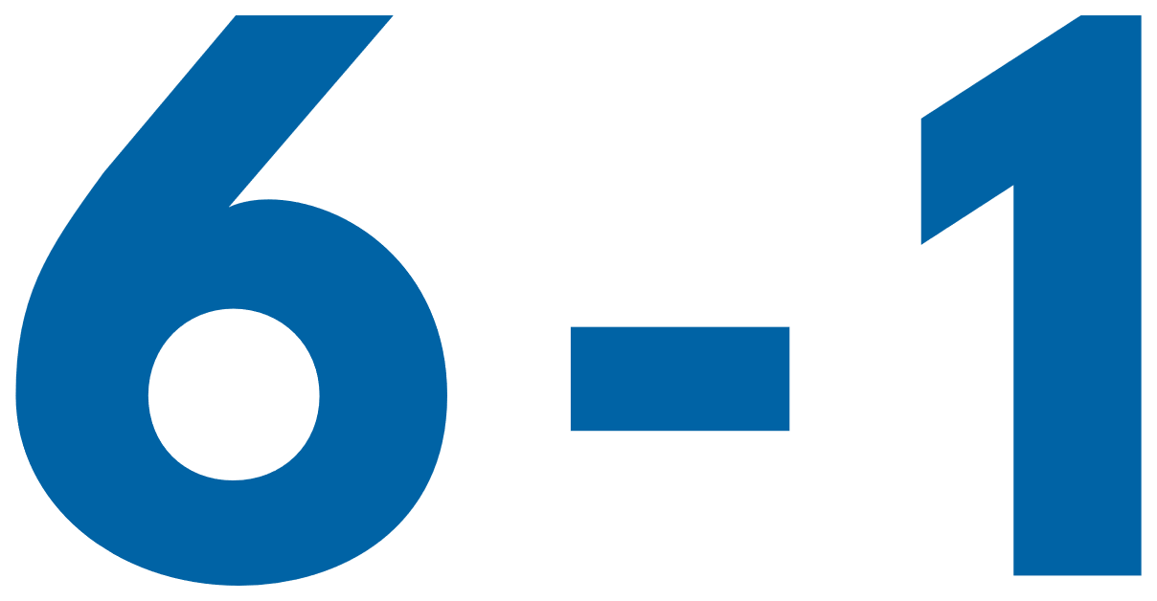 | If you or your mentor/helper gave a total score for any topic of 6 or below, that topic should be one of the first you consider starting at because that shows you have more to learn on that topic.  For example, the athlete listed above who scored five (5) on Healthy Relationships will go to the Healthy Relationships lessons first. If this lesson that you have is not what you are looking for, you can find all 5 topics at the Special Olympics resources website (https://bit.ly/41GT7rW) or you can ask your Program where to find it.
What happens if you and your mentor have scored a topic very differently?
If you and your mentor have different scores for a topic, discuss this with your mentor. Having different scores is an excellent opportunity to receive feedback from someone else and learn more about how others view your knowledge and skills in that category. It is okay if they think that you are lower in a category than you scored yourself. They have a different perspective of your strengths and weaknesses.
There are activities within Communication, Healthy Relationships, and Handling Disappointment that will help you get better with giving and receiving feedback.
 | 2 |  | Continue completing lessons until you have completed all the leadership lessons within the leadership topics that you or your mentor scored 6 or less. Stop after each lesson and give yourself a big round of applause!
 | 3 |  | Take your time and go through one leadership topic or lesson daily so you have time to practice and tell your coach, teammates, and friends what you are learning.
 | 4 |  | After you have completed all the leadership lessons where you scored a 6 or below, complete all the other leadership topics and lessons you are interested in. Even if you scored above a 6 in them, there is always more to learn, so go through all of them! Again, you can find all 5 topics and their 15 lessons by visiting the Special Olympics resources website (https://bit.ly/41GT7rW) or contacting your local Special Olympics staff member and ask for help.

Level 1:
The Basics of Setting Goals
Leadership Lessons
Setting Goals
Level 1
Setting Goals
The Basics of Goal Setting
 | Think about these questions:
 | 1. | What is a goal and why is it important?
 | 2. | How do I set a goal for myself?
 | If you do not know yet, do not worry! This lesson will teach you all about setting goals!
Think about something you have gotten better at. Write or draw it below.
Possible answers: better grades, better at sports, more independent…
Setting goals can help us get better at things we want!

LEARN
 |  |  |  |  | A goal is something you want to get better at or achieve.
 | 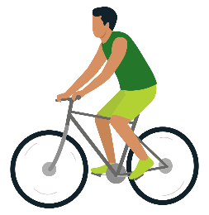
 | A goal can be about learning a new skill, like riding a bike. |  |  |  |  |  | Or getting better at something you like to do, like lifting heavier weights!
 | Setting goals is important because it helps us get better at things and motivates us to work hard. Setting goals can be exciting!
 | Have you ever set a goal ?
 | Circle one!
 | Yes |  |  | No |  |  |  |  | I am not sure
 | It is ok if you have not! You will be able to by the end of this lesson!
 | Goals can be small and take a short time, like finishing a book |  |  |  |  | Goals can be big and take a long time, like saving money to buy a car!
 |  |  |  |  |  | 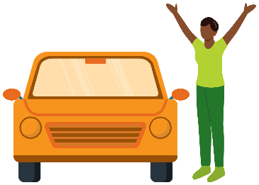

 | Part 1: How to set a goal
 | Follow these steps when you are ready to set a goal!
 | Step 1:  Think |  |  | Step 2:  Choose | Step 3:  Plan
 | Let us take a closer look at each step!
 |  | Step 1: Think
Think about what you want to do or get better at.
Here are some examples of goals you might have!
 | 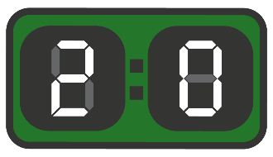
 | I want to score a point for my team! |  |  | I want to get better at being a leader. | I want to eat healthier foods.
 | Can you think of any other goals someone might have?
 | Write or draw your ideas below

 |  | Step 2: Choose
 | Choose one thing to focus on as your goal.
 | It can be hard to choose a goal to start with and that is okay! Think about what is the most important to you right now!
 |  |  | “It is most important to me to start with eating more vegetables because being healthy will help me reach my other goals!”
 | 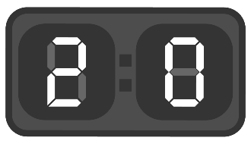
 | I want to score a point for my team! |  |  | I want to get better at being a leader. |  | I want to eat healthier foods.
Remember, choosing one goal to focus on does not mean you
cannot still work on your other goals later!

 |  | Step 3: Plan
 | Plan what you will need to do to meet your goal.
 | My goal is: |  | I want to eat more vegetables.
 | To reach my goal I will:
 | 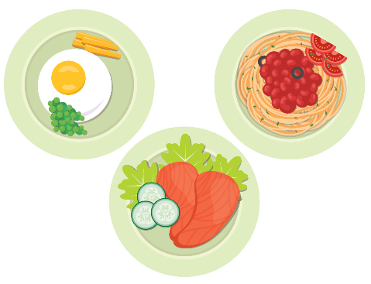
 | Eat 1 vegetable each meal |  |  |  | Put vegetables in my smoothies
 | Making a plan helps us to get closer to our goals!

 | Lesson Checkpoint
 | Check-in with yourself to see what you might need next.
- Any of these choices are okay! It is healthy to make a choice that is best for YOU!
- Circle what you are going to do next!
 | Take a break | Ask for help | Come back to this another day | Try another level | Keep going
 | You made the right choice! You are AWESOME!

 |  | Part 2: Practice
 | Story 1
Muhammed's basketball coach wants him to set a goal for himself.
He is not sure where to start!
 |  |  | His coach tells him to follow the 3 steps:
 |  |  |  |  |  | Step 1:  Think |  |  |  |  |  |  | Step 2:  Choose |  |  |  |  | Step 3:  Plan
 |  |  |  | Step 1: Muhammed THINKS of things he wants:
 |  |  | 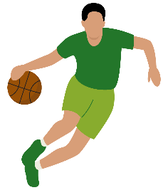 |  |  |  |  |  | 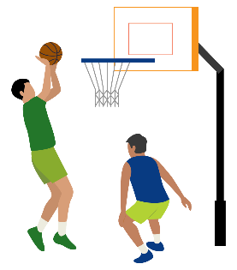
 |  |  | Improve his dribbling skills |  |  |  |  |  | Score 6 more points than last year |  |  |  |  |  | Win the championship
 |  |  |  | Step 2: Now Muhammed needs to CHOOSE one.
 |  |  | He decides that if he wants to score more goals and win the championship, he should first work on dribbling skills.
 |  |  |  | Step 3: Muhammed makes a PLAN. To reach his goal he will:
 |  |  | 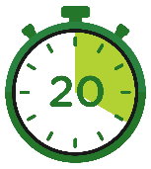 |  |  |  |  |  |  |  |  | 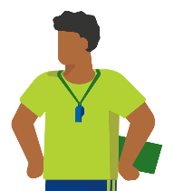
 |  |  | Practice dribbling every day for 20 minutes |  |  |  |  |  |  |  |  | Ask his coach for help

 |  | Check off the steps that Muhammed completed!
 |  | Did Muhammed THINK of something he wanted? | YES | NO
 |  | Did Muhammed CHOOSE a goal to focus on? | YES | NO
 |  | Did Muhammad PLAN how he would reach his goal? | YES | NO
 |  | Answers
 |  | Did Muhammed THINK of something he wanted? | YES | NO
 |  | Did Muhammed CHOOSE a goal to focus on? | YES | NO
 |  | Did Muhammad PLAN how he would reach his goal? | YES | NO

 | Story 2
 |  |  | Step 1: Ashley THINKS of things they want:
 |  | 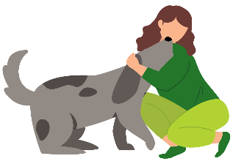
 |  | Get a dog |  |  |  |  | Go on vacation |  |  | Get a job
 |  |  | Step 2: Now Ashley must CHOOSE one:
 |  | They decide they need money first, so they choose to get a job!

 |  |  | Step 3: Ashley makes a PLAN. To reach their goal they will:
 |  | 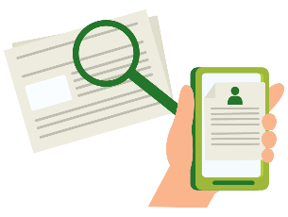
 |  | Find places that need new employees. |  |  |  |  | Apply to 5 jobs a week.
 |  | Ashley did a great job setting a goal that was important to them!
Ashley eventually get a job
at the animal shelter!
 |  | Ashley wants to set another goal!
 |  | Write or draw what their next goal could be.
 |  | Their next goal could be: work every day to stay busy, save enough money to buy a dog from the shelter, help a friend find the perfect pet.

 | Story 3
 |  | Omar is very shy and it is hard for him to make new friends.
 |  | He THINKS about the 3 steps to make a goal
 |  |  | Step1: Omar THINKS of things he wants:
 |  | 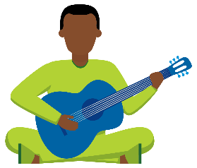 |  |  |  |  |  | 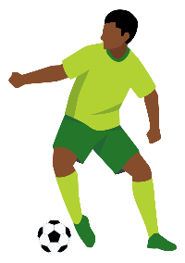
 |  | He wants to learn how to play guitar |  |  |  |  |  | He wants to be better at passing in football |  |  |  |  | He wants more friends
 |  |  | Step 2: Now Omar has to CHOOSE one:
 |  | He decides making friends is the MOST important to him.
 |  |  | Step 3: Omar makes a PLAN. To reach his goal he will:
 |  | 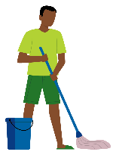
 |  | Clean his room |  |  |  |  |  |  |  | Read his book for 15 minutes
 |  | Did Omar THINK about what he wanted or needed? |  |  |  |  |  |  |  |  | YES |  |  | NO
 |  | Did Omar CHOOSE a goal ? |  |  |  |  |  |  |  |  | YES |  |  | NO
 |  | Did Omar PLAN how to reach his goal? |  |  |  |  |  |  |  |  | YES |  |  | NO

 |  | Answers
 |  | Did Omar THINK about what he wanted or needed? |  |  | YES | NO
 |  | Did Omar CHOOSE a goal ? |  |  | YES | NO
 |  | Did Omar PLAN how to reach his goal? |  |  | YES | NO
Omar is disappointed because he has not made any friends after cleaning his room and reading a book. Omar’s plan did not match the goal he set.
- What could Omar fix about his plan?
- Would cleaning or reading help him make friends?
 |  | Write or draw ways Omar could make new friends.
 |  | Talk to a mentor or friend about what Omar could do for his plan instead and write or draw their answer below.
 |  | TIP: If making a plan is hard for you, try this!
 |  | Make a list of what you are already good at at!
 |  | Omar makes a list of what he is good at:
 |  | I am good at |  | How can I use what I am good at to reach my goal of making friends?
 |  |  | Writing | Write a note to Seb asking if he wants to play catch.
 |  |  | Swimming | Ask Malik over to swim.
 |  |  | Being funny | Tell Zara my best jokes.
 |  | It was hard for Omar to make his plan. What helped him?
Omar did not have a plan at first.
He thought about what he was GOOD at and that helped him begin.
What are some things YOU are good at?
Write or draw your answer.

Part 3: Your turn!
Think
Create a vision board!
A vision board helps us to help us see our goals and dreams!
Look at the pictures of this vision board.
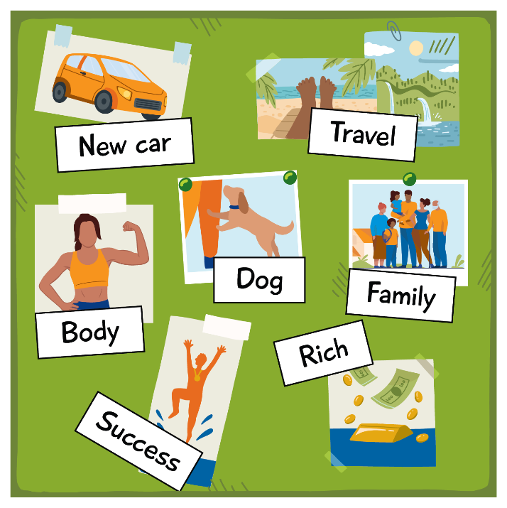
Talk to a friend or mentor about the goals and dreams that are on this vision board. What is important to this person?
Answers: get a new car, win the lottery, travel, have a family, have a dog…
Think of 2-5 goals that might be on your vision board! Then draw or write them below!

Choose
Choose which goal you want to start working on first and write or draw it below. Why did you choose to start with this goal first?
Talk to someone you know about a time they set a goal. Ask them the questions below. You do not need to write down their answers.
- Why did you choose that for your goal?
- What did you do to help you reach your goal?
- What was hard about reaching your goal?
- Did anyone help you? If so, how?
Plan
Use the space below to write or draw a plan! It is ok if you only have 1 or 2 ideas on your plan!
Ask yourself:
- What do I have to do to get closer to my goal?
- Who can help me reach my goal?
REFLECT
Setting goals is a way to have fun and improve. Do not be afraid to ask for help or change your plan if you need to.
Keep going!
Write or draw what you have learned about in this lesson and how you will use it in the future!

When you are ready for level 2,
you will learn about a different kind of goal – SMART goals!

Lesson Summary
- Goals help us get better and learn!
- There are 3 steps for setting a goal: think of what you want, choose something that is the most important, plan how you will reach your goal!

Setting Goals
Leadership Lessons
Level 2:
Setting SMART Goals
Check-in
Welcome to Level 2! Before you begin this lesson, see if you can answer a few of the questions below. If these questions are challenging, go to Level 1 and complete that level before starting this level. If you already completed Level 1 and still do not know the answers below, it may be a good idea to go back and review it again before continuing with Level 2.
What is the definition of a “goal”?
What is one goal that you have for yourself?
Why are goals important?

Check in
Check your answers
What is the definition of a “goal”?
Answers could include:
A goal is something you work hard to get because it is important to you!
What is a goal that you have for yourself?
Answers could include:
- Finish reading 2 books by the end of the month.
- Jump .5 meters farther in the long jump than last year.
- Beat my record in the 400m speed walk.
- Get a job.
Why are goals important?
Answers could include:
- Goals help you achieve something you have been wanting to achieve.
- Goals help you plan for the future.
- Achieving goals help build confidence.
- Goals help you focus on what you want and need.
If you could answer these three questions, continue with Level 2. If you did not know how to answer them, go to Level 1 to learn all about goals!

Level 2
Setting Goals
How to make SMART goals?
Setting a goal is a great way to stay focused on achieving something in the future. This lesson will help you set a specific kind of goal and create steps to help you meet that goal. Here is what you will learn in this lesson:
- What is a SMART goal?
- The difference between a goal and a SMART goal
- How to set a SMART goal for yourself

Work through these lessons to learn about SMART goals and then create your own SMART goal.

Part 1: What is a SMART goal?
A SMART goal is an acronym, which means that each letter in SMART represents a different word. Read through what each letter represents.

 | S | M | A | R | T
 | Specific | Measurable | Achievable | Relevant | Time-bound
 | Be detailed in your goal! | Can you measure your progress? | Is this a realistic goal? | Why is it something that is important to you? | Have an end time and date so you can focus!
SMART goals can help you set up a plan to achieve your goal!
Pictures can help you remember what each of these words mean. Under the word, draw a little picture to help you remember what the letter stands for.
- For example: the letter ‘S’ could have a magnifying glass because it helps you see details and specific things.
- Turn to the next page if you would like to see some other ideas.
 | S | M | A | R | T
 | Specific | Measurable | Achievable | Relevant | Time-bound

 | S | M | A | R | T
 | Specific | Measurable | Achievable | Relevant | Time-bound
 | A magnifying glass helps you see details and specific things | A ruler helps you make accurate measurements | A thumbs up means you can do this, even if it might be difficult | This person is pointing to themselves because your goal needs to matter to you first | A clock is one way to measure time. You could also draw a calendar to show that you will track your goal and complete the goal by a certain date.

Look at the next page to see some questions that
will help you think through how to set a SMART goal.

 | S | Five “W” Questions  - What do I want to accomplish?  - Why is this goal important?  - Who is involved?  - Where is it located?  - What resources do I need to accomplish it?
 | Specific
 | M | - How many?  - How will I know when it is complete?
 | Measurable
 | A | - How will I accomplish my goal?  - Is this goal realistic based on obstacles such as money or transportation?
 | Achievable
 | R | - Is it something that is important to me?  - Is this a good time to set this goal or should I wait?
 | Relevant
 | T | - When do I want to start this?  - When do I want to finish?
 | Time-bound

Here are some different examples of SMART goals.

Remember, SMART goals are:
Specific | Measurable | Achievable | Relevant | Time-bound
 | Non-SMART Goal Examples |  | SMART Goal Examples
 | I want to run faster. |  | I want to shave 30 seconds off my 400m run time by the end of May.
 | I want to get good grades. |  | I want to study 2 hours outside of school every week for the rest of the semester.
 | I want to be healthy. |  | I want to exercise for 20 minutes, 3 times a week for the next 8 weeks.
 | I want to read more books. |  | I want to read 1 book each month for the next year.
 | I want to do more pushups. |  | I want to be able to do 10 knee pushups every day without resting in the next 8 weeks.

 | Lesson Checkpoint
 | Check-in with yourself to see what you might need next.
- Any of these choices are okay! It is healthy to make a choice that is best for YOU!
- Circle what you are going to do next!
 | Take a break | Ask for help | Come back to this another day | Try another level | Keep going
 | You made the right choice! You are AWESOME!

Now you try!
Read the goal examples below and circle yes if it is a SMART goal or no if it is not.

Remember, SMART goals are:
Specific | Measurable | Achievable | Relevant | Time-bound

 | Example |  | Is this a SMART goal?
 | I want to practice basketball a lot. |  | Yes | No
 | If no, why?
 | Every day for a month, I will eat a fruit or vegetable. |  | Yes | No
 | If no, why?
 | I want to decrease my screen time by 10 minutes per day by the end of the month. |  | Yes | No
 | If no, why?
 | I want to make more friends. |  | Yes | No
 | If no, why?

Answers

 | Example |  | Is this a SMART goal?
 | I want to practice basketball a lot. |  | Yes | No
 | If no, why?
 | No - This is not a SMART goal because it is not specific or measurable and does not include a deadline of when you will be done.
 | Every day for a month, I will eat a fruit or vegetable. |  | Yes | No
 | If no, why?
Yes - This is a SMART goal because it completes all 5 components of SMART goals:
Specific, Measurable, Achievable, Relevant, Time-Bound
 | I want to decrease my screen time by 30 minutes per day by the end of the month. |  | Yes | No
 | If no, why?
Yes - This is a SMART goal because it completes all 5 components of SMART goals:
Specific, Measurable, Achievable, Relevant, Time-Bound
 | I want to make more friends. |  | Yes | No
 | If no, why?
 | No - This is not a SMART goal because it is not measurable or time-bound. How many friends do you want? When will you complete your goal?

Part 2: The difference between a regular goal and a SMART goal
Now it is time to follow an example of writing and checking a SMART goal.
Here is an example of a SMART goal:
I want to be able to do 10 knee push-ups without resting at the end of 8 weeks so I will be stronger and better at my sports.
Now let’s go through the 5 words and answer some questions to make sure it is a SMART goal.
S  Specific  Five “W” Questions |  |  | - What do I want to accomplish? |  | Doing 10 pushups from my knees
 |  |  | - Why is this goal important? |  | I want to become stronger and better at sports
 |  |  | - Who is involved? |  | Me
 |  |  | - Where is it located? |  | My house
 |  |  | - What resources do I need? |  | A piece of paper to keep track of my pushups or a calendar
M  Measurable |  |  | - How many? |  | 10 pushups from my knees
 |  |  | - How will I know when it is complete? |  | I can complete 10 pushups from my knees without resting
A  Achievable |  |  | - How can I accomplish my goal? |  | Each day I will do a couple of pushups from my knees, doing one more every day
 |  |  | - Is this goal realistic based on obstacles such as money or other problems? |  | Yes! It will be difficult, but I believe I can do it. I do not need any equipment and I can do this from my house
R  Relevant |  |  | - Is it something that is important to me? |  | Yes! I really want to build muscle in my arms so that chores around the house are easier and I am stronger for sports season
 |  |  | - Is this a good time to set this goal or should I wait? |  | Yes! It is a goal that will not take a lot of time each week and does not cost any money. It is something I can do inside if it is cold or rainy.
T  Time-bound |  |  | - When do I want to start this? |  | Right away
 |  |  | - When do I want to finish? |  | 8 weeks
 |  |  | - When should I check in? |  | Write down how many pushups I did each day and check in every 2 weeks to see my progress grow each day
Steps to make sure I reach my goal
 | 1 | Create or find a calendar
 | 2 | Write down how many pushups I do every day, with the goal to reach 10 in one day without resting
 | 3 | Tell a family member or friend about my goal so they can hold me accountable, which means that they check in to see that I am sticking with your goal.

Other SMART goal examples
 | Example 1
 | Billy wants to study for 2 more hours each week for the rest of the semester because he needs to improve his grades.
 | Specific | The goal is to study for 2 hours per week.
 | Measurable | Billy can keep track of how many hours he has studied in a planner or on his phone.
 | Achievable | 2 hours per week is achievable, especially if Billy is focused.
 | Relevant | Billy wants to improve his grades and studying is a great way to do that.
 | Time-bound | This goal is to be done by the end of the semester, so he has a time frame of around 4 months to achieve it.

 | Example 2
 | Shondra wants to start a sport that she has not tried before, like tennis. She wants to do this over winter because she does not play any winter sports. This way she is ready before the next Special Olympics tennis season starts.
 | Specific | She identified tennis as the sport she wants to try.
 | Measurable | She will know when she completed her goal when she is playing the new sport.
 | Achievable | Yes! There are many great sports to try, and she can get connected to Special Olympics, school, or her community to find options.
 | Relevant | Trying a new sport is a great way to make friends and stay active in a season that she does not normally participate in.
 | Time-bound | This goal is to have this done by the time the next tennis season for Special Olympics begins.

 | Example 3
 | Haseeb wants to apply for 3 jobs that he is interested in by the end of the year because he needs more money to help his family.
 | Specific | The goal is to apply for 3 jobs.
 | Measurable | He can measure his goal if he applied for at least 3 jobs.
 | Achievable | Yes! Applying for jobs is free and with the right support, can be done easily.
 | Relevant | He is motivated to do this because he needs money to help his family.
 | Time-bound | The end of the year is the end time for this goal.

Part 3: How to set a SMART goal for yourself?
Now it is your turn! Think about a goal you would like to achieve and answer the questions below to make sure it is a SMART goal.
My goal:
Now let’s go through the 5 words and answer some questions to make sure it is a SMART goal.

S  Specific  Five “W” Questions |  |  | - What do I want to accomplish?
 |  |  | - Why is this goal important?
 |  |  | - Who is involved?
 |  |  | - Where is it located?
 |  |  | - What resources do I need to accomplish it?
M  Measurable |  |  | - How many
 |  |  | - How will I know when it is complete?
A  Achievable |  |  | - How can I accomplish my goal?
 |  |  | - Is this goal realistic based on obstacles such as money or other problems?
R  Relevant |  |  | - Is it something that is important to you?
 |  |  | - Is this a good time to set this goal?
T  Time-bound |  |  | - When do I want to start this?
 |  |  | - When do I want to finish?
 |  |  | - When should I check in?
List a few steps below that you will take to help reach your goal.
 | 1
 | 2
 | 3
Now share your goal with 1 or 2 people and have them hold you accountable,
which means check in and make sure that you are sticking with your goal!
Once you complete this goal, you can set a new goal to work towards!

Lesson Summary
Setting a goal is a great way to stay focused on achieving something in the future.
In this lesson we learned:
- What is a SMART goal?
- The difference between a regular goal and a SMART goal
- How to set a SMART goal for yourself

Level 3:
Overcoming Obstacles
Leadership Lessons
Setting Goals
Check-in
Welcome to Level 3! Before you begin this lesson, see if you can answer a few of the questions below. If these questions are challenging, go to Level 1 or Level 2 and complete those lessons before starting this level. If you already completed Level 1 and Level 2 and still do not know the answers below, it may be a good idea to go back and review them before continuing with Level 3.
What is a SMART goal?
What is the difference between a goal and a SMART goal?
What is an example of a SMART goal?

Check in
Check your answers
What is a SMART goal?
Answers could include:
A SMART goal is a clear and focused goal that is Specific, Measurable, Achievable, Relevant, and Time-bound.
What is the difference between a goal and a SMART goal?
Answers could include:
A goal is a general target you want to reach. A SMART goal is a specific, measurable, achievable, relevant, and time-bound version of that goal, making it more actionable.
What is an example of a SMART goal?
Answers could include:
An example of a SMART goal: I want to be able to do 10 pull ups without resting in the next 4 weeks.
If you could answer these three questions, continue with Level 3. If you did not know how to answer them, go to Level 2 to learn all about SMART goals!

Level 3
Setting Goals
Overcoming Obstacles
 |  | Workbook Activity Time | 10 minutes
 |  | On Your Own Practice Time | 10 minutes

Learning to overcome challenges while working on your goals is important. This lesson will help you build on your understanding of SMART goals and how to overcome challenges when trying to achieve them.
Here is what you will learn in this lesson:
- How to learn and grow with your goals.
- Why it is important to be able to accept and prepare for failure.
- Why it is important to keep going and follow through on our goals.

Part 1: Learning from achievement
Think of a time when you achieved something that you or others did not think you could achieve. For example: speaking in front of a large crowd, getting a job you wanted, serving in a leadership position, running your fastest race, taking the bus by yourself, etc.
Pick one achievement in your life that makes you proud. Think about what it took to achieve that and then answer these questions:
What was the achievement?
How did you feel after the achievement?
What did you learn from this experience?
How will you use that experience to set even higher goals the next time?
Congratulations!
You achieved something that you or others previously did not think you could. I bet if you think harder you can think of many more examples when you achieved a goal that other people did not think that you could.

 | Part 2: Four steps to achieving your goals
Did you know you can learn to set goals that will help you achieve many more things that you or others never thought you could?
You can do this with four easy steps:
 |  |  |  |  |  |  |  | 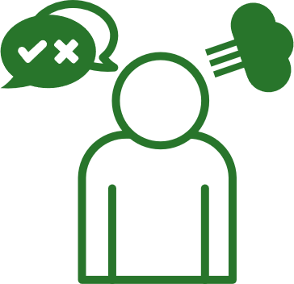
 | Step 1:  Be willing to stretch your goals |  |  |  | Step 2:  Use positive  self-talk |  |  | Step 3:  Learn to be comfortable with failure |  |  |  | Step 4:  Keep going
We will explain each step next…
 |  |  | Step 1: Willingness to Stretch Your Goals
 | The first step is your willingness to stretch yourself beyond what you thought possible.
- Think about when you are stretching before doing sports and your body may feel a bit stiff, but the more you stretch the more flexible it gets over time? It is the same with our goals, we can stretch them so we can achieve more things.
- You must be willing to keep going and push yourself beyond where you might usually stop and say, “I cannot do that” or “that’s too hard” or “I’ll never achieve that goal”, etc.
- Everyone struggles sometimes with doing something that is uncomfortable or challenging, but the only way to achieve big goals in life is trying something new or being willing to fail at things. We will talk more about this in the other steps below.
 |  |  | Step 2: Positive Self-Talk
 | To reach goals you never thought you could, it is necessary for you to replace any negative statements (such as, “I’ll never be able to do that!”) with positive self-talk.
Positive self-talk is saying positive things to ourselves, especially when things are not going well, and others are telling us that we cannot do it!
Examples of Positive Self Talk?
- I can do it.
- I am good enough.
- It’s ok if I make a mistake. I will learn from it and do better next time!
- I deserve this and I deserve to be happy.
Want to learn more about how to practice positive self-talk?
There is an entire Lesson dedicated to this skill. If you haven’t been through the Level 3: “Accepting Me” from the Handling Disappointment lesson, visit it next.

 | Lesson Checkpoint
 | Check-in with yourself to see what you might need next.
- Any of these choices are okay! It is healthy to make a choice that is best for YOU!
- Circle what you are going to do next!
 | Take a break | Ask for help | Come back to this another day | Try another level | Keep going
 | You made the right choice! You are AWESOME!

 | 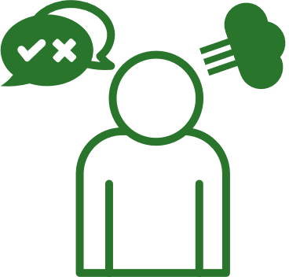 |  | Step 3: Open to Failure and Feedback
 | One reason we do not like to set goals that are hard to achieve is because we are afraid of failing.
- So, although it is challenging to achieve hard goals and push beyond your previous goals, you need to ACCEPT and PREPARE for some form of failure.
  - This does not mean that you should just quit after running into one problem and say that you failed (see more on “Keeping Going” below).
  - This means that you should think about potential roadblocks or barriers that might keep you from achieving your goals and prepare for them as much as you can.
- If you end up failing at something, that is okay!
- Ask yourself:
  - What did I do well?
  - What can I improve for the next time?
Asking yourself those questions after each opportunity will prepare you for the future!
- Also, you need to be open to feedback. Some people are just as afraid of guidance from others as they are of failure, but to stretch your goals you will need to ask for help and receive feedback (good or bad) from other people. They could share a different side of things that you did not think of before.
 |  |  | Step 4: Keep Going
 | Follow through and keep going when it is difficult.
This is probably the most important step to achieving goals you find challenging or out of your grasp.
- Keep going, even (or especially) when the path to your goal is not going smoothly.
- Think about the moments in your life when you have been most proud of yourself or when others have been proud of you. Those moments probably came after you worked really hard at something and did not give up, right? Times where you pushed through something difficult.
- Whether it is sports or your leadership journey, most things in life that bring you the most joy are the things that you worked really hard for.
Did you learn about getting calm and breathing in the “Handling Disappointment: Level 3 - Accepting Me” lesson?
You can use these skills to deal with setbacks. If you haven’t been through the Accepting Me lesson, visit it next.
Examples of Goal Stretching
 | Below are three examples of your peers stretching their goals and how they did it.
 | Maria
Maria has wanted to serve as her team captain for two seasons, but her communication skills have kept her from applying to be captain.
This year, she decided she will try, but how? Here are the steps she will take:
 |  |  |  | - She works with her coach and mentor to improve her communication skills. She asks for honest feedback and learns new skills by taking an online course on communication skills.
 |  |  |  | - She asks her teammates to tell her when she is communicating with them in a way that is not helpful. This takes a lot of courage! It is important for her teammates to feel comfortable sharing with Maria when she says something that is not helpful or constructive.
 |  |  |  | - She identifies the negative things she says to herself that has kept her from trying in the past. And she replaces those statements with positive notes all over her apartment and in her sports bag.
 |  |  |  | - She creates a plan of how she will react and deal with failing. For instance, she has signed a contract with herself, and discussed it with her mentor, to try again next year if she falls short of her goal of being captain.
 |  |  |  | Question
 |  |  |  | What did Maria do that got her closer to her goal of being team captain?
 | Jon
Jon has played tennis for 15 seasons and is very accomplished on the tennis court. He hears his teammates talking about being in other sports, too, and he thinks he would like to try a new sport when tennis is not in season. He is so used to success in tennis, that he is afraid of failing in this new sport, being laughed at, or not making the team.
He decides to give it a try, and these are the steps he takes:
 |  |  |  | - He meets with his mentor to share his goal of playing a new sport and his reasons why this is so difficult for him.
 |  |  |  | - He works with his coach, who knows his athletic skills, to identify a sport that is closest to his tennis skills and knowledge. They come up with a sport he can try that is offered outside of the tennis season.
 |  |  |  | - Jon begins his new sport at the recreation level, asks for feedback from the coach, and practices his hardest, but he is tempted to quit each time a teammate laughs at his lack of skills.
 |  |  |  | - Jon works with his mentor to develop a plan for how he can deal with the teasing by his teammates instead of quitting.
 |  |  |  | - Jon realizes he will be faced with more challenges as the skills of the new sport advance, but the hard work is worth it because he has grown to love this new sport!
 |  |  |  | Question
 |  |  |  | What did Jon do that kept him from quitting his goal of playing a new sport?
 | Kimiko
Kimiko wants to serve as a board member for their Special Olympics Program. Kimiko has been a Special Olympics athlete for more than 15 years and wants to share their opinions on how to improve the Program they love. They are told that they do not have the leadership experience to apply for the board position.
With the help of their mentor, they decide to put a plan together to reach their goal, and these are the steps they take:
 |  | - Kimiko takes all the SOI Leadership & Skills Curriculum courses required for an athlete to become a board of directors’ member.
 |  | - Kimiko writes a personal mission statement on why they want to be a board member and how they can help the Program.
 |  | - Kimiko works with their mentor and staff to identify their strengths and weaknesses. They put an action plan together to build on their strengths, improve their weaknesses, and to think through any potential roadblocks they may run into during this process.
 |  | - Kimiko meets with a current board member who teaches them what is required of a board member.
 |  |  |  | Question
 |  |  |  | What did Kimiko do that kept them from quitting the personal goal of serving as a board member?

Part 3: Practice making a challenging goal
Activity
In this activity you will create a goal that you would like to achieve but have previously avoided because you thought it was too hard.
We will go through these steps together below to create a new goal…
Stretch
Are you willing to stretch yourself beyond what you thought you could do?
z
What is your goal?
Why did you avoid this goal before?
What makes you want to try this goal now?
Why is this goal important to you?

 |  | Positive Self-Talk
 |  | To reach goals you never thought you could, it is necessary for you to replace negative statements with positive self-talk.
With this new goal in mind, what three positive things will you say to yourself to keep yourself moving toward your new goal, even when things get tough:
 | 1 |  |  | 1
 | 2 |  |  | 2
 | 3 |  |  | 3
 |  | Asking for feedback
To go bigger and better than your previous goals, you need to ask for and receive constructive feedback so you can grow, learn, and get closer to your goal.
With this new goal in mind, who will you ask for help and how can they help you? Name two people below and list out the ways they can help you.
 | 1 |  | 1 |  | (Who & How)
 | 2 |  | 2 |  | (Who & How)
Preparing for failure
Every day you prepare for potential failure and you do not even realize it. For example, memorizing the bus schedule so you are not late for work, knowing how much lunch costs so you’ll have enough money to eat, practicing your tennis drills for another 20 minutes so you can win a gold medal, etc.
 |  |  | Question
 |  |  | With this new difficult goal in mind, what are potential barriers that might keep you from achieving your goal? (For example: time, money, unsupportive people around you, people that don’t believe in you, etc.).
 |  |  | Question
 |  |  | List two strategies of how you will overcome the barriers you just listed.
 |  | Keep going
 |  | Keep going, even (or especially) when the path to your goal is not going smoothly.
 |  | Try this contract with yourself to keep going when faced with setbacks.
 |  | I _[write your name here]_ accept that this goal will be challenging, and I might experience setbacks or roadblocks related to my goal. When I do experience setbacks, I will do the following to calm myself down and get back to my goal and keep going, instead of giving up:
 | 1 |  | 1
 | 2 |  | 2
 | 3 |  | 3
 | Keep practicing. Like anything else, setting goals takes practice.

Lesson Summary
In this lesson, we learned:
- How to learn and grow with your goals.
- Why it is important to be able to accept and prepare for failure.
- Why it is important to keep going and follow through on our goals.

Congratulations on completing a lesson on
Personal and Professional Development!
If you completed all 3 Levels on this topic, please take a 5-minute survey using this link or this QR code. Your feedback will help us improve lessons for the future and help us decide what topic or subject we should create next!
 | Click or scan |  | Or type in your browser
 |  |  | https://bit.ly/3H5v1NU
Do not forget that we have 4 other subjects on Personal and Professional Development that you can complete. If you do not know where to find them, email your Special Olympics Program staff member and they can help you.
Again, congratulations for completing this lesson. We hope that you learned a lot and will use it to become a better leader within your community and within the Special Olympics movement.

