Independent Activities
Managing^ Time and Tasks
Note: If you see a word you do not know and it has a ^ next to it, you can look at the glossary on the final page of this document. You can also use a dictionary (www.m-w.com).
Athletes: You can use this training on your own or with personal support. Print out and fill in answers to the questions or type your answers into the Word document. Go through these trainings at your own speed.
In this course, you will:
- Learn basic skills for managing^ your time and tasks
- Explore techniques and tools to manage^ your time and organize tasks
- Learn how to create a schedule
- Learn why time management^ is important to being a good leader
- Practice tracking^ your daily tasks
- Learn how to adjust your schedule^ when unexpected^ things happen

Topic | Description
Lesson 1: Where does my time go?  - Defining basic skills | Examine how effective you are at managing^ your time and tasks. Define the basic skills for managing^ your time and tasks.
Lesson 2: Managing time and tasks  - Tools and techniques  - How to apply to your personal life | Review the tools and techniques for managing^ time and tasks then apply those skills to real-life scenarios.
Lesson 3: Developing my skills  - Managing^ time activity  - Thinking about my skills | Assessing your own time and task management^ skills. Reflect on your strengths and develop a plan to improve in these skills. Apply the tools & techniques to an event or task of your own.

Updated: June 2021
Managing Time & Tasks: Lesson 1
Thinking about my time
Tips for managing^ my time (Source: Forbes (John Rampton)
- Analyze^ your time: This is the first step toward getting better at managing your time. You may think you only spend 30 minutes per day on social media, but after analyzing your time, you may find out you are spending a couple of hours per day online.
- Set a time limit on tasks: Putting limits on how long you will spend on a task helps you focus. You can use a timer app on your phone to dedicate time to certain tasks. For example: When you are on social media, set a timer for 15 minutes so you do not lose track^ of time. Then you can get back to other tasks on your list.

- Use a to-do list: Create a to-do list for your goals and projects. Having a list of tasks helps you make the most of your time during the day. It also helps you focus your time each day on tasks that are most important.

- Break large tasks down into smaller tasks: Break your goals and projects down into smaller tasks so they are easier to complete. For example, if you want to get better at running the 400M run by 10 seconds, that sounds hard at first, right? How can you break that down into smaller tasks? Think about it like this: Try to lower your time by 1 second every week over the next 10 weeks. That makes your overall goal of 10 seconds a lot easier because you are spreading it out over time! Practice this tip with your school, work, or Athlete Leadership goals.

- Plan ahead: One of the best things you can do is at the end of the day, look at your schedule for the next day. Think about what you want to accomplish during the next day. Then write down the top 3 tasks that are the most urgent^.

- Do the hard tasks first: Most people are the most productive^ in the morning when they have the most energy. It is better to work on hard tasks when you are not too tired. Plus, that feeling of accomplishment^ of completing tasks in the morning will give you a boost to get through the day.

- Stay focused: No matter what you are working on, try to focus and not get distracted. Put away distractions while you are focusing on your task. If you get distracted by having your email open or your phone nearby while working on something, close your email or put your phone away for an hour or two every day so you can focus.

- Group certain tasks together: When you look at your to-do list and see that some tasks are related to one another, try to do them at the same time. When working on something, your brain is already focused on that thing, so instead of going to another task on your list, find similar^ tasks on the same topic to work on together.

- Do less: Doing less does not mean “less is more.” It means “less is better.” This is done by slowing down, paying attention to what needs to be done, and focusing only on those things.
- It is okay to say “no”: Do you always say “yes” when someone asks you to go and give a speech or to help with something even when you know you do not have time? You need to figure out how to say “no” every once and a while or you could become very tired.
  - As a leader within Special Olympics, you will probably be asked to do a lot of things. The organization may depend on you to give a presentation or to attend committee meetings. You may feel like you must go and help when you can. If you do not go, you might think they may not ask you again. You need to learn that if you are tired or do not feel like you can spend enough time on something, it is okay to tell someone “I’m sorry, but I just do not think I can take this on right now. Please keep me in mind for future opportunities though!”
  - If you must tell your Special Olympics program that you do not have time to support with an activity remind them that this will allow a new athlete leader to have an opportunity. Maybe you have someone in mind that you think would be great for this opportunity and you suggest that person instead!
  - Do not be afraid to speak up and tell people when you are overworked and too tired to do anymore tasks. They probably see you saying “yes” to everything and assume that you can take on more and more. If you do not speak up, how will they know you are overworked?
Activity
- Either print out pages 4 and 5 to use the chart. Or, find another piece of paper and draw the chart. This will be your time diary for the next week. The point of this activity is to keep track^ of everything you do for a week.
- Using the time diary template on pages 4 and 5, or the one you made, write down everything you do each day for one week. Be specific; include everything you do during the day. Also make sure you write down the length of time that you do something for.
    - Example:
      - 8-8:30 a.m. -- Breakfast
      - 8:30-8:45 a.m. -- Wash the dishes
      - 9-10 a.m. -- Check email and social media
      - 10 a.m.-noon – Work on Athlete Leadership lessons
- At the end of each day, think about your schedule and how you spent your time today. What surprised you? Did you spend a long time doing something? Did you do more than you planned for the day?
- After filling out the time diary for every day in the week, complete the reflection questions on page 6-7.

Reflection Questions
- What surprised you the most about your time diary? Did you spend too much time on something? Did you not spend as much time on something as you thought you would?

- What are some things that you should spend less time doing during the week? Think of things that were maybe not a good use of your time.

- Is there anything you did that you could cut out completely because it is not a good use of your time, or because you do not enjoy doing it?

- Is there anything you should spend more time doing during the week? Think of things that could help you reach a goal or help you achieve personal well-being?

- What time management^ tips from pages 2-3 did you end up using over the past week? Which ones worked?

- Which time management^ tips did not work for you? Why do you think they did not work? Will you try them again? Why or why not?

- Ask a family member, mentor, coach, or peer if they have any time management^ tips that they use. Write their answers down. Compare their answers to your list and write down if you will try any of their tips.

- Why is time management^ an important skill to have as a leader?

<< END OF LESSON 1 >>

Managing Time & Tasks: Lesson 2
Scheduling my time
Now that you have completed your time diary from Lesson 1 and answered the reflection questions, it is time to plan your next week using a schedule^ maker! Think about what you said you in the reflection questions from Lesson 1 and make those changes in this schedule^.
Do one of the following:
  - Print out pages 9 and 10.
  - If you do not have access to a printer and want to handwrite your answers, draw the template on a blank piece of paper and fill that in.
  - Fill in the worksheet on your computer by typing in the boxes.

Before filling out your calendar, here are a few things to think about:
  - If you said you should spend less time doing something, schedule^ that activity for a shorter amount of time.
  - If you said you should spend more time doing something, schedule^ that activity for a longer amount of time.
  - Think about the time management tips from Lesson 1 and find a way to use them during the next week as you fill out your calendar.
  - If you said you could leave something off your list, do not include^ it in this calendar.
  - If you said there was something you did not have time for last week, find time to include^ it on your calendar this time.
  - Think about the order you do things. Are there more important things that you need to schedule^ first? Do you have something that has to be done before another thing can be done? An example is how you need to get dressed before you leave the house. The order you do things is important; this is called prioritizing.
Fill in the calendar in the way that works best for you (printing and writing, typing in this document, etc.).
After you have made your schedule for the next week, answer the reflection questions on pages 11-12.

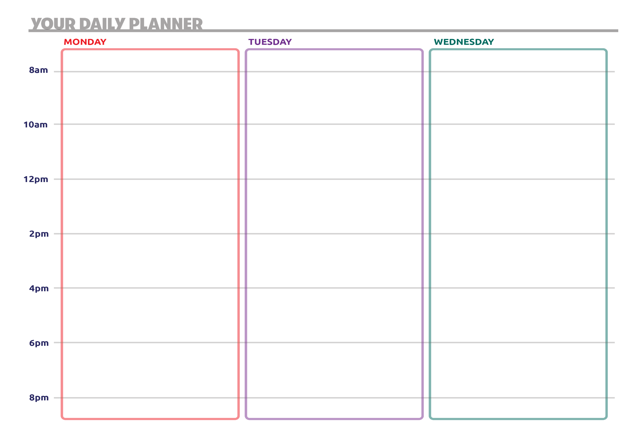

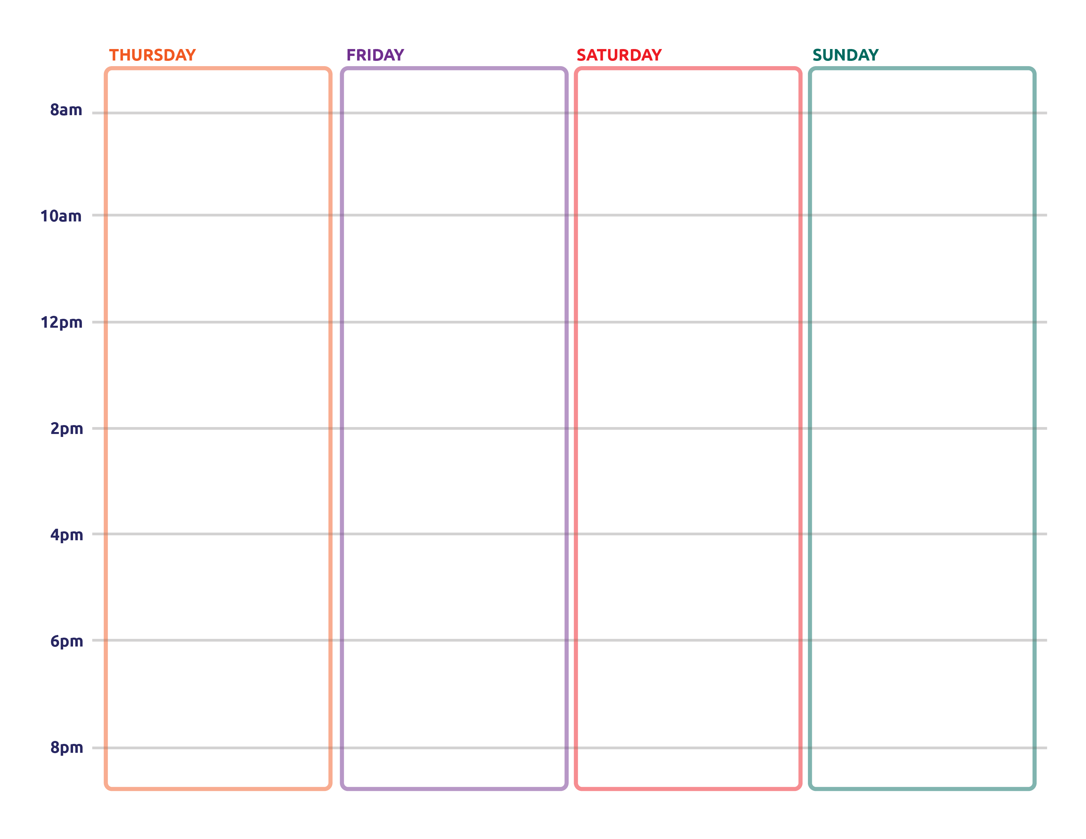

Reflection Worksheet
Note: Do not feel like you need to complete all these questions at the same time. Take your time! If you need more space to answer your questions, use a separate sheet of paper or another Word document.

- What changes did you make to your schedule^ after completing Lesson 1? Did you remove anything or add anything because you spent too much time or too little time on it last week?

- Did you like using the calendar to help plan out your week? Why or why not? Do you think you will be more productive this week after because you have a plan?

- How can scheduling a week ahead of time help you be more productive?

- Why is being productive important to being a good leader?

- What does it mean to prioritize^ something on your schedule? How is that action important to becoming more organized^?

- Ask a family member, mentor, coach, or peer if they plan out their week using a calendar like this. If they do, what can you learn from the way they do it? If they do not, ask them how they stay on task during the week without a calendar.

<< END OF LESSON 2 >>

Managing Time & Tasks: Lesson 3
Planning a discussion
How to deal with changes to your schedule
There is a saying: “The only constant^ in life is change.” This means that the one thing you know will happen without a doubt^ is that things will always change.

Some of us are great at dealing with change, while for others it is more difficult to manage. Being able to adapt to change is a very important trait of a good leader. Knowing that change will happen and understanding that plans will rarely go exactly as planned, it is important for leaders to have back-up^ plans so they can adjust^ and keep moving forward.
You can spend hours planning out your future days, weeks, months, and years, but unexpected^ things will always happen. Think about the plans you had for 2020. You might have had plans to compete at a Special Olympics event. Most of your plans in 2020 were put on hold because of COVID-19, right? We all had to adjust^ to not being able to see our friends as much. We all had to adjust^ to not going outside as much. What plans of yours were cancelled in 2020? How did you adapt?

Here are some quick tips on how to deal with change:
- Make room for change: Try including buffers^ in between events on your schedule. Buffers^ are a short period of time (5-30 minutes) that you can use in your schedule to help you adjust^ if something comes up at the last minute. If you make room in your schedule for change, you will be able to adapt better when things do come up at the last minute.
  - Example:
Time | Activity
8 a.m. | Wake up
8-8:15 a.m. | Breakfast
8:15-9:30 a.m. | Gym
9:30-10:30 a.m. | Meeting
10:30-11 a.m. | Answer emails
Schedule WITH buffers^
Schedule without buffers^
Time | Activity
8 a.m. | Wake up
8-8:15 a.m. | Buffer^
8:15-8:30 a.m. | Breakfast
8:30-9 a.m. | Buffer^
9-10 a.m. | Gym
10-10:30 a.m. | Buffer^
10:30-11:30 a.m. | Meeting
11:30-11:45 a.m. | Buffer^
11:45 a.m.-1 p.m. | Answer emails

  - If we have breakfast from 8-8:15 a.m., work out from 8:15-9:30 a.m., and have a meeting from 9:30-10:30 a.m., there is no room for something to go wrong like sleeping through your alarm, or getting stuck in traffic.
  - If you build in little buffers^ into your schedule like in the second table, it allows you to have extra time in case something goes wrong, or you run behind.

- Allow yourself time to be upset, BUT… : It is okay if you are upset or angry when change happens and ruins your plans. It can be frustrating if a week before the dance you were planning, the event venue^ cancels. It is okay to take a few minutes to be angry. However, most of the time being angry or upset will not change anything. You may still be able to save the dance if you act quickly and find a different place to host it! Good leaders can get over their feelings in the moment of a big change and focus on how to adapt.

- Be patient^: Just like with anything new, this will take practice – and you cannot really go out and practice changes to your schedule like you can practice your basketball skills. You will have many chances to learn how to deal with change. You will never be perfect at it – no one is. But by understanding the tips and by practicing the skills you have learned in Lessons 1, 2, and 3, you will be better prepared to deal with unexpected^ change when it comes. Keep in mind too as you get better at dealing with change, other people will not be good at it. So just like you were patient^ with yourself, be patient^ with other people too. Ask if you can share what you have learned from these lessons with them. You can lead by example and show them how good leaders deal with change!

That is why flexibility (being able to deal with change) and problem-solving (can look at a problem and know how to fix it) are very important skills in time management. Let us practice being flexible and problem-solving! Look at the schedule you created in Lesson 2 (pages 9-10). Hopefully, you have a lot of things on your calendar for each day.

While looking at your full schedule, imagine all these things happen:
- You get an email from your local Special Olympics program reminding you that you have an event to be at on Thursday morning from 9-10 a.m.
- You get a call from your doctor saying you need to go in for two appointments^ this week – one on Monday afternoon and one on Friday morning. You get to pick the times on those days.
- Your internet provider needs to come out to your home to install internet for you, but they say you need to be home from 9 a.m.-2 p.m. on Wednesday. They could come at any moment during that time, so you need to be home the whole time.

Using the calendar you put together from Lesson 2 and the blank schedule on pages 16-17, print and write or type out in this document your new calendar with the Special Olympics meeting, the doctor’s appointments^ (both of them), and the internet service appointment^. Depending on how busy your schedule was, you might need to move a lot of things around on your schedule to fit it all in.

Things to consider:
- Are there things you can move to a different day?
- Are there things that you can skip for this week?
- Is there something that you can do for a shorter amount of time to make space for the unexpected^ meetings and appointments^?
- Are there appointments^ that you need to reschedule^ and move to a different day or time?
- If you have to cancel any appointments^ or events, what steps would you take to do that?

Reflection Questions
Note: Do not feel like you need to complete all these questions at the same time. Take your time! If you need more space to answer your questions, use a separate sheet of paper or another Word document.
- When you had to add the new appointments^ to your calendar, how did you do it? What other things did you move around or cancel?

- Explain every step of how you made those decisions.
- Before this lesson, how did you usually handle changes? How did you usually react? What did you feel?

- When you had to change your calendar during this lesson, how did that make you feel? Why?

- Why do you think being able to adapt to change is important to being a good leader?

- How can you become better at dealing with change? What steps can you take to get better?

<< END OF LESSON 3 >>

Glossary/Dictionary
It is okay if you do not know what a word means. This glossary (also known as a short dictionary) is supposed to help you learn new words and how to use them. Some of these words have more than one meaning. The definitions below relate to how the words are used in this document only. If there are other words in this lesson that you do not understand, try looking them up online at www.m-w.com.
Lesson 1:
- Accomplishment: the act of reaching a goal or finishing something
- Analyze: to study deeply; to think about
- Manage/Management: to keep track of; to work on
- Productive: good at getting things done
- Similar: something that is like another thing
- Track/Tracking: paying special attention to something usually involving someone taking notes
- Urgent: most important; needs to be done immediately
----------------------------
Lesson 2:
- Include: to take in; to be a part of a group
- Organized: having a way of doing things in an orderly way; not sloppy
- Prioritize: to list or rate something in order of what is most important
- Schedule: a plan to do things at a specific time (for example: 3 p.m.) or in a specific amount of time (for example: this activity will last 1 hour)
-----------------------
Lesson 3:
- Adjust: to change; to make fit with something new
- Appointment: an event or meeting on a schedule
- Back-up: a second plan to your main plan; a substitute
- Buffers: short period of time built into a schedule to allow flexibility when things change
- Constant: to be the same, always; without change
- Doubt: when used as “without a doubt” it means “for sure” or “definitely”
- Patient: take your time; not rushing in
- Reschedule: when something goes wrong, and you need to move an appointment to another time or day
- Unexpected: did not plan for; did not see coming
- Venue: a place where events are held
Please complete the Training Evaluation Form:
You can also access the evaluation form by typing this link into your browser (it is case-sensitive!): https://bit.ly/2SrjVNG or by taking a picture of the QR code with your phone.

