Independent Activities
Leading Discussions^
Note: If you see a word you do not know and it has a ^ next to it, you can look at the glossary on the final page of this document. You can also use a dictionary (www.m-w.com).
Athletes: You can use this training on your own or with personal support. Print out and fill in answers to the questions or type your answers into the Word document. Go through these trainings at your own speed.
In this course, you will:
- Understand the basic skills for planning and leading discussions^
- Identify and apply the basic skills for keeping the discussion^ going
- Learn techniques^ to help you get better at engaging^ other people in discussions^
- Learn why these techniques^ are important to being a good leader
- Learn what “themes” are
- Learn what it means to “compromise”
- Learn why compromising with others is important to being a good leader
- Learn what a meeting agenda is and how to put one together

Topic | Description
Lesson 1: Engaging your audience  - Engagement techniques | Explore how your actions can encourage others to stay engaged and participate in the discussion.
Lesson 2: Managing the discussion  - Identifying themes and compromise | Not all conversations will flow easily. Once you begin the discussion you will need to keep the conversation going. Learn and practice the basic skills needed to keep the discussion going.
Lesson 3: Planning and facilitating your discussion  - Create your agenda | Preparing and planning for your discussion is an important part of building your confidence to lead the discussion and respond to questions. Explore basic techniques for planning to lead a discussion.

Updated: June 2021
Leading Discussions: Lesson 1
Engagement^ Techniques^
What are engagement^ techniques^ and how do you use them?
Techniques^ are methods or ways that people deal with something. Simply put, they are tools for you to use when communicating with other people.
The engagement^ techniques^ you are learning about today are: active^ listening, nodding^ your head, positive body language and facial^ expressions, positive tone of voice, limiting distractions, and staying positive.
Some of those words or terms may be new to you. Take some time to think about what they might mean. Then look at the activity on page 3. Read through the definitions on the right and draw a line to the technique on the left that you think it fits with. We did one for you already so you can see how it should work. Remember the answers are on Page 4 if you want to check your work after you are finished.

Engagement^ Technique Definition
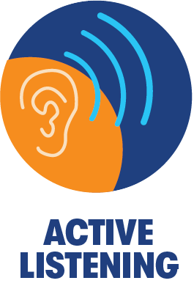
Move your head up and down. Doing this shows the person you are talking
to that you understand or agree with
what they are saying.

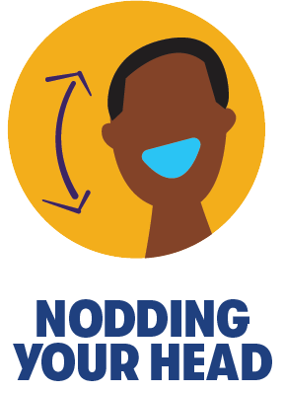
It is sometimes easier to be upset or negative but doing this anyway is important. Even if someone is saying something you do not agree with, you find the good things they are saying and try to focus^ on those.

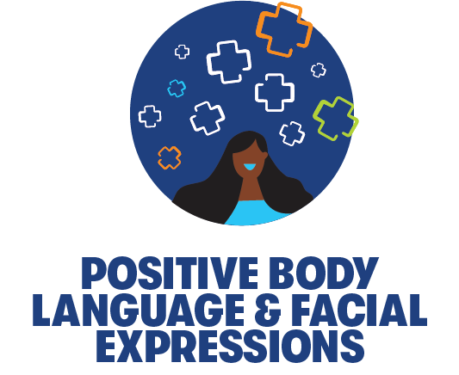
Doing this shows the person you are talking to that you are fully focused^ on what they are saying. One way you can do this is by repeating what they said to you back to them showing that you understood.

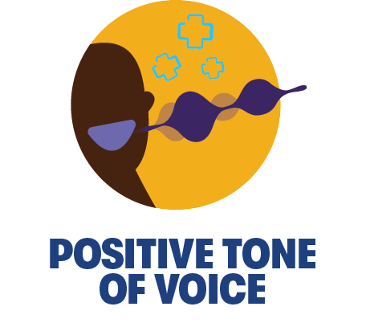
Doing this shows that you respect the person you are talking to -- you are paying attention to them. For example: Your phone is put away and you are focused^

Doing this helps you stay calm and in control when you are angry or upset about something. It also shows others that you are in control, and they have nothing to worry about.

Doing this makes sure people know just by looking at you that they can come talk to you about something.

Engagement^ Technique Definition
Move your head up and down. Doing this shows the person you are talking
to that you understand or agree with
what they are saying.

It is sometimes easier to be upset or negative but doing this anyway is important. Even if someone is saying something you do not agree with, you find the good things they are saying and try to focus^ on those.

Doing this shows the person you are talking to that you are fully focused^ on what they are saying. One way you can do this is by repeating what they said to you back to them showing that you understood.

Doing this shows that you respect the person you are talking to -- you are paying attention to them. For example: Your phone is put away and you are focused^

Doing this helps you stay calm and in control when you are angry or upset about something. It also shows others that you are in control, and they have nothing to worry about.

Doing this makes sure people know just by looking at you that they can come talk to you about something.

Reflection Worksheet
Note: Do not feel like you need to complete all these questions at the same time. Take your time! If you need more space to answer your questions, use a separate sheet of paper or another Word document.

- How do you know when someone is actively^ listening to you? How do you know when someone is not listening to you? How does that make you feel?

- What are some examples of positive body language and facial^ expressions? What are some examples of negative body language and facial^ expressions? When you are talking to someone and they have negative body language and facial expressions toward you, how does that make you feel?

- What are some things that might be a distraction to you in an in-person meeting? What are some different things that would distract you during a virtual meeting?

- Which of the techniques^ on Page 3-4 are you best at? Which one could you get better at? How do you think you can get better at it?

- What are some techniques^ you use that are missing from this list?

- Ask a mentor, coach, peer, or family member if they have any techniques^ they use that are not on this list. List those here.

- Why is learning these engagement^ techniques^ important to being a good leader?

<< END OF LESSON 1 >>
Leading Discussions: Lesson 2
Themes and Compromise
Themes
- A theme is a piece of an idea that is common between at least two things. You may see a theme in a topic or idea that is talked about more than once or twice.
- If you notice that a certain topic or idea comes up in a discussion multiple times, it is often called a theme. You can use themes to help you make decisions on the topic you are discussing.
  - For example: You are at a Special Olympics Board of Directors meeting and while talking about a new program, Rodrigo asks how much money this new program might cost. You remember at the last board meeting Rodrigo asked a similar^ question about how much something else might cost. You see that Rodrigo is very concerned^ about finances and some of their questions have the theme of cost.
- Movies and books are great examples of things that have themes:
  - For example, a theme of Harry Potter is facing your fears.
  - A theme in the movie Frozen is chasing your dreams.
  - You could say some themes Frozen and Harry Potter have in common are family and love.
- Themes are sometimes difficult to find or understand. They are not always specific^ and if you are talking about themes in books or movies or even in your discussion to improve Special Olympics, there is often more than just one theme.
  - Practice: The next time you watch your favorite TV show, think about what themes are in that episode. Take notes on what you think they are and discuss with someone else who watches the show to see if they saw other themes.
- Themes help people think about things in different ways. They help us understand and explain things in a way that is easy for everyone to understand.

Compromise
- Compromise is when people talk about an idea, sometimes through arguing^, and then make a decision that works the best for most people. When people compromise, they are not getting everything they want, but reaching a decision that benefits the most people.
  - For example: You and your friend both want to watch a movie but are having a hard time deciding what to pick. You want a comedy, but your friend wants an action movie. You each argue^ about which one you would like to watch. A compromise is when one of you says something like, “Let’s watch your movie this time, but next time we can watch mine.”
  - For example: You want to host a competition in a new Special Olympics sport, but your Program director says they do not think that is a good idea because the sport is not popular enough yet. A compromise could be that the Program director will allow the new sport to have a competition when you can find 50 athletes and 10 coaches to learn the sport.
- Compromises are give and take – someone needs to give up something to get something.
- Learning how to compromise is a very important trait for everyone, not just people who want to lead.
- Compromise is something that you can practice. Some people want to avoid conflict and will likely give in and compromise faster than others. Others like to boss other people around because they know the other person will give in and compromise quickly. It is important for leaders to recognize which way they lean (submissive^ or bossy) and practice the right way to compromise.
- People compromise on things every day. It is important to understand how to compromise in a healthy way. Here are some things to keep in mind when thinking about compromise:
  - It is okay to disagree^: There is nothing wrong with having a different opinion from someone else. Sometimes when people disagree, they argue about a topic. If people are not physically^ or verbally^ hurting each other, arguing is a good exercise in communication. Learning how to argue^ and negotiate is an important part of being a leader. Sometimes people will not believe in you or your idea. You will need to convince^ them by coming up with good points to back up your idea. Sometimes you will need to also come up with something you are willing to give up to get what you want – this is called a compromise.
    - A tip to have healthy arguments or debate is to take the emotion out of your decision and what you are arguing. If you understand that it is okay to not always agree with someone and to not take things personally when they do not like your idea, then you will have more success coming up with compromises.
  - Win-win situations are great, but…: A win-win situation means that everyone in the argument or debate win in some way; they all give up a little something to get a little something.
    - For example: Two kids want to play with the same toy. A win-win situation that helps both is giving a time limit for each kid to play with the toy or a parent can buy two of the same toy so they can each have it at the same time. If only one person gives something up, it is not a compromise, and it usually leads to someone having hurt feelings.
    - Win-win situations are great, but they are not always possible. Sometimes as a leader you need to know when to fight for something and when to find a compromise. It is difficult at first, but you will get better at it with practice.
  - Empathy is important: You might have learned about “empathy” in the “Understanding Emotions” class. Empathy is caring about what other people want and need. If you are in a healthy argument and trying to find a way to compromise, put yourself in that person’s shoes. Stop and think about how they might feel. It is easier to compromise on something when you understand where the other person is coming from.

Scenario^ Exercise
Read each scenario^ and select the correct answer from the multiple choice.

Scenario^ 1:
Your group is trying to decide on a theme for the next competition logo. Listen to what your three committee members have to say and then look at the multiple-choice answers and choose which one best identifies the theme.
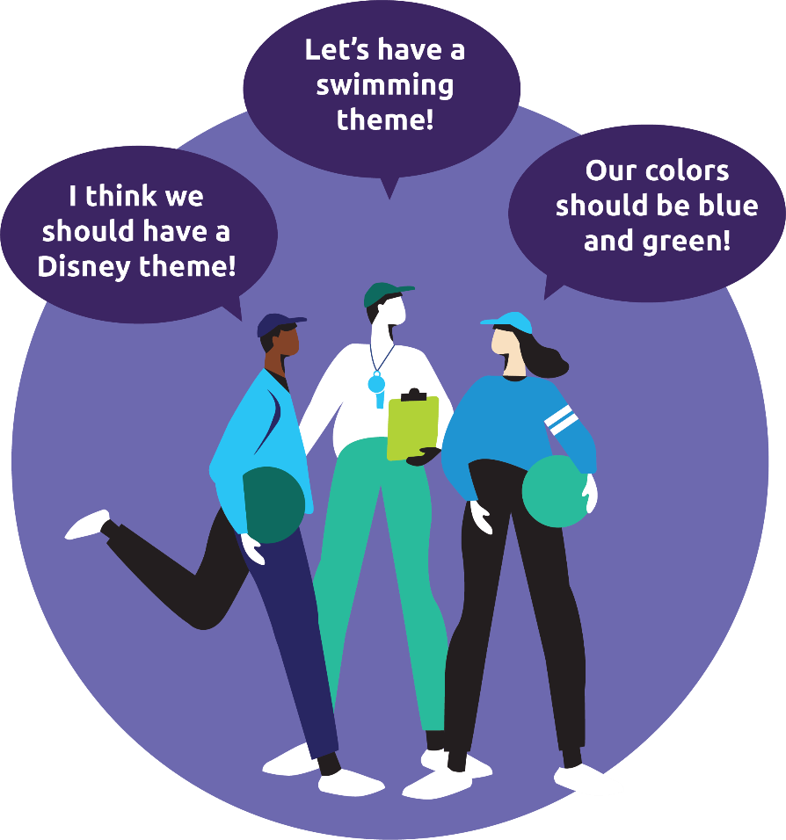
Our area is known for its lakes and streams, so it should show that somehow.

I think the logo
should show all the sports we can compete in -- swimming, track, and soccer.
My favorite colors are blue and teal. Let us make the logo those colors!

Using the picture above, put yourself in this situation. As the facilitator of this discussion, can you identify the theme?
- “What about a logo that shows swimming, track, and soccer in blue and teal colors? It’s only missing the lakes and streams part.”
- “Those are all great ideas. But you know what people love most right now – superheroes? It should include superheroes!”
- “I think we could combine all of these ideas and have a logo that is blue and teal in color, but also uses a sketch of a local lakes or stream, plus the logos of the sports.”

Answer: C – It includes everyone’s ideas so it is a great theme. It may be difficult to design a logo with all those things, but it is worth a try!

Scenario^ 2
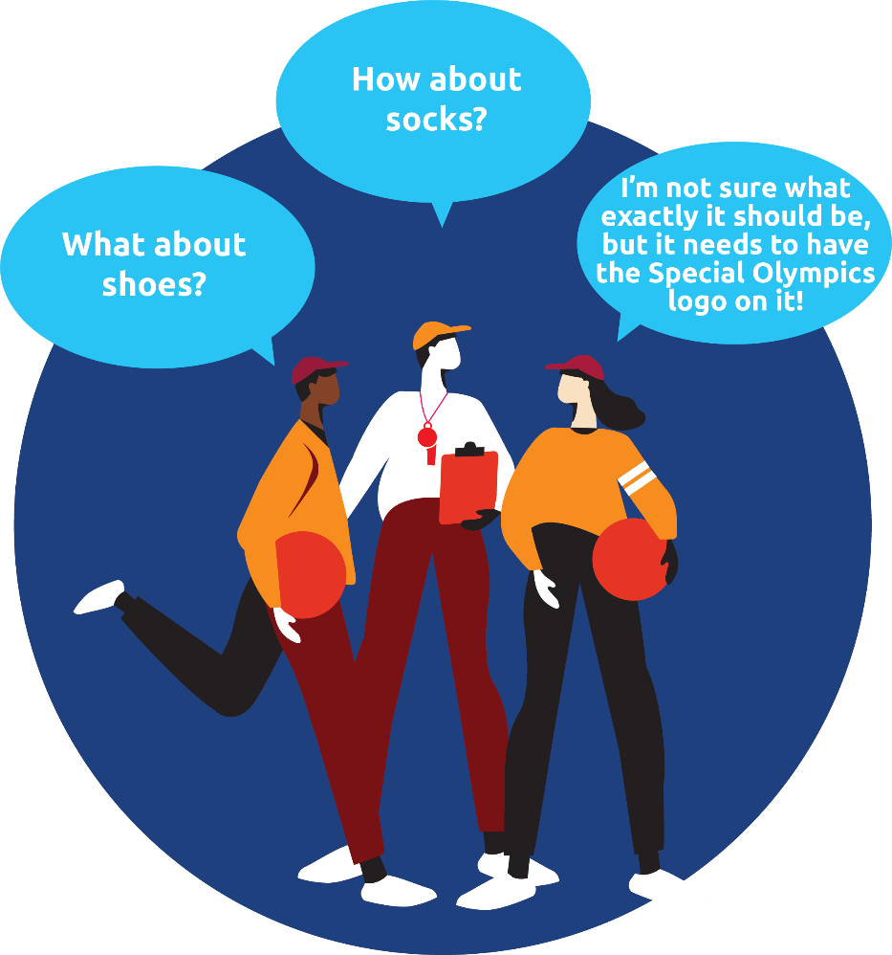
Your group is setting up a Healthy Athletes screening for Fit Feet at a competition. Your group is trying to decide on what giveaway to hand out at this station.

Using the picture above, put yourself in this situation. As the facilitator of this discussion, can you help the group compromise?
- “Shoes might be too expensive, but what if we were able to get the logo on hats?”
- “Let’s do shoelaces with the Special Olympics logo instead!”
- “I like the idea of new Special Olympics hats!”

Answer: B – The theme of the Healthy Athletes screening is feet, so the item should be a giveaway that athletes have on their feet. Shoes and socks might be a bit too expensive, but shoelaces is a great compromise!
Reflection Worksheet
Note: Do not feel like you need to complete all these questions at the same time. Take your time! If you need more space to answer your questions, use a separate sheet of paper or another Word document.

- Name your favorite book or movie. What are some of the themes of that book or movie?

- How can understanding what themes are help you become a better leader?

- What does it mean to compromise?

- Can you think of a time when you had to compromise with a family member or friend? Explain what happened.

- Can you think of a time when you had to compromise in Special Olympics? Explain what happened.

- How can understanding what compromise is help you become a better leader?

- Do you like arguing with other people? Why or why not?

- If you are good at arguing, what makes you good? If you are bad at it, how do you think you could get better?

- How is healthy arguing important to being a good leader?

<< END OF LESSON 2 >>

Leading Discussions: Lesson 3
Planning a discussion
When meetings are unorganized and have no purpose, or when people go off topic during the meeting, it can feel like the meeting was not a good use of their time. One of the best ways to solve those problems is to have a meeting agenda.
An agenda is something you (as the facilitator or meeting organizer) would put together and send out to all participants before the meeting. Creating an agenda helps you organize your thoughts and plan for the meeting. It also helps keep other members on track during meetings.
If you have never created an agenda before, you might not know where to start. Here are some tips to help you create an agenda:
- Prepare your agenda early: Do not wait until the last minute to put your agenda together. Try to set an agenda at least three days ahead of your meeting. This gives you plenty of time to share the agenda with other members so they can be prepared for the meeting.
- Start with the basics:
  - What time will the meeting start and end?
    - Be realistic^ about what you need to cover in the meeting. If you have a lot to cover, do not try to fit it all in a 30-minute meeting. Most meetings should not last more than one hour.
    - Ask your participants what time of day works best for them to have your meetings.
  - Who must be at the meeting?
    - Have you ever attended a meeting before where you did not need to be there? That is not a good feeling. Make sure you take the time to identify^ the people who truly need to be there. If people are interested in a topic from your meeting, instead of having them attend the whole meeting, they can just read the meeting notes.
  - Where is the meeting located?
    - Will it be in-person or virtual? Is it located in an area of town that all participants can easily get to?
    - Decide on a location that is easy to reach for all participants.
- Define your meeting objectives^: Think about what your goal is for this meeting. Is it to set the theme for the next dance? Is it to gather feedback about a Special Olympics rule change? Is it to come up with a training plan for Athlete Leadership? Is it all three of those things? Knowing your meeting objectives^ will help you set an agenda. Have conversations with other participants ahead of time and ask them what they think you should cover in the meeting.
- Ask other members for their thoughts: Some of the points made above suggest^ that you reach out to other members for feedback on certain topics. Getting feedback from other members is important to a productive meeting. If you want everyone engaged^, you need to know what they want to discuss in a meeting. If you are not able to include their topic in this meeting, make sure you tell them why and maybe move it to another future meeting if it is not time-sensitive^.
- Plan for the future: Taking notes during a meeting helps members remember what was covered in a meeting, but it also helps the group understand if there is anything they need to work on before your next meeting. Get in the habit of sharing notes on those things at the end of a meeting so you leave the meeting with action items (things that people need to do before the next meeting).
Source: Calendar.com

Agenda Practice
Now that you know what an agenda is and some tips for putting one together, let us have you practice organizing an agenda!
- Here’s the scenario: You are a Special Olympics Health Messenger and you are leading a meeting with other Health Messengers in your Program.
  - Some topics you need to cover at the meeting are:
    - Your group wants to create a newsletter^ that includes healthy recipes and…
    - Your group wants to gather feedback from other athletes on how to get healthier food at competitions.
  - Using the blank agenda provided on page 16, create your agenda for the meeting. What are some questions you will need to ask the group to start the conversation for each topic? What are the different parts of each of those topics that you will need to put in the agenda? Some examples of agenda items for each of those topics are below:
    - Newsletter^ with recipes: Who will write the newsletter^?; How often will it go out?; How many recipes will it include?; What kind of recipes should it include?
    - Healthier food at competitions: Is this something our athletes want?; Who would we talk to at our Special Olympics Program to make this happen?; Healthier food is usually more expensive, so would we need to fundraise to pay for it?
  - Those are just examples of discussions and parts of the meeting that you might want to cover in the agenda; you will want to come up with some of your own. You will want to put a time limit to talk about each topic or the meeting could run long.
- Do one of the following:
  - Print out and fill in the worksheet on Page 16.
  - Fill in the worksheet on your computer and save.
  - If you do not have access to a printer and want to handwrite your answers, draw the template on a blank piece of paper and then fill it in.

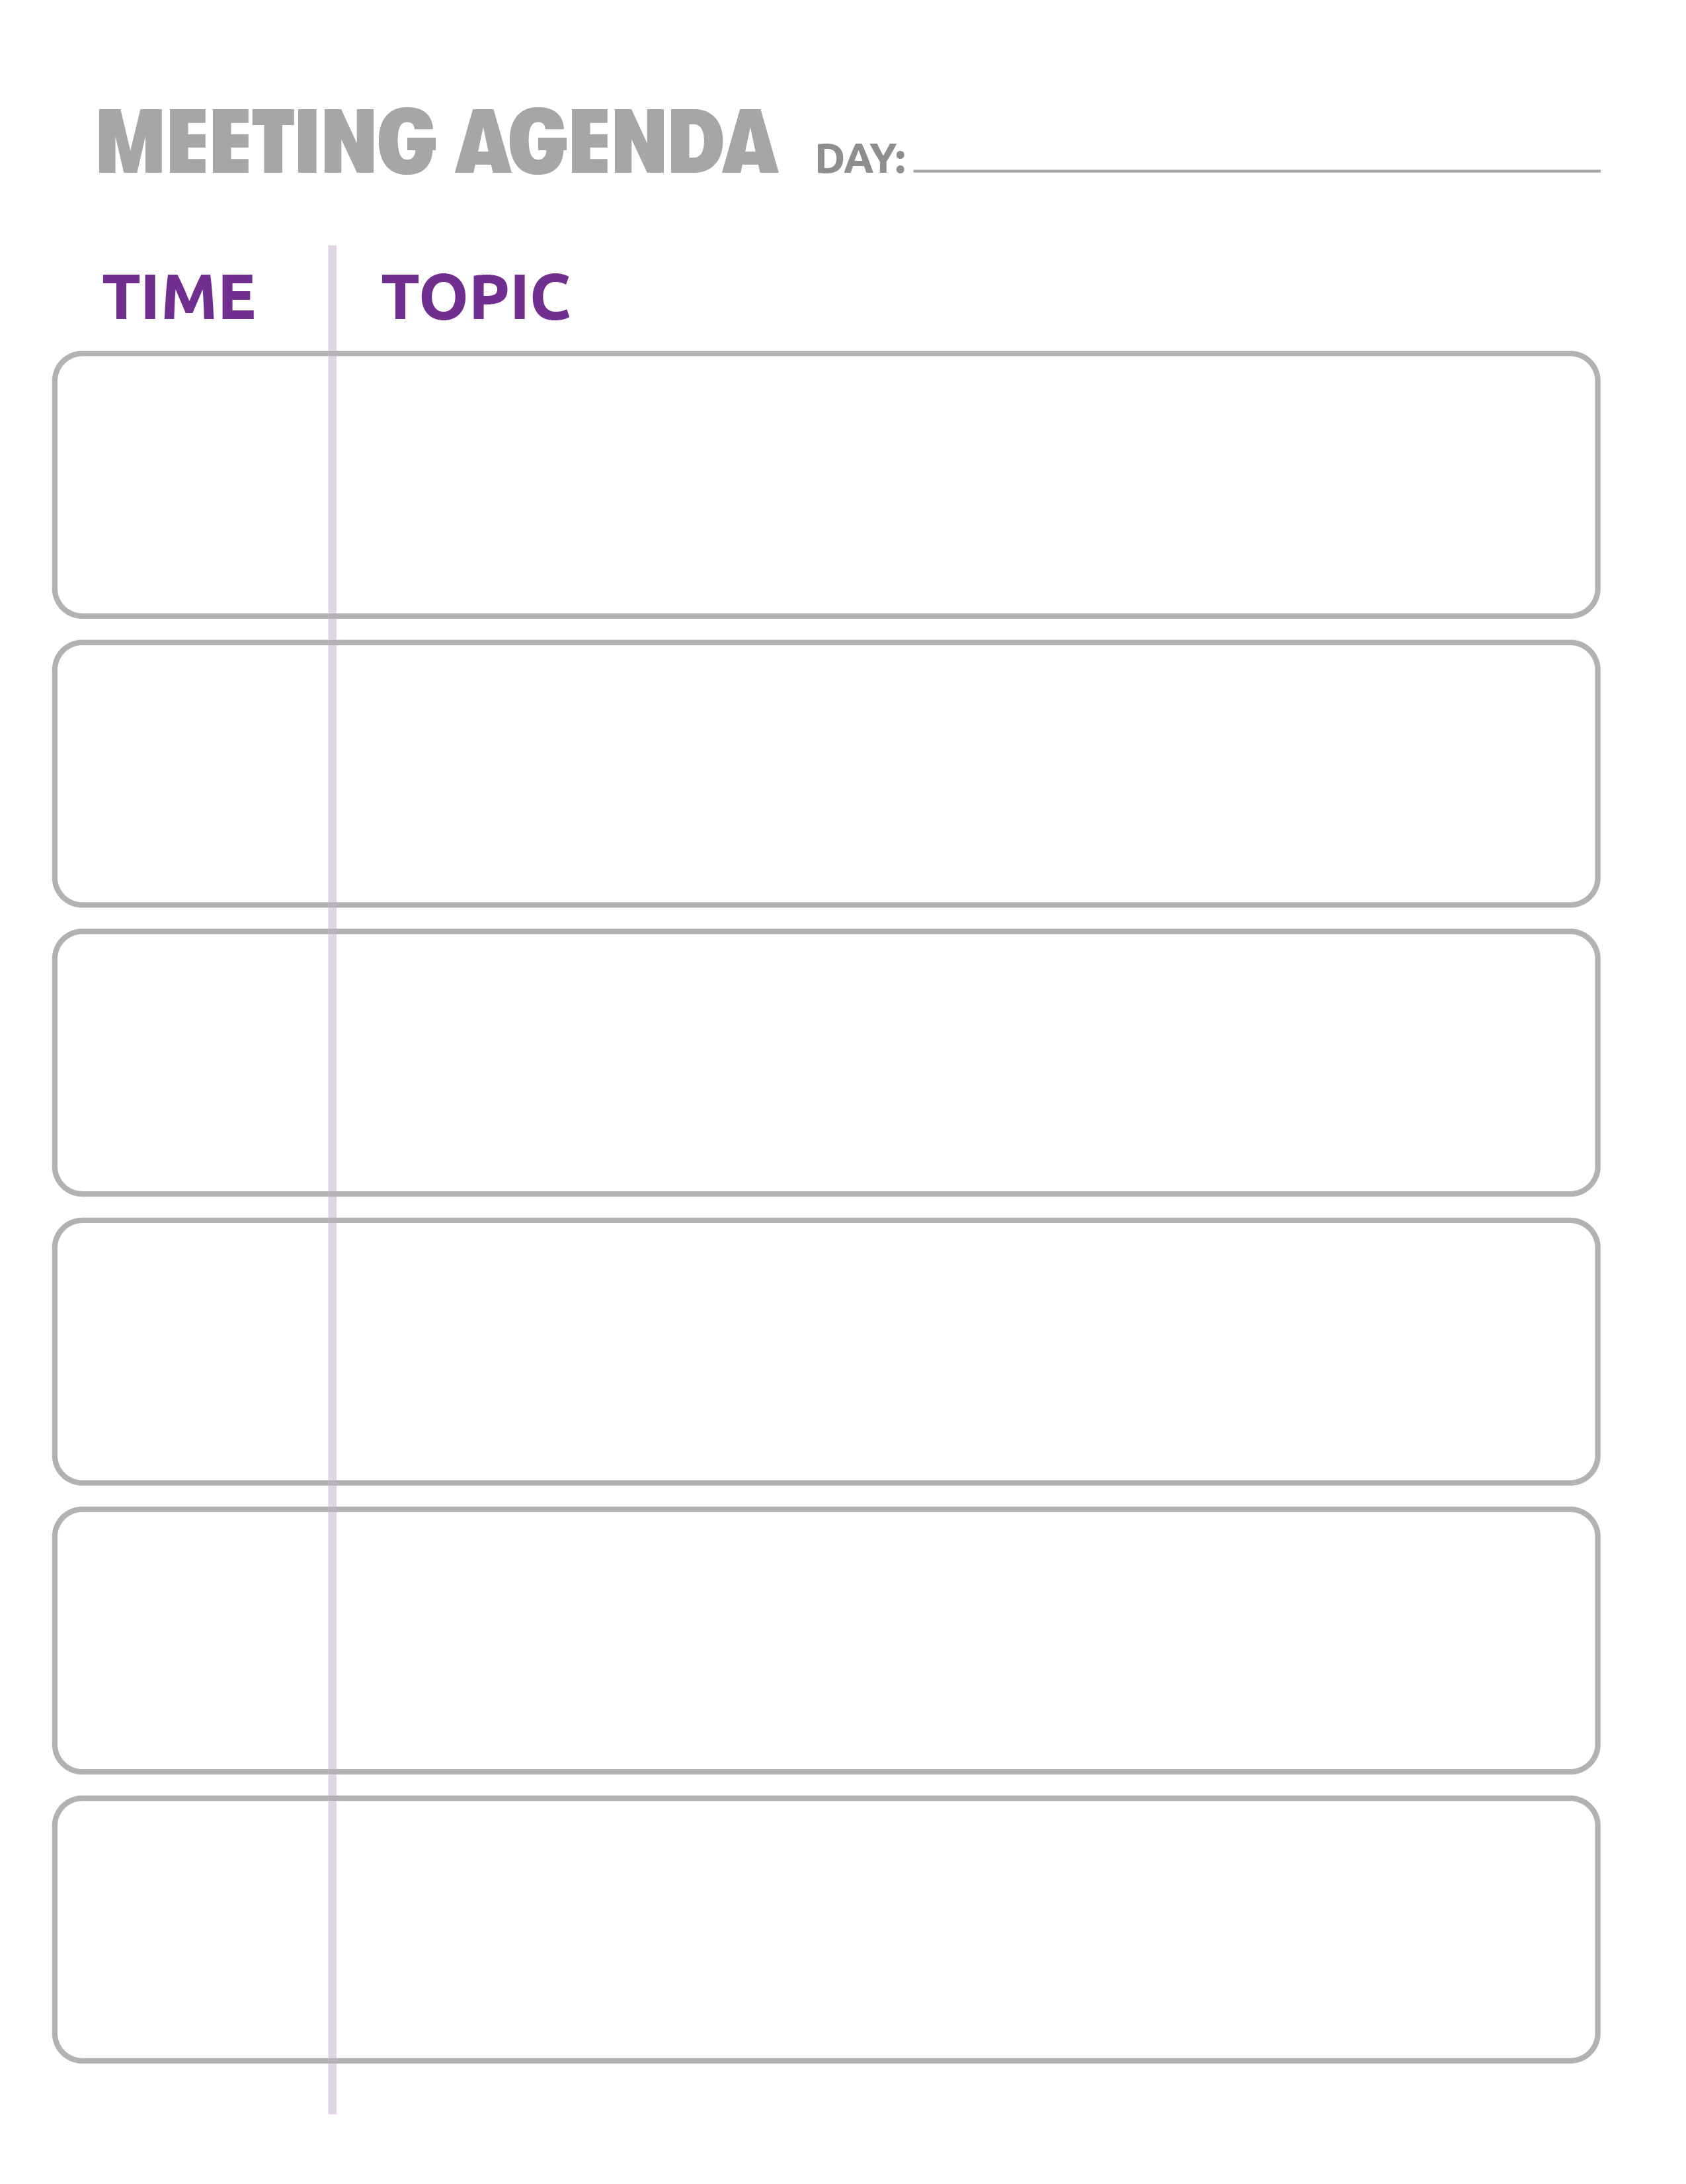

Reflection Questions
Note: Do not feel like you need to complete all these questions at the same time. Take your time! If you need more space to answer your questions, use a separate sheet of paper or another Word document.
Review what you learned from Lessons 1 and 2 by answering the questions below.

- Have you ever been to a meeting before that was unorganized? How did that make you feel?

- Why is it important for meetings to have agendas?

- How can agendas help you keep meetings organized?

- What did you learn from putting together the practice agenda? Was anything missing?

<< END OF LESSON 3 >>
Glossary/Dictionary
It is okay if you do not know what a word means. This glossary (also known as a short dictionary) is supposed to help you learn new words and how to use them. Some of these words have more than one meaning. The definitions below relate to how the words are used in this document only. If there are other words in this lesson that you do not understand, try looking them up online at www.m-w.com.
Lesson 1:
- Active: something that takes action
- Audience: group of people listening or watching
- Discussion: talking between at least two people
- Engage/Engaging/Engagement: to hold someone’s attention; to talk to someone
- Facial: of the face
- Focus/Focused: not distracted; will not let something get in the way of completing a task or goal
- Nodding: moving the had up and down
- Techniques: ways or methods of doing something
----------------------------
Lesson 2:
- Argue/Argument: to disagree; to give reasons for or against something; a discussion that involves at least two sides that disagree
- Concerned: worried; anxious
- Convince: to persuade; to get someone to agree with you
- Physically: to act in a way that involves body contact
- Scenario: an example or possible outcome; a situation or event to test or try something
- Similar: used to compare things; something that is related to something else
- Specific: focused; obvious; clear
- Verbally: done through spoken words
-----------------------
Lesson 3:
- Engaged: to be involved in and aware of what is going on
- Identify: to see something and know what it is
- Newsletter: a way to communicate with people – usually through email; like a long email that describes what is going on within a program or organization
- Objectives: goals; things you want to complete
- Realistic: possible; something that is close to real; not something you hope for or dream on, but something you can accomplish
- Suggest: to guide; to point someone toward doing something; a recommendation
- Time-sensitive: something needs to be done by a certain date, usually quickly; something that cannot wait and must be done immediately

Please complete the Training Evaluation Form:
You can also access the evaluation form by typing this link into your browser (it is case-sensitive!): https://bit.ly/2SrjVNG or by taking a picture of the QR code with your phone.

