Introduction to Athlete Leadership
Facilitator Guide

This facilitator guide provides an outline on how to host and lead the Introduction to Athlete Leadership training course using the PowerPoint presentation and the participant workbook.

These resources are for you to use in the way that works best for you and your Program (virtually, in-person, individually, etc.). Feel free to adapt them. If you are looking for resources to help prepare for and lead a training virtually through Zoom, WhatsApp, Facebook, etc., you can find them here. Alternatively, the workbook, PowerPoint, and this resource can be used for in-person delivery as well.

Be sure to complete the following actions to prepare for each session:
- Identify at least one athlete leader to co-facilitate.
- Review this facilitator guide and accompanying PowerPoint presentation.
- Review the workbook and complete each activity yourself to be familiar with the activity and have examples to share. Additionally, think about what information you can add from your Program’s perspective. Ask the athlete leader what they can add from their perspective.
- Host a practice session with all facilitators and cover every slide.
- Give feedback to each other.
- Host a second practice of the entire presentation.
- Send out the workbook and session instructions to the participant one or two weeks before the training. Invite athlete leaders to look through all the resources before the training so they are familiar with the content.

Training Overview

Topic | Description | Estimated Time
Lesson 1: Overview of Special Olympics  - Review the Special Olympics mission statement  - Review what makes Special Olympics unique  - Learn important facts about Special Olympics | Before you can write your own personal mission statement, you need to understand what one looks like by analyzing the Special Olympics mission statement. It is also important for you to learn as much as you can about Special Olympics. | 35 mins
Lesson 2: Definition of Athlete Leadership  - Three guiding principles of Athlete Leadership | To become a great leader, you must first understand the three parts of Athlete Leadership. | 45 mins
Lesson 3: Roles/action plan  - Explore roles available to athlete leaders  - Finding your strengths  - Write your own mission statement  - Start an action plan | You will ask yourself, “What am I good at?” and “What do I need to improve?” Writing a personal mission statement and creating an action plan will set you up for success. | 45 mins

We encourage you to add Program-specific content to make it more relatable to your group of athlete leaders. It is recommended that lessons are facilitated in order and each session be no longer than 2 hours in length. The course can be divided into multiple sessions. In the end, these are just resources at your disposal. You will need to adapt them to fit your constraints as a Program (time, space, technology, etc.).

Special Olympics International
Facilitator’s Guide

Introduction to Athlete Leadership

Time | Lead | Topic | Description | Slide
10 min | Facilitator 1 | Welcome and overview of session | Welcome participants  Mention who is the on call  Short Zoom tutorial (feel free to change some of these to fit with your Program/culture):  Let’s learn about using the chat feature. Type a comment, question or response in the chat box:  How many years have you been involved in Special Olympics?  There is a reaction feature button. What reaction do you have when…  - …you win a race?  - …you are told to sing a song in front of others (karaoke)?  - …you are asked to give a speech in front of a lot of people?  Now we are going to practice taking a poll. It will pop up on your screen and you can make your pick.  Which ice cream flavor do you like the best?  - Vanilla  - Chocolate  - Mint chocolate chip  - Rum raisin  - Cookie dough  Review the module objectives  Introduce the second facilitator | 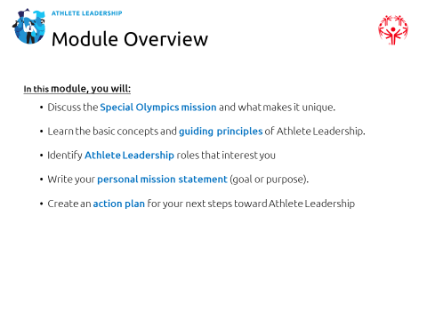
5 min | Facilitator 2 | Introductions | Good afternoon everyone. Welcome participants!  I would like to ask each person to introduce themselves very briefly, please, by telling us where you are from and telling us something you learned from participating in Special Olympics.  Each person introduces themselves; be mindful of how long each person is taking here. Try to keep this moving quickly. | 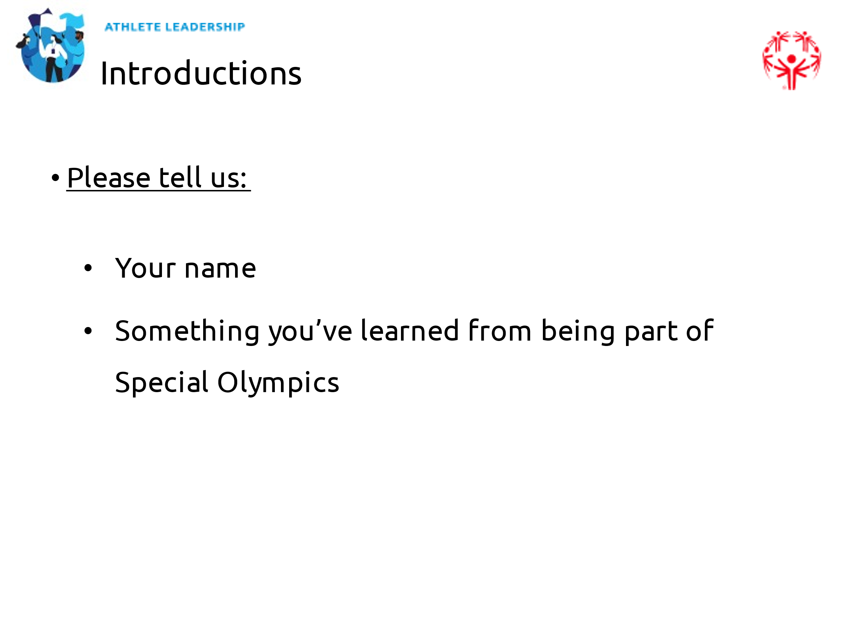
5 min | Facilitator 2 | Expectations | Go over how each group – athlete leaders, mentors, facilitators – all have different expectations during this training | 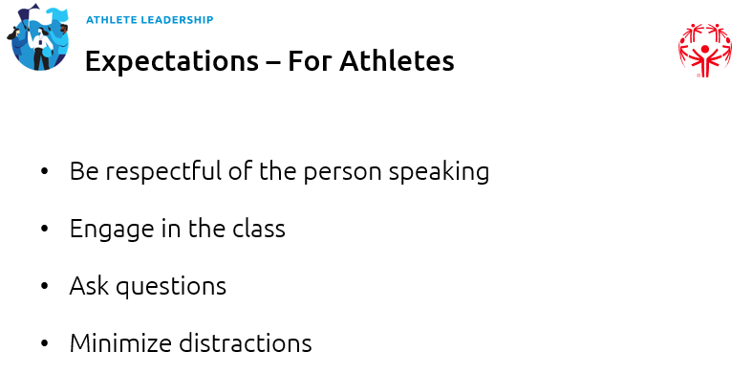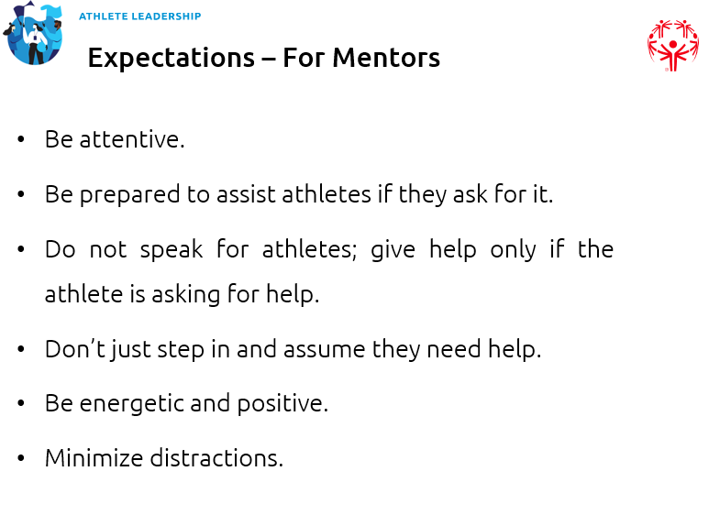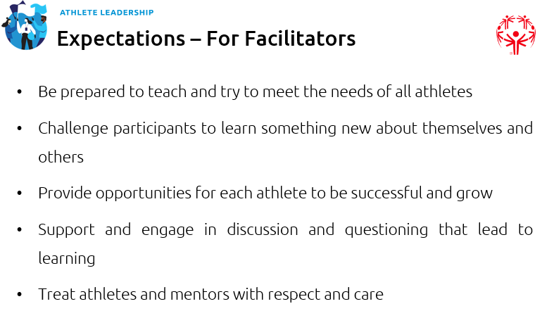

5 min | Facilitator 2 | Guest Athlete Leader to share their journey | OPTIONAL: Introduce guest athlete leader who shares their leadership journey and experience in leadership roles. Have a little Q&A time where you have questions pre-prepared and allow participants time to ask questions if they have any. | 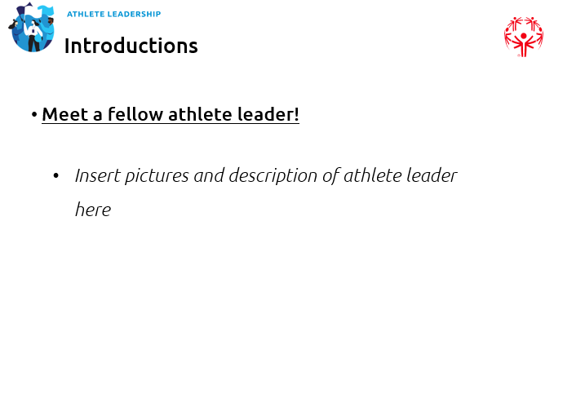
5 min | Facilitator 2 | Overview of lessons | Wow, thank you!  - Add comment on their remarks, examples are:  - We learned a lot from you  - Thank you for sharing your story with us  - Thank you for being a leader of inclusion  In today’s training we are going to learn three important lessons. They are:  - Overview of Special Olympics  - Principles of Athlete Leadership  - Your Role in Athlete Leadership  Let’s get started! | 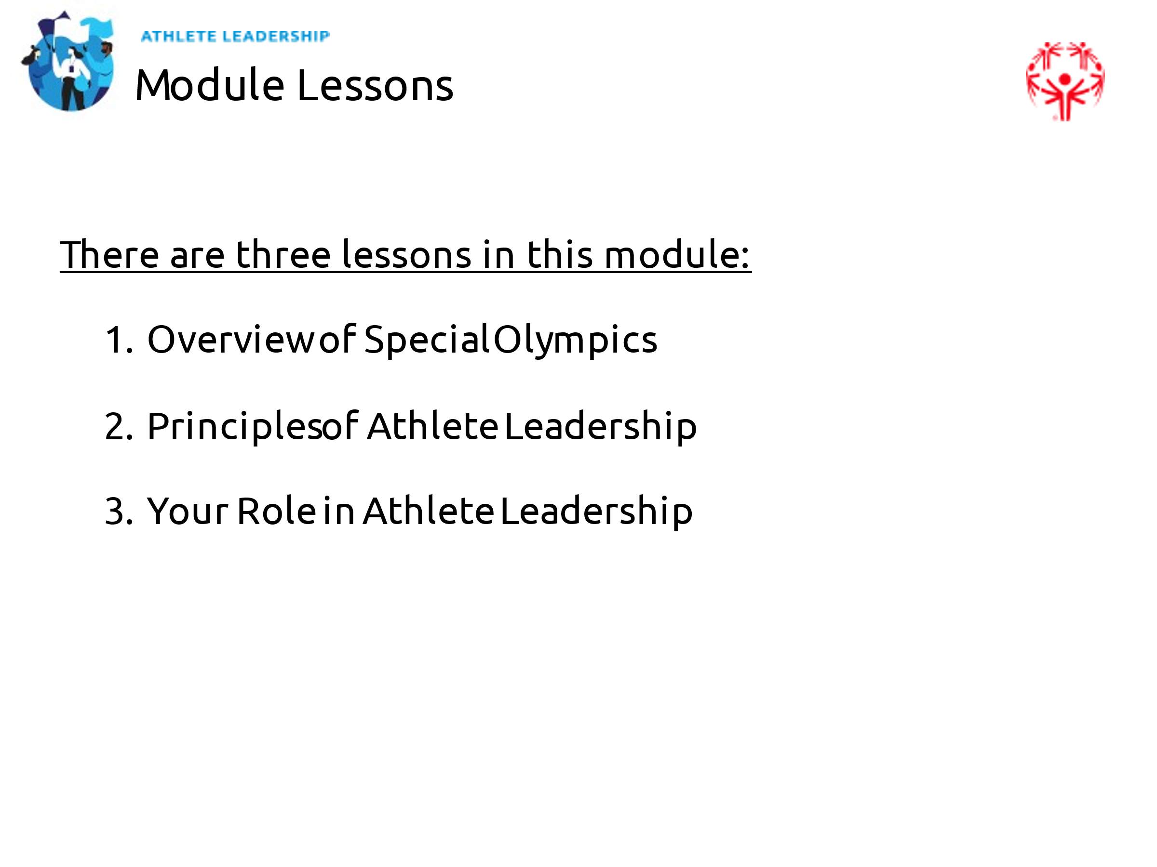
5 min | Facilitator 2 | Lesson 1 Introduction | As representatives of Special Olympics, you must make sure you know a lot about the organization you represent!  There are three objectives of this lesson:  - Review and discuss the Special Olympics Mission Statement  - Review what makes Special Olympics unique  - Learn important facts about Special Olympics  You are experienced athletes in Special Olympics.  Can I ask for a volunteer to tell us how you would describe Special Olympics to someone who has never heard of it before?  Thank you for volunteering.  Do we have 1 or 2 more people who would like to tell us how they would describe Special Olympics? | 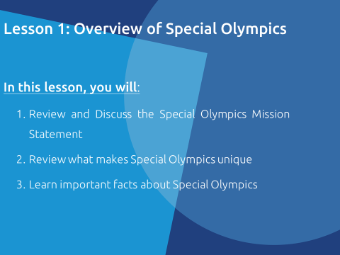
10 min | Facilitator 2 | Mission Statement | It is important as leaders of the movement that you know the Special Olympics Mission Statement.  Can anyone tell me what a mission statement is? What does that mean? Why is having one important?  If no one gives a correct answer, tell them a mission statement explains the purpose or goal of a person or an organization. It helps organizations and people stay on track and understand what they are supposed to do and why they are supposed to do it.  I will read the mission statement to all of you (read slowly and emphasize key words or phrases that are bold and in different colors on the slide):  “To provide year-round sports training and athletic competition in a variety of Olympic-type sports for children and adults with intellectual disabilities, giving them continuing opportunities to develop physical fitness, demonstrate courage, experience joy and participate in the sharing of gifts, skills and friendship with their families, other Special Olympics athletes and the community.”  Now, please take a minute to think about the Mission Statement. When you are ready, please write down or type out three words or phrases from the Special Olympics mission statement that mean the most to you.  Would anyone like to share what they put down?  If in-person, have them address the class when sharing their words and ask them why those selected those. If virtual, either have them un-mute themselves to share or just put in the chat.  OPTIONAL: This activity works better if you are in-person but give every athlete leader three votes to pick their three favorite words or phrases from the mission statement. You can keep track of the votes on a Word document or pad of paper that everyone can see. Then have the mentors select their three favorite words or phrases from the mission statement but do it in a way that shows which answers are the athletes’ and which are the mentors’. Have some athlete leaders explain their reason for picking those words or phrases and then have the mentors do the same. | 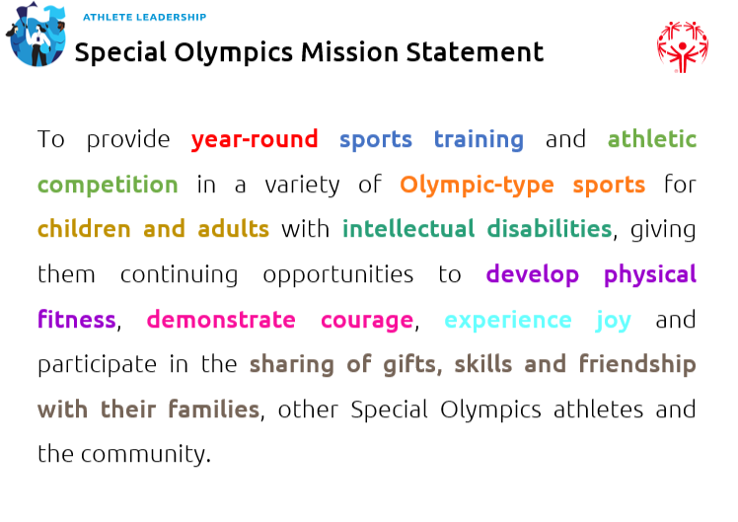
5 min | Facilitator 2 | What makes Special Olympics unique? | Some people may have heard of Special Olympics but maybe they do not know what makes our organization unique.  Special Olympics provides a variety of sports opportunities for all ability levels.  People are grouped by ability through a process called divisioning.  Awards, medals or ribbons, are provided to all participants who compete.  Special Olympics does not charge a fee for athletes to train nor compete. | 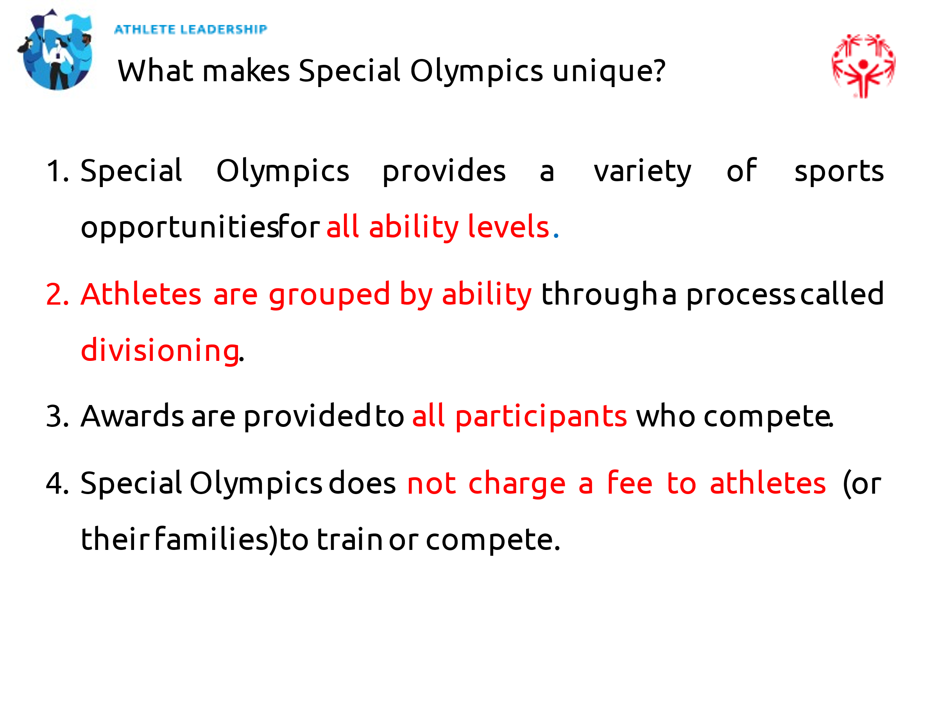
5 min | Facilitator 2 | Special Olympics Data | As a representative of Special Olympics, it is also important to know facts about the organization.  Let’s see how much you know about Special Olympics. This data is from 2019.  You will want to update with new information as it becomes available.  OPTIONAL: Create a poll with the answers below and some other numbers you came up with to quiz their knowledge before giving them the answers. You can also just ask them to guess out loud or in the chat if you do not want to create a poll. | 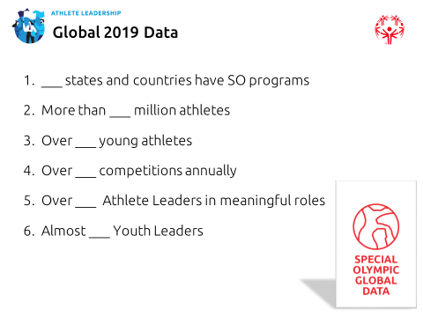
5 min | Facilitator 2 | SO Data (continued) | Let’s see how you did!  - 216 states and countries have Special Olympics programs  - More than 5.7 million athletes  - Over 500,000 young athletes  - Over 100,000 competitions annually  - Over 50,000 Athlete Leaders in meaningful roles.  - Almost 100,000 Youth Leaders  At this time, we will hand it over to (Facilitator 1). | 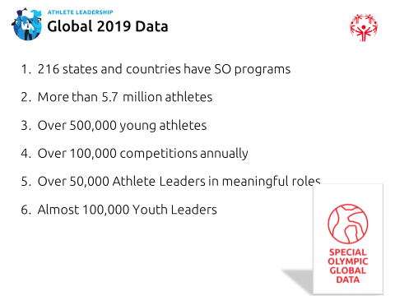
5 min | Facilitator 2 | Your Program data | Use this slide to insert facts and information that are specific to your Program. | 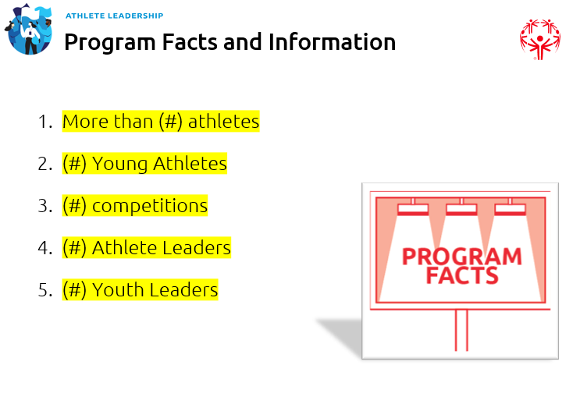
1 min | Facilitator 1 | Lesson 2: Principles of Athlete Leadership | Share overview of what Lesson 2 will cover | 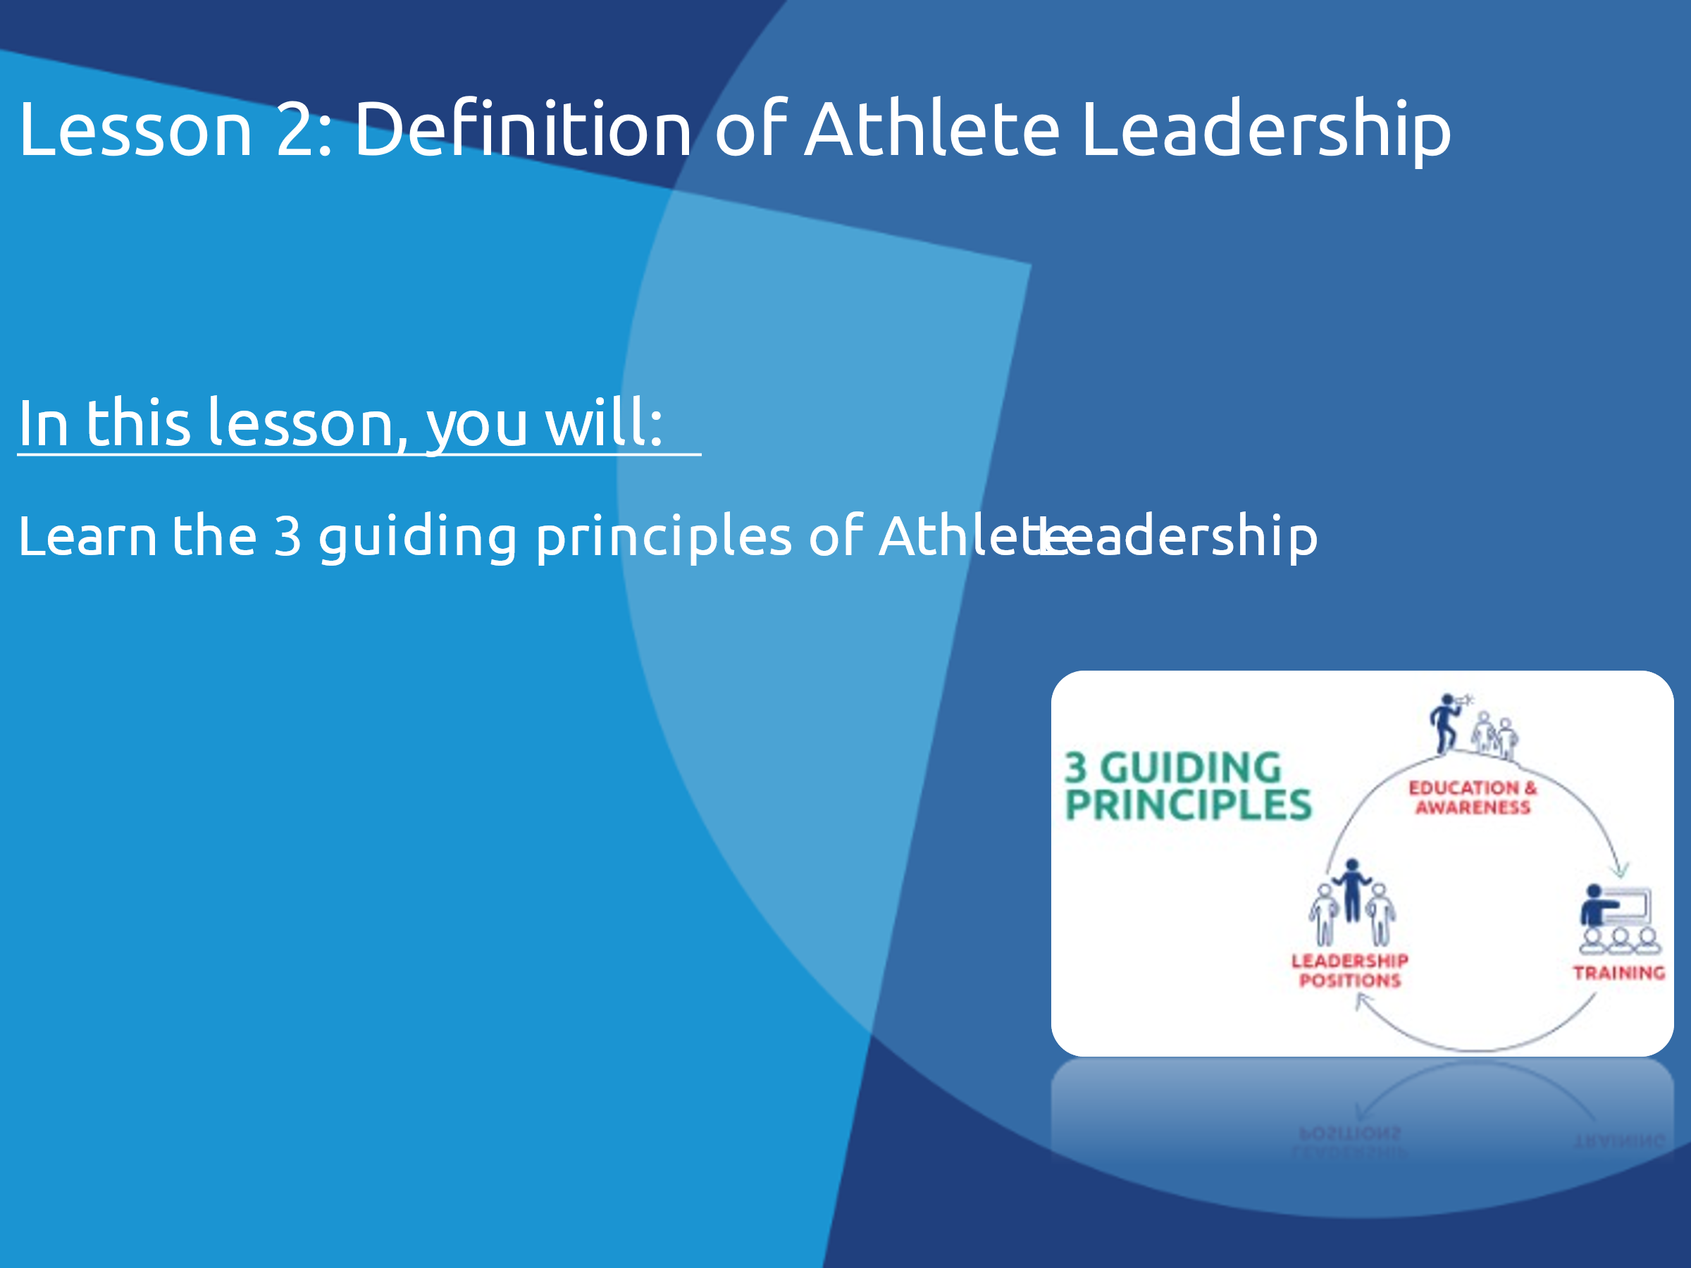
9 min | Facilitator 1 | State 3 Guiding Principles | The three principles work together.  It starts with “Education and Awareness building.” It is important to educate Program leaders and community leaders without ID about the abilities of people with ID. One way we do this is through the Unified Leadership approach. We will learn more about that in a minute.  The second principle is “Training for Athletes.” We are empowering you and other athletes to identify your area of interest and take training courses to prepare you for the roles. We want you to have a choice in how and where you lead in Special Olympics.  The third principle is athletes serving in “Meaningful Positions of Influence and Leadership” throughout the organization and community.  Ask if they know what we mean by the word “meaningful.” Explain that a role cannot be a token role if it is meaningful. Also explain that a meaningful role needs to be meaningful to both the athlete AND the organization. Ask them if they can remember a time where they were used as a token and ask them how that felt.  When more people with intellectual disabilities, including you and your fellow athlete leaders, are in meaningful leadership roles it will raise awareness and educate others about the abilities of athletes and how you can and should contribute to the organization and develop inclusive communities. | 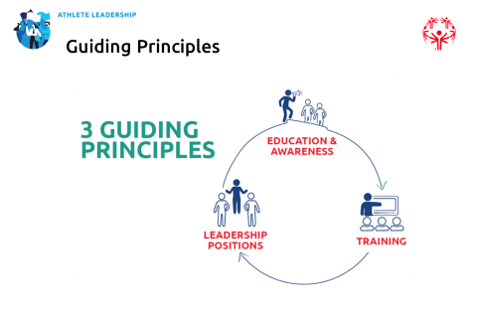
5 min | Facilitator 1 | Unified Leadership | Let’s watch a short video that describes Unified Leadership.  Play the video  Building from sport, Unified Leadership teaches leaders without disabilities to value and learn from people with ID, and to make changes and create environments where people with ID get opportunities to have meaningful jobs and roles.  Unified Leadership is not replacing Athlete Leadership. Just like Athlete Leadership – through classes like this one -- trains you to become a better leader; Unified Leadership trains people without intellectual disabilities to become better leaders as well. We teach them to recognize their biases and help you and your friends become leaders within the movement and in your communities. | 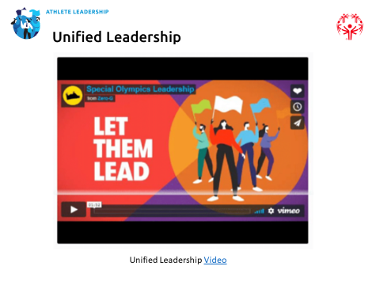
10 min | Facilitator 1 | Leadership & Skills Training | To be a program that helps develop athletes into leaders, Special Olympics needed to offer leadership courses. The new Leadership & Skills curriculum currently includes 7 courses on leadership generally. There are also other courses that can be offered to enhance leadership training and are more specific to certain roles within the organization.  Today you are taking one of the core courses titled “Introduction to Athlete Leadership.”  The next course you will take is “Understanding Leadership.”  The five remaining leadership courses (considered our “Advanced Modules”) provide advanced training in leadership skills.  We are focusing on virtual deliver now but will soon introduce in-person and e-learning courses.  In addition to the core leadership courses, we will provide training for 5 types of Special Olympics roles. We have a section for them on the PowerPoint in blue, but before we reveal them to you, let’s see if you can guess them first.  We will show a photo of an athlete leader in that role. Please shout out or add to the chat what role you think they have.  The pictures will come up one at a time. Give everyone a chance to guess before moving to the next picture.  - 1st is Athlete Representative  - 2nd is Event Coordinator  - 3rd is Global Messenger  - 4th is Health Messenger  - 5th is Sport Leader | 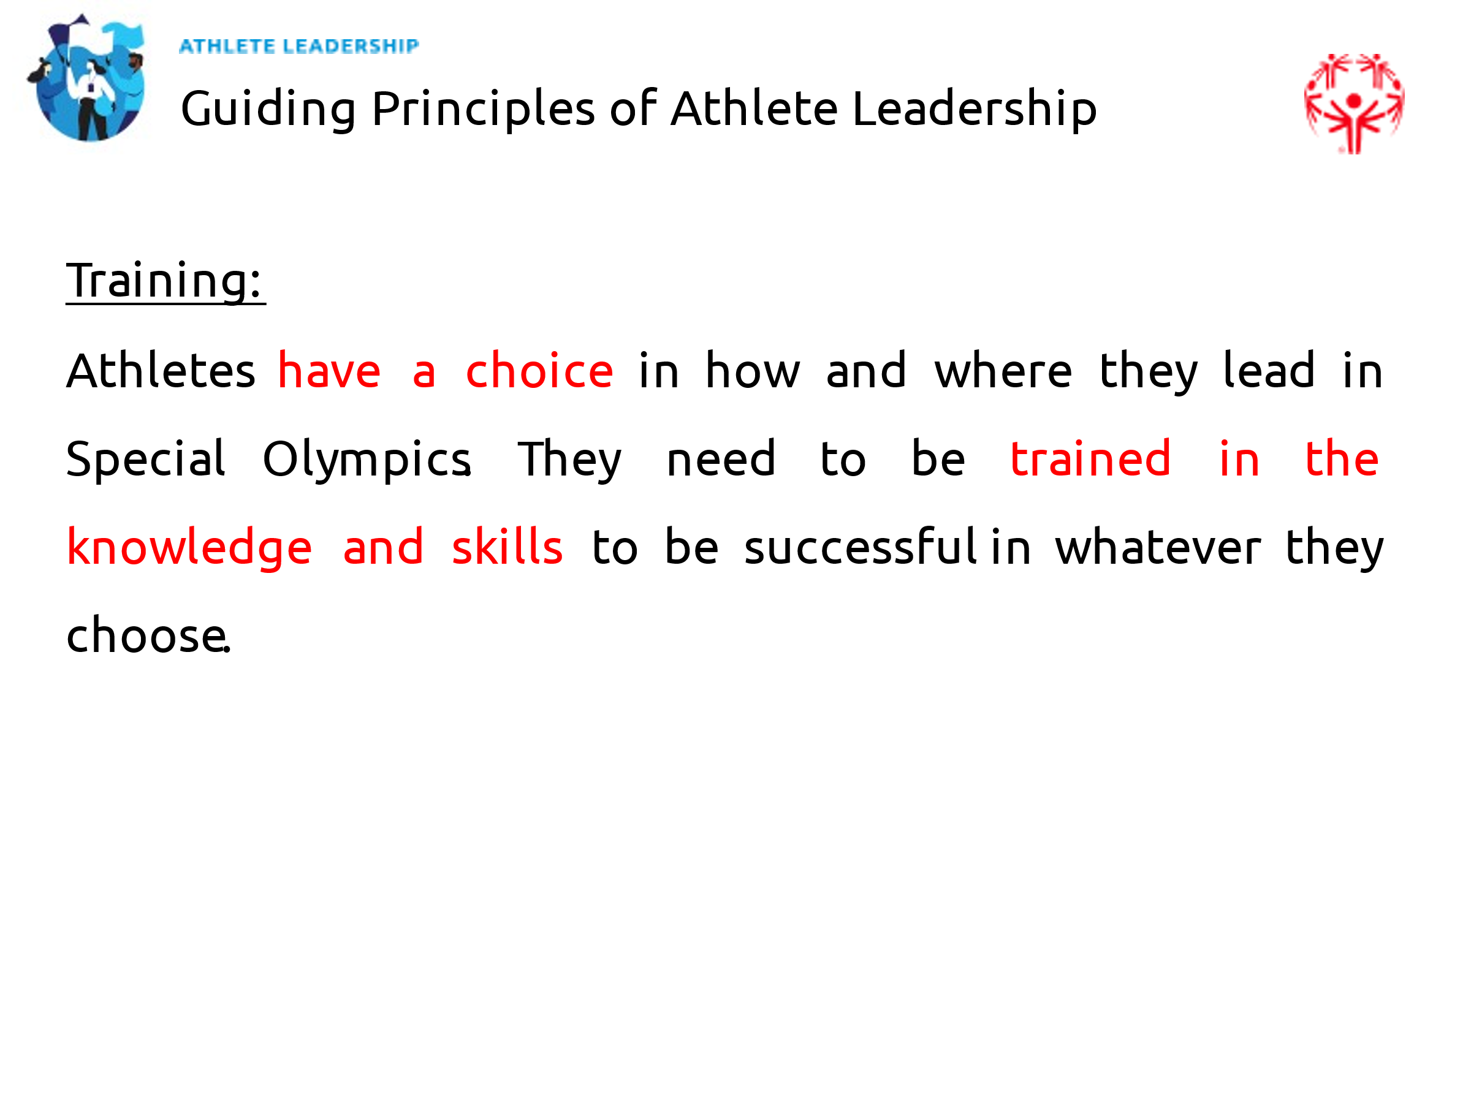  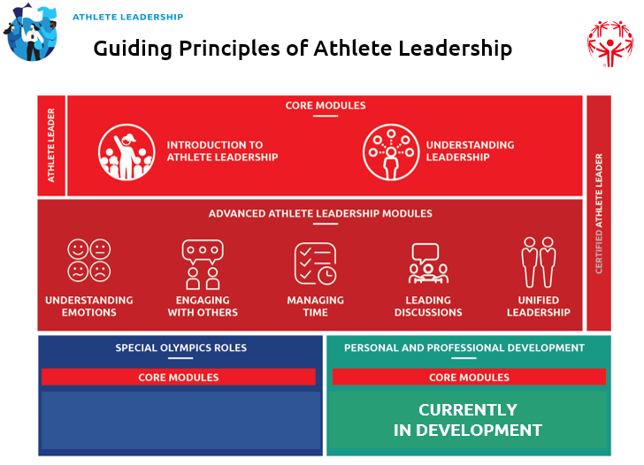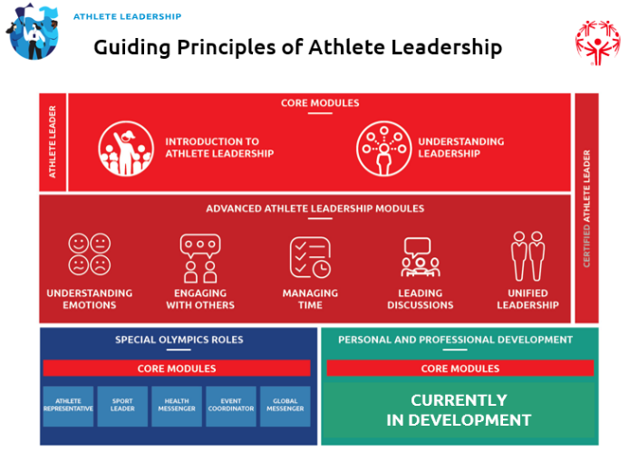
2 min |  | Meaningful roles and | The third principle is encouraging athletes to have meaningful leadership roles. This includes following your ideas. It talks about how the organization should be supporting you in these roles. It also means the organization needs to be creating opportunities for athletes to lead and be held accountable if they are not doing that.  Ask them again to explain what they think “meaningful” means and how to spot when a role or responsibility is not meaningful. It is very important that they understand this concept. | 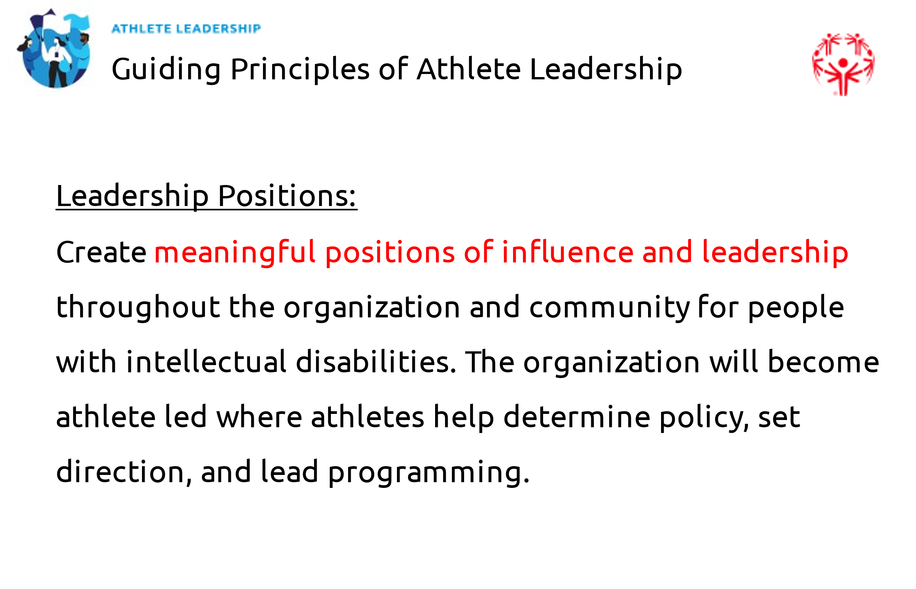
3 min | Facilitator 1 | Organizational shift | Special Olympics is going through an organizational shift from a service provider by working for people with ID to becoming an organization that works with and eventually be led by people with ID.  If you have any examples of how this shift has taken place in your organization, now is a good time to share them. Do you have any athlete leaders who have led the organization in some idea or project? It is okay if you do not have one now, but as you see them happening, collect those stories so you can share in future trainings. | 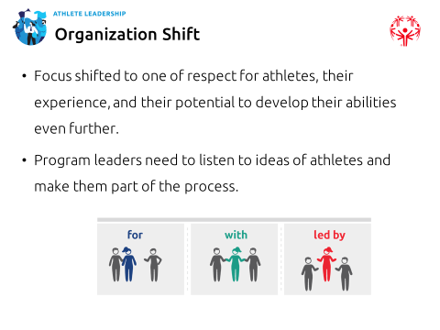
15 min | Facilitator 1 | Principles in Practice | Depending on if you are in-person or virtual, you will need to adapt this exercise to fit your needs.  Break up your group into three smaller, equal groups.  The goal as a team is to – using everything we just learned – be able to creatively explain what each principle of Athlete Leadership (Education & Awareness, Training, Leadership Positions) should look like when it is successful.  You can do this by drawing something as a group, performing a skit, singing a song, etc. Be creative!  Have an example of your own to share for each principle so they understand what to do.  The first group is assigned Education & Awareness, the second group has Training and the third group has Leadership Positions.  Be prepared to share your finished product with the rest of the class.  - Depending on the time you could give them 10-15 minutes to work on this.  - Bring everyone back from their groups and have them share what they came up with  Welcome back. I am looking forward to hearing what everyone came up with.  Groups share  Great job, everyone! Thanks for participating. | 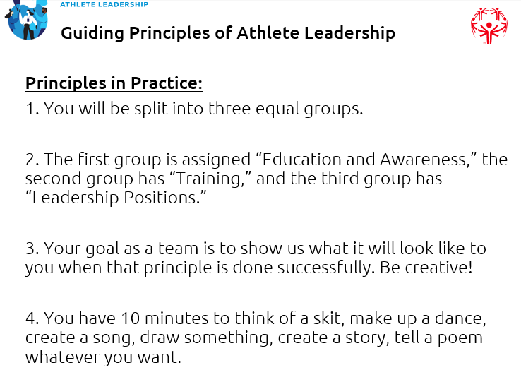
5 min | Facilitator 2 | Lesson 3 overview | Wow, great job everyone! That was a lot of fun. Thank you for your hard work so far.  We are now at the final lesson of the training.  This is where you should think more about what you are interested in and where you would like to contribute.  You will think about your strengths and opportunities to get better.  You will write a personal mission statement and develop a short action plan. This action plan will help you achieve your goals of becoming an athlete leader.  OPTIONAL: Whether in-person (raise hands) or virtual (Zoom poll), ask them to take a poll on what Special Olympics role they are most interested in.  Let’s start with another poll. Which of the 5 Special Olympics roles are you interested in:  Athlete Representative  Global Messenger  Health Messenger  Sport Leader  Event Coordinator  After the results come in, share which type of role is most popular with this group.  There are many other roles within Special Olympics that athlete leaders can take on, but these are the main ones that we have courses developed for (or will soon) at the moment. | 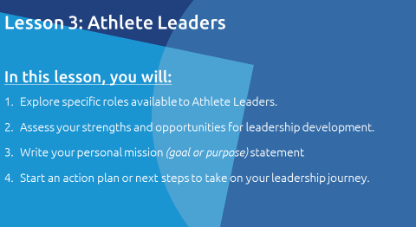
5 min | Facilitator 1 | Program roles | Talk about the roles and responsibilities that athlete leaders in your own Program can take on. Give examples of roles that athlete leaders have filled in the past and share some of their success stories here.  Ask the athlete leaders what roles they would like to take on within the Program even if they aren’t listed here. Their answers may surprise you! | 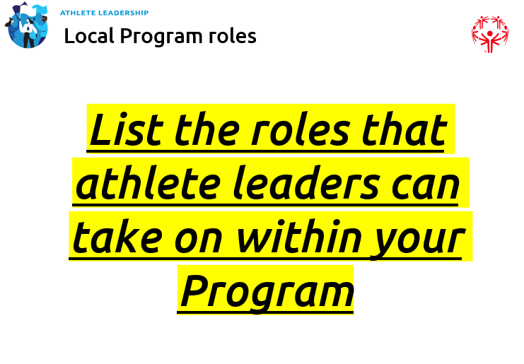
10 min | Facilitator 2 | Personal strengths and opportunities to grow | Now think about your personal strengths and areas where you want to improve.  Take a few minutes now to reflect. You will do this on your own or working with your mentor.  Here are the questions:  What am I good at?  What is most important to me and why?  How can I contribute to Special Olympics? Why is that important to me?  What is something I want to get better at and how can I do that?  I will give you 5-10 minutes to complete this.  Everyone should work on this with their mentor away from others/distractions.  Time’s up! Now we are going to spend some time writing your personal mission statement. | 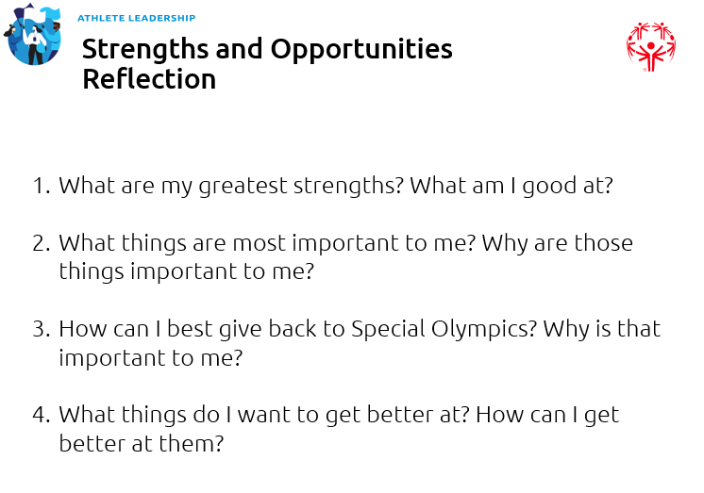
10 min | Facilitator 2 | Personal Mission Statement | A personal mission statement is a guide. It asks you to answer questions about yourself. They are:  What do I want to do? / What type of leader do I want to be?  How will I do it?  Why do I want to do it?  It is important to have a personal mission statement so that you have something to aspire to. It is the same thing as having a goal or something you want to achieve in life.  You do this in sports, right? You set goals all the time in your athletics to be faster or stronger. You explain why that is important to you and how you are going to reach that goal. A mission statement helps you stay focused and outlines what you want to do and how you will do it.  For example, this is a personal mission statement:  I want to be a coach in track and field. I can do this through taking more leadership training. My goal is to lead and coach more athletes because I know how important a good coach is to an athlete’s success.  For your homework, before the next training, you need to come up with a personal mission statement. This will help guide you on the Athlete Leadership path. It will help you understand what courses you want to take in the future. | 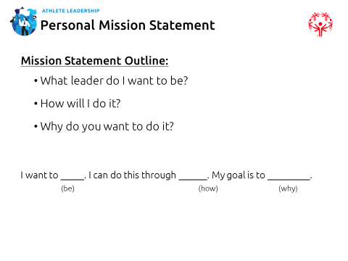
10 min | Facilitator 2 | Action Plan & Homework | We have come to the final part of the training. Having a mission statement is great, but that is only one piece of the puzzle. The second is coming up with a way to achieve the goal in your mission statement. The way we achieve goals is through creating action plans.  In addition to writing your personal mission statement for your homework, please answer these questions and create an action plan:  Who are the people that can help me?  What training do I need?  What challenges might I face?  What are the solutions to those challenges?  I hope you found today’s session useful. I am looking forward to seeing you at next week’s training session. | 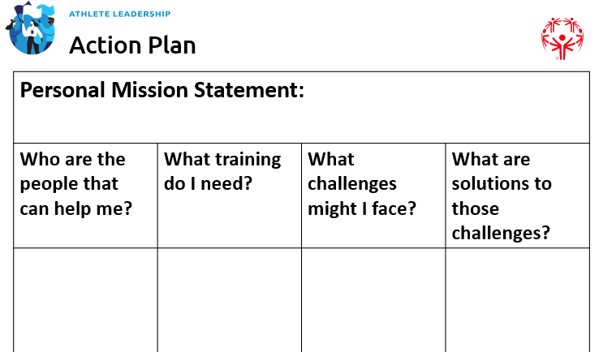
5 min | Facilitator 1 & Facilitator 2 | Wrap up and questions | Ask the group if they have any questions.  Tell them we look forward to hearing your mission statements at the beginning of the “Understanding Leadership” class next week.  Include date for next training

