Independent Activities
Introduction to Athlete Leadership
Note: If you see a word you do not know and it has a ^ next to it, you can look at the glossary on the final page of this document. You can also use a dictionary (www.m-w.com).
Athletes: You can use this training on your own or with personal support. Print out and fill in answers to the questions or type your answers into the Word document. Go through these trainings at your own speed.
In this course, you will:
- Review the Special Olympics mission statement
- Learn why Special Olympics is unique^
- Learn important facts about Special Olympics
- Learn the goals of Athlete Leadership
- Discuss Unified^ Leadership
- Discuss the different roles Athlete Leaders can have in Special Olympics
- Explore your own skills and interests
- Write a personal mission statement

Topic | Description
Lesson 1: What is Special Olympics?  - The Special Olympics Mission Statement  - What makes Special Olympics unique?  - Why is Special Olympics important to you? | Learn the mission statement. Learn what makes Special Olympics unique and test how much you know about global and local participation numbers.
Lesson 2: Definition of Athlete Leadership  - Three guiding principles of Athlete Leadership  - What is Unified^ Leadership?  - Learn how Special Olympics is adapting | Learn the three important areas of Athlete Leadership: education, leadership and skills training, and creating leadership opportunities. Discuss the changes in the organization as we move toward full inclusion.
Lesson 3: Athlete Leaders  - What roles are there for athlete leaders?  - Learn your own strengths and weaknesses  - Write a personal mission statement | There are leadership roles in Sport, Health, Events, Communications, and as an Athlete Representative. You will think about their strengths and weaknesses. You will write your own personal mission statement.

Updated: June 2021
Introduction to Athlete Leadership: Lesson 1
What is Special Olympics?
The Special Olympics Mission Statement is…
To provide year-round^ sports training and athletic^ competition in a variety of Olympic-type^ sports for children and adults with intellectual disabilities, giving them continuing^ opportunities to develop^ physical fitness, demonstrate^ courage, experience joy and participate^ in the sharing of gifts, skills and friendship with their families, other Special Olympics athletes and the community.

What makes Special Olympics Unique ^
- Special Olympics provides a variety of sports opportunities for all ability levels.
- For competitions, Special Olympics groups athletes by ability through a process called divisioning. This is done to ensure as fair of a competition as possible by putting athletes who are the same age, gender, and/or ability level in the same division competing against one another.
- Awards are provided^ to all participants who compete – only 1st-3rd receive medals, others receive ribbons
- Special Olympics does not charge a fee to athletes or their families to train or compete at the local level.

Reflection Worksheet
Note: Do not feel like you need to complete all these questions at the same time. Take your time! If you need more space to answer your questions, use a separate sheet of paper or another Word document.

- After reviewing^ the mission statement, which parts stand out to you most? There is no right or wrong answer; it is what YOU think is important. Why are those points important to you?

- How is Special Olympics unique^ to you?

- Knowing what makes Special Olympics unique^ (your answers from No. 2 above), how do you think you can help Special Olympics as an athlete leader?

- What have you gained from participating in Special Olympics?

- You have a chance to tell someone about the gifts and skills you and your fellow Special Olympics athletes have to offer the world. What would you tell them?

- Share the Special Olympics mission statement and the parts that stood out to you with a peer, mentor, or family member. Ask them what parts stand out to them and why they are important to them. What favorite parts do you have in common? What parts are different than yours?

<< END OF LESSON 1 >>
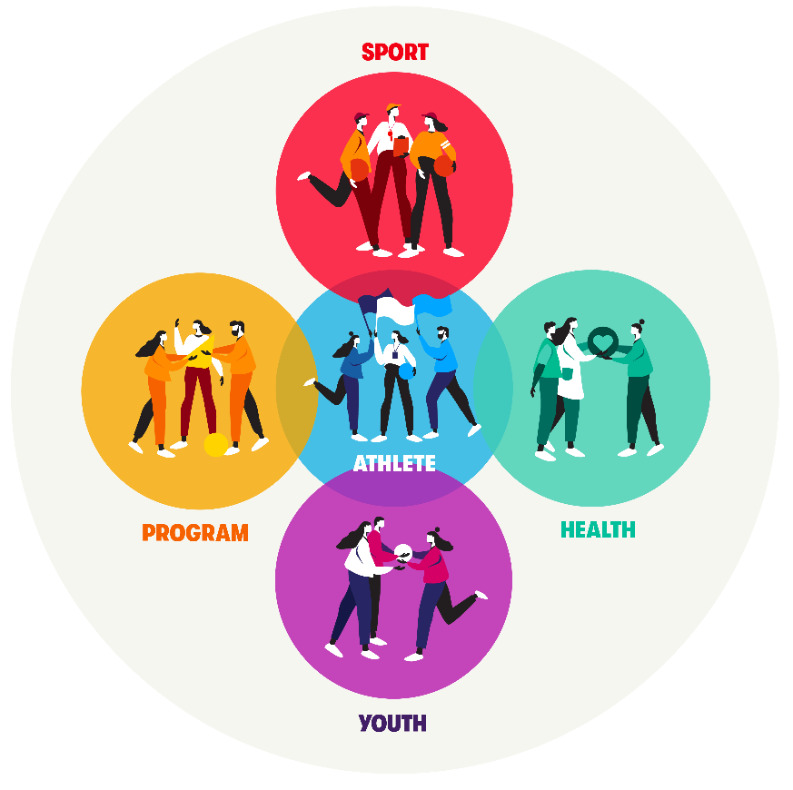
Introduction to Athlete Leadership: Lesson 2
What is Athlete Leadership?
Guiding Principles^ for Athlete Leadership

- Education and awareness building.
For athlete leaders to have chances to lead, we need to educate and raise awareness about their abilities for people without intellectual disabilities. One way to do this is through the Unified Leadership approach^.
  - Athlete Leadership is about people with intellectual disabilities gaining new skills through education/training and taking on new responsibilities^.
  - Official Unified^ Leadership definition: Building from sport, Unified Leadership teaches leaders without disabilities to value and learn from people with ID, and to make changes and create environments where people with ID get opportunities to have meaningful jobs and roles.
Unified Leadership approach¹
    - Unified Leadership teaches leaders without intellectual disabilities about inclusive leadership (people from all backgrounds coming together to lead). The goal is for these leaders to think about their own behaviors and create inclusive environments^ where people with intellectual disabilities can succeed^ in meaningful roles and jobs.

- Athletes have a choice in how and where they lead in Special Olympics. They need to be trained in the knowledge^ and skills to be successful. Learning what leadership is and how each athlete can become better is very important. Learning new skills sets the athlete up for success in Special Olympics leadership roles, and it also gives them a chance to take on new roles that will benefit Special Olympics and their communities as well. There are a variety of courses that athletes can take to learn and grow as leaders. A list of all available classes is on the website.
- Creating meaningful positions of influence and leadership throughout the organization^ for people with intellectual disabilities is an important goal of Athlete Leadership. There is incredible value added when athletes help determine^ policy^, set direction^, and lead programming.
  - Looking at the graphic below, often people will start out by doing things FOR you because they do not think you can do them yourself or they think they are helping you by doing everything for you.
  - Next, they may invite you to take part in the activity, but that’s not full inclusion quite yet.
  - Ultimately^, we want everyone to think about the potential for YOU to be leading the activity or planning of the event. YOU have the experience and knowledge and training from your participation in sports and leadership development to lead within Special Olympics!
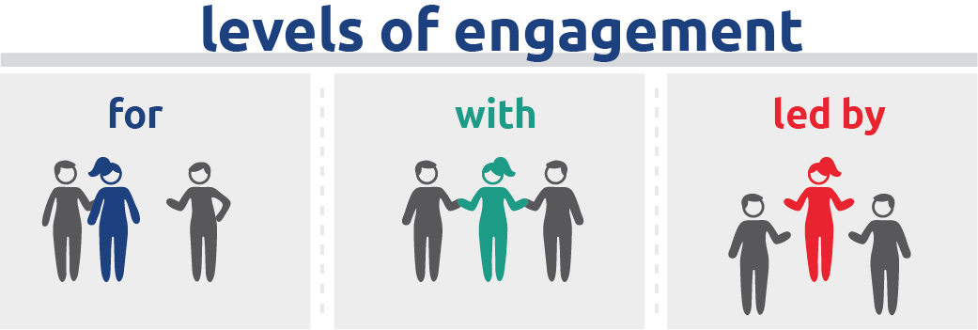

A dance being organized and LED BY people with intellectual disabilities.
Being invited to a dance to take part WITH others.
A dance being organized FOR people with intellectual disabilities.

Reflection Worksheet
Note: Do not feel like you need to complete all these questions at the same time. Take your time! If you need more space to answer your questions, use a separate sheet of paper or another Word document.

- Why is the Unified^ Leadership approach important to make sure you and other athletes have the chance to lead?

- What does Athlete Leadership mean to you?

- Why is it important for you to take courses to become a leader? What courses are you most excited about?

- Talk to a family member, mentor, or Special Olympics staff member and ask them what “leadership” means to them and write down their answers. Write down what “leadership” means to you.

- What similarities^ do your answer and their answer have?

- What differences do your answer and their answer have?

- Since you woke up today, what are some choices you made already?

- What choices have you made in your time as a Special Olympics athlete?

- You have a choice in how you want to lead in Special Olympics. What choices do you have to make when it comes to becoming an athlete leader?

- Take a moment to think about a time when you were going to do something yourself and someone else stepped in and did it for you instead of letting you try it for yourself first. How did that make you feel? What could have been different?

- Take a moment to think about a time when you participated in a leadership role but were treated differently than others. How did that make you feel? What could have been different?

- Did you tell them how it made you feel? Why or why not? If you did tell them, how did they react? If you did not tell them, what would you have said to them if you had the chance?

- Think about a time when you were involved in a group and had the same amount of decision-making^ power as others. How did it feel? How can you make sure other athletes feel that feeling when giving their opinions?

- Share the Unified^ Leadership approach^ with a peer^, mentor, or family member. Do they have any ways they model Unified Leadership in their community or Program?

<< END OF LESSON 2 >>
Introduction to Athlete Leadership: Lesson 3
Write your own mission statement
Personal Mission Statement
Most leaders have a mission statement that provides a vision^ to guide^ them. Having a mission statement helps you set goals^ and make decisions. It helps you decide^ how best to make an impact.

A mission statement is specific^. It would NOT be something generic^ like, “I want to be an athlete leader.” Instead, a mission statement should be something specific^ such as, “I want to be a softball official for Special Olympics. I used to play softball and I believe that having an athlete’s perspective^ as an official is important.” It provides you with direction for your leadership path. It helps you understand what you want to do, how you want to do it, and why you want to do it. It should answer those three questions: What do I want to do, why do I want to do it, and how will I do it?

Reflection Questions
- Look back at your reflections/answers from the previous lessons (lessons 1 and 2 above) and think about how you want to help Special Olympics. Is there a problem you want to solve? Do you want to create a new program that helps athletes? Do you want to start and coach a new sport? Do you want to teach others about Athlete Leadership? These are just examples of ways you could want to help Special Olympics. This should be your idea, not someone else’s.

- If you are having trouble coming up with an idea, answer the reflection questions below, then use the My Ideas section and the Mission Statement Template^ below to create your mission statement.

- Share your ideas with a peer, mentor, or family member and get their feedback. Ask them if they have a personal mission statement of their own!
My Ideas
Note: Don’t feel like you need to complete all of these questions at the same time. Take your time! If you need more space to answer your questions, use a separate sheet of paper or another Word document.

- What am I good at/what are my strengths? What do I like doing?

- What am I not good at/what are my weaknesses? What could I be better at?

- What kind of leader do I want to be in Special Olympics?

- Why do I want to be a leader? Why is this important to me?

- How do I plan on reaching my goals^? What do I need to do next to become an athlete leader?

Mission Statement

I want to __________________________________________________.
What kind of leader do you want to be?
Because .
Why is becoming that kind of leader important to you?
I can do this through .
How will you become that kind of leader?

- You now have a mission statement! Now answer the following questions: What are my next steps to help me reach my goals^? What classes do I need to take next?

- Who can help me reach my goals^? What steps will I take to reach my goals^?

- When will I reach my goals^? How will I know when I have reached my goals^?

<< END OF LESSON 3 >>
Glossary/Dictionary
It is okay if you do not know what a word means. This glossary (also known as a short dictionary) is supposed to help you learn new words and how to use them. Some of these words have more than one meaning. The definitions below relate to how the words are used in this document only. If there are other words in this lesson that you do not understand, try looking them up online at www.m-w.com.
Lesson 1:
- Athletic: relating to athletes or sports
- Continuing: ongoing; constant; something that is always there
- Demonstrate: to show clearly; to prove
- Develop: create; work on; to make clear
- Olympic-type: like something you’d see in the Olympics
- Participate: take part in; join
- Provided: given to you
- Reflect: to think about; to consider
- Reviewing: look over; think about
- Unique: different from most; special
- Unified: Together; with someone else or another group of people
- Year-round: something that happens every season of the year
----------------------------
Lesson 2:
- Approach: way of looking at something; lesson; teachings
- Decision-making: ability to choose
- Developing: create; work on; to make clear
- Determine: decide; set
- Direction: where you want to go as an organization
- Engagement: being involved/included
- Environment: a space
- Knowledge: what you gain after learning something new
- Meaningful: something that has meaning or importance
- Organization: a group or business or non-profit like Special Olympics
- Peer: someone who is at the same level of you either personally or in a job; teammate
- Policy: rules; regulations of an organization
- Principles: key point or part
- Responsibilities: things that you are accountable for; things you must do
- Similarities: things in common; things that are the same
- Solutions: answers to a problem
- Succeed: to accomplish a set of goals; win
- Ultimately: in the end
-----------------------
Lesson 3:
- Decide: make a choice
- Goals (setting): people set goals when they want to accomplish something; you “set goals” as an athlete to win a race or run/swim a few seconds faster than your last race and would do something similar when wanting to become a leader
- Generic: without a plan; missing key details; opposite of Specific
- Guides: helps direct someone in a direction
- Perspective: way of looking at something
- Specific: focused; obvious; clear
- Template: an example; a form of doing things in a way that helps guide you
- Vision: way of looking at something; clear understanding
Please complete the Training Evaluation Form:
You can also access the evaluation form by typing this link into your browser (it is case-sensitive!): https://bit.ly/2SrjVNG or by taking a picture of the QR code with your phone.

