Facilitation Skills Training
Team Planning Instructions
Participant Resources
Special Olympics Facilitation Skills Training
Participant Resource
SESSION NORMS:
Agreements to create a safe space for everyone to learn from each other, have fun, and accomplish the learning goals

Facilitation is a way of helping people share thoughts and ideas

Characteristics of an effective facilitator
Think of facilitators you’ve seen:
- What makes them good?
- What are they thinking when they are facilitating?
- What are they saying? What are they feeling? What are they doing?
Facilitator as coach
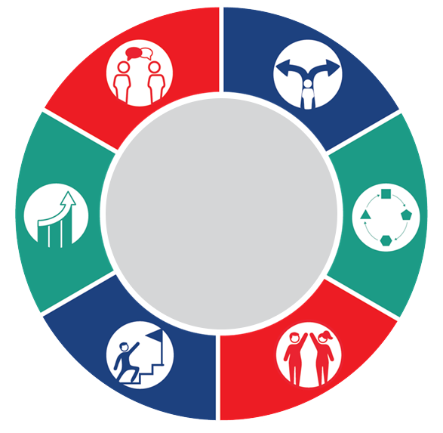
COMMUNICATION DECISION MAKING ADAPTABILITY RELATIONSHIP BUILDING GOAL ORIENTED CONTINUOUS IMPROVEMENT
BASIC LEADERSHIP SKILLS
 |  |  |  | NOTES:
 | ADAPTABILITY  Responding to learning needs in the moment. |  | CONTINUOUS IMPROVEMENT  Constantly supporting participants to be their best.
 | GOAL ORIENTED  Knowing the goal of the training. |  | RELATIONSHIP BUILDING  Helping the participants to work together by building understanding with others in the training.
 | DECISION-MAKING  Knowing when to ask someone a question, when to give people silence, and when to start, discuss, and complete the training. |  | COMMUNICATION  Sharing information on what the training requires, what the participant group needs, what an individual participant needs.

Key facilitation skills
 |  |  |  | 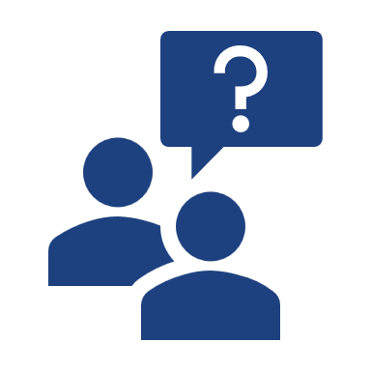
Listen by: |  | Engage by: |  | Connect by:
Asking questions |  | Encouraging |  | Summarizing

Types of Questions
Open-ended:
Questions that begin with ‘What’, “How” and sometimes ‘Why’. They are to clarify and gain elaboration to open up a conversation.
Closed-Ended:
Questions that elicit short answer responses (i.e. yes/no or one word) to narrow/close down a conversation
Leading:
Questions that prompt or encourage the answer the facilitator wants participants to give
Encouraging
Through words:
Uh huh, Say more about that, That’s great, anybody have anything to add?, Good!, Thank you, etc.
Through our gestures and body language:
Nodding one’s head, maintaining eye contact, open body position
Paying attention:
Picking up on the last word or two of someone else’s sentence to build your response on, making sure you are not distracted doing other things.
Summarizing
Summarizing is pulling important ideas together for further discussion and to check for understanding. Summarizing:
- Encourages participants to think more about what they or others say
- Ensures that everyone in the discussion is clear about what has happened in the just completed portion of the discussion
We often start off summarizing with phrases like:
From our work this morning, I see that..
Let me try to summarize…
I think what we are saying is that we want to...
NOTE: We have an additional skill of Paraphrasing that we have not discussed in the training, but it is here as an additional resource.

Paraphrasing is using your own words to reflect what the speaker is saying and feeling in a concise way.

- Seek to Understand:
Show that you are paying attention and that what the speaker says is important
- Clarify Ideas:
Give the speaker the chance to correct you if what you understood is not quite correct.
We often start off paraphrasing with words like:
You are saying...
In other words...
I gather that...
If I understood what you are saying...
Key facilitation skills practice
Please make note of how you would respond to:
“Tell me about your experience in the Special Olympics”.

Deciding how to handle questions
When a facilitator is asked a question, they either know the answer or they do not.

If they DON'T know the answer, they should…
Actively listen to gain understanding by paraphrasing and encouraging as needed.
Make a choice:
RETURN:
Ask the asker what they think/what their experience tells them.
For example: “That’s a good question, what are your thoughts on that?”
RELAY:
Ask the group if they know the answer/what their experience tells them
For example: “Interesting, what do others think about that?”
PASS:
Don’t answer now, but maybe later with the person who asked or in another meeting.
For example: “Thanks for offering that question, unfortunately we don’t have time to answer it now, could you and I discuss it more during the break?”
If they DO know the answer, they should…
Actively listen to gain understanding by paraphrasing and encouraging as needed.
Make a choice:
ANSWER
As direct and concise as possible
RETURN or RELAY:
Decide it is better for others to contribute
PASS:
Decide there is not enough time in the meeting/training to answer
Action planning
Today we covered:
- Characteristics of a good facilitator
- Definition of facilitation and the facilitator role
- Key facilitation skills (asking questions, paraphrasing and encouraging)
- Different ways to answer questions (Return, Relay, Pass)
Continuing the learning journey
- What are your facilitation goals going forward? (What do you want to improve?)

- How will you practice being a facilitator? (reference facilitation opportunities)

