Instructions
Event Leader
Participant Workbook
- When you participate in an Event Leader training you will use this workbook, you could do one of the following:
  - Print out and complete it by hand.
  - Complete on your computer and save.
- It can also be helpful if you go through it before the training session so you can get familiar with the information beforehand.

Lesson 1:
Special Olympics Events

Lesson 1:
Special Olympics Events
If you are interested in leading Special Olympics events, it’s important to learn about the types of events Special Olympics hosts all over the world.

Special Olympics hosts many types of events.
- Sport events such as competitions
- Health events such as Healthy Athletes’ screenings
- Leadership events like an Athlete Congress or Youth Summit
There are other types of events like marketing and fundraising but for the purposes of this training we will focus on these three areas that are implemented in most of Special Olympics Programs around the world.
Athletes should have a role leading all these types of events.
SPORTS EVENTS
First, let’s have a closer look at our Sport events:
Special Olympics offers 30-plus Olympic-style individual and team sports and each of them provide meaningful training and competition opportunities for persons with intellectual disabilities.
Special Olympics World Games are held every two years, alternating with Summer and Winter Games.

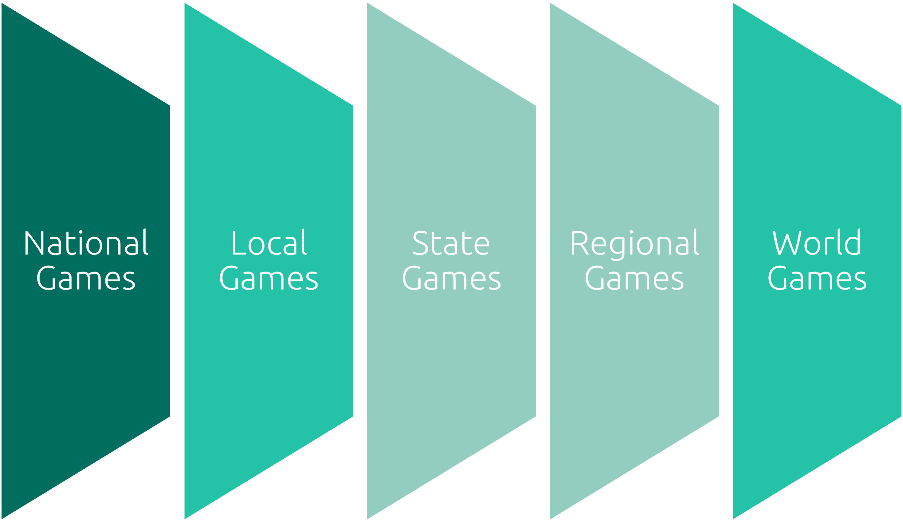
In addition to the World Games, Special Olympics holds competitions at the local, state/province, country, region and world level every year.
HEALTH EVENTS
Other events we offer are in the world of health. Special Olympics work in health has grown worldwide over the past couple of decades.
People with ID most often face more significant challenges in accessing quality health care and obtaining opportunities that promote fitness and wellness, which usually results in health disparities.
A health disparity is the difference between the quality of care you receive as someone with an IDD compared to someone who does not have an IDD. That’s not fair, right? Everyone should have the same access to the same healthcare.
Here are some examples of events you can participate. The role you can have in these events will depend on the programming and needs of your Special Olympics Program.

Healthy Athletes®
In 1997, Special Olympics Healthy Athletes® began offering free health screenings and education to Special Olympics athletes in a welcoming, fun environment.
We offer health screenings in eight disciplines:
- MedFest (history and physical exam)
- Special Olympics Lions Clubs International Opening Eyes (eyes)
- Healthy Hearing (ears)
- Special Smiles (teeth)
- Health Promotion (prevention of diseases and nutrition)
- Strong Minds (emotional health)
- FUNfitness (physical therapy)
- Fit Feet (feet)
Fitness
Physical fitness is a key part of the Special Olympics mission. Fitness is being in good physical shape. For you to be fit, you must practice healthy habits year-round and lifelong.
There are other events related to health such as:
Young Athletes: is an early childhood play program for children with and without intellectual disabilities, ages 2 to 7 years old. Young Athletes introduces basic sport skills, like running, kicking and throwing.
Developmental Sports: provides an age-appropriate introduction to sports for children with and without intellectual disabilities, ages 6 – 12 years old. Sport-specific, inclusive, and age-appropriate resources can be used to support a child’s transition to traditional Special Olympics participation, or as an introduction to Unified Sports.
Family Health Forums: provides a space for the families and caregivers of people with ID to engage with health professionals and community leaders.
LEADERSHIP EVENTS
Special Olympics is shaping a new understanding of leadership, inspired by our athletes, and unleashing leadership potential in people of all abilities.
Here are some examples of leadership events:
- Athlete Leadership events, such as Athlete Leadership Council Meeting, Athlete Forums, Training sessions (Leadership & Skills Curriculum).
- Unified Leadership trainings or engagement with other organizations.
- The Special Olympics Leadership Academy sessions.
- Youth Leadership Summits pairing young people with and without ID.

REFLECTIVE QUESTIONS
    - What is your favorite Special Olympics event and why?

    - What is your favorite part of every event?

    - Have you ever thought of volunteering or participating in the planning of a Special Olympics event? If you have, what would you like to do?

Lesson 2:
Event Planning

Lesson 2:
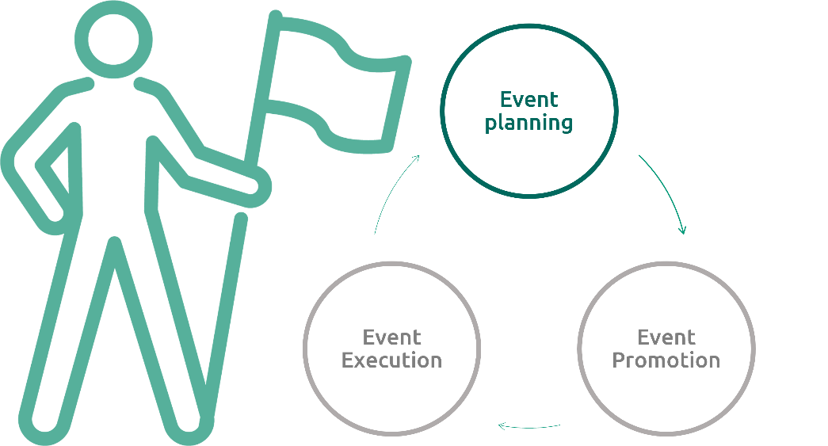
Event Planning

Planning is the process of thinking about the activities required to achieve a desired goal.
When you know that an event will take place, planning is the first and most important activity you need to do to achieve the results you want.
It involves the creation of the event, but helps you understand what steps you need to take for it to be successful.
Planning Skills
To be a good event planner you need to understand what you are trying to accomplish with the event. Here are five questions you can ask yourself (and others) to make sure you understand purpose of the event.

Who is participating in the event?
What is the event about?
When will it happen?
Where will it happen?
Why are we doing the event?
There are four skills that will help you as you plan for events:
Organization Skills
As a planner it’s important to have a process and method. This means:
- Following timelines
- Budgets
- Appointments
- Keeping important documents and information organized.
There are many tools you can use that will help you stay organized: to-do lists, checklist, daily planners, calendars, alarms, etc.
Communication Skills
Event planners need good communication skills and aren’t afraid to talk to different people like event attendees, donors, guests, and hosts.
Communication is very important so that everyone understands their role. It’s important to share information with confidence, respect, and clarity.
Problem Solving Skills
Event planners will face problems, its important they can solve them calmly. When faced with a challenge good event planners make decisions, they sometimes have back up plans and if not, they have people in their team that can support and help solve problems in a creative and effective way.
Creativity
As an event planner, you need to use your creativity and be flexible at times. When planning an event think about ways you can make things new and different.
For some creative ideas, seek inspiration from online blogs, social media platforms, or brainstorming with others.
Now that you know the training you need and general information and skills you will need as a planner, let’s look at what opportunities Special Olympics offers if you would like to begin your journey as a Special Olympics event planner.
Let’s look at some examples of leadership roles while planning a Special Olympics events.
Note:
Some of these opportunities may or may not be available in your Special Olympics Program, we encourage you reach out to them and let them know your interests and together you can identify opportunities for you and how to start your Event Leader journey.

Planning Leadership Roles
Sports Events
Role | Description
Opening & Closing Ceremonies Advisory Team | Serve as advisors to the production agency in creating the concept for the Opening and Closing Ceremonies  Help ensure that the Ceremonies show is athlete-focused, and features athletes in leadership roles
Experience Mapping Participants (Athletes) | As part of the initial event planning process, participate in Experience Mapping for the athlete experience, providing input on the optimal service delivery from arrival at the airport through departure, including accommodation, host town, and competition experiences.
Logo Development Team | Collaborate with designers to advise, provide art ideas and help create the narrative around the logo  Participate in the creation and/or selection of the logo for the event
Functional Area Committee Member | Participating in different planning committees. For example: transportation, meals, credentialing, etc.
Staff/Volunteer Orientation | Participate in regular orientation sessions for the events volunteers or staff.

Planning Leadership Roles
Health Events
Role | Description
Healthy Athletes Coordinator | Serving on a planning committee
Healthy Habits Leader | Leading health education
Planning Leadership Roles
Health Events
Role | Description
Site selection committee
General organizing committee | Meals.  Setting up agendas and communicating with the participants ahead of time.  Selecting content, designing the activities. Coordinating with guest speakers.  Identifying roles for athlete leaders in the promotion and execution of the events.
Participate in fundraising and sponsor meetings

REFLECTIVE QUESTIONS
- What planning skills do you have or already use?

- Which planning skills you feel you can improve? How?

- Rank your planning skills 1 through 4. #1 is the skill that you believe is your strongest and #4 is the one you need to improve most.
Skill | Ranking #
Organization
Communication
Problem Solving
Creativity

- How do you plan on improving your skills that you ranked 3 and 4?
- Ask your mentor, a family member, or a friend what they think your best skills are and write them down here.

- Ask your mentor, a family member, or a friend what skills they think you could improve on and write them down here.

- Do they have any suggestions on how you can improve those skills?

Lesson 3:
Event Promotion

Lesson 3:
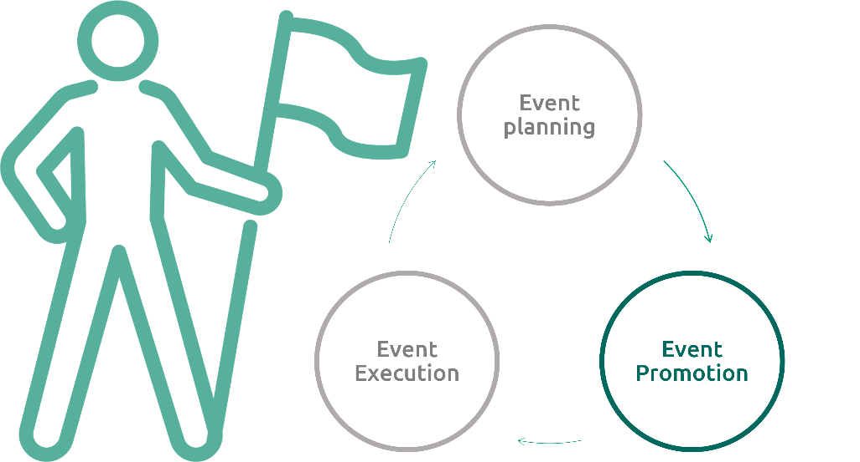
Event Promotion

Promoting means trying to advance something, to make others pay attention to a specific thing.
A well-promoted event increases public awareness of the organization, this is a reason why events are so important.
Promoting an event will help you:
- Have more people attending or paying attention to the event.
- You can create interest in others.
- Find new supporters or volunteers.
Achieving this is a critical part of a successful event.
Let’s look at some examples of leadership roles while planning a Special Olympics events.
Note:
Some of these opportunities may or may not be available in your Special Olympics Program, we encourage you reach out to them and let them know your interests and together you can identify opportunities for you and how to start your Event Leader journey.

Promotion Leadership Roles
Sports Events
Role | Description
Spokesperson / Global Messengers | Participate in speaking opportunities, panels, and interviews leading up to the event representing Special Olympics athletes
Sponsor Activation | Participate in meetings with potential event sponsors  Participate in sponsor activation events leading up to the event

Promotion Leadership Roles
Health Events
Role | Description
Spokesperson / Health Messengers | Participate in speaking opportunities, panels, and interviews leading up to the event representing Special Olympics athletes  Presenter during Inclusive Health Meeting

Promotion Leadership Roles
Health Events
Role
Recruiting more participants (athlete leaders).
Interview event participants and share it / Collect testimonials from participants (including athlete leaders that are participating).
Local TV/Press promotion for delegations attending the events.
Interview with press about the event.
Being an influencer on social media.

REFLECTIVE QUESTIONS
- Think about the event promotions you encounter on a weekly basis (concerts, plays, professional sporting events, etc.). What do those promotions do to grab your attention?

- Have you ever promoted something before? What all did you do?

- Imagine that you are on a committee for an event that wants to raise money to support your local Special Olympics Program. How would you promote this event?

- Imagine that you are a Health Messenger promoting a Healthy Athletes event to recruit athletes to get free health screenings. How would you promote this event?

Lesson 4:
Event Execution

Lesson 4:
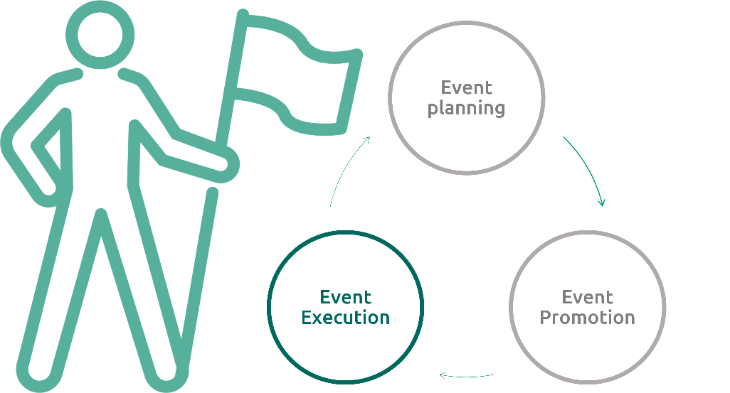
Event Execution

This part of being an event leader is called “event execution.” You are “executing” or “doing” the event or making sure that the event happens!
Working or volunteering during Special Olympics events can be very exciting and demanding.
Our events involve a lot of people and different pieces that add up to a great event.
Being able to work in teams and to communicate well are important skills to succeed in this role.
Let’s look at what opportunities Special Olympics offers if you would like to begin your journey in helping Special Olympics execute events.
Note:
You can do it as a volunteer or a paid staff member depending on the opportunities available in your Special Olympics Program.

Execution Leadership Roles
Sports Events
Role | Description
Spokesperson / Global Messengers | Participate in speaking roles at events and receptions and on panels.  Participate in Unified Sports Experiences  Give and conduct interviews during the events
Athlete Volunteers/Staff | Participate in volunteer or staff roles as part of the event Workforce.
Athlete Officials | Participate as sport technical officials during the event
Event Evaluation Team Members | Participate in the evaluation team, conducting evaluations of pre-determined functional areas, especially focused on the athlete experience  Prepare evaluation report post-event

Execution Leadership Roles
Health Events
Role | Description
Health & Fitness Leader | Leading a Fit 5 session.
Health Advocate | Attending Inclusive Health trainings.
Role Model | Demonstrating healthy behaviors at events
Coach/assistant coach | Leading or supporting Young Athletes or Developmental Sports activities

Execution Leadership Roles
Health Events
Role
Mentoring other athletes.
Facilitators/instructors.
Emcee/host.
Photography, social media posts, blogs.
Opening and Closing sessions.
Be part of the evaluation committee.
Be part of a judging panel.
Facilitate panel discussions

REFLECTIVE QUESTIONS
- Have you ever volunteered for an event before? What was that experience like? What did you learn?

- If you could volunteer at any Special Olympics event your Program puts on, what event would you like to help with?

- Why did you choose that event and what would you like to do at that event?

- What would you need to learn to be successful in that role at the event you chose?

Thanks for participating, you have now concluded the first part of the Event Leader training course.
Remember, there are many leadership roles you can have as an Event Leader
If you are interested in participating in Special Olympics events, we invite you to:
Look at the different leadership roles we shared. Once you have identified if you are interested in planning, promoting, or executing think about which leadership roles you found most exciting. What role do you think fits better with your skills?
Remember there is a second part to this training, to continue your training toward becoming an Event Leader, we encourage you to take the courses we mentioned earlier.
Most importantly, connect with your Special Olympics Program and let them know your interests and together you can identify opportunities for you and how to start your Event Leader journey.

Please complete the Training Evaluation Form:
https://specialolympics.qualtrics.com/jfe/form/SV_5cZHOzU0qemAkDP

