Event Leader
Facilitator Guide
Event Leader
Facilitator Guide
This facilitator guide provides an outline on how to host and lead the Event Leader training course using the PowerPoint presentation and the participant workbook.
If you are looking for resources to help prepare for and lead a training virtually, you can find them here. Alternatively, the worksheets, PowerPoint and this resource can be adapted for delivery via platforms like Zoom, WhatsApp, Facebook or for in person delivery.

Be sure to complete the following actions to prepare for each session:
- Identify athlete leader to co-facilitate.
- Identify how many participants you are expecting in the workshop/training.
- Review this facilitator guide and accompanying PowerPoint presentation.
- Adapt or change the material to suit their local context and needs.
- Review the worksheets and complete each activity yourself to be familiar with the activity and have examples to share. Additionally, think about what information you can add from your Program perspective.
- Think about who to invite as guest speakers. This could make the workshop/training more interesting.
- Host a practice session with all facilitators and cover every slide.
- Give feedback to each other.
- Host a second practice of entire presentation.
- Send out the worksheets and session instructions to the participant one or two weeks before the training. Invite athlete leaders to look through all the resources (with support from their mentor, if necessary) so they are familiar with the content.

Training Overview
The Event Leader training consists of two parts:
PART I
These lessons focus on Special Olympics events and what types of leadership roles are available. All aspiring event leaders with ID must complete these trainings.

PART II
This part is devoted to skill development and the courses will depend on the leadership role the event leader with ID wants to take on.

PART I | Topic | Description | Estimated time
 | Lesson 1:  Special Olympics Events | You will learn the types of events Special Olympics hosts all over the world. | 25 mins
 | Lesson 2:  Planning a Special Olympics Event | You will learn what types of leadership roles you can have planning an event | 40 mins
 | Lesson 3:  Promoting a Special Olympics Event | You will learn important information about how Special Olympics promotes its events | 30 mins
 | Lesson 4:  Volunteering at a Special Olympics Event | You will learn what volunteer roles you can have in Special Olympics events | 30 mins

PART II | Leadership Role | Courses | Estimated time
 | Event Planner | - Managing time  - Athlete Representative  Lesson 1  Preparing for meetings  Lesson 2  Meeting Behaviors  Lesson 5  Committees | - 2 hrs  - 2.5 hrs
 | Event Promoter | - Global Messenger  or  - Health Messenger | - 4.5 hrs  - 8 hrs
 | Event Volunteer | - Managing Time  - Engaging with others  - Unified Leadership | - 2 hrs  - 2 hrs  - 2 hrs

It’s important you review all the slides so you can identify which types of events and leadership roles are available in your Program. You may need to make changes so participants can have a clear picture of what opportunities are available for them in your Special Olympics Program.
It is recommended that lessons are facilitated in order and each session be no longer than 2 hours in length. The course can be divided into multiple sessions. In the end, these are just resources at your disposal. You will need to adapt them to fit your constraints as a Program (time, space, technology, etc.).

Prep | Description | Slide
Topic  Welcome and introductions  Time: 5 min  Lead: xx | - Welcome participants  - Introduce the facilitators  Hello everyone. Welcome participants  I would like to ask each person to unmute and introduce themselves, please.  Each person introduces themselves.  Please tell us your name and which Program you are from and something you learned from being part of Special Olympics. | 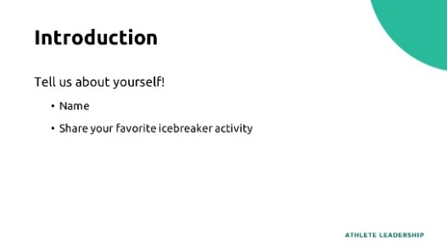
Topic  Event Leader Training  Time: 5 min  Lead: xx | Within Special Olympics, and especially within Athlete Leadership, we have adopted the motto “Nothing About Us Without Us.”  Who knows what this means?  That’s right! It means that every competition, fundraising event, decision, etc., should not be made without first asking people with ID what you think.  This program is for you; it should be by you as well.  What are some ways athletes represent Special Olympics?  Special Olympics hosts many types of events. To execute successful events, athletes must lead these events, not just participate in them. Some of these events are sport competitions at a local, national, and international level or could be part of Special Olympics programming around health, schools, and leadership, among others.  The purpose of the Event Leader training course is to:  Provide athletes the required knowledge that will allow them to take on leadership roles in the planning, promotion, and execution of Special Olympics events. | 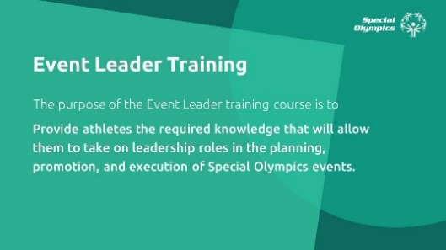
Topic  Event Leader Training  Time: 5 min  Lead: xx | The Event Leader training course is divided in two parts:  The first part provides details on:  - What are Special Olympics Events?  - Leadership roles you can have while:  - Planning a Special Olympics event  - Promoting a Special Olympics event  - Volunteering or working at a Special Olympics event  The second part focuses on skill development and will depend on the leadership role you want to take on. Depending on the role you choose, you need to focus on different skills trainings that are offered in the Leadership & Skills Curriculum.  Once this training is completed, invite athletes to think about how they want to engage in events, meaning:  - In what capacity? (plan, promote or execute)  - What type of event?  - In which leadership role?  Of course, this will depend on the opportunities your Program provides. | 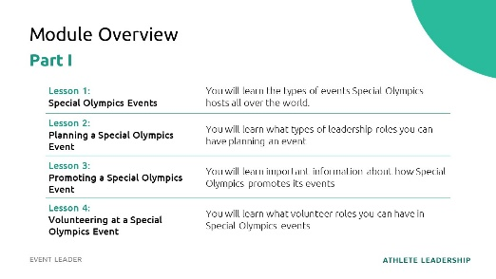  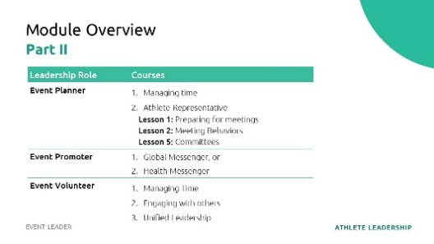
 | This training focuses on PART I:  First, we will talk about the different types of events Special Olympics offers.  Next, we will explain each of the three different ways athletes engage in events and share examples of leadership roles you can have while:  - Planning the event.  - Promoting the event  - Volunteering/Working at the event.  It’s important you review all the slides prior to the training so you can identify which types of events and leadership roles are available in your Program. You may need to make changes so athletes participating in the training have a clear picture of what opportunities are available for them in your Special Olympics Program. | 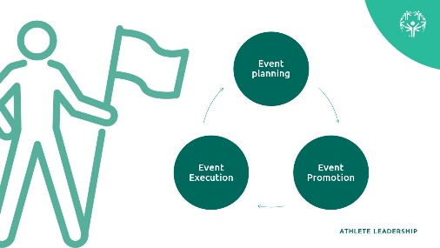  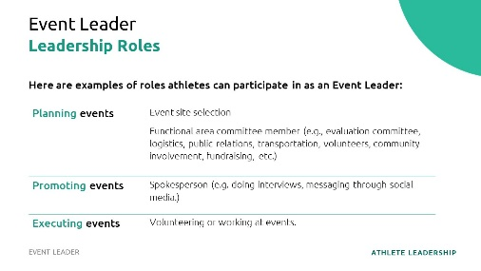
Topic  Lesson 1:  Special Olympics Events  Time: 2 min  Lead: xx | If you are interested in leading Special Olympics events, it’s important to learn about the types of events Special Olympics hosts all over the world. | 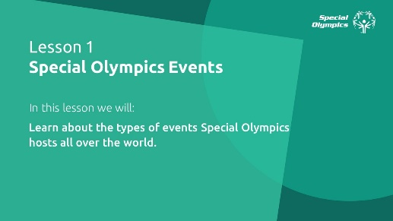
Topic  Lesson 1:  Special Olympics Events  Time: 3 min  Lead: xx | Special Olympics hosts many types of events. Sport events such as competitions. Health events such as Healthy Athletes’ screenings and leadership events like an Athlete Congress or Youth Summit.  There are other types of events like marketing and fundraising but for the purposes of this training we will focus on these three areas that are implemented in most of Special Olympics Programs around the world.  Athletes should have a role leading all these types of events. | 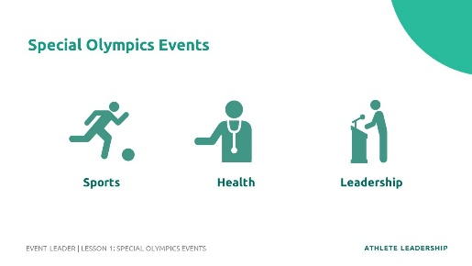
Topic  Lesson 1:  Special Olympics Events  Time: 7 min  Lead: xx | First, let’s have a closer look at our Sport events:  Who remembers how many sports Special Olympics offers around the world?  That’s right! Special Olympics offers 30-plus Olympic-style individual and team sports and each of them provide meaningful training and competition opportunities for persons with intellectual disabilities.  Special Olympics World Games are held every two years, alternating with Summer and Winter Games.  Does anyone know the next World Summer Games and where it will be located? What about the next World Winter Games?  In addition to the World Games, Special Olympics holds competitions at the local, state/province, country, region and world level every year.  How many sporting events do you think Special Olympics offers each year?  In all, more than 100,000 Special Olympics competitions are held every year.  A sport event is a sport competition, some have one sport, others have more than one.  Here is a great opportunity for you to talk about how YOUR Program’s sporting events are scheduled. When are they? What sports are included? How many athletes usually compete in each one?  Events can be very large with lots of participants and last several days or some are smaller and may last just a few hours. Regardless of that there are always opportunities to participate planning, promoting, or executing Special Olympics sport events. What will change is how many people need to be involved to ensure its success. | 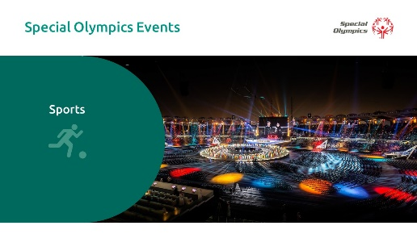  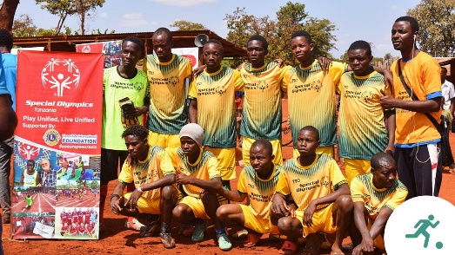  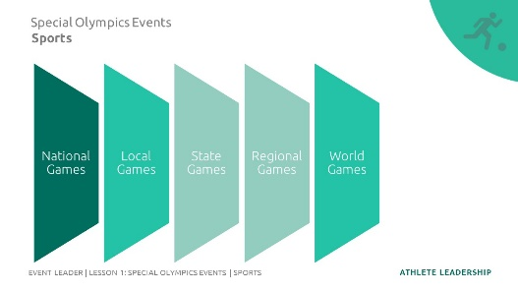
Topic  Lesson 1:  Special Olympics Events  Time: 5 min  Lead: xx | Other events we offer are in the world of health. Special Olympics work in health has grown worldwide over the past couple of decades.  People with ID most often face more significant challenges in accessing quality health care and obtaining opportunities that promote fitness and wellness, which usually results in health disparities.  Who knows what a health disparity is?  That’s right! A health disparity is the difference between the quality of care you receive as someone with an IDD compared to someone who does not have an IDD. That’s not fair, right? Everyone should have the same access to the same healthcare. That’s what Special Olympics is trying to solve through its Healthy Athletes program.  Special Olympics’ health programming focuses on improving the physical and social-emotional well-being of people with IDD by increasing inclusion in health care, wellness, and health systems for Special Olympics athletes.  Here are some examples of events you can participate. The role you can have in these events will depend on the programming and needs of your Special Olympics Program.  In 1997, Special Olympics Healthy Athletes® began offering free health screenings and education to Special Olympics athletes in a welcoming, fun environment.  We offer health screenings in eight disciplines:  - MedFest (history and physical exam)  - Special Olympics Lions Clubs International Opening Eyes (eyes)  - Healthy Hearing (ears)  - Special Smiles (teeth)  - Health Promotion (prevention of diseases and nutrition)  - Strong Minds (emotional health)  - FUNfitness (physical therapy)  - Fit Feet (feet)  Fitness  Physical fitness is a key part of the Special Olympics mission. Fitness is being in good physical shape. In order for you to be fit, you must practice healthy habits year-round and lifelong. Fitness programming empowers athletes and your supporters to take charge of your own health and fitness by providing necessary education, social support, opportunities and tracking of progress.  Let’s look at a video of how a Healthy Athletes event looks like  https://www.youtube.com/watch?v=KMrXNgWO0RE  Feel free to change a Healthy Athletes event video from your Program or Region if you want.  There are other events related to health such as:  Young Athletes  It’s an early childhood play program for children with and without intellectual disabilities, ages 2 to 7 years old. Young Athletes introduces basic sport skills, like running, kicking and throwing.  Let’s look at a video of how a Young Athletes event looks like  https://www.youtube.com/watch?v=igf4MqfKzJ4  Feel free to change a Young Athletes video from your Program or Region if you want.  Developmental Sports:  Provides an age-appropriate introduction to sports for children with and without intellectual disabilities, ages 6 – 12 years old. Sport-specific, inclusive, and age-appropriate resources can be used to support a child’s transition to traditional Special Olympics participation, or as an introduction to Unified Sports  Family Health Forums:  Provide a space for the families and caregivers of people with ID to engage with health professionals and community leaders. | 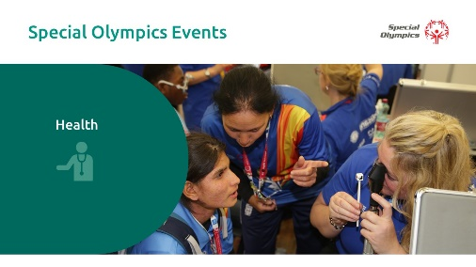  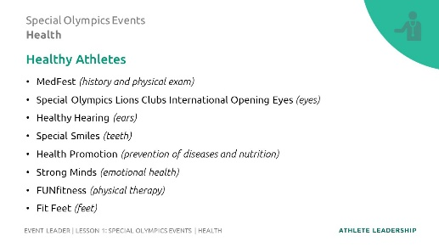  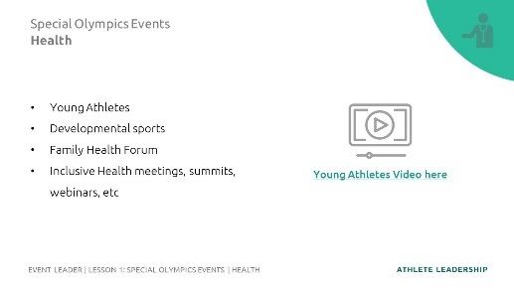
Topic  Lesson 1:  Special Olympics Events  Time: 3 min  Lead: xx | Lastly, let’s look at events related to Leadership.  Special Olympics is shaping a new understanding of leadership, inspired by our athletes, and unleashing leadership potential in people of all abilities.  Here are some examples of leadership events:  - Athlete Leadership events, such as Athlete Leadership Council Meeting, Athlete Forums, Training sessions (Leadership & Skills Curriculum).  - Unified Leadership trainings or engagement with other organizations.  - The Special Olympics Leadership Academy sessions.  - Youth Leadership Summits pairing young people with and without ID.  Let’s look at a video of how a Youth Summit event looks like  https://www.youtube.com/watch?v=2X1a9_sC_w0  Feel free to change a Youth Summit video from your Program or Region if you want. | 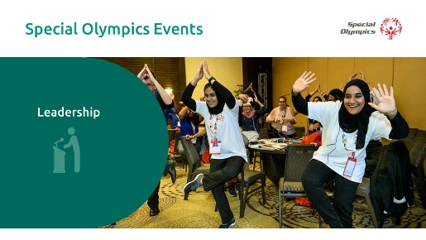  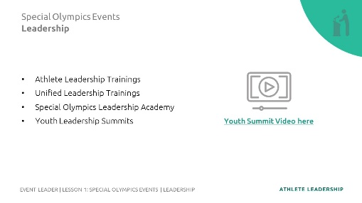
Topic  Lesson 1:  Special Olympics Events  Time: 5 min  Lead: xx | These are some examples of Special Olympics events, there sure are many more but these have a larger presence in the movement on a global scale.  In the following lessons we will look into how you can be engaging in Special Olympics events, and we will share examples of leadership roles.  Does anybody have any questions or comments?  Suggestions for more interaction with the participants: You could use a poll to ask them which type of events they are most interested in.
Topic  Lesson 2:  Planning a Special Olympics Event  Time: 3 min  Lead: xx | In this lesson we will learn what types of leadership roles you can have while planning an event.  But first, what is “planning?”  Planning is the process of thinking about the activities required to achieve a desired goal.  When you know that an event will take place, planning is the first and most important activity you need to do to achieve the results you want. | 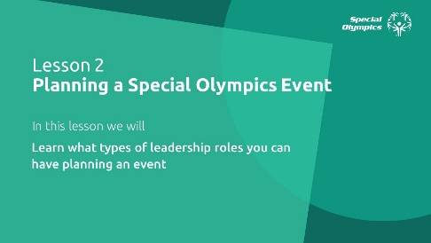  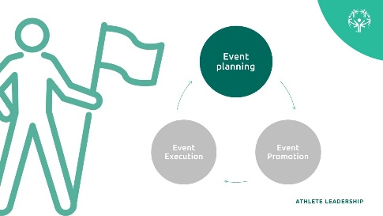
Topic  Lesson 2:  Planning a Special Olympics Event  Time: 2 min  Lead: xx | To participate as an event planner in Special Olympics, it’s important you train in the necessary skills that will help you succeed in the role.  The Leadership & Skills Curriculum offers the following courses for this purpose:  - Managing time  - Athlete Representative:  Lesson 1 – Preparing for meetings  Lesson 2 – Meeting behaviors  Lesson 5 - Committees | 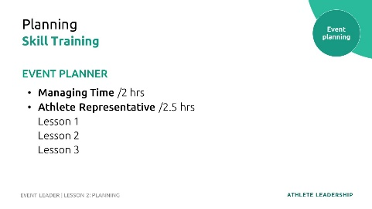
Topic  Lesson 2:  Planning a Special Olympics Event  Time: 5 min  Lead: xx | Event planning is more than just attending events, a well-executed event doesn’t happen by accident. Event planning can be stressful, but there are skills than can help you be a good event planner.  In this lesson we will talk about four skills that will help you as you plan for events.  But before we start talking about skills, the first thing you need to consider is you need to have a basic understanding of the event.  To be a good event planner you need to understand the event. Here are some questions you can ask yourself to make sure you know what the event is about. Who is participating in the event? What is the event about? When will it happen? Where will it happen? Why are we doing the event?  Think about the last competition you participated in. What was the event about? Who was the event for? When did it happen? Where did it happen? Why did the event take place?  Answer all of those questions out loud or in groups.  This is the same process the planners of that event participated in many months before the event actually took place to prepare/plan for the event. | 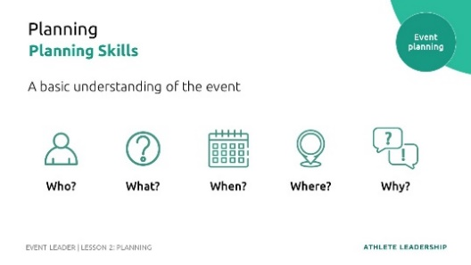
Topic  Lesson 2:  Planning a Special Olympics Event  Time: 5 min  Lead: xx | 1. Organization skills:  As a planner, it’s important to have a process and method. This means, sticking to timelines, budgets, and appointments as well as keeping important documents and information organized.  There are many tools you can use that will help you stay organized: to-do lists, daily planners, calendars, alarms, etc.  Do you think you are good at being organized? Would a family member say you are organized? It is okay if you are not organized yet, but it is a skill that you should practice regularly.  Let’s look at an example of a Travel Checklist, imagine you are traveling to a foreign country and want to make sure you don’t forget anything, what would you include on your checklist?  2. Communication skills:  Event planners need good communication skills and aren’t afraid to talk to different people like event attendees, donors, media, and hosts.  For example, having a clear communication when asking a question or giving an instruction, sound enthusiastic when speaking to donors or media, etc.  Communication is very important so that everyone understands their role. It’s important to share information with confidence, respect, and clarity. Most importantly, event planners pay attention to everyone, which helps them understand the needs and wants of everyone to make the event a success.  There are many ways to communicate with others. For example, email, WhatsApp, Zoom, in person meetings, etc.  It’s important you and the planning committee decide how you will communicate. | 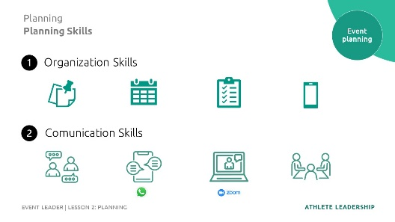  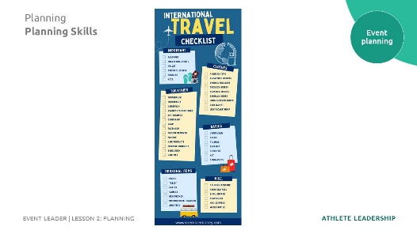
Topic  Lesson 2:  Planning a Special Olympics Event  Time: 5 min  Lead: xx | 3. Problem Solving skills:  Event planners will face problems, that is a given. It is important they can solve them calmly. When faced with a challenge, good event planners make decisions (sometimes difficult ones). They sometimes have back-up plans and if not, they have people on their team who can support and help solve problems in a creative and effective way.  Unmute yourself or share in the chat some examples of problems someone can face during event planning.  Read a few of their answers out loud before moving on  4. Creativity:  As an event planner, you need to use your creativity and be flexible at times. When planning an event think about ways you can make things new and different. For some creative ideas, seek inspiration from online blogs, social media platforms, or brainstorming with others. | 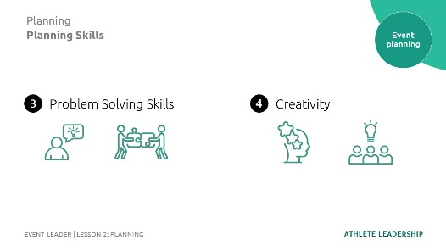
Topic  Lesson 2:  Planning a Special Olympics Event  Time: 5 min  Lead: xx | These are four very important skills for event planners. And don’t worry if you are not very good at these skills quite yet. As you gain more experience planning events, your skills will get better.  In your handbook you will find a list of reflective questions, please think about these skills apply to you:  - What planning skills do you have or already use?  - Which planning skills you feel you can improve? How?  Rank for planning skills. #1 is the skill that you believe is your strongest and #4 is the one you need to improve most. | 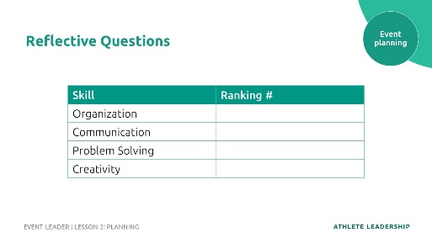
Topic  Lesson 2:  Planning a Special Olympics Event  Time: 10 min  Lead: xx | Now that you know the training you need and general information and skills you will need as a planner, let’s look at what opportunities Special Olympics offers if you would like to begin your journey as a Special Olympics event planner.  First, we will share examples of some planning leadership roles at Sport events:  Remember, these are just examples. Your Special Olympics Program may have different roles or simply different names for the roles.  We encourage Programs to adjust this section to fit the names and descriptions of roles on their own teams that athletes can fill.  Opening & Closing Ceremonies Advisory Team  - Serve as advisors to the production agency in creating the concept for the Opening and Closing Ceremonies  - Help ensure that the Ceremonies show is athlete-focused, and features athletes in leadership roles  Experience Mapping Participants (Athletes)  - As part of the initial event planning process, participate in Experience Mapping for the athlete experience, providing input on the best service delivery from transportation, accommodation and competition experiences.  Logo Development Team  - Participate in the creation and/or selection of the logo for the event  - Collaborate with designers to advise, provide art ideas and help create the narrative around the logo  Functional Area Committee Member  - Participating in different planning committees. For example: fundraising, communications, transportation, meals, credentialing, etc.  Staff/Volunteer Orientation  - Participate in regular orientation sessions for the events volunteers or staff. | 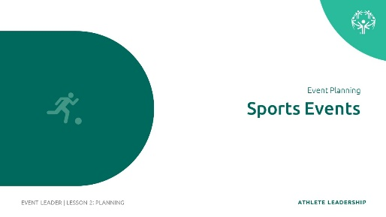  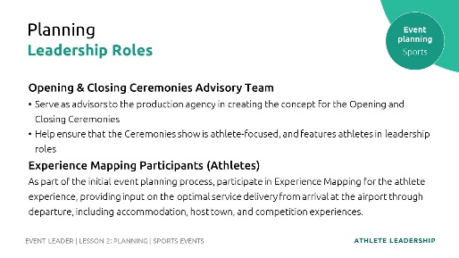  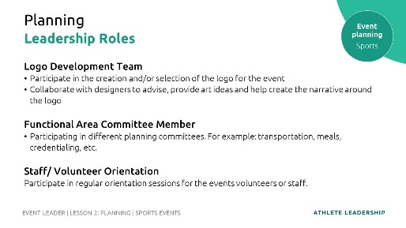
Topic  Lesson 2:  Planning a Special Olympics Event  Time: 5 min  Lead: xx | Now we will share examples of some planning leadership roles at Health events:  We encourage Programs to adjust this section to fit the names and descriptions of roles on their own teams that athletes can fill.  Healthy Athletes Coordinators  - Serving on a planning committee. For example: fundraising, communications.  Healthy Habits Leader  - Leading health education | 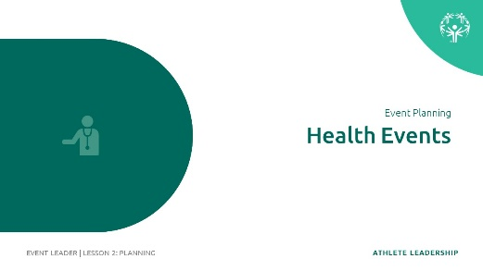  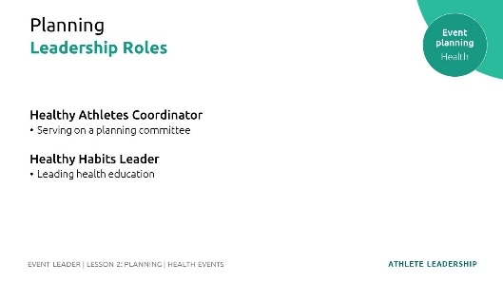
Topic  Lesson 2:  Planning a Special Olympics Event  Time: xx min  Lead: xx | How might we engage athletes in the planning of our leadership events?  Now we will share examples of some planning leadership roles at Leadership Events, remember these could be related to Athlete Leadership, Unified Leadership, Youth Leadership or Leadership Academy:  We encourage Programs to adjust this section to fit the names and descriptions of roles on their own teams that athletes can fill.  - Site selection committee.  - General organizing committee:  - Meals.  - Setting up agendas and communicating with the participants ahead of time.  - Selecting content, designing the activities. Coordinating with guest speakers.  - Identifying roles for athlete leaders in the promotion and execution of the events.  - Participate in fundraising and sponsor meetings. | 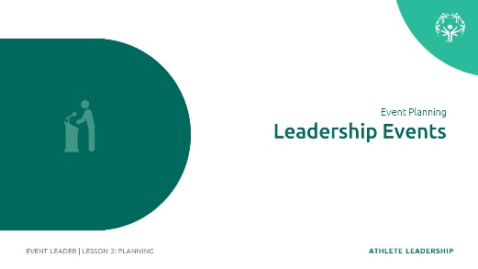  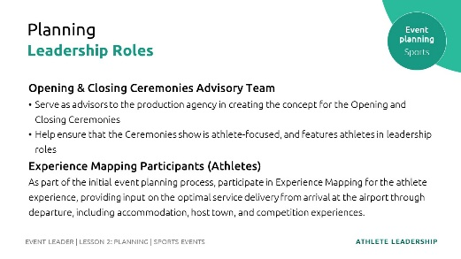
Topic  Lesson 2:  Planning a Special Olympics Event  Time: 5 min  Lead: xx | Does anybody have any questions or comments about planning Special Olympics events?
Topic  Lesson 3:  Promoting a Special Olympics  Time: 2 min  Lead: xx | Promoting means trying to sell something, to make others pay attention to a specific thing.  A well-promoted event increases public awareness of the organization, this is a reason why events are so important.  Promoting an event will help you have more people attending or paying attention to the event, you can create interest among others and even find new supporters or volunteers. Achieving this is a critical part of a successful event.  What would happen if we created the world’s best event to raise money for your Program and forgot to promote the event? No one would show up and we would have wasted all the time planning an event that didn’t raise any money or awareness for our Program. This is why promoting events is so important. | 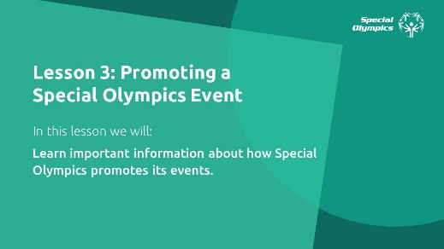  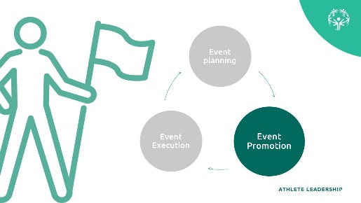
Topic  Lesson 3:  Promoting a Special Olympics  Time: 5 min  Lead: xx | To participate in promoting events in Special Olympics, it’s important for you to train in the necessary skills that will help you succeed in the role.  The Leadership & Skills Curriculum offers the following courses for this:  - Athlete Spokesperson/Global Messenger:  Is meant for athletes who want to educate and inform others about the mission, benefits, and direction of Special Olympics. It goes beyond giving public speeches and interviews, it is about spreading the word about the Special Olympics movement through different outlets.  - Health Messenger  It’s a training for athletes who want to serve as a health and wellness leader, educator, advocate, and role model within their community. It’s a spokesperson focused on health. | 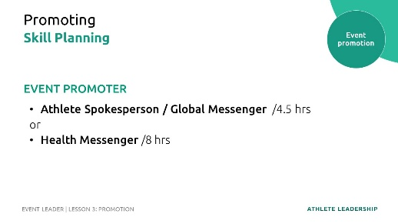
Topic  Lesson 3:  Promoting a Special Olympics  Time: 5 min  Lead: xx | Let’s look at what opportunities Special Olympics offers for you to begin your journey as a Special Olympics event promoter.  We encourage Programs to adjust this section to fit the names and descriptions of roles on their own teams that athletes can fill. If you have videos that describe these roles you can show them to the group.  First, let’s talk about leadership roles in promoting Sport events:  Spokesperson / Global Messengers  - Participate in speaking opportunities, panels, and interviews leading up to the event representing Special Olympics athletes  - Activities with Sponsors  - Participate in meetings with potential event sponsors  - Participate in sponsor activation events leading up to the event | 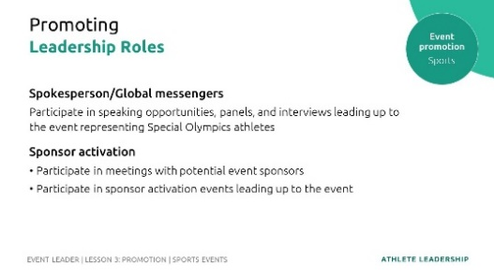
Topic  Lesson 3:  Promoting a Special Olympics  Time: 8 min  Lead: xx | We encourage Programs to adjust this section to fit the names and descriptions of roles on their own teams that athletes can fill.  There are many events that help us move Special Olympics Inclusive Health work forward. If you have a special interest in Inclusive Health, you can become a Health Messenger!  Special Olympics Health Messengers are athletes who are trained to serve as health and wellness leaders, educators, advocates, and role models within their Special Olympics communities, as well as the community at large. They are leading their teams, families, friends, and communities to pursue healthy lifestyles, and are advocating for healthcare providers and governments to adopt inclusive policies around health, wellness services, education, and resources for people with intellectual disabilities.  Health Messengers participate in promoting health events:  - Participating in speaking opportunities, panels, and interviews leading up to the event representing Special Olympics athletes  - Presenting during Inclusive Health Meetings. | 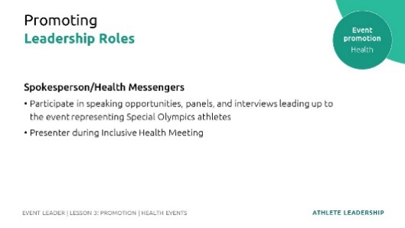
Topic  Lesson 3:  Promoting a Special Olympics  Time: xx min  Lead: xx | We encourage Programs to adjust this section to fit the names and descriptions of roles on their own teams that athletes can fill.  Now let’s talk about leadership roles in promoting Leadership events:  - Recruiting more participants (athlete leaders/youth leaders).  - Interview event participants and share it/Collect testimonials from participants (including athlete leaders that are participating).  - Local TV/Press promotion for delegations attending the events.  - Interview with press about the event.  - Being an influencer on social media. | 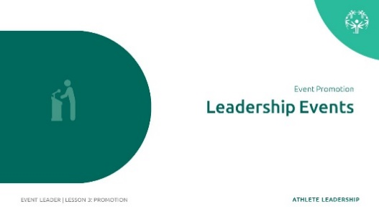
Topic  Lesson 3:  Promoting a Special Olympics  Time: 5 min  Lead: xx | Does anybody have any questions or comments about promoting Special Olympics events?
Topic  Lesson 4:  Executing a Special Olympics  Time: 3 min  Lead: xx | Event volunteers and staff assist on the event day for set-up, guest assistance, registration or clean up.  This part of being an event leader is called “event execution.” You are “executing” the event or making sure that the event actually happens! | 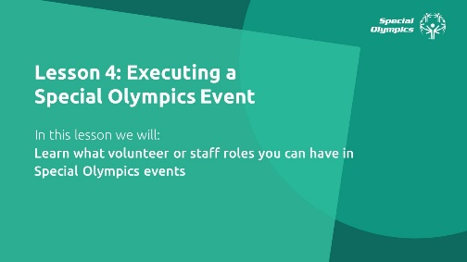  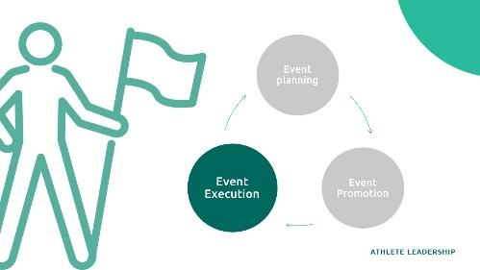
Topic  Lesson 4:  Executing a Special Olympics  Time: 3 min  Lead: xx | Working or volunteering during Special Olympics events can be very exciting and demanding. Our events involve a lot of people and different pieces that add up to a great event.  Being able to work in teams and to communicate well are important skills to succeed in this role.  The Leadership & Skills Curriculum offers the following courses for this:  Managing Time, Engaging with Others, and Unified Leadership. | 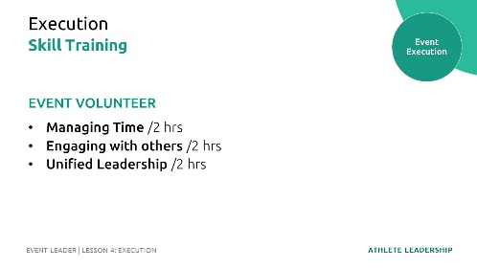
Topic  Lesson 4:  Executing a Special Olympics  Time: 10 min  Lead: xx | Let’s look at what opportunities Special Olympics offers if you would like to begin your journey in helping Special Olympics execute events.  We encourage Programs to adjust this section to fit the names and descriptions of roles on their own teams that athletes can fill.  You can do it as a volunteer or a paid staff member depending on the opportunities available in your Special Olympics Program. First, let’s talk about leadership roles during Sport events:  Spokesperson / Global Messengers  - Participate in speaking roles at events and receptions and on panels.  - Participate in Unified Sports Experiences  - Give and conduct interviews during the events  Athlete Volunteers/Staff  - Participate in volunteer or staff roles as part of the event.  Athlete Officials  - Participate as sport technical officials during the event  Event Evaluation Team Members  - Participate in the evaluation team, conducting evaluations, especially focused on the athlete experience  - Prepare evaluation report post-event | 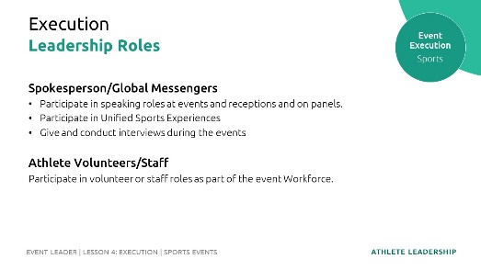
Topic  Lesson 4:  Executing a Special Olympics  Time: 5 min  Lead: xx | There are many opportunities for athletes to lead during our Health events:  We encourage Programs to adjust this section to fit the names and descriptions of roles on their own teams that athletes can fill.  Health & Fitness Leader  - Leading a Fit 5 session.  Health Advocate  - Attending Inclusive Health trainings.  Role Model  - Demonstrating healthy behaviors at events  Coach/assistant coach  - Leading or supporting Young Athletes or Developmental Sports activities | 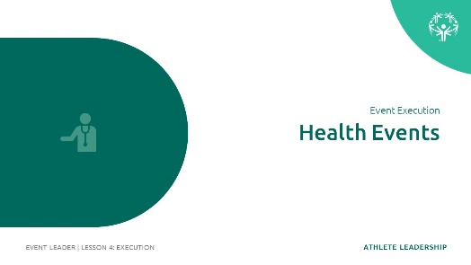  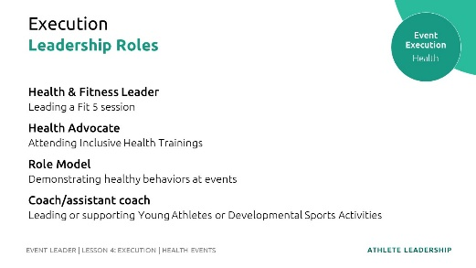
Topic  Lesson 4:  Executing a Special Olympics  Time: xx min  Lead: xx | We encourage Programs to adjust this section to fit the names and descriptions of roles on their own teams that athletes can fill.  Here are many opportunities for athletes to lead during our Leadership events:  - Mentoring other athletes.  - Facilitators/instructors.  - Emcee/host.  - Photography, social media posts, blogs.  - Opening and Closing sessions.  - Be part of the evaluation committee.  - Be part of a judging panel.  - Facilitate panel discussions. | 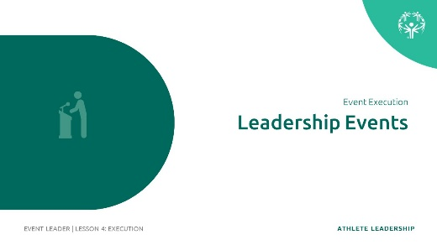
Topic  Lesson 4:  Executing a Special Olympics  Time: 5 min  Lead: xx | Does anybody have any questions or comments?
Topic  Lesson 4:  Executing a Special Olympics  Time: 5 min  Lead: xx | Thanks for participating, you have now concluded the first part of the Event Leader training course.  Remember, there are many leadership roles you can have as an Event Leader  If you are interested in participating in Special Olympics events, we invite you to:  - Look at the different leadership roles we shared. Once you have identified if you are interested in planning, promoting, or executing think about which leadership roles you found most exciting. What role do you think fits better with your skills?  - Remember there is a second part to this training, to continue your training toward becoming an Event Leader, we encourage you to take the courses we mentioned earlier.  Most importantly, connect with your Special Olympics Program and let them know your interests and together you can identify opportunities for you and how to start your Event Leader journey.

