Social Media Guide

Using Social Media

Social media is a great place for sharing of ideas, thoughts, and information.

Some examples of Social Media platforms are Facebook, Instagram, WhatsApp, Twitter, WeChat, Weibo, etc.

You can use social media to:

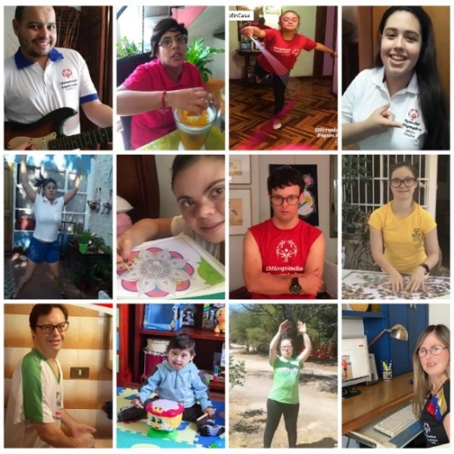
- Communicate and connect with friends and family.

- Share experiences.
  - Exercise routines
  - School or Work
  - Music
  - Thing you like, movies, videogames, series.
  - Issues that you want to reflect on

- Spread the Word on inclusion and the work Special Olympics.
  - You can “Like” or share posts made by your Special Olympics Program, teammates, or coaches.
  - Share your story, invite people to learn more of you and follow Special Olympics. Tag @Special Olympics and use the Hashtag #ChoosetoInclude.

REMEMBER!
- Many people, including other athletes, friends and Family may see you as a role model.
- Share positive things that bring light, educate, motivate, and inspire your followers.
- Communicate with your Friends, family, and other athletes through social media. Is nice to reach out, connect and support each other.

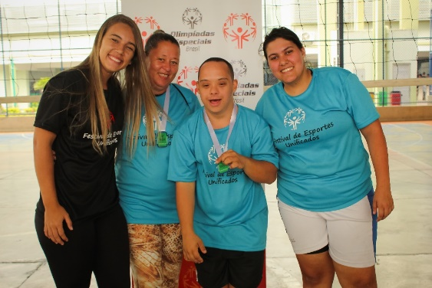

Safety and Privacy

Safety
Social Media is great if you want to communicate with people you know. But remember there are many people you DONT know that can also see your posts, videos, and pictures.

Never share personal information!
- Phone number
- Home address
Or any other very personal information:
- Bank account
- ID or Passport number
- Passwords
Never share this in social media!

Privacy
There are topics that are private or personal that other people do not need to know. They can be related to you, your family, or friends.

Think twice before sharing personal information, is this something you want everyone to know? Even people you don’t know well?

If you are not sure about sharing something personal in social media, ask a family member or mentor what they think so you have another opinion.!

What not to do

Do not write everything in UPPERCASE. In social media this means you are yelling.

Do not use offensive language or swear words.

Posting too much in social media may bore people and they can stop paying attention to you. Is better to not post more than four times a day.

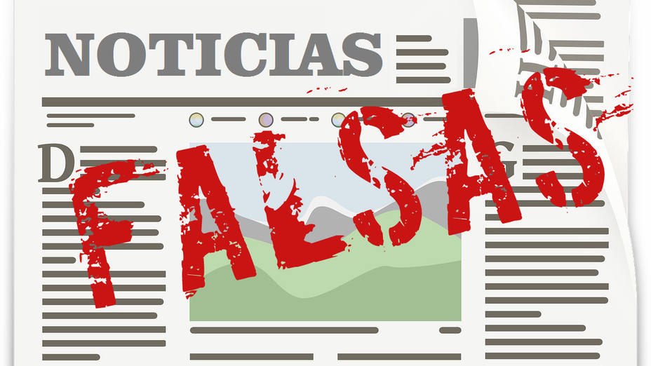
Do not share Fake News!
When you see a story or news you want to share with others, try to look more information about or ask a family member or mentor if it’s true. There is a lot of fake information in social media.

If you want to share information about Special Olympics you can’t go wrong if you use our official social media accounts.

Avoid arguments or fights.
There are many people that just want to provoke, insult, or argue.
If you receive disrespectful or inappropriate messages ignore, report, and block them.

