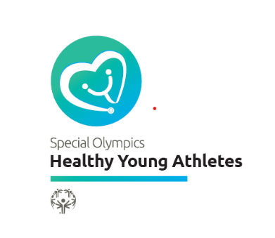
The Healthy Young Athletes (Pediatric Screening) Clinical Director Role
Special Olympics is a global movement of people creating a new world of inclusion and
community, where every single person is accepted and welcomed, regardless of ability or
disability. We are helping to make the world a better, healthier and more joyful place -- one
athlete, one volunteer, one family member at a time.

The Healthy Athletes program is dedicated to providing health services and education to Special Olympics athletes, and changing the way health systems interact with people with intellectual
disabilities. Through free health screenings, training for healthcare professionals, and evaluation
of the health status of people with intellectual disability, Healthy Athletes has become a powerful
public health organization worldwide.

Special Olympics Young Athletes delivers direct, evidence-based support to children ages 2-7 with and without intellectual disabilities (ID) through inclusive developmental skill activities, with the potential to make a long-term, meaningful impact on the social, cognitive, psychological and physical development of young children. Young Athletes programming lasts a minimum of eight weeks and takes place in homes, schools and communities, led by family members, teachers, and volunteers supported with Special Olympics training and resources.
Over the years, Healthy Athletes has attempted to address the unique health needs of young children through age-appropriate screenings. These protocols and practices have been implemented with varying success for a variety of reasons, including the structure of the protocols themselves and limited communication to Programs about the protocols. To address these challenges, many Programs are using the general Healthy Athletes protocols (designed for athletes ages 8+) for Young Athletes and, as a result, these protocols may not always meet the needs of our youngest participants.
To address the concerns of conducting a proper Healthy Young Athletes screening, and to reach individuals with ID at a younger age, Special Olympics believes Young Athletes participants would benefit from a holistic pediatric screening as an initial offering through Healthy Athletes. The screening can close the loop and ensure all children are getting the right level of services and support, regardless of their access to a primary care provider. Additionally, the pediatric screening could be used in settings outside of Healthy Athletes, for instance in school or community-based Young Athletes sessions, to create a deeper connection between Young Athletes and health programming.
Healthy Young Athletes would not take the place of a child’s regular well visits with their primary care provider. Rather, the screening would complement a child’s primary care and provide an additional review of the child’s health that can be shared with their primary care provider, if they have access to one.
Healthy Young Athletes promotes opportunities for families to maximize their child’s health and development outside of the primary care visit through comprehensive educational materials.

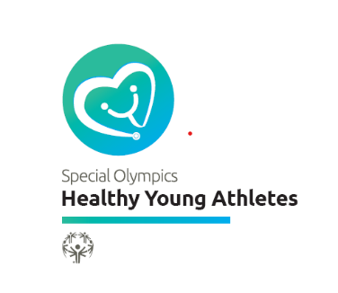
THE ROLE OF THE CLINCAL DIRECTOR
Healthy Young Athletes Clinical Directors play a vital role in the success of the event. A Clinical Director should be licensed to practice medicine and prescribe medications in the state or country in which the screenings are held. Expertise should include appropriate interpretation of all health and developmental screening results, medical assessment and decision-making, developmental screening/evaluation, and referrals. Extensive experience in pediatrics. Medical decisions & treatment, and developmental screening and referrals for young children under 8 years old.
Pediatric Screening Clinical Director Background and Requirements:
- Pediatrician – board certified/ eligible general or subspecialty (MD, DO)
- Independently practicing Pediatric Nurse Practitioner (PNP), DNP
- Family medicine (FM) physician (MD, DO) or independently practicing Family NP (FNP) with > 50 documented pediatric patient experiences in children < 8 yrs old.
- Physician Assistant with experience managing pediatric patients.
- A minimum three-year commitment to serving as a Clinical Director to ensure quality and
- continuity of services; and
- Completion of the online or in-person Train-the-Trainer Module, where information and training about Special Olympics, Healthy Athletes, and the pediatric screening specific management and clinical requirements are provided.
- Interested healthcare professionals must submit their resume/cv for consideration and approval prior to taking the online training module.
- The Online Training is accredited through American Academy of Family Practitioners for 2.5 hours of prescribed credit.
- If you are interested in serving as a Clinical Director, please contact your local Special Olympics Program --http://www.specialolympics.org/program_locator.aspx

If candidates lack this experience, preference should be given to those with a pediatric practice, sports medicine or general practice background, followed an internal medicine background.
The Clinical Director will serve as the primary authority for medical operations of the Pediatric Screening event. He or she will assist Special Olympics staff in:
- Determining event opportunities
  - Identifying and scheduling the best opportunity to provide a pediatric screening is a joint effort between the Clinical Director and their local Special Olympics Program. Clinical Directors will also help determine how to design the events based on the primary purpose of the event.

- Recruiting and training volunteers
- Clinical Directors are the best people to identify and train health volunteers to work in the specific areas that will be offered in the pediatric screening venue, because they know their community and its local health care professionals. Potential volunteers may come from:
Private Practitioners
Universities/Colleges/Schools
Health and Professional Associations
Medical Facilities
Government Medical Facilities (Military/VA/State/National/Local) and
State or Local Public Health Agencies

- Approving clinical equipment and supporting capacity grant application
- Clinical Directors will work with their local Program to ensure that supplies and equipment needed to deliver the core components of the pediatric screening are included in the Healthy Athletes’ Capacity Grant application. These grants assist Programs in purchasing interactive educational materials, athlete giveaways and incentives, volunteer recognition, signage and other supplies/equipment needed to conduct an impactful pediatric screening program.
- Finding referral networks
- Enforcing the standard of care and improving protocols
- Serving as the clinical authority if questions or issues arise at a Pediatric Screening
- Oversee data collection/ quality control, Setting Up and Supervising the Healthy Athletes Venue
- On the day of the event, the Clinical Director is responsible for supervising the set up and delivery of screening and interactive education services by trained volunteers.
- Collecting and Reporting Data
  - Clinical Directors use the pediatric screening form to document screening data collected during the event. Data is used to determine the need for health care provider referrals, and to assess the health status and needs of individual Special Olympics Young Athletes. This data provides Healthy Athletes Programs worldwide with information to increase awareness and provide more services.
- Program Evaluation
  - Evaluation gives Clinical Directors the opportunity to continuously improve and adapt their programs to the needs of the athletes and families.

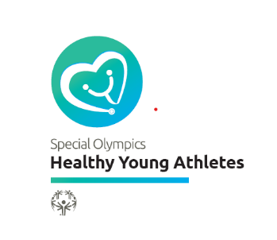
Dear Clinical Director Candidate,

Thank you for expressing an interest in becoming a Clinical Director for the Special Olympics Healthy Young Athletes program. We appreciate your willingness to consider becoming a member of the pediatric screening team. Your involvement in this program could mean a potential life-changing experience for the people you care for and yourself as well!

A Clinical Director, approved by the local Special Olympics and Special Olympics International team, will participate in an online Train-the-Trainer Program, or at an in-person training. Please complete the following questionnaire so that we can learn more about you, your professional background and clinical experience to see if your interests and skills match the needs of the program. Your responses to the following questions will help us both determine if we are a good match. We aspire to make your volunteer experience joyful and impactful.

The questionnaire contains three sections:

• Background on the pediatric screening program
• Your interest and motivation to work as a leader with the program
• Your academic and clinical background

Feel free to contact us for further information.

Thank you for considering this exciting role in the Special Olympics Pediatric Screening Program.

Mercy Ng’eno MD, MMed
Sr Clinical Program Manager, Pediatrics
mngeno@specialolympics.org

Jennifer Hansen
Young Athletes Manger
jhansen@specialolympics.org

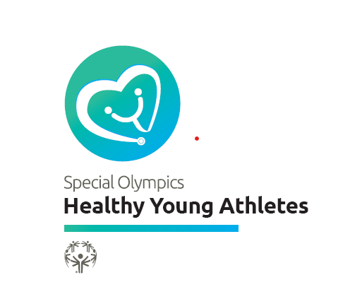
Pediatric Screening Clinical Director Engagement
Steps to vet a candidate interested in becoming
a Healthy Young Athletes Clinical Director

Process to prepare candidate to assume the role of Pediatric Screening Clinical Director

- Local Health Manager reviews candidate CV and completed questionnaire to determine if the candidate meets the requirements for the role. If yes, local Health Manager submits the CV and questionnaire to SOI for peds screening team review.
- The pediatric screening clinical program manager and GCA’s review CV and questionnaire to determine if the candidate is approved for the role.
- Local Health Manager is informed and advises approved candidate to complete Online or in-person training module for the candidate.
- Candidate completes Training Module and participates in a supervised experience at a pediatric screening event.
- Once 1-4 above are complete, the individual can assume the event supervision role including pre, during and post-event responsibilities outlined in the HYA Clinical Director Manual.

Resources

Healthy Young Athletes Overview
Healthy Young Athletes CD Questionnaire
Healthy Young Athletes Clinical Director Manual
Training Module

For more information, including assistance with recruitment, please contact Mercy Ng’eno, mngeno@specialolympics.org or Jennifer Hansen, jhansen@specialolympics.org

