NUTRITION TOOL KIT
For SPECIAL OLYMPICS
COACHES

Table of Contents

GENERAL OVERVIEW 6
Overall general guideline for breakfasts, lunches, and dinners 6
Carbohydrates 7
Foods high in Carbohydrates 7
Protein 9
Examples protein rich foods 9
Fat 9
HEALTHY FATS 10
UNHEALTHY FATS 11
MEAL AND SNACK TIMING 12
Pre-game meal 12
During practice/competition/physical activity 12
Post-workout meal 13
Combo (Carbs + Protein) Meal Ideas for your athletes 13
SNACKS 14
Mini-Menu Ideas: 15
The Trail Mix Bar: 16
Athletics (Track & Field) 20
General Nutrition Guidelines for Track & Field Athletes 20
Track & Field Meal Plans Guidelines 20
21
Aquatics/Surfing/Stand Up Paddle 21
General Nutrition Guidelines Aquatics 22
General Meal Plan for Aquatics/Surfing 22
BASKETBALL 23
Basketball General Nutrition guidelines: 24
Training (practice) schedule: 25
Nutrition on days of competition 27
Off Season 28
Weight gain 28
Weight loss 28
Weight Maintenance 28
Bocce 29
General Nutrition Guidelines Bocce ball 29
Meal ideas for Bocce ball athlete: 29
Bowling 30
General Nutrition Guidelines for Bowling: 31
Bowling Meal plan for 150 lb / 68 kg athlete 31
Snack ideas for bowling alley 32
Cheerleading 32
General Nutrition Guideline Cheerleaders 32
Cheerleading General Guideline, What to Eat and When: 33
Sample Meal Plan for Cheerleader: 34
CYCLING 34
General Cycling Nutrition guidelines: 35
Macronutrient and Fluid Timing for training and Racing 35
SHORT RIDES 36
MEDIUM-LENGTH RIDES 36
LONGER RIDES 37
Cycling Training Day Meal Plan 37
Equestrian 38
Nutrition tips for those high stress show days: 38
General Nutrition Guideline Equestrian: 38
Equestrian Meal Plan for a 150 lb/68 kg athlete 38
Typical Meal Plan Equestrian: 39
Flag Football 40
Flag Football General Nutrition guidelines: 40
Flag Football Example of meal plan for 150 lb / 68 kg athlete 40
Football (Soccer) 41
Football (Soccer) General Nutrition Guidelines 41
) Overall energy 43
Football (Soccer) General day to day breakdown of calories 43
Golf 44
General Nutrition Guidelines for golf: 45
Golf Meal Plan for 68 kg / 150 lb athlete 45
Snack Pack(s) 46
Gymnastics 47
General Nutrition Guidelines Gymnast: 47
Energy Restriction Issues: 47
Body Composition: 47
Gymnast Meal Plan for 68 kg / 150 lb athlete 47
Powerlifting 49
General Nutrition Guidelines Powerlifters 49
Meal Plan for 150 lb / 68 kg powerlifting athlete 49
Softball 50
General Nutrition Guidelines Softball: 51
Softball Meal plan for 150 lb / 68 kg athlete 51
Tennis/Stand-Up Paddle 52
General Nutrition Guidelines Tennis/Stand-Up Paddle: 52
Tennis/Paddle Meal plan for 68 kg / 150 lb. athlete 53
Volleyball 53
General Nutrition Guidelines Volleyball 53
Meal plan for 150 lb / 68 kg volleyball athlete 54
General Meal Plan for Volleyball 54
Suggested HANDOUTS for your athletes: 55
65
HYDRATION 66
Tips for staying Hydrated 66
Avoiding dehydration strategies 66
Practical tips for athletes: 67
SLEEP / REST 67
Tips on how to sleep better to get those needed ZZZ’s 67

GENERAL OVERVIEW
Without getting into too much physiology, your body needs carbohydrates, proteins and fats. Carbohydrates are the body's main source of energy. Proteins are the basis for your muscles and fats/oils help with your nerves and hormones among other things. A proper diet should include all of these, but the key to maximum performance is the ratio you intake. An athlete should eat a balanced diet that is high in carbohydrates, low in fat, and adequate in protein.
A well-chosen diet offers many benefits to athletes no matter their age, skill level, event or gender.
- Optimal gains from the training program
- Enhanced recovery within and between workouts and events
- Achievement and maintenance of ideal body weight and physique
- A reduced risk of injury and illness
- Confidence in being well prepared for competition
- Consistency in achieving high-level performance
- Enjoyment of food and social eating occasions
Despite all these advantages, many of today’s athletes fail to meet their nutrition goals. Common problems and challenges include:
- Poor knowledge of food and drinks and inadequate cooking skills
- Poor food choices when shopping and or dining out
- Poor or outdated knowledge of sports nutrition
- Inadequate finances
- Busy lifestyle leading to inadequate time to obtain or consume the most appropriate foods
- Poor availability of nutrition dense food or drink choices
- Frequent travel
- Incorrect use of sports nutrition supplements

Overall general guideline for breakfasts, lunches, and dinners
Breakfasts
Juice and milk (2%) should be consumed at breakfast.
Scrambled eggs and toast (whole wheat)
Cereal with fruit and toast (use low sugar cereals)
Oatmeal and grapefruit (or other fresh fruit)
Waffles or pancakes with fruit Bagel and yogurt with fruit Leftover dinner
Note: Baked goods like muffins can be eaten at breakfast but are not enough on their own. Also extra protein can be added with breakfast meats or protein shakes with whey powder or egg whites in them.

Lunches
Sandwiches (peanut butter and honey or jam, tuna, sliced meat, cheese)
Sub sandwiches (lots of fillers) (whole wheat bread is best)
Fresh or dried fruit, carrots, celery sticks, other cold veggies
Yogurt, bagels, pretzels, rice cakes, crackers (spreads of cream cheese or peanut butter too) Carbohydrate bars, granola bars, trail mix, dry breakfast cereals (low in sugar)
Potatoes, noodles, rice or pasta can be included as quick carbohydrates if the meal is before a workout using minimal protein.

Dinners
These full meals should include as many of the food groups as possible with an emphasis on protein with carbohydrates in the form of vegetables if they occur soon after a workout. Potatoes, noodles, rice or pasta can be included as quick carbohydrates if the meal is before a workout using minimal protein.

Carbohydrates
Carbohydrates are the main, preferred source of energy for the body; it is a critical nutrient for the athlete who has high-energy demands during physical activity such as training or competition. Stamina, power and endurance sports are dependent on adequate carbohydrates in the diet in order to provide the proper fuel the body needs.

Training increases the body’s ability to store glycogen (energy warehouse)
- The body is only able to store a certain amount of glycogen (which increases with training)
- Trained athletes may have more than twice the amount of glycogen in their muscles than sedentary people, which gives them more endurance!
- The importance behind getting enough carbohydrates in the diet and filling up the “gas tank” with stored glycogen comes from the fact that our bodies burn through 1/5th of its stored energy in the first 20 minutes of exercise before switching over to fat as a source of energy or fuel.

Foods high in Carbohydrates

Bread Products Portion Size Carbs (g)
Bagel – Lender’s frozen 1 plain bagel 30
Bagel – Panera 1 plain bagel 60
Bread 1 regular slice 15-23
Bread Stuffing ½ Cup 20
Breadstick-soft 1 bread stick 15-25
Bun: Hamburger or Hot dog 1 regular size 15-30
Corn Bread 2” cube 15
Croissant Medium 2 oz 25
Croutons: from Italian Restaurant ½ Cup 15
Croutons: pkg from fast food restaurant 1 pkg 10
Dinner Roll Small 15
English Muffin 1 whole 30
Pancake 6” diameter (avg size) 30
Pita bread Large 6”-9” 30-45
Tortilla-corn 7” 15
Waffle (frozen type) 1 15

Cereals/Beans/Grains/Pasta Portion Size Carbs (g)
Beans: refried ½ Cup 18
Oatmeal, cooked ½ Cup 10
Cream of Wheat, cooked ½ Cup 15
Cornmeal: dry 3 Tbsp 15
Beans/legumes/lentils as prepared ½ Cup 15
Flour: dry 3 Tbsp 15
Hummus ½ Cup 10-15
Pasta, cooked 1 Cup 45
Rice, cooked 1 Cup 45

Starchy Vegetables Portion Size Carbs (g)
Corn: cooked or canned ½ Cup 15
Corn Cob 6”-9” 30-45
Peas ½ Cup 15
Potato – Wendy’s Avg baked (10 oz) 60
Potatoes (hashed, mashed) ½ Cup 15
Squash (winter type: acorn, Hubbard, etc) 1 Cup 10-30
Sweet Potato/Yams-plain cooked 10oz baked 60

Milk & Yogurt Portion Size Carbs (g)
Cow’s milk (fat-free, 1%, 2%, Whole) 1 Cup 12
Rice Milk-Plain 1 Cup 20
Soy Milk (plain) 1 Cup 8
Yogurt (plain) 1 Cup 12
Yogurt- Dannon Light & Fit 1 serving (6oz) 10
Yogurt-Yoplait Light (blue top) 1 serving (6 oz) 19

Fruit Portion Size Carbs (g)
Apple 4-8 oz 15-30
Applesauce-unsweetened ½ Cup 15
Apricots, dried 7 pieces 15
Banana 6” – 9” 30-45
Blackberries, Blueberries 1 Cup 20
Canned Fruit Cocktail-in its own juice ½ Cup 15
Cantaloupe, Honeydew Melons 1 Cup 15
Cherries 12 15
Dates-dried Medjool type 1 15
Grapefruit ½ Large 15
Grapes 15 small 15
Kiwi 1 small 15
Orange 1 medium 15
Peaches (canned-in its own juice) ½ Cup 15
Pear 6 oz 20
Pineapple 1 Cup diced 20
Prunes- dried 3 15
Raisins 35 or 1/8 Cup (2 Tbsp.) 15
Raspberries 1 Cup 15
Strawberries-fresh 1 Cup halves 12
Watermelon 1 Cup diced 12

Fruit/Vegetable Juice Portion Size Carbs (g)
Apple Juice 100% ½ Cup 15
Carrot Juice 1 Cup 12
Cranberry Juice Cocktail 100% ½ Cup 12
Cranberry Juice Cocktail- Light 1 Cup 10
Grape Juice 100% ½ Cup (4 oz) 15
Orange Juice ½ Cup 13
Tomato or V8 juice 1 Cup (8oz) 10

Baked Goods Portion Size Carbs (g)
Biscuit (large Bob Evans) 1 30
Biscuit (small Pillsbury) 1 10
Brownie-large (Zimmerman’s) 1 70
Cake 2 layer frosted 4” square 80
Chocolate Chip cookie-refrigerator dough 1 15
Cupcake with frosting (Hostess) 1 30
Danish (large bakery type) 1 45
Donut (Dunkin Donuts-plain or jelly filled) 1 25-40
Donut (Krispy Kreme) 1 20
Apple Crisp ½ Cup 70
Fruit pie 1/8 of 9” pie 50
Muffin (homemade standard size) 1 20-30
Muffins (bakery type) 1 60-75

Snack Foods Portion Size Carbs (g)
Dark Chocolate 1 oz 15
Dove Chocolate 3 pieces 15
French Fries-crinkle cut frozen type 10-15
French Fries-diner style Side order 60
French Fries-fast food Small order 30
Graham Cracker 3 squares 15
Granola: SEE LABEL ½ Cup 15-45
Hershey Kisses 5 15
Ice Cream- No Sugar Added ½ Cup 12-15
Ice Cream- plain vanilla ½ Cup 15
Jell-O ½ Cup 20
Jell-O-Sugar Free ½ Cup 0
Oyster Crackers ½ Cup 15
Popcorn 3 Cups 15
Potato Chips 1 oz (10-15 chips) 15
Pretzels 11 small 15
Pudding-Regular 1 snack pack 30
Pudding-Sugar Free 1 snack pack 15
Saltine Crackers 7 squares 15
Sherbet ½ Cup 30
Sorbet ½ Cup 35-40
Tortilla Chips 1 oz (10-15 chips) 20

Sauce/Condiments (g)
Apple Butter 2 Tbsp 15
Barbeque Sauce BBQ 2 Tbsp 15
Cranberry Sauce-jellied ¼ Cup 25
Fat Free Mayo/Salad Dressing 2 Tbsp 5
Fruit Jam or Jelly 1 Tbsp 15
Fruit Spread- Jam- 100% Fruit-less sugar 1 Tbsp 10
Fruit Spread-Jams-Sugar Free 1 Tbsp 5
Gravy-brown prepared from mix 1 Cup 15
Hoisin Sauce 2 Tbsp 15
Hollandaise Sauce made from mix 2 Tbsp 5
Honey 1 Tbsp 15
Honey Mustard 2 Tbsp 7
Ketchup ¼ Cup 15
Marinara Sauce ½ Cup 15
Plum Sauce 2 Tbsp 15
Ranch- fat free 2 Tbsp 8
Ranch- regular 2 Tbsp 2
Sloppy Joe Sauce ¼ Cup 15
Sugar 1 Tbsp 15
Sweet and Sour Sauce 2-3 Tbsp 15
Syrup 1 Tbsp 15
Syrup- Lite 2 Tbsp 15
Szechuan sauce 1/3 Cup 15

Combination Foods Portion Size Carbs (g)
Bean Soup (split pea, lentil, etc) 1 Cup 30
Beans & Cheese Burrito- avg frozen type 6 oz 45-60
Cabbage Roll with meat and rice 1 avg roll 15
Chicken Noodle Soup- from can 1 Cup 15
Chili with beans & meat 1 Cup 25
Chili-vegetarian 1 Cup 30-50
Cream Soup 1 Cup 15
Dumpling- Chinese type 3 15-20
Egg Roll 1 avg roll 15-25
Lasagna from restaurant Avg serving 50-80
Macaroni & Cheese 1 Cup 45
Pizza (individual pan) 1 whole pizza 75
Pizza 12” 1 avg slice 30
Pot pie (small frozen) 1 30
Red Beans & Rice 1 Cup 45
Tuna Noodle Casserole 1 Cup 30

Protein
Protein is the building block of muscle in our athletes.
Essential for maintenance, growth and recovery.
Protein is necessary for reducing the risk of iron deficiency anemia and to improve healing.
About 10 to 15 percent of an athlete's total calories should come from protein.

Examples protein rich foods
    - 85-95% lean meats such as beef, turkey and ham
    - Beans and peas
    - Skinless, grilled or baked chicken. Roasted chicken or turkey breast
    - Seafood that is steamed, broiled, baked or grilled
    - Low fat cottage cheese (pair with fruit for added nutrients!)
    - Cheese 2% or fat free versions
    - Milk 2% or fat free versions
    - White tuna in water
    - Trimmed (removal of excess fat) steaks, lamb or pork chops
    - Nuts or seeds
    - Eggs
    - Low fat yogurt
    - Turkey bacon or sausage

Fat
Fat is an extremely important fuel for our athletes, especially our endurance athletes.
Provides essential fatty acids (omega’s 3,6,9) needed for growth, recovery and overall health.
Fat helps to protect our internal organs.
Fat can be stored in limitless quantity, which provides that energy for those long training sessions.
Gram for gram it provides twice the amount of energy as does its brother the carbohydrate.
    - Omega 3 & Omega 6; increase stamina and helps the body fight inflammation that is brought on by the physical activity, reduce muscle soreness more commonly known as DOMS syndrome (delayed onset muscle soreness), and helps to burn fat and slow muscle loss.
      - EXAMPLES OF OMEGA 3 & 6 Heart Healthy Fats
        - Food Amount of Total Omega 3s
        - Salmon, 4 oz 1.7 g
        - Sardines, 4 oz 1.8 g
        - Cod, 4 oz .6 oz
        - Tuna .3 g
        - Scallops .5 g
        - Omega 3 fortified egg .1 g
        - *Flax cereal, ¾ C 1.0 g
        - *Walnuts, 1 oz 2.6 g
        - *Keep in mind, the most beneficial form of Omega 3’s is found in cold-water fish

HEALTHY FATS
Omega-3 Fats
Omega-3 fatty acids are a type of polyunsaturated fatty acids that may help lower cholesterol levels and support heart health.

What to Eat

Fatty Fish
Current dietary recommendations are to include fish in your meals at least twice a week. Fish high in omega-3 fats are salmon, albacore tuna (fresh and canned), sardines, lake trout and mackerel. Watch to discover the no-mess way to cook fish.

Walnuts
Walnuts are rich in vitamin E and an excellent plant-based source of omega-3. Add walnuts to cereal, salads or muffins. Try walnut oil in salad dressings and sautés, too.

Canola Oil
Replace solid fats like butter or margarine with canola oil when cooking or baking. It works well for sautéing and stir-frying.

Flaxseed
Add ground flaxseed to breakfast cereal, yogurt, baked goods like breads and muffins or mixed dishes and casseroles. Or drizzle flaxseed oil over quinoa or use it for salad dressing. (Your body cannot break down whole flaxseeds to access the omega-3-containing oil.)

Eggs
Some chickens are given feed that is high in omega-3s so their eggs will contain more as well. When buying eggs, check the package label.

Monounsaturated Fats
Monounsaturated fats improve blood cholesterol levels, which can decrease your risk of heart disease.

What to Eat

Nuts
In addition to heart-healthy fats, nuts are a good source of protein, fiber and a variety of vitamins and minerals. Just keep portion control in mind. One portion of nuts is equal to one ounce or 1/3 cup and provides approximately 160 to 180 calories. Download this free Academy poster celebrating the benefits of nuts.

Olive Oil
Use olive oil in place of saturated fat, such as butter. Use it in salad dressing or to sauté vegetables, seafood, poultry and meat.

Avocado
Avocados not only contain monounsaturated fat, but they are also packed with folate, vitamins E, C and B6, potassium and fiber. Try adding avocado to salad, pizza, soup, salsa, eggs and sandwiches. Watch how to buy and open an avocado.

Peanut Butter
Nearly half the fat in peanut butter is monounsaturated fat. Resist the urge to pour off the heart-healthy oil that’s separated out of natural peanut butter. See how to mix it in without making a mess.

UNHEALTHY FATS
Saturated fats and trans fats are known as the “bad fats” because they increase your risk of disease and elevate cholesterol.

Appearance-wise, saturated fats and trans fats tend to be solid at room temperature (think of butter or traditional stick margarine), while monounsaturated and polyunsaturated fats tend to be liquid (think of olive or corn oil).

Trans fats create inflammation, which is linked to heart disease, stroke, diabetes, and other chronic conditions. They contribute to insulin resistance, which increases the risk of developing type 2 diabetes.

Here are some foods that are high in saturated and trans fats:
- French Fries
- Anything Fried or battered
- Pie and Pie crust
- Cake mixes and frosting
- Ice cream
- Non-diary coffee creamers
- Ground beef
- Cookies
- Biscuits and sweet rolls (cinnamon rolls)
- Breakfast sandwiches (Bacon, sausage, cheese)
- Frozen dinners
- Pizza
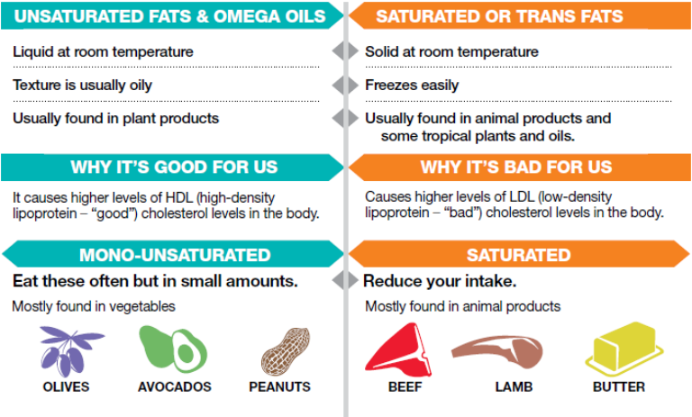

MEAL AND SNACK TIMING

Pre-game meal
- Focus on carbohydrates, like 100% whole wheat breads along with fruits like bananas and oranges. These types of foods digest more slowly and provide the body with a sustained source of energy for training.
- Remember that consuming a meal or snack that is too high in sugar can actually cause an insulin spike which could create a low blood sugar level during the course of exercise causing a decrease in performance from fatigue and confusion.
- A meal or snack that is high in fat may also create a negative outcome. Fats tend to digest more slowly, which can cause necessary energy for your muscles to function properly to be diverted to the digestion process. Think of it as a tug of war going on within your body. Energy is being divided between digestion and your working muscles.
  - PRE-GAME / WORKOUT RULE
    - Consume a snack 1 hour prior, higher in carbohydrates, avoid higher amounts of fats and proteins, and try to drink 16 oz of water.

During practice/competition/physical activity
GOALS:
- To maintain physical and mental performance
- Consuming carbohydrates helps our muscles maintain the power and energy they need to do the work we are asking of them, while our brain is also getting powered by this same fuel source to ensure it stays happy so we can continue to work out hard.
Quick Tips
  - If exercise is under 45 minutes, no additional carbohydrate source is needed
  - During exercise that last between 45 and 75 minutes, a small source such as half a banana or 3-4 ounces of a sports drink may be necessary.
  - If the exercise last between 1 and 2 ½ hours, 30-60 grams of carbohydrate is the target such as a whole banana, granola bar, and sports drinks such as Gatorade.

Post-workout meal
GOALS:
    - Refill our gas tanks (energy stores) that have been used during physical activity
    - Restoring our fluids and electrolytes that were lost in sweat during activity
    - Providing protein to aid in repairing damaged muscle and helping our body build new and improved muscle.
“Recovery Window”
    - “Your body uses stored energy (glycogen) in your muscles to power through your workout or game, but after that workout, you need to refill the nutrients lost. What to do?
      - As soon as possible post workout, have a meal that contains carbohydrates and protein. This gives your muscles the ability to refill the tank, and helps your tired and trained muscles rebuild and repair for the next day’s training session.

Combo (Carbs + Protein) Meal Ideas for your athletes
Examples of nutrient-rich carbohydrate and protein combinations
(Contains 50-75 g carbohydrate and15-20 g protein)

2-3 cups Low Fat Chocolate Milk
1-2 sports bars (check labels for carbohydrate and protein content)
1 large bowl (2 cups) breakfast cereal with low fat milk
1 large or 2 small cereal bars + 1 cup fruit-flavored yogurt
1 bread roll with cheese or peanut butter + large banana
2 cups fruit salad with 1 cup fruit flavored yogurt
Bagel with thick spread peanut butter + 1-2 cups low fat milk
Large baked potato + low fat cottage cheese filling + 1-2 cups low fat milk
2-3 slices lean meat and veggie pizza
2 cups breakfast cereal with milk 2 cups flavored yogurt
2-3 cups fruit smoothie
Thick bread sandwich with meat and salad filling
2 cups stir-fry with rice or noodles and meat

SNACKS

Healthy snacks are important for everyone! Athletes and non-athletes included. Snacking can be a helpful way for athletes to build muscle and recover after an intense training session or competition. Unhealthier foods that are high in sugar, sodium, and inflammatory fats can interfere with recovery and may reduce overall athletic performance. For a healthy snack, opt for fruits and vegetables with whole grains, lean protein, or low-fat dairy. Here are some examples of healthy snacks to go along with a mini menu for your athletes to choose from:
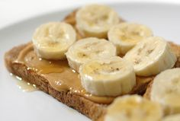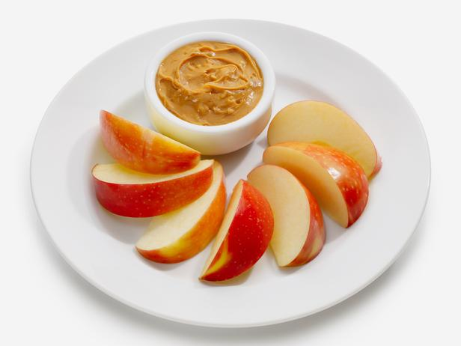
Apple slices & Peanut Butter
Apple & PB on whole wheat toast
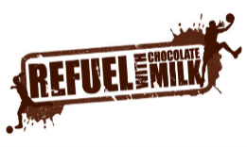
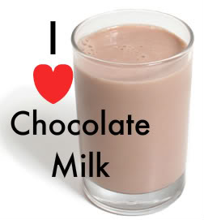

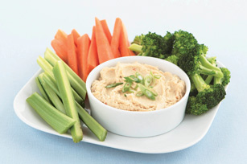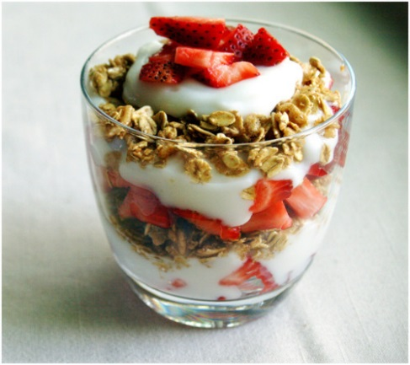
Carrots, Celery, Broccoli, and hummus
Greek Yogurt Parfait:
Greek Yogurt, granola, fresh fruit choice

Mini-Menu Ideas:
Dry cereal: Try some finger-food cereals (unfrosted) alone or mixed with nuts, raisins or dried fruits. Take your cereal blend with you and eat it dry if you don't have time to add milk.
Yogurt: Buy it with the fruit added, or buy it plain and add your own favorite fruits or granola. Try the regular or thick-and-creamy fruited versions or the yogurt drinks.
Instant oatmeal: Make it with low-fat milk instead of water. Add chopped nuts and raisins.
Crackers: Try the whole-grain or stone-ground wheat variety and reduced-fat versions.
Nut butter (almond, cashew and peanut): Spread it on a banana, bagel or rice cake. Make your own snack using peanut butter and whole-grain crackers.
Pretzels: Try various sizes and shapes to find the ones you like best. Buy the salt-free variety, or knock off the salt entirely if reducing your salt intake is important. Avoid pretzels with fat added.
Fruit: Fresh fruit is always a good choice. Make your own snack packs using dried fruits like raisins, cherries and cranberries.
Energy bars, breakfast bars and low-fat granola bars: Bars are convenient, but they can be expensive. Don't believe everything that the front labels say about enhancing your performance thought, it’s the calories you’re consuming that give you energy, not some magical ingredient. Be sure to read the label carefully. Look for the following ratio when it comes to grams of protein (10-15 grams), carbohydrate (30-40 grams) and fat (4-8 grams).
Sandwiches: Use whole-wheat or whole-grain bread. Be sure to use lower-fat meat-and-cheese choices and reduced-fat versions of mayo or substitute with Greek yogurt. Add lettuce, tomatoes and green pepper slices to provide a vitamin and mineral boost!
Cottage cheese: Use the snack-size, low-fat versions. Eat cottage cheese along with snack-size canned fruit or green pepper and tomato.
Popcorn: The snack-size microwave light versions are just the right size to take on the run. Instead of using butter, try spraying popcorn with cooking oil sprays and adding spices like chili powder or garlic powder. Ms. Dash no salt seasoning mixes are a great way to add flavor without the added sodium.
Raw vegetables: Baby carrots, slices of bell peppers (red, yellow, orange, green), broccoli, cauliflower, celery, and snap peas great snacking options as they are low in calories but high in nutrients that the body needs. Try low fat dipping sauces like French or Italian dressings to dip them in.
Tuna: A can of the water-packed snack size goes well with crackers and fruit.

The Trail Mix Bar:
Its fast, it taste great, it’s easy and fun to make, and it’s one of the more convenient snack foods that are available for athletes, but what is it? Trail Mix! “Trail mix" is the term for a mix of bite-sized ingredients that travels well. These ingredients include nuts, seeds, dried fruits, grains, and savory sweets that provide powerful nutrients to keep you healthy and full of energy to take on the day.
To make your own trail mix, (individually or as a group) choose one item from each of the categories listed below.
Trail Mix: Choose one that contains nuts, fruit and some cereal or pretzels. (Make your own via a trail mix workshop, have your athletes bring in their favorite items and the team can participate in preparing their individual bags)

Nuts – packed with healthy mono and poly unsaturated fats, protein, fiber, antioxidants, vitamin E, and other vitamins and minerals
Choose from Almonds, pistachios, cashews, peanuts and walnuts
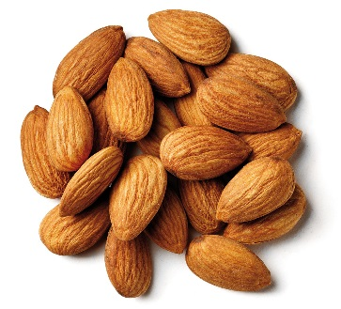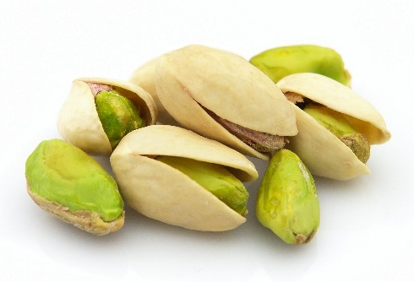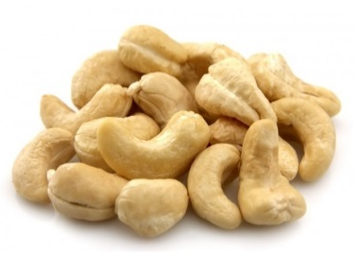
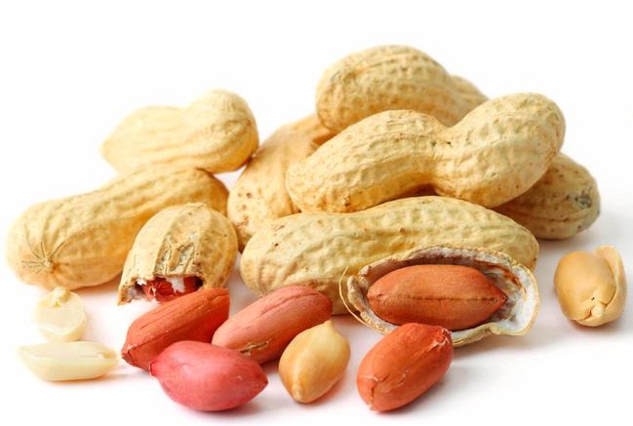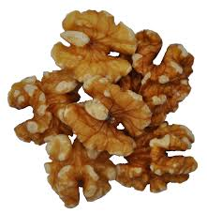

Seeds – A great alternative for those athletes who may have nut allergies or for the athlete who is looking for even more variety in their trail mix bag. Seeds provide many of the same great health benefits that nuts do!
Choose from Hemp seeds, pumpkin, sesame, flax, chia, and sunflower

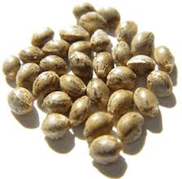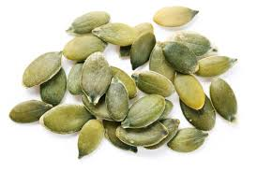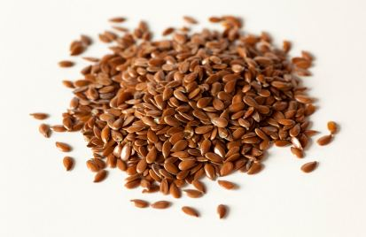
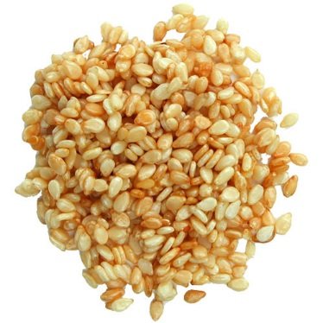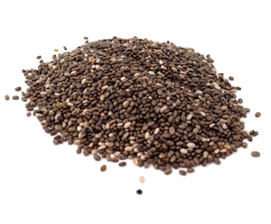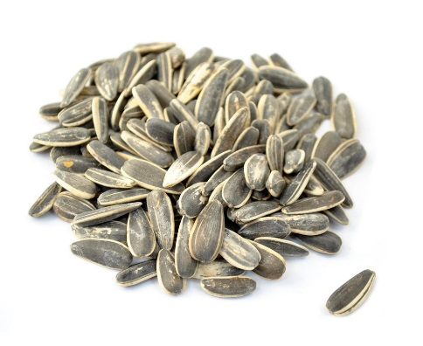
Dried Fruit – Great source of fiber, antioxidants, calcium, and vitamins A, C, and K.
Choose from apples, cherries, cranberries, blueberries, apricots, raisins, banana chips, figs, pineapple chunks, and mangos.
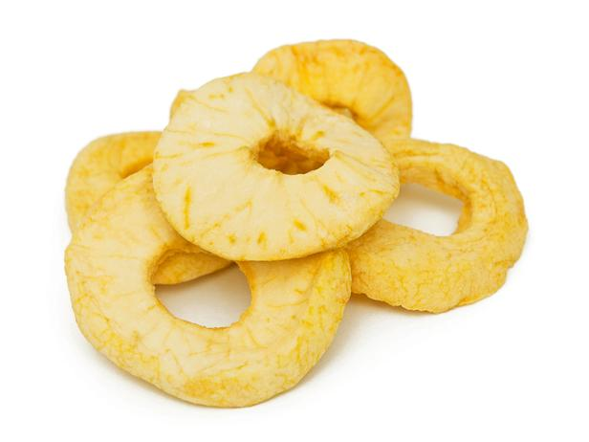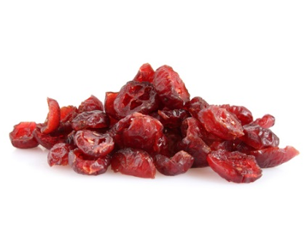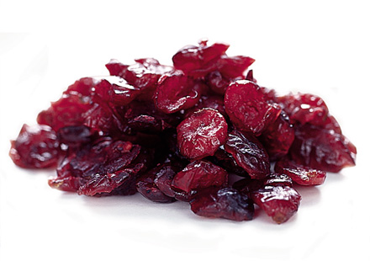
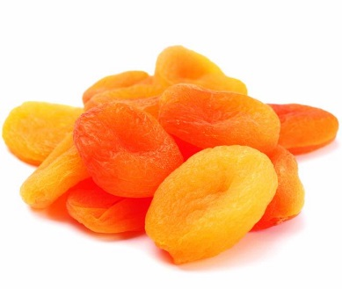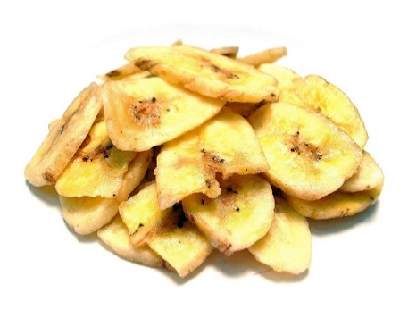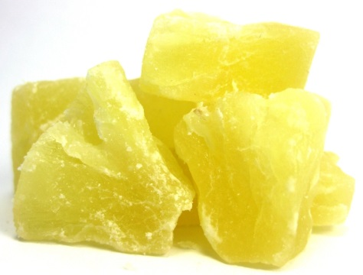
Grains – This is a great way to add some complex carbohydrates to your trail mix bag for sustained energy. Remember to choose whole grain options whenever possible. Grains can also add a crunch factor to the athletes trail mix bag which aides in overall consumption.
Choose from shredded wheat cereal (unfrosted), other whole grain cereals like cheerios, Chex, bran flakes, puffed rice cereal, whole wheat crackers, granola, toasted oats, and even air popped popcorn.
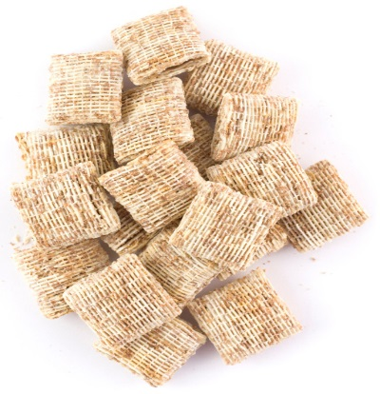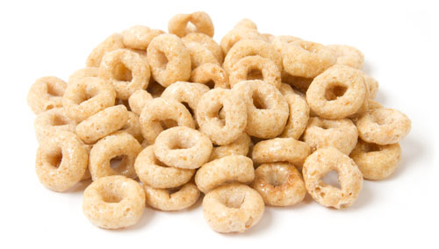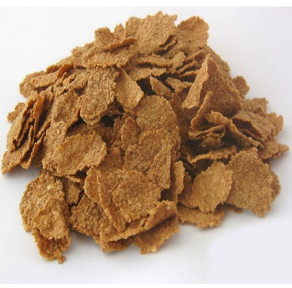
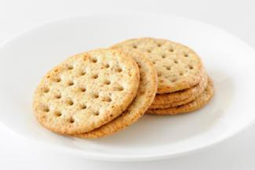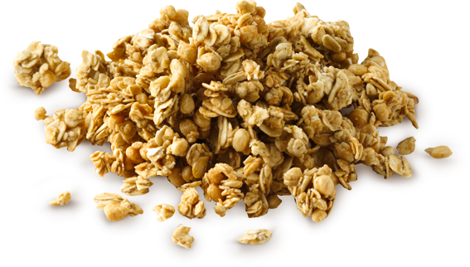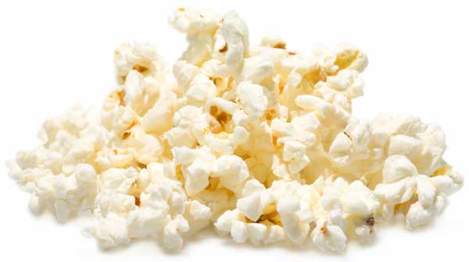

Sweets – A little bit of sweetness can help to round out the trail mix bag by improving overall taste and providing the athletes with a quick dose of carbohydrates for energy. Remember to add the following items sparingly.
Choose from M&M’s, chocolate chips, butterscotch chips, peanut butter chips, yogurt covered raisins and or pretzels, chocolate covered coffee beans (the caffeine helps to act as a natural stimulant for your athletes), mini marshmallows, and chocolate covered nuts.
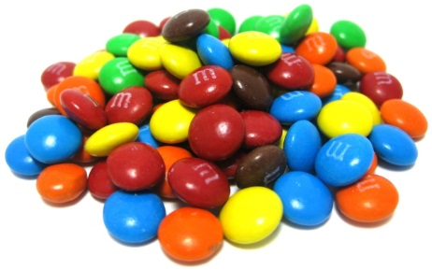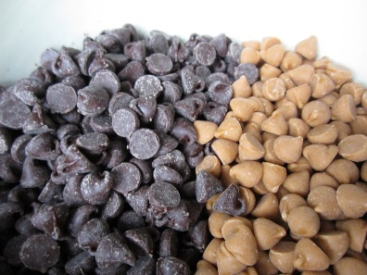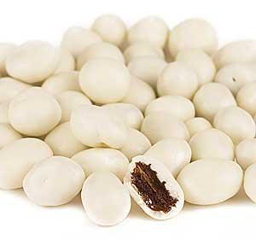
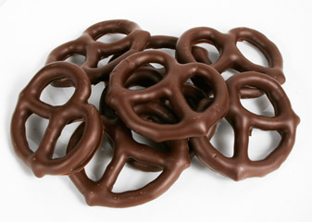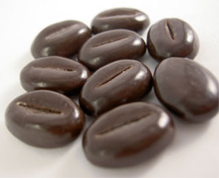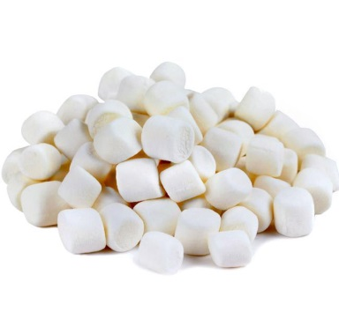

Savory Extras – This is an option that helps to add variety to your trail mix bag without adding extra calories. Try adding spices such as nutmeg, cinnamon, sea salt, ground ginger, cardamom, and even cayenne pepper for those who enjoy the heat!

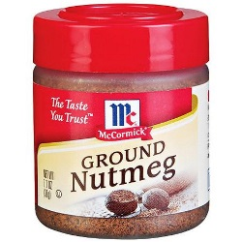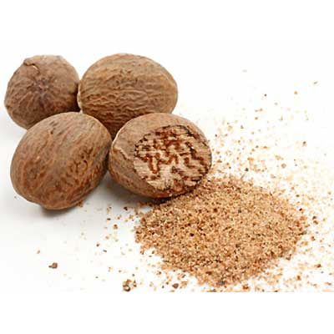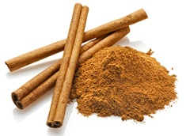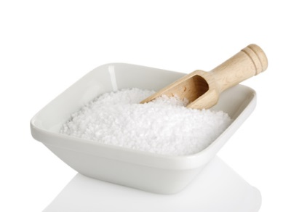
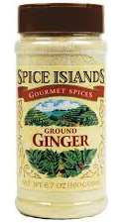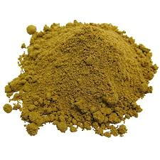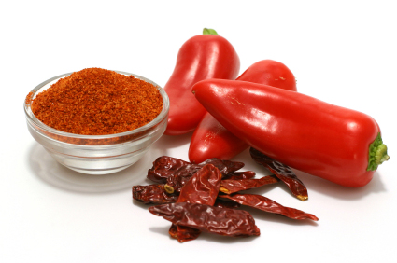

Athletics (Track & Field)
Track & Field includes several events, and so the nutritional needs of track and field athletes vary, but regardless of your event, the benefits of feeding your body well are numerous. Good nutrition will optimize your training program; promote consistency in performance; enhance recovery after workouts and events; maintain or gain (if desired) weight; reduce risk of injury and illness; and give you confidence to face competition.

As a general guideline, eat CARBOHYDRATES BEFORE training or competition and eat PROTEIN AFTER.
- Eat small meals every two to three hours
- Meals should include protein and complex carbohydrates
- Stay hydrated with at least eight ounces of water per hour, depending on climate conditions (you may need more if it's hot out)
- Eat post-workout meal within 30 minutes
- Never skip meals

General Nutrition Guidelines for Track & Field Athletes
Calories: Generally a high calorie expenditure sport, may vary by event
Carbohydrates: 5-7 g/kg/day
Protein: 1.2-1.7 g/kg/day
Fat: Remainder of calories coming from heart healthy fats

Track & Field Meal Plans Guidelines
Pre-workout meal = one to three hours before practice or competition
Pre-workout snack = one hour to 15 minutes before practice or competition
Post-workout snack = within 30 minutes after practice or competition
Post-workout meal = one to two hours following practice or competition
Evening snack = two to three hours after last meal

Endurance Events
Pre-workout meal: 16-20 ounces of water, lean meat on whole grain bread, fruits and nuts
Pre-workout snack: Five to 10 ounces of water, low-fat granola bar
During practice or competition: Six ounces of water per 20 minutes of activity; six ounces of sports drink per hour; energy liquid gel for sessions over two hours
Post-workout snack: Fruit, granola bar, chocolate milk or yogurt
Post-workout meal: Lean meat or grilled fish, vegetables, whole grain pasta, rice or bread
Evening snack: Fruit, cheese slices or chocolate milk

Sprinters, Hurdlers, Jumpers
Pre-workout meal: 16 ounces of milk, beans and/or lean meats on whole grain bread, fruits and nuts
Pre-workout snack: Eight ounces of water, low-fat granola bar and fruit
During practice or competition: Eight ounces of water per 20 minutes of activity; eight ounces of sports drink with electrolytes per hour
Post-workout snack: Fruit, yogurt and granola bar; pretzels or bagel with peanut butter; or 16-ounce meal replacement bar with protein and carbohydrates
Post-workout meal: Lean meat or grilled fish, vegetables and whole grain pasta, rice or bread
Evening snack: Fruit, cheese slices or chocolate milk

Throwers
Pre-workout meal: 16 ounces of chocolate milk, beans and/or lean meats on whole grain bread, fruits and nuts
Pre-workout snack: Eight ounces of milk or protein shake, granola bar or fruit
During practice or competition: Eight ounces of water per 20 minutes of activity; eight ounces of sports drink with electrolytes per hour
Post-workout snack: Fruit, yogurt and granola bar; pretzels or bagel with peanut butter; or 16-ounce meal replacement bar with protein and carbohydrates
Post-workout meal: Lean meat or grilled fish, vegetables and whole grain pasta, rice or bread
Evening snack: Fruit, cheese slices or chocolate milk

Aquatics/Surfing/Stand Up Paddle
Aquatics is a general term for a variety of sports played in the water. These sports include water polo, diving, swimming, sailing, canoe/kayaking, rowing or sculling, water skiing, stand up paddle and surfing. Swimming is a sport consisting of swimming a defined distance (which varies depending on the four recognized stroke categories) as quickly as possible. Rowing and sculling is a sport consisting of a speed race in a straight line over a maximum distance of 2000 m; races take place on calm water in boats designed for the purpose. Stand up paddle (SUP) is a sport consisting of a speed race in both straight and curved distances (which vary) and take place on calm water. Surfing is a sport consisting of riding the side of a breaking wave on a surfboard.

Aquatic athletes may experience insufficient caloric intake either voluntarily when trying to manipulate body shape and composition or involuntarily in the face of physically demanding training. Although the aquatic disciplines may not have the body weight restrictions faced by athletes in other sports that emphasize leanness, some athletes experience energy and nutrient deficits. Carbohydrates play a key role in supplying the necessary energy needed in order to participate in the training and competition aspects of these sports.

General Nutrition Guidelines Aquatics
Calories: Relatively high calorie expenditure sport, will vary based on individual athletes intensity of training and the distance involved per sport.
Carbohydrates: 5-7 g/kg/day
Protein: 1.2-1.7 g/kg/day
Fat: 1.0 g/kg/day

Aquatics Meal Plan for 150 lb / 68 kg athlete
Energy: 2700 calories
Carbohydrates: 6 g/kg (408 grams) (1632 calories)
Protein: 1.4 g/kg (95 grams) (380 calories)
Fat: 1.0 g/kg (68 grams) (612 calories)

General Meal Plan for Aquatics/Surfing

8 AM Breakfast
Concentrating on getting 100 grams of carbohydrate and 25 grams of protein.
2 pieces whole wheat bread
3 eggs
1 banana
1 chocolate milk
2 tbs grape/strawberry jelly

10 AM Snack
1 cup fresh fruit

Noon Lunch
Concentrate on additional 100 grams of carbohydrate to ensure enough energy for afternoon training session.
4-6 ounces grilled chicken over a salad (pick your vegetables)
1 cup rice (wild or brown)
1 apple
1 cup sweet potato
16-32 ounces of a sport drink

2 PM Training (2 hours)

5:30 PM Dinner
Recovery is the name of the game. Make sure you eat at least 25 grams of protein with an additional 100 grams of carbohydrates.
2 Peanut butter and jelly or turkey sandwiches using whole wheat bread
2 cups chocolate milk
1 cup fresh fruit

9 PM Snack
Important to have your athletes consume 20-25 grams of protein to ensure muscle recovery and repair for the next day is complete.
½ cup cottage cheese with ½ cup fruit & 1 scoop of whey or casein protein
Or
1 turkey sandwich
Or
1 smoothie using 1 cup chocolate milk, 1 tbs peanut butter and 1 banana

BASKETBALL
Basketball is an intermittent, high intensity sport requiring strength, power, cardiovascular fitness, agility and a unique skill set. The game is usually played in 4 quarters with a break at half-time. The body uses energy to perform skills such as jumping and passing the ball, sprinting up and down the court along with performing quick accelerated movements.

Basketball General Nutrition guidelines:
Calorie needs: Varies depending on the individual, but for players in training, generally a high calorie expenditure sport
Carbohydrate: less than 6 g/kg/day, 7-8 g/kg during heavy training and or competition
Protein: 1.4-1.7 g/kg/day
Fat: Remainder of calories as fat, with an emphasis on heart healthy fats to reduce inflammation.

Conversion factor: 1 lb = 2.2 kg

Example of meal plan for 150 lb / 68 kg athlete in basketball
Calories: 3000 calories for the day
Carbohydrate: – using 7 grams per kg, 476 grams (1904 calories)
Protein: – 95-116 grams (380 – 464 calories)
Fat: Remainder of calories as fat, emphasis on heart healthy fats to reduce inflammation

Snacks
(see snack section for great ideas)
5-10 grams of protein
20-40 grams of carbohydrate
Remainder of energy from fat (varies)

Carbohydrates
Basketball athletes need larger amounts of carbohydrates to continually restock their energy reserves within the body. On average a basketball athlete weight 150 lbs or 68 kilograms will consume around 115 grams of carbohydrate each meal and the remaining carbohydrate will be consumed as snacks (20-30 grams for each snack).

Protein
A basketball athlete looking to achieve a lower energy intake per day, look to 96 grams per day which can be divided out by 5 meal times for an average of 19 grams per meal. For the athlete that is using more force or power during his or her sport, or training at a higher intensity, look to achieve 116 grams of protein throughout the day or 23 grams per meal/snack.

I like to have snacks contain fewer grams of protein compared to breakfast, lunch or dinner to create balance and a more normal eating pattern. In this instance for the 96 grams, each meal contains 25 grams, and both snacks around 10 grams. For the 116 grams, the athlete would look to consume 32 grams at each meal and 10 grams of protein at each snack.

Fluids
Fluid demand is high to avoid dehydration, as well as replenishing key minerals that are lost through an athlete’s sweat during training or competition. Fluids should be consumed at each meal, snack, between training and meal times as well as during a training or competition setting.

Training (practice) schedule:

8 AM Breakfast/Pre-workout
If the athlete has training at 10 AM, then we want to achieve around 2 grams/kg of carbohydrate in this meal. For a 150 lb athlete that would 136 grams of carbohydrates, here are a few food choices to help your athletes achieve success:
Carbohydrates:
2 pieces of whole wheat bread with 2 tbs of jelly
1 cup of oatmeal with 2 tbs maple syrup
1 banana 8 inches
16 ounces (2 cups)
Corn flakes (2 cups)
Honey Nut Cheerios (2 cups)
Milk (2 cups)
Bagel
Raisins (1/2 cup)

Protein options:
Milk 2% (1 cup)
Cottage cheese (1 cup)
Eggs (3 scrambled)
2 tbs Peanut butter / 1 banana smoothie (made with 1 cup milk and 1 cup ice)

10 AM TRAINING

1 PM Lunch/post workout
Looking at 115 grams of carbohydrate with a minimum of 19 grams of protein.
Examples:
Backed potato
½ baked chicken breast
1 cup applesauce
1 cup vegetable medley
½ cup of baked beans
Or
2 slice of pepperoni pizza
1 cup milk
1 apple

3 PM Snack 1
20-40 grams of carbohydrate
5-10 grams of protein
5-10 grams of fat
Total calories 145-290

Examples:
1 apple
2 tbs peanut butter
Or
Chobani Greek yogurt , 1 serving
1 graham cracker

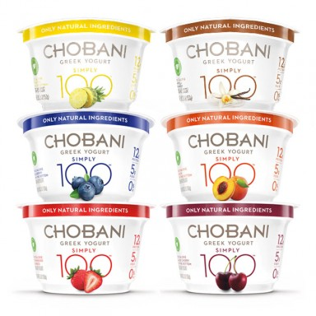

6 PM Dinner
115 grams of carbohydrate and a minimum of 19 grams of protein
1 turkey burger with whole wheat bun
1 corn on the cob
1 cup fresh fruit
1 cup of chocolate milk
Or
2 cups spaghetti and meatballs
1 piece of whole wheat toast

9 PM Bedtime snack
20-40 grams of carbohydrate
5-10 grams of protein
5-10 grams of fat
Total calories 145-290

Peanut butter and jelly sandwich (36 grams carbohydrate and 18 grams protein)
Or
20 mini pretzels and 1 scoop of whey protein (mixed with water) (25 grams carbohydrate, 20 grams protein)

How does this look on a plate?

Nutrition on days of competition
The one true adjustment that needs to be made when it comes to nutrition and meals on the day of competition is the timing around your pre-event meal. In this instance we want to “top off” our energy stores so the body has plenty of fuel available for the event. The ideal pre-event meal is carbohydrate rich, palatable, and well-tolerated by the individual athlete.

The meal should contain anywhere between 1 and 4 grams/kg of bodyweight consumed 1-4 hours prior to the event. To control and help eliminate the possibilities of gastrointestinal stress (stomach aches) the carbohydrate and calorie count of the meal needs to be lowered the closer to exercise the meal is consumed.

Example: If an athlete is only to have his or her meal 4 hours prior to the event due to travel and or other logistics, then we would want to consume 4 grams/kg (272 grams of carbohydrate) in that meal. If the athlete is going to consume a meal 1 hour prior to the event, then the total number of carbohydrates consumed needs to be at or as close as possible to 68 grams.

4 hours prior to event:
2 cups elbow macaroni
1 5 inch sweet potato
1 cup granola
1 cup rice
2 cups whole grain cereal with 2 cups milk and 1 cup of fruit

1 hour prior to event:
Bagel and cream cheese (65 grams)
Turkey sandwich with 1 cup fruit juice and 10 mini pretzels (65 grams)
1 large sports drink (36 ounces) (62 grams of carbohydrate)

Off Season
With the grind of the season behind you, this is the perfect time to focus on your eating habits and make any changes to your body composition you seem fit (lose/maintain/gain weight). You can do this by picking a couple habits you’d like to improve during this time period. For example, focus on drinking more water, eating breakfast daily or avoiding fast food.

Weight gain
If you’re looking to add some lean mass during the offseason, a realistic goal is about a half to one pound a week. This is the equivalent of an extra 500 calories per day or roughly 3500 calories per week. Gaining weight too quickly can mean putting on unwanted body fat. When planning and preparing your meals, use these tips to help incorporate more quality calories into your diet to promote weight gain:
- Include beverages, such as low-fat milk or 100 percent juice, with all of your meals.
- Eat often — having a meal or snack every two to three hours can ensure you are getting adequate calories throughout the day.
- Add calorie-dense foods such as nuts and nut butters, granola, avocado, and olive oil; these foods can help increase calories with little increase in food volume.
- Use olive oil when preparing foods to add some additional calories from healthy fats.

Weight loss
For weight loss during the offseason, focus on low-calorie, high-nutrient foods such as fruits, vegetables and lean proteins. Losing about one to two pounds per week is a realistic goal to strive for to avoid losing your lean mass. Keep in mind the following:
- Include lean protein at every meal and snack (e.g., lean meat, nuts, Greek yogurt, eggs, and cottage cheese).
- Avoid drinking sugary beverages such as soft drinks, punches and energy drinks, as the calories can add up quickly.
- Continue to eat often, ideally every three to four hours. This will prevent you from becoming too hungry and overeating.
- Look to whole-grain foods, fruits and low-fat dairy products to fulfill your carbohydrate requirements.

Weight Maintenance
With a likely decrease in activity during the offseason, decreasing calories and carbohydrate intake are necessary to avoid unwanted weight gain. Remember to:
- Continue to eat often throughout the day, cutting back on portion sizes at meals.
- Avoid eating too many high-calorie extras such as creamy sauces, salad dressings and desserts.
- Reach for water and unsweetened beverages for hydration.
- Match your carbohydrate intake to your activity level. That means reducing your carbohydrate intake on an off-day as opposed to a high-intensity training day when you need more carbs for fuel and recovery.

Bocce
Bocce is not a very physically demanding sport. In most cases, walking, standing and rolling the ball, is the extent of the physical activity. Because of this, bocce does not burn a very high number of calories per hour. In general, bocce burns approximately 200 calories per hour for an average 150 pound / 68 kilogram person.

When looking at the nutrition and health aspect for those athletes participating in bocce ball, the importance lies in making sure adequate carbohydrate (50-70%), protein and healthy fats are spread throughout the diet. Most bocce ball players will come in all sorts of shapes and sizes, and each athletes meal plan is determined individually by that athlete and his or her goals whether it be weight loss or weight gain.

General Nutrition Guidelines Bocce ball
150 lb/68 kg athlete
Carbohydrates: 4-6 g/kg/day (using 5 kg gives us 340 grams and 1360 total calories)
Protein: 1.0-1.4 g/kg/day (using 1.2 gives us 82 grams and 328 calories)
Fat: The remaining calories will be made up of heart healthy fats

Conversion factor: 1 lb = 2.2 kg

Meal ideas for Bocce ball athlete:
8 AM Breakfast
3 eggs
1 piece of whole wheat toast
1 cup fresh fruit

10 AM Snack
1 apple
2 TBS peanut butter

Noon Lunch
Salad (vegetable toppings, low fat dressing)
4 ounces of turkey meat
1 cup fresh fruit
1 cup of potatoes (sweet or white)

3 PM Snack
1 cup Greek yogurt
1 graham cracker sheet
5 PM Dinner
1 cup pasta
1 cup red pasta sauce
2 cups white or chocolate milk
1 cup watermelon
½ cup vegetable such as corn, broccoli, and carrots

6 PM GAME/TRAINING SESSION

9 PM Bedtime snack
Crackers with 2 ounces of cheese
Yogurt
Fruit smoothie

Bowling
Many things are crucial to a bowler's performance. First, there are the technical elements such as equipment, lane conditions and lane surfaces, practice techniques, and the little things like taping, bowler supports & aids. Another element often investigated of late is the psychological element or the mental game and how it affects the athletes bowling performance. Lastly, there are the physical or physiological factors such as aerobic conditioning, strength, and flexibility. Of all things that impact your performance, one element remains neglected within the vast array of technical advancements and psychological importance, and that's the nutritional element. As bowlers, it is challenging to find healthy food options at the bowling center. Bowling’s physical demands are not unlike other sports. Strength and endurance can be added benefits to maximizing performance and utilizing good nutrition will complement any physical conditioning plan.

The major nutritional crisis for most bowlers is extra body weight. Excess body fat is only a hindrance. Not only does it add extra stress to the muscles and bones as you bowl, the stress on your heart is potentially life threatening. Excess body fat also can hinder your bowling technique, making it more difficult to execute the delivery. Fatigue from carrying the extra weight can reduce your training time and add distractions to your game.

General Nutrition Guidelines for Bowling:
Calories: Relatively low calorie expenditure sport, the body does not use up many calories during play
Carbohydrates: 4-6 g/kg/day
Protein: 0.8-1.2 g/kg day
Fat: 1.0 g/kg/day mostly made up of heart healthy fats

Conversion factor: 1 lb = 2.2 kg

Bowling Meal plan for 150 lb / 68 kg athlete:
Carbohydrates 4 g/kg = 272 grams of protein and 1088 calories for the day
Protein 1.2 g/kg = 82 grams of carbohydrate and 328 calories for the day
Fat 1.0 g/kg = 68 grams of fat and 612 calories for the day

7 AM Breakfast
Meal totals 62 grams carbohydrate
3 eggs
2 pieces of whole wheat toast
1 cup fresh fruit
1 cup 2% milk

10 AM snack
1 granola bar
1 apple

12 PM Lunch
4-8 oz of lean meat (chicken, turkey)
1 cup red skin potatoes
1 cup green beans
1 cup fresh fruit
1 cup cranberry juice

Bowling Practice 1 PM – 4 PM

6 PM Dinner
4 oz lean meat
½ cup rice
1 cup carrots
1 cup fresh fruit medley
1 cup 2% milk

9 PM Bedtime snack
1 apple
½ cup cottage cheese
¼ cup mixed nuts

Snack ideas for bowling alley
Pretzels
2 – TBS of peanut or nut butter
Gatorade or other sports drink
Apple, Banana, orange
Peanut butter and Jelly sandwich on whole wheat bread
Turkey sandwich on whole wheat bread
Granola Bars
Nut/Dried fruit mix (1:1 ratio)
String cheese
Yogurt

Cheerleading
As in any sport, diet and nutrition are important to Cheerleaders. A proper diet can help build strong muscles, keep your mind alert, give you energy and enhance your performance. Simply said, "Food fuels your body and mind". There is so much focus on the appearance of Cheerleaders; they sometimes become victims of fad diets, fast weight loss and improper nutrition.

General Nutrition Guideline Cheerleaders
The diet or meal plan of a cheerleader should follow the path of an overall healthy diet such as making half your plate full of healthy carbohydrates like fruit and vegetables, 1/4th your plate should contain a protein source and the other portion should be made up of healthy whole grain options.

Cheerleading General Guideline, What to Eat and When:
Before
Eat high carbohydrate foods like bread, pasta, whole grains, vegetables, and fruits. Carbohydrates are digested quickly and provide glucose to the muscles. Stay away from dairy products and too much protein like greasy hamburgers, pizza, ice cream, and cheese. Avoid soda pop and candy bars. They can give you a quick burst of energy, but it will drop quickly, leaving you feeling spent.

Timing your meal from 1 to 4 hours before strenuous activity will help keep plenty of blood glucose available for your muscles.

It is also important to drink plenty of water to keep your muscles hydrated.

During
Drink plenty of water. Exertion and perspiration deplete your body of fluids and can lead to dehydration. It is recommended you drink at least a half of cup of water for every twenty minutes of exercise or strenuous activity.

If your activity is hard and continuous, over 90 minutes, drink a sports beverage or a drink with sugar added.

After
This is the time to eat protein to replenish what you lost during your physical activity, but don't overdo it. Remember protein can not only come from meats but is also present in dairy products and eggs.
Replace carbohydrates if your activity was long and exerting.
Replace any potassium or sodium that has been lost during competition or training by eating fruits, vegetables and salty foods.
Continue to replace fluids.

Sample Meal Plan for Cheerleader:
Breakfast:
1/2 cup oatmeal
1/2 cup cottage cheese, low fat
1/2 banana
1 tbsp peanut butter
Lots of water and maybe a plain coffee with a little low fat milk

Mid Morning Snack:
2 fat free string cheeses
An apple or a slice of Ezekiel bread

Lunch:
Sandwich made from 2 slices Ezekiel bread with
4 - 6 oz. chicken
A few slices of avocado
And non-fat condiments of your choice
Carrots, broccoli, and other assorted veggies
Non-fat dressing (Walden Farms is a good choice)
A fruit of your choice or a sample size cliff bar

Before Practice:
PowerBar or other nutrition bar with about 30g carbs and 10-20g protein

After Practice:
8-16 oz. Gatorade
A few slices of low-sodium turkey (to tide you over until dinner)

Dinner with the parents:
1 sweet potato
4-6 oz. of chicken
1 oz. of almonds
A giant serving of cooked broccoli
Glass of milk

Before Bed:
1 Greek yogurt (6 oz) with 1 tbsp peanut butter mixed in

CYCLING
Cycling is a sport of various intensities and durations, from sprinters who’s races last merely seconds to those athletes who are involved in endurance races like the Tour de France when races last anywhere from a couple of hours to an event that encompasses hours of riding a day for multiple days. The overall energy demand can differ depending on the type of cycling the athlete is involved in. (Sprinter, endurance, mountain biker, BMX)

General Cycling Nutrition guidelines:
Calories: Typically calculated on an individual needs basis based on demands of training/type of cyclist.
Carbohydrates: 6-8 g/kg/day (typically 65% of total calories)
Protein: 1.2-1.7 g/kg/day
Fat: Remaining calories based on energy needs but focusing on heart healthy fats

Conversion factor: 1 lb = 2.2 kg

Energy and carbohydrates:
Nutrient and energy needs are often very high for cyclist, especially those endurance cyclists. A well balanced diet is important so that proper fuel is provided for the intense training and or days of competition. Endurance cyclist will need to eat carbohydrates during the ride/event and must learn to consume food and or sport drinks/bars while on the bike. Examples of these items include electrolyte drinks such as Gatorade, energy bars, gels, and bananas. These items are usually well tolerated by the athlete.

Cycling Example of meal plan for 150 lb / 68 kg athlete
Using 6 g/kg for carbs, 1.5 g/kg for protein and the remainder of the athlete’s diet from fat calories.
Carbohydrate – 408 grams which totals 1632 calories for the day
Protein – 102 grams which totals 408 calories for the day
Fat: Remainder of calories as fat, emphasis on heart healthy fats to reduce inflammation

Macronutrient and Fluid Timing for training and Racing
Hydration plays a vital role in the athlete’s ability to perform and train. The rule of thumb is that your athlete’s urine color should be a light yellow, similar to a glass of lemonade. Here is an example of a timing schedule when it comes to fluids:
Before the Race/training:
Drink 17-20 oz of fluid 2 hours before training
Drink 7-10 oz of a sport drink (Gatorade) 10 to 20 minutes before training
Consume 1-4 g/kg of bodyweight of carbohydrate 1-4 hours before competition (remember the rule 4 hours before a race use 4g/kg, 1 hour before a race use 1g/kg)
During the Race/training:
Consume 30 to 60 grams of carbohydrate per hour of training from a liquid source (Gatorade) or a semi solid source such as a sport gel.
Consume 7 to 10 oz of fluid every 15-20 minutes during training or as close to that time period as possible. Include sodium (Sports drink)
After the Race/training:
Drink 20-24 oz of sport drink for every pound of body weight lost; include sodium
Eat 1.0 – 1.2 g of carbohydrate per kg of bodyweight within the first hour to start replenishing those carbohydrate stores for tomorrow.

SHORT RIDES
RIDE DURATION: 1 hour or less
PRIMARY CONCERN: Fluid replenishment
WHAT TO DRINK: Plain water
WHAT TO EAT: Most people start with enough stored energy for a 60-minute workout, but carry 1 Power Bar Gel, which has 27 grams of carbs and 200mg sodium, just in case stored energy was lacking from initial plan.
BONUS TIP: For optimal recovery, eat a full meal within an hour of finishing an intense workout.

MEDIUM-LENGTH RIDES
RIDE DURATION: 1 to 3 hours
PRIMARY CONCERN: Carbohydrate replenishment
WHAT TO DRINK: 1 bottle of water and 1 bottle sports drink per hour, at least
WHAT TO EAT: 30-60g of carb per hour from bars, gels and sports drinks--up to 80g if you're consuming glucose and fructose together
BONUS TIP: Don't dilute the sports drinks--your body absorbs them most efficiently at their correct concentrations.

LONGER RIDES
RIDE DURATION: 3 hours or more
PRIMARY CONCERN: Carbohydrate and electrolyte replenishment; food boredom
WHAT TO DRINK: 1 bottle of water and 1 bottle sports drink per hour, at least
WHAT TO EAT: 30-60g of carbohydrates per hour, total. Digestion can get harder as rides get longer, so eat more solids at the beginning of the ride, and rely on gels for quick energy in the last third of the ride.
BONUS TIP: Supplement bars and gels with carb-rich, low-protein, and moderate-fat "real" foods. Don't worry about specific amounts of protein or fat; just eat what tastes good so you keep eating.

Cycling Training Day Meal Plan
Carbohydrate – 408 grams which totals 1632 calories for the day
Protein – 102 grams which totals 408 calories for the day
Fat: Remainder of calories as fat, emphasis on heart healthy fats to reduce inflammation

8 AM Breakfast
Meal containing 2 grams of carbohydrates per kg of bodyweight 2 hours prior to game/training
This meal would contain 136 grams of carbohydrate. (68*2)

2 slices whole wheat bread
3 TBS strawberry jelly
3 TBS peanut butter
1 orange
1 sweet potato
2 cups 2% milk

11 AM 2 hour practice ride

1:30 PM Lunch
This meal contains approximately 107 grams carbohydrate

Grilled chicken
White potato
1 cup broccoli
1 banana
1 cup chocolate milk

3:30 Recovery Snack
This snack contains 31 grams carbohydrate
Apple
1 cup cottage cheese (6 grams carbohydrate)

6 pm Dinner
This meal contains 113 grams carbohydrate

1 cup black beans
1 cup rice
1 cup mixed vegetable
1 cup blueberries
1 cup 2% milk
8 PM Snack
2 100 calorie Chobani Greek Yogurt packages

Equestrian
Nutrition is not a consideration only for show days. It is about developing healthy eating habits for every day of your life. This makes particular sense for riders. The very business of caring for a horse is tough physical work -- from mucking stalls to pushing wheelbarrows, lugging sacks of grain, stacking hay bales, slogging water buckets. Even grooming the horse for an hour has been estimated to burn as many calories as a session of low-to-medium impact aerobics. Riders typically forget about their own nutrition since their main focus is on their four legged partners. Here is the key, if we can help our riders find a better way to fuel their bodies, their performance will not only make show days run more smoothly, it will help them cope with all the day-to-day chores of horse keeping.

Nutrition tips for those high stress show days:
A day before competition, riders should eat carbohydrate-rich meals and drink lots of extra fluids. On the day of the show, they should eat a light, easily digestible breakfast -- and here each may have to experiment to see what sits easily in the stomach when jitters may take over. Riders should avoid high protein or high fat foods, which not only tend to trigger unhappy digestive tracts, but may leave them with an energy deficit just when they need it most.

General Nutrition Guideline Equestrian:
Carbohydrates: 4-6 g/kg/day
Protein: 1.2-1.5 g/kg/day
Fat: 1.0-1.2 g/kg/day

Conversion factor: 1 lb = 2.2 kg

Equestrian Meal Plan for a 150 lb/68 kg athlete
Energy: 2400 total calories per day
Carbohydrates: Using 5 grams per kilogram would equal 340 grams or 1360 calories
Protein: Using 1.5 grams per kg gives us 102 grams or 408 calories
Fat: Using 1.0 grams gives us 68 grams or 612 calories

Typical Meal Plan Equestrian:
Day Before Show:
Low-fat, high-carbohydrate meals, such as:
Pasta with a tomato or primavera (vegetable) sauce (rather than a cream sauce), baked potatoes, or skinless grilled chicken and rice.
Lots of fluids.
If a rider knows she won't be able to eat much of a breakfast, she should have a late-night carbohydrate snack before going to bed.

Morning of the show:
Something light, such as:
Fruit 'smoothie' shakes, made with yogurt or low-fat ice cream.
Soft cooked cereals such as Cream of Wheat.
Bagels or toast.
Fruit (grapefruit, oranges, bananas) or fruit juice.
Avoid traditional, greasy breakfast foods like fried eggs, bacon, sausage, doughnuts, and hash browns.

During the show:
Pack a cooler with low-fat, high-carbohydrate items such as:
Turkey or tuna sandwiches (hold the mayo), fruits (frozen seedless grapes are great on hot days), bagels, dry cereal, Melba toast, string cheese, or soup.
Lots of cold water and juices.
Save the caffeine for the drive home, if you need it!

Flag Football
Flag football is a sport that involves high intensity, short duration activity with a short rest period between each play. The typical game can last between 3 and 4 hours. Body composition varies by position, with lineman dependent on their size, power, and strength to achieve the objective and receivers and or running backs using lean body mass and their speed to outmaneuver their opposition. Body size of players typically increases as an athlete moves from amateur levels of competition up to the professional leagues.

Flag Football General Nutrition guidelines:
Calories: Energy expenditure and requirements varies by level of sport (high school, college, and professional), level of training, amount of muscle mass, growth, etc, and must be individually determined.
Carbohydrate: less than 6 g/kg/day, 7-8 g/kg during heavy training and or competition
Protein: 1.4-1.7 g/kg/day
Fat: remainder of calories as fat, emphasis on heart healthy fats to reduce inflammation

Conversion factor: 1 lb = 2.2 kg

Flag Football Example of meal plan for 150 lb / 68 kg athlete in flag football during heavy training
Energy for the day - (4000 total calories)
Carbohydrate: 476 grams of carbohydrates (7 g/kg) and totals 1904 calories
Protein: 116 grams of protein (1.7 g/kg) and totals 464 calories
Fat: 70 grams of fat and totals 630 calories

8 AM Breakfast
3-4 eggs
1-2 cups chocolate milk
2 pieces whole wheat toast with 2 tbs jelly

11 AM Snack
Greek Yogurt
Mixed nuts
1 piece fruit (apple/banana)

1 PM Lunch
This meal should be higher in carbohydrate to supply fuel for practice.

2 sandwiches (Turkey, chicken, peanut butter and jelly) on whole wheat bread
16-32 oz sport drink such as Gatorade
1 piece or cup of fresh fruit
½ cup rice
½ cup black beans

3:30 – 6 PM practice

6:30 PM Dinner/Training table
6-10 oz lean meat
Chicken, Turkey, lean red meat options
2 cups fresh fruit (watermelon, strawberries, blueberries, oranges, bananas)
2 cups vegetables (broccoli, carrots, asparagus, cauliflower, green beans, baked beans)
1 serving whole wheat bread
1 – 2 cups 2% milk

9 PM Snack
20-25 grams of whey protein with 2 cups milk
1/4 lb sliced deli meat (turkey or chicken breast)
2 oz sliced cheese
¼ cup mixed nuts with 2 cups chocolate milk

Football (Soccer)
Soccer involves short, intense burst of activity combined with moderately intense durations of endurance exercise and occasional rest periods. The average soccer player will cover between 8 and 12 km (5-7 miles) in a game.

Football (Soccer) General Nutrition Guidelines
Calories: Relatively high expenditure sport that burns a large amount of calories
Carbohydrates: 6 g/kg/day, 8-10 g/kg/day during training and competition
Protein: 1.4-1.7 g/kg/day
Fat: Remainder of calories with an emphasis on heart healthy fats such as oils and nuts/seeds.

Conversion factor: 1 lb = 2.2 kg

) Overall energy cost is high during training and games, as the athletes are covering a lot of ground in miles/km and are usually moving constantly throughout the period of play. For instance a 75 kg or 165 pound athlete may expend more than 1500 calories in a game. The issue for most young athletes who play the game of soccer is the lack of energy consumption prior to a game that usually leads to fatigue and poor performance.

Fluids should be consumed early and at regular intervals during the game. Fluid intake rises during times of the year which produces hot and humid conditions. During the game, carbohydrate and electrolyte solutions such as Gatorade are most beneficial as they allow the body to continue to function (electrolytes) as well as quick sources of energy (carbohydrates).

Football (Soccer) General day to day breakdown of calories
Soccer athlete consuming 3000 calories a day.
150 lb / 68 kg athlete diet plan on training day (8 g/kg carbohydrate, 1.6 g/kg protein)

Breakdown for the day
Calories 3000
Carbohydrates: 544 grams which equals 2176 calories for the day
Protein: 108 grams which totals 432 calories for the day
Fat: 43 grams of fat which totals 392 calories

Football (Soccer) Plan for 150 lb /68 kg athlete:
Meal containing 4 grams of carbohydrate per kg of bodyweight 4 hours prior to game/training
This meal would contain 272 grams of carbohydrate (68*4)

2 cups pasta
1 ½ cups red pasta sauce
2 slices Texas toast garlic bread
1 banana
1 ½ cups chocolate milk

Meal containing 3 grams of carbohydrates per kg of bodyweight 3 hours prior to game/training
This meal would contain 204 grams of carbohydrate (68*3)

2 cups frosted flakes
1 ½ cups 2% milk
2 slices whole wheat bread
3 TBS strawberry jelly
2 cups orange juice

Meal containing 2 grams of carbohydrates per kg of bodyweight 2 hours prior to game/training
This meal would contain 136 grams of carbohydrate. (68*2)

2 slices whole wheat bread
3 TBS strawberry jelly
3 TBS peanut butter
1 orange
1 sweet potato
2 cups 2% milk

Meal containing 1 gram of carbohydrate per kg of bodyweight 1 hour prior to game/training
This meal would contain 68 grams of carbohydrate. (68*1)
Granola bars
1 cup grapes
1 sports drink 20 oz

Golf
Golf is a low-endurance, precision skill sport. It requires fine motor control and coordination. Swinging a club requires power and walking the course (especially if the golfer is carrying his or her clubs) requires a certain general fitness level that must be maintained. Golf courses have changes in topography and distance with most public courses range from 5,000 to 7,000 yards. The athlete typically spends 4-6 hours during a competitive round of golf.

General Nutrition Guidelines for golf:
Golfers do not have significantly increased demands for energy or nutrients; thus general nutrition guidelines are used and adjusted based on an individual basis.
Energy: Relatively low energy costs
Carbohydrates: 5-7 g/kg/day
Protein: 1.2-1.7 g/kg/day (usually nearer the lower end of this range)
Fat: 1.0 g/kg/day or remainder of calories with an emphasis on heart healthy fats

Conversion factor: 1 lb = 2.2 kg

Energy: Approximately 2300 calories for the day
Carbohydrates: 5 g/kg = 340 grams of carbohydrate and totals 1360 calories
Protein: 1.2 g/kg = 81 grams of protein and totals 324 calories
Fat: 68 grams of fat and totals 612 calories

Energy intake:
The focus is typically on overall nutrient balance, although some players may wish to reduce calorie intake to lose body fat. Slow weight loss should not affect performance, but severe energy restrictions could lead to impaired performance such as low blood glucose levels, which has a negative effect on overall performance.

Fluid:
Golf often takes place outdoors during the summer months (or year round if living in the southern parts of the United States). Dehydration is a daily concern for the athletes and golfers are encouraged to consume fluids between holes (or every 15 -20 minutes, which is the typical playing time per hole).

Golf Meal Plan for 68 kg / 150 lb athlete
Typically breakfast or the previous night’s dinner are the 2 most important meals when it comes to providing energy for a golfer as they usually begin their competition and or training early in the morning. Also, something to consider is planning snacks that are available while the golfer is out on the course for 4-6 hours.

7 AM Breakfast
3 eggs
Bagel and cream cheese
1 cup chocolate milk

8 AM – Noon GOLF Competition 18 holes
Snack Pack(s)

Lunch 1 PM
Lean meat such as sliced chicken breast or turkey
6-8 oz of meat lasagna

3 PM snack
Banana and ¼ cup almonds

7 PM Dinner
Chicken salad (4-6 oz chicken)
1 cup fresh fruit
1 cup broccoli and carrots
1 cup 2 % milk
1 whole wheat dinner roll

9 PM Snack
Greek yogurt with ¼ cup mixed nuts
1 peanut butter and jelly sandwich

Snack Pack(s)
Pretzels
2 – TBS of peanut or nut butter
Gatorade or other sports drink
Apple, Banana, orange
Peanut butter and Jelly sandwich on whole wheat bread
Turkey sandwich on whole wheat bread
Granola Bars
Nut/Dried fruit mix (1:1 ratio)
String cheese

Gymnastics
Gymnastics involves activities that are typically characterized as high to very high intensity and short duration. In competition, athletes perform and then rest before beginning a new event. The sport of gymnastics requires strength, power, and flexibility. Training is demanding, often involving many repetitions of individual skills or routines. Athletes have the ability to rest when they are not performing. Female gymnast tend to be shorter and lighter than most other athletes and other females their age. A high percentage of lean body mass and a low percentage of body fat are desirable characteristics not only needed to perform the skills, but also because such bodies are aesthetically appealing. Male gymnast have an overall easier time attaining and maintaining the “ideal” body type for this sport.

General Nutrition Guidelines Gymnast:
Calories: Individualize based on body composition goals
Carbohydrates: 5-8 g/kg/day
Protein: 1.2-1.7 g/kg/day
Fat: Remainder of calories with an emphasis on heart healthy fats

Conversion factor: 1 lb = 2.2 kg

Energy Restriction Issues:
Despite the high calorie demands of training, research has shown that many female gymnasts limit their calorie intake. If body fat loss is an appropriate goal, it must be slow with small restrictions on overall calorie intake so that lean body mass can be protected and training will not be negatively affected.

Body Composition:
A low percentage of body fat, which may be difficult for females to attain or maintain, is considered necessary success because of the physical demands of the sport and appearance. The potential for disordered eating and eating disorders is high in this population group and must be monitored with early intervention.

Gymnast Meal Plan for 68 kg / 150 lb athlete
Energy: 3304 calories for the day
Carbohydrates 8 g/kg, gives us 544 grams of carbohydrate for the day which equals 2176 calories
Protein: 1.5 g/kg, gives us 102 grams of protein for the day which equals 408 calories
Fat: 1.2 g/kg gives us roughly 80 grams of fat for the day, equaling 720 calories

8 AM Breakfast
1 cup cold cereal
1 cup 2% milk
1 cup fresh fruit
½ bagel with 1 TBS peanut butter

10 AM Snack
1 granola bar
Half peanut butter and jelly sandwich
1 cup chocolate milk with 1 apple or banana

12 PM Lunch
1 cup rice
1 cup vegetable (peppers, onions, broccoli)
2 cups chocolate milk
1 whole wheat roll
½ cup baked beans

3 PM Practice

7 PM Dinner
16-32 oz sport drink
1 banana, orange or apple
1 turkey or chicken sandwich
1 cup potatoes or corn

9 PM Snack
20-25 grams whey or casein protein source with 1-2 cups milk

Powerlifting
Powerlifting is about lifting the heaviest weights you can in the squat, bench press and deadlift, but it's not just about lifting weights. To optimize performance, plan your nutrition in accordance with your training schedule and weight class and work on your fitness. Powerlifting may not place huge demands on your cardiovascular system, but you do need a base level of fitness. Sufficient carbohydrate is needed to meet the demands of training. Protein intakes generally increase during the various phases of training such as muscle building, tapering, and cutting.

General Nutrition Guidelines Powerlifters
Calories: Calorie intake and expenditure is best determined on an individual scale. Estimated calorie needs are as low as 30 calories/kg/day or as high as 60 calories/kg/day.
Carbohydrates: 4-5 g/kg
Protein: 1.5-2.5 g/kg
Fats: Remaining calories made up of heart healthy fats

Conversion factor: 1 lb = 2.2 kg

Meal Plan for 150 lb / 68 kg powerlifting athlete
Energy: 3000 calories for the day
Carbohydrates: 5 g/kg, gives us 340 grams of carbohydrate which equals 1360 calories
Protein: 2.5 g/kg, gives us 170 grams of protein for the day, which equals 680 calories
Fat: 106 grams gives us our fat calories for the day at 954

Meal Plan for Powerlifting

6 AM Breakfast
5 eggs
3 pieces whole wheat toast
3 tbs peanut butter
1 cup milk
1 cup fresh fruit

7 AM Training session 1

10 AM Snack
20-25 grams whey protein with 1-2 cups milk

12 PM Lunch
1 cup pasta
6-8 oz lean meat
1 cup fresh fruit
1 cup vegetable (broccoli, carrots, peppers, asparagus)
16-32 oz sport drink

2 PM Training session 2

4 PM Recovery snack
16-32 oz sport drink
Greek yogurt with ¼ cup mixed nuts (hit 25 grams protein)

6 PM Dinner
½ cup rice
½ cup black beans
2 flour fajitas
1 cup vegetables (peppers, onions, carrots)
2 cups chocolate milk

9 PM Bedtime snack
20-25 grams whey protein shake with 1-2 cups milk
Or
2 pieces whole wheat bread with 2 tbs peanut butter and 1 banana

Softball
Softball requires fine motor control, coordination, and reaction time as well as anaerobic power and general fitness conditioning. Collegiate and youth softball is a spring/summer sport and seasons last in duration from 3-6 months depending on the club.

General Nutrition Guidelines Softball:
Calories: Relatively low amount of calories used to perform physical play
Carbohydrates: 5-7 g/kg/day
Protein: 1.2-1.7 g/kg/day
Fat: 1.0 g/kg/day

Conversion factor: 1 lb = 2.2 kg

Softball Meal plan for 150 lb / 68 kg athlete
Energy: 2624 calories total for the day
Carbohydrate: 6g/kg, gives us 408 grams of carbohydrates which equals 1632 calories
Protein: 1.4 g/kg, gives us 95 grams of protein for the day which equals 380 calories
Fat: 1.0 g/kg, gives us 68 grams of fat for the day which equals 612 calories

7 AM Breakfast
1 banana
12-24 oz sport drink
2 pieces whole wheat toast
2 TBS jelly
3 eggs

10 AM Practice

1 PM Lunch
½ cup fresh corn
1 cup white or sweet potato
4-6 oz lean meat
1 cup fresh fruit (peaches or pears)
1 cup 2% milk

4 PM Snack
½ cup oatmeal with ¼ cup raisins and 2 TBS brown sugar

6 PM Dinner
1 slice cheese pizza
1 apple
12-24 oz sport drink
8 PM Snack
1 cup carrots
2 TBS hummus
½ cup Greek Yogurt with 15 grams scoop of whey or casein protein
9 PM Snack
½ cup pretzels
2 TBS peanut butter
1 cup milk

Tennis/Stand-Up Paddle
Tennis requires anaerobic power, aerobic conditioning, strength, and agility. The game may be played casually or with great intensity and duration. Training and nutrient requirements may vary tremendously due to these factors. Men’s matches are usually 3-5 sets lasting 3-5 hours, while most women’s matches are 2-3 sets lasting 2-3 hours. Many tournaments are between 1-2 weeks and proper nutrition will need to be planned for the duration spent at the tournament. Recreational players play at a variety of intensity, some players would not need an increase in calories for energy.

General Nutrition Guidelines Tennis/Stand-Up Paddle:
Calories: Varies depending on level of training and intensity and duration of play.
Carbohydrates: 5-8 g/kg/day
Protein: 1.2-1.7 g/kg/day
Fat: 1.0 g/kg/day or the remainder of calories as fat with an emphasis on hearth healthy fats

Conversion factor: 1 lb = 2.2 kg

Fluid and electrolyte intake
Practice and play typically takes place in hot/humid conditions. Dehydration is a daily concern. Some players may be “cramp prone” due to large losses of sodium in sweat. These players may need additional sodium in addition to fluids and sports drinks to prevent heat cramps.

Tennis/Paddle Meal plan for 68 kg / 150 lb. athlete
Energy: 3116 calories for the day
Carbohydrates: 8 g/kg, gives us 544 grams of carbohydrates for the day which equals 2176 calories
Protein: 1.2 g/kg, gives us 82 grams of protein for the day which equals 328 calories
Fat: 1.0 g/kg, gives us 68 grams of fat for the day which equals 612 calories

Volleyball
Volleyball, a very fast paced, dynamic sport requiring agility, explosive strength, skill, and concentration, relies heavily on the anaerobic energy system. What propels the ball over the net is energy, primarily anaerobic muscle energy, for serving, spiking, blocking, and digging. Long rallies and training sessions are fueled by a combination of anaerobic glycolysis and aerobic metabolism, a combination of fuels from the breakdown of muscle sugars called glycogen and a balanced diet containing carbohydrates, protein and fats.

General Nutrition Guidelines Volleyball
Calories: Varies depending on the individual, but for players in training and competition, generally the body uses up a lot of calories to provide energy.
Carbohydrates: 6-8 g/kg/day
Protein: 1.4-1.7 g/kg/day
Fat: Remainder of calories with an emphasis on heart healthy fats

Conversion factor: 1 lb = 2.2 kg

Meal plan for 150 lb / 68 kg volleyball athlete
Energy: 3000 calories total for the day
Carbohydrates: 7 g/kg, gives us 476 grams of carbohydrate for the day which equals 1904 calories
Protein: 1.4 grams, gives us 96 grams of protein for the day, which equals 384 calories
Fat: 80 grams of fat for the day which equals 720 calories

General Meal Plan for Volleyball

7 AM Breakfast
Emphasis on carbohydrates and fats to provide energy for the upcoming training/practice in the morning.
2 pancakes 44
1 cup fresh blueberries 15
1 tbs butter
1 cup orange juice 26
3 egg whites
2 tbs maple syrup 26

10 AM TRAINING

1 PM Lunch
Emphasis on protein and carbohydrates for recovery.
6-8 oz chicken breast or lean meat
2 cups vegetables (broccoli, carrots, peppers, snow peas)
1 cup chocolate milk
1 whole wheat roll
1 cup wild rice/brown rice

4 PM snack
1 cup Greek Yogurt
¼ cup granola
½ cup fresh fruit (strawberries, peaches, blueberries, raspberries, blackberries)

6 PM Dinner
1 cup pasta
1 cup red marina or spaghetti sauce
4-6 ounces ground turkey meatballs
1 banana or orange

9 PM Snack
1 scoop whey/casein protein (20-25 grams of protein)
2 TBS peanut butter
2 cups almond/plant based milk or water
1 cup ice

Suggested HANDOUTS for your athletes:
(Click on the link {hold control button while you toggle over headline} and print)

Nutrition Strategies for Making Weight

Sports Nutrition for Teens

Eating before Exercise

Hydration

Competition Day Nutrition

Snack Tips for Parents

Building a Healthy Meal

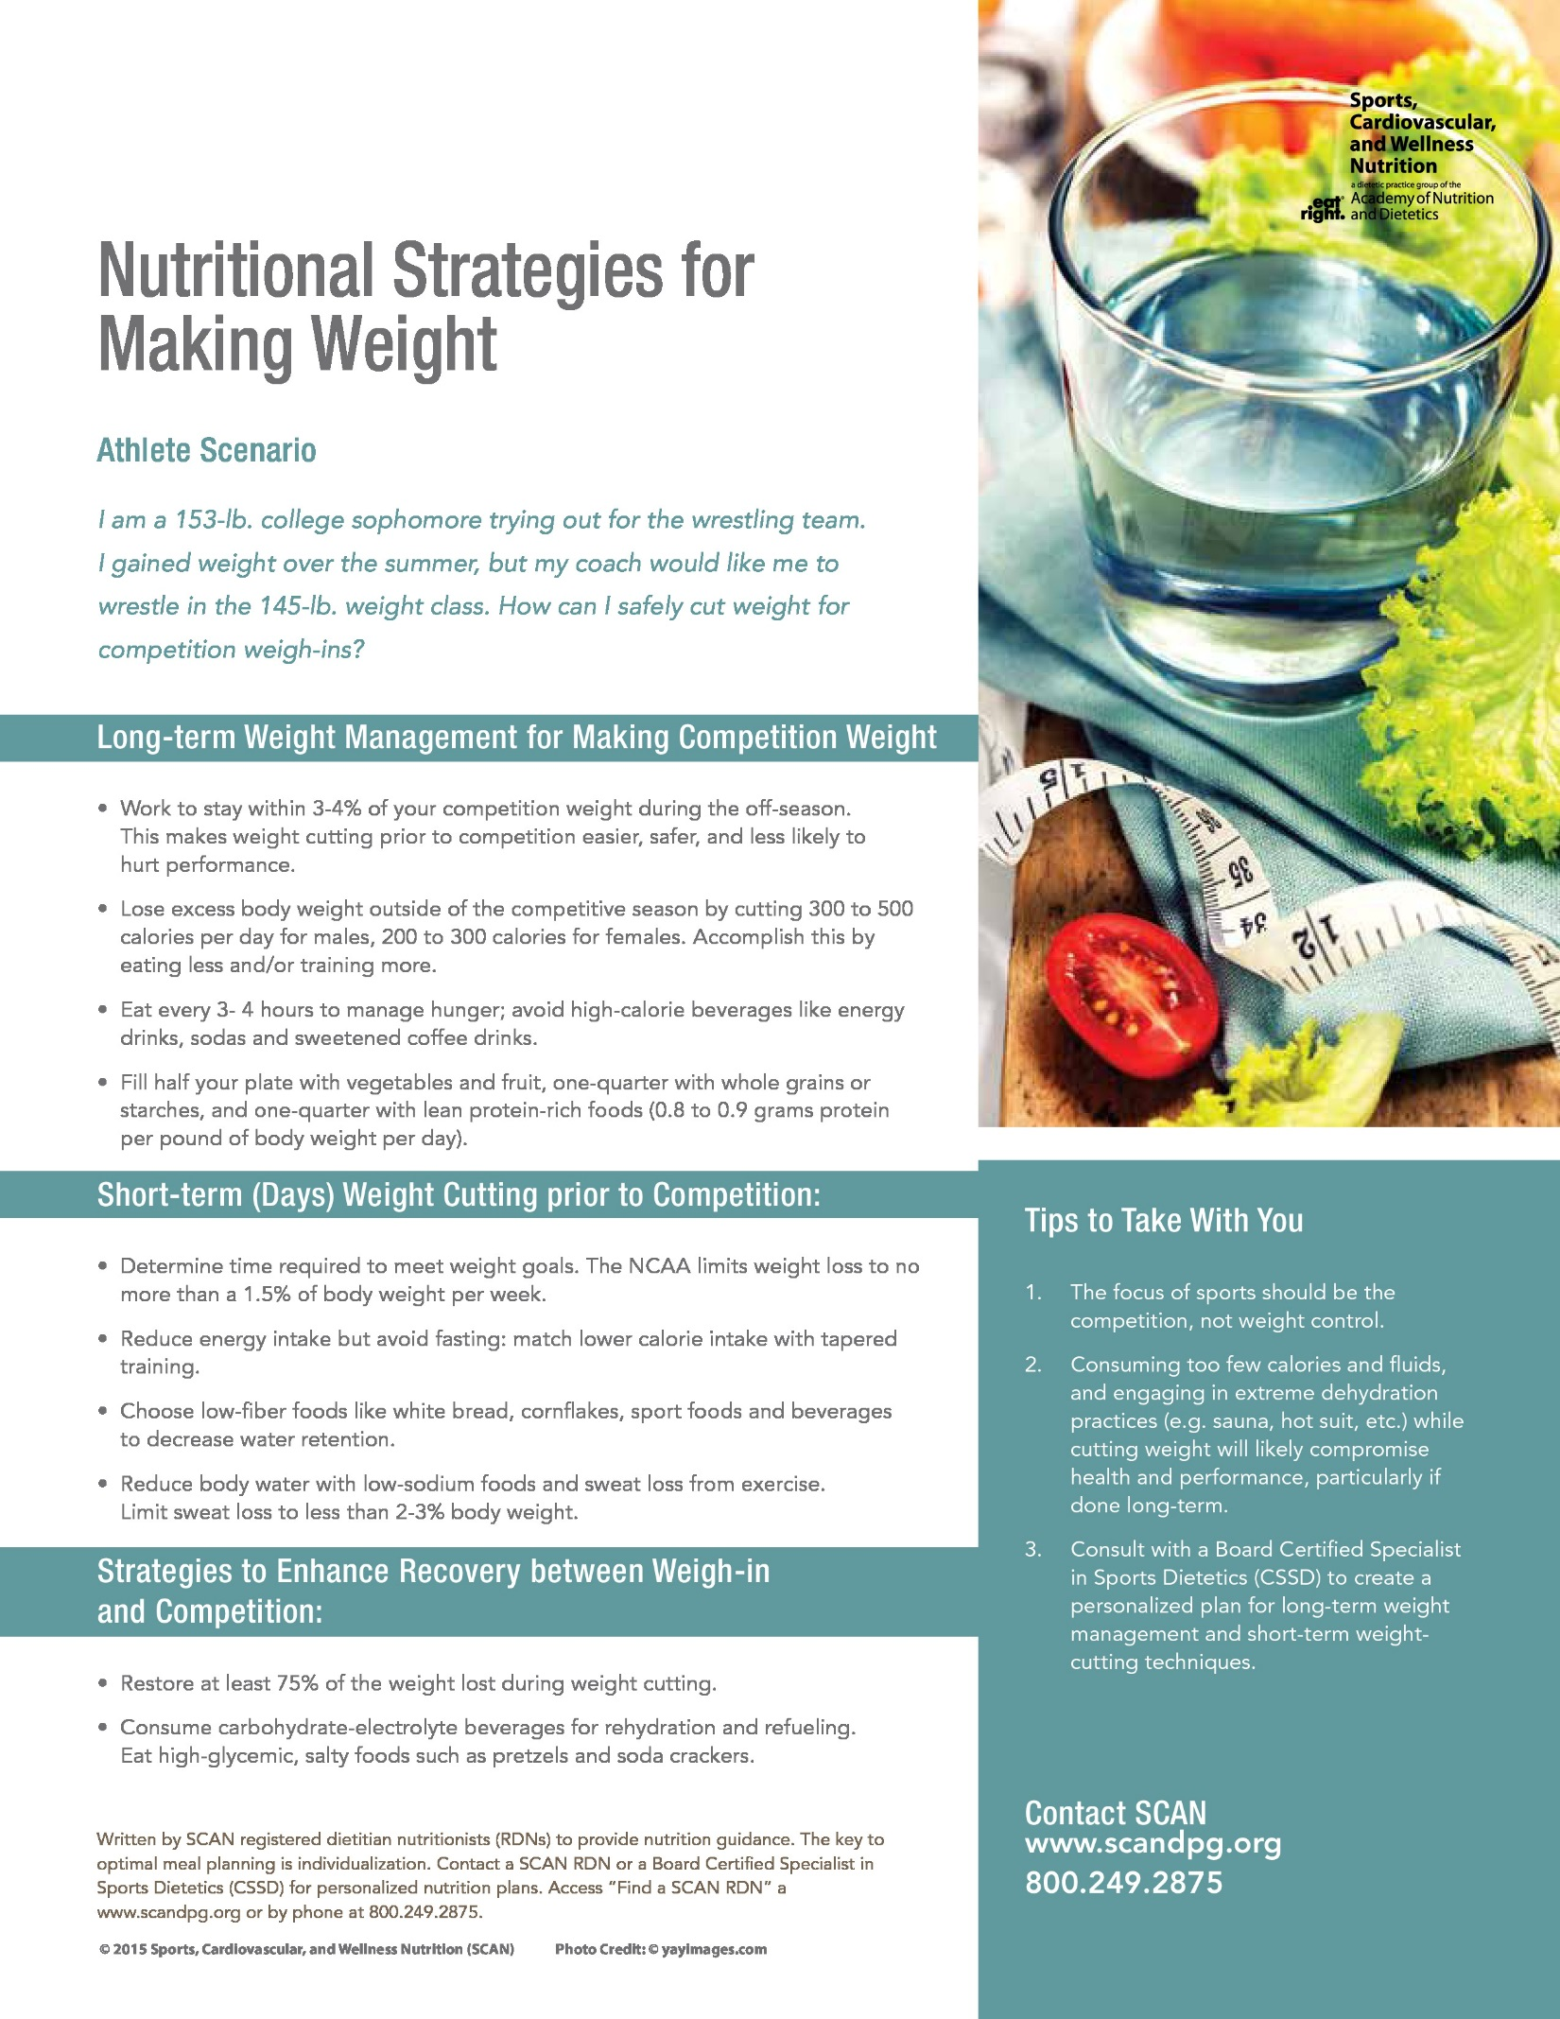

Long-term Weight Management for Making
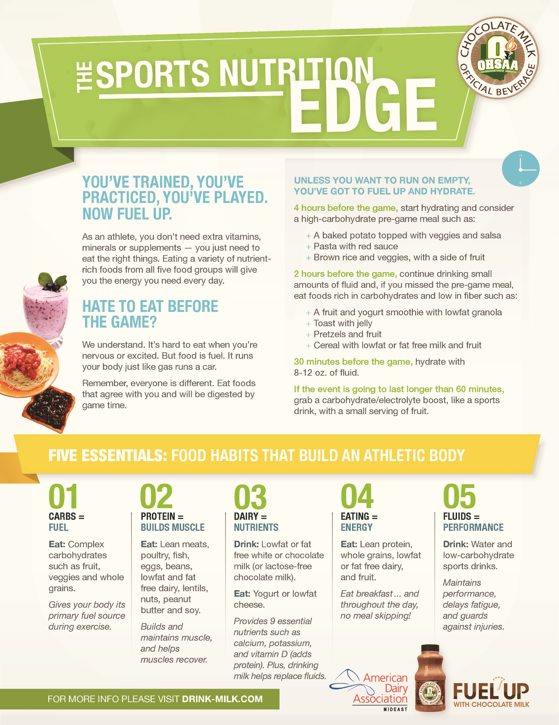

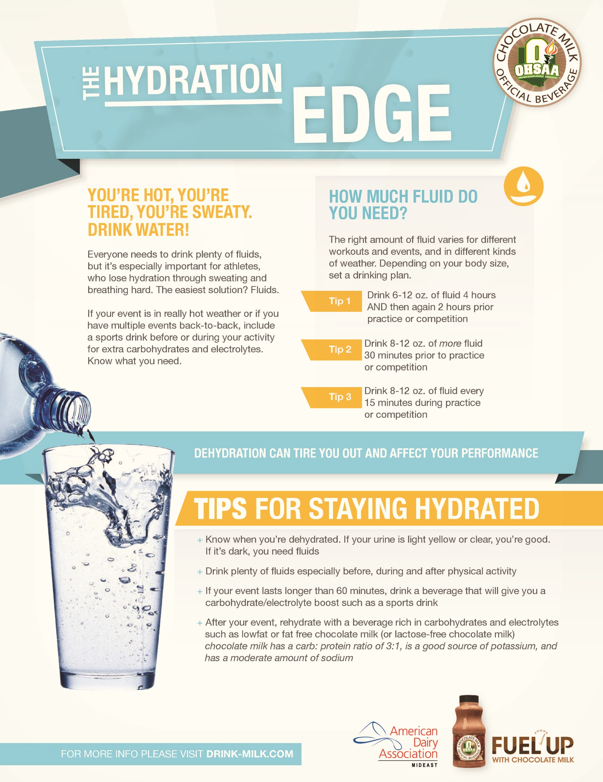

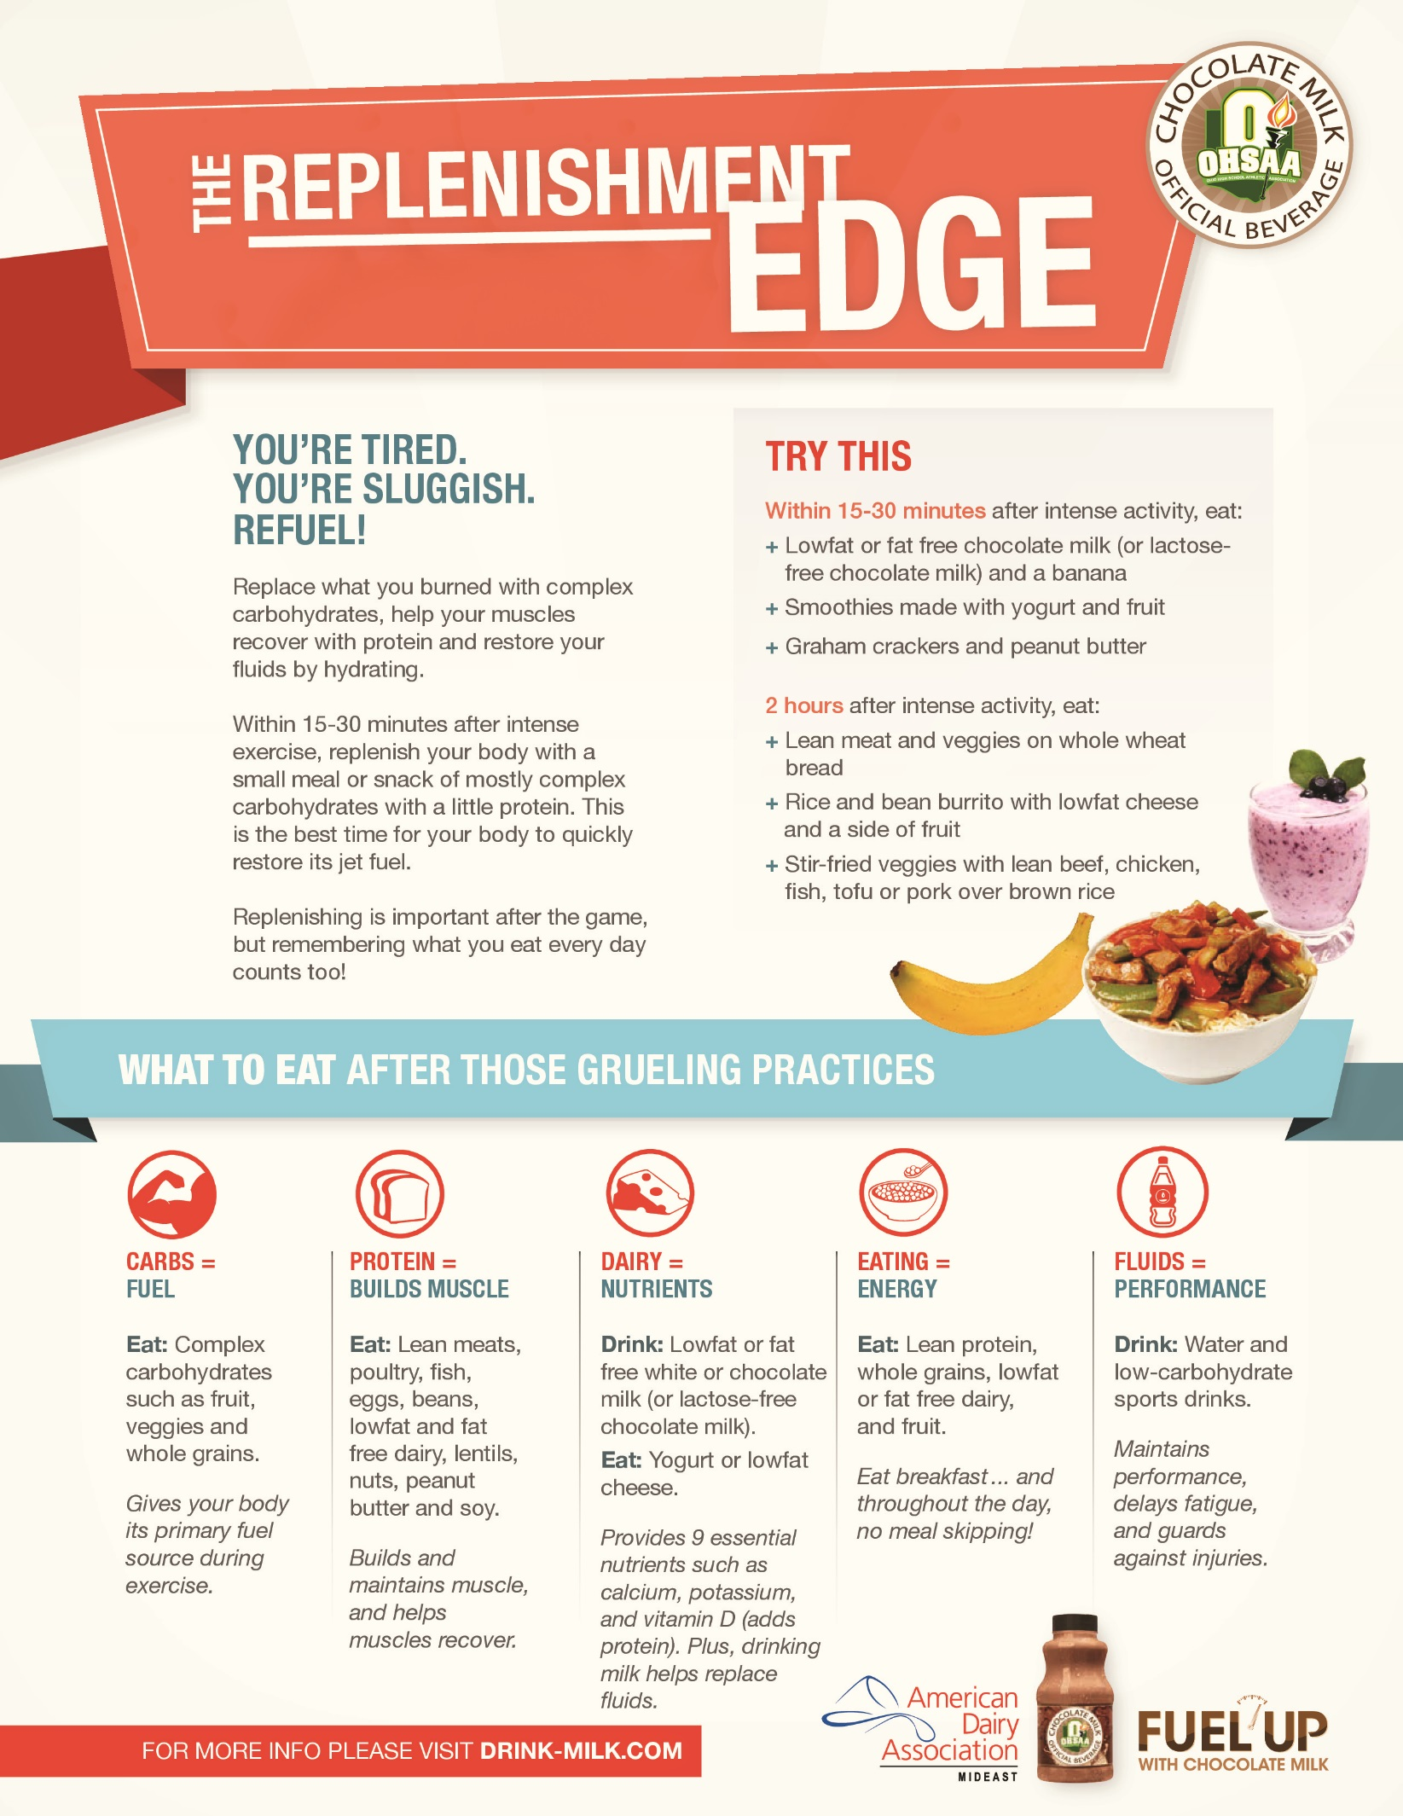

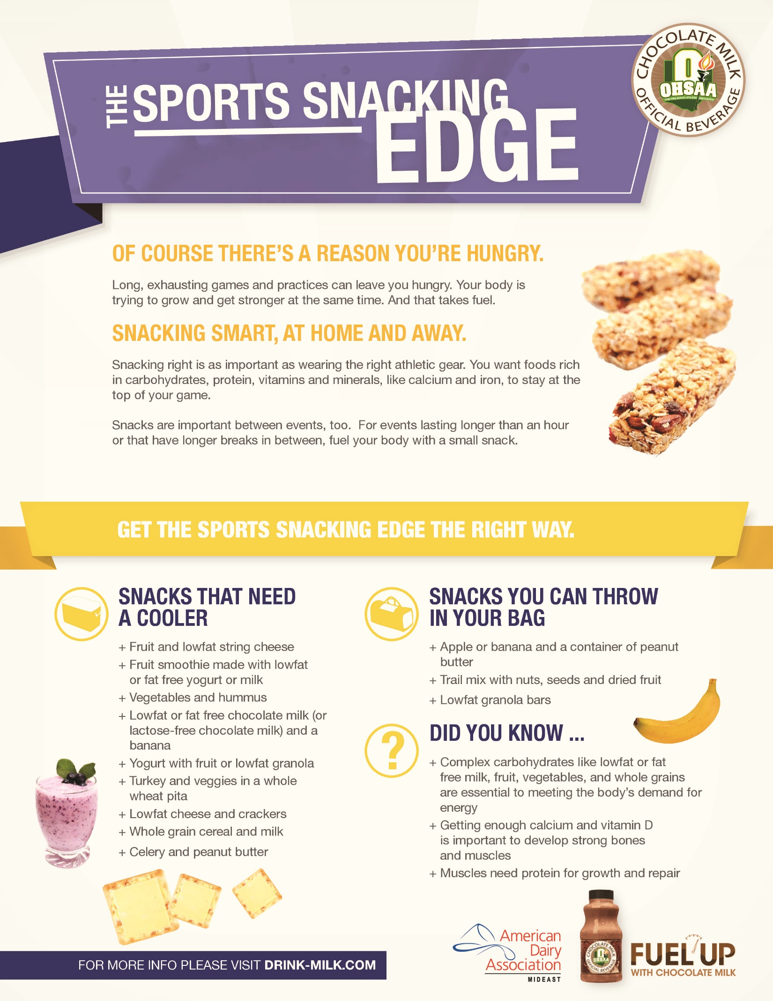

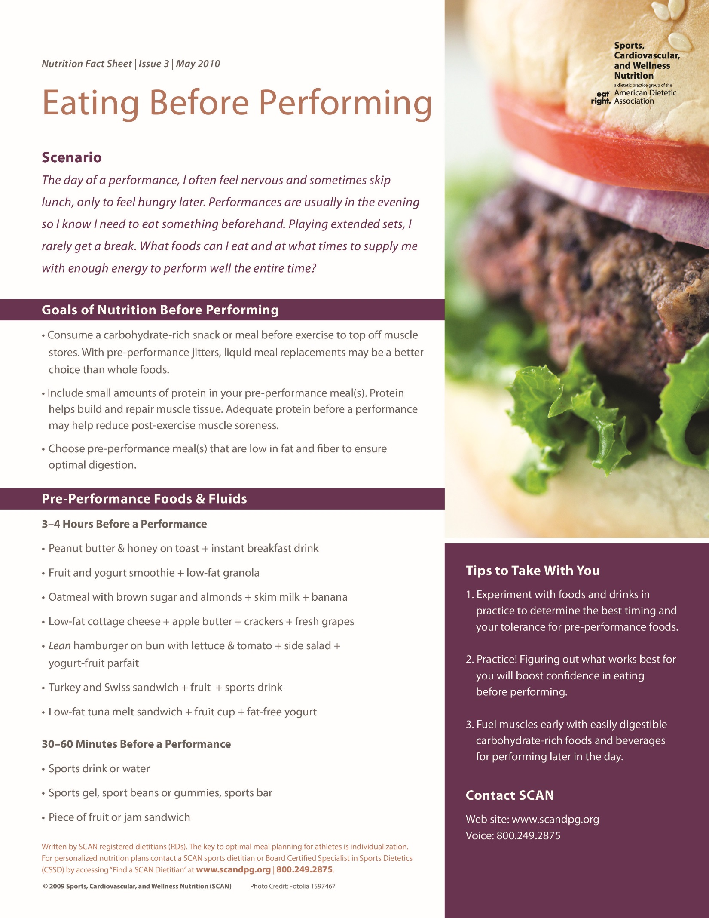

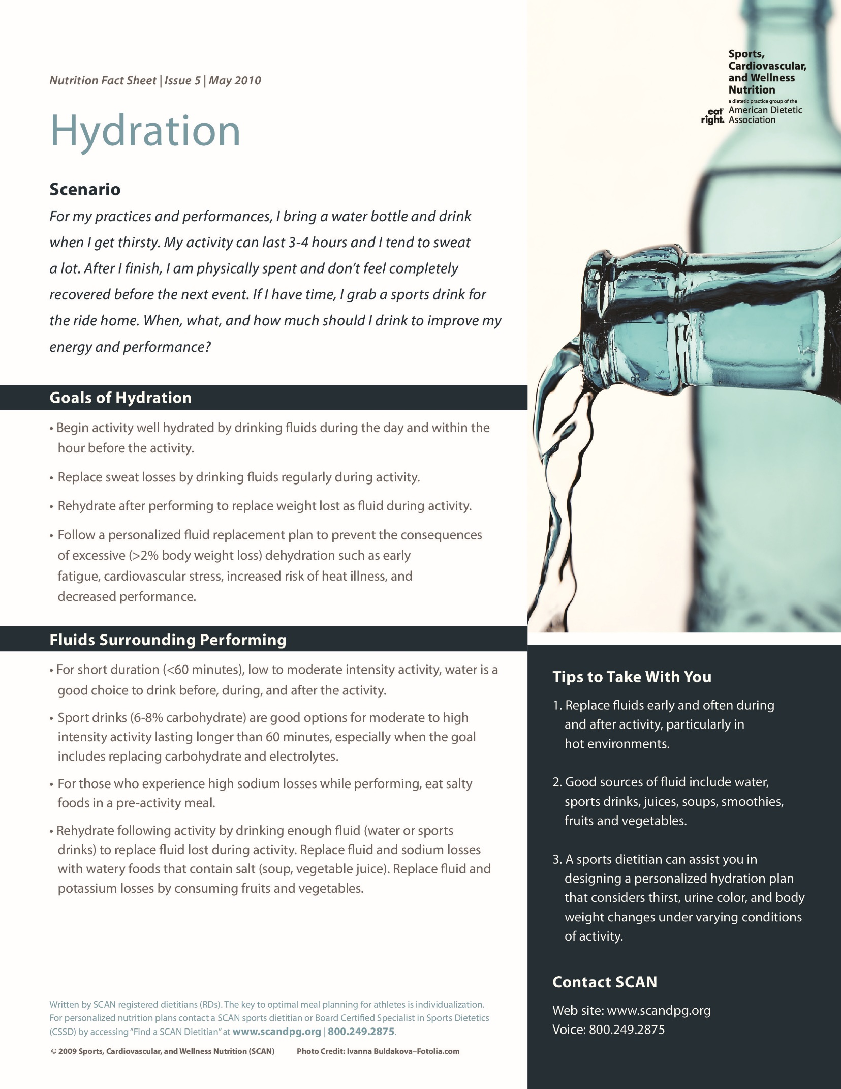

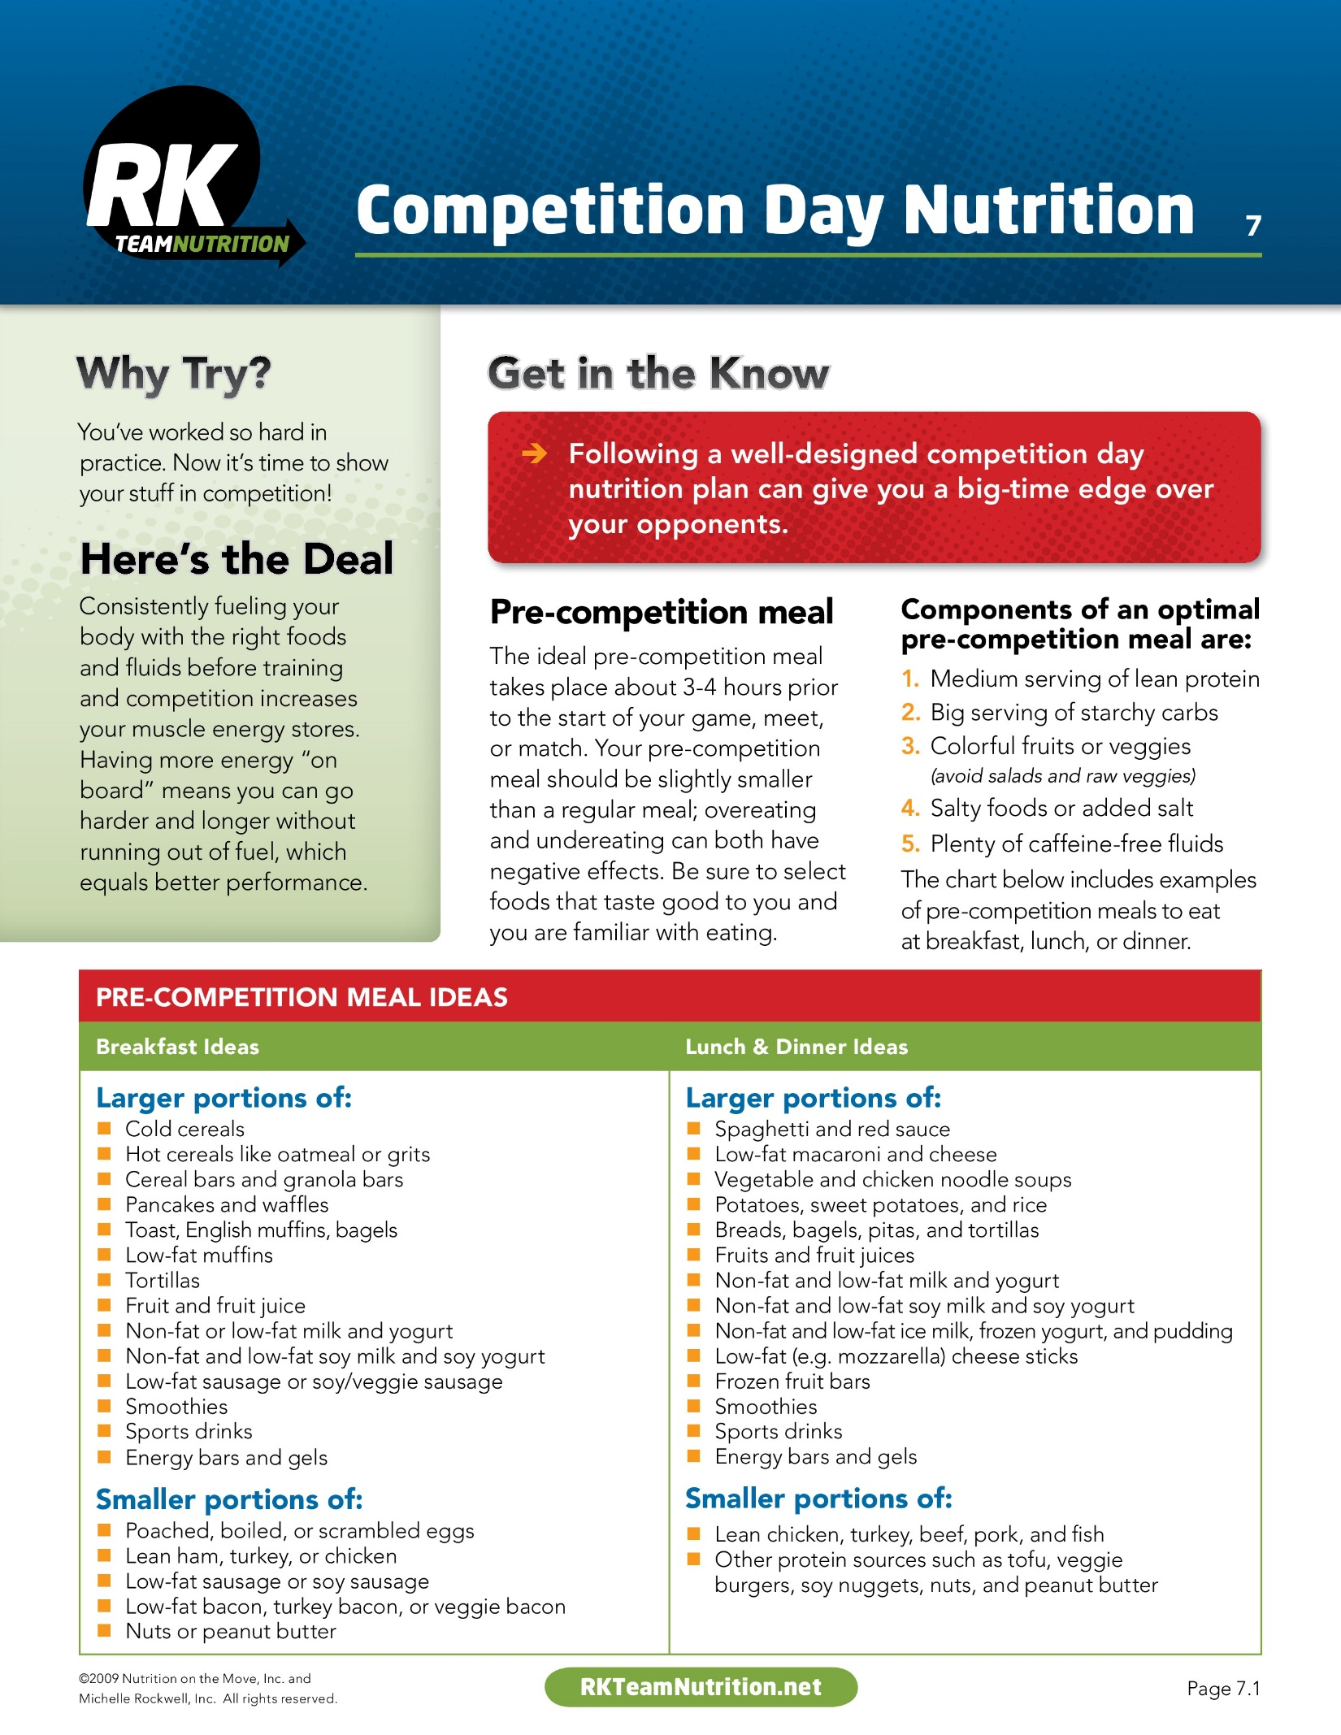

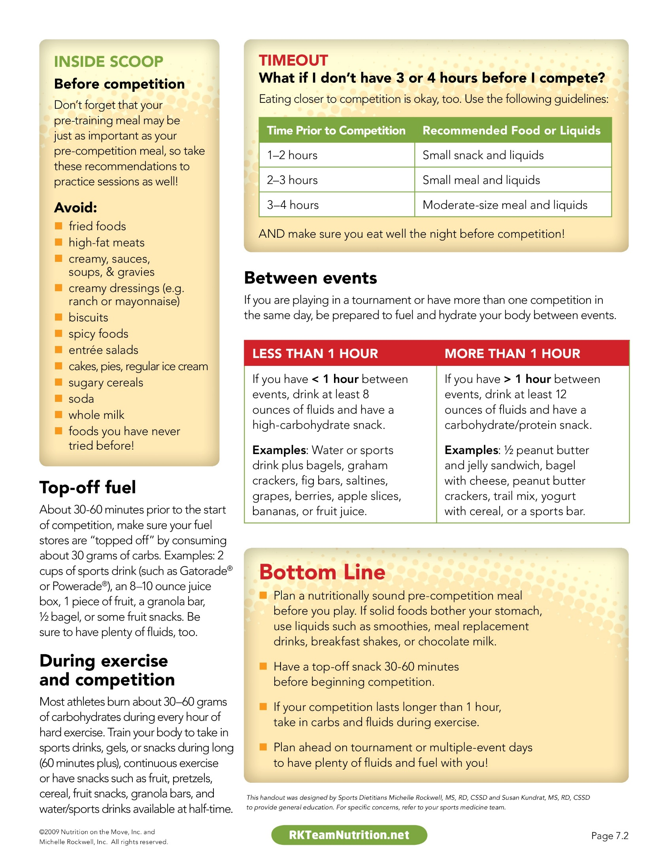

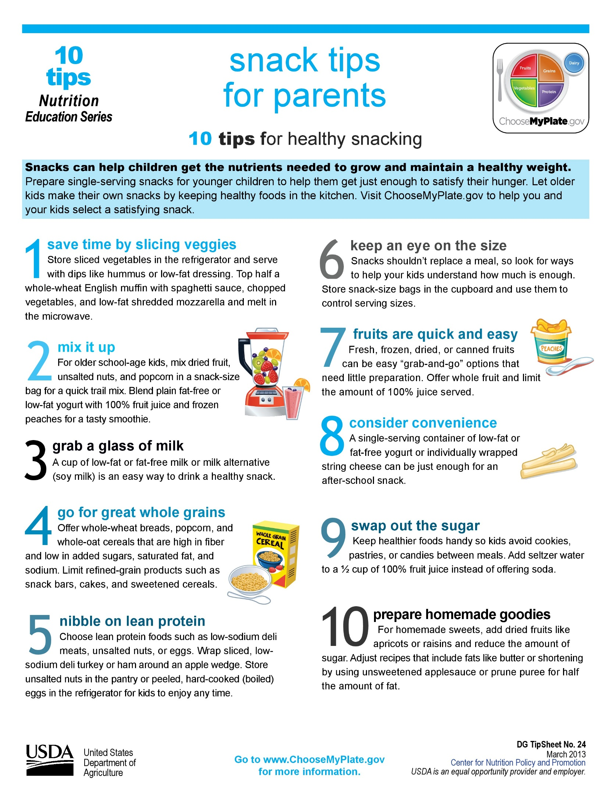

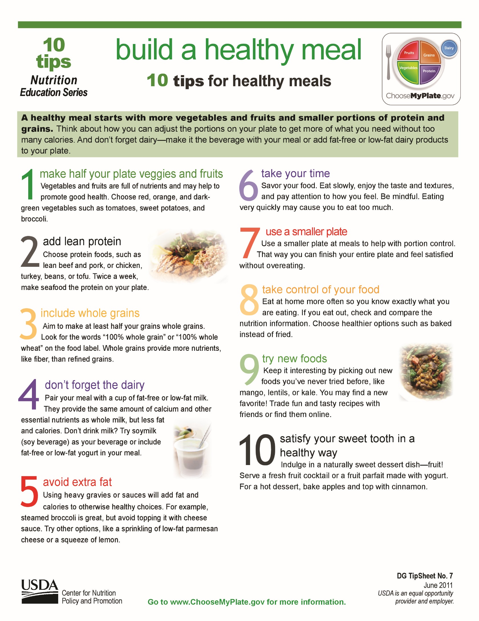

HYDRATION
Water comprises about 60-70% of a person's body weight. Mild to moderate physical activity usually results in whole body sweat loss around 0.8 – 1.4 L per hour. The fluctuation comes from the individual athlete’s ability to deal the humidity that is in place during activity. Sweat loss rates vary between sport and those athletes participating in the sport.

Water is ideal beverage to drink, although sports performance drinks like Gatorade or Powerade may be used to promote the act of drinking greater than water due to their sweet flavors.

Tips for staying Hydrated
- Use individual water bottles / clear bottles for monitoring
- “rule of thumb” – drink ½ to 1 cup of water every 15 min depending on heat/humidity
- Check your urine color
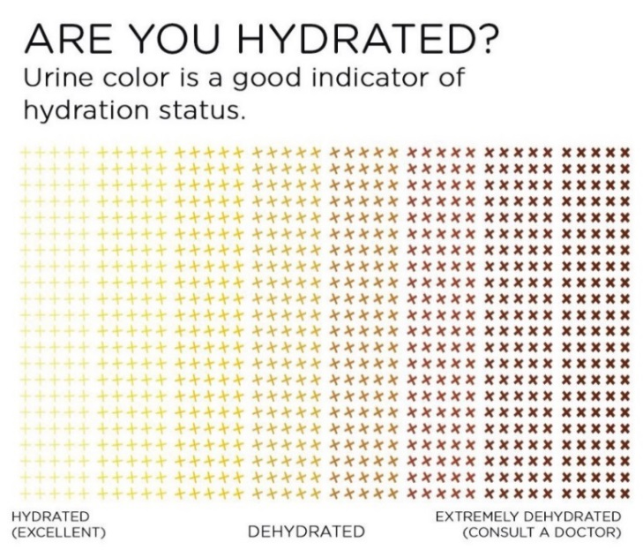

Avoiding dehydration strategies
- Understanding each athletes sport dynamics such as timeouts or stoppages in play, and fluid accessibility during competition or practice.
- Understanding each athletes acclimated state to sport
- Non-acclimated athletes tend to sweat more and lose more electrolytes during physical activity
- Understanding and anticipating “high risk” conditions for the athletes
  - High temperature (uniform and or clothing i.e. football pads) effects sweat loss
  - High humidity (indoor sports, uniform or clothing effects sweat loss)
  - Low air movement (indoor facility)
  - Bright sun / direct sunlight (dark colored clothing)
- SPORTS DRINKS
  - Contain water, carbohydrates, and electrolytes such as sodium and potassium to help retain fluid during exercise.
  - Is a source of fluid and electrolytes
    - Gatorade per 12 oz: 160 mg sodium / 45 mg potassium
    - Powerade per 12 oz; 150 mg sodium / 35 mg potassium

Practical tips for athletes:
- Encourage each athlete to develop a daily fluid intake plan that is suited to their fluid needs, and altered according to the weather and their exercise activities. This plan should avoid fluid extremes. Just as it is important to avoid dehydration, it is also important not to overhydrate with excessive fluid consumption
- Thirst is a sign of dehydration, and lags behind actual fluid needs. It may also be turned off by drinking small volumes of fluid before full hydration is restored. While it provides some information about fluid needs and the success of a fluid plan, other information should be considered.
- Encourage athletes to keep an eye on the volume and color of their urine.
- Research has shown that a lightly flavored beverage with a small amount of sodium, like Gatorade, encourages people to drink greater volumes of fluid and better match their fluid needs.
- To reduce the risk of waking up dehydrated on the day of competition or training, some athletes need to develop special strategies to replace fluid and electrolytes on the previous day. The use of a sports drink may be part of the strategies used to reduce the body’s fluid output and enhance effective rehydration.

SLEEP / REST
Exercise reduces energy, fluids, and breaks down our muscle fibers. Hydration and the right fuel are only part of training and recovery. What athletes do in the moments during and immediately after competition also determines how quickly their bodies rebuild muscle and replenish lost nutrients. This helps maintain endurance, speed, and accuracy.
Sleep deprivation is a very common problem – one that you may not even be aware you have. If you get less than eight hours sleep a night, if you fall asleep instantly or need an alarm clock to wake up, then you can consider yourself sleep-deprived. Sleep experts suggest that the average adult needs 7-9 hours of sleep a night. However children and teenagers need more, and athletes need extra sleep to help them recover from the rigors of training. Research has shown that even mild sleep deprivation can have a negative impact on a person’s performance throughout the day, especially for athletes who often require their body’s to be operating at peak performance in order to optimize their training or competition.

Tips on how to sleep better to get those needed ZZZ’s
Set a regular bedtime – Try to go to bed at the same time every night. Pick a time that is usually the moment when you start to feel tired or exhausted from the day’s activities. The key is finding that time where you won’t toss and turn while you first attempt to close your eyes and fall asleep.
Wake up at the same time every day – This will help you get in a routine that makes it easier to get things done during the day but also to feel that exhaustion at the same time each evening.
Be smart about napping – If you do fail to get adequate sleep from the night before, a power nap of 20-30 minutes is a great way to recoup those lost minutes or hours. Be careful though as a nap to close to bedtime may increase your risk of insomnia.
Turn off the TV, computer, phone 30-60 minutes before bedtime in order to increase the body’s natural hormone melatonin which is responsible for controlling your sleep/wake cycle.
Create a relaxing bedtime routine that allows you to unwind from the busy day. This could be turning on a bedside fan, eliminating outside noise, turning down the temperature (keep the room cool), and making sure your bed is comfortable for the nights rest.
Avoid caffeine 3-4 hours prior to sleep, this includes energy drinks, sodas and coffee.

