Single Health Evaluation (SHE) Instruction Guide: HA Events Only

We are collecting ALL health data through the Single Health Evaluation (SHE) in Qualtrics. This is also known as the Health Impact Grant (HIG) Report. This report must be completed by SO Programs receiving a Healthy Athletes or Health Impact Grant. Please note, a Health Impact Grant is a general term SOI Health uses for Health Grants and can comprise of several initiatives. For example, you may have received funding for a Healthy Communities project, for a Family Health Forum (FHF), a Fitness or Young Athlete Initiatives. Check with your Regional Health Manager if you have any questions about that or the terminology.

SO Programs not receiving these grants are not required to complete this report, but are strongly encouraged to do so.
This document will help guide Programs that are not recipients of a Health Impact Grant but need to report on Healthy Athlete Events.

Reporting Deadlines:

CDC-Funded Programs:
Health Impact Grant Mid-Year Report:
- Please report on Health activities completed between 1 August 2021 – 31 January 2022
- Must be completed by 15 February 2022
Health Impact Grant End-of-Year Report:
- Please report on Health activities completed between 1 February 2022 – 31 July 2022
- Must be completed by 15 August 2022
Golisano-Funded Programs:
Health Impact Grant Mid-Year Report:
- Please report on Health activities completed between 1 January 2022 – 30 June 2022
- Must be completed by 15 July 2022
Health Impact Grant End-of-Year Report:
- Please report on Health activities completed between 1 July 2022 – 31 December 2022
- Must be completed by 15 January 2023

Instructions for Completing the Single Health Evaluation if your Program is NOT a Health Impact Grant Recipient

If you are only reporting on Healthy Athlete events, you will need to complete the General Information section that comes after the introduction. Then you will enter “0” for every question that is not in the Healthy Athlete section. The Healthy Athlete events section is titled “Pillar 2: Asses to address” which includes two subsections, “Pillar 2: Assess to Address | Number of Events” and “Pillar 2: Assess to Address | Event details.” You can see these titles in the screenshot below on the menu on the left side.

First, you will need to complete the General Information section. The first question asks you to select your Program Region as shown below:

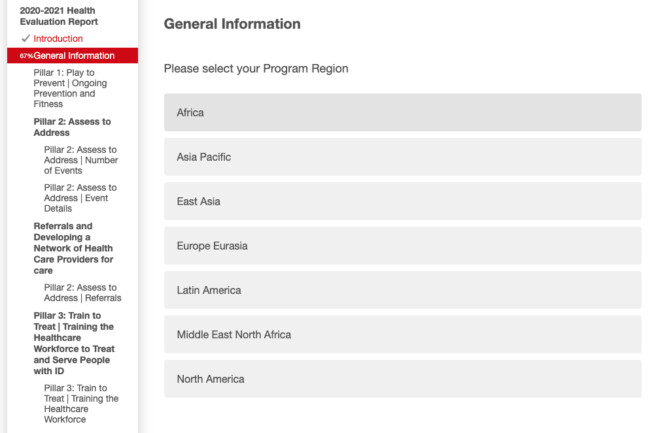
After you complete this section, which ends with questions regarding how your Program has responded to the COVID-19 pandemic, you will be at the start of the Pillar 1 section. Below is a screenshot of the first page of the Pillar 1: Play to Prevent section. Just like in the screenshot, you will be entering “0” for every question you do not wish to report on.
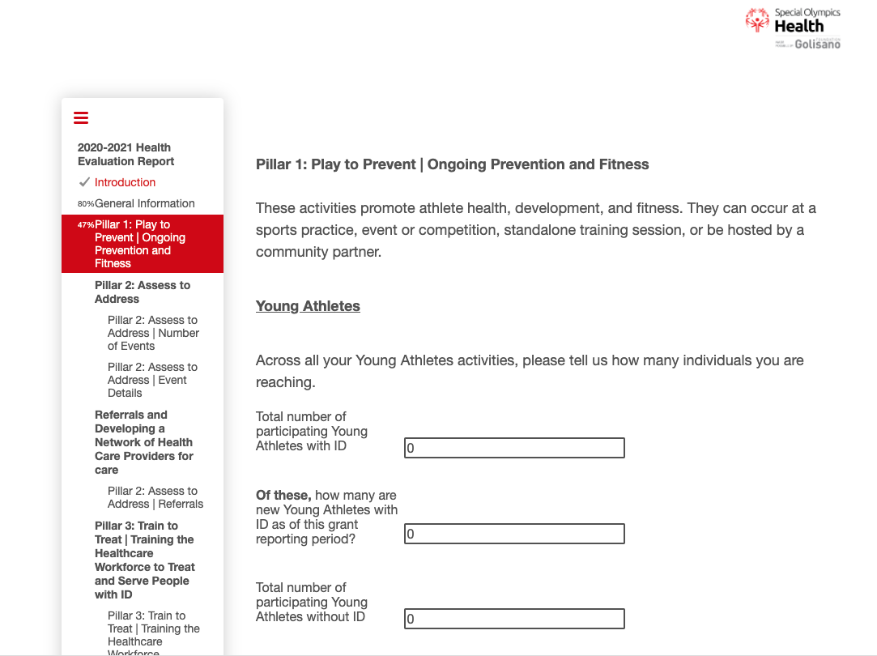

The next page is on Fitness and Health Education. For the first two questions you will enter “0” as shown in the screenshot below:
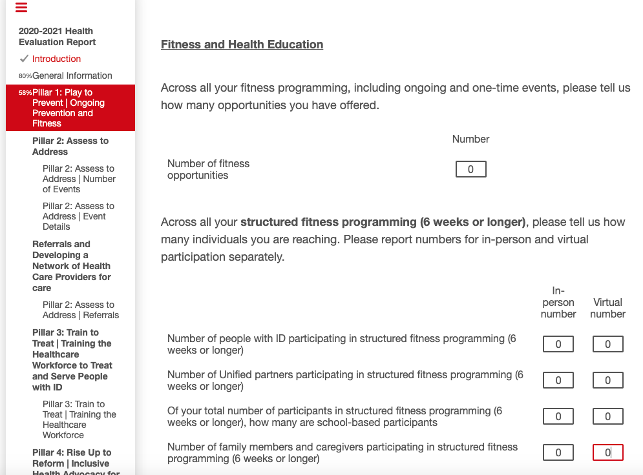

The third question on this page, asks you to select the fitness program(s) implemented. As shown in the screenshot below, please select “Did not implement fitness programming.”

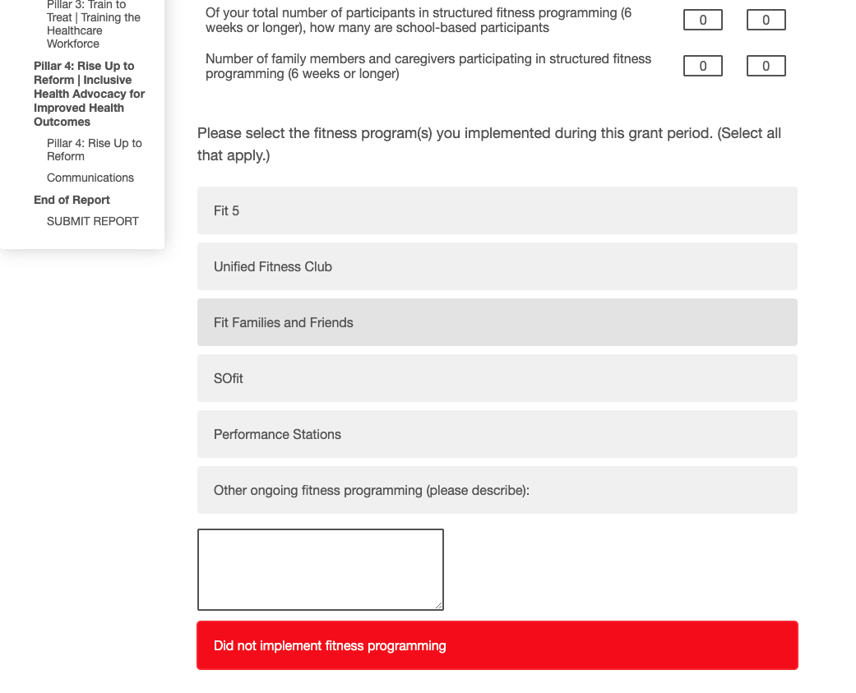

The next page (shown below) asks about preventative health education. For the first two questions, as shown below, please enter “0.”

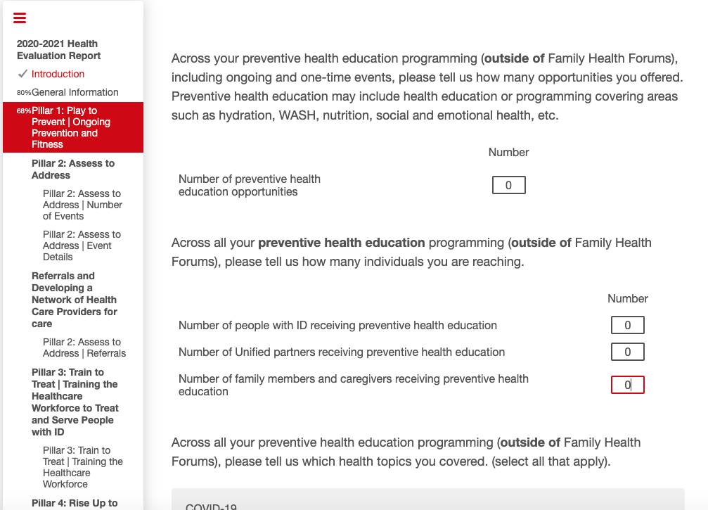

Then in the third question on this page, please select “Other (please describe):” and enter “not applicable” as shown in the screenshot below:

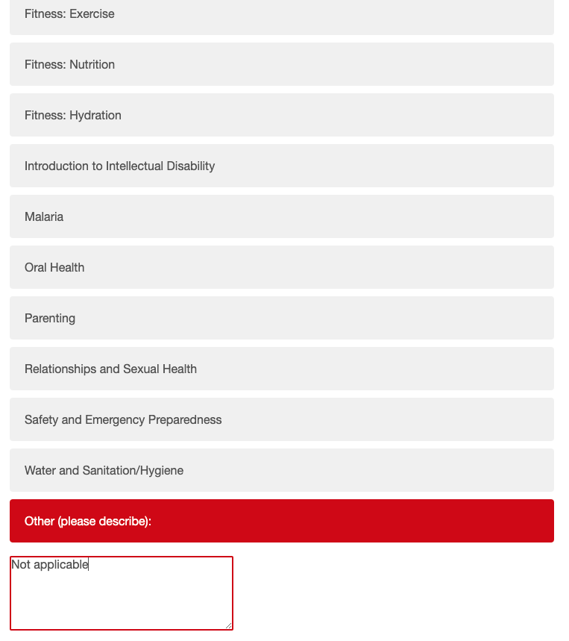

The next page is on coaches. Enter “)” for the first two questions as show in the screenshot below:

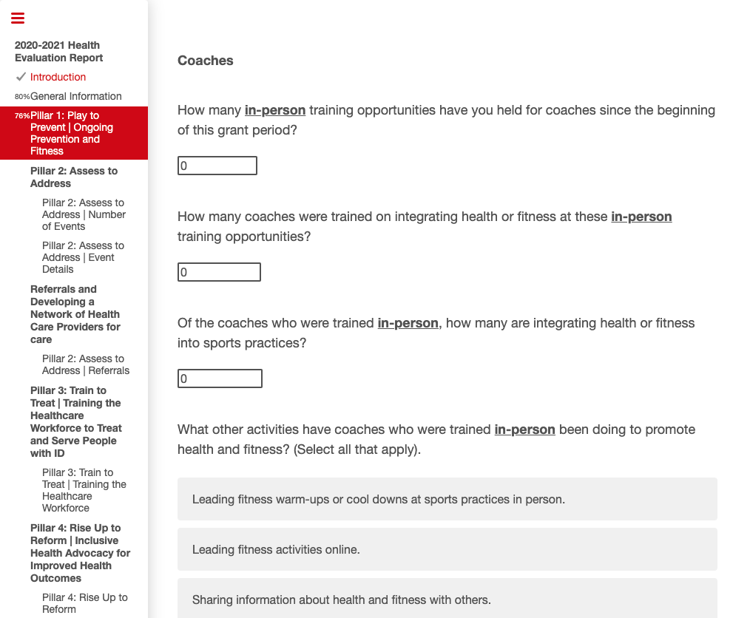

Then in the third question on this page, please select “Other (please describe):” and enter “not applicable” as shown in the screenshot below:

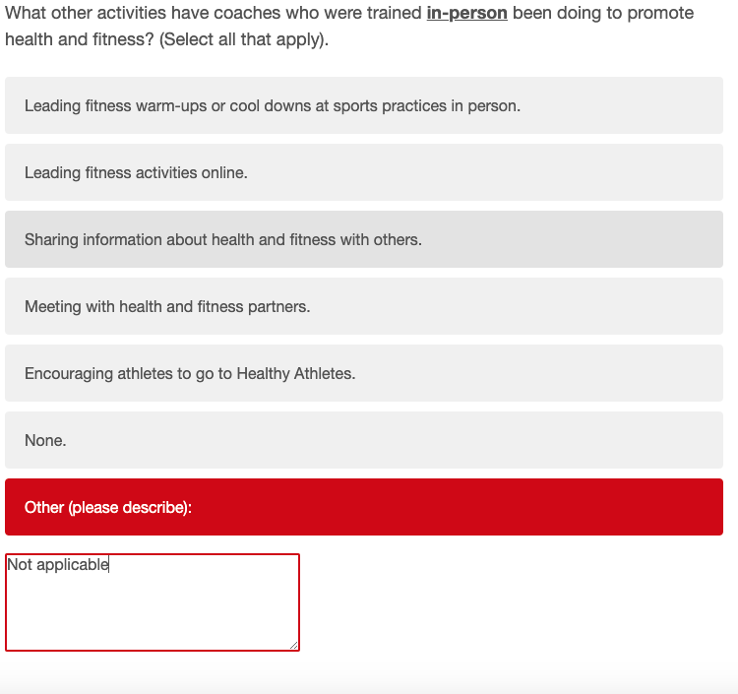

Then in the next two questions regarding virtual trainings, enter “0” as shown in the screenshot below:

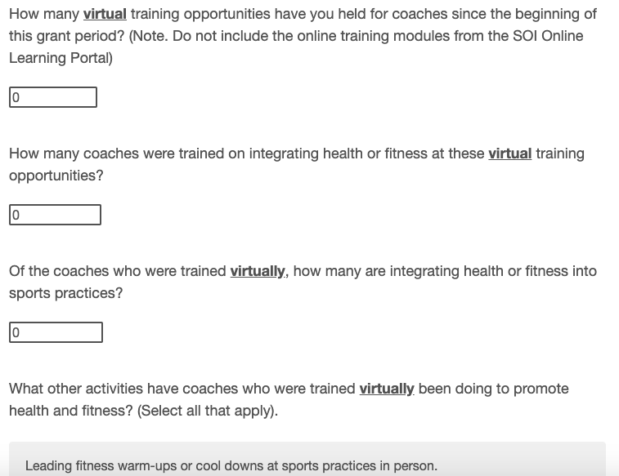

Then in the last question on this page, please select “Other (please describe):” and enter “not applicable” as shown in the screenshot below:

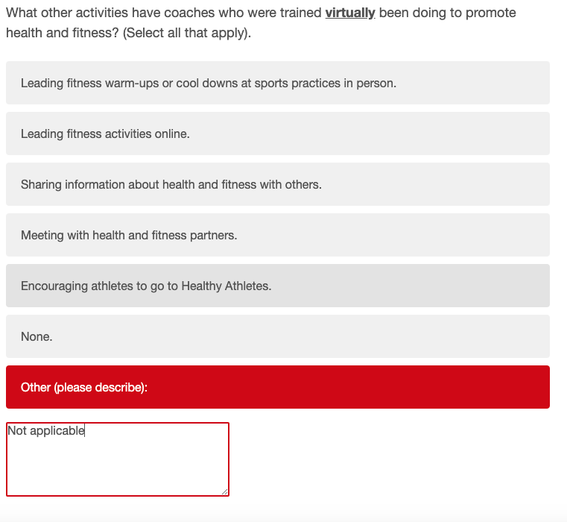

You have now completed the Pillar 1 section! The next section is the Pillar 2 section where you report on Healthy Athletes events. Below is a screenshot of the first page of this section:
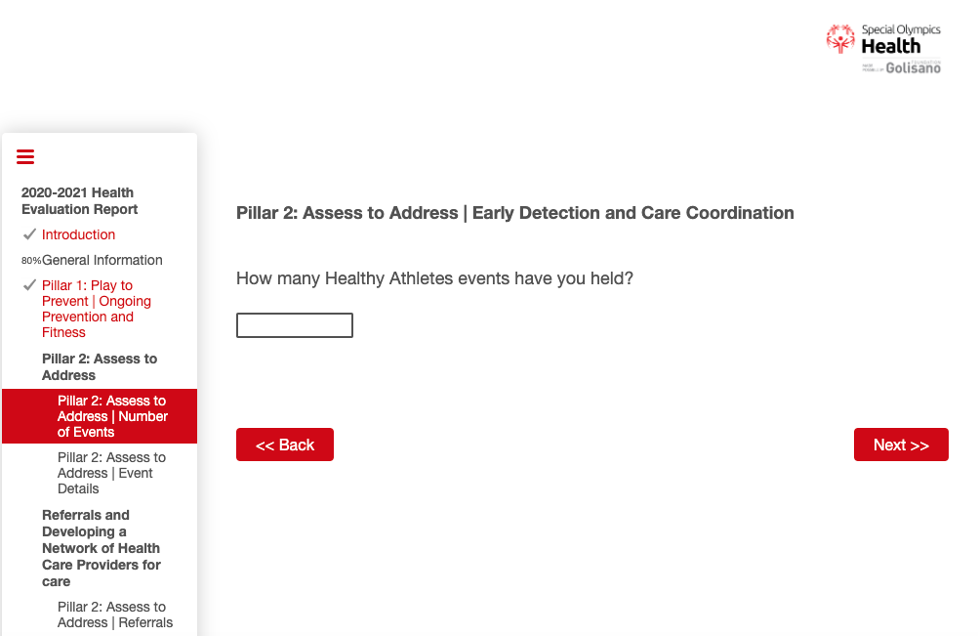

After you have reported your Healthy Athlete events, the next section asks about Referrals outside of Healthy Athlete events. For the first question, enter “not applicable.” For the second question select “no” as shown in the screenshot below:

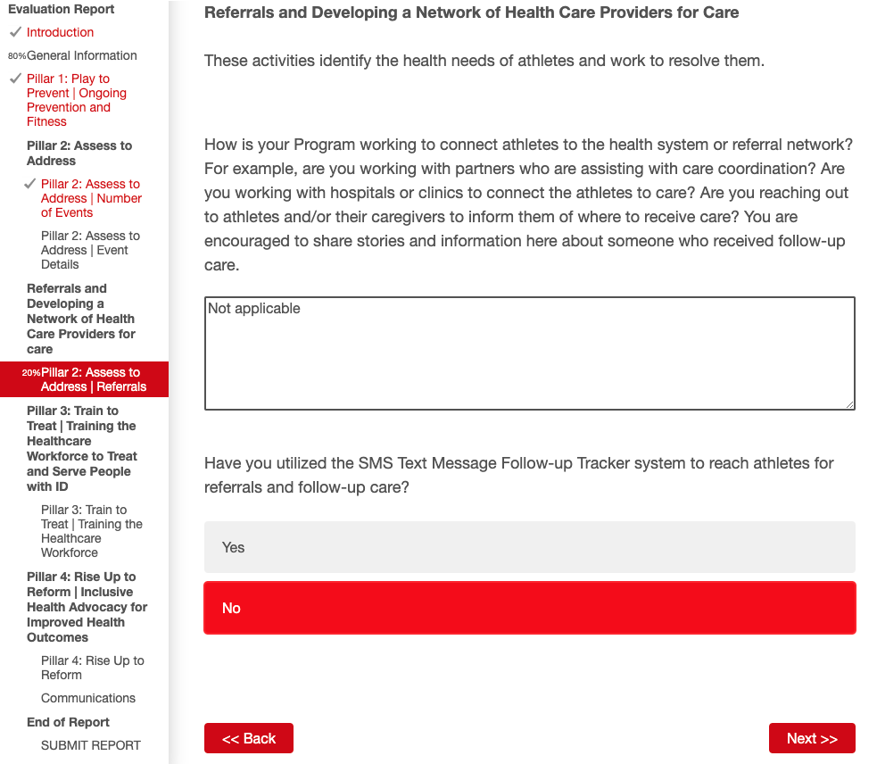

For the question on the next page enter “0” as shown in the screenshot below:
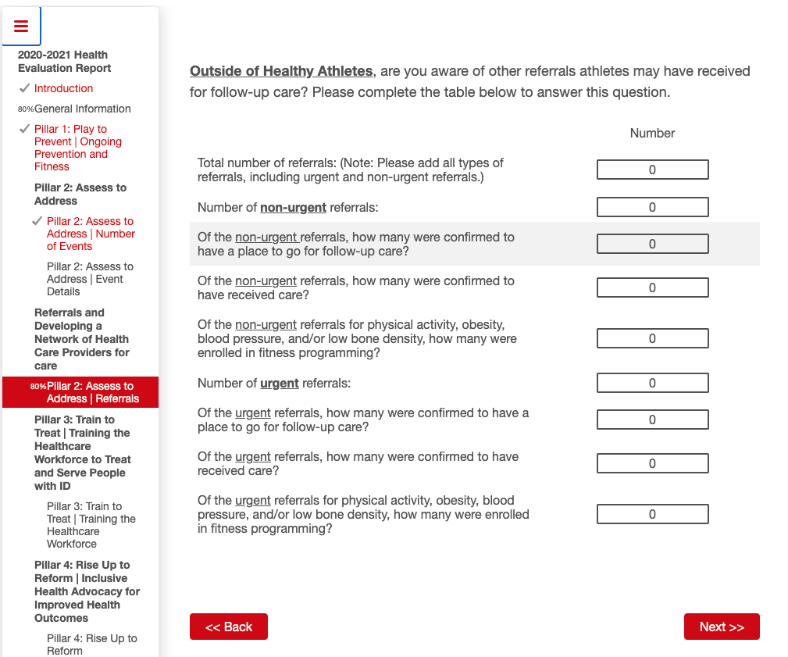

Then the Pillar 3 section starts on the next page. Enter “0” for every question on this page as shown in the screenshot below:

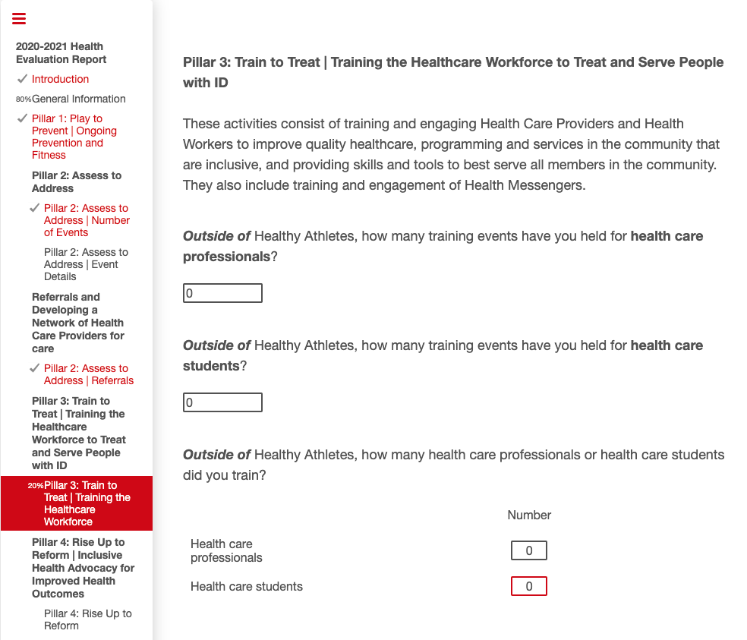

On the next page, when asked about your number of current partnerships, enter “0” as shown in the screenshot below:

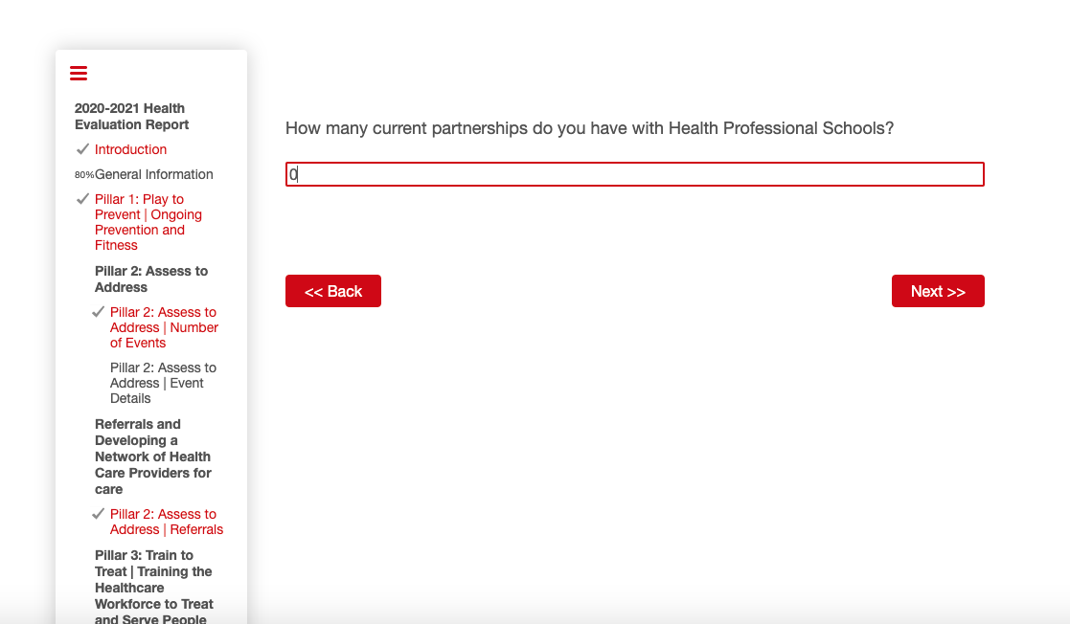

The next page asks two questions about community health workers. Enter “0” for both questions as shown in the screenshot below:

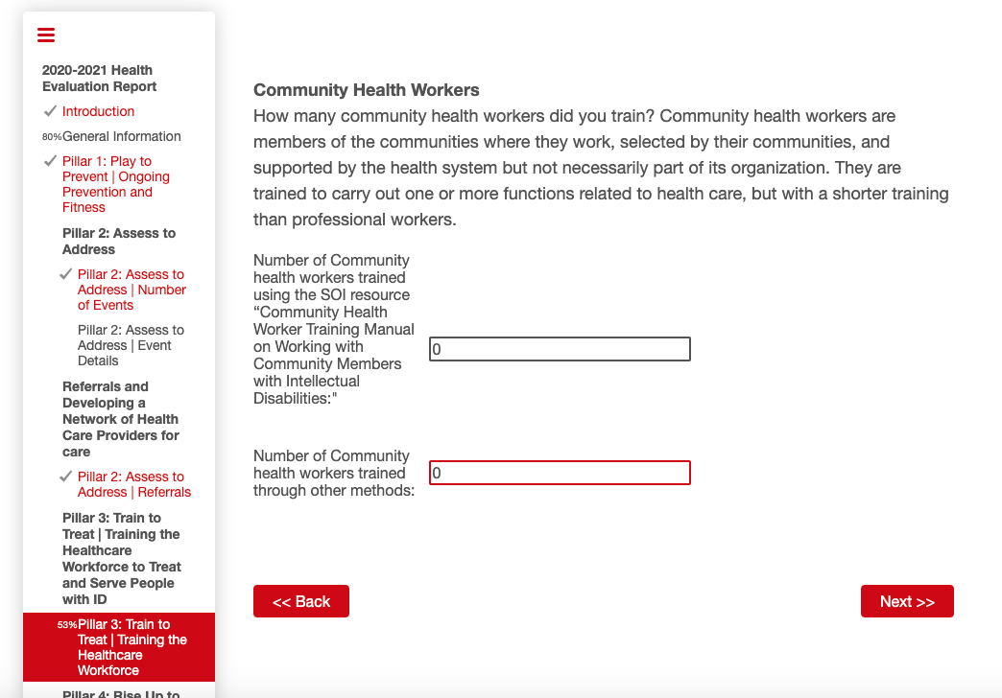

The next page asks 5 questions about Health Messengers. This is the last page of the Pillar 3 section. Enter “0” for every question as shown in the screenshot below:

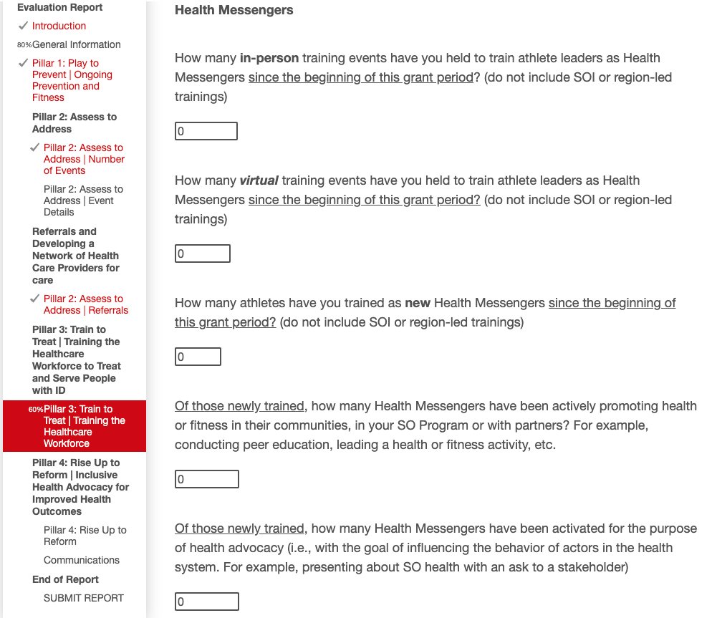

The next page is the start of the Pillar 4 section. It asks one question about currently engaged partners. Enter “0” as shown in the screenshot below:

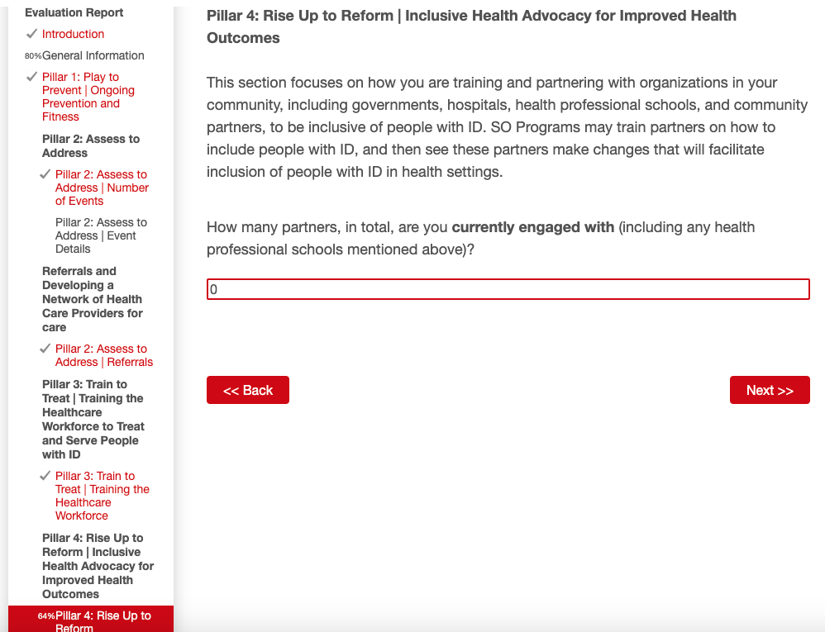

The next page has three questions. For the first two questions enter “0” and for the last question select “No” as shown in the screenshot below:

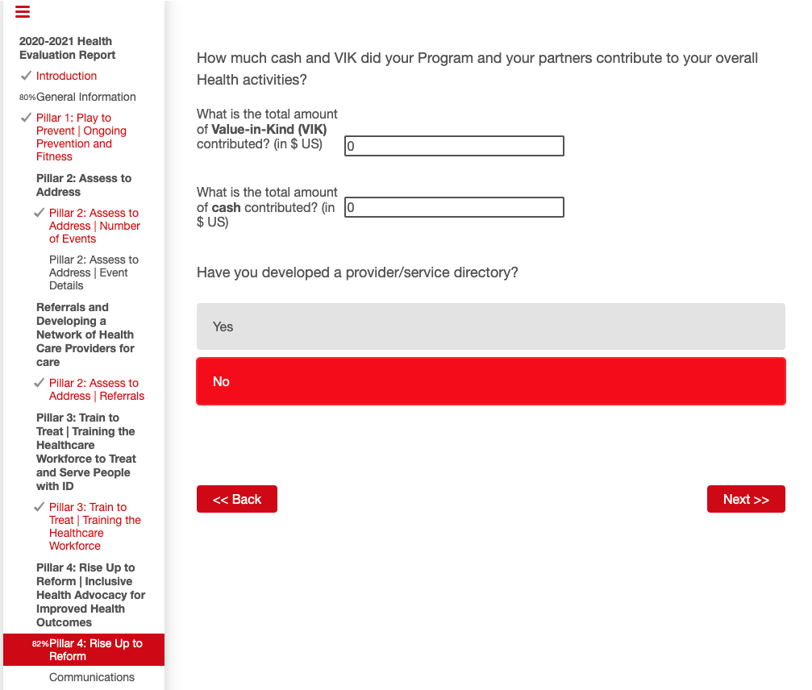

The next page asks questions about Communications. The first question is a file upload. This is the only question in the SHE that does not require an answer. You can skip this one. For the last two questions on this page you will enter “0” as shown in the screenshot below:

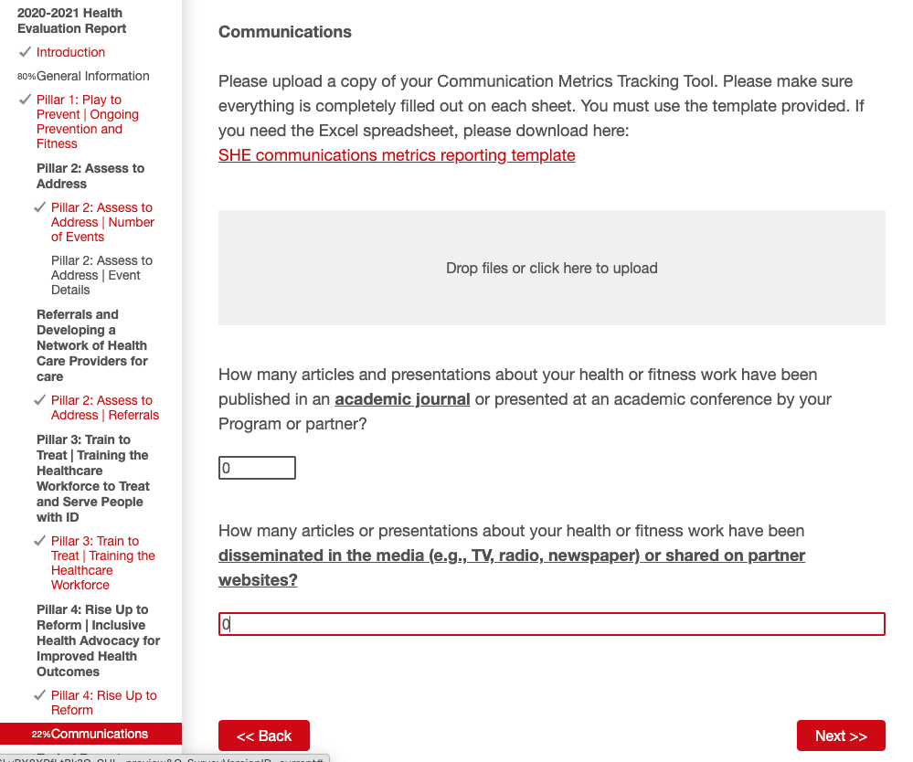

The next page will ask you one question about health-focused stories. Enter “0” as shown in the screenshot below:

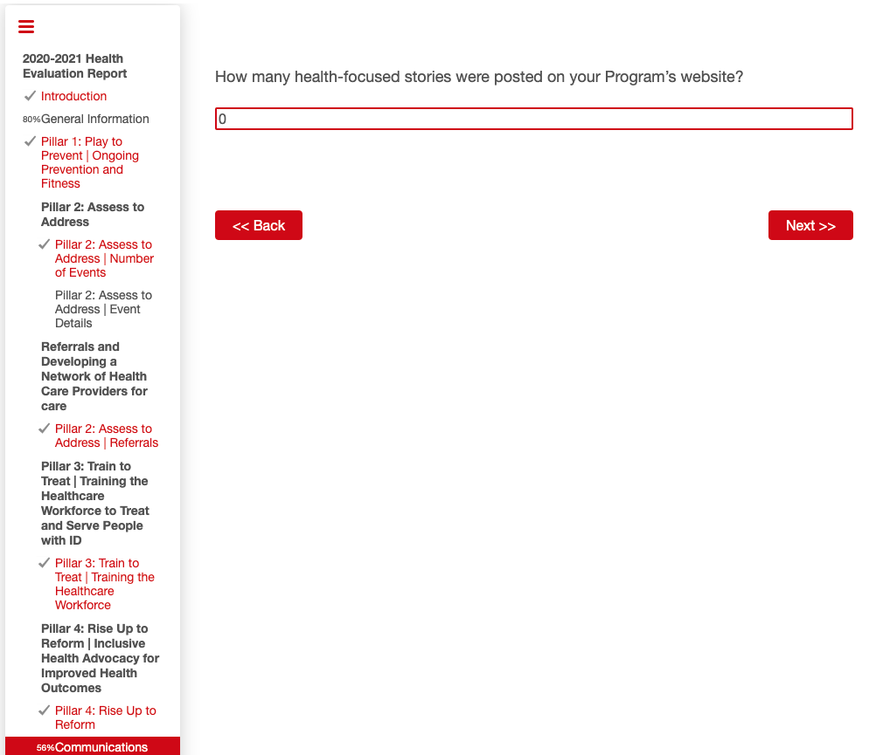

There are three questions on the next page. Enter “0” for all of them as shown in the screenshot below:

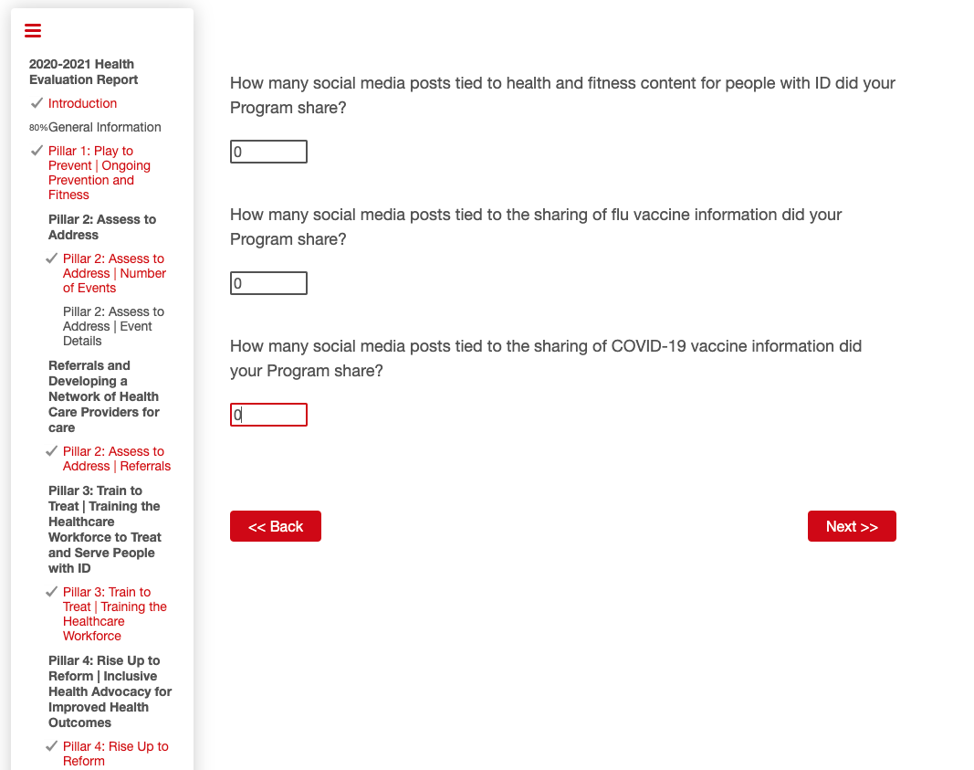

Then you are ALMOST done! This is the next page you will see (shown below) make sure you click the “SUBMIT” button to submit the survey:

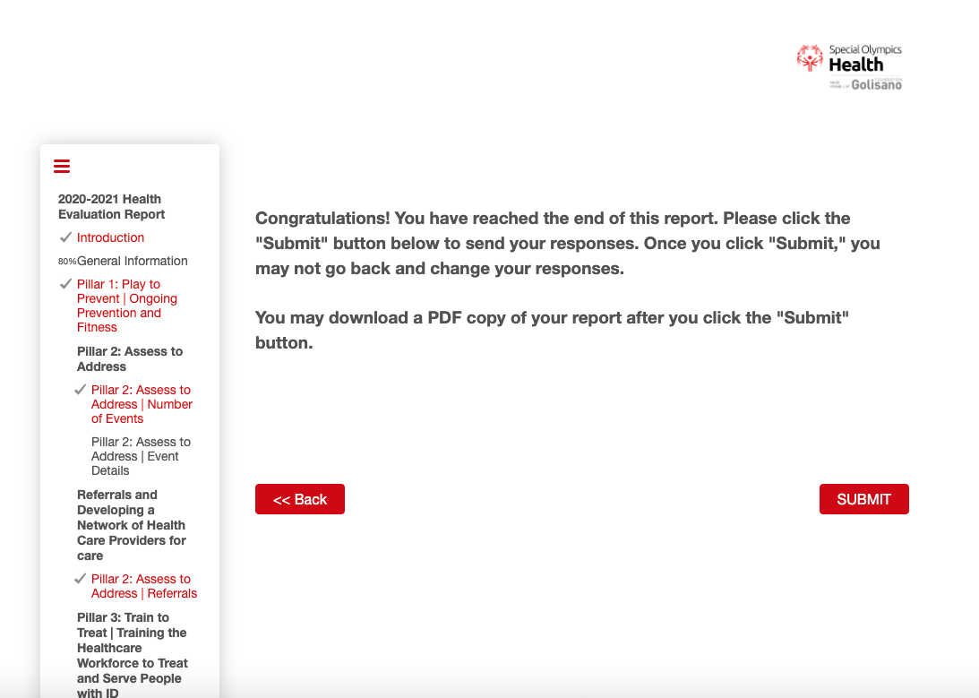

Once you click submit this is the start of the page with the PDF of your answers (shown below) you are now officially done!

