HIG End of Year Report Reminders:

Single Health Evaluation (SHE):
We are collecting all health data through the Single Health Evaluation (SHE), which is the HIG Report in Qualtrics.
- This report must be completed by SO Programs receiving a Healthy Athletes, Family Health Forum or Health Impact Grant.
- For Programs not receiving these grants, completing this survey/report is optional and not required.

Reporting Deadlines:
Programs who did not apply for an extension should have submitted their EOY Report by March 31st. Programs who applied and received an extension must submit their EOY Report by July 31th.

Reporting on the last half of the grant year in the EOY Report:
For information that needs to be updated, Programs only need to include numbers from October 1st through June 30th.
- Please do not include any numbers//info/events/etc. that occurred from April 1st 2020-October 1st 2020. We do not want you to report anything you already reported in the mid-year report.
- However, if for example you held events or trainings in September 2020 that you did not count in the mid-year report, please report them in the EOY report. Likewise, if you reported events or trainings that were held after October 1st, in the mid-year report, please do not report on them again in the EOY report.
- For Programs who did not submit a mid-year report, please report on your total numbers since April 1st 2020.

Exception:
The only question that will ask Programs to report on numbers for the entire year is the question below asking about total cash and VIK numbers:

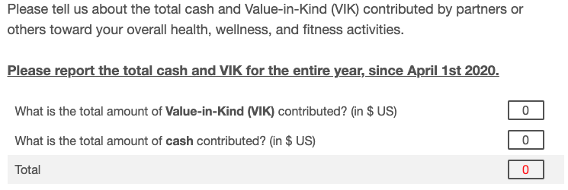

Completing the SHE/HIG Report while not a Healthy Community recipient:
For programs who would like to report Healthy Athlete events but are not a HC recipient, they would need to respond to the Introduction question at the beginning of the survey that asks, "By which date do you intend to submit your HIG report?" and then complete the General Information Questions, which appear directly after the Introduction. For the Introduction question show below, Programs can just select, “June 30th, 2021.”

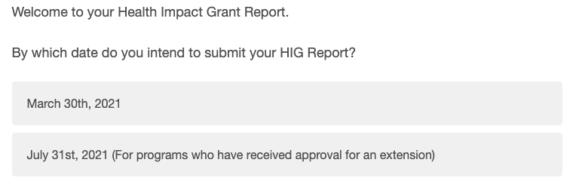

Next, in the General Information section, these programs will need to make sure they select "No" to the question shown below; "Are you working towards Healthy Communities recognition criteria?"

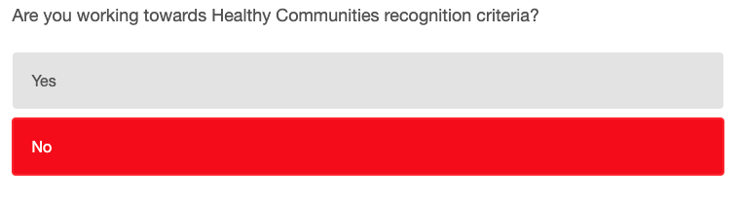

Then, once they complete the General Information section, they will be asked in the question shown below, to report how many Healthy Athlete Events they held in the past year.

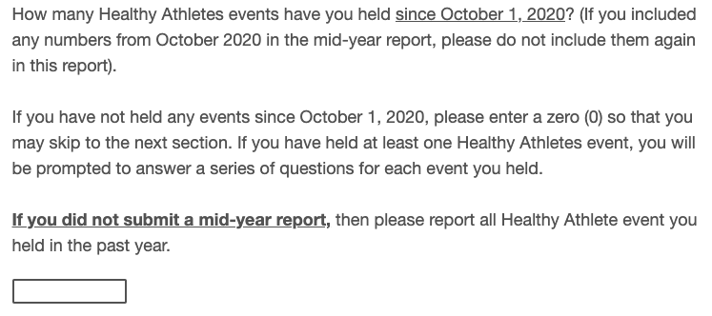

Then a series of questions regarding the details of each HA event held will appear. In this section, Programs will be asked "Did you receive a Healthy Athletes Capacity grant from SOI for this event on [Event Date]?" for each event they indicated they held. These programs will need to make sure they select "No, this event was fully self-funded by the Program."

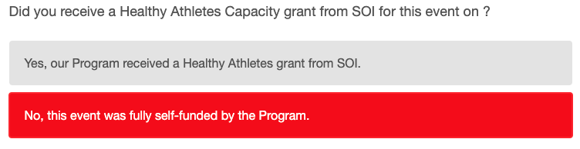

Once they are done with the HA Event section, they can either complete the rest of the survey, or skip the rest of the sections. To skip the rest of the sections, they will need to respond "0" to each question at the beginning of each section which asks how many opportunities, events, trainings, etc. they held. If they indicate that they held 1 or more in any of these questions, they will be prompted to complete the section asking for details (just like the Healthy Athlete Event section) and will not be able to skip the sections.

