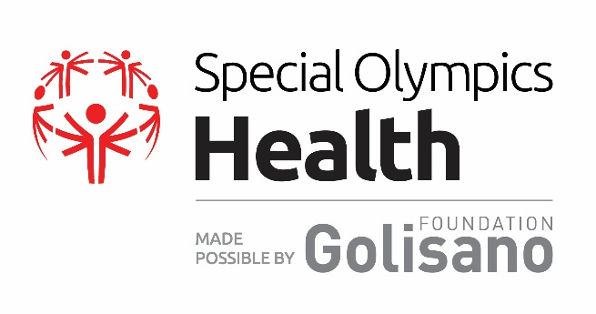
Official Nomination Form
2025 Global Golisano Health Leadership Award

About the Award:

The Global Golisano Health Leadership Award is the highest honor for health partners and individuals given by Special Olympics. The award was created to recognize health champions and their extraordinary efforts toward fulfilling the goals, values, and mission of Special Olympics Health, made possible by the Golisano Foundation.

Awards recognize individual leaders and/or organizations that are making significant contributions to Special Olympics Health’s programs and the promotion of equal access to healthcare, wellness, and fitness for people with intellectual disabilities. Approximately every two years, one honoree per region is selected from the pool of Program- level awardees and invited to a global event to be presented with the Global Golisano Health Leadership Award for their region. Any Special Olympics Program may nominate an individual or organization for this award.

Nominees for the Global award will be evaluated based on their leadership for and contributions to the PATH to Health Equity outlined in the following areas:

- Prevention: Ongoing prevention and fitness programs, for all ages
  - Increasing athletes’ access to and participation in year-round health education and fitness programs.
  - Increasing access to and participation in Young Athletes and early childhood programming.
  - Strengthening family health education programming, including Family Health Forums.
- Assessment: Early detection and care coordination
  - Expanding the Special Olympics Healthy Athletes® program in the nominee’s home state/country.
  - Increasing local athletes’ ability to access quality follow-up health care.
- Training: Educating the health workforce
  - Increasing/improving training for health care professionals, students, fitness professionals, and others on providing quality care and services to people with IDD.
- Health Systems Strengthening:
  - Promoting partnerships, policies, and self-advocacy to further health equity.
- Increasing the financial sustainability of Special Olympics Health work.

Eligibility:
To be considered for this Global award, nominations must include:
- A completed Nomination Form submitted to: https://app.smartsheet.com/b/form/7813fa12965342179e7a788eae4185c6 by 30 November 2024
- A bio and headshot for the individual nominee or a logo and short write up on the organization nominated

Please note that nominees cannot be paid staff of Special Olympics.

Nomination form continues below.
Special Olympics Program
SO Program Name (Connecticut, Kenya, etc.):

SO Program Contact Name:

SO Program Contact Email:

Nominee Information
Name:

Phone:

Email:
Is this nominee fluent in English*? Yes No
*Please note: if honoree is not fluent in English, interpretation services will be provided at the event.
Is this nominee able to travel to a global award ceremony in the USA in 2025*: Yes No
*Please note: if selected for global award, all travel expenses for the honoree will be paid by Special Olympics, Inc.

Please describe how the nominee has contributed to the areas below.
Prevention: Ongoing prevention and fitness programs (including Young Athletes, family health education, and physical activity/nutrition/ hydration programming)
Please describe the nominee’s contributions in this area:

Please describe the impact this has had on Special Olympics athletes’ health:

Assessment - Expanding Healthy Athletes & Increasing Athletes’ Access to Quality Healthcare
How many years has the nominee been involved with Healthy Athletes?

Is the nominee a Healthy Athletes Clinical Director or Regional Clinical Advisor?

Please describe the nominee’s contributions to the Healthy Athletes Program:

Please describe the nominee’s contributions to ensuring athletes have community access to quality healthcare:

Please describe the impact this has had on Special Olympics athletes’ health:

Training - Increasing/Improving Training for Healthcare Professionals, Students, Fitness Professionals, and Others on Providing Quality Care and Services to People with ID.
Please describe the nominee’s contributions in this area:

Please describe the impact this has had on Special Olympics athletes’ health:

Health Systems Strengthening - Promotion of partnerships, policies, and self-advocacy to further health equity
Please describe the nominee’s contributions in this area:

Please describe the impact this has had on Special Olympics athletes’ health:

Increasing the Financial Sustainability of Special Olympics’ Health Program:
Please describe how the nominee has contributed to the financial sustainability of the health work in their home state/country:

Additional Information for the Nomination Committee’s Review:
Please provide any additional information you would like the Award Review Committee to know about this nominee and the impact that they are making in your community:

Nominated by:
Title:
Date:
Nomination Approval Page

Approval by Program’s President/CEO
Signature
Date

Approval by Local Athlete Leader
Signature
Date

Approval by Regional Health Manager
Signature
Date

