

**Post-Training Survey**

**Health Messenger Post-Training Survey**

Thank you for participating in the Special Olympics Health Messenger Training!  This survey will ask you questions about the things that you do to be healthy. There are no right or wrong answers. You can skip any questions you don't want to answer.

**Your Name:**

**Today’s Date:** **_____/_____/_____**

1. **How did you feel about the Athlete Health Messenger training today?**

 Not good  Okay  Good



1. **Which Health Messenger leadership role(s) did you do (check all that apply)?**
   * + Health Spokesperson and Advocate
     + Healthy Athletes Coordinator
     + Healthy Habits Teacher
     + Fitness Leader
     + Other: ___________________________

**Please circle an answer for each question below.**

1. **How many FRUITS and VEGETABLES *should a healthy person* eat every day?**

|  |  |  |  |  |  |
| --- | --- | --- | --- | --- | --- |
| 0 | 1 | 2 | 3 | 4 | 5 or more |



1. **A close up of a bottle

   Description automatically generatedHow many BOTTLES of WATER *should a healthy person* drink every day?**

|  |  |  |  |  |  |
| --- | --- | --- | --- | --- | --- |
| 0 | 1 | 2 | 3 | 4 | 5 or more |

1. 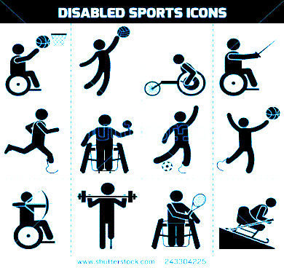**How many days each week *should a healthy person* EXERCISE?**

|  |  |  |  |  |  |  |
| --- | --- | --- | --- | --- | --- | --- |
| 1 day | 2 days | 3 days | 4 days | 5 days | 6 days | 7 days |



|  |  |  |  |
| --- | --- | --- | --- |
| **I feel more comfortable speaking about Special Olympics.** | Most of the Time   | Not Sure | None of the Time   |
| **I feel more comfortable talking about the health challenges people with intellectual disabilities face.** | Most of the Time   | Not Sure | None of the Time   |
| **I have a better understanding of Special Olympics’ health work.** | Most of the Time   | Not Sure | None of the Time   |
| **I want to become a health role model to athletes in my community.** | Most of the Time   | Not Sure | None of the Time   |
| **I know how to share my health story.** | Most of the Time   | Not Sure | None of the Time   |
| **I feel ready to do my practicum health project when I go home.** | Most of the Time   | Not Sure | None of the Time   |
| **I feel confident talking to athletes in my community about eating healthy.** | Most of the Time   | Not Sure | None of the Time   |
| **I feel confident helping athletes in my community be more physically active.** | Most of the Time   | Not Sure | None of the Time   |

**Please indicate whether you agree with the following statements. Circle an answer for each.**

**What was your favorite part of Health Messenger training?**

**What could we do to make the athlete Health Messenger training better?**

**What is the most important thing you learned at the Health Messenger training?**

**What are you most likely to share with athletes in your community?**