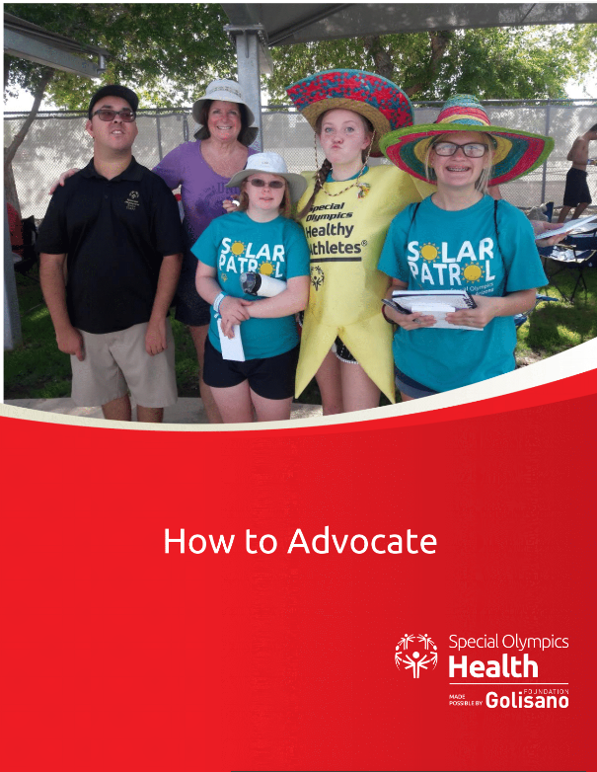
What Is Self Advocacy?
1. Speaking up for your rights, and the rights of others.
2. Having your voice heard.
3. Making sure that your views and opinions are considered when decisions
are being made that directly impact your life.

Why Is Self Advocacy Important?
People with intellectual disabilities are negatively impacted by lack of access to
health care, policies and programs, so they are the best people to speak to policy makers.
Key Messages:
- People with Intellectual disabilities die 16 years earlier and have more chronic conditions than people without intellectual disabilities.
- Health care, services and education are not inclusive of people with intellectual disabilities.
- All people deserve to be in their best health.
- People with intellectual disabilities should have equal access to health care, services and education in their communities.
- Health systems need to take steps to be inclusive of all people and address the needs of people with intellectual disabilities.

Have Your Voice Heard:

The most effective way to influence policy makers is to put a “human face” on the issue of inclusion. This table helps you tell your story.

