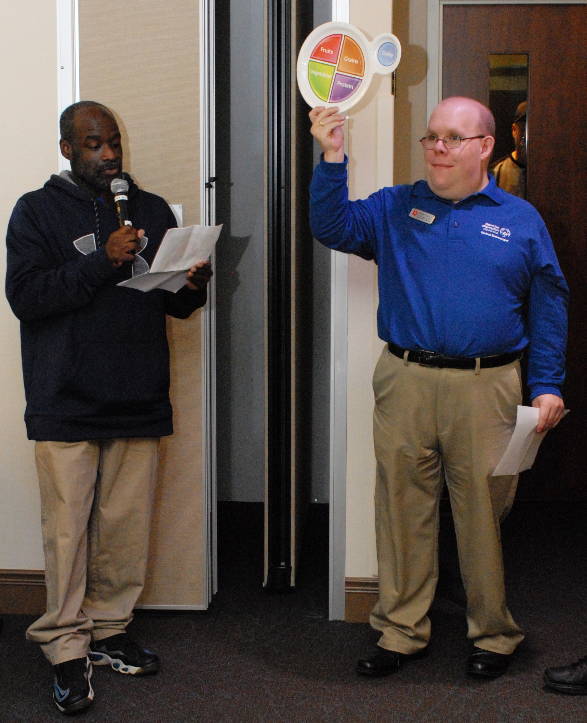



What You Can Do As A

Health Messenger

**Who is a Health Messenger?**

A Health Messenger is a Special Olympics athlete who has been trained to serve as a health and wellness leader, educator, advocate and role model.

There are lots of ways that Health Messengers can be active. You don’t need to pick just one!

Answer these questions to figure out what you might want to do as a Health Messenger:

1. Why did you volunteer to be a Health Messenger?

__________________________________________________________________________________________________________________________________________________________________________________________________________________________________________

1. Do you like teaching people how to do things?

**Yes No (circle one)**

Tip: if you circled “yes” you may be interested in teaching your fellow athletes about healthy habits, in person or on social media.

1. Are you good at motivating teammates?

**Yes No (circle one)**

Tip: if you circled “yes” you may be interested in helping your fellow athletes set—and meet—personal health goals.

1. Do you have a passion for fitness or nutrition?

**Yes No (circle one)**

Tip: if you circled “yes” you may want to be involved in leading fitness or nutrition education at your sports practices, Healthy Athletes events, Family Health Forums, or more!

1. Do you like talking to people in the community about why they should support Special Olympics?

**Yes No (circle one)**

Tip: if you circled “yes” you may want to participate in partner meetings or speaking to the media.

1. Do you like talking to people, especially decision-makers, about why the health needs of people with intellectual disabilities?

**Yes No (circle one)**

Tip: if you circled “yes” you may want to participate in partner meetings or speaking to the media.

1. Do you want to get more athletes in your Special Olympics Program to go to Healthy Athletes screenings?

**Yes No (circle one)**

Tip: if you circled “yes” you may want to organize team challenges for screening participation or do social media to get fellow athletes interested in participating.

1. Is there some other type of activity you have in mind that you would like to do? What is it?

__________________________________________________________________________________________________________________________________________________________________________________________________________________________________________