The Importance of Being Healthy
What does being healthy mean to you?

_______________________________________________________________________________________________________________________________________________________________________________________________________________________________________________________________
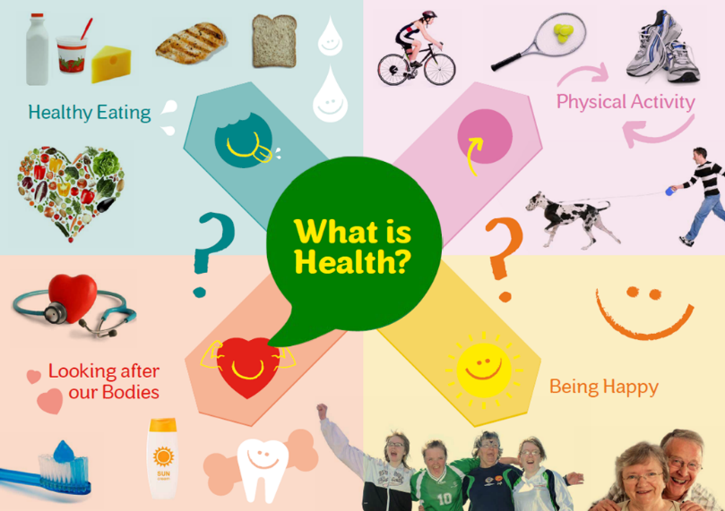

It is important to take good care of our bodies and minds so that unhealthy choices don’t turn into big health problems.

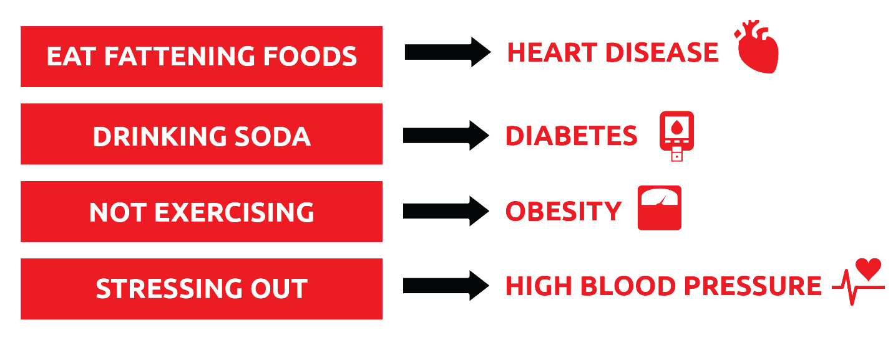

People who are healthy:
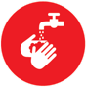

Eat healthy meals and snacks

Exercise for 30 minutes 5 days a week
Drink 5 water bottles per day

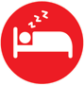
Sleep 6-8 hours at night

Don’t smoke
Wash their hands before eating and after using the toilet

Brush their teeth at least once a day

Have happy relationships with family and friends

Try to relax and not stress

Visit the doctor and dentist every year

Walking the Health Talk:
As a Health Messenger, people will look up to you and copy your actions, so it is important to take good care of yourself and practice healthy habits as much as you can!

What do you do every day to be healthy? (check all the things that you do)

_____Eat healthy meals and snacks

_____Exercise for 30 minutes

_____Drink 5 water bottles

_____Sleep 6-8 hours at night

_____Don’t smoke

_____Wash my hands before eating and after using the toilet

_____Brush my teeth at least once

_____Have happy relationships with my family and friends

_____Try to relax and not stress

For most people, it is hard to do all these things all the time. Doing just one of these habits can make a big difference to your health.

Which new healthy habit will you try?

____________________________________________________________________________________

