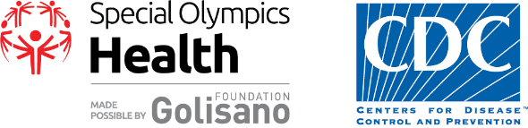
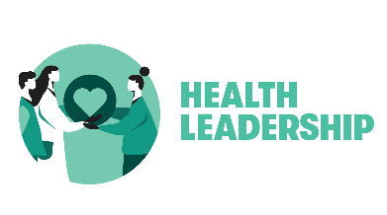
Health Messenger Mentor – Role Description
A Health Messenger is a Special Olympics athlete who has been trained to serve as a health and wellness leader, educator, advocate, and role model within their community.
The aims of the Health Messenger program include:
- providing athletes with a technical skill set that enhances their ability to be a leader and advocate for themselves and others in all aspects of health (e.g., health, fitness, with healthcare providers, etc.),
- empowering athletes to advocate for the health needs of people with intellectual disabilities, and
- promoting athlete knowledge of health and change in health behaviors.
A Health Messenger Mentor is someone who supports the athlete in their training as a Health Messenger and in their Health Messenger role after the training is over.

What Mentors do
- Attend Health Messenger training with the athlete
- Ensure opportunities to activate the Health Messenger to apply learnings
- Provide constructive feedback to the Health Messenger and the Program
- Coordinate logistics with caregiver(s), if applicable
- Help athlete stay on task and remain accountable (e.g., homework during the training, training attendance, activation)
- Research learning opportunities

How Mentors do it
- Recognize the role as a true partnership
  - Value the Health Messenger’s opinions and preferences
  - Allow the athlete to express himself or herself – give help only if he or she can’t
  - Listen – people want to know what the athlete thinks, not the ideas of the mentor
  - Each mentorship is unique and changes with the relationship over time; the mentor may fade their assistance as the Health Messenger becomes more proficient and capable

- Utilize the complementary—and likely evolving—strengths you and the athlete with whom you work possess
  - Get to know the athlete ~ communication style, support needs, goals in becoming an athlete leader
  - Consistency, reliability, and boundaries are key.
  - Be focused but flexible.

- Personal and professional learning
  - Represent Special Olympics in a professional manner
  - Always give encouragement – especially before a speech or event
  - Learn about local Special Olympics health efforts and possible opportunities
  - Understand Special Olympics and Special Olympics Health, made possible globally by the Golisano Foundation and the CDC in the US.

Basic Qualifications
- Must be 21 years of age or older
- Must be an approved Class A volunteer (background check, protective behavior class)
- Must complete the Athlete Leadership: Mentor Course on learn.specialolympics.org
- Must be available for the “Becoming a Health Messenger” training that the athlete is interested in
- Must commit to be a mentor for at least one year
- Willingness to commit to a minimum of 5 hours per month depending on athlete’s activities

