# A Guide to Using Physical Activity Wearables

**Introduction:** Physical activity wearables are cool gadgets that can help you stay active and healthy. In this guide, we'll learn how to wear them, why they're important, how to sync and charge your device, and how to use them to get moving!

**How to Wear Them:**

1. **Put It On:** Wear your device on your wrist. Make sure it's snug but not too tight.
2. **Comfort Check:** Make sure it's comfy. You don't want it too loose or too tight; it should stay on without bothering you.
3. **Charging and Syncing:** We'll get to this in a bit.

**Why Wear Them:**

1. **Stay Active:** Wearables remind you to move and be active, which is super important for your health.
2. **Set Fun Goals:** You can set exciting goals and challenges to keep you going.
3. **Track Progress:** They help you see how much exercise you're getting each day.

**Ways to Use:**

1. **Set Step Goals:** Try to reach a certain number of steps each day. Start with a number that's not too hard and make it higher as you get better. For example, you can set a goal to get a minimum of 7,000 steps in each day.
2. **Active Breaks:** Your wearable might remind you to take short breaks and move around. Follow these reminders.
3. **Fun Challenges:** Some wearables have fun challenges like "Dance for 5 minutes" or "Jump 10 times." Give them a shot!
4. **Record Workouts:** If you play sports or do exercises, use your wearable to keep track of how active you are during these activities.
5. **Share with Friends:** If your friends have wearables, you can challenge each other and see who's the most active.

**How to Charge and Sync Your Device:** Charging and syncing are like giving your wearable a power boost and connecting it to your phone or computer.

**Charging:**

1. **Find the Charger:** Look for a small slot on your device where you can plug in a charging cable or dock.
2. **Connect It:** Plug the charger into your device and then into a power source, like a computer or a wall socket.
3. **Check the Screen:** Your wearable will usually show a battery icon or a charging symbol when it's charging.

**Sync to SO FitNow app:**

1. Use the SO FitNow User Guide to use the Special Olympics fitness app!
2. **Click here**: SpecialOlympics-userguide-EN-2.pdf
3. [](https://www.dropbox.com/scl/fi/00x7e8wak1cctc57pm52v/Getting-Started-in-the-SO-FIT-NOW-App.mov?rlkey=ltwn28yw1xcgqzrso18cf9raa&dl=0)**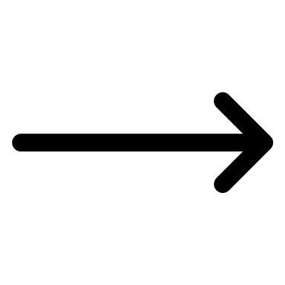Click on this video link** to learn how to get started!

**Sync to wearable app software**

1. **Get the App:** Download the app or software for your wearable on your smartphone or computer. You can find it in your device's app store or on the maker's website.
2. **Create an Account:** Open the app or software and make an account if you don't have one yet. Follow the steps to link your wearable to your device.
3. **Pair Up:** Once you’re connected, your wearable will send the data to your phone or computer. You can check your steps, exercise, and more on the app.

As an example, you can watch this video led by Health Messenger Abe Assaad. He will show you how to connect an Apple Watch to the app.



**Click the picture**

**Conclusion:** Physical activity wearables are awesome tools to help you stay healthy and active. By wearing them the right way, understanding why they're important, and using them for fun activities, you can make staying active part of your everyday life. So, put on your wearable, charge it up, and get moving!