Pledge Wall Training
Thank you for your help with the pledge wall! Making a goal/pledge is often the first step towards a lifestyle change. Writing a specific pledge or goal can be difficult, but important for a successful change. Many people know they want to perform better or live a healthier life, but it can be hard to narrow down to a specific goal. Your job today is to work with each participant and try to help then narrow down their ideas so they have a SMART goal. A goal is SMART when it follows the following criteria:

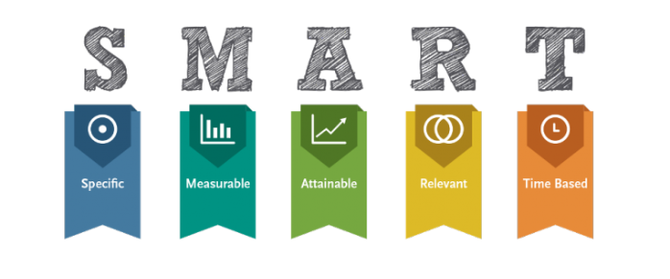
Example:
My goal is to lose weight.

SMART: My goal is to lose 5lbs this month by drinking water instead of soda and walking for 30 minutes each day.

Notice, the SMART goal in the previous example is still focused on weight loss, but the process the person will take in attempt to lose weight is specified. The goal is bound by time (one month) and measurable (5 lbs.) so the person can determine whether or not they reached their goal. Finally, they set a goal that is challenging but possible for them, which can help set them up for success.
Below are a few examples of goals/pledges you might hear, followed by some questions that might help the participant come up with a SMART goal.
“I want to win more games/competitions.”
- How will you win more games/competitions?
- What are things you can do to improve your skills?
- How often do you think you can do that?
- How long will it take you to improve that?
“I will eat healthier.”
- What is one thing you’d like to change about how you eat?
- Is there something you can do about that?
- When do you think you can make that change?
“I will exercise more.”
- What type of exercise do you want to do more often?
- Where will you do this type of exercise?
- How often do you want to do it?
“I want to be stronger.”
- How do you get stronger?
- When do you want to be stronger?
- How will you know if you are stronger?

Now that you’ve thought through the process of helping others make a goal, you are ready to get started! Thanks again for your help!

