Printing Instructions
- Select “Size”
- Select “Actual Size”
- Select “Landscape”

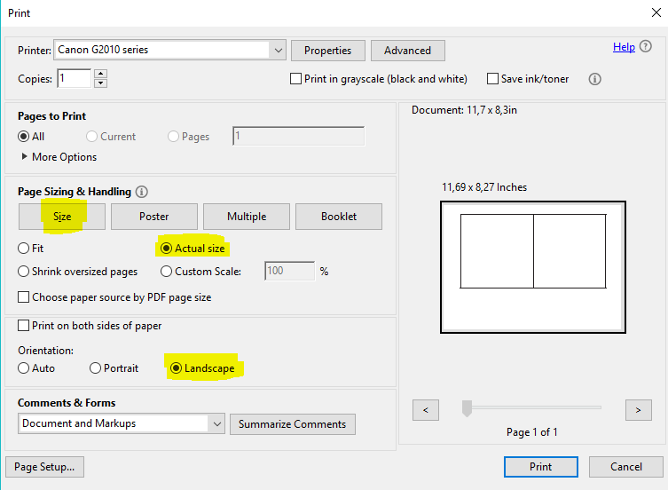
3
2
1

