Family Health Forum (FHF) Toolkit – for 2021 FHF Events
Purpose and Objectives
Sponsored by Lions Club International, the Family Health Forum (FHF) initiative is designed to engage families of those with intellectual disabilities (ID) in Special Olympics and offer an environment where parents and caregivers can gain direct access to health information, resources, and support. The objectives of the Family Health Forum initiative are to:
- Provide families of Special Olympics athletes with direct access to community leaders, health care professionals, and social service providers;
- Provide orientation to new families as to what Special Olympics is, the services provided through such initiatives as Healthy Athletes and Young Athletes, and other community-based programs for people with ID;
- Provide health care professionals, community leaders and social service providers with the opportunity to learn more about the challenges that athletes and their families face, and explore ways to help facilitate better access to health care, education, and inclusive activities;
- FHF can also be a great opportunity for Programs to build a foundation for future Healthy Athletes, Healthy Community, or Fitness programming. Keep that in mind as you plan your FHF and other health programs;
- Provide the donor an opportunity to share information on their services, programs and products that are relevant to family members.

Support
If you have any questions related to the implementation of your FHF, please contact your Regional Healthy Athlete Manager or Taylor Braun (tbraun@specialolympics.org).

Agenda and Implementation Requirements
A Family Health Forum can occur:
1) As a stand-alone event, outside of any other Special Olympics competition or event;
2) During a Special Olympics competition or special event or Healthy Athletes screening

Special Olympic Programs should develop Family Health Forums that address the specific questions and concerns of their local family members, however there are some requirements that must be met in order to receive funding.
- The event must be scheduled and held between January 15 – September 15, 2021
- All fields of the application must be complete (including budget justification)
- The agenda MUST include:
  - At least one health topic, but a variety of related topics can also be included.
  - A member of the local Lions Club to speak to families about Lions Clubs International, the services offered at the local level, and the benefits of becoming a Club member.
  - A description of Healthy Athletes, Healthy Young Athletes (if offered) and why they are important, how athletes get access to Health programming and ensure follow-up care as needed.
  - A question and answer period.
- Banner with the Lions Club logo must be displayed at the event and photos showing the banner and Lions club members must be taken and submitted to SOI. Banner templates available here: Vertical |Horizontal
- The SO Program MUST by accredited and not have any outstanding reports for SOI grants.
- An online evaluation and financial report must be completed and submitted within 30 days of the conclusion of the event.
  - Financial report must include participant list and signed per diem sheets, if per diems are given.
  - Programs are also encouraged to complete the participant exit survey and enter the data through the online survey system.
Additionally, some programs may be asked to complete a feedback form based on the topics presented at their FHF.
All evaluation materials will be provided after award letters are sent.
Partnership Collaboration
FHFs are an opportunity to engage partners in the community who can serve as resources for people with intellectual disabilities to access key health, educational and social services. In addition to local universities, awareness groups, etc, some important partners include Lions Club International, UNICEF, Catholic Relief Services (CRS), International Federation of Red Cross and Red Crescent (IFRC), Ministries of Health or your local Public Health Department. Contact Taylor Braun (tbraun@specialolympics.org) for information about involving these organizations.

These partnerships can also help you build sustainability for future FHFs or other health programming.

Building Toward Special Olympics Success
Use your family health forums as an opportunity to help your Program achieve success in all areas of Special Olympics Programming. FHF can be a great opportunity for engaging family and athlete leaders. FHF can also help you build and generate interest in your Unified, School Engagement, Young Athletes, Healthy Athletes, Fitness and/or your healthy community programming as well as improving recruitment of new athletes for your sport competition. So remember to work cross department as you plan and implement your FHF.

Potential Topics for FHF Events – see page 3 for specific ideas
- Diabetes Prevention and/or Disease Management – NOTE: This is a priority topic for Lions Club
- Nutrition and Healthy Lifestyles
- Fitness – strength and conditioning
- Water, Sanitation, and Hygiene – particularly female menstruation and hygiene (a priority topic for UNFPA)
- Healthy Relationships and Social Media/Internet Safety
- Navigating the Healthy Athlete and general health system
  - Importance of follow-up and how to access care and services
- Forming Family Network Committees
- Mental Health
- Alzheimer’s and Dementia
- Heat Illness and Injury Prevention
- Concussion Awareness
- Parental and Caregiver Health – maintaining your own health to ensure your athlete’s health

Deadlines and Key Dates
November 25, 2019: Application Deadline -- applicants must not have any overdue reports.
December 16, 2019: Award Letters will START to be sent for approved grants (some letters may be sent later, depending on date of event.)
January 15, 2020: Earliest event can be held (For events in January/early February funding may not have been sent yet so Program may have to cover costs upfront and be reimbursed)
Ongoing 2020: 85% of funds will be disbursed 2 months prior to event, 15% will be disbursed after report is received (must be received within 30 days)
March 15, 2021: Second application period opens
April 16, 2021 Second application period ends
September 15, 2020: Grant ends (all events must be held before this date)

Funding Limits
Special Olympics Programs may submit applications for up to $3,000.00 in award funds per new Family Health Forum event – you cannot get additional money for a previously funded event. YOU MAY NOT APPLY FOR MORE THAN TWO GRANTS. Funding cannot be used for Healthy Athlete screening or other programming costs. Programs will be solely responsible for any expenditures in excess of the award. The award monies will be disbursed in two payments (85% pre-event and 15% post-report), in US dollars (USD) only. (Use www.oanda.com for currency conversions.) Any unspent funds must be returned to Special Olympics International at the end of the award reporting period.
Potential Agendas and Background for Select Topics:

Diabetes Prevention and Care Management
Lions Clubs have recently expanded their focus and have a mission to reduce the prevalence of diabetes and improve the life for those diagnosed. A FHF session around Diabetes, in partnership with Lions Club and other organizations could include:
- An Overview of Diabetes, Risk Factors, and Health Outcomes (e.g, wellness, vision, podiatry)
- Healthy Eating for Diabetes Prevention
  - Exploration of how Special Olympics Health programming can assist (e.g., Health Promotion and Fitness and Sport)
- Offer a Fitness Session for the participants to actively engage in during the FHF.
- A Type 2 Diabetes screening for athletes and family members (screening itself and the costs associated should be delivered by a partner)
  - If a screening will be offered, you need to be sure that follow-up care and resources are available to assist those that may be diagnosed as diabetic or pre-diabetic.
- For those with a diabetes diagnosis (newly identified or previously known), a support group and disease management care session.
Potential Partners: Lions Club International, American Association of Diabetes Educators, Wellness Initiative, Diabetes Education and Camping Association, Diabetes Patient Advocacy Coalition (US), International Diabetes Federation, local physicians and healthcare providers, local health departments. This is not an exhaustive list, but a start.

Female Menstrual Hygiene and People with Intellectual Disabilities:
The London School of Tropical Medicine and Hygiene who created an intervention teaching girls with intellectual disabilities about menstrual hygiene using culturally appropriate dolls. It is called the Bishesta program, and was originally Gates funded. They are interested in scaling it and for some Programs, this might be a great FHF to explore. Below is some background information about the Bishesta:
- Blog on the formative research findings which explored the barriers people with different impairments face: https://washmatters.wateraid.org/blog/we-must-ensure-people-with-disabilities-have-dignity-during-menstruation.
- After analysing the formative research findings, LSTHM developed a menstrual hygiene behaviour change intervention. This blog explains that process: https://washmatters.wateraid.org/blog/disability-and-menstruation-in-nepal-how-we-developed-our-behaviour-change-intervention.
- The intervention was delivered with a small sample last year in Nepal. Results from the evaluation are captured in this final blog: https://washmatters.wateraid.org/blog/disability-and-menstruation-in-nepal-five-wide-reaching-effects-of-empowering-young-people.

General Introductory FHF (From SOAF Region):
- Intellectual Disability Overview and Breaking Down Barriers
- Skillful Parenting (a lot of families are breaking; especially men leaving their families after giving birth to a child with ID)
  - Roles and responsibilities in parenting; Community Parenting; Customs, beliefs and culture
- Fitness Programs
  - Healthy habits and exercising through Special Olympics and through home setting activities
- Healthy Athletes
  - Family Health Engagement Opportunities and why they are important
  - How family members can get their children to Healthy Athletes, find out results, and follow up as recommended.
- Lions Club Orientation
  - What is Lions Club International; The services offered at the local level; Benefits of becoming a Club member.
Budgets
After your application is approved by SOI, you will need to enter your budgeting information into SmartSimple.

Expenses will vary by the type of work that you plan to complete. We anticipate that the most common funds needed will be: speakers, facilities, supplies, equipment, meals and transportation/travel. For virtual Family Health Forums, the costs for implementation should be limited and will mostly rely on staff time. If you have any questions about how funds may be spent, please contact your Regional Health Manager and/or, at SOI, Taylor Braun, tbraun@specialolympics.org

Restrictions:

The grant funding is not to be used for covering part of the Program’s existing overhead costs such as office, internet, telephone, photocopier rentals, and gift certificates.

Funds may be used to provide up to US $100 stipends or gift (per speaker), if necessary. Each expense will need a receipt submitted for approval at the end of the project period.

The grant funding cannot cover standard Healthy Athletes event costs. Healthy Athletes events are covered through the standard process of capacity grants.

We strongly encourage you to seek financial support (both cash and VIK) from partners to support your work.

You will be responsible for providing receipts for all expenses that Special Olympics International provides through the award and will upload them in these categories in Qualtrics. *For Financial Report, you must have participant list for all participants. Must have signed per diem forms for anyone receiving per diem.
Reporting
A final narrative and financial report, including detailed receipts and a program evaluation, will be required 30 days after the event or activity. The final 15% of funding will not be provided until the report is received. Late reports will result in a hold on additional grant funding to the program.

For the narrative report, programs are asked to complete and return two types of documents (three if you had select topics):

1) Evaluation Form and Financial Information
This form should be completed by program staff within 30 days after implementation of the FHF. It asks general information about the FHF such as topics, types of partners, speakers, most/least successful aspects, and a success/impact story related to the event and pictures from the event. The program only needs to submit one of these per FHF grant. You will be able to submit this information online through the system called Qualtrics, which will allow you to enter your evaluation form, feedback form (on certain topics), financial report, and receipts in one place online. You will receive more information about how to log-in to complete this online form when you receive your grant.
  - Have a list of participants that attended the event.
    - If giving cash per diem reimbursement for transportation – each participant who receives a per diem must sign that they received the money and the amount of money received. A template will be provided in your award agreement letter
    - If giving cash per diem to Speakers you MUST have a signed contract that lists the amount given and provide a copy of the Speaker’s photo ID. A template will be provided with your award letter.
  - Have all your receipts clearly labeled, included US$ conversion using OANDA, and submit under the proper category.

If you are unable to enter your form directly into the online system, please contact your Regional Healthy Athletes Manager who can send you a word version of the survey to complete.
You should receive the URL for the survey and a log-in username with your award letter. If not, please contact Taylor Braun (tbraun@specialolympics.org) or your Regional Health Manager.

2) FHF Exit Survey (OPTIONAL, but STRONGLY ENCOURAGED)
This survey should be completed by FHF participants at the end of the FHF. It is a series of questions that will gauge the value and impact of the session on each individual participant. This information is important because it tells you whether FHFs are valuable and how you can continue to improve them for future events.

Please distribute to participants at the end of the session and have them return the completed forms. Once these forms are complete, you can enter the data online through a system called Qualtrics. This online method is the cheapest and easiest, and will allow you to see your results quickly. Additional instructions are provided in a FHF Exit Survey FAQ document.

3) Feedback Form on Select Topics
Depending on the topic(s) you plan to present in the FHF, you might be asked to complete a feedback form that asks specific questions about that topic and how it was presented and received by attendees. Certain topics are new areas or are of particular interest to Special Olympics, and the questions on the feedback form will help us better understand the needs of our families and athletes. You may be asked to participate in a call with SOI if your topic falls into this category.
How to complete the online Evaluation and Financial Report through Qualtrics:
- Use the link for the Evaluation Report provided in your award letter.

- When prompted enter the username that was provided in your award letter and click Red Button with the “>>” on it.
  - If you received more than one grant, be sure to use the correct log-in. Each grant has its own log-in.
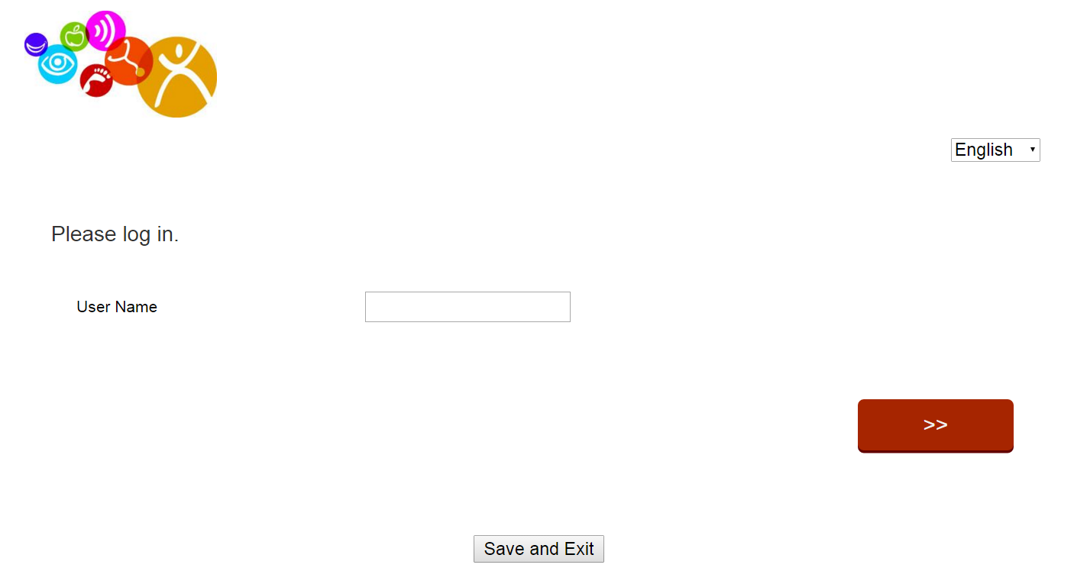

NOTE: Using the dropdown box at the top right of the screen, you can also select whether you want the questions to display in English, French, or Spanish (however, please enter your answers in English)

- Answer all the questions as instructed.
  - Be sure to use the correct Grant Number, if you received more than one grant.

- Please either upload your photos from the event (particularly one showing Lions Club Logos and members) or email them to Taylor Braun (tbraun@specialolympics.org).

- When you get to the budget portion of the report, please be sure to upload all the receipts associated with the specific expense category (e.g., transportation, communication). The receipts must be translated to English and show the conversion to USD using the OANDA conversion rate.
  - If you have multiple receipts for a category, scan and save them as one file. Do not upload them as individual files. Alternatively, you can upload all associated receipts for each category as a ZIP file.
    - To ZIP files:
      - Locate the file or folder that you want to compress
      - Right-click the file or folder, select “Send to” from the menu, and then click “Compressed (zipped) folder”. A new compressed folder is created in the same location. To rename it, right-click the folder, click Rename, and then type the new name.

- If you aren’t able to complete the report in one attempt, click “Save and Exit.” The next time you log-in to complete the form, all the questions you previously answered will still be there and you will be taken to the remaining questions you still need to answer.

- When you have entered all the required information, be sure to click “Submit” or SOI will not receive your report.

If you have any issues or questions about the online evaluation report, please contact your Regional Health Manager or contact Taylor Braun (tbraun@specialolympics.org) at SOI.

How to complete the Participant Exit Survey: (OPTIONAL, but strongly encouraged)

Programs are encouraged to have participants complete the exit surveys as a way to gauge the success and impact of the event and figure out areas for improvement for future events. However, this survey is optional (unlike the evaluation survey which you must complete for reporting requirements)
Here is the typical process:
- Print a copy of the Participant Exit Survey– as long as you don’t modify the questions themselves, you can customize the form with your Program Logo or other information.
  - NOTE: Your Regional Healthy Athlete Manager has a copy of the survey.
- Distribute the printed survey to participants at the event and then be sure to collect the forms as participants leave.

- After the event the Program enters the information from each of the paper forms into the online Qualitrics Survey: https://specialolympics.qualtrics.com/SE/?SID=SV_8eVdXqWT4U43t89, you do not need a password for the exit survey -- fill out the survey for each paper copy you have.

- Let Taylor Braun (tbraun@specialolympics.org) know once all your surveys have been entered into the system and they can send you a summary of the data.

If you have any issues or questions about the online Participant Exit Survey, please contact your Regional Healthy Athletes Manager or contact Taylor Braun (tbraun@specialolympics.org).
How to Compressed PDF or Pictures to submit/email files:
Generally, if you zip the files as instructed above, you shouldn’t have an issue with the files being to large. However, if for some reason you need to reduce the size of a file, here are some tips:

To reduce the size of a PDF:
- Open the PDF file.
- Under the File menu, select “Save As”
- From the “Save As” menu, select “Reduced size PDF”
- Follow the prompts and then click “Save” and re-name the file.

NOTE: To reduce the size of a Microsoft Word document – try converting it to a PDF and then using the process above.

To reduce the size of an image file (e.g. JPEG, PNG):
- From your computer, select the image file you want to reduce, and right click.
- From the right click menu, select “Open with” and then choose “Paint”
- Once the Paint Application opens, select the “Resize” tool from the toolbar
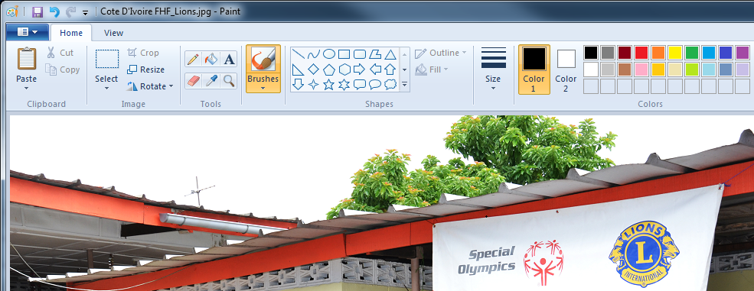

- Reduce the percentage or the pixels to make smaller using the pop-up tool (see example below)
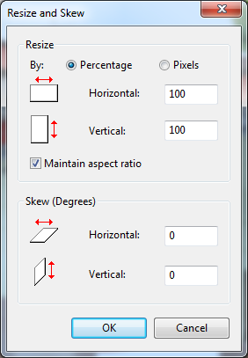

- Re-save the file.

