* 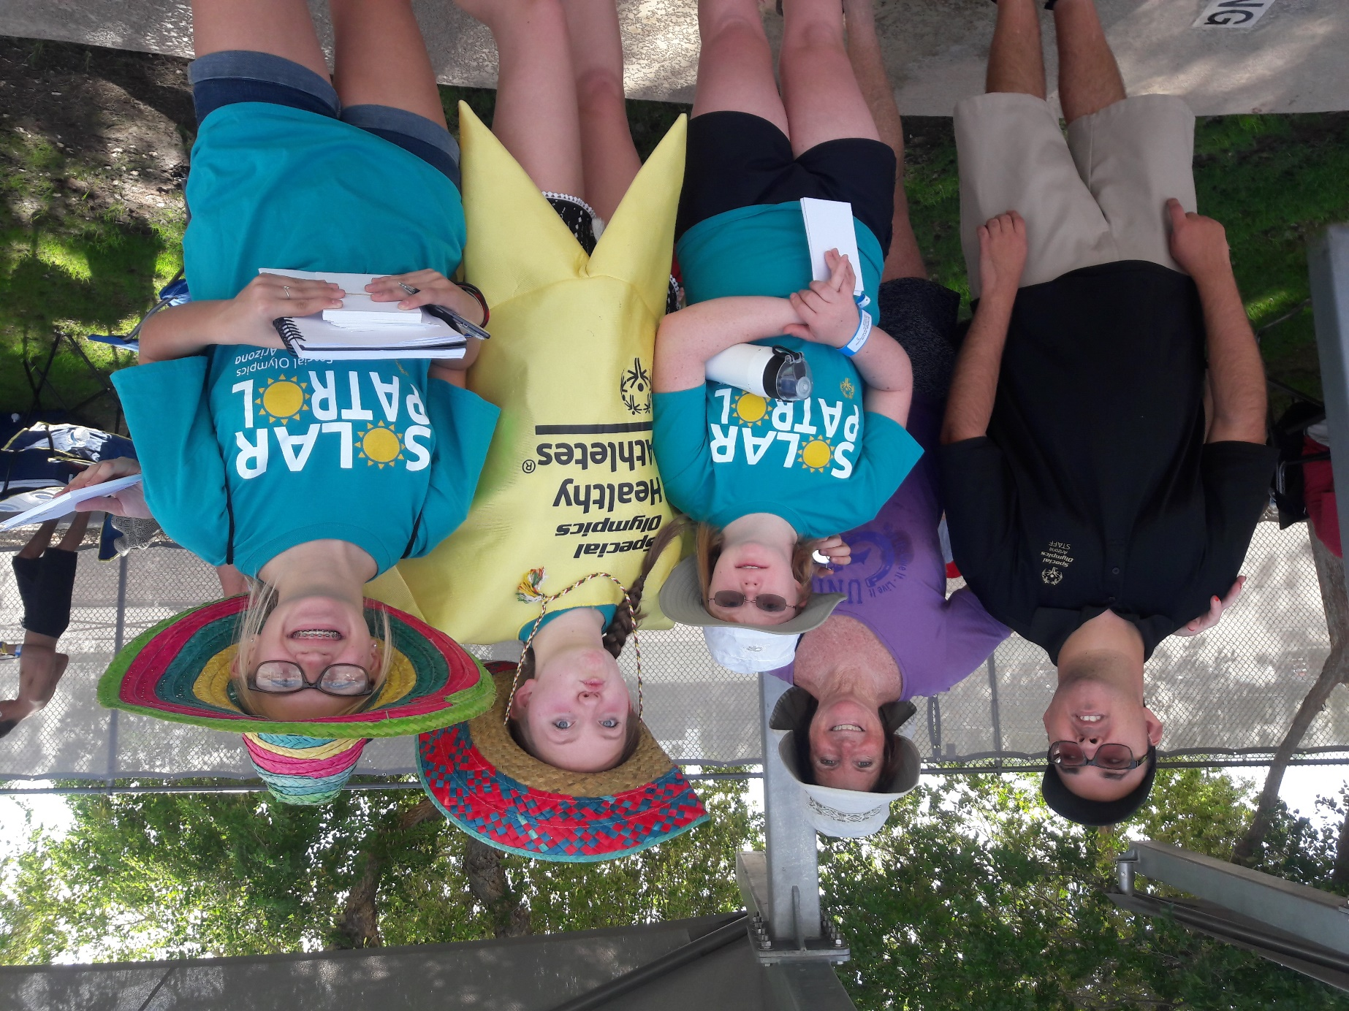



How to Advocate for Your Family’s Health



**What Is Family Health Advocacy?**

1. Speaking up for your family member’s rights.
2. Making sure that your family member’s views and opinions are considered when decisions are being made that directly impact their life.
3. Having your voice heard.

**Why Is Family Health Advocacy Important?**

People with intellectual disabilities (ID) are negatively impacted by lack of access to health care, policies and programs and are often excluded from making decisions about their health.

**Key Messages:**

* People with ID die 16 years earlier and have more chronic conditions than people without intellectual disabilities.
* Health care, services and education are not inclusive of people with ID.
* All people deserve to be in their best health.
* People with ID should have equal access to health care, services and education in their communities.
* Health systems need to take steps to be inclusive of all people and address the needs of people with ID.

**Have Your Voice Heard:**

The most effective way to influence health decision makers is to put a “human face” on the issue of inclusion. This table helps you tell your family member’s story.

Prepare to talk to any health decision maker by creating 3 Ws and an H.

Decision makers = anyone in your community who can impact your family member with ID’s health.

* Health care providers and workers
* Fitness and wellness professionals
* Businesses

**WHO:** Describe who your family member with ID is. What is important for decision makers to know?

_________________________________________________________________________________________________________________________________________________________________________________________________________

______________________________________________________________________________________________________________________________________

**WHAT:** Explain some of the challenges your family member with ID faces being healthy, and the impact that being excluded has on their health.

_________________________________________________________________________________________________________________________________________________________________________________________________________

______________________________________________________________________________________________________________________________________

**WHY:** Describe the reason for your appointment, conversation or meeting. Why are you there?

_______________________________________________________________________________________________________________________________________________________________________________________________________________________________________________________________________________________________________________________________________________

**HOW:** Give ideas for what can be done so that your family member with ID is included, feels comfortable, gets the best health care or has the best experience possible.

_______________________________________________________________________________________________________________________________________________________________________________________________________________________________________________________________________________________________________________________________________________