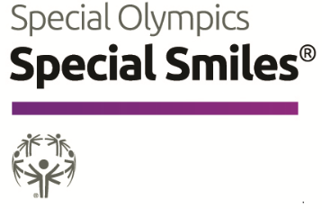
SPECIAL SMILES CLINICAL DIRECTOR RECRUITMENT QUESTIONS

Thank you for your interest in Special Olympics Special Smiles! Below are just a few questions to help us make sure that Special Smiles is a good fit for you. There are no right or wrong answers to any of the questions and no expectation that you would have any experience with Special Olympics or to working with people with Intellectual disability, but in addition to your CV/resume, this helps us understand experience. If you are approved as Clinical Director, this information will also help us improve the training we provide you. Thank you for your consideration and time.

Part I – General Overview
- Did anyone recommend you for this position? If so, who? | ☐ Yes ☐ No
  - If so, who:
- Do you have any past involvement with the Special Olympics Special Smiles Program? | ☐ Yes ☐ No
  - If so, please briefly describe:

- What type of clinical dental degree do you hold (i.e., DDS (Doctor of Dental Surgery), DMD (Doctor of Dental Medicine), RDH (Registered Dental Hygienist), etc)? | ☐ Yes ☐ No
  - Please specify 1) degree attained, 2) Year attained, 3) Institute attained from:

- Do you hold an active license to practice in the area your program is conducting the Special Smiles Screening? | ☐ Yes ☐ No
  - If so, please provide your license number? Or any identifier used to confirm ability to practice dentistry. And governing body (where identifier accepted)
  - If your license is not active, please explain.

- Do you agree to notify your SO program immediately, in the event your license is no longer active? | ☐ Yes ☐ No
- Do you have experience training other oral health professionals? | ☐ Yes ☐ No
  - If so, please briefly describe:

- Do you have experience recruiting volunteers and/or students? | ☐ Yes ☐ No
  - If so, please briefly describe:

Part II – Motivation
- Why do you want to join the Special Smiles team and support Special Olympics Athletes?

- Are you planning to request SOI data and/or assistance for publication | ☐ Yes ☐ No
  - If so, please briefly share the trend(s) you are hoping to evaluate, and how it can improve understanding of the oral health of our athletes:

Part III - Professional and Educational Background
- Please ATTACH your professional CV/resume in English. Be sure it:
  - Includes information about your educational background.
  - Lists any licenses or credentials for your clinical profession.
  - Outlines your professional work experiences

- For More information about Special Olympics Healthy Athletes and Special Smiles, visit: https://resources.specialolympics.org/health/special-smiles
- A full description of the Special Smiles Clinical Director requirements available here: https://media.specialolympics.org/resources/health/disciplines/specialsmiles/Clinical-Director-Role-Special-Smiles.pdf?_ga=2.196157292.1111228731.1587934454-1137030687.1519746336

