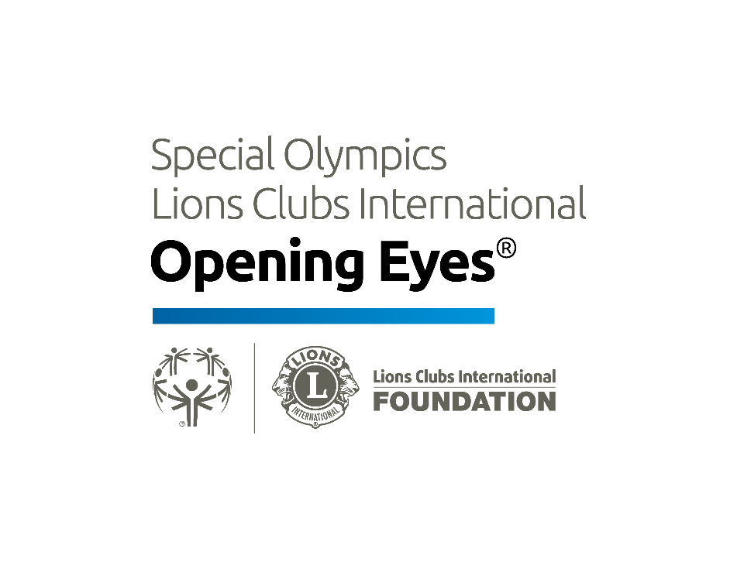  Vision Report Card  Name: ___________________________  Date: ____________________________  Special Olympics Lions Clubs International Foundation Opening Eyes sponsored the vision and eye health assessment that the Special Olympic athlete listed above participated in. The testing performed was designed only to detect possible vision problems. The results of the testing do not reflect a complete exam of the health and function of your visual system. It is recommended that the athlete have complete eye examination at regular intervals.  Visual Acuity (VA)- The measurement of sight sharpness. The ability to discern detail at distance.  Cover Test - Measures eye alignment to insure both eyes are used together. Eye teaming skills.  Color Vision - The ability to discriminate colors which may lead to confusion in recognizing teammates by uniform color in group sports.  Stereopsis - The ability to use both eyes together to make relative depth judgments.  Refraction - An estimate of the need for spectacle prescription. A person can be nearsighted, farsighted or have astigmatism. Either glasses or contact lenses can correct this condition.  Eye Health - Detects the presence of eye diseases, which may cause discomfort or threaten sight.  The information presented on the reverse side will explain the results of your performance in the various areas tested. Your primary eyecare professional can address any vision problem noted. For additional information about the program or if you have questions regarding the results, stop by our area during the competition or contact Special Olympics Lions Clubs International Opening Eyes, Local Clinical Director (Please add Local Clinical Director name, address, mail and phone number prior printing) | Based on our testing:  The athlete has passed the vision screening. However, please  remember that passing the screening in no way guarantees that further  eye or health care is not required.  The athlete had difficulty in the area(s) checked below that the:  Visual Acuity Cover Test  Eye Health Stereopsis  Refraction Color Vision  Other:  Please refer to the back of this form for explanation of the areas listed  above.  A new pair of glasses is being provided at no cost for the athlete. The  glasses may be delivered during the games or mailed to them after the  event. The glasses are to be used as follows:  Full time wear (all day long) Distance Viewing (TV, movies)  Sports Activities Close work (reading, school work)  The athlete has been referred for additional care to:  ______________________________________________.  Thank you for participating in the screening. If you have any questions,  please call (fill in clinical director’s name, phone and email)  VISION REPORT  CARD  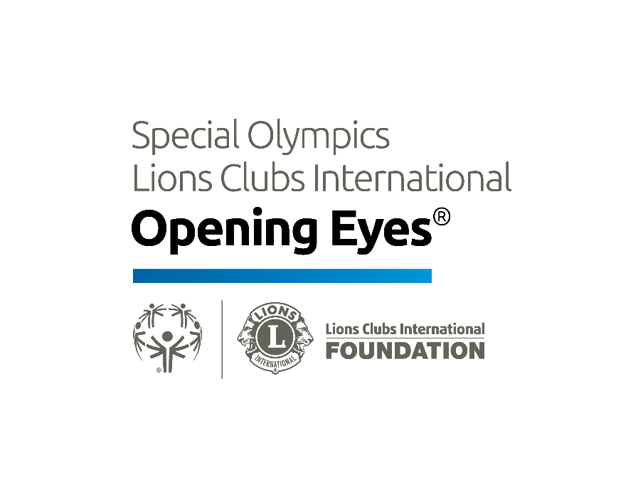

Instructions:

- Include the name and contact detail of the Clinical Director or program director so that athletes can follow up if they have questions
- Print out the first two pages of this document double sided on either A5, A4 or letter page size (print as many as athletes you expect to screen)
- Fold the page to a booklet.

