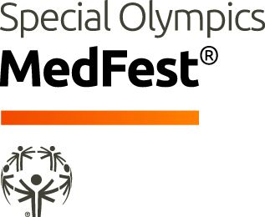 MEDFEST CLINICAL DIRECTOR RECRUITMENT QUESTIONS

Thank you for your interest in Special Olympics MedFest! Below are just a few questions to help us make sure that MedFest is a good fit for you. There are no right or wrong answers to any of the questions and no expectation that you would have any experience with Special Olympics or to working with people with an intellectual disability, but in addition to your CV/resume, this helps us understand your experience. If you are approved as a Clinical Director, this information will also help us improve the training we provide to you. Thank you for your consideration and time.

Part I – General Overview
Name:
Special Olympics Program:
- Have you volunteered with Special Olympics? | ☐ Yes ☐ No
  - If so, please briefly describe:

- Do you have professional/clinical experience providing clinical care and/or health education to people with Intellectual Disabilities (ID)? | ☐ Yes ☐ No
  - If so, please briefly describe:

- Do you have experience recruiting volunteers? | ☐ Yes ☐ No
  - If so, please briefly describe:

- Do you have experience training other health professionals? | ☐ Yes ☐ No
  - If so, please briefly describe:

Part II – Motivation
- Please elaborate on your interest to volunteer with the Special Olympics.

Part III – Professional and Educational Background
- Please ATTACH your professional CV/resume in English. Be sure it:
  - Includes information about your educational background.
  - Lists any licenses or credential for your clinical/allied health profession.
  - Outlines your professional work experiences

- For More information about Special Olympics Healthy Athletes and MedFest, visit:
https://resources.specialolympics.org/health/medfest?locale=en
- A full description of the MedFest Clinical Director requirements is available here:
https://media.specialolympics.org/resources/health/disciplines/medfest/Clinical-Director-Role-MedFest.pdf?_ga=2.121304264.1995177960.1625585310-1361295655.1621440469

