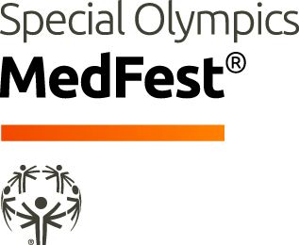

Certificate of Appreciation
Presented to
[NAME]
With deep gratitude and appreciation for your participation as a volunteer during the Special Olympics Med Fest Screening Event
[Location] on [Date],
and for your willingness to support
Special Olympics [Program Name] athletes.

[Signature]  Program Health Staff |  | [Signature]  Program Chief Executive Officer

