

**Health Promotion Virtual Health Assessment Toolkit**

**Background and Overview**

The Virtual Health Promotion Health Assessment Protocol, called the Health Assessment, offers a hybrid of an individual athlete assessment including self-reported weight, and measured height and waist, targeted health education and feedback on key health habits. Athlete, family and coach engagement is invited.

The Health Assessment model is developed for use on computers, tablets and smart phones. It uses the Google Form platform and may be adapted for alternate platforms. The Health Assessment captures athlete’s response data, with the opportunity link the educational component to the health habits questions. Athlete responses can be recorded later onto the HAS form as “self-reported data”. Any number of athletes may participate in an “event”, whether or not athletes live alone, with family or in a group home. The interactive educational webinar may be delivered by HP Clinical Directors, Program staff, clinical volunteers or students.  **Identified resources are posted on** [**Virtual Health Promotion web page.**](https://resources.specialolympics.org/health/health-promotion/virtual-health-promotion)

**Health Assessment Process**

**Health Assessment Template (Google Form)**

The Health Assessment includes self-reported weight and measured waist circumference and height, and questions on health habits, which focus on behaviors linked to chronic disease risks . These include vitamin D supplement use, beverage choices, bone building foods, fruit and vegetables, salty or sweet snacks and sugar sweetened beverage consumption and frequency, exposure to second-hand smoke and handwashing knowledge and habits.

**Clinical Measurements** Athletes should enter weight, height and waist circumference and answer health habits questions online before the educational webinar.



**Resources:**

* Printed instructions with graphics describing how to correctly measure their height are available for [Imperial](https://www.dropbox.com/s/mrfak02igc8mg8q/Waist%20Height%20Measurement%20Guide%20print%20Imperial.pdf?dl=0) and [Metric](https://www.dropbox.com/s/2zsm11qgw6svlkh/Waist%20Height%20Measurement%20Guide%20print%20Metric.pdf?dl=0)  A video describing the same for [Imperial](https://www.dropbox.com/s/id1al7am57lgor8/Waist%20and%20Height%20Measurement%20video%20Imperial.mp4?dl=0) and [Metric](https://www.dropbox.com/s/5gse5hg3o84utge/Waist%20and%20Height%20Measurement%20video%20Metric.mp4?dl=0).
* [**Height and Weight Measurement Guide**](https://resources.specialolympics.org/health/health-promotion/special-olympics-waist-height-measurement-guide-imperial?locale=en)  **(**YouTube or narrated PPT format) is available for use by athletes, parents, caregivers or coaches. [Imperial](https://resources.specialolympics.org/health/health-promotion/special-olympics-waist-height-measurement-guide-imperial?locale=en) | [Metric](https://resources.specialolympics.org/health/health-promotion/special-olympics-waist-height-measurement-guide-metric)
* Instructions to [upload waist measurement photo](https://media.specialolympics.org/resources/health/disciplines/health-promotion/virtual/How-to-Upload-Waist-Circumference-Photo-into-Health.pdf?_ga=2.135405297.1515086409.1613187643-1373198571.1613187643).

Programs will receive a **Health Assessment Template** form named and linked to their program. It can be further personalized with program information and additional data the Program wishes to collect. Programs may save it on their Google drive or adapt for use on another platform.

The **Health Assessment Template**  includes questions about health habits and pictures to facilitate the response. Exhibit 1 shows an example of Health Assessment questions with pictures. Photos can be customized to meet local needs. The Health Assessment questions may be used on alternate platforms.

**Resources:**

* The **Health Assessment Template** is formatted on a Google Form. To request access, email Alice Lenihan [lenihanaj@aol.com](mailto:lenihanaj@aol.com) and HP Manager [healthpromotion@specialolympics.org](mailto:healthpromotion@specialolympics.org).
* [**Health Assessment Template-US**](https://media.specialolympics.org/resources/health/disciplines/health-promotion/virtual/Health-Assessment-Template-US.pdf?_ga=2.125388296.322106652.1604437538-1821482185.1604437538)  or [**Health Assessment Template - International**](https://media.specialolympics.org/resources/health/disciplines/health-promotion/virtual/Health-Assessment-Template-International.pdf?_ga=2.125388296.322106652.1604437538-1821482185.1604437538)



**Exhibit 1**

**Athlete Engagement and Invitation**

After deciding on the date(s) and times for the Health Assessment Template dissemination, the Google Survey Invitation should be emailed to athletes with a link to the Health Assessment. By sending the Health Assessment Template in advance of the planned education webinar, so the athlete has time to enter their self-reported weight and their measured height and waist circumference and to consider their health habits survey responses before they electronically return the completed Health Assessment. The Health Assessment Template reporting feature provides the program with readymade charts, graphs and daily tabulation of answers on the completed forms.

**Resources:**

* [**Athlete Health Assessment Invitation**](https://www.dropbox.com/s/35838883ehbn4sh/2.%20%20Invitation%20email%20template%20for%20Athletes.docx?dl=0)  Templatewith instructions is found at:
* [**Virtual Health Assessment Disclaimer**](https://www.dropbox.com/s/rz4kwnvaaerlmau/3_SO%20Program%20Virtual%20HA%20Disclaimer%2007202020.pdf?dl=0) may be attached to the registration form or to the Health Assessment Template.

**Health Assessment Athlete Webinar**

* The Health Assessment Education webinar is coordinated by the Program and will be led by a Clinical Director and/or clinical volunteers. Additional clinical volunteers may help to implement the event and/or to lead breakout groups if needed for large groups of athletes.
* At the Health Assessment webinar, aggregate summaries of the Health Assessment responses and targeted education is provided on the topics covered in the Health Assessment.
* Depending on athlete input and discussion, the session will take approximately 1 hour. The Clinical Director can decide to handle questions via the chat box, a raised hand or other method. Not all questions have to be handled on the spot. The response can go out later to the group if research or more information is needed.

**Suggested Session Flow**

* + - Program staff or a Health Messenger can introduce the session, explain the purpose, and thank the participants for participating.
    - The Clinical Director should congratulate and thank the athletes and others who submitted completed Health Assessments. Remind everyone the information is confidential and will not be shared and then begin the session. over the results of the Health Assessment and discuss key educational messages for the relevant topics
    - Allow for questions and answers from participants.
    - Within a few days following the session, the Athlete Health Report 2020 with referrals should be sent to each athlete.

**Resource:** [**A PowerPoint template**](https://www.dropbox.com/s/q37yvp5p3p54rc6/4_Health%20Assessment%20webinar_Template_with%20Script%2010.25.2020.pptx?dl=0)to share the Health Assessment aggregated responses and educational scripting is available. It can be adapted with the Program’s Health Assessment results or topics the Clinical Director wants to emphasize or add.

**NOTE:** We discourage online polling during the webinar since athletesneed time to take and record their measurements, view the pictures, and consider their responses. [**A PowerPoint presentation**](https://www.dropbox.com/s/3lfpnczwxgc67nz/5_Health%20Assessment%20%20Webinar_withPolling%20and%20script10.25.2020.pptx?dl=0) available for use for Programs who are only able to offer the Health Assessment using online polling. This alternate PowerPoint template with the Health Assessment questions and images built in. Regardless of the polling platform used, results should be saved as an excel file so graphs and charts can be easily extrapolated.

**Follow-Up**

A competed Health Assessment can alert the Clinical Director and Program staff to athletes who need follow up and referral. The process should be the same one the program has been using for athlete health promotion referrals. In addition to referrals for physician or dietitian follow-up, include referrals to health and fitness programs offered through Program, for example, Fit 5, School of Strength and others.

The Health Assessment screening results for newly measured height and waist results, and self-reported weight should be entered on the [**Athlete Health Report 2020**](https://www.dropbox.com/s/xykls8tkfl3wsri/6%20Athlete%20Health%20Report_2020%20%2B%20reverse%20copy.pdf?dl=0)**.** It should be emailed to the athlete to explain screening results and recommend referrals.

**Future Health Promotion Sessions**

Athlete questions and discussions on various topics indicate opportunities for additional information, education, and programming. The Clinical Director and staff should look for and listen for such opportunities. For example, athletes may be interested in learning more about portion sizes, trying new foods and tastes, healthy cooking. Contact the Health Promotion Program Manager to access additional education resources.

**Additional Education Resources for Social Media Platforms**

* 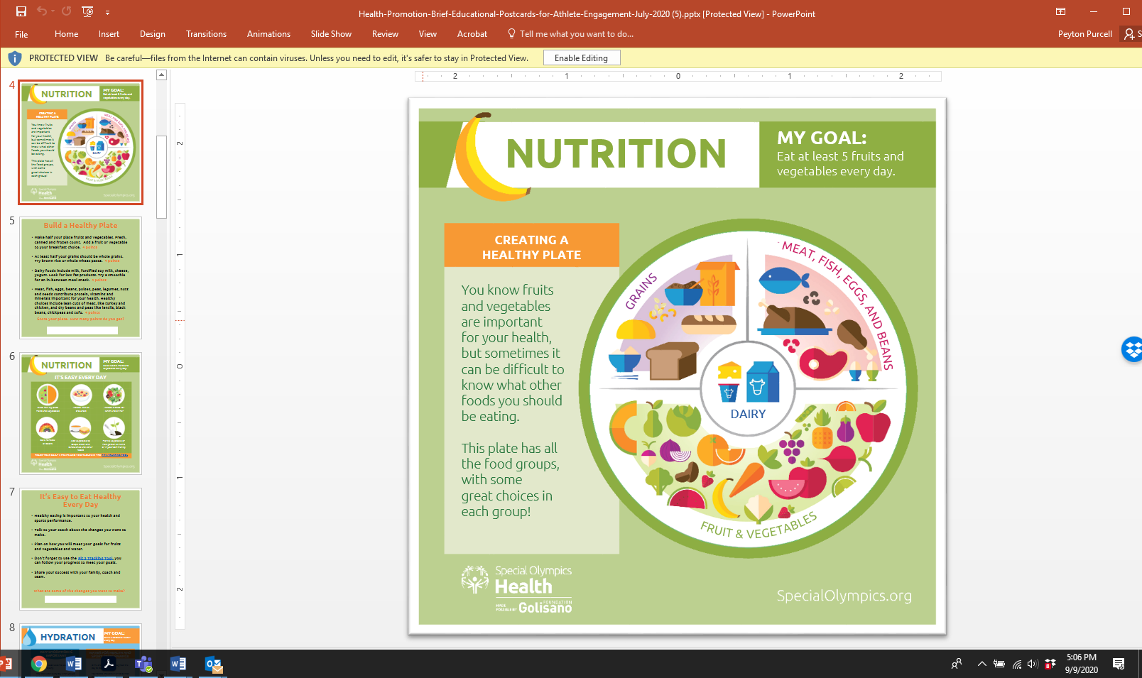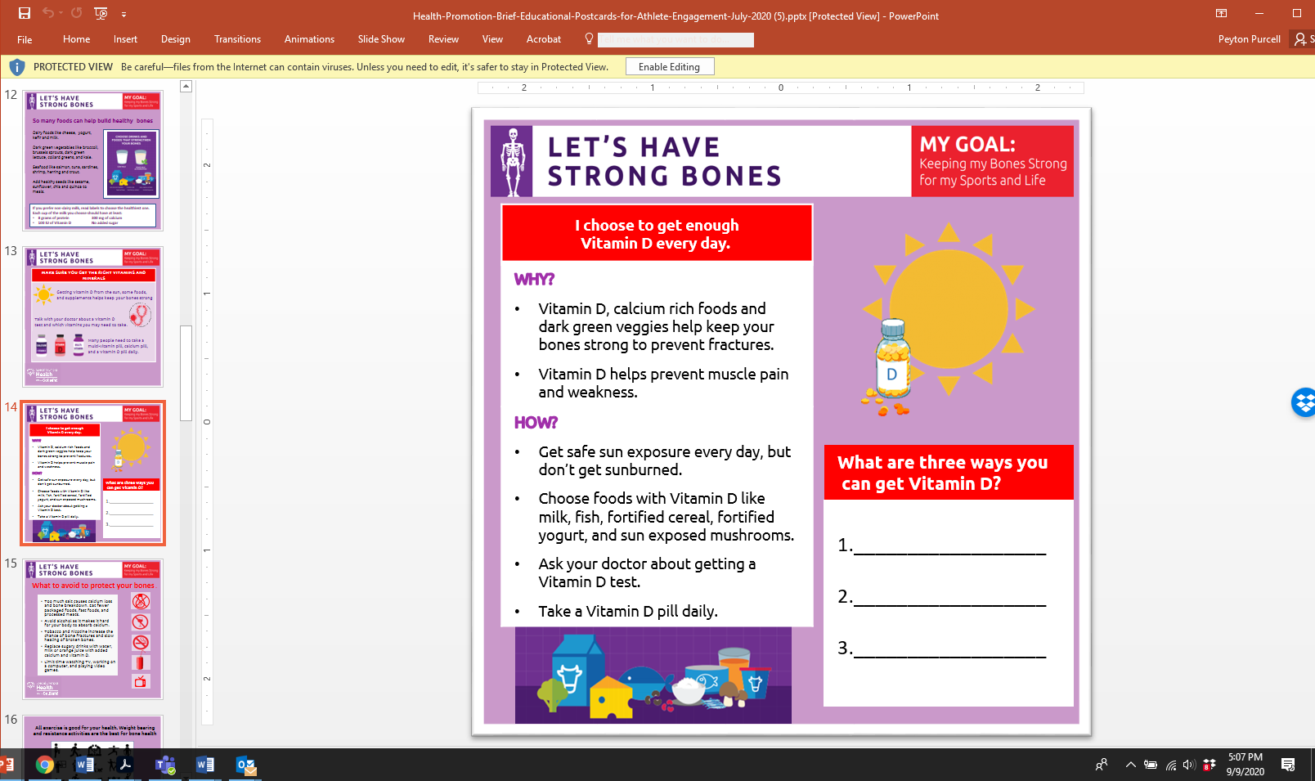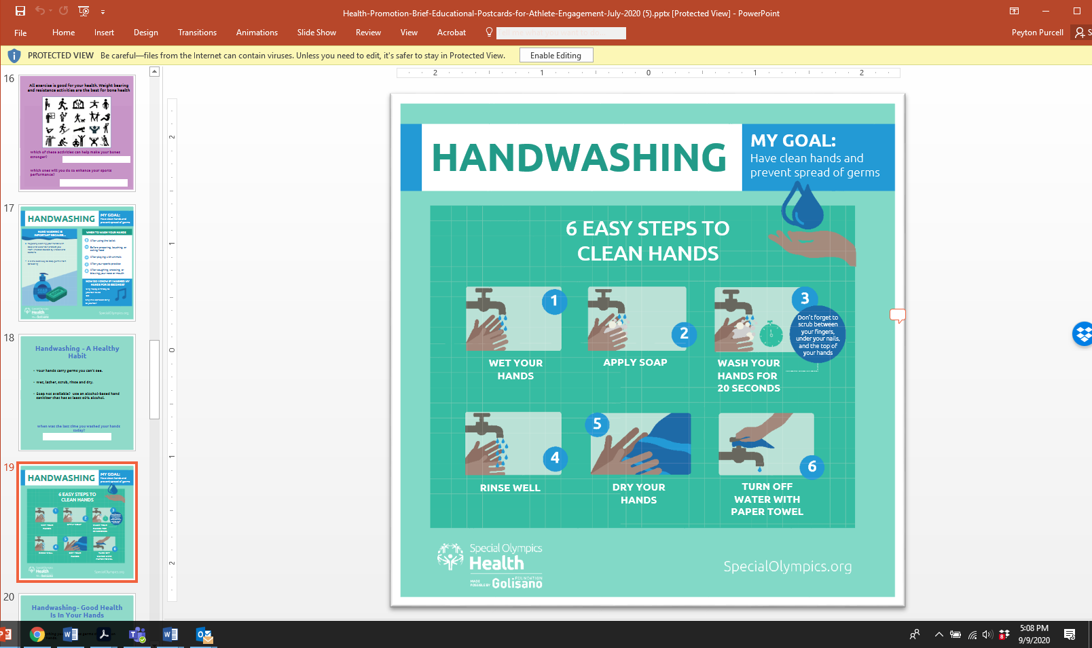**Health Promotion Posters** Smaller versions of the HP educational posters with focused education messages, are available for use in webinars, Family Health Forums, social media or for “advertisement breaks” during Virtual Games. These resources are available at [**Social Media Resources Toolkit**](https://media.specialolympics.org/resources/health/disciplines/health-promotion/Health-Promotion-Brief-Educational-Postcards-for-Athlete-Engagement-July-2020.pptx?_ga=2.216096726.1753197251.1603926250-265292229.1603926250)

* [**Virtual Athlete Power Pack**](https://www.dropbox.com/s/3y4b34tdoyrr2mg/8%20Virtual%20Athlete%20Power%20Pack_SOA_Editable.pptx?dl=0) (SO Africa) Materials suited for athletes who are “offline” without access to WIFI or electronic communication devices.
* [**Additional virtual Health Promotion resources**](https://resources.specialolympics.org/health/health-promotion)  will be posted As they become available, on the Virtual Health Promotion webpage.